Practical - 3
Practical Title: Project Initiation, Requirement Analysis, Sitemap, Wireframe, and GitHub Setup

Design responsive layouts for Home, About, Registration, Dashboard, and

Events pages using CSS Grid and Flexbox. Optional to use CSS

framework such as Bootstrap or Tailwind. Ensure mobile-first

responsiveness.

Theory

1. How does the layout adapt for mobile, tablet, and desktop screens?
It shrinks to fit smaller screens because of the 95% width, but it relies on simple table resizing instead of special mobile code.

2. Which layout technique is used and why?
HTML tables(<table>)are used to easily build and align the boxed layout without using complicated CSS layouts.

3. Are typography, spacing, colors, and contrast readable?
Yes, the black text on white and gray backgrounds is easy to read, and the simple font and spacing keep everything neat.

4. Is the framework used consistently without unnecessary inline CSS?
Yes, all styling is kept inside one single CSS file, and all inline style="..." code has been completely removed.

Output
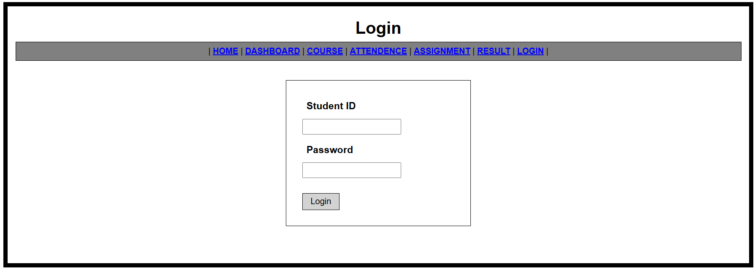
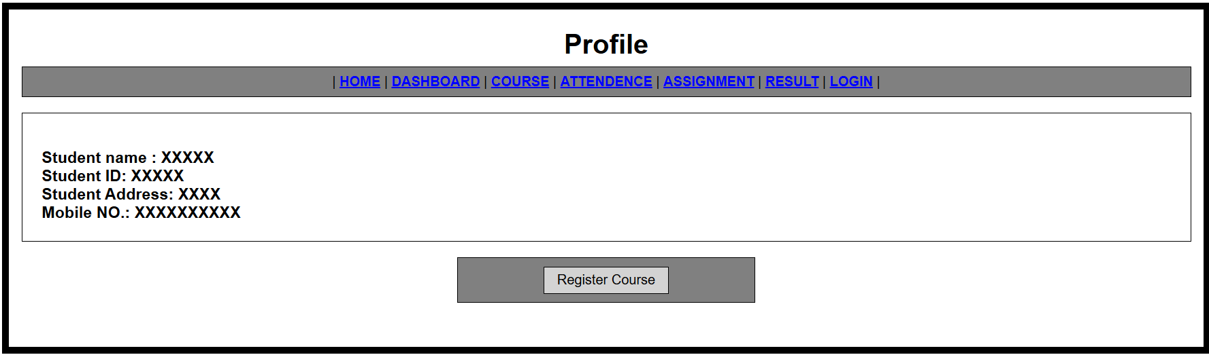
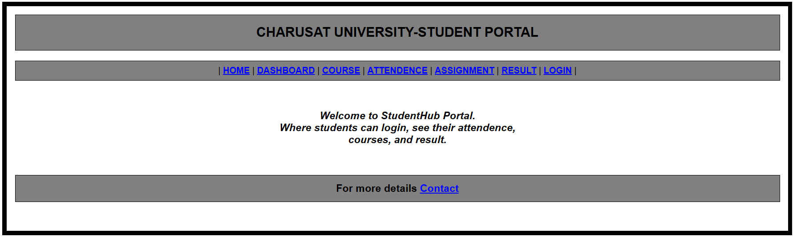

Evidence of Work (Screenshots)
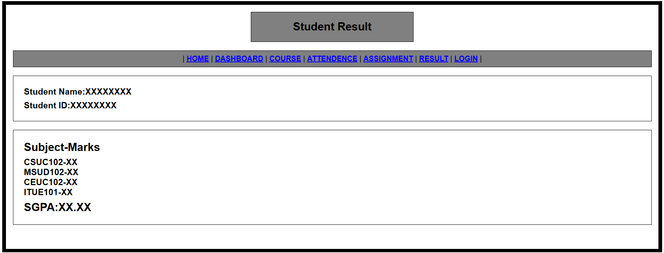Description:
Picture of result page showing student details and marks.
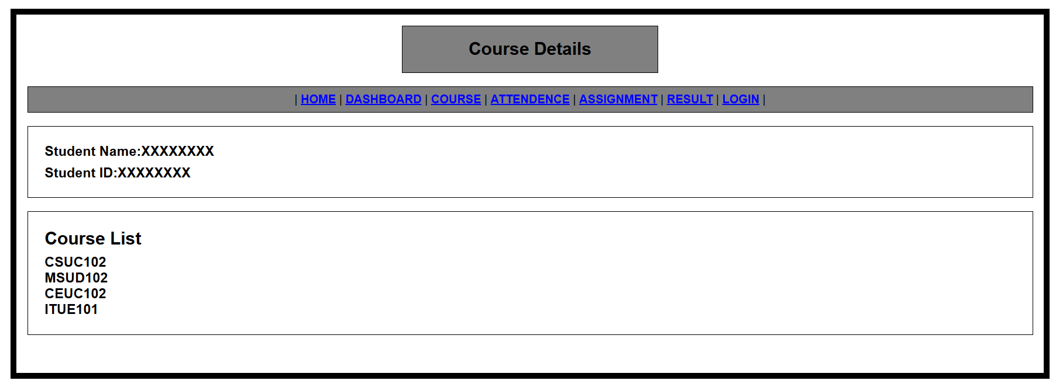
Description:
Course page of website showing the courses student has selected earlier.

GitHub Repository Link: https://github.com/shreyajodhani/studenthub.git

Challenges Faced:

Efficiently styling every HTML page at once using a single external CSS file without writing repetitive styling rules for each page.

Learning Outcomes:
Through this CSS practical, I learned how to style a full 10-page website consistently using a single external CSS file while keeping the HTML completely clean of inline styles.

Faculty Remarks: (Keep this blank for faculty)

