**CSE 489/589 – Fall 2020**

**PA 2**

**Team Member 1: Team Member 2:**

Kavitha Conjeevaram Mohan Shreya Pampattiwar

UBIT: 50336816 UBIT: 50336817

UBID: kavithac UBID: spampatt

**Academic integrity declaration:**

**I have read and understood the course academic integrity policy.**

**Timeout Scheme:**

**SR:**

**Experiments:**

***Experiment 1:***

Protocol > ABT

1. Window size: 10; X-axis: Loss probability; Y-axis: Throughput

Number of messages: 1000

Loss Probability: 0.1, 0.2, 0.4, 0.6, 0.8

Corruption: 0.0

Window Size: 10

1. Window size: 50; X-axis: Loss probability; Y-axis: Throughput

Number of messages: 1000

Loss Probability: 0.1, 0.2, 0.4, 0.6, 0.8

Corruption: 0.0

Window Size: 50

Protocol > GBN

1. Window size: 10; X-axis: Loss probability; Y-axis: Throughput

Number of messages: 1000

Loss Probability: 0.1, 0.2, 0.4, 0.6, 0.8

Corruption: 0.0

Window Size: 10

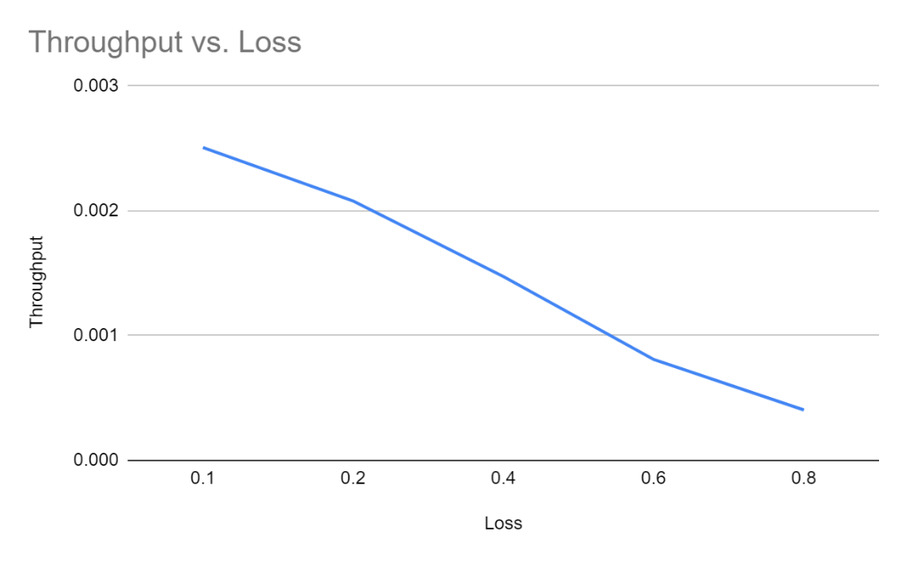

1. Window size: 50; X-axis: Loss probability; Y-axis: Throughput

Number of messages: 1000

Loss Probability: 0.1, 0.2, 0.4, 0.6, 0.8

Corruption: 0.0

Window Size: 50

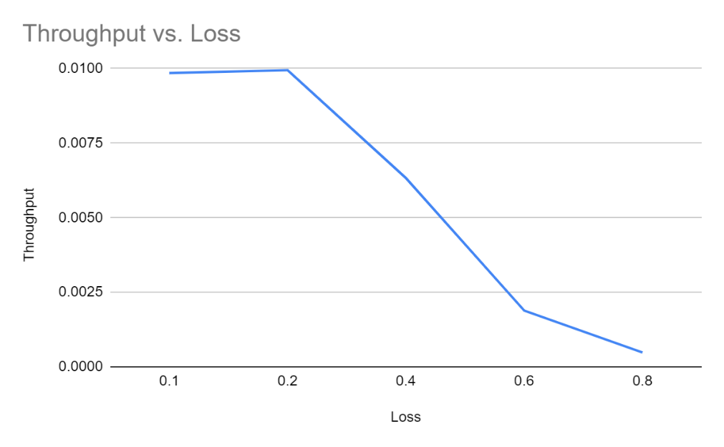

Protocol > SR

1. Window size: 10; X-axis: Loss probability; Y-axis: Throughput

Number of messages: 1000

Loss Probability: 0.1, 0.2, 0.4, 0.6, 0.8

Corruption: 0.0

Window Size: 10

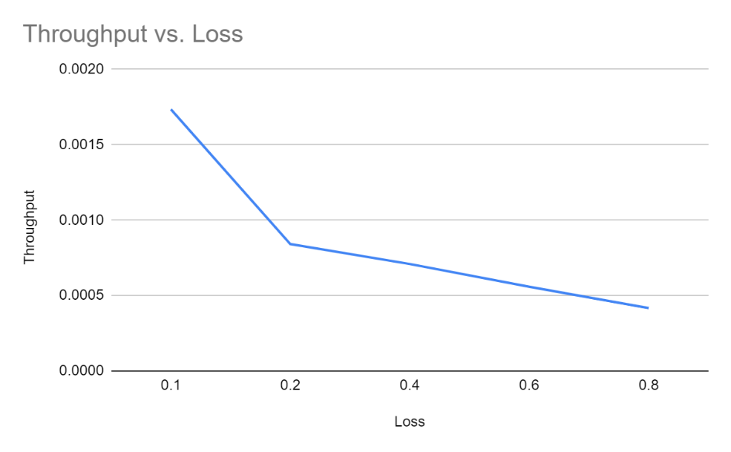

1. Window size: 50; X-axis: Loss probability; Y-axis: Throughput

Number of messages: 1000

Loss Probability: 0.1, 0.2, 0.4, 0.6, 0.8

Corruption: 0.0

Window Size: 50

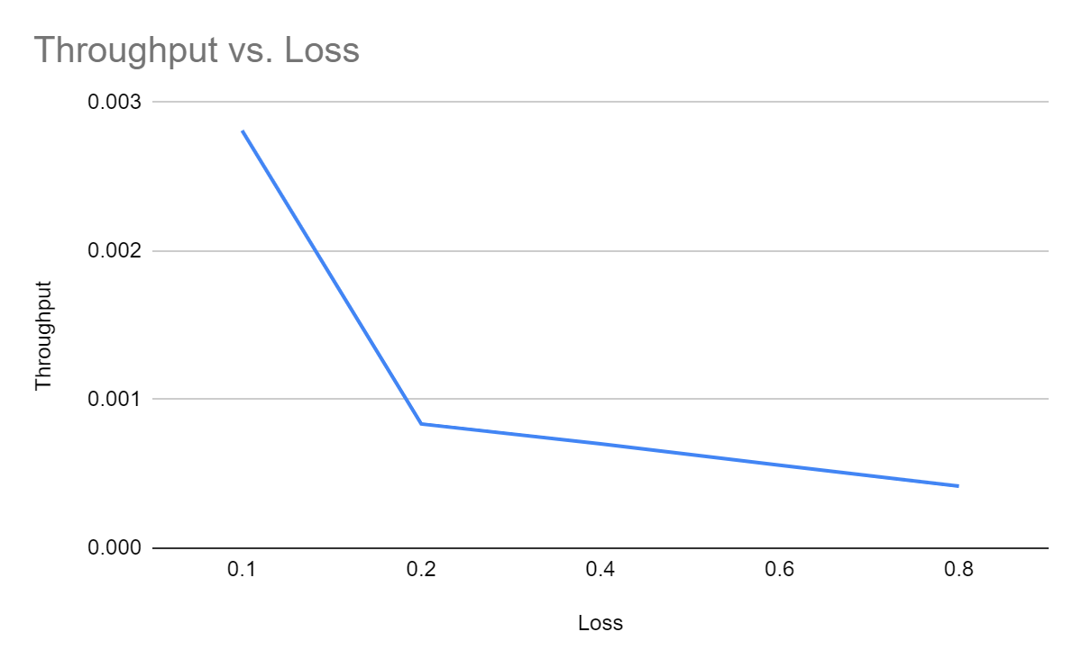

***Experiment 2:***

Protocol > ABT

1. Window size: 10; X-axis: Loss probability; Y-axis: Throughput

Number of messages: 1000

Loss Probability: 0.2, 0.5, 0.8

Corruption: 0.0

Window Size: 10

1. Window size: 50; X-axis: Loss probability; Y-axis: Throughput

Number of messages: 1000

Loss Probability: 0.2, 0.5, 0.8

Corruption: 0.0

Window Size: 50

1. Window size: 100; X-axis: Loss probability; Y-axis: Throughput

Number of messages: 1000

Loss Probability: 0.2, 0.5, 0.8

Corruption: 0.0

Window Size: 100

1. Window size: 200; X-axis: Loss probability; Y-axis: Throughput

Number of messages: 1000

Loss Probability: 0.2, 0.5, 0.8

Corruption: 0.0

Window Size: 200

1. Window size: 500; X-axis: Loss probability; Y-axis: Throughput

Number of messages: 1000

Loss Probability: 0.2, 0.5, 0.8

Corruption: 0.0

Window Size: 500

Protocol > GBN

1. Window size: 10; X-axis: Loss probability; Y-axis: Throughput

Number of messages: 1000

Loss Probability: 0.2, 0.5, 0.8

Corruption: 0.0

Window Size: 10

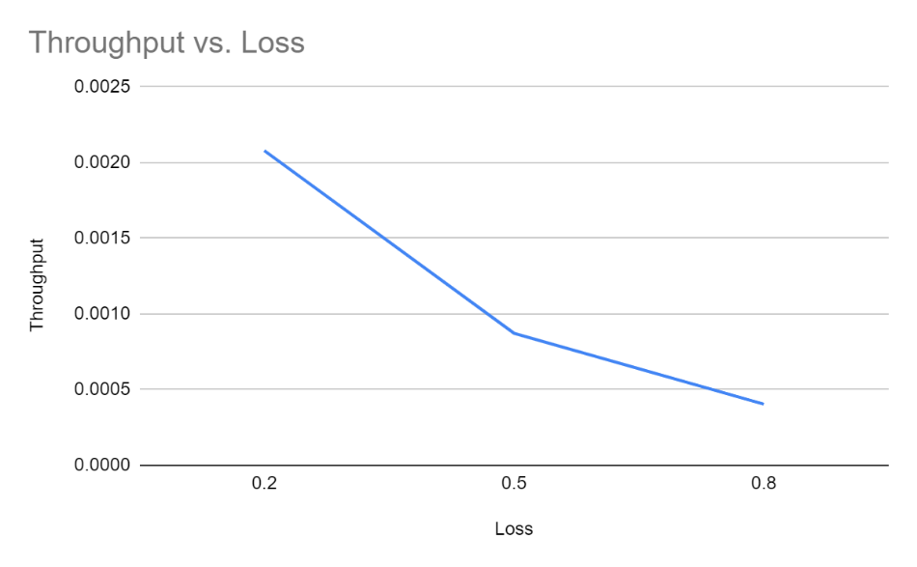

1. Window size: 50; X-axis: Loss probability; Y-axis: Throughput

Number of messages: 1000

Loss Probability: 0.2, 0.5, 0.8

Corruption: 0.0

Window Size: 50

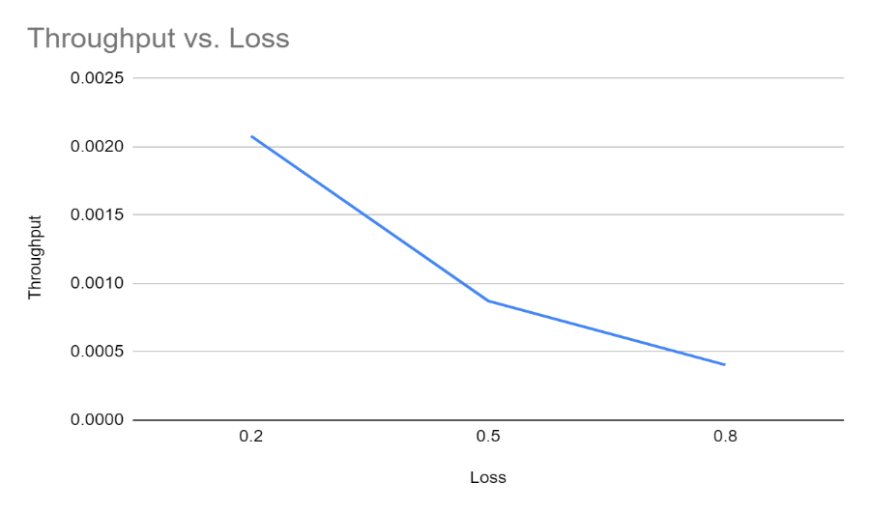

1. Window size: 100; X-axis: Loss probability; Y-axis: Throughput

Number of messages: 1000

Loss Probability: 0.2, 0.5, 0.8

Corruption: 0.0

Window Size: 100

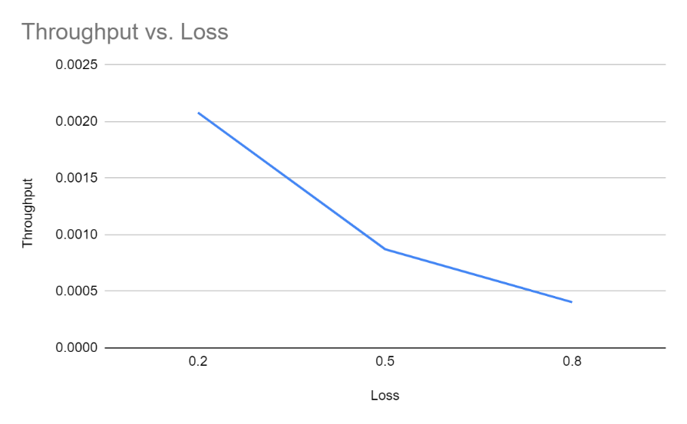

1. Window size: 200; X-axis: Loss probability; Y-axis: Throughput

Number of messages: 1000

Loss Probability: 0.2, 0.5, 0.8

Corruption: 0.0

Window Size: 200

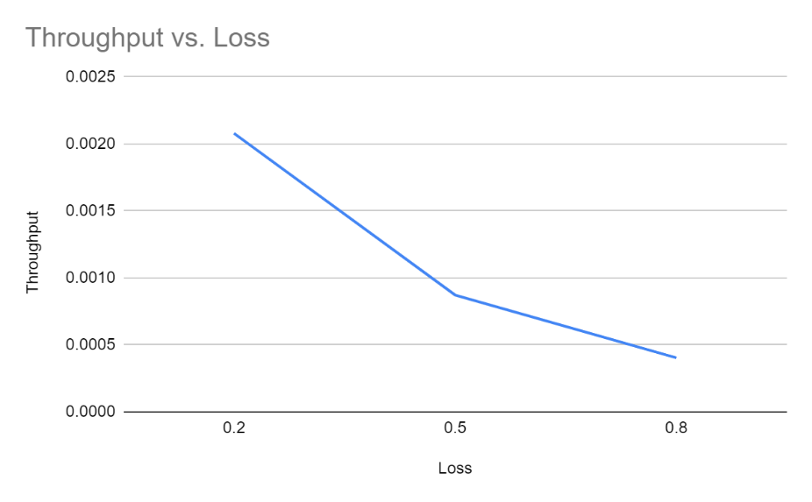

1. Window size: 500; X-axis: Loss probability; Y-axis: Throughput

Number of messages: 1000

Loss Probability: 0.2, 0.5, 0.8

Corruption: 0.0

Window Size: 500

