TE IT 2021-2022

Laboratory Practice-II

Subject Incharge: PROF. PRAGATI MAHALE

TABLE OF CONTENT

Index No | Content | Page No | Date
01 | Bridge The Gap | 03
02 | Assignment 1 A
03 | Assignment 1 B
04 | Assignment 2 A
05 | Assignment 2B
06 | Assignment 2 C
07 | Assignment 3A
08 | Assignment 3 B
09 | Assignment 4 A
10 | Assignment 4 B
11 | Content Beyond Syllabus
12 | Mini Project Report

Aim: Bridge the Gap

Problem statement:
Understand the basic concepts of XML
Theory:
- XML and HTML

XML (Extensible Markup Language) is an extensible markup language similar to HTML grammar and belongs to markup language. So how do you tell them apart?
- Design Difference

XML is designed to transfer and save data, and its focus is on the content of data. HTML is designed to display data, focusing on the appearance of the data. It can be said that HTML aims at displaying information and XML aims at transmitting the information.

- Grammatical Difference

- HTML has a variety of formats, some of which can not appear in pairs, and XML requires all tags to appear in pairs.

- HTML tags are fixed and limited in style. XML can be extended in any way, and tag types can be defined by themselves.
- HTML can have multiple tag headers, and XML only allows one tag header.
- HTML tags are case-insensitive and XML case-insensitive.

- XML Explanation

Have you ever remembered whether the system configuration document used in the development of the system is an XML document? As the configuration file of the system, it is the main application of XML. At the same time, it can also be used to transfer data in Ajax or Web Services.

- XML History

Before we get to know the basic usage of XML in detail, let’s take a look at the history of markup language.

The predecessor of XML is SGML (The Standard Generalized Markup Language), which is also optimized based on HTML. SGML is a standard after GML has been sorted out, but SGML is a very rigorous text description method, which is too large and complex to understand. At the same time, W3C (World Wide Web Consortium) also found HTML problems, such as: being unable to explain other forms of content such as audio-visual files, chemical formulas, and poor performance is not easy to expand poor elas, city, and so on. In order

to solve the above problems, experts use SGML to make simple and develop XML according to the development experience of HTML.

2. XML usage

Let’s start with an XML instance
XML/HTML CodeCopy content to clipboard
<?xml version=“1.0” encoding=“utf-8”?>
<?xml-stylesheet type=‘text/xsl’ href=‘content.xsl’?>
<book>
<List of books>
<Computer Books>
<bookname isbn=“xxx1234567”><<XMLApplication Daquan>></bookname>
<price>39.00</price>
</Computer Books>
</List of books>
<! – I added a comment – >
<List of books>
<Computer Books>
<bookname><! [CDATA [Oracle Application Complete’;’;””]></bookname>
<price>39.00</price>
</Computer Books>
<Computer Books>
<bookname>Java Application Complete</bookname>
<price>39.00</price>
</Computer Books>
</List of books>
</book>

  - statement

A well-formed XML file begins with an XML declaration, that is, <? XML version = “1.0” encoding = “utf-8”?> in the example above, which provides basic information about the document. The encoding represents the character encoding method used by the XML file, and the encoding attribute value must be the encoding attribute value to preserve the encoding format of the XML document.

  - elements

The element is the start tag, the end tag, and everything in between.
Like HTML, XML also has a basic tag structure. The format of tags is the same as HTML tags. The difference is that XML tags must have end tags when they have start tags, and they are case-sensitive. It allows the tag format to be nested, but it must be nested correctly.
XML structure is a tree structure, its content must have only one root element, and other elements must be nested in the root element. For example, <book></book> in the example above is the root element.

  - Entity Reference

Entity references print some special symbols in the XML document in a specific format, similar to the text in CDATA.

XML/HTML CodeCopy content to clipboard
<book>
<List of books>
<Computer Books>
<bookname isbn=“xxx1234567”><<XMLApplication Daquan>></bookname>
<price>39.00</price>
</Computer Books>
</List of books>
</book>
<! – Use IE to open the above code to see the results – > Use IE to open the above code.
Basic entity references are not detailed.

  - Special Labels

CDATA is a special label that enables all content within it to be printed out as text. The forms are as follows:
XML/HTML CodeCopy content to clipboard
<! [CDATA [Text Content]>

<?xml version=‘1.0’ encoding=‘utf-8’?>
<List of books>
<Computer Books>
<bookname><! [CDATA [Oracle Application Complete’;’;””]></bookname>
<price>39.00</price>
</Computer Books>
<List of books>

  - Chowder

(1) XML documents are organized by graphs, which is a tree structure. IE is often used to open them when they are displayed.
(2) The values of attributes in XML tags must be enclosed in quotes (single or double quotes, but they must be consistent);
(3) XSL format can be used to beautify the display of XML in XML documents with complex internal structure. The format: <? Xml-stylesheet type=’text/xsl’href=’the name of the XML document to be converted. xsl’?>.
Three, pay attention to
1. Statement: <? XML version=”” encoding=”?>;
2. The encoding type should be saved to the corresponding type when it is saved. Don’t forget to choose the type when it is saved.
3. There is only one top element.
4. Case sensitivity;
5. Attribute values must be enclosed in quotation marks (single or double quotation marks);
6. Start and finish.
7. Nested form should be correct.
The basic application of XML is discussed above. XML is very simple. Is XML all about that? Of course not. It’s also a programming language from its basic name. It should have some features of the programming language, such as templates in some languages or APIs in Java. Yes, XML can also define its grammatical structure. It can write template functions like programming languages, but in XML it is called legitimate XML, which is what we call legitimate XML verified by DTD or Schema.

Assignment No:1
Aim:
- Create a responsive web page that shows the eCommerce/college/exam admin dashboard with sidebar and statistics in cards using HTML, CSS, and Bootstrap.

- Write a JavaScript Program to get the user registration data and push it to array/local storage with the AJAX POST method and data lion an in new page.

Theory:
Part a.
  - HTML
- HTML stands for HyperText Markup Language
- HTML is the standard markup language for creating Web pages
- HTML describes the structure of a Web page
- HTML consists of a series of elements
- HTML elements tell the browser how to display the content
- HTML elements label pieces of content such as "this is a heading", "this is a paragraph", "this is a link", etc
A simple HTML Document

<!DOCTYPE html>
<html>
<head>
<title>Page Title</title>
</head>
<body>
<h1>My First Heading</h1>
<p>My first paragraph.</p>
</body>
</html>
- The <!DOCTYPE html> declaration defines that this document is an HTML5 document
- The <html> element is the root element of an HTML page
- The <head> element contains meta-information about the HTML page

- The <title> element specifies a title for the HTML page (which is shown in the browser's title bar or the page's tab)
- The <body> element defines the document's body and is a container for all the visible contents, such as headings, paragraphs, images, hyperlinks, tables, lists, etc.
- The <h1> element defines a large heading
- The <p> element defines a paragraph

  - CSS
- CSS stands for Cascading Style Sheets
- CSS describes how HTML elements are to be displayed on the screen, on paper, or in other media
- CSS saves a lot of work. It can control the layout of multiple web pages all at once
- External stylesheets are stored in CSS files
- CSS is used to define styles for your web pages, including the design, layout, and variations in display for different devices and screen sizes.

Simple CSS example

<!DOCTYPE html>
<html>
<head>
<style>
body {
background-color: lightblue;
}

h1 {
color: white;
text-align: center;
}
p {
font-family: verdana;
font-size: 20px;
}
</style>
</head>
<body>
<h1>My First CSS Example</h1>
<p>This is a paragraph.</p>
</body>
</html>

    - Bootstrap

Bootstrap is a free and open-source tool collection for creating responsive websites and web applications. It is the most popular HTML, CSS, and JavaScript framework for developing responsive, mobile-first websites. It solves many problems which we had once, one of which is the cross-browser compatibility issue. Nowadays, the websites are perfect for all the browsers (IE, Firefox, and Chrome) and all sizes of screens (Desktop, Tablets, Phablets, and Phones).
Why Bootstrap?
- Faster and Easier Web Development.
- It creates Platform-independent web pages.
- It creates Responsive Web-pages.
- It is designed to be responsive to mobile devices too.
- It is Free! Available on www.getbootstrap.com

Simple Example

<!DOCTYPE html>
<html lang="en">
<head>
<title>Bootstrap Example</title>
<meta charset="utf-8">
<meta name="viewport" content="width=device-width, initial-scale=1">
<link rel="stylesheet" href="https://maxcdn.bootstrapcdn.com/bootstrap/3.4.1/css/bootstrap.min.css">
<script src="https://ajax.googleapis.com/ajax/libs/jquery/3.6.0/jquery.min.js"></script>
<script src="https://maxcdn.bootstrapcdn.com/bootstrap/3.4.1/js/bootstrap.min.js"></script>
</head>
<body>
<div class="container">
<h1>My First Bootstrap Page</h1>
<p>This is some text.</p>
</div>
</body>
</html>

Bootstrap CDN

<!-- Latest compiled and minified CSS -->
<link rel="stylesheet" href="https://maxcdn.bootstrapcdn.com/bootstrap/3.4.1/css/bootstrap.min.css">
<!-- jQuery library -->
<script src="https://ajax.googleapis.com/ajax/libs/jquery/3.6.0/jquery.min.js"></script>
<!-- Latest compiled JavaScript -->
<script src="https://maxcdn.bootstrapcdn.com/bootstrap/3.4.1/js/bootstrap.min.js"></script>

Program Code:

Output:

Conclusion:

Part b.
AJAX stands for Asynchronous JavaScript and XML.AJAX is a new technique for creating better, faster, and more interactive web applications with the help of XML, HTML, CSS, and JavaScript.
Ajax uses XHTML for content, CSS for presentation, along with Document Object Model and JavaScript for dynamic content display.
Conventional web applications transmit information to and from the server using synchronous requests. It means you fill out a form, hit submit, and get directed to a new page with new information from the server.
With AJAX, when you hit submit, JavaScript will make a request to the server, interpret the
results, and update the current screen. In the purest sense, the user would never know that anything was even transmitted to the server. XML is commonly used as the format for receiving server data, although any format, including plain text, can be used. AJAX is a web browser technology independent of web server software.
A user can continue to use the application while the client program requests information from
the server in the background. Intuitive and natural user interaction. Clicking is not required, mouse movement is a sufficient event trigger. Data-driven as opposed to page-driven.
AJAX is based on the following open standards −
- Browser-based presentation using HTML and Cascading Style Sheets (CSS).
- Data is stored in XML format and fetched from the server.
- Behind-the-scenes data fetches using XML HttpRequest objects in the browser.
- JavaScript to make everything happen

AJAX cannot work independently. It is used in combination with other
technologies to create interactive WebPages.
• JavaScript
– Loosely typed scripting language.
– The javaScript function is called when an event occurs on a page.
– Glue for the whole AJAX operation.

• DOM
– API for accessing and manipulating structured documents.
– Represents the structure of XML and HTML documents.
• CSS
– Allows for a clear separation of the presentation style from the content
and maybe changed programmatically by JavaScript
• XMLHttpRequest
– JavaScript object that performs asynchronous interaction with the server.
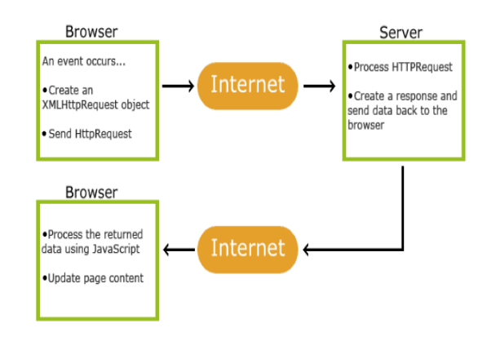
Fig 1. How AJAX works

AJAX – Events: onreadystatechange Event Properties

Property | Description
onReadyStateChange | It is called whenever the ready statemate attribute changes. It must not be used with synchronous requests.
readyState | represents the state of the request. It ranges from 0 to 4.  - 0: request not initialized (open() is not called.)  - 1: server connection established (open is called but send() is not called.)  - 2: request received (send() is called, and headers and status are available.)  - 3: processing request (Downloading data; responseText holds the data.)  - 4: request finished and response is ready (The operation is completed fully.)
Status | 200: "OK"  403: "Forbidden"  404: "Page not found"

XMLHttpRequest object properties

Property | Description
readyState | An integer from 0. . .4. (0 means the call is uninitialized, 4 means  that the call is complete.)
onreadystatechange | Determines the function called when the objects readyState changes.
responseText | Data returned from the server as a text string (read-only).
responseXML | Data returned from the server as an XML document object (read-only).
status | HTTP status code returned by the server
statusText | HTTP status phrase returned by the server

XMLHttpRequest object methods

Method | Description
open('method', 'URL', asyn) | Specifies the HTTP method to be used (GET or POST as a string, the target URL, and whether or not the request should be handled asynchronously (as should be true or false, if omitted, true is assumed).
send(content) | Sends the data for a POST request and starts the request, if GET is used you should call send(null).
setRequestHeader('x','y') | Sets a parameter and value pair x=y and assigns it to the header to be sent with the request.
getAllResponseHeaders() | Returns all headers as a string.
getResponseHeader(x) | Returns header x as a string.
abort() | Stops the current operation.

Sample code:
ajaxcommunication.html

<html>
<body>
<div id="xyz">
Hello Friends <br>
Welcome to Pune!!!!!<br>
<button type="button" onclick="load()">
Submit
</button>
</div>
<script>
function load(){
var req=new XMLHttpRequest()
req.onreadystatechange=function() {
if(this.readyState == 4 && this.status == 200){
document.getElementById("xyz").innerHTML=this.responseText
}
}
req.open('GET','data.txt',true)
req.send()
}
</script>

</body>
</html>

Data.txt

I am enjoying learning JavaScript!!!!!!

Program Code:

Output:

Conclusion:
Studied and implemented experiment with HTML,CSS,Boostrap,AJAX

Assignment No: 2
Aim:
- Create a version control account on GitHub and use Git commands to create a repository and push your code to GitHub.

- Create Docker Container Environment (NVIDIA Docker or any other).

- Create an Angular application that will do the following actions: Register User, Login User, Show User Data on Profile Component

Theory:
Part a.
1. What is Git?
Git is a popular version control system. It was created by Linus Torvalds in 2005 and has been maintained by Junio Hamano since then.
It is used for:
- Tracking code changes
- Tracking who made changes
- Coding collaboration
2. What does Git do?
- Manage projects with Repositories
- Clone a project to work on a local copy
- Control and track changes with Staging and Committing
- Branch and Merge to allow for work on different parts and versions of a project
- Pull the latest version of the project to a local copy
- Push local updates to the main project
3. Working with Git
- Initialize Git on a folder, making it a Repository
- Git now creates a hidden folder to keep track of changes in that folder
- When a file is changed, added, or deleted, it is considered modified

- You select the modified files you want to Stage
- The Staged files are Committed, which prompts Git to store a permanent snapshot of the files
- Git allows you to see the full history of every commit.
- You can revert to any previous commit.
- Git does not store a separate copy of every file in every commit, but keeps track of changes made in each commit!
4. Why Git?
- Over 70% of developers use Git!
- Developers can work together from anywhere in the world.
- Developers can see the full history of the project.
- Developers can revert to earlier versions of a project.
5. What is GitHub
- Git is not the same as GitHub.
- GitHub makes tools that use Git.
- GitHub is the largest host of source code in the world and has been owned by Microsoft since 2018.
6. Steps to Push and PULL version control repository to GitHub

Step No | Command | Description
1 | Git Installation | Download Git from the website: https://www.git-scm.com/
2 | Command-line  >git –version | If Git is installed, it should show something like git version X.Y
3 | git config --global user.name "w3schools-test"  git config --global user.email "test@w3schools.com" | Configure Git  Change the user name and e-mail address to your own
4 | mkdir myproject  cd myproject | Creating Git Folder
5 | git init | Initialize Git  Initialized empty Git repository in /Users/user/myproject/.git/
6 | git status | To check the status
7 | Git-add index.html | Add file to a staging environment
8 | Git-add --all | add all files in the current directory to the Staging Environment:
9 | git commit -m "First release of Hello World!" | The commit command performs a commit, and the"message" adds a message.
10 | git commit -a -m "Updated index.html with a new line" | Skips staging environment
11 | git log | To view the history of commits for a repository, you can use the log command
12 | git command -help | See all the available options for the specific command
13 | git help –all | See all possible commands
14 | git commit -help | See help for a specific command
15 | git branch hello-world-images | a branch is a new/separate version of the main repository. This command creates a new branch hello-world-images
16 | git checkout hello-world-images | checkout is the command used to check out/ move to a branch
17 | git checkout master | Used to switch between branches
18 | https://github.com/ | Create a new account on Github
19 | https://api.github.com/user/repos-d | Create a Repository on GitHub
20 | git remote add origin https://github.com/w3schools-test/hello-world.git | Push Local Repository to GitHub
21 | git push --set-upstream origin master | push the master branch to the or URL URL,
22 | $ git pull origin master | go back into GitHub and see that the repository has been updated:
23 | git fetch origin | fetch gets all the change history of a tracked branch/repo
24 | git merge origin/master | merge combines the current branch, with a specified branch.
25 | git pull origin | The pull is a combination of fetch and merge  It is used to pull all changes from a remote repository into the branch you are working on.

Program Code:

Output:

Conclusion:

Part b: Docker Container Environment.

Program Code:

Output:

Conclusion:

Part c:
Useful link - https://www.tutorialsteacher.com/angular/install-angular

- Angular requires a current, active LTS(long-term support) or maintenance LTS version of Node.js and NPM.
install node.js https://nodejs.org/
It will automatically install the NPM - node package manager
- Install Angular CLI
npm install -g @angular/cli@latest
To Create an Angular 2 Application Angular CLI is required
- To create a new project
through CLI go to the folder of the new project
Give command as -
ng new project-name
press ENTER
The project will be created as a directory structure below –
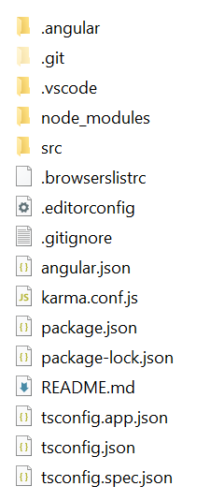

Open folder src/app
Modify app.module.ts for form application
import { NgModule } from'@angular/core';
import { BrowserModule } from'@angular/platform-browser';

import { AppRoutingModule } from'./app-routing.module';
import { AppComponent } from'./app.component';
import {FormsModule} from'@angular/forms'

@NgModule({
declarations: [
AppComponent
],
imports: [
BrowserModule,
AppRoutingModule,
FormsModule,
],
providers: [],
bootstrap: [AppComponent]
})
exportclassAppModule { }

Open app.component.html
Write HTML code for form (representative code is mentioned here, modify for multiple inputs)

<h1>Simple Form</h1>
<form#simpleForm = "ngForm"(ngSubmit) = "getValues(simpleForm.value)">
<inputtype ="text"ngModelname = "user"placeholder = "Enter Name">
<br><br>
<inputtype ="text"ngModelname = "age"placeholder = "Enter age">
<br><br>
<inputtype ="text"ngModelname = "city"placeholder = "Enter city">
<br><br>
<button>Get user value</button>
</form>

Make changes in app.component.ts
import { Component } from'@angular/core';
@Component({
selector:'app-root',
templateUrl:'./app.component.html',
styleUrls: ['./app.component.css']
})
exportclassAppComponent {
title = 'AngProj1';
getValues(val:any)
{
console.log(val);
}
}

Here getValue() function which is called in the form file is defined.
You can check inputted values through the form in the console.

Build application
1. Use Angular CLI command ng serve -o to build an application.
The -o indicates to open it automatically in the default browser.
2. Use the NPM command ‘npm start’ to build an application
http://localhost:4200 to see the application home page.
3. Open the terminal in VS Code from menu Terminal -> New Terminal,
, and type ng serve -o command and press enter,

You can send the form contents from the console on another p
Based on the above implementation, you can design a logo for the user, and show user data.

Program Code:

Output:

Conclusion:

Assignment No: 3
Aim:
a. Create a Node.JS Application that serves a static website.

b. Create four API using Node.JS, ExpressJS, and MongoDB for CURD Operations on assignment no 2.

Theory:
Part a:
Create a Node.JS Application that serves a static website.
Installation: Node.js (site – Node.js), Express.js(installed through cmd)
Node.js overview
In basic terms, Node is an open-source cross-platform library for server-side programming that permits clients to develop web applications rapidly. With Node, we can execute JavaScript applications or network applications. Its basic modules are engraved in JavaScript.
It is generally utilized for server applications in real-time. Node.js permits JavaScript to execute locally on a machine or a server.
Node.js gives numerous systems to utilize. One of such structures is Express.js. It is more valuable and mainstream than the different structures of Node.js.
Features of Node.js
- Versatility: Node is incredibly adaptable as the server reacts in a non-blocking way.
- Zero Buffering: Applications yield the measurements in enormous pieces. This gives the advantage of ‘No buffering’ to developers.
- Network: Node.js upholds an open-source community. This is the main explanation that numerous glorious modules have been added to Node.js applications over time.
- Occasion driven Input and output: APIs of Node.js is non-blocking, meaning that the server won’t wait for the arrival of information from an API. Rather, it will move to another API.
Advantages of Node.js
- Easy to learn: Nodeis quite simple for developers to utilize and learn. Learning Node.js is less difficult than React.

- Better Performance: Node.js takes the code of JavaScript via Google’s V8 JavaScript engine. The main advantage of this process is that it complies with the JavaScript code directly into the machine code
- Freedom: Node.js offers a lot of freedom when it comes to development. There are generally fewer constraints with Node.
- Extended support for tools: Another advantage of Node.js is that developers have more community support.
- Extensible: Node.js is known to be quite extensible. You can utilize JSON to give the degree to trade of information between the web server and the client.
- Scalability: Node.js makes it simple to scale applications in horizontal as well as vertical directions. The applications can be scaled even by the option of extra hubs to the current framework.
Limitations of Node.js
- Programming interface isn’t steady: The Application Programming Interface (API) of Node can be challenging to work with. It changes regularly and doesn’t remain stable.
- No strong library support system: JavaScript does not hold a strong library system. This limits the developers to implement even common programming tasks using Node.js.
- Programming model is not synchronous: Many developers find this programming model tougher in comparison to linear blocking I/O programming. In asynchronous programming, the codes become clumsier, and developers have to depend on the nes

Express.js
"Express is a fast, unopinionated minimalist web framework for Node.js" - official website: Expressjs.com
Express.js is a web application framework for Node.js. It provides various features that make web application development fast and easy which otherwise takes more time using only Node.js.
Express.js is based on the Node.js middleware module called connect which in turn uses the HTTP module. So, any middleware which is based on connect will also work with Express.js.

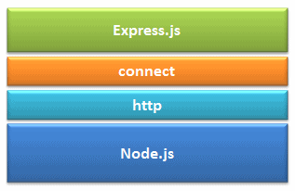
Advantages of Express.js
- Makes Node.js web application development fast and easy.
- Easy to configure and customize.
- Allows you to define routes of your application based on HTTP methods and URLs.
- Includes various middleware modules which you can use to perform additional tasks on request and response.
- Easy to integrate with different template engines like Jade, Vash, EJS, etc.
- Allows you to define an error handling middleware.
- Easy to serve static files and resources of your application.
- Allows you to create a REST API server.
- Easy to connect with databases such as MongoDB, Redis, MySQL
Steps:
- Install Node.js
- Setting up express.js
- Structuring files
- Creating your express server
- Servicing your static files
- Building your web page
- Running your project
Open the Node.js command terminal &run the following in your terminal-
Setting up express.js
- Create a new directory for your project - mkdir your-project-name
- Change into your new directory - cd your-project-name
- Initialize a new Node project with defaults. This will set a package.json file to access your dependencies: npm init -y

- Create your entry file, index.js. This is where you will store your Express server: if you are working on Linux, you can run: touch index.js. if you are working on windows, you can edit in VSCode
- Install Express as a dependency: npm install express –save
- Edit package.json. Within your package.json, update your start script to include node and your index.js file.
Let express-static-file-tutorial is your project name
Package.json
{
"name": "express-static-file-tutorial",
"version": "1.0.0",
"description": "",
"main": "index.js",
"scripts": {
"start": "node index.js" // change start value as node index.js
}, // This will allow you to use the npm start command in your terminal to launch
"keywords": [], your express server
"author": "Paul Halliday",
"license": "MIT"
}

Structuring Your Files
To store your files on the client-side, create a public directory and include an index.html file
express-static-file-tutorial
|- index.js
|- public
|- index.html

Creating Your Express Server

Edit index.js file
Index.js
const express = require('express');
const app = express();
const PORT = 3000;

app.use(express.static('public')); // represents application is serving static webpage in public directory

app.get('/', (req, res) => {
res.send('Hello World!');
});

app.listen(PORT, () => console.log(`Server listening on port: ${PORT}`));

First of all, import the Express.js module.
In the above example, we imported the Express.js module using require() function. The express module returns a function. This function returns an object which can be used to configure the Express application (app in the above example).
The app object includes methods for routing HTTP requests, configuring middleware, rendering HTML views, and registering a template engine.
The app.listen() function creates the Node.js web server at the specified host and port. It is identical to Node's http.Server.listen() method. Instead of Get(), post(), put() and delete() methods can be used.

Building Your Web Page – client side
Navigate to your index.html file in the public directory. Populate the file with body and image elements:
[label index.html]
<html>
<head>
<title>Hello World!</title>
</head>
<body>
<h1>Hello, World!</h1>
<img src="shark.png" alt="shark"> //download & store image in public directory
</body>
</html>

(Instead of building a Hello world application, building applications like student’s Registration form/main page othe f website is recommended)

Running Your Project
In your terminal, launch your Express project
npm start
It will display
Server listening on port: 3000

Open your web browser, and navigate to http://localhost:3000.

Program Code:

Output:

Conclusion:

Part b: Operations on assignment No 02

Program Code:

Output:

Conclusion:

Assignment No: 4
Aim:
a. Create a simple Mobile Website using jQuery Mobile.

b. Deploy/Host Your web application on AWS VPC or AWS Elastic Beanstalk. Mini Project
Develop a web application using full-stack development technologies in any of the following domains:
1. Social Media
2. eCommerce
3. Restaurant
4. Medical
5. Finance
6. Education
7. Any other

Theory:
Part a:
jQuery Mobile
JQuery Mobile is a user interface framework, built on jQuery Core and used for developing responsive websites or applications that are accessible on mobile, tablet, and desktop devices. It uses features of both jQuery and jQueryUI to provide API features for mobile web applications. This tutorial will teach you the basics of the jQuery Mobile framework. We will also discuss some detailed concepts related to jQuery Mobile.
Why Use jQuery Mobile?
- It creates web applications that will work the same way on a mobile, tablet, and desktop devices.
- It is compatible with other frameworks such as PhoneGap, Whitelight, etc.
- It provides a set of touch-friendly form inputs and UI widgets.
Features of jQuery Mobile
- It is built on jQuery Core and the "write less, do more" UI framework.
- It is an open-source framework, and cross-platform as well as cross-browser compatible.
- It is written in JavaScript and uses features of both jQuery and jQuery UI for building mobile-friendly sites.

Download jQuery Mobile
When you open the link https://jquerymobile.com/, you will see there are two options to download the jQuery mobile library.

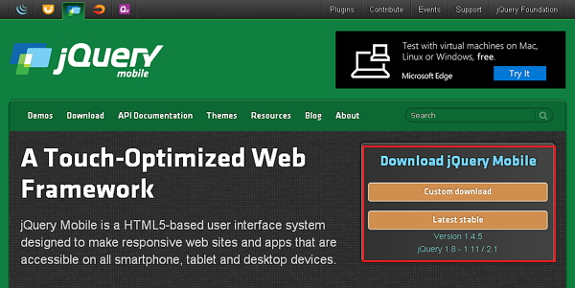

Click the Stable button, which leads directly to a ZIP file containing the CSS and JQuery files, for the latest version of the jQuery mobile library. Extract the ZIP file contents to a jQuery mobile directory.
This version contains all files including all dependencies, a large collection of demos, and even the library's unit test suite. This version helps get started.

Program Code:

Output:

Conclusion:

Part b:
What is Cloud Computing?
Cloud computing is a term referred to storing and accessing data over the internet. It doesn’t store any data on the hard disk of your personal computer. In cloud computing, you can access data from a remote server.
What is AWS?
The full form of AWS is Amazon Web Services. It is a platform that offers flexible, reliable, scalable, easy-to-use, and, cost-effective cloud computing solutions.
AWS is a comprehensive, easy-to-use computing platform offered by Amazon. The platform is developed with a combination of infrastructure as a service (IaaS), platform as a service (PaaS), and packaged software as a service (SaaS) offerings.
It is a secure cloud services platform, offering to compute power, database storage, content delivery, and other functionality to help businesses scale and grow.
In simple words AWS allows you to do the following things- Running web and application servers in the cloud to host dynamic websites.
History of AWS
- 2002- AWS services launched
- 2006- Launched its cloud products
- 2012- Holds first customer event
- 2015- Reveals revenues achieved of $4.6 billion
- 2016- Surpassed $10 billion revenue target
- 2016- Release snowball and snowmobile
- 2019- Offers nearly 100 cloud services
- 2021- AWS comprises over 200 products and services

Important AWS Services
Amazon Web Services offers a wide range of different business purposes global cloud-based products. The products include storage, databases, analytics, networking, mobile, development tools, and enterprise applications, with a pay-as-you-go pricing model.

Applications of AWS services
Amazon Web services are widely used for various computing purposes like:
- Websitete hosting
- Application hosting/SaaS hosting
- Media Sharing (Image/ Video)
- Mobile and Social Applications
- Content delivery and Media Distribution
- Storage, backup, and disaster recovery
- Development and test environments
- Academic Computing
- Search Engines
- Social Networking

Creating an AWS Account is the first step you need to take to learn Amazon Web Services.
The steps to follow are as follows:
Step 1 – Visiting the Signup Page
Go to https://aws.amazon.com
You should see something like the below:
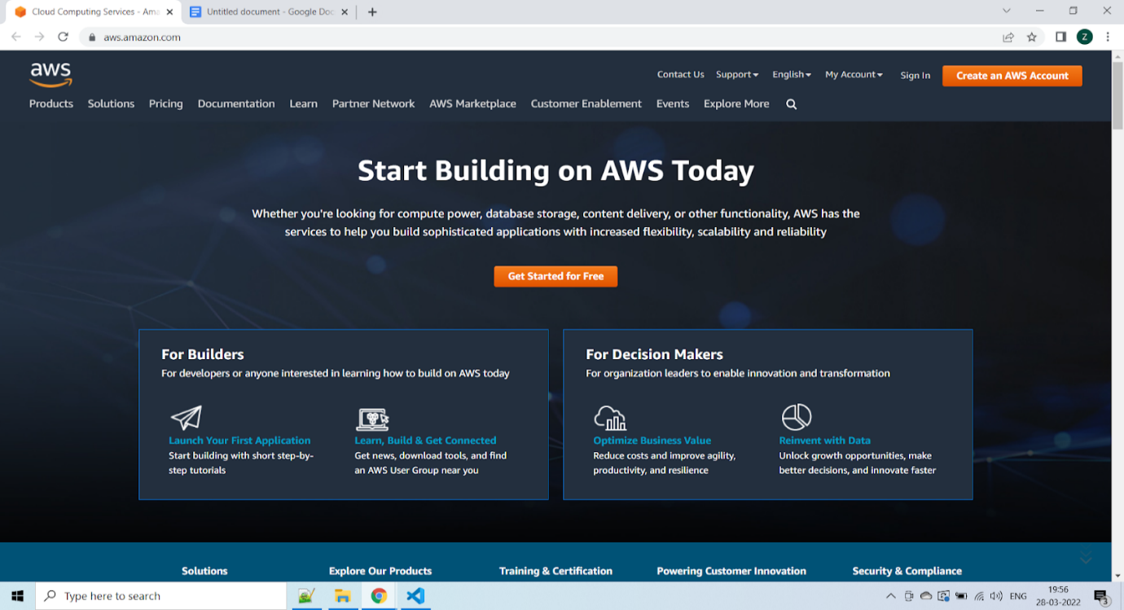

To continue, click the Complete Sign Up button in the middle of the screen or on the top right corner of the screen. You will see the below screen.

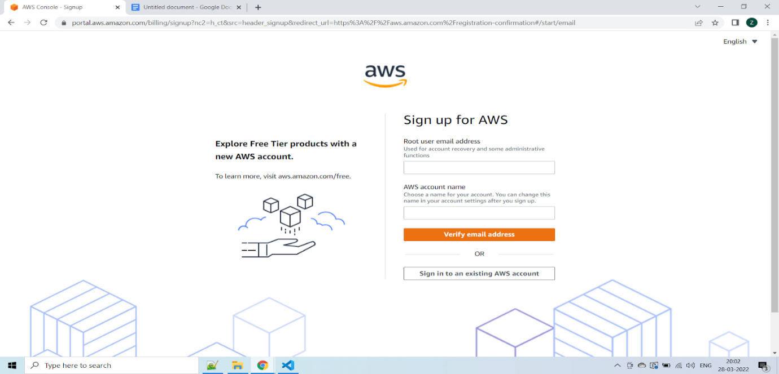

Step 2 – Entering User Details
After you have chosen to create a new AWS account, you will see the below screen asking for a few details.
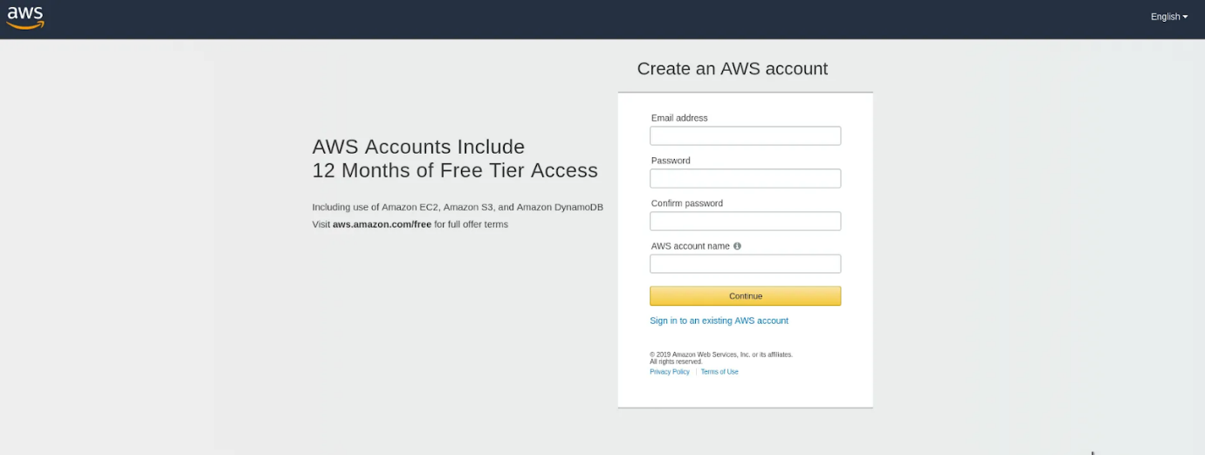

You can fill up the details as per your requirements and click Continue.
Next, you will be asked to fill up your contact details such as contact number, country, address, and so on. You should fill them up properly because your contact number is important for further steps.
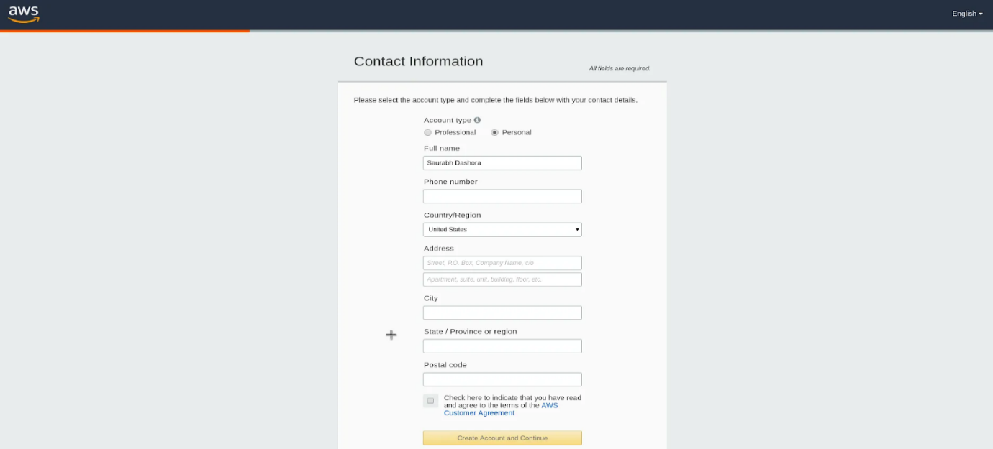
After filling up the details, click on the Create Account and Continue button at the bottom of the form.

Step 3 – Filling up the Credit Card details
For Creating an AWS Account, you need to enter your Credit Card details.
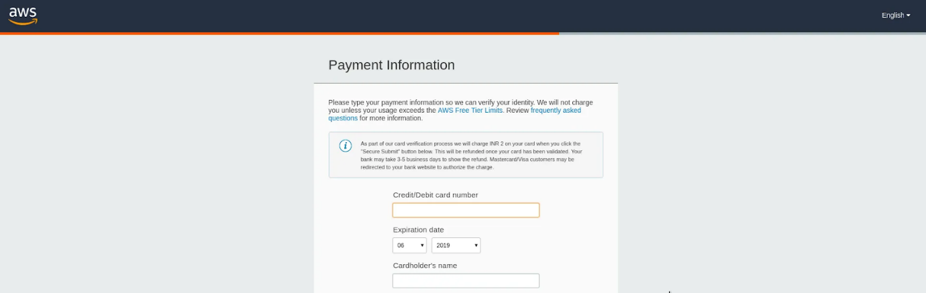
After entering the details, click on the Secure Submit button. It might take a while to process the request depending on your bank/credit card company servers.

Step 4 – Identity Confirmation
Once the credit card details are confirmed, you will need to complete the Identity Confirmation step. You will see the below screen:

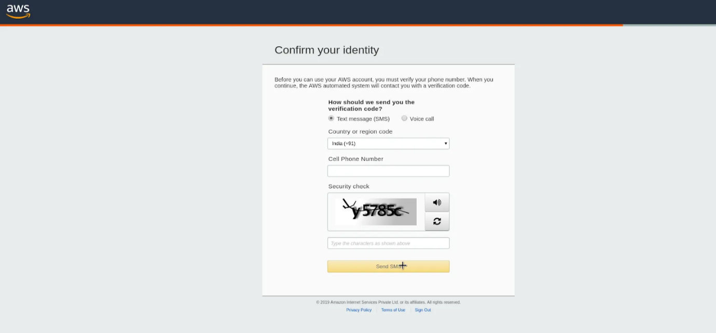

Once you have verified successfully, you should see a screen like the below:
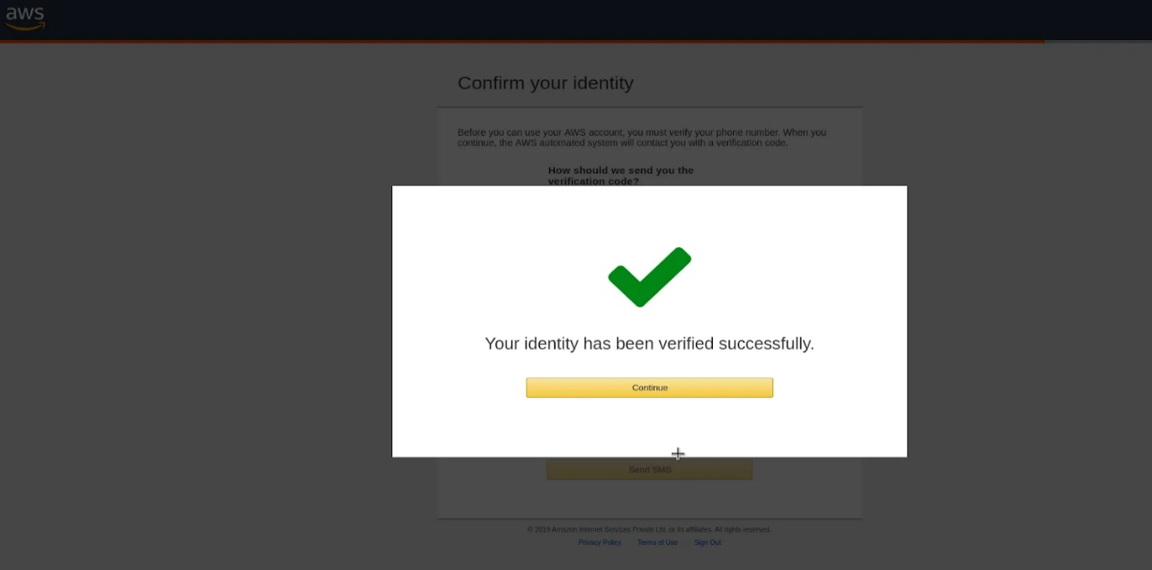

Step 5 – Selecting a Support Plan
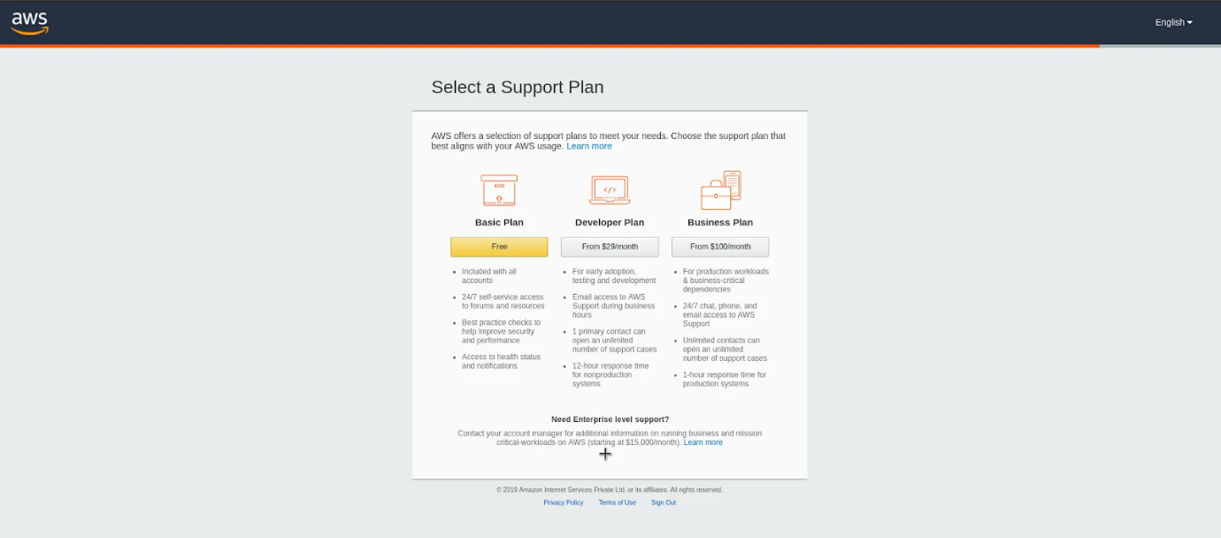

Go for Basic Plan. It is Free of cost and great for learning purposes.
The other plans are Developer Plan and a Business Plan. But both of them are paid options.
Once you select your plan, you will see the below Welcome screen. From here on, you can Sign in to your AWS Console.

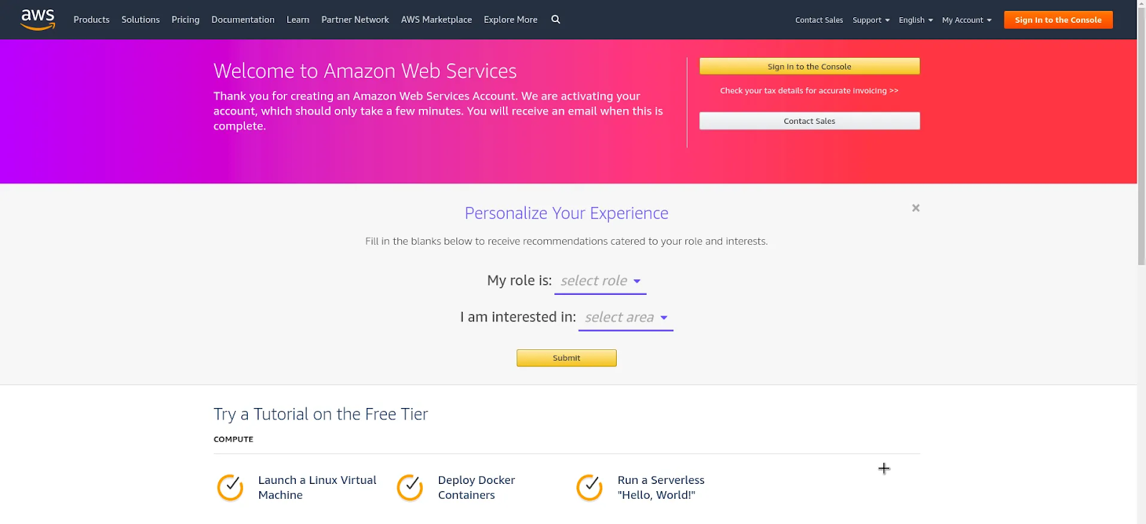

Finally, after logging in, you should be able to see the AWS Management Console as below:

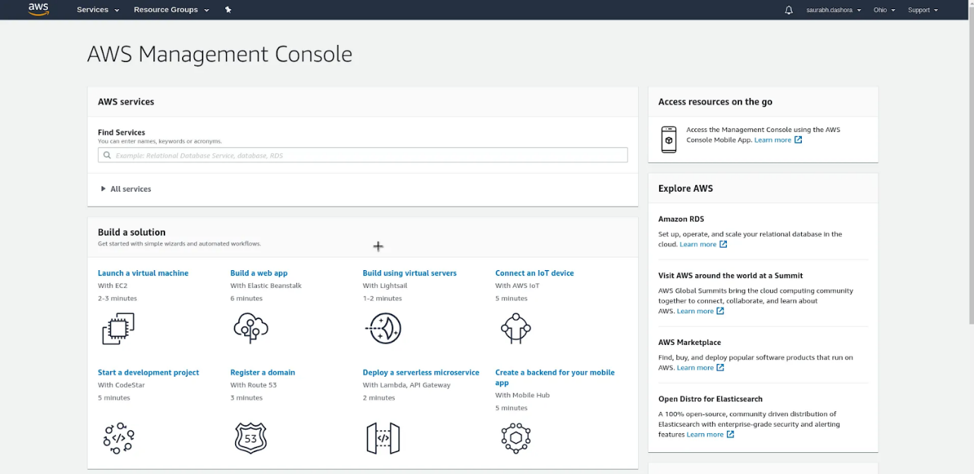

If you have reached this far, you have successfully finished Creating an AWS Account.
Deployment Steps:
Step 1: Launch a Windows Server Amazon EC2 instance.
Step 2: Configure your source content to deploy to the Windows Server Amazon EC2 instance.
Step 3: Upload your "hello, world!" ...
Step 4: Deploy your Hello World application.
Step 5: Update and redeploy your "hello, world!" ...
Step 6: Clean up your "hello, world!"

Program Code:

Output:

Conclusion:

MINI PROJECT REPORT

