Advance Linux:
- What is the size of MBR and what does it contains.
The MBR consists of 512 or more bytes located in the first sector of the drive.
A master boot record (often shortened as MBR) is a kind of boot sector stored on a hard disk drive or other storage device that contains the necessary computer code to start the boot process.
The MBR is created when a hard drive is partitioned, but it's not located within a partition. This means non-partitioned storage mediums, like floppy disks, don't contain a master boot record.
The specific address on the disk is Cylinder: 0, Head: 0, Sector: 1.
- In which file you can write commands which you want to run whenever Linux system starts/restarts?
rc.local
- Restart cron service.
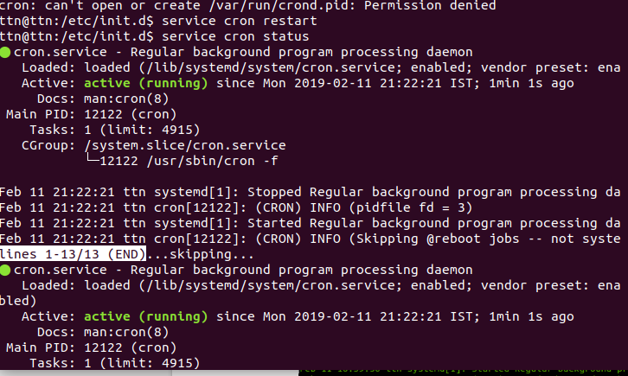
- Create an ext4 filesystem
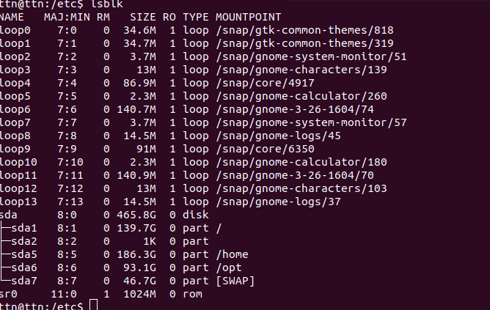
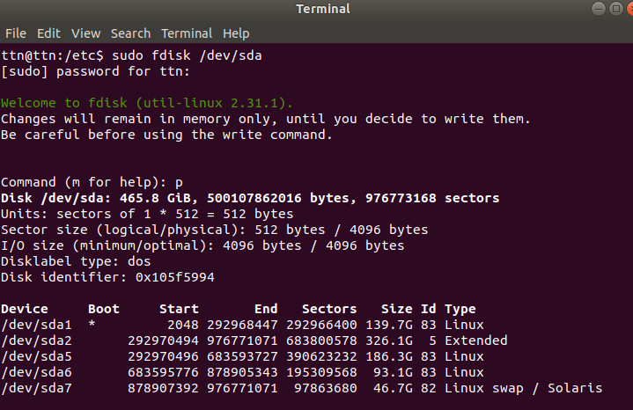
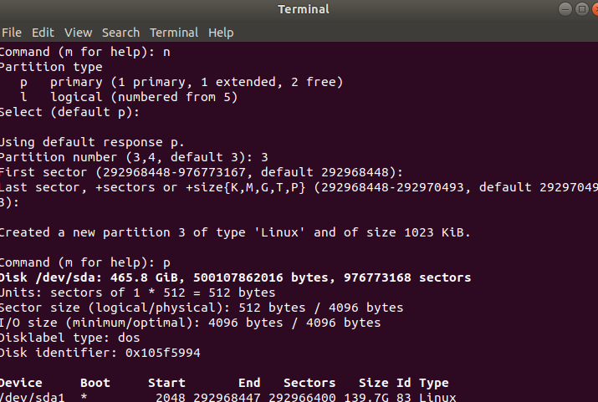

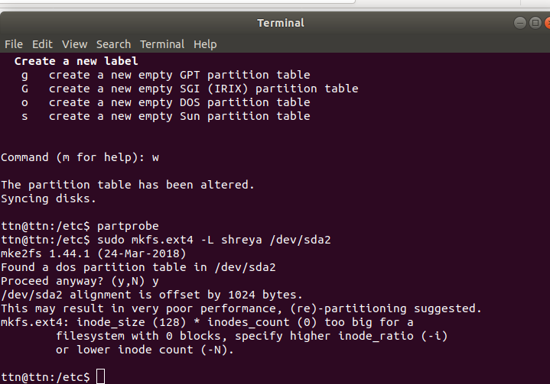

- Create a user and add it to one secondary group.
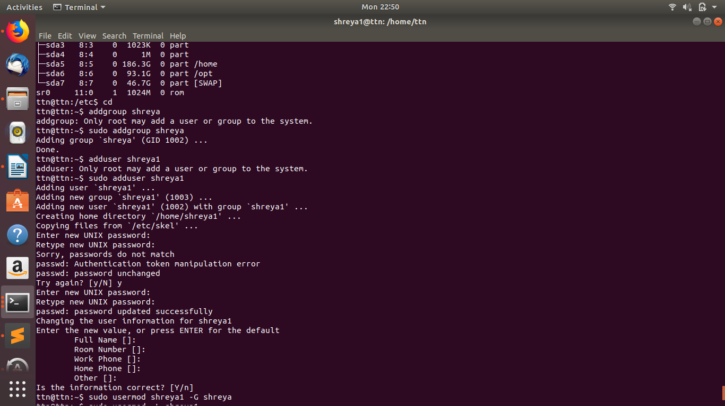
- Lock this user.
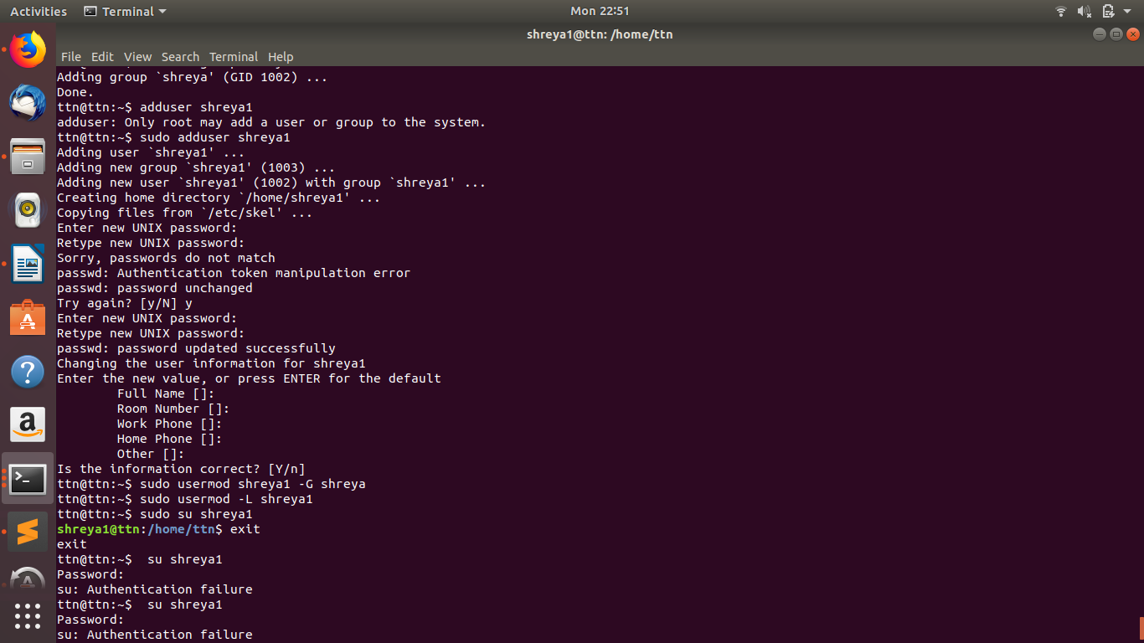
- Give this user full access (without password).

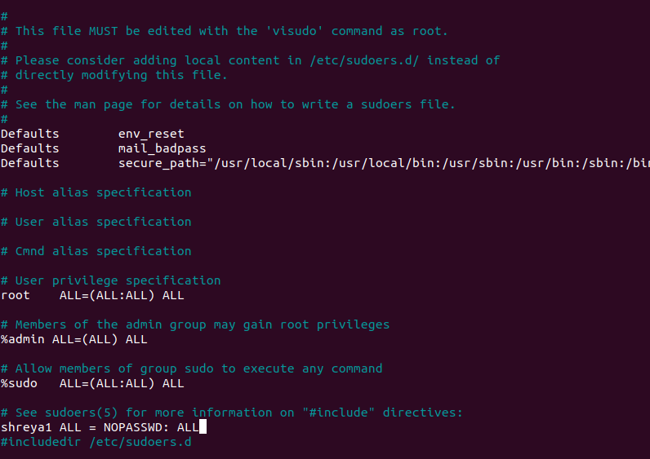

9.Delete the create user after taking backup of it home directory.
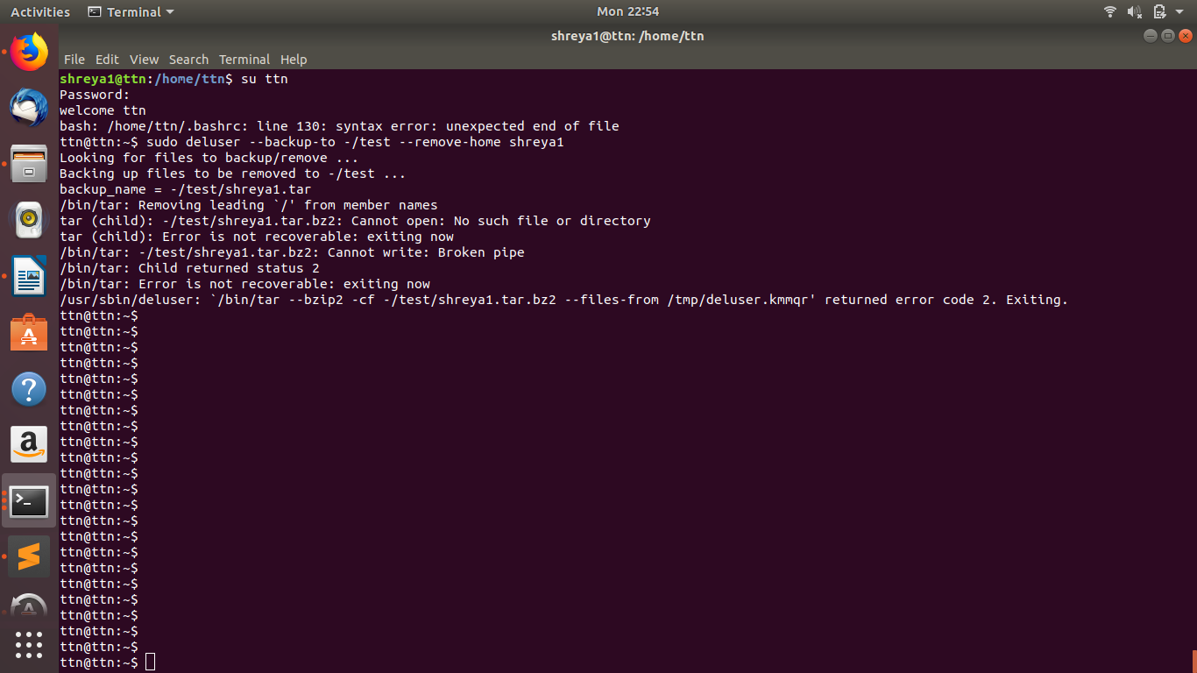
- Create a file with some content. Change all lower case letter to upper case letter and save output to another file using redirections.
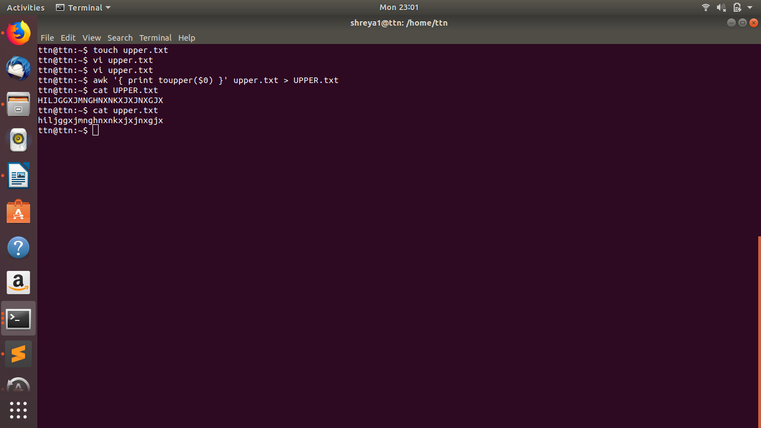
- Set nice value of a process to -1.
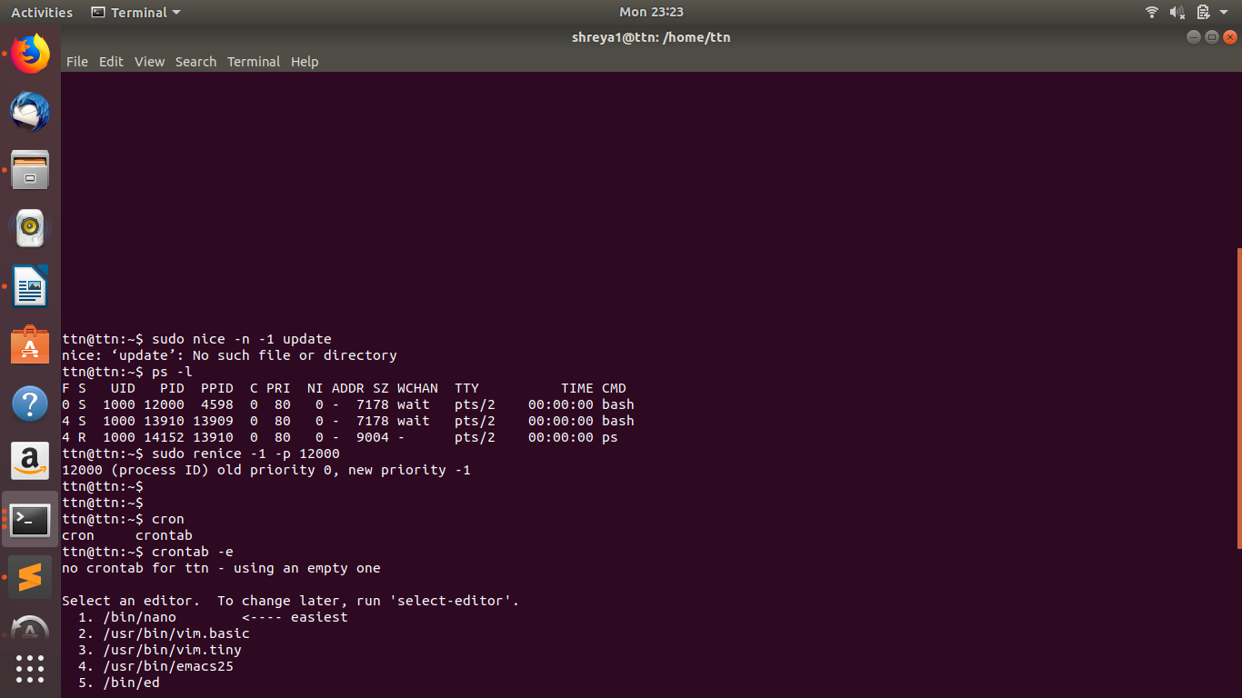
- Get list of all files used by “telnet”.
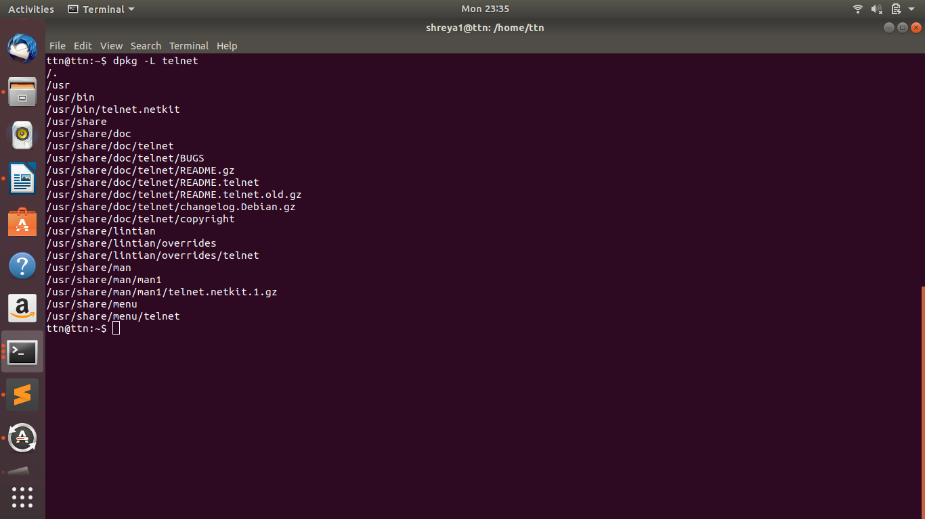
- Check if port 22 is listening using netstat and telnet command.
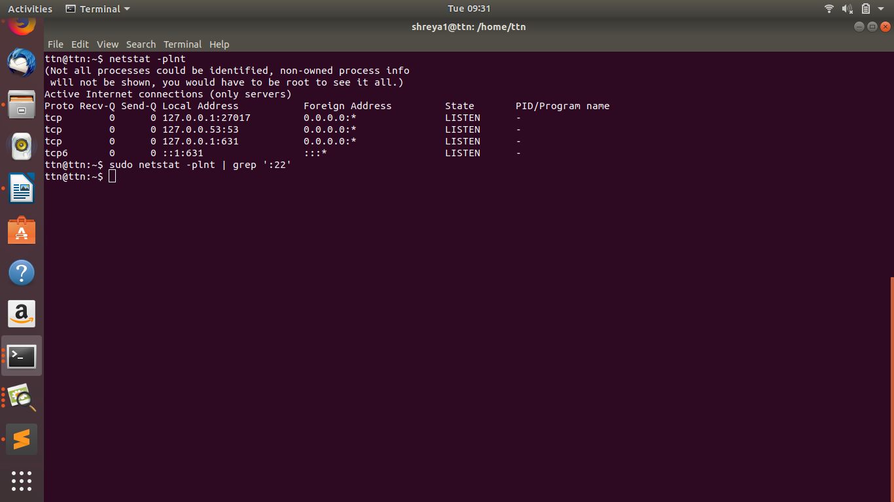
- Create a cron job which runs once in a week at 23:45.

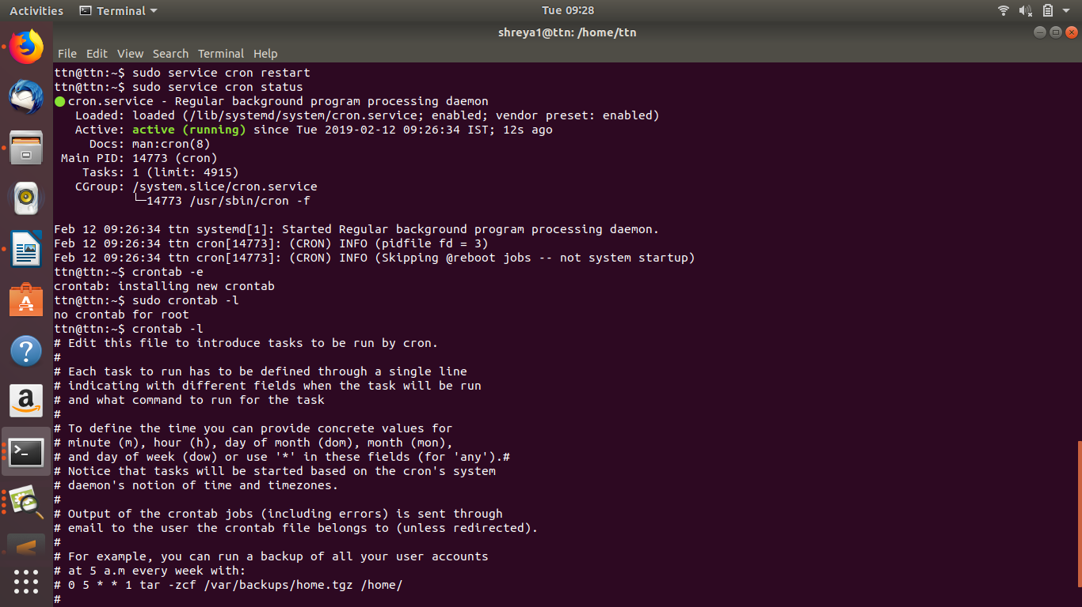
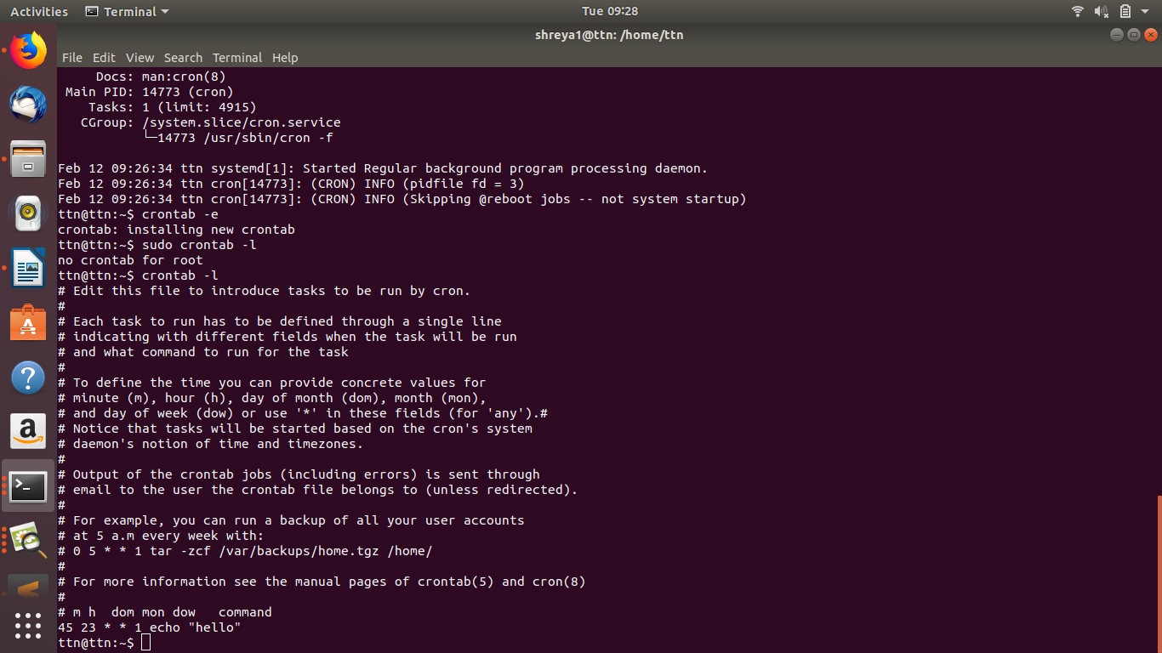
Shell Script:
1. (output to terminal)Write a script to print:
a) “Welcome to Intelligrape”
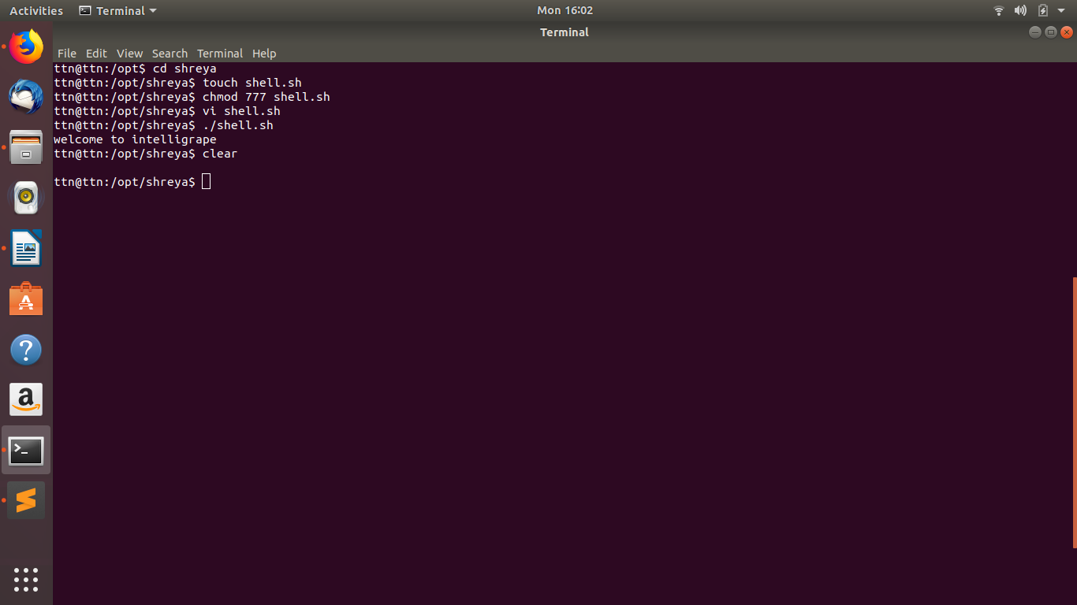
b. <username>@<hostname>:<your present wowrking directory>
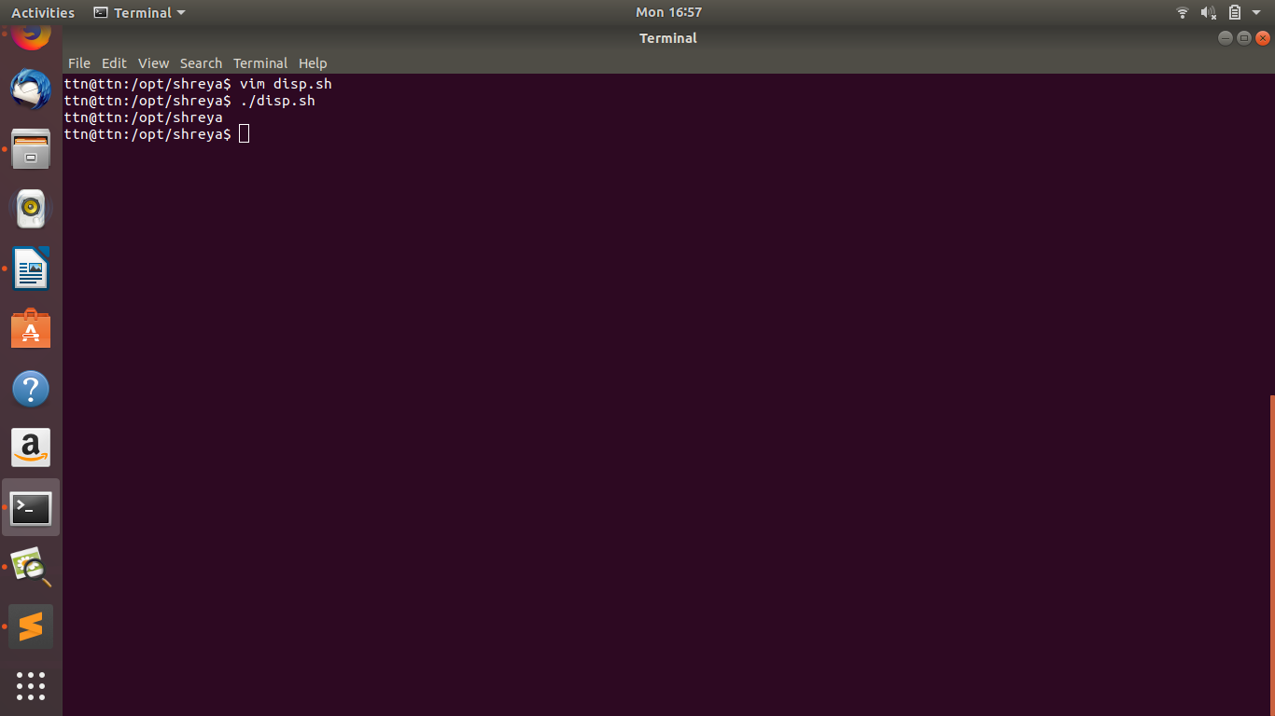

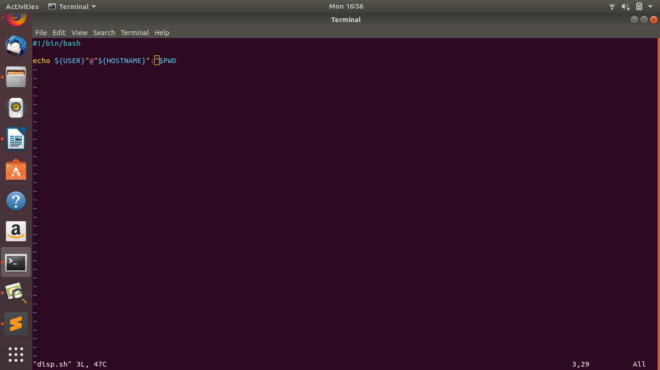
2 (arguments)Write a script
a. which takes in two arguments and print those arguments.
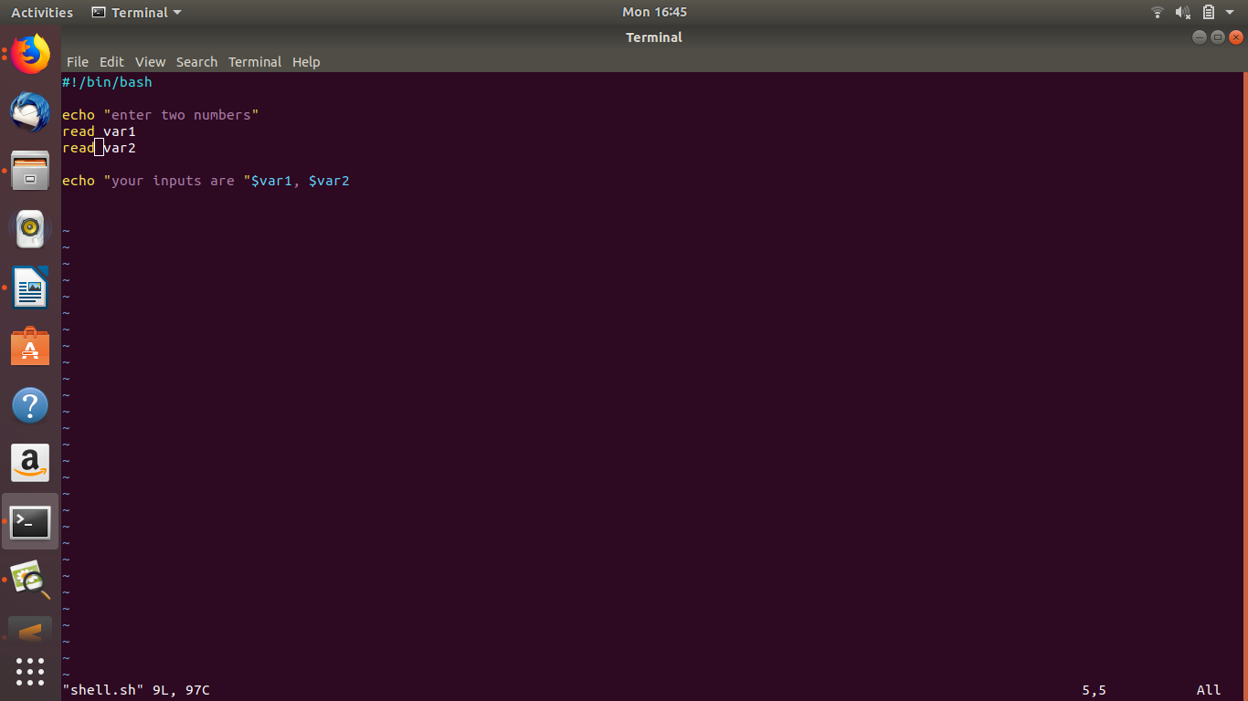
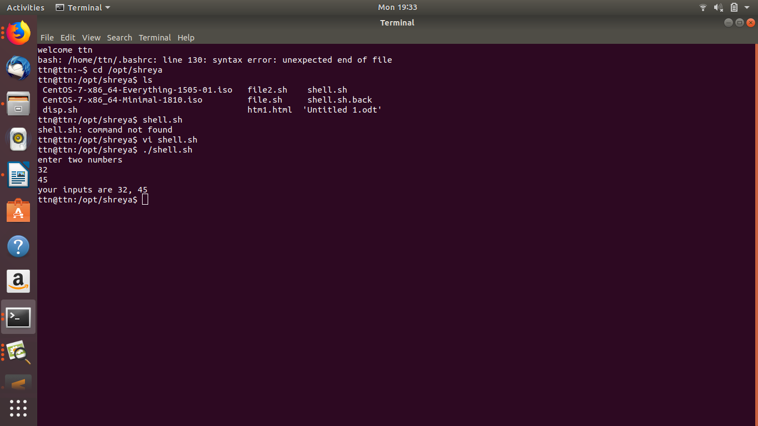
b. which checks the number of arguments passed and if the number is greater than two print
ERROR message along with printing the number of arguments.
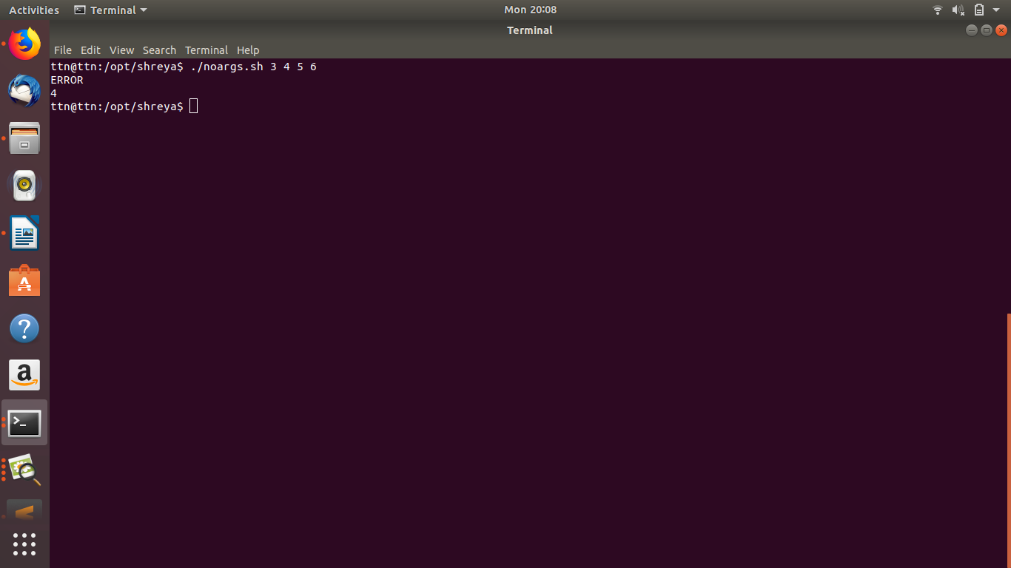
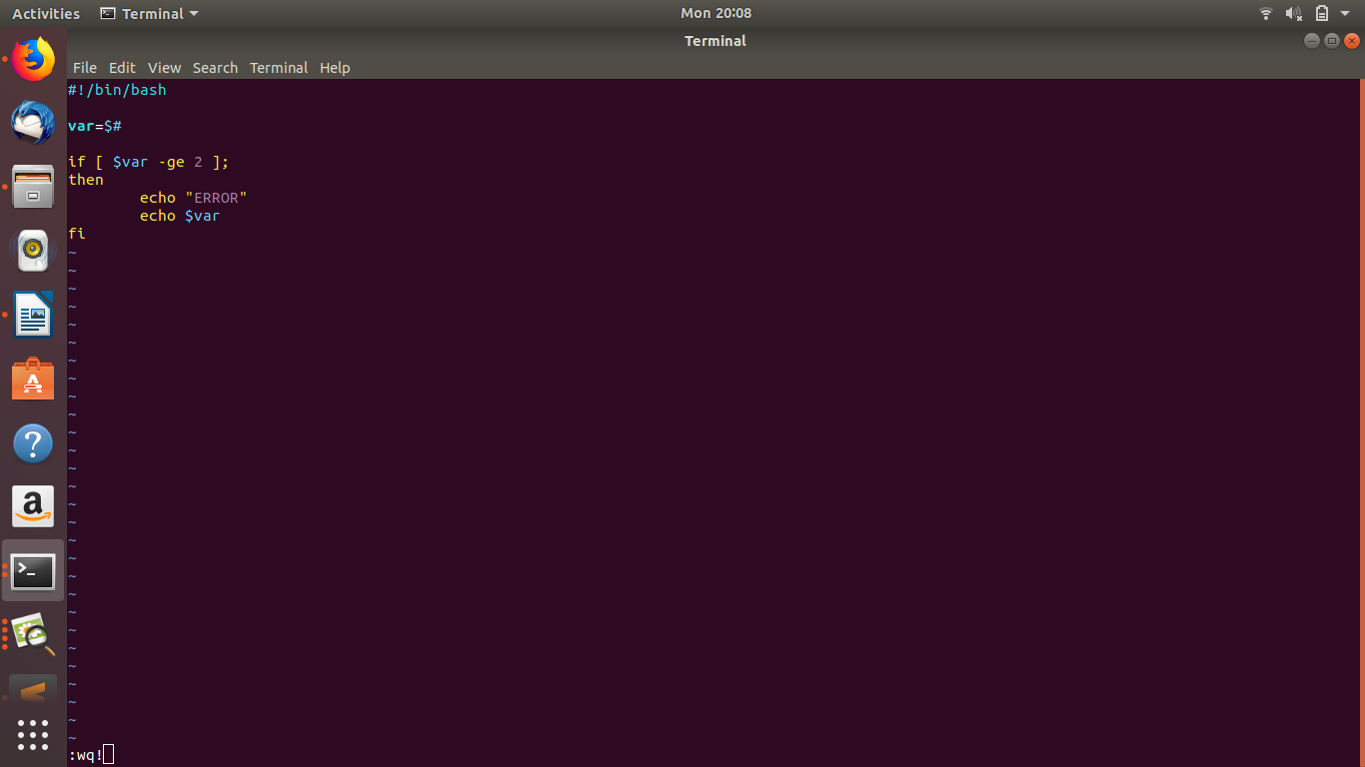
3. Continue with the above script
a. check the two arguments are only integer values and if these are not integers print the proper error on terminal and also log it into a file.
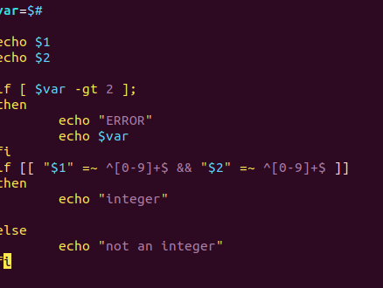

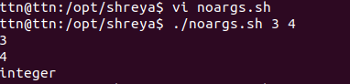

b. perform addition on the two arguments and print result on screen. Use function for this.
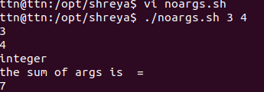
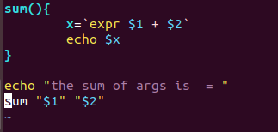

4. Create a calculator using the above script which would perform addition,subtraction,division and multliplication.
a. the script should ask user which operation the user wants to perform:+,-,*,/
b. if user enters other than “+.-,*,/”, print proper message on terminal and keeps on asking for correct input(use while loop to accomplish this).
c. Use case statement instead of if.
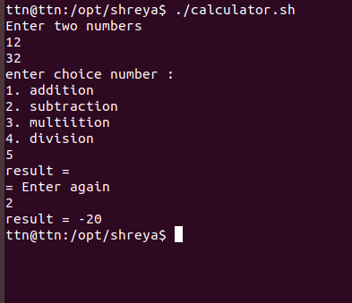

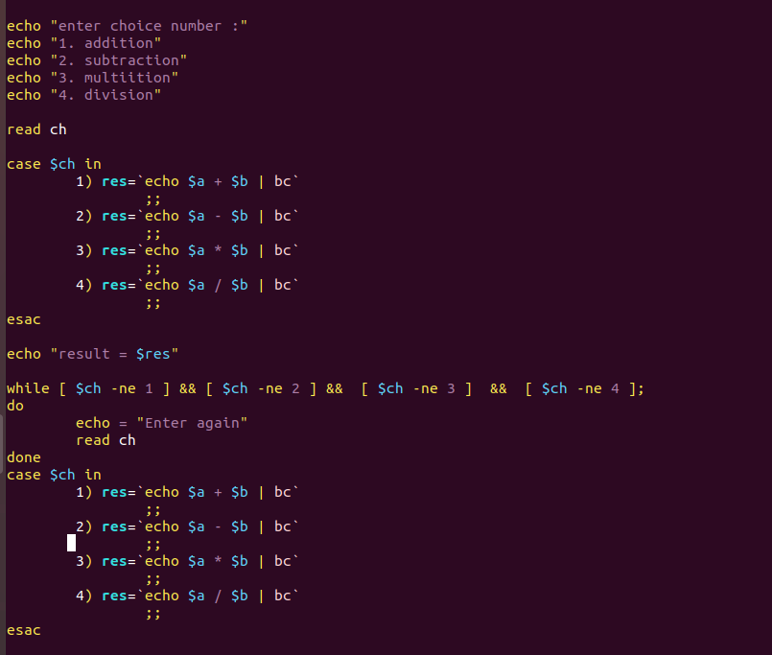

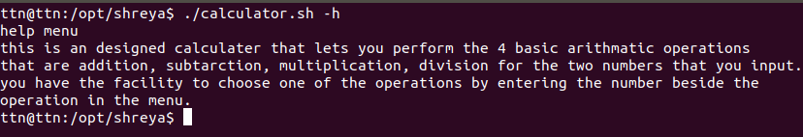
5. Write proper help documentation and print it with -h for above script.

6. Create a script which takes input of "/etc/passwd" file and find out and print the sum of uids and gids. The script should tell which sum of greater.
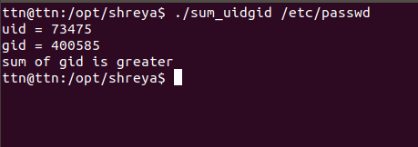

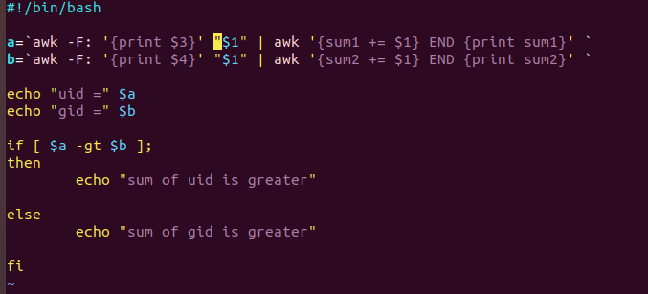

7. A directory contains files and sub-directories. Move files to destination1 and directories to destination2

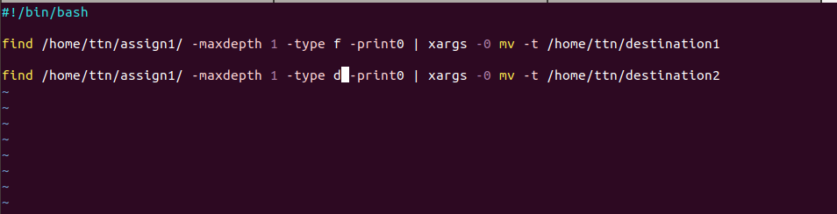

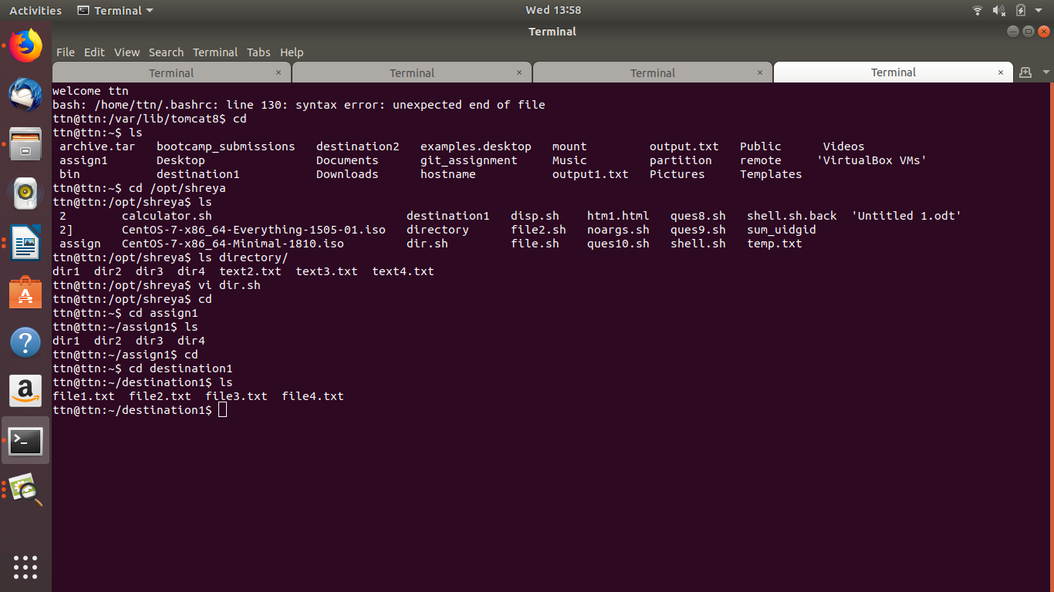

8. Create a script which take three arguments, append first argument to every line in a file and second argument to the end of every line of the same file..

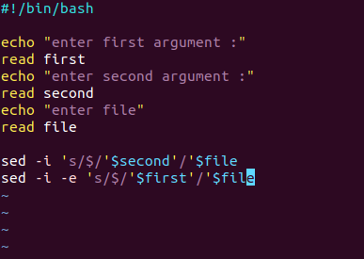

9. Make a list of files in /usr/bin that have the letter "a" as the second character. Put the result in a temporary file.

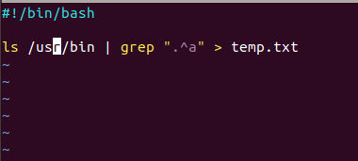

10. List all files in your home directory and print name and size in a table format.
