1. How many subnets and hosts per subnet can you get from the network 192.168.119.0/28?
This is class c network
Default mask for class C is 255.255.255.0
In this case mask is 255.255.255.240
Ie. 11111111.11111111.11111111.11110000
X = no. of 1s in host part = 4
Y = no. of 0s in host part = 4
No. of subnets = 2^x = 16
No. of hosts = 2^x = 16-2 =14

2. You need to subnet a network that has 5 subnets, each with at least 16 hosts. Which classful subnet mask would you use?

a. 255.255.255.192
b. 255.255.255.224
c. 255.255.255.240
d. 255.255.255.248

ans b. 255.255.255.224

3. What is the broadcast address of the network 172.24.160.0 255.255.240.0?

172.24.160.0
= 10101100.00011000.10100000.00000000

netmask = 1111111.11111111.11110000.00000000

broadcast ip = 10101100.00011000.10101111.11111111
= 172.24.175.255

4. Describe steps involved during communication between between two network.

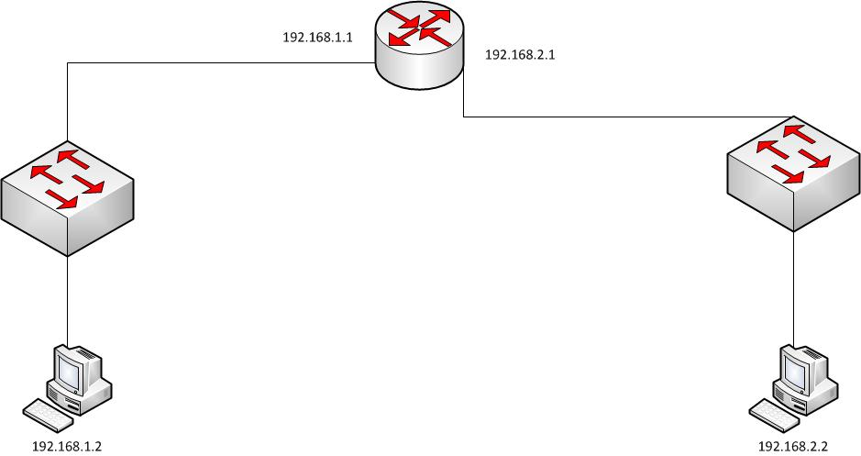

In the diagram, a router is used to segregate two networks. The networks are 192.168.1.0/24 and 192.168.2.0/24. The corresponding interface IP address on the routers are 192.168.1.1/24 and 192.168.2.1/24 as shown in the diagram.
The interfaces on the router are connected to ports on the switch , to which the computers are connected. The IP address of the computers are 192.168.1.2 (PC1) and 192.168.2.2 (PC2).
PC1 wants to communicate with PC2. For the communication to be succesfull, the TCP/IP adapter settings of PC1 and PC2 should be configured with the corresponding gateway addresses. The gateway addresses are required , since , communication is to be achieved between devices on two different networks.
The gateway for PC1 should be a device , which is accessible to it , and which is capable of forwarding the information to the intended network. In the diagram, the router would be the ideal gateway. But the router has two interfaces, which are configured for two different IP addresses.
So which IP address should the PCs use. For example, the IP address 192.168.1.1 should be used as the gateway IP address for PC1 and IP address 192.168.2.2 should be used as the gateway IP address for PC2. What would happen if 192.168.2.1 is used as the gateway for PC1 ?
PC1 would not be able to access it since , the IP address (192.168.2.1) itself is on a different network.Gateways are devices which should belong to the same network, and has knowledge about how to reach other networks. The following sequence of events follow, once the TCP/IP adapter settings is configured with the gateway address.
1. PC1 pings PC2
2. The routing table on PC1 identifies that PC2 (192.168.2.2) is on a different network
3. The packet would be sent to the gateway IP address configured on the PC as the destination is on a different network and the PC does not have any other option as a specific route to the network 192.168.2.0 is unavailable on the routing table of the PC.
4. Since the specific route is unavailable, the default route on the PC, which is populated by the operating system after the gateway IP address is configure would be used.
5. The packet has to be encapsulated in a frame and sent to the gateway
6. To generate the frame, the destination mac-address of the gateway is required.
7. PC1 sends ARP request to find out the mac-address of the interface of the router configured with the IP address 192.168.1.1. ( Note: If the ARP Cache on the PC contains the IP/Mac mapping for 192.168.1.1, this step would skipped and the frame encapsulating the IP packet would be sent directly to 192.168.1.1)
8. The router responds with an ARP reply.
9. PC1 uses the mac-address in the ARP reply, constructs the frame and sends the packet to the router.
10. The router is configured with two IP addresses, 192.168.1.1/24 and 192.168.2.1/24. When configured, routing tables are populated and 192.168.1.0/24 and 192.168.2.0/24 ( the corresponding network addresses) are listed as directly connected networks.
11. When the packet reaches the router, the destination IP address is looked into (192.168.2.1). The router checks if it is aware of the destination network for the destination IP packet.
12. Since the network is a directly connected network, the router knows which interface to use.
13. The router sends out an ARP request to find out the mac-address of PC2 (( Note: If the ARP Cache on the router contains the IP/Mac mapping for PC2, this step would be skipped and Step 15 would be executed)
14. PC2 would send an ARP Reply with it's mac-address.
15. The router would encapsulate the packet with the new frame, where the source mac-address is the mac-address of the interface corresponding to 192.168.2.1 and the destination mac-address would be PC2'S
5. When to use Elastic IP over Public IP

Public IP addresses are dynamic - i.e. if you stop/start your instance you get reassigned a new public IP.
Elastic IPs get allocated to your account, and stay the same - it's up to you to attach them to an instance or not. You could say they are static public IP addresses.
you get charged for them, if they're not attached to an instance.
With an Elastic IP address, you can mask the failure of an instance or software by rapidly remapping the address to another instance in your account.
An Elastic IP address is a public IPv4 address, which is reachable from the internet. If your instance does not have a public IPv4 address, you can associate an Elastic IP address with your instance to enable communication with the internet; for example, to connect to your instance from your local computer.
AWS currently do not support Elastic IP addresses for IPv6.

6. Valid IP Ranges for LAN, Implication of using Public IP ranges for Private Network.

A private IP address is an IP address that's reserved for internal use behind a router or other Network Address Translation (NAT) device, apart from the public.

Private IP addresses are in contrast to public IP addresses, which are public and can not be used within a home or business network.

The Internet Assigned Numbers Authority (IANA) reserves the following IP address blocks for use as private IP addresses:

- 10.0.0.0 to 10.255.255.255
- 172.16.0.0 to 172.31.255.255
- 192.168.0.0 to 192.168.255.255

Implication of using Public IP ranges for Private Network.

If we want to connect our private network to server later sometime the it would give replication error.

7. Draw AWS Network Arch Diagram based on following criteria :
  - Tech Stack will have “Web, App, Cache, DB, Operation”.
  - Web stack Required Public Interaction
  - 250 hosts, 10 nodes per stack
  - Should be Redundant
  - Enable Internet Access for Private Subnet
  - Security Service at each Layer.
