- Git Setup https://confluence.atlassian.
- Initialize a Git Repository
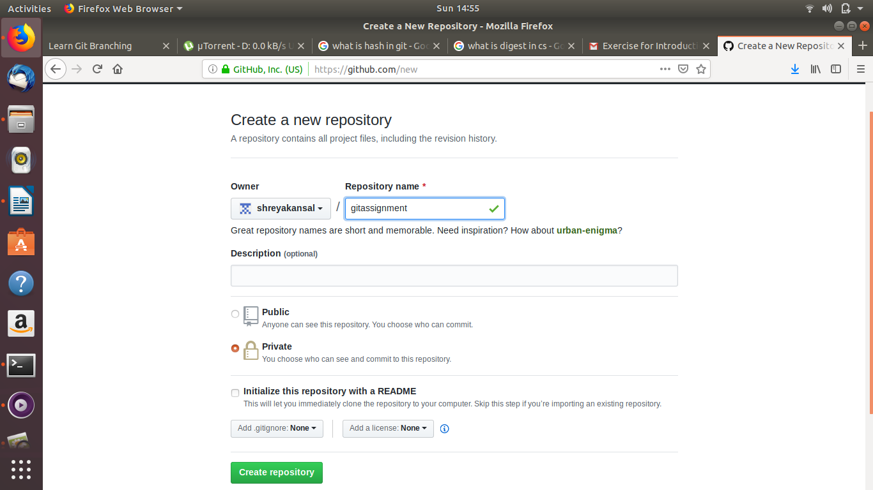
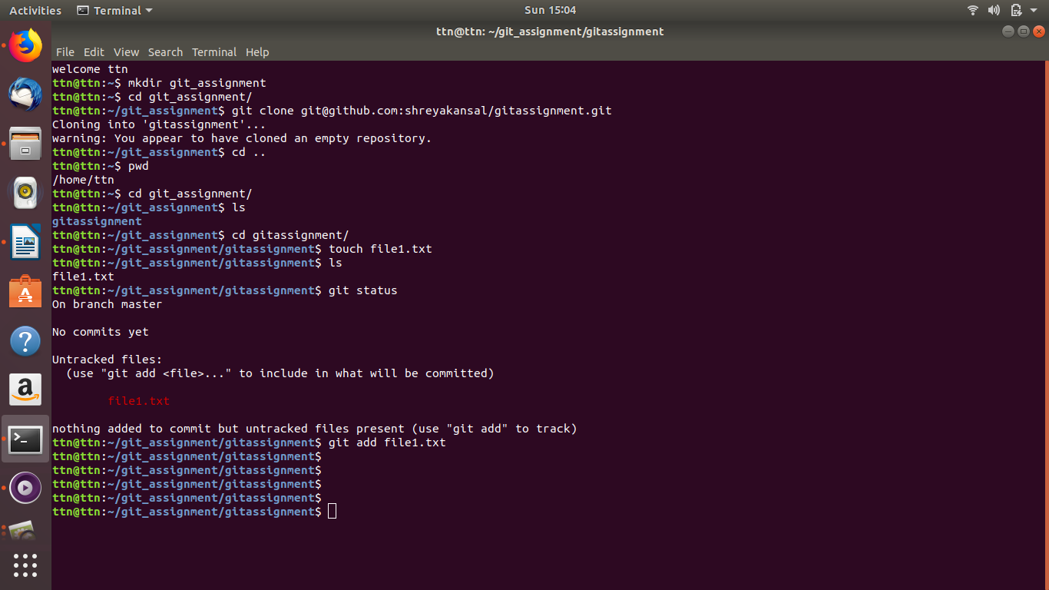
- Add files to the repository
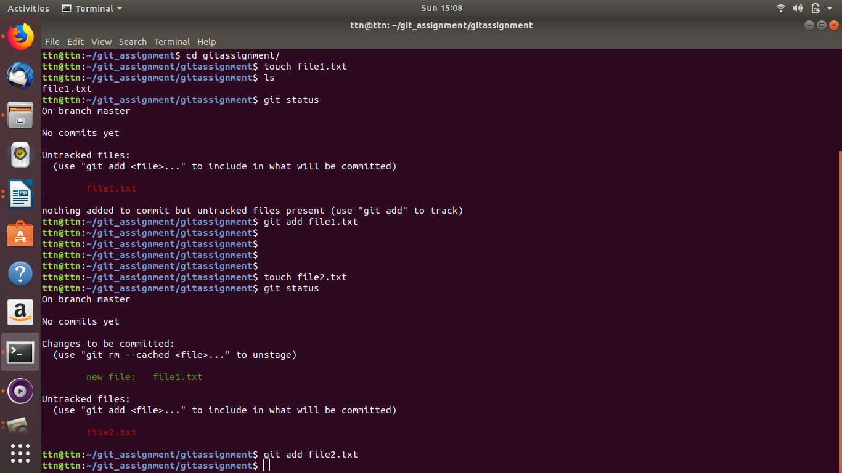

4. Unstage 1 file
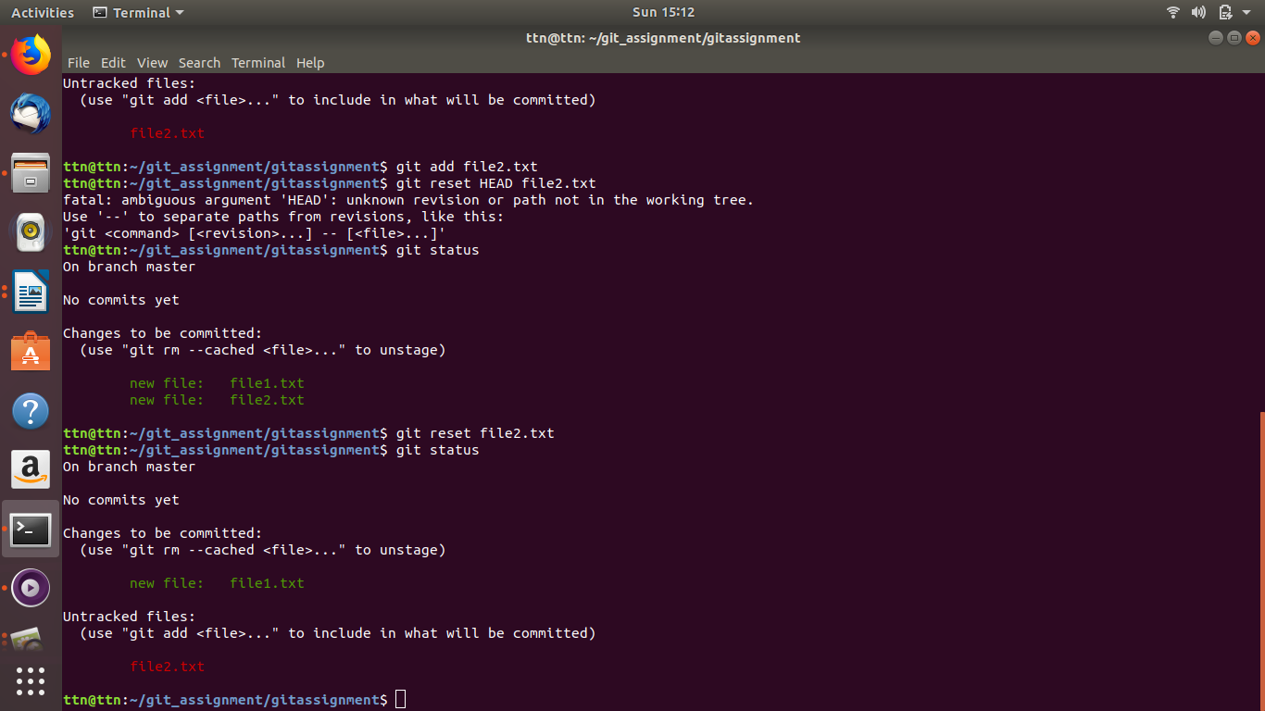

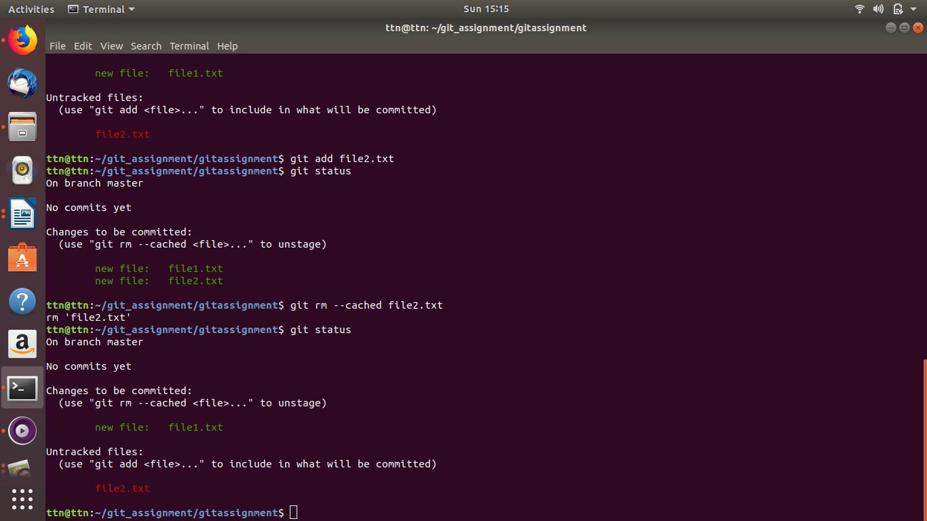

5. Commit the file

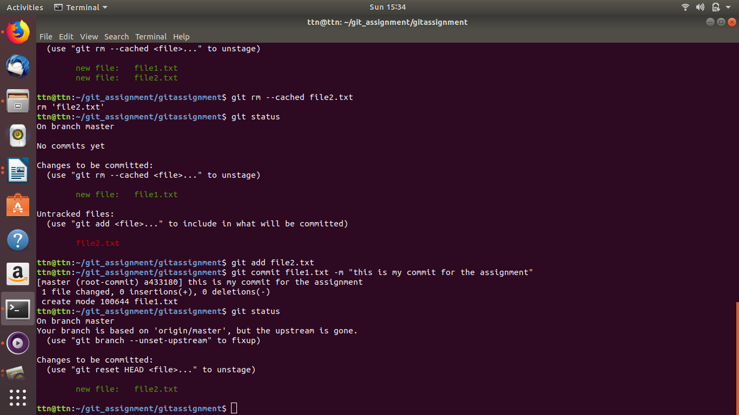
6. Add a remote
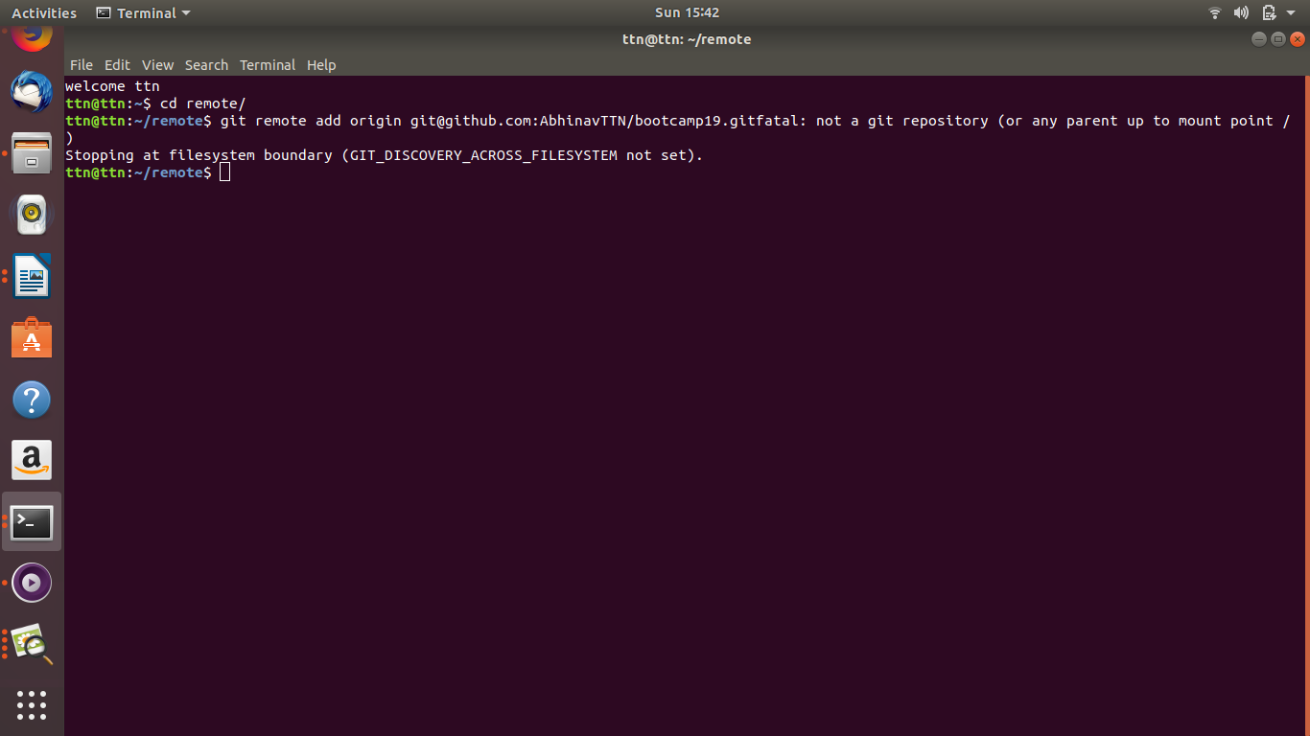

7. Undo changes to a particular file
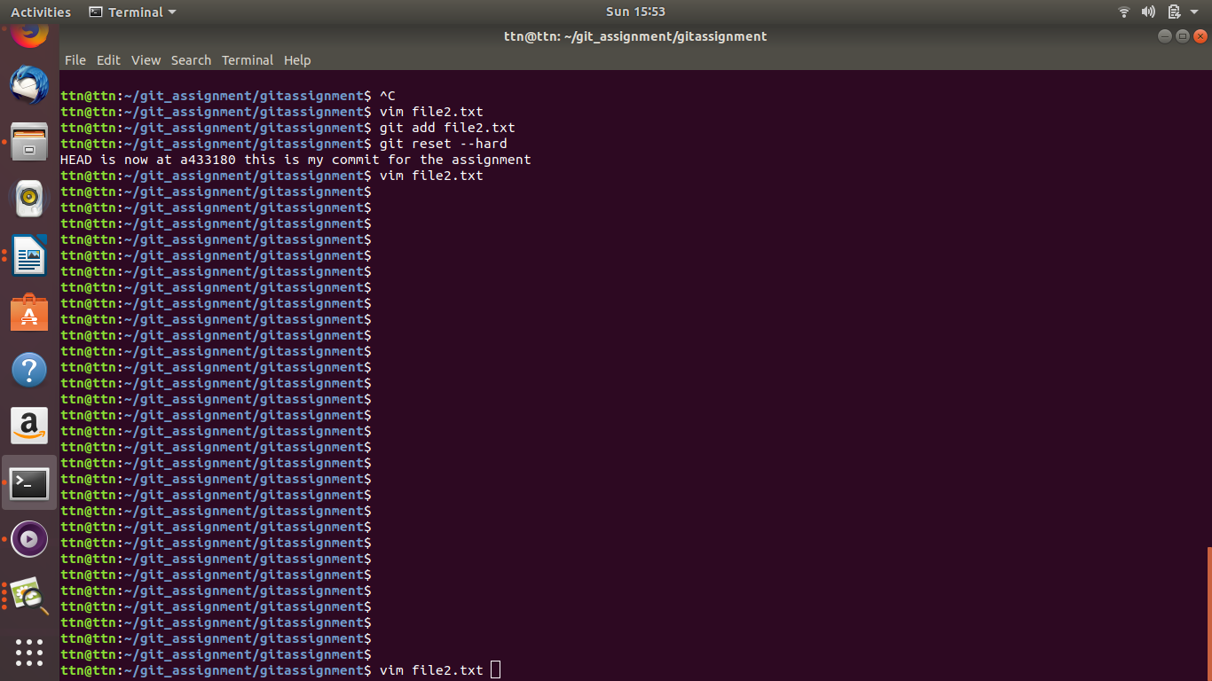
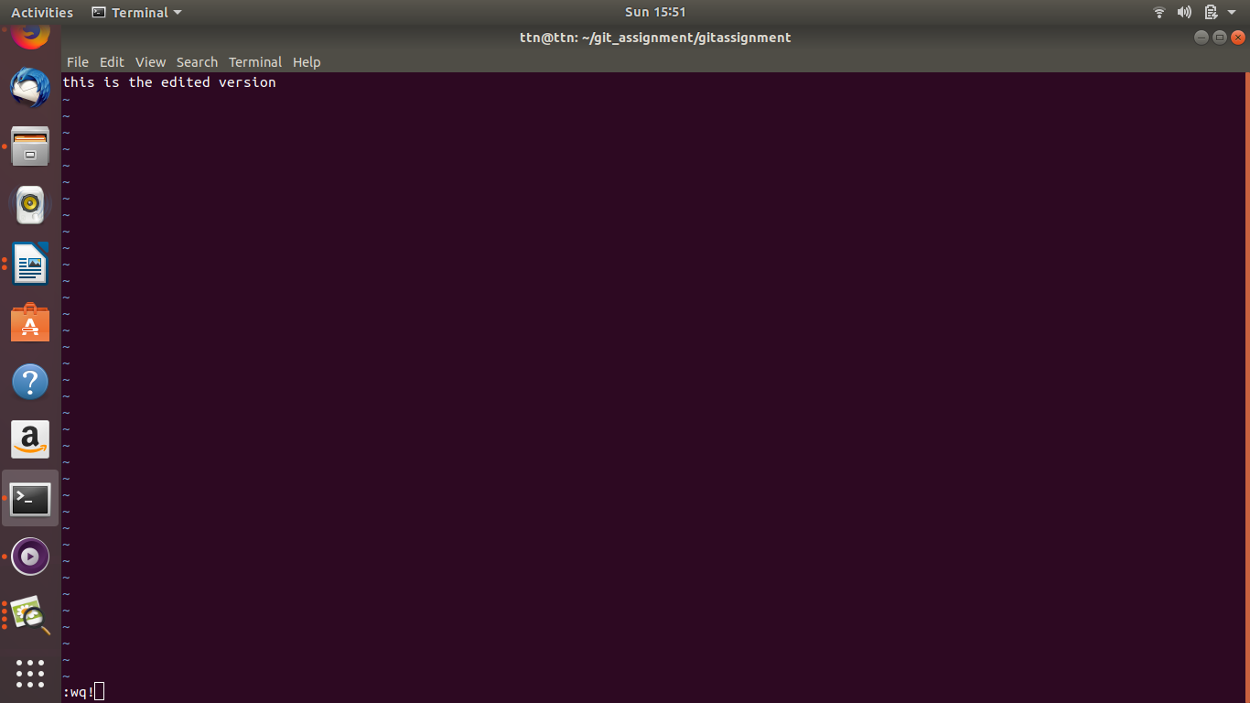

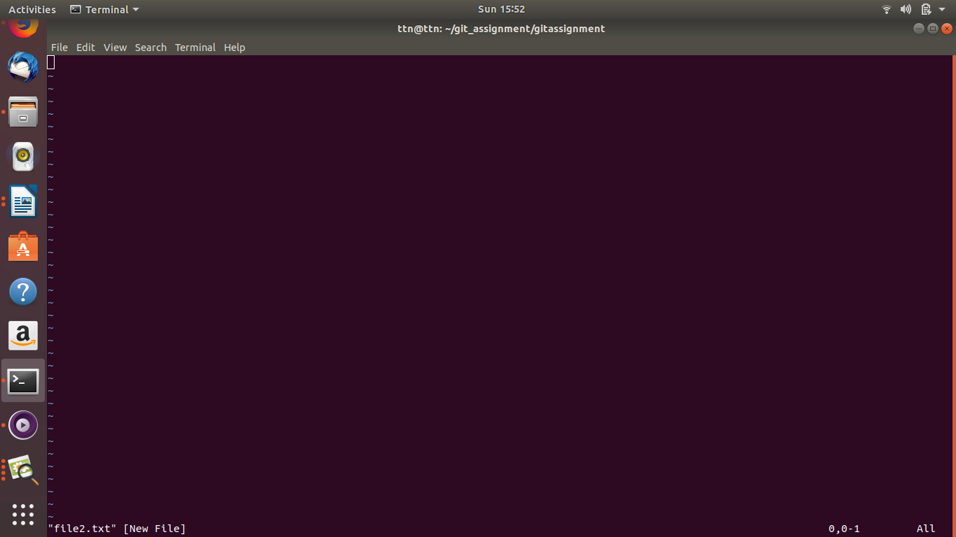

8. Push changes to Github

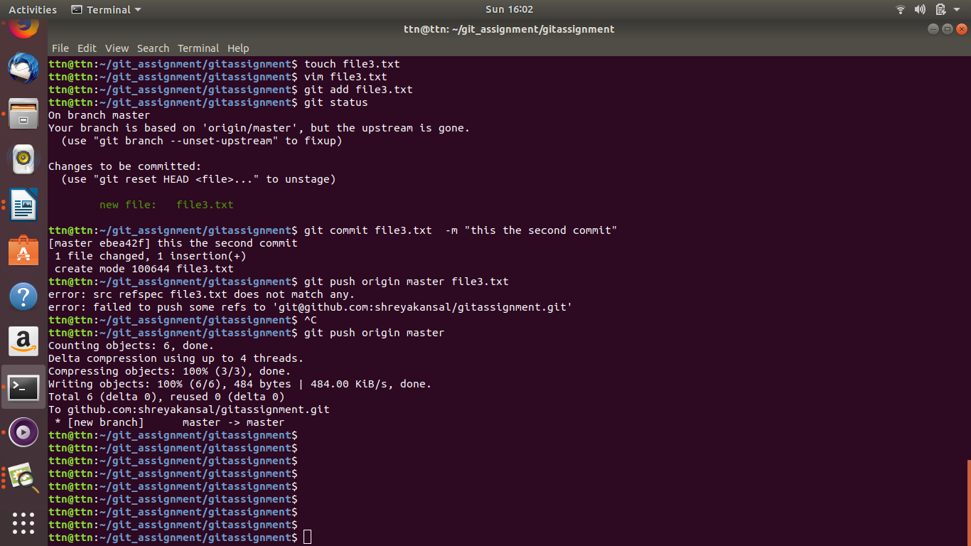
9.Clone the repository

10. Add changes to one of the copies and pull the changes in the other.

11. Check differences between a file and its staged version

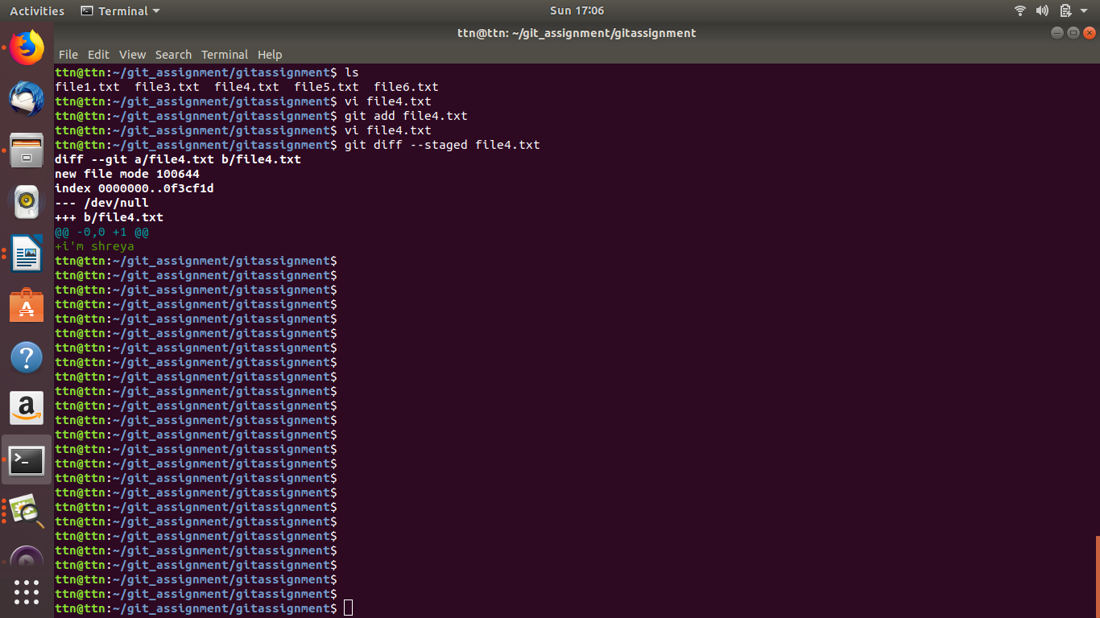
12 Ignore a few files to be checked in

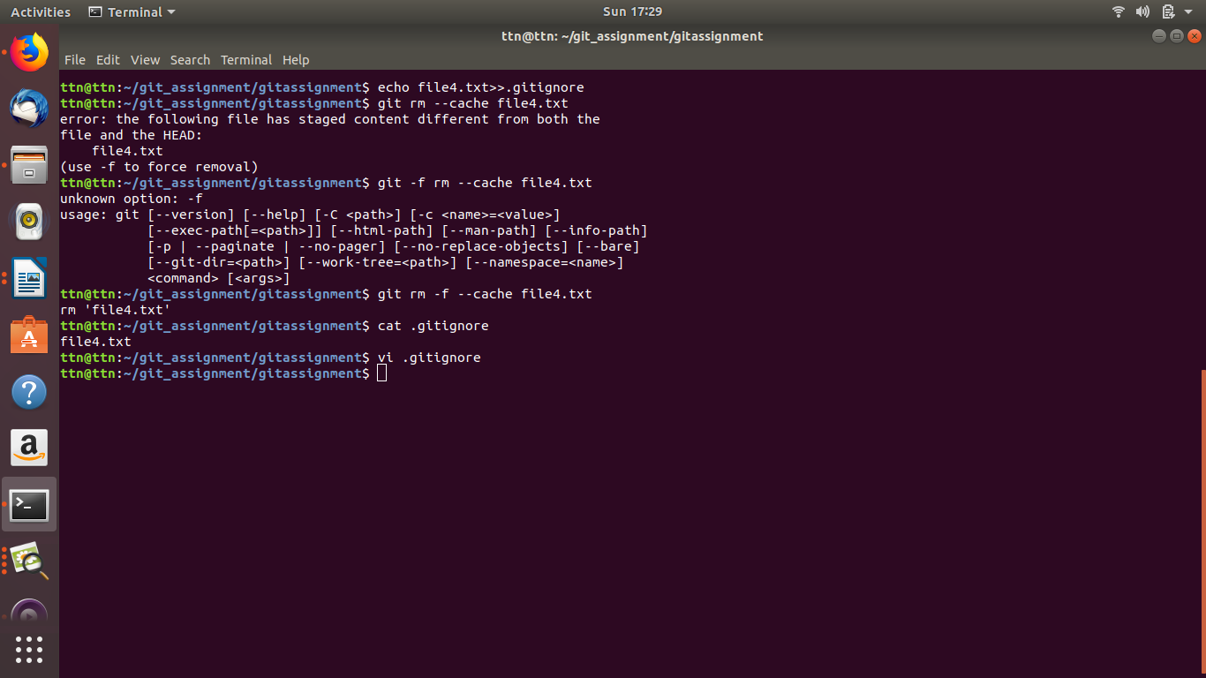

13. Create a new branch.

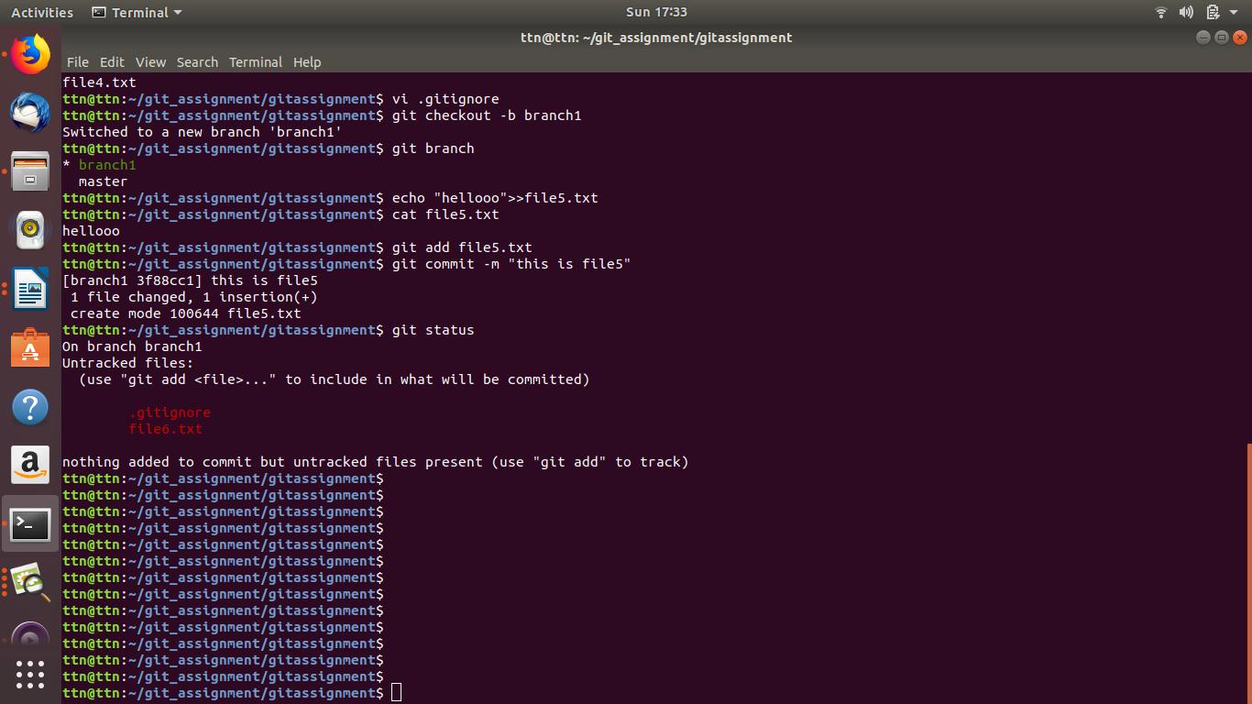
14.Diverge them with commits

15. Edit the same file at the same line on both branches and commit

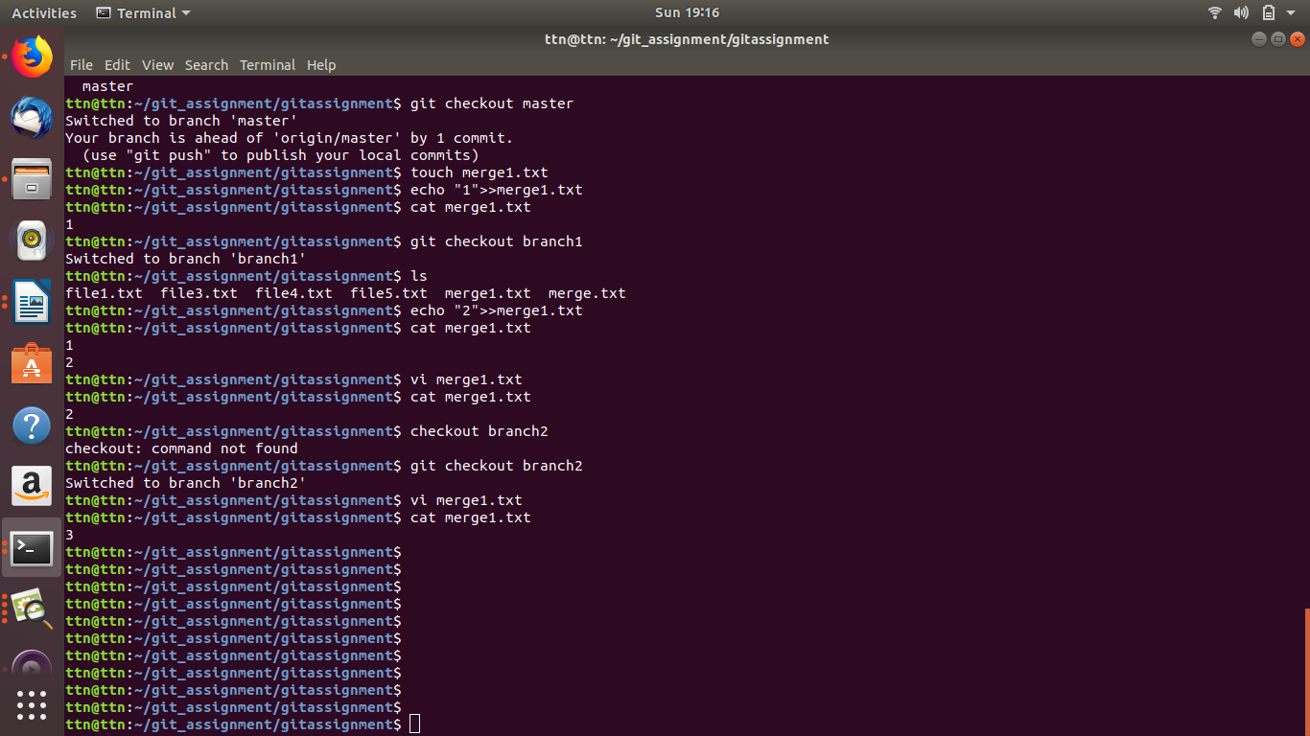
16. Try merging and resolve merge conflicts

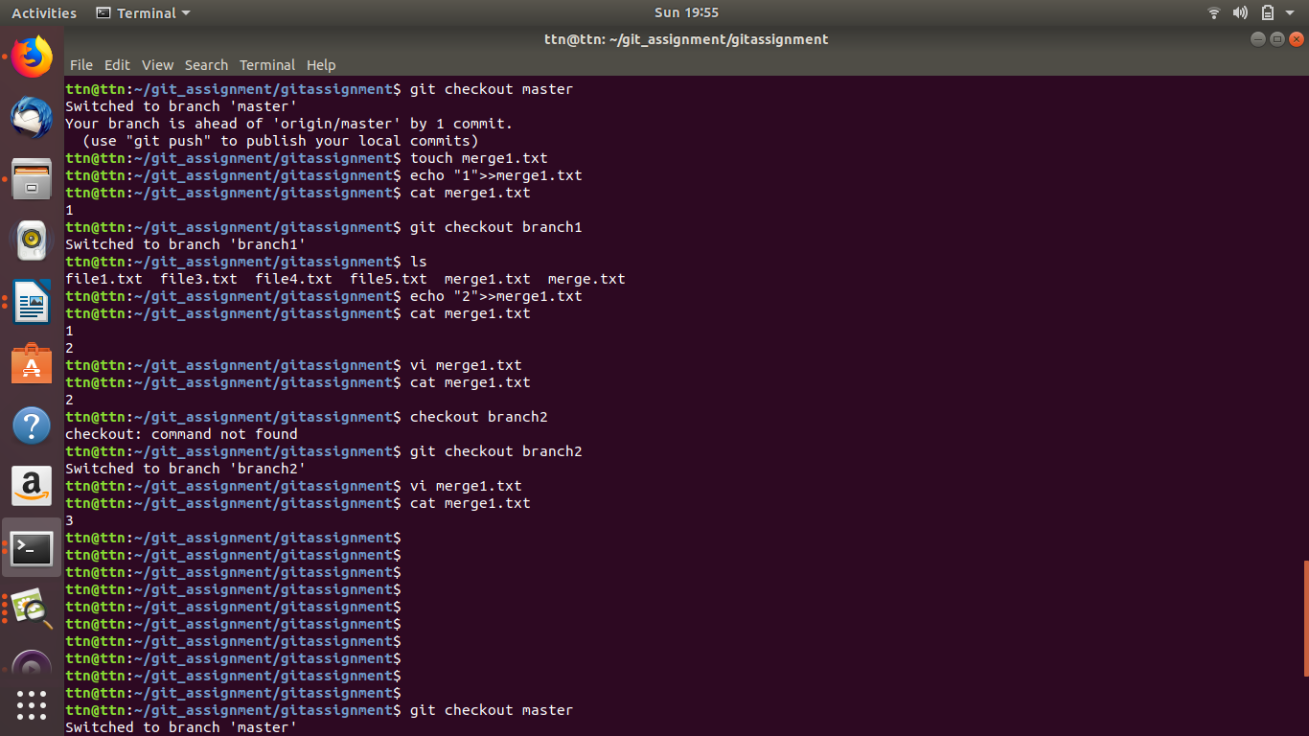
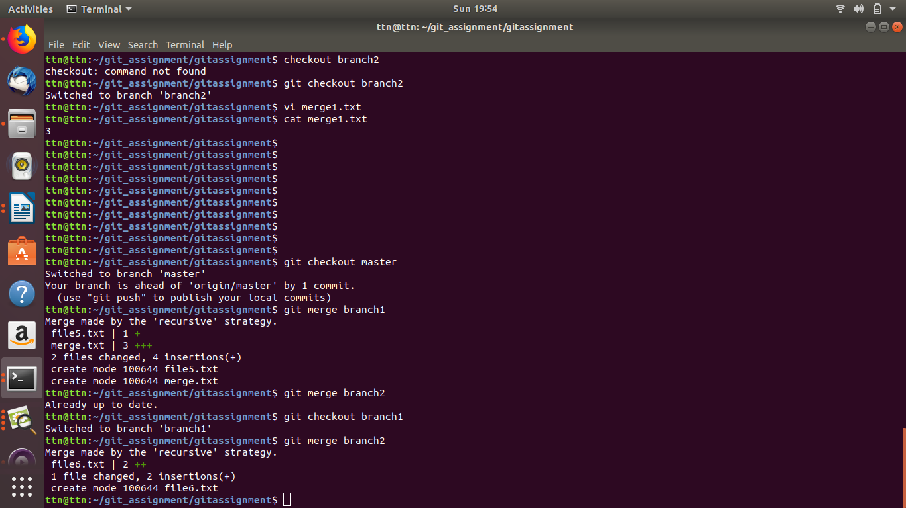
17. Stash the changes and pop them
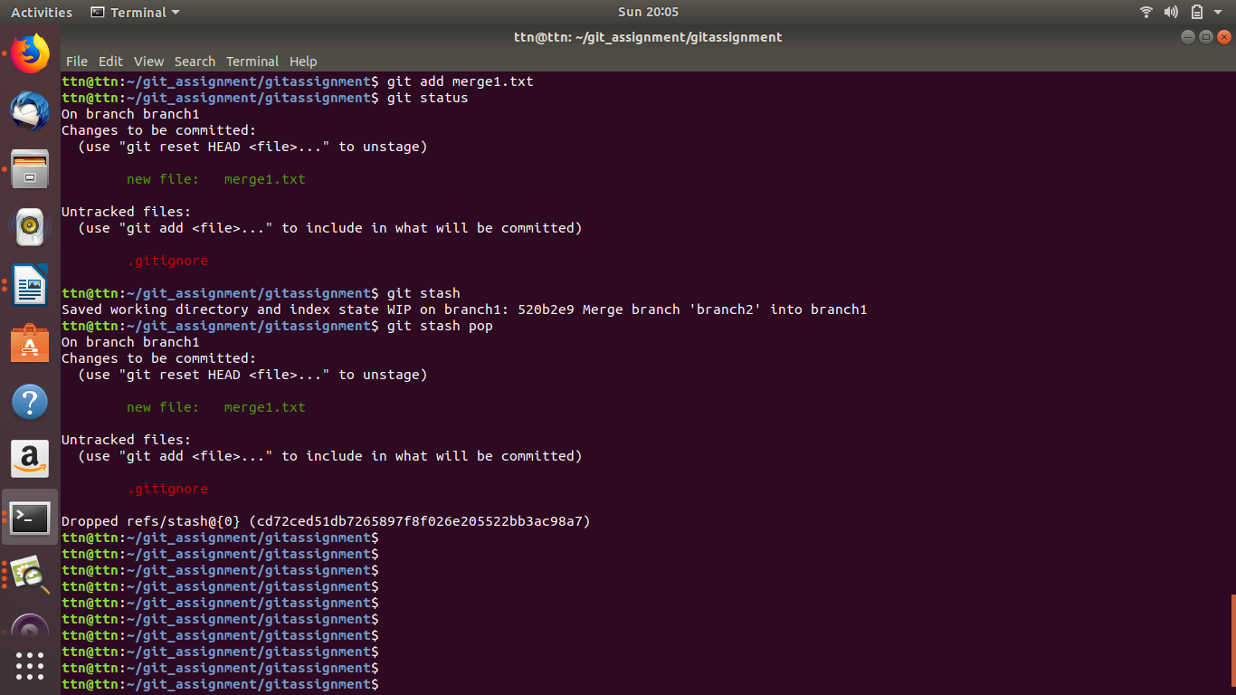
18. Add the following code to your .bashrc file : color_prompt="yes"
parse_git_branch() {
git branch 2> /dev/null | sed -e '/^[^*]/d' -e 's/* \(.*\)/(\1)/'
}
if [ "$color_prompt" = yes ]; then
PS1='\u@\h\[\033[00m\]:\[\033[
else
PS1='\u@\h:\W $(parse_git_branch)\$ '
fi
unset color_prompt force_color_prompt
