- What is the difference between an Application Server and a Web Server?
- Write down name of Application Servers and Web Servers.
- What are java servlet?
- Describe tomcat directory structure.
- How to change default port in tomcat?
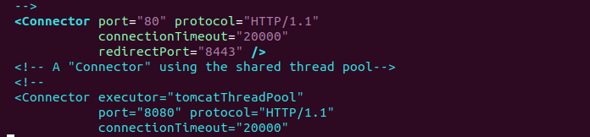

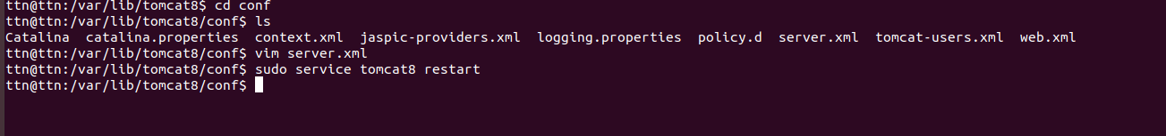
- Install tomcat and nginix and set proxy_pass in nginx to display tomcat.
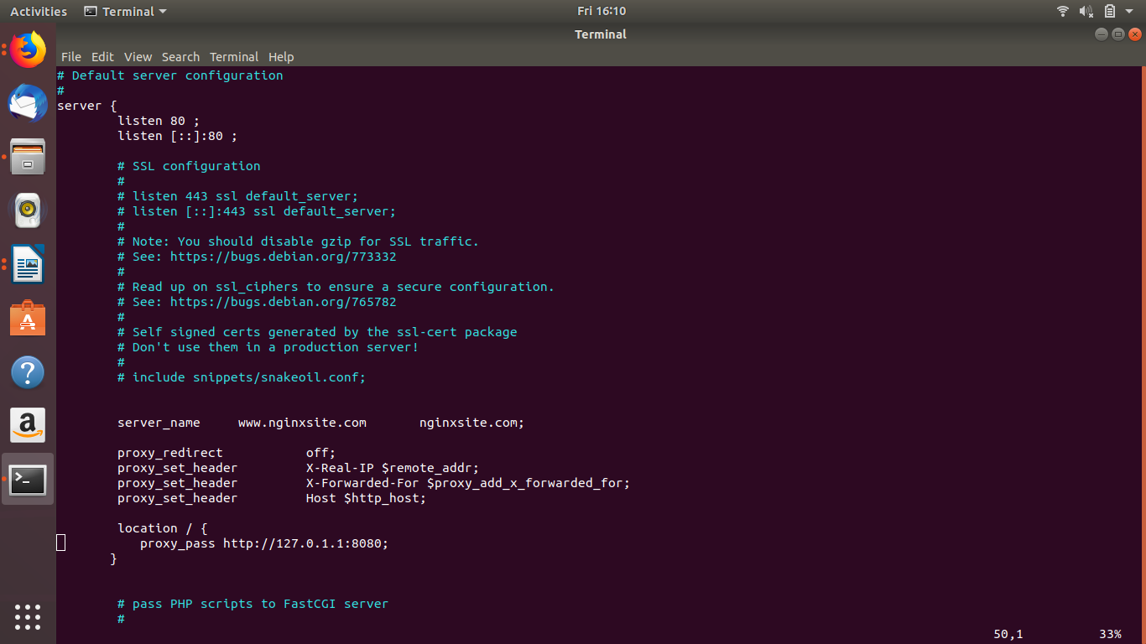

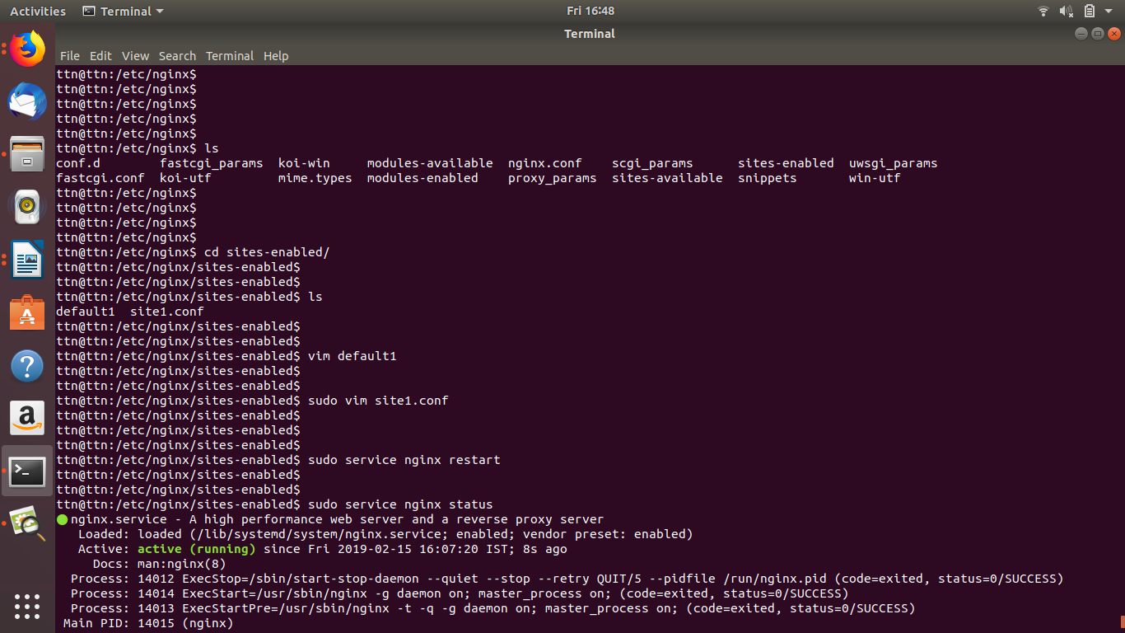
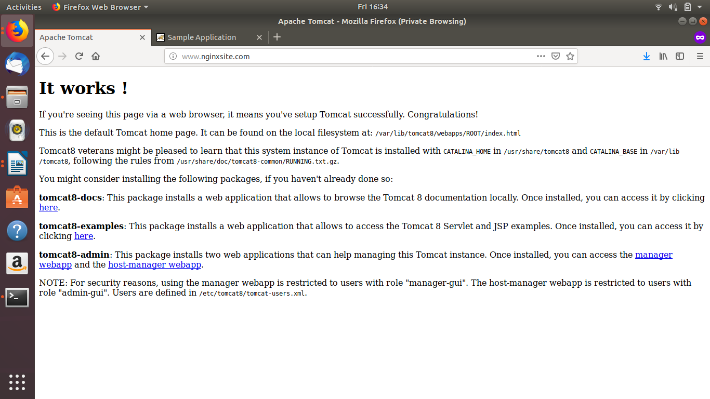

- Configure Tomcat as a Service
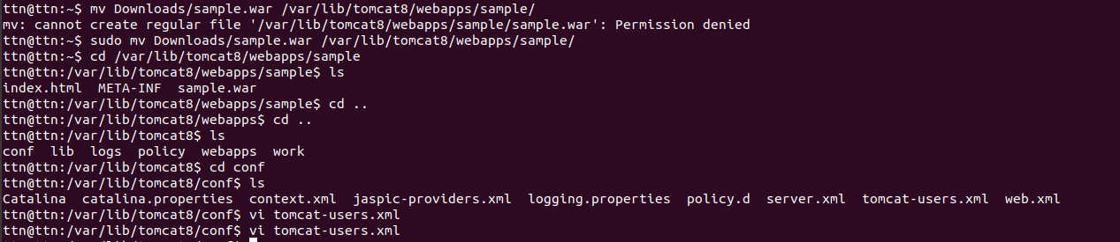
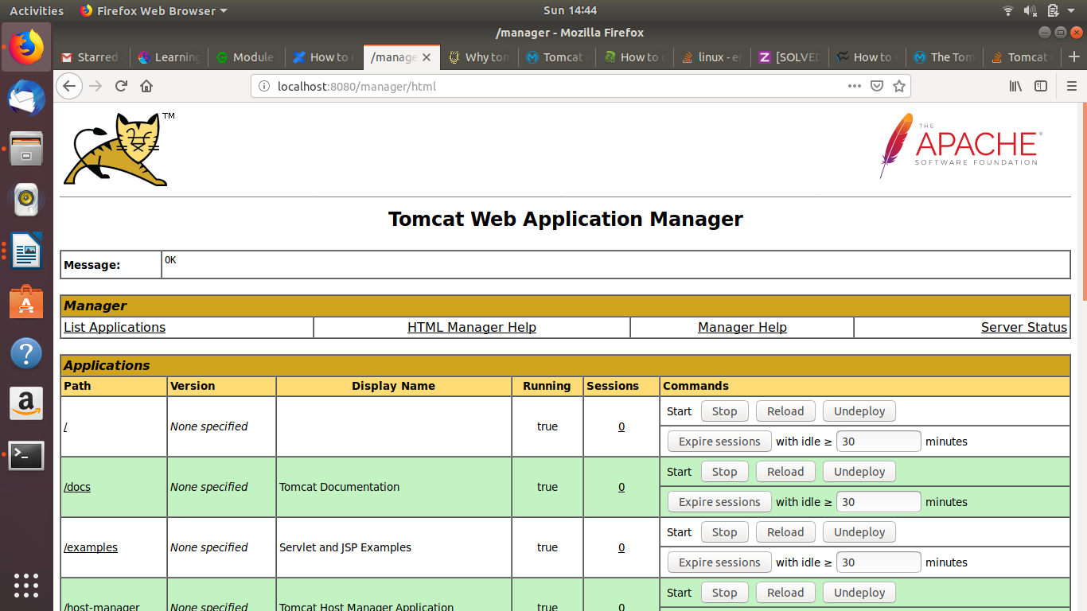

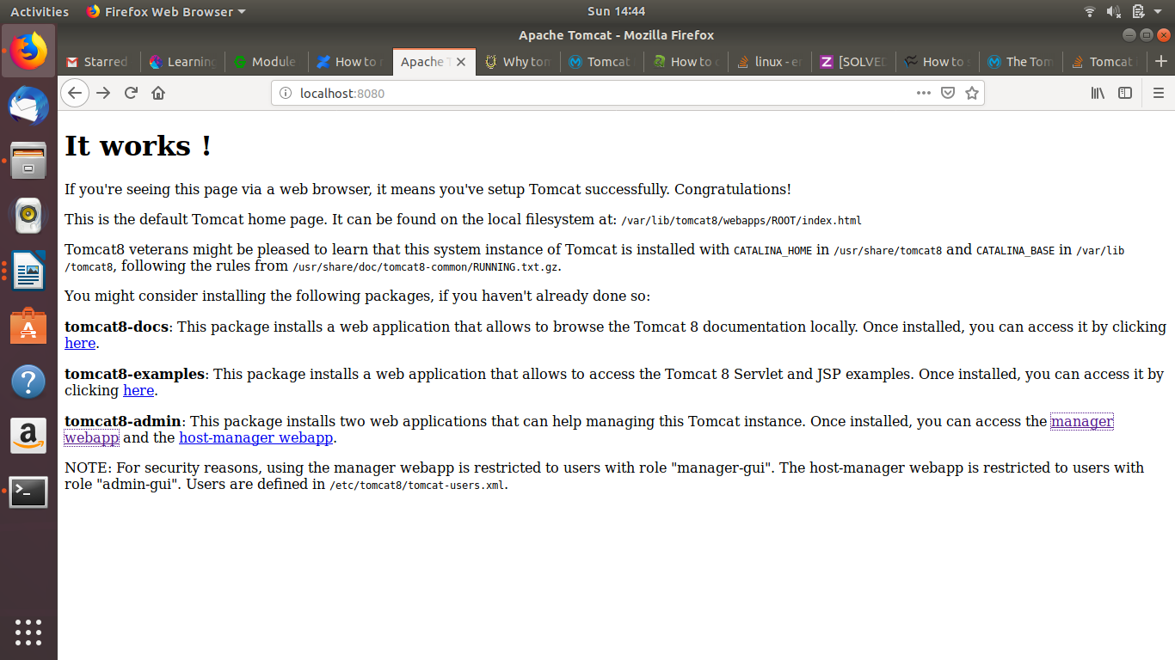

Use any web server in front of tomcat using AJP and HTTP connector.
- Configure tomcat to use any mysql server.

