Mysql:

- Install mysql;
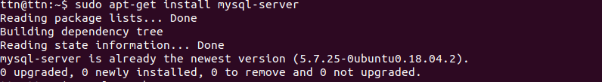
- setup root password;
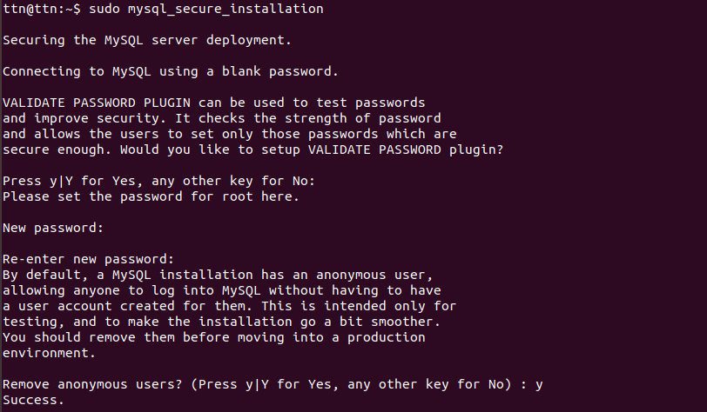
- set the bind address to 127.0.0.1
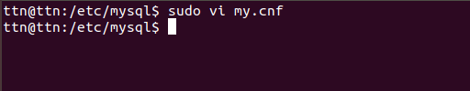

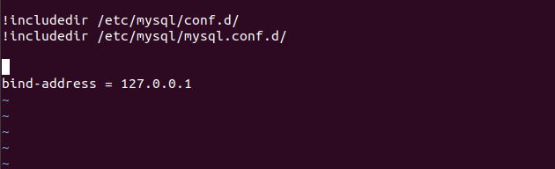

- change the log file location to /tmp/

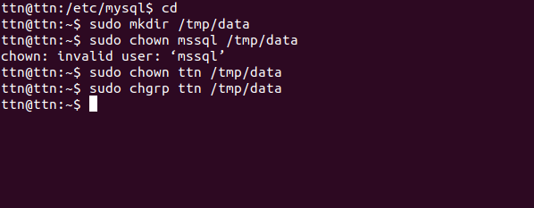
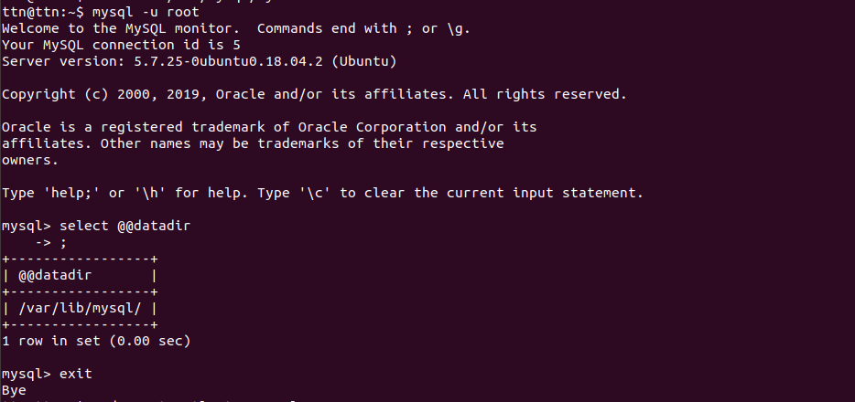
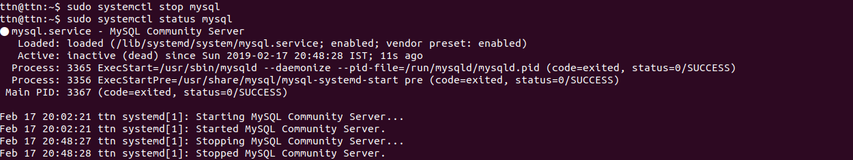
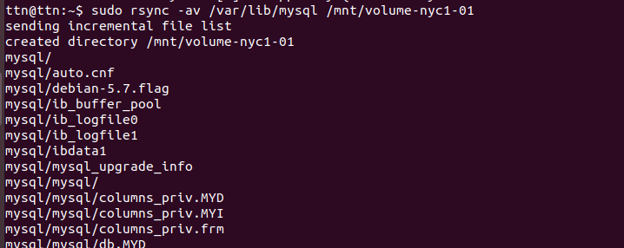

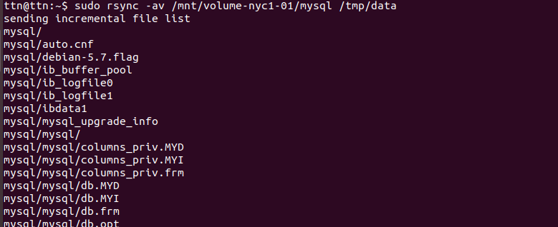


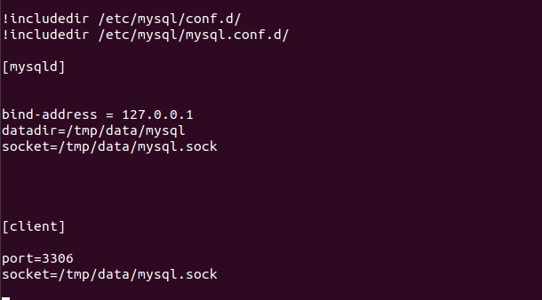

- reset the root password without using you current root password

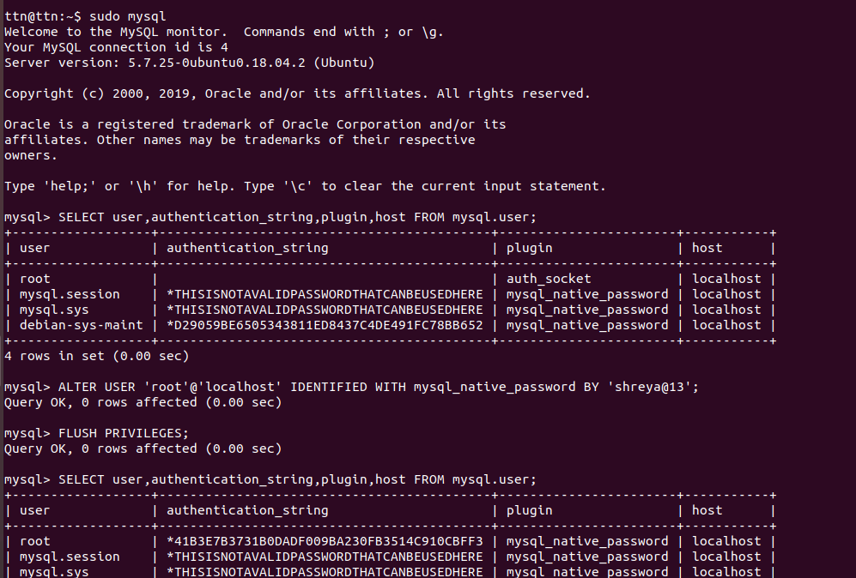

- create a dummy database with some tables
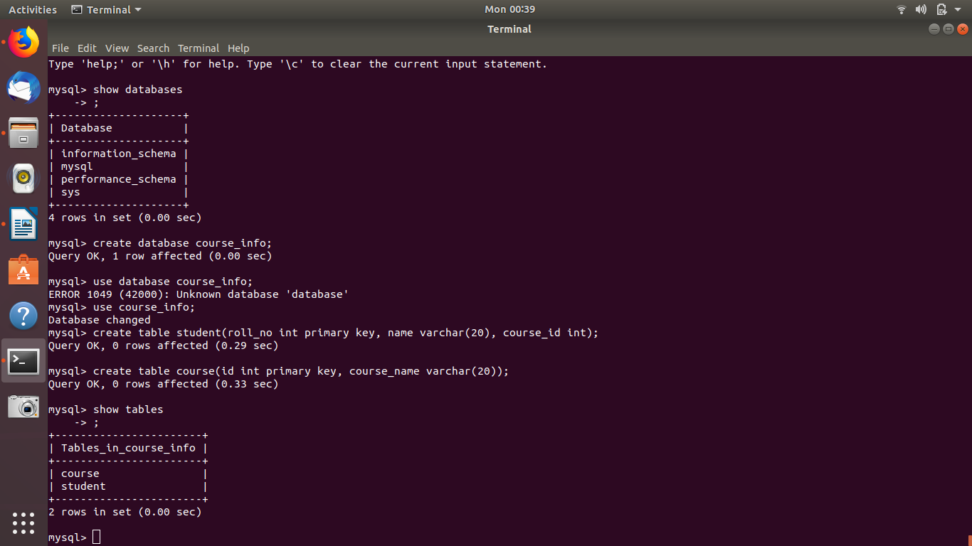
7.take the dump of the database created above
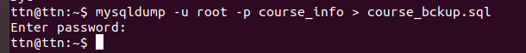

8. restore the backedup database to another database

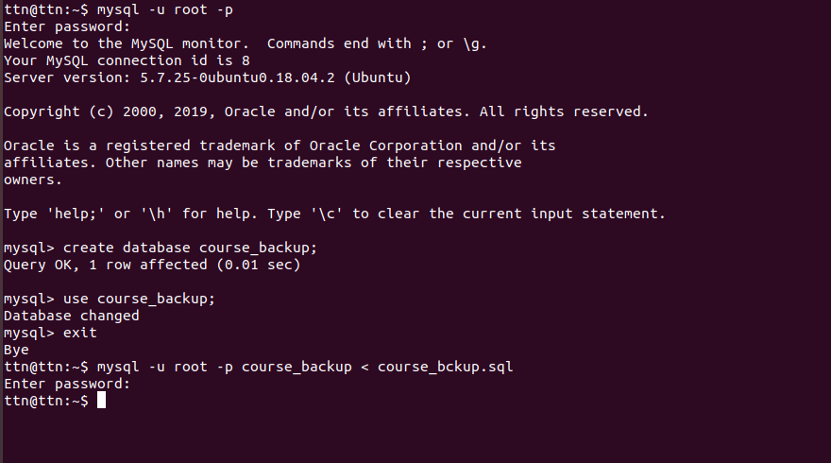
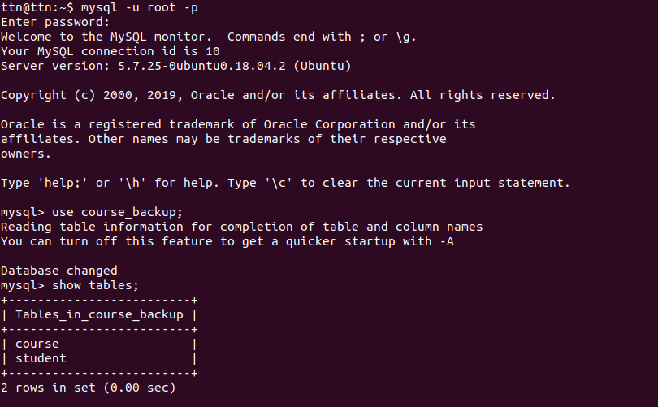

9. create a new user and grant access only to the new database
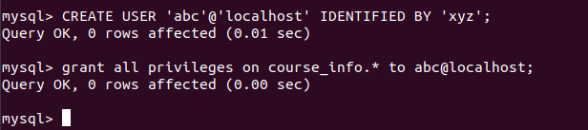

10. show grants/privileges of the newly created user
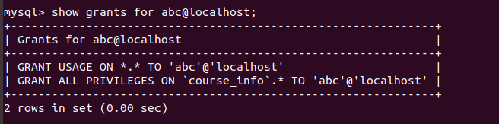

11. Setup master-slave for MySql.

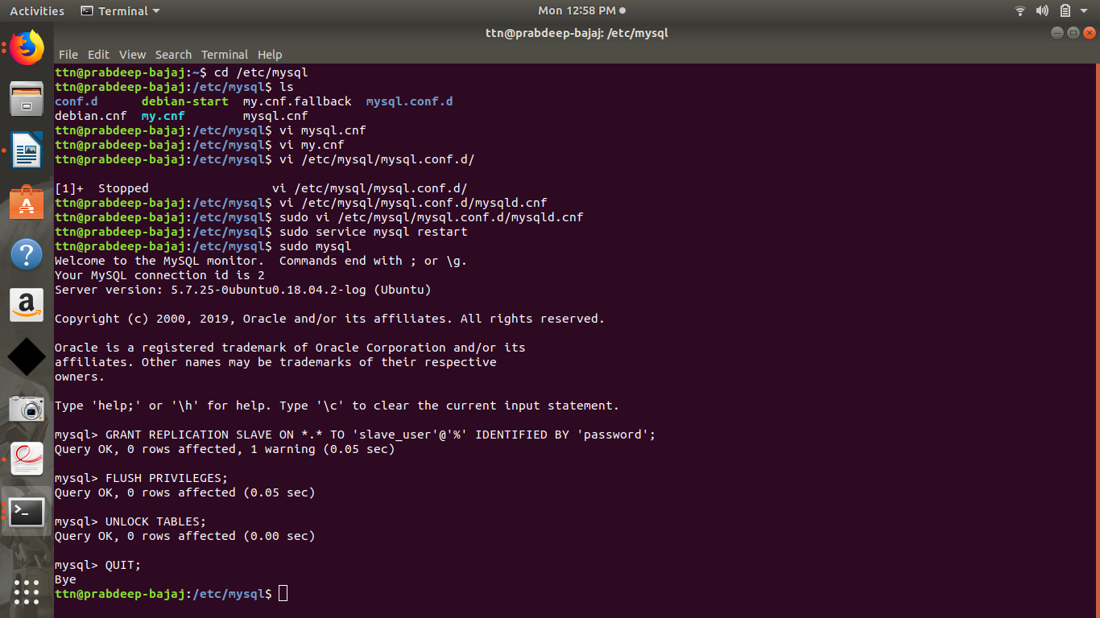

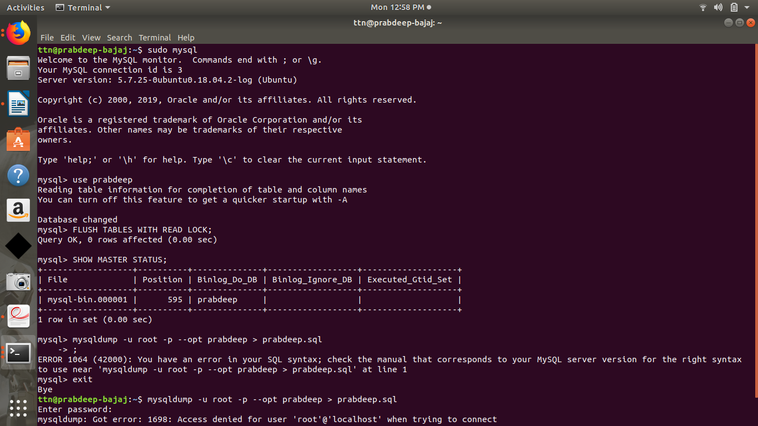

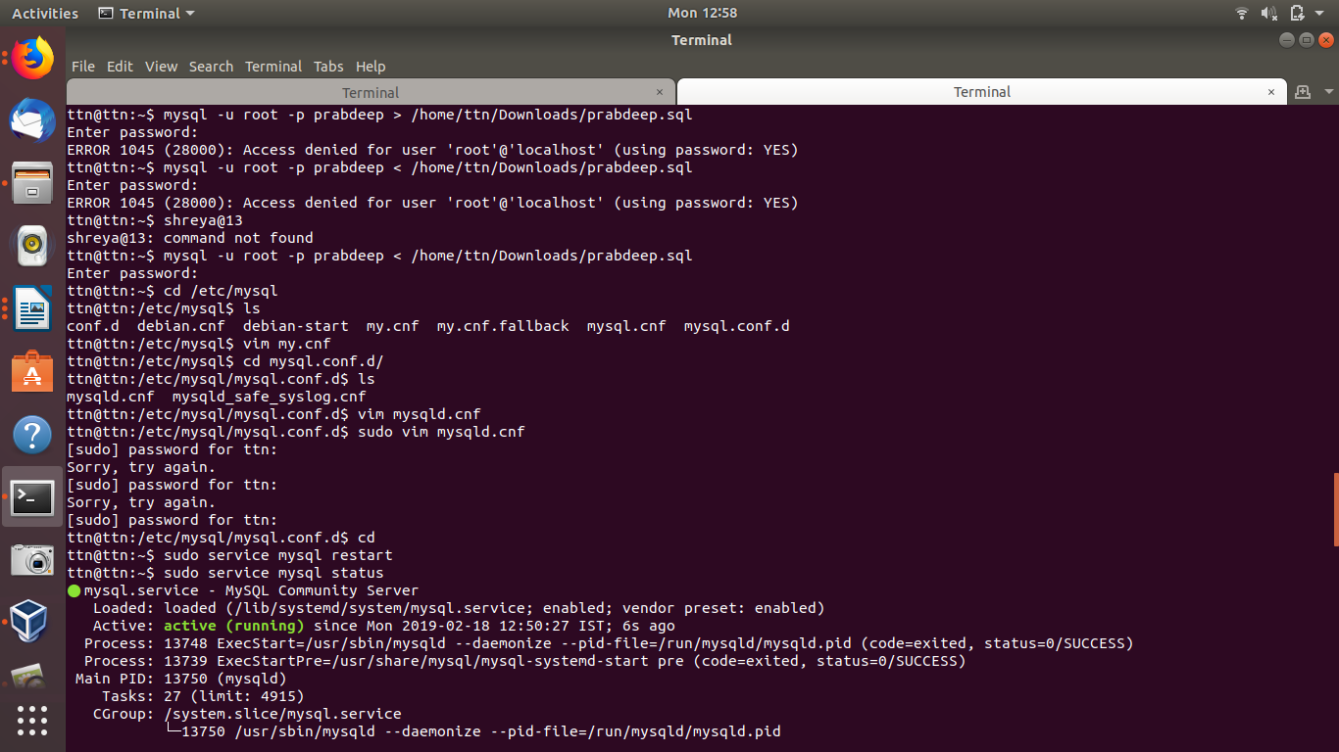
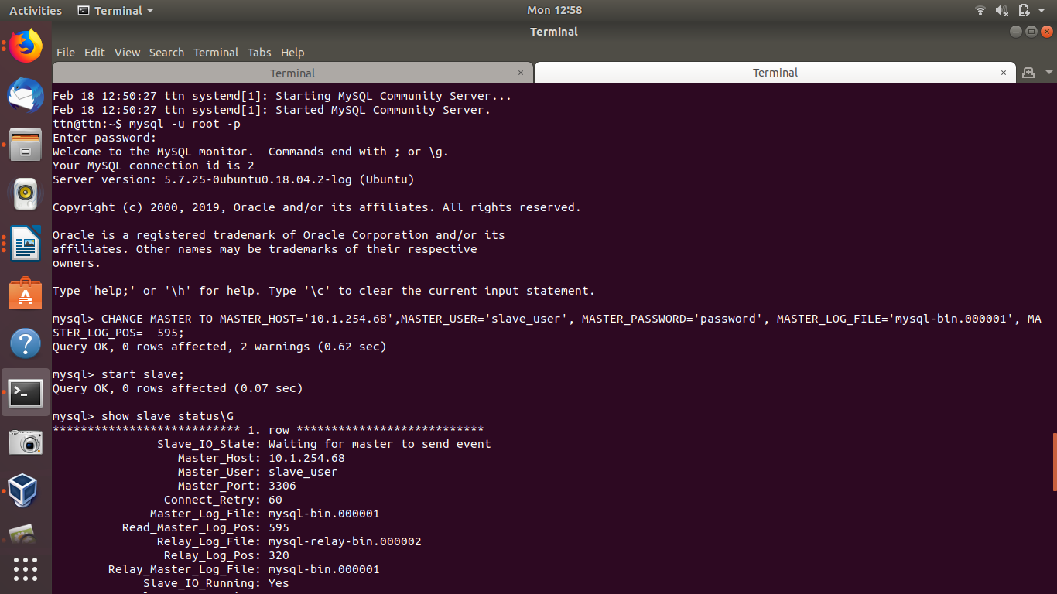

MongoDB:
- Install latest version of MongoDB from apt-get repository
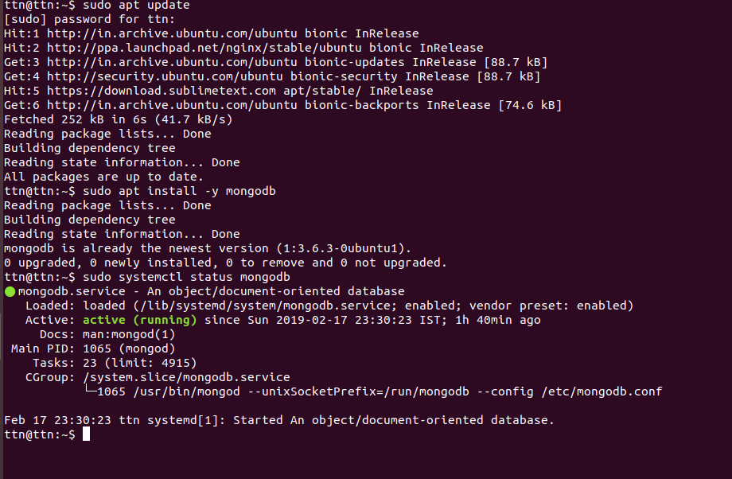
- Create a database student
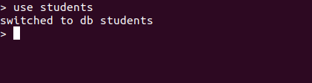

- Insert operation : 5 students data (Name, Contact, City, Roll No, Branch)

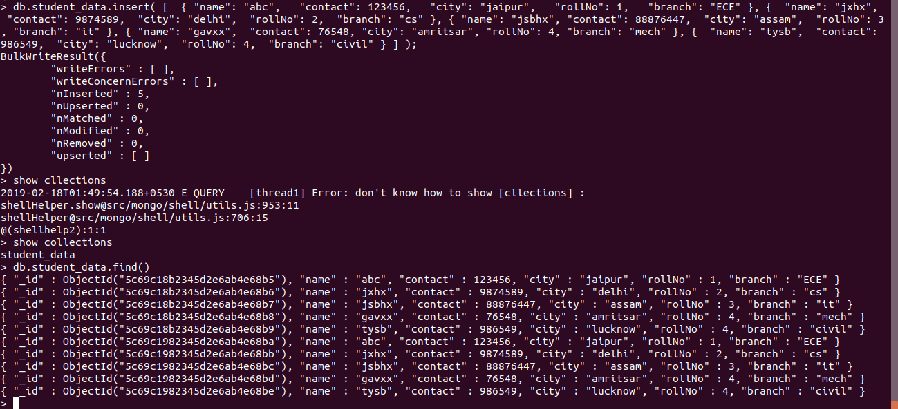

- Read operation : All the students belong to a particular city

- Update operation : Update the branch of all the students to CSE

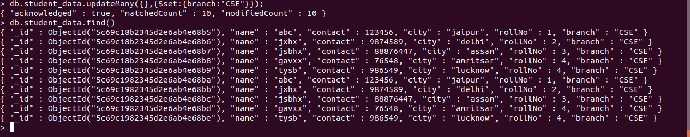
- Take dump of the database



- Delete operation : Delete the record of last 2 students according to the roll number

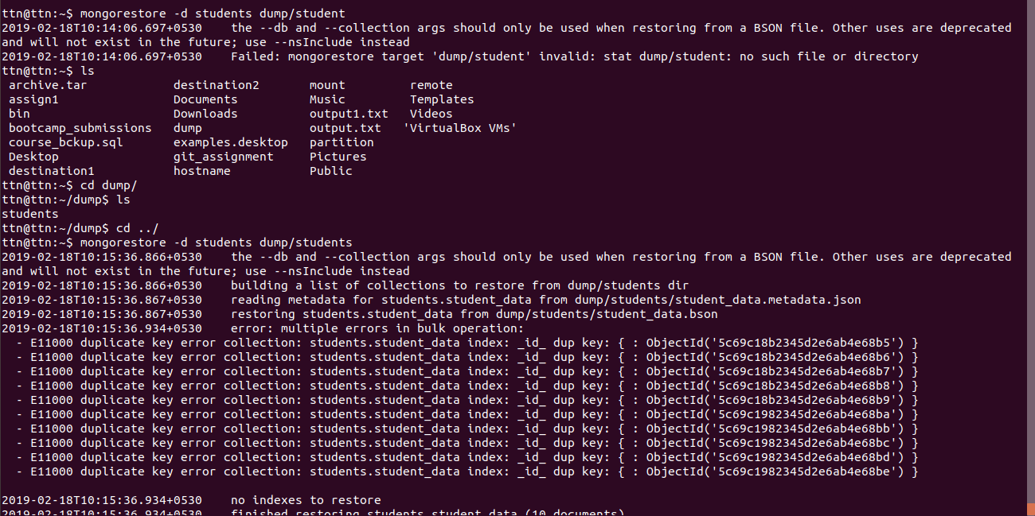
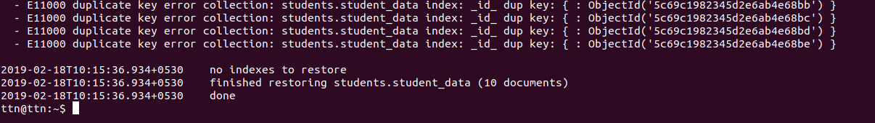

- Drop the database
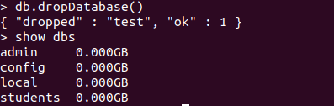

- Restore the database again to have the full data

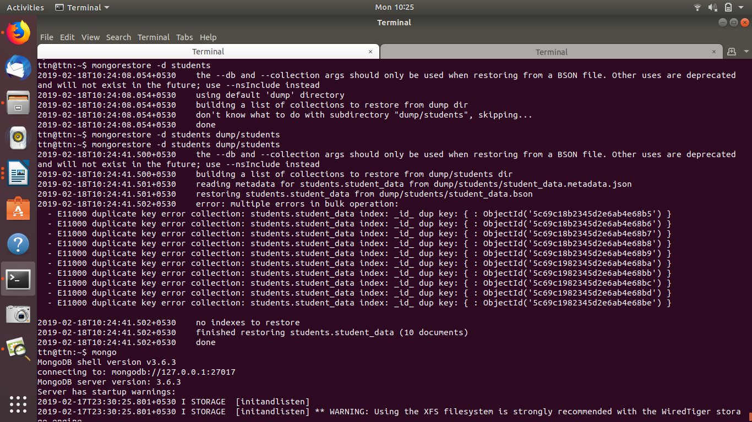
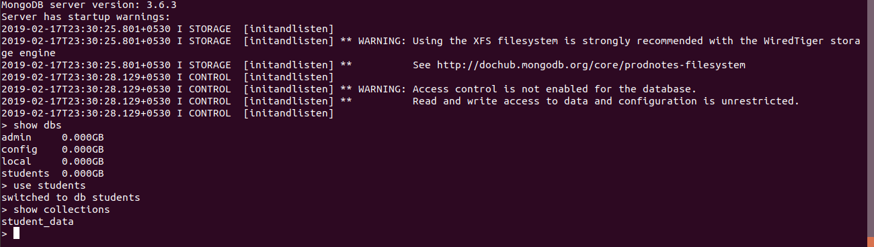
- Enable authentication on the Mongo

