LOGISTICS DELIVERY PERFORMANCE
& PREDICTIVE ANALYTICS
Week 3 Report
Advanced Data Analysis and Visualization in Logistics
Internship Role: Logistics Data Analyst Intern
Project: Logistics Delivery Performance & Predictive Analytics
Tools: Python, Pandas, Matplotlib
Dataset: DataCo Supply Chain Dataset

1. Executive Summary
Week 3 focused on advanced exploratory data analysis (EDA) and visualization of logistics performance using the cleaned DataCo supply-chain dataset prepared in Week 2. The analysis examined delivery-time performance, schedule adherence, shipping-mode performance, market sales, product-category sales, profitability, and relationships among key logistics variables.
Average actual shipping time was 3.50 days versus 2.93 scheduled days, a 0.57-day gap. 103,400 orders (57.28%) had actual shipping time greater than scheduled shipping time. Second Class had the largest schedule gap at about 1.99 days. Europe generated the highest market sales at about $10.87 million and had the highest observed market late-delivery risk at 55.21%.

2. Objectives
- Perform descriptive and exploratory analysis on the cleaned logistics dataset.
- Compare actual shipping performance with scheduled expectations.
- Analyze shipping-mode performance and schedule adherence.
- Compare sales and late-delivery risk across markets.
- Identify high-sales product categories.
- Explore the relationship between sales and profit per order.
- Analyze correlations among key logistics variables.
- Translate findings into practical logistics recommendations.

3. Dataset and Methodology
The analysis used the cleaned DataCo Supply Chain dataset produced during Week 2. It contains historical order-level logistics, sales, customer, product, and delivery information. A real public dataset was used instead of a simulated dataset to provide concrete, data-backed findings for the internship exercise.
Pandas was used for data loading, descriptive statistics, grouping and correlation analysis. Matplotlib was used to create the seven visualizations. Each visualization was selected for a specific analytical purpose: comparisons for schedule adherence, a histogram for delay distribution, bar charts for shipping modes/markets/categories, a scatter plot for sales-profit relationships, and a heatmap for correlations.

4. Key Metrics
Metric | Value
Records analyzed | 180,519
Average actual shipping | 3.50 days
Average scheduled shipping | 2.93 days
Average gap | 0.57 days
Orders exceeding schedule | 103,400
Percentage exceeding schedule | 57.28%
Total sales | $36,784,735.01
Total profit | $3,966,902.97
Average profit/order | $21.97

5. Visualization 1 — Scheduled vs Actual Shipping
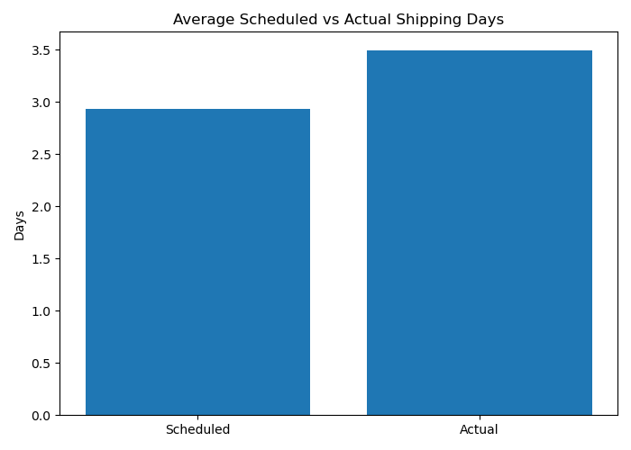
Figure 1. Average Scheduled vs Actual Shipping Days
Observation: Actual shipping time is higher than scheduled time.
Evidence: 3.50 actual days vs 2.93 scheduled days; gap = 0.57 days.
Interpretation: Shipments took about half a day longer than planned on average.
Logistics Impact: Repeated small delays can reduce schedule reliability and affect customer experience.
Recommendation: Review fulfillment and transportation stages to identify where the additional time is introduced.

6. Visualization 2 — Shipping Delay Distribution
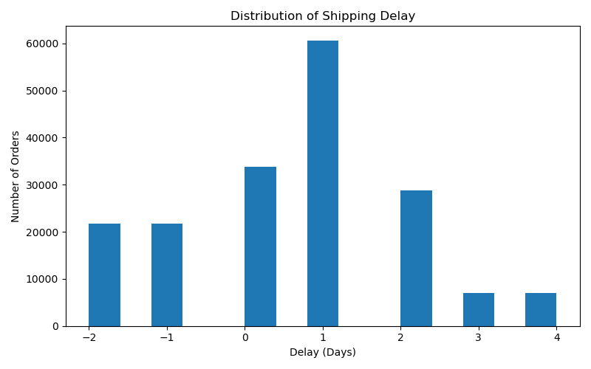
Figure 2. Distribution of Shipping Delay
Observation: The distribution contains both early/on-schedule and delayed shipments, with many positive delays.
Evidence: 103,400 orders (57.28%) exceeded their scheduled shipping duration.
Interpretation: More than half of records exceeded the planned shipping duration.
Logistics Impact: Schedule adherence is a major operational KPI.
Recommendation: Track delay distribution by shipping mode, market and fulfillment location.

7. Visualization 3 — Shipping Mode Performance
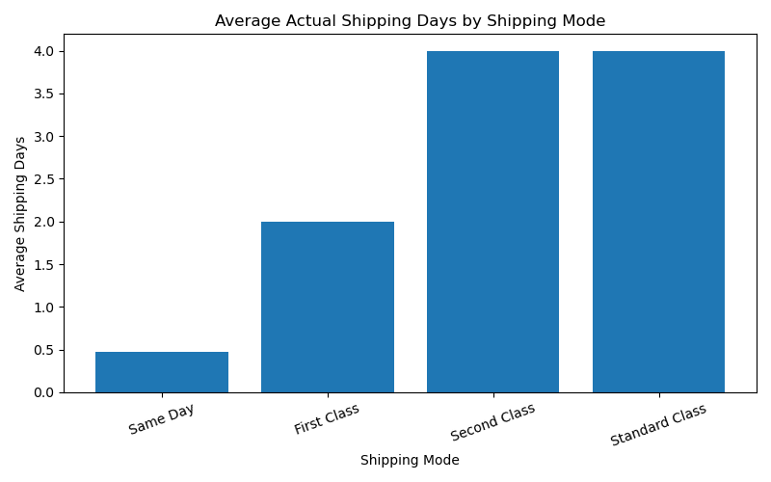
Figure 3. Average Actual Shipping Days by Shipping Mode
Observation: Shipping modes show different actual times and schedule gaps.
Evidence: Second Class: 3.99 vs 2.00 days, +1.99 days. First Class: 2.00 vs 1.00, +1.00 day. Standard Class: about 4.00 vs 4.00, approximately on schedule.
Interpretation: Second Class has the largest schedule gap.
Logistics Impact: Performance should be judged against promised schedule, not speed alone.
Recommendation: Investigate Second Class for carrier, processing and route-level bottlenecks.

8. Visualization 4 — Market-wise Sales
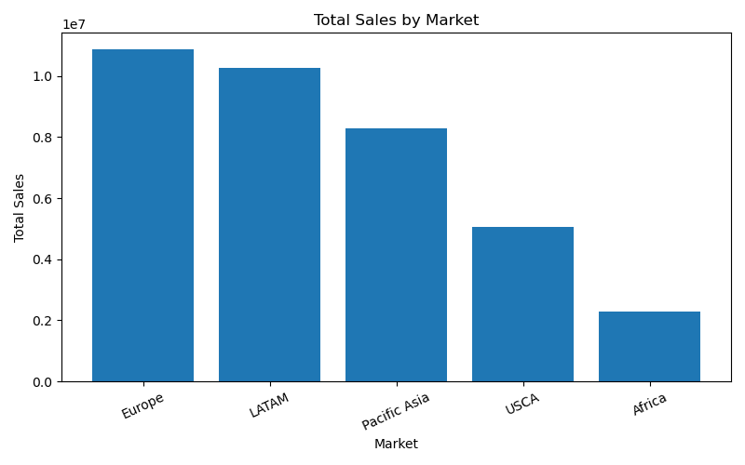
Figure 4. Total Sales by Market
Observation: Sales contribution varies substantially by market.
Evidence: Europe $10.87M; LATAM $10.28M; Pacific Asia $8.27M; USCA $5.07M; Africa $2.29M.
Interpretation: Europe is the largest sales market; Africa is the lowest among these markets.
Logistics Impact: Delivery issues in high-sales markets can affect greater commercial value.
Recommendation: Prioritize capacity and service-level monitoring in Europe and LATAM.

9. Visualization 5 — Top Product Categories
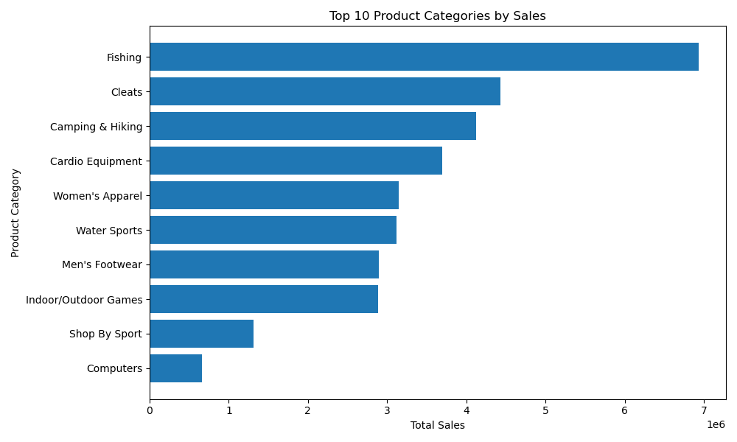
Figure 5. Top 10 Product Categories by Sales
Observation: A small group of categories contributes strongly to sales.
Evidence: Fishing $6.93M; Cleats $4.43M; Camping & Hiking $4.12M; Cardio Equipment $3.69M; Women's Apparel $3.15M.
Interpretation: Fishing generated about $2.50M more sales than Cleats.
Logistics Impact: High-sales categories deserve attention in inventory and fulfillment planning.
Recommendation: Use category-level demand information to improve inventory availability and fulfillment priority.

10. Visualization 6 — Sales vs Profit
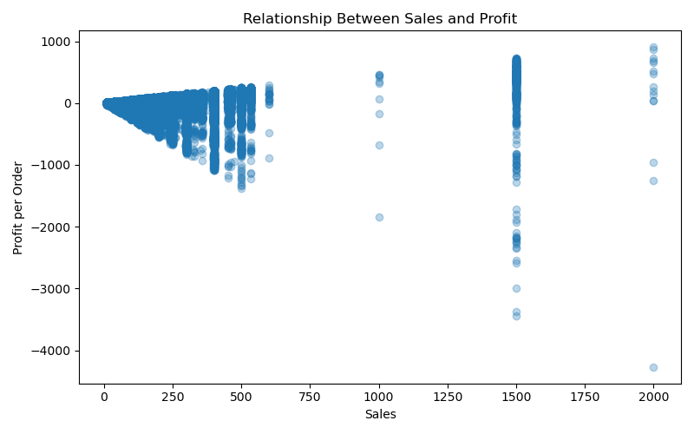
Figure 6. Relationship Between Sales and Profit
Observation: Profit varies considerably across sales values, including negative-profit observations.
Evidence: Total sales $36.78M; total profit $3.97M; average profit/order $21.97.
Interpretation: Higher sales do not automatically mean proportionally higher profit.
Logistics Impact: Revenue alone is insufficient for operational evaluation.
Recommendation: Combine sales, profit, discount, margin and delivery measures.

11. Visualization 7 — Correlation Heatmap
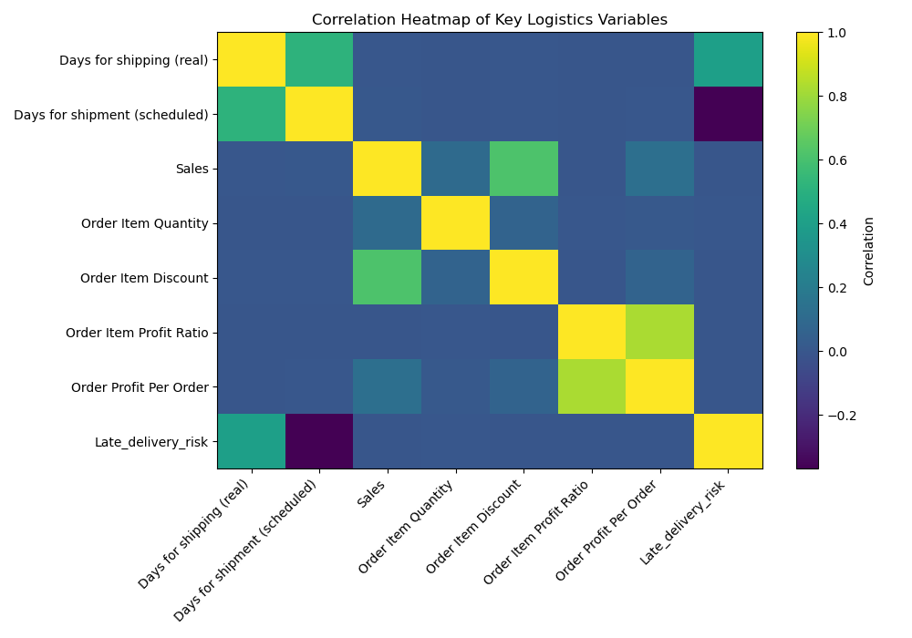
Figure 7. Correlation Heatmap of Key Logistics Variables
Observation: Actual shipping days have the strongest positive association with late-delivery risk among the selected variables.
Evidence: Actual shipping days vs risk = 0.401; scheduled days vs risk = -0.369; sales vs risk = -0.004; quantity vs risk ≈ 0.000.
Interpretation: Actual shipping duration has a moderate positive linear association with late-delivery risk, while sales and quantity show almost no linear association.
Logistics Impact: Delivery-time variables appear more relevant to risk analysis than basic sales or quantity.
Recommendation: Future predictive work should investigate operational variables available before the delivery outcome. Correlation indicates association, not causation.

12. Market Late-Delivery Risk
Market late-delivery risk was close across the five markets. Europe had the highest observed risk at 55.21%, while LATAM had the lowest at 54.36%. The narrow range suggests that market alone does not explain a dramatic difference in delivery risk, but Europe remains strategically important because it also has the highest sales.
Market | Late-Delivery Risk
Europe | 55.21%
Pacific Asia | 55.05%
USCA | 54.80%
Africa | 54.59%
LATAM | 54.36%

13. Overall Analytical Insights
- Delivery reliability is the main operational concern: actual shipping averaged 3.50 days versus 2.93 scheduled days.
- 57.28% of records exceeded their scheduled shipping duration.
- Second Class had the largest schedule gap at approximately 1.99 days.
- Europe combined the highest sales ($10.87M) with the highest observed market late-delivery risk (55.21%).
- Fishing was the highest-sales category at $6.93M.
- Total profit was approximately $3.97M with average profit per order of $21.97.
- Actual shipping time had a 0.401 correlation with late-delivery risk, while sales and quantity had near-zero correlations.

14. Data Quality, Limitations and Reflection
Week 2 preprocessing resulted in 180,519 records with missing values handled and duplicate records removed. Potential Sales outliers identified with the IQR method were retained because extreme transaction values may represent genuine high-value orders rather than data-entry errors.
- This is historical/public data rather than a live logistics system, so findings should not be treated as current operational KPIs.
- Correlation shows association, not causation.
- Some delivery variables describe outcomes after shipping. They are useful for Week 3 descriptive analysis but require care in future predictive modeling to avoid target leakage.
- Retained Sales outliers can influence averages and visual scales, but removing them without validation could discard genuine business cases.
- Market/category differences may reflect order volume, product mix or business structure; a single operational cause cannot be assumed.
Reflection: Data quality directly affects the reliability of logistics conclusions. Cleaning missing and duplicate records improves consistency, while retaining potentially valid extreme transactions preserves important business cases. Analysts must also clearly distinguish what the dataset demonstrates from what it cannot prove.

15. Logistics Recommendations
- Investigate the 1.99-day schedule gap for Second Class shipments.
- Monitor schedule adherence as a core KPI alongside average shipping time.
- Prioritize operational monitoring in high-sales markets such as Europe and LATAM.
- Use category-level demand information for inventory and fulfillment planning.
- Evaluate sales and profitability together rather than revenue alone.
- For future predictive modeling, use only information available before the delivery outcome and avoid variables that directly encode the target outcome.

16. Python Implementation Approach
The analysis was implemented with Pandas and Matplotlib. The workflow was: load the cleaned CSV → calculate delivery and financial metrics → group by shipping mode, market, customer segment and category → calculate correlations → generate and save seven PNG visualizations.
df = pd.read_csv("Dataset/cleaned_supply_chain.csv")
df["Shipping_Delay_Days"] = df["Days for shipping (real)"] - df["Days for shipment (scheduled)"]
market_sales = df.groupby("Market")["Sales"].sum().sort_values(ascending=False)
correlation = df[["Days for shipping (real)", "Days for shipment (scheduled)",
"Sales", "Order Item Quantity", "Late_delivery_risk"]].corr()

17. Conclusion
Week 3 converted raw logistics records into actionable insights through exploratory analysis and visualization. The strongest finding was the schedule-adherence gap: 3.50 actual days versus 2.93 scheduled days, with 57.28% of orders exceeding their scheduled duration. Second Class showed the largest gap, while Europe and the Fishing category represented important high-sales areas. Correlation analysis showed a moderate association between actual shipping duration and late-delivery risk.
These findings provide a foundation for the next project stage: deeper driver analysis and predictive work, with careful attention to data quality and prevention of target leakage.

Data Simulation / Dataset Structure
The Week 3 task specifies a hypothetical logistics dataset structure containing variables such as delivery time, shipment volume, and transportation cost. Instead of generating synthetic data, this analysis uses the real DataCo Smart Supply Chain dataset, which provides realistic logistics records. Relevant variables include actual shipping days, scheduled shipping days, order quantity, sales, profit, shipping mode, market, delivery status, and late-delivery risk. These variables provide the same type of information required for logistics performance analysis while avoiding assumptions that could arise from simulated values.

