Lakshmi Narain College of Technology



THE PROJECT REPORT

**QizoPhile**

Department of Electronics and Communication Engineering

Name:SHREYA KUMARI

Enrollment: - 0103EC191171

**ABSTRACT**

QizPhile is a web-based examination or quiz creating.The main objective of this is to efficiently evaluate the candidate through a fully automated system that not only saves lot of time but also gives fast results. The system will show result instantly after the examination is finished. A teacher/Admin has control in the question bank and is supposed to make schedule for the quizzes also. Not only this system carries out the quizzes but also auto-grade that for it. Administrative control of the whole system is provided.

**INTODUCTION**

* QizPhile refers to service as conduct online test. It will use for student’s progress evaluation using modern computer technology. The main aim of this Project is to facilitate a friendly environment for users and to reduces the manual efforts. (for kids as well as for elders)
* It replaces paperwork and overcome the outcomes of traditional way of examinations using paper or pen and also saves time.
* It is fully developed automated system to efficiently evaluate the candidate progress that
* Not only saves the time of Examination Invigilator but also gives fast result.
* The only Administrator of the system has authority to create tests or quizzes and students can login only with their name and enrolment according to student’s database.
* It will be completely automate the old manual procedure of conducting exam or quiz buzzer game to Online Web Based Exam System which has became very important during this covid pandemic.

**PURPOSE (PROBLEM)/SOLUTION**

* **Logistical Hassle**

[Qizophile](https://mettl.com/computer-based-tests/online-exam-software?utm_source=www.google.com&utm_medium=blog)help overcome the challenge of setting up physical test centers, minimizing resource requirements – time, cost of setting up, and the need for human proctors – speeding up the examination process.

* **-Scalable**

It cater to a broad audience and students and easily manage vast content. Considering this feature, educational institutions facing a paucity of time would find it extremely convenient to conduct examinations.

* **Lack of Exhaustive Skill and Question Bank**

For ease of use, examiners can choose the relevant skills they wish to test via the exam to frame the questionnaire. This saves examiners’ time and effort in this project.

* **Burden Of Teachers and lack of time management**

This give an automated reports do away with manual correction and save notable working hours. A report is a comprehensive approach to a candidate’s performance so it decreases the burden of teachers or organisers from checking the papers manually.

Besides that, the system is very reliable, flexible, and efficient. New modules, features, and components can be easily integrated into the system as per user requirements to make this project a even better one.

**FLOW CHART**

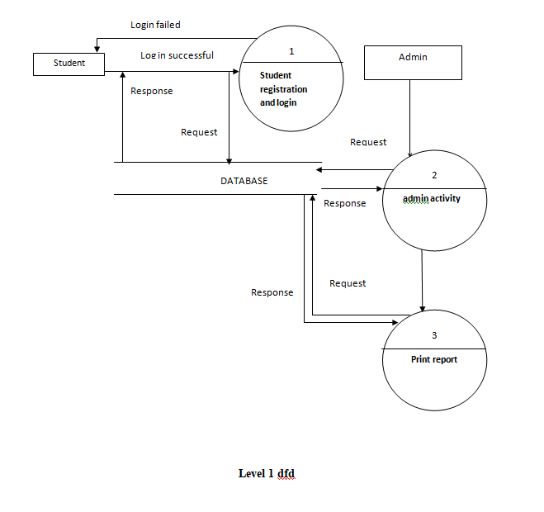

**CONCLUSION**

As mentioned in the project is based on java platform (jdk 8u271) which is coded in NetBeans IDE 8.2 with help of Java Swing (UI), sql(database), But this project is only for MCQ exam or game test.

To conclude, this is a simple desktop web application for Quiz in which a teacher is able to punch MCQ question to system which will be store in SQL Server database and able the students will be able to attempt any test for once. The marks of student will be calculated according to questions they attempt and will be displayed by the system to teachers/creator and student/candidates.