T & P Assignment -2

Name- Shreya Kumari Enrollment- 0103EC191171

College- LNCT(EC) Section-‘D’

========================================================

Q1. Take three numbers from the user and print the greatest number.

import java.lang.*;

import java.util.Scanner;

public class AssignmentJava1 {

public static void main(String[] args)

Scanner scan = new Scanner(System.in);

System.out.print("Input the 1st number");

int n1 = scan.nextInt();

System.out.print("Input the 2nd number");

int n2 = scan.nextInt();

System.out.print("Input the 3rd number");

int n3 = scan.nextInt();

if(n1>n2){

if(n1>n3){

System.out.println("The greatest: "+n1);

}

}else if(n2>n3){

System.out.println("The greatest: "+n2);

}

else{

System.out.println("The greatest: "+n3);

}

}

}

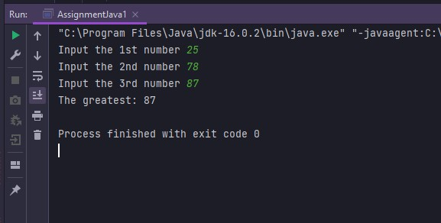

Q2. a Java program that keeps a number from the user and generates an integer between 1 and 7 and displays the name of the weekday.

import java.util.Scanner;

public class AssignmentJava1 {

public static void main(String[] args) {

Scanner scan = new Scanner(System.in);

System.out.print("Input number");

int n= scan.nextInt();

switch (n){

case 1:

System.out.println("Monday");

break;

case 2:

System.out.println("Tuesday");

break;

case 3:

System.out.println("Wednesday");

break;

case 4:

System.out.println("Thursday");

break;

case 5:

System.out.println("Friday");

break;

case 6:

System.out.println("Saturday");

break;

case 7:

System.out.println("Sunday");

break;

default:

System.out.println("Enter a number between 1-7");

break;

}

}

}

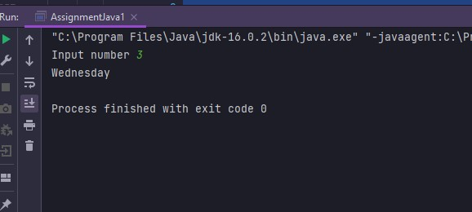

Q3. Write a Java program that reads in two floating-point numbers and tests whether they are the same up to three decimal places.

import java.util.Scanner;

public class AssignmentJava1 {

public static void main(String[] args) {

Scanner scan = new Scanner(System.in);

System.out.print("Input floating-point number:");

double fpn1= scan.nextDouble();

System.out.print("Input floating-point another number:");

double fpn2= scan.nextDouble();

fpn1=fpn1%1000;

fpn2=fpn2%1000;

if(fpn1!=fpn2)

System.out.println("They are different");

else

System.out.println("They are same");

}

}

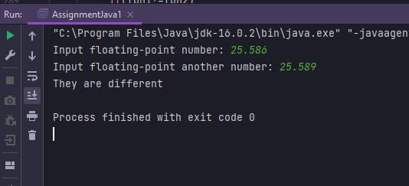

Q4. Write a Java program to find the number of days in a month.

import java.lang.*;

import java.util.Scanner;

public class AssignmentJava1 {

public static void main(String[] args) {

Scanner scan = new Scanner(System.in);

System.out.print("Input a month number");

int month_num=scan.nextInt();

System.out.print("Input a year");

int year= scan.nextInt();

String month= " ";

int num_days=0;

switch(month_num){

case 1:

month="January";

num_days=31;

break;

case 2:

month="February";

if((year%4==0 && year%100!=0)||(year%400==0))

num_days=29;

else

num_days=28;

break;

case 3:

month="March";

num_days=31;

break;

case 4:

month="April";

num_days=30;

break;

case 5:

month="May";

num_days=31;

break;

case 6:

month="June";

num_days=30;

break;

case 7:

month="July";

num_days= 31;

break;

case 8:

month="August";

num_days=31;

break;

case 9:

month="September";

num_days=30;

break;

case 10:

month="October";

num_days=31;

break;

case 11:

month="November";

num_days=30;

break;

case 12:

month="December";

num_days=31;

break;

default:

System.out.println("Input a number between 1 to 12");

}

System.out.println(month+" "+year+" has "+ num_days+" days");

}}

}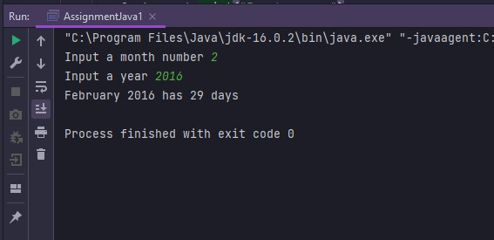

Q5. Write a Java program that takes the user to provide a single character from the alphabet. Print Vowel or Consonant, depending on the user input. If the user input is not a letter (between a and z or A and Z), or is a string of length > 1, print an error message.

import java.lang.*;

import java.util.Scanner;

public class AssignmentJava1 {

public static void main(String[] args) {

Scanner scan = new Scanner(System.in);

System.out.print("Input an alphabet: ");

String message = scan.next();

if (message.length() > 1 || !message.matches("[A-Za-z]")) {

System.out.println("error");

} else {

message = message.toUpperCase();

if (message.matches("[AEIOU]")) {

System.out.println("Input letter is Vowel");

} else

System.out.println("Input letter is Consonant");

}

}

}

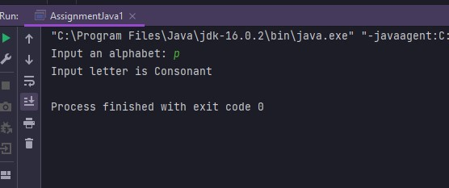

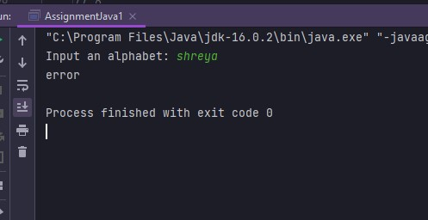

Q6. Write a program in Java to display the n terms of odd natural number and their sum.

import java.util.Scanner;

public class AssignmentJava1 {

public static void main(String[] args) {

Scanner scan = new Scanner(System.in);

System.out.print("Input number of terms is: ");

int n_odd = scan.nextInt();

int sum = 0;

System.out.println("the odd numbers are: ");

for (int i = 1;i<=n_odd ; i++) {

System.out.println(2*i-1);

sum+=2*i-1;

}

System.out.println("The Sum of odd Natural Number upto "+ n_odd + " terms is: " + sum);

}

}

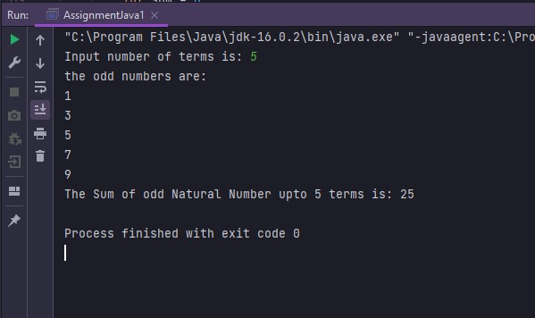

Q7. write a java Program to print following pattern

import java.util.Scanner;

public class AssignmentJava1 {

public static void main(String[] args) {

Scanner scan = new Scanner(System.in);

int row=scan.nextInt();

for(int i=row; i>0; i--){

for(int j=1; j<=row; j++){

if (j==i) {

System.out.print(row--);

}

else

System.out.print(". ");

}

System.out.println();

}

}

}

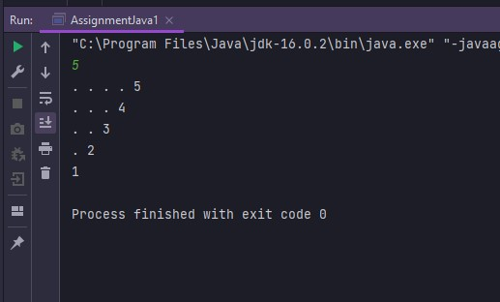

Q8. Write a program to accept gender ("Male" or "Female") and age (1-120) from command line arguments and print the percentage of interest based on the given conditions.

import java.lang.*;

import java.util.Scanner;

public class AssignmentJava1 {

public static void main(String[] args) {

Scanner scan = new Scanner(System.in);

System.out.print("Gender ==> ");

String gender = scan.next();

System.out.print("Age ==> ");

int age = scan.nextInt();

if (gender.equalsIgnoreCase("Female")) {

if (age >= 1 && age <= 58)

System.out.println("Interest == 8.2% ");

else if ((age >= 59 && age <= 120))

System.out.println("Interest == 7.6% ");

} else {

if (gender.equalsIgnoreCase("Male")) {

if (age >= 1 && age <= 60)

System.out.println("Interest == 9.2% ");

else if ((age >= 61 && age <= 120))

System.out.println("Interest == 8.3% ");

}

}

}

}

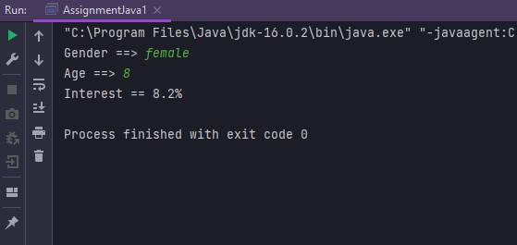

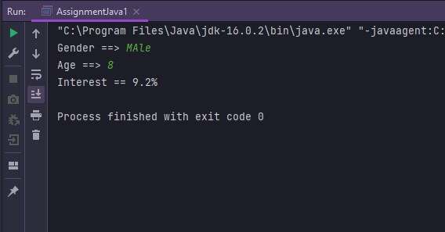

Q9. Write a program to convert from upper case to lower case and vice versa of an alphabet and print the old character and new character as shown in example (Ex: a->A, M->m).

import java.lang.*;

import java.util.Scanner;

public class AssignmentJava1 {

public static void main(String[] args) {

Scanner scan = new Scanner(System.in);

System.out.print("Enter an alphabet in any case");

String ch = scan.next();

if (ch.matches("[A-Za-z]")) {

if(ch.matches("[A-Z]"))

System.out.print(ch + " -> "+ch.toLowerCase());

else {

System.out.println(ch + " -> "+ch.toUpperCase());

}

}else

System.out.println("Error");

}

}

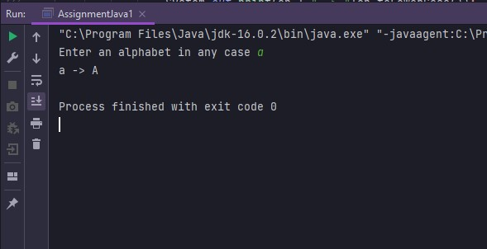

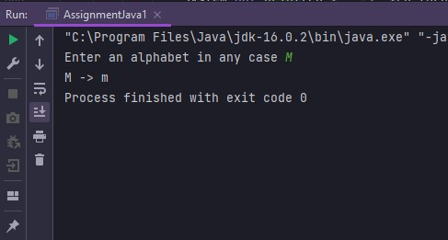

Q10. Write a program to print month in words, based on input month in numbers

import java.lang.*;

import java.util.Scanner;

public class AssignmentJava1 {

public static boolean isNum(String str) {

if (str == null)

return false;

try {

int intVal = Integer.parseInt(str);

return true;

} catch (NumberFormatException e) {

return false;

}

}

public static void main(String[] args) {

Scanner scan = new Scanner(System.in);

String[] month = {"January", "February", "March", "April", "May", "June", "July", "August", "September", "October", "November", "December"};

String monthNum;

System.out.print("java Sample ");

monthNum = scan.nextLine();

if(isNum(monthNum)){

int iVal = Integer.parseInt(monthNum);

if(iVal>=1&&iVal<=12)

System.out.println(month[iVal-1]);

else

System.out.println("invalid month");

}

else{

System.out.println("Please enter the month in numbers");

}

}

}

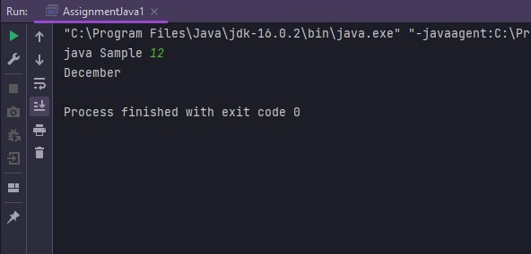

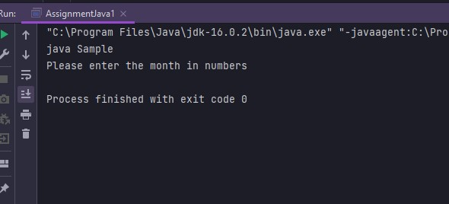

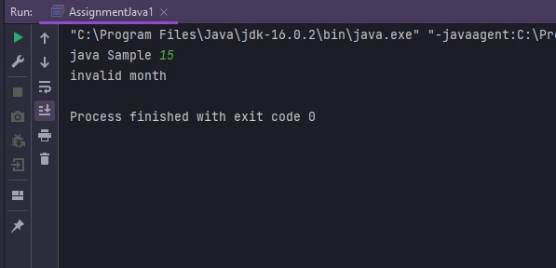

Q11. Write a program to print prime numbers between 10 and 99.

public class AssignmentJava1 {

public static void main(String[] args) {

int count;

String prime="";

for (int i = 10; i <= 99; i++) {

count=0;

for (int j = 2; j <= i / 2; j++) {

if (i % j == 0) {

count++;

}

}

if (count>= 2){

}

else

prime= prime+" "+i;

}

System.out.println(" prime number between 1-99\n"+prime);

}

}

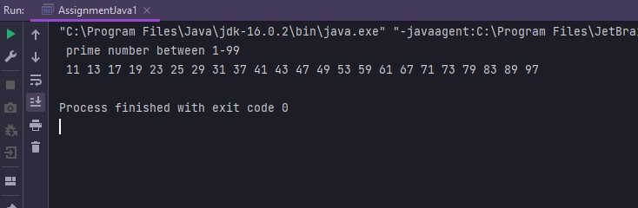

Q12. Write a Java program to find if the given number is prime or not.

import java.lang.*;

import java.util.Scanner;

public class AssignmentJava1 {

public static boolean isNum(String str) {

if (str == null)

return false;

try {

int intVal = Integer.parseInt(str);

return true;

} catch (NumberFormatException e) {

return false;

}

}

public static boolean isPrime(int no) {

if (no < 0) no *= -1;

Boolean isPrime = true;

for (int i = 2; i < no / 2 + 1; i++) {

if (no % i == 0) {

isPrime = false;

break;

}

}

if (no == 0 || no == 1) isPrime = false;

return isPrime;

}

public static void main(String[] args) {

Scanner scan = new Scanner(System.in);

System.out.println("java Sample");

String num = scan.nextLine();

if (isNum(num)) {

int number = Integer.parseInt(num);

if (number == 0 || number == 1) {

System.out.println(number + " is neither prime nor composite");

} else if (isPrime(number))

System.out.println(number + " is a prime number");

else

System.out.println(number + " is not a prime number");

}else

System.out.println("please enter an integer number");

}

}

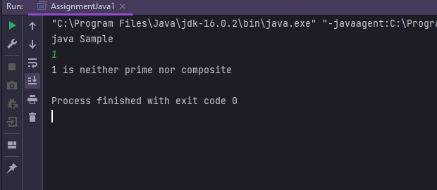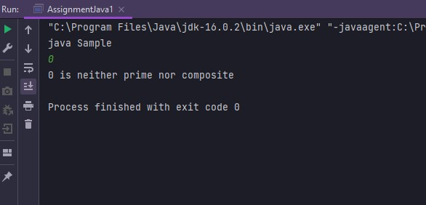

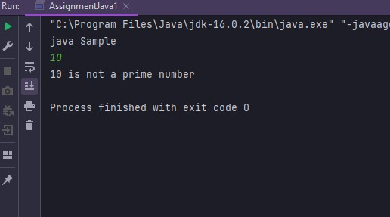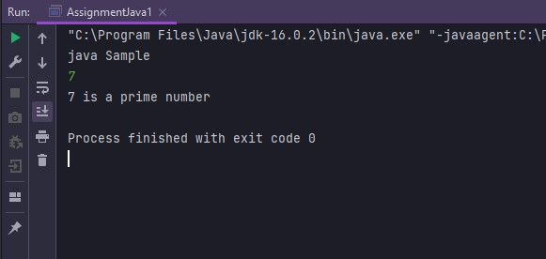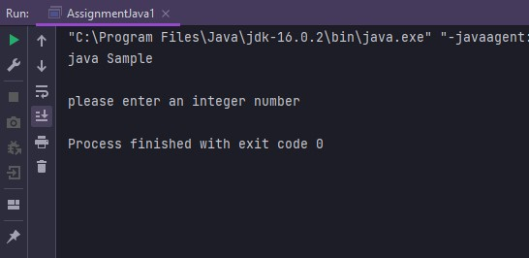

Q13. Write a program to reverse a given number and print

import java.lang.*;

import java.util.Scanner;

public class AssignmentJava1 {

public static void main(String[] args) {

Scanner scan = new Scanner(System.in);

System.out.println("java Sample");

int num= scan.nextInt();

StringBuffer st= new StringBuffer(String.valueOf(num));

st=st.reverse();

System.out.println(st);

}

}

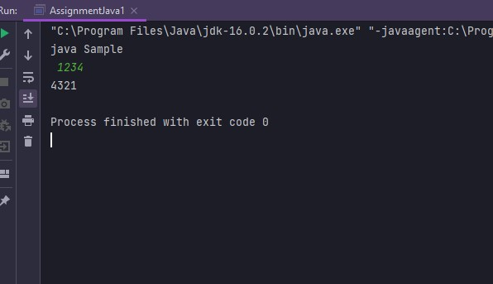

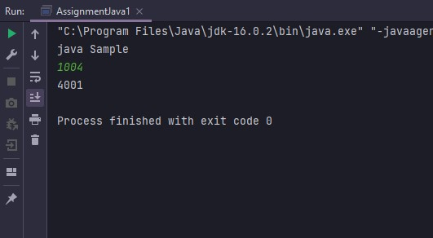

Q14. Write a Java program to find if the given number is palindrome or not

import java.util.Scanner;

public class AssignmentJava1 {

public static void main(String[] args) {

Scanner scan = new Scanner(System.in);

System.out.println("java Sample");

int num= scan.nextInt();

int rev = 0, r;

int oNum = num;

while (num >0) {

r = num % 10;

rev = rev * 10 + r;

num /= 10;

}

if (oNum == rev) {

System.out.println(oNum + " is Palindrome.");

} else {

System.out.println(oNum + " is not Palindrome.");

}

}

}

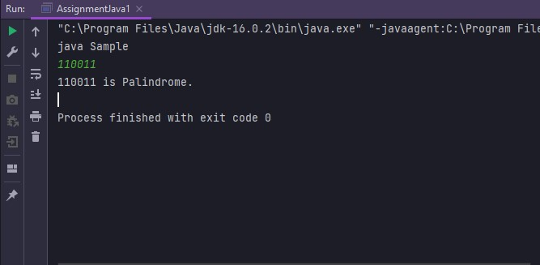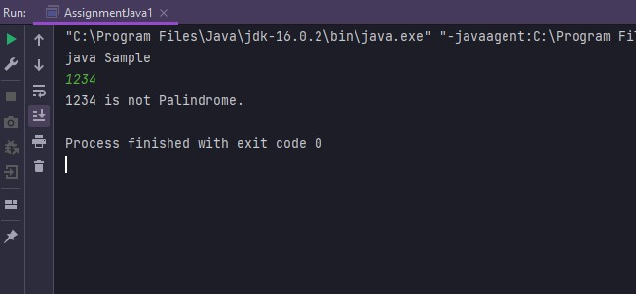

Q15. Write a program that displays a menu with options

1. Add

2. Sub

import java.lang.*;

import java.util.Scanner;

public class AssignmentJava1 {

public static void main(String[] args) {

Scanner scan = new Scanner(System.in);

System.out.println("1. Add\n2. Sub");

int choice = scan.nextInt();

int num1;

int num2;

int result;

if (choice == 1) {

System.out.println("Enter first operand: ");

num1 = scan.nextInt();

System.out.println("Enter second operand: ");

num2 = scan.nextInt();

result = num1 + num2;

System.out.println("Result: " + result);

} else if(choice==2) {

System.out.println("Enter first operand: ");

num1 = scan.nextInt();

System.out.println("Enter second operand: ");

num2 = scan.nextInt();

result = num1 - num2;

System.out.println("Result: " + result);

}

else{

System.out.println("invalid");

}

System.out.println("Do you want to continue? Y or N");

scan.nextLine();

choice = scan.nextLine().charAt(0);

if (choice == 'Y' || choice == 'y')

main(args);

}

}

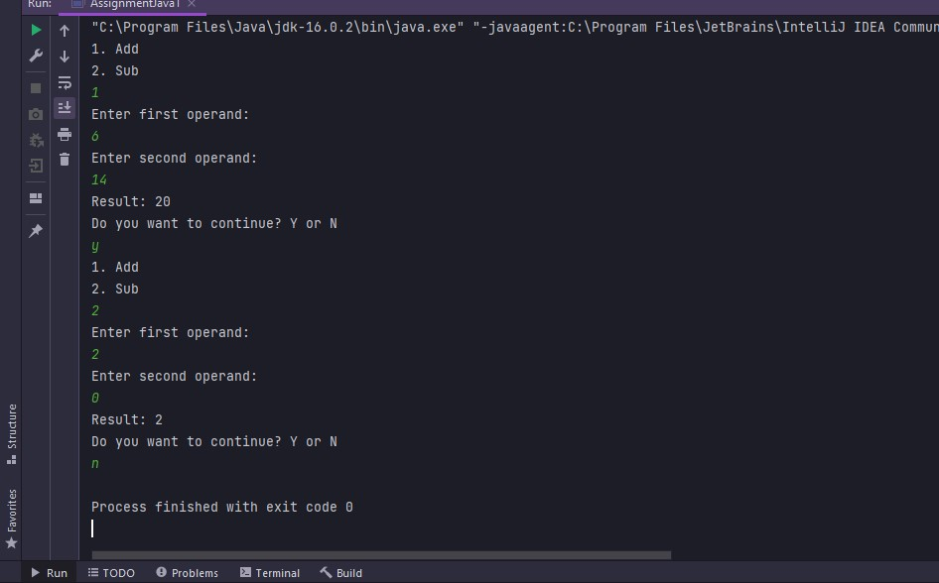

Q16. Write a program to print first 5 values which are divisible by 2, 3, and 5.

public class AssignmentJava1 {

public static void main(String[] args) {

int count=0;

System.out.println("First 5 values which are divisible by 2, 3, and 5");

for(int i=1; i<1000;i++){

if(i%2==0 && i%3==0 && i%5==0 && count<5){

System.out.println(i);

count++;

}

}

}

}

