T and P java Class

Assignment-1

* Name- Shreya Kumari
* College - LNCT
* Branch/Sec- EC/D
* Year- 3rd year
* Enrollment no.- 0103EC191171

1. Write a Java program to convert a given integer (in seconds) to hours, minutes and seconds.

code

import java.util.Scanner;

public class AssignmentJava1 {

public static void main(String[] args) {

Scanner scan = new Scanner(System.in);

// Question number 1:

System.out.println("Take any time in seconds");

int timeInSec= scan.nextInt();

System.out.println("\nConverting time in H:M:S format");

System.out.println(timeInSec/(60*60)+":"+ (timeInSec%(60*60))/(60)+":"+ ((timeInSec%(60*60))%(60)));

}

}

# Output of Q1:

Q2. Write a java program to convert a given integer (in days) to years, months and days,assumes that all months have 30 days and all years have 365 days.

Code

import java.util.Scanner;

public class AssignmentJava1 {

public static void main(String[] args) {

Scanner scan = new Scanner(System.in);

//Question 2:

System.out.println("\nTake any Integer (in days)");

int numInDays = scan.nextInt();

System.out.println("\nConverting Integer (in days) to Year, Month and Days:");

System.out.println(numInDays / (365) + " Years(s)" +

"\n" + (numInDays % (365)) / (30) + " Month(s)" +

"\n" + ((numInDays % (365)) % (30)) + " Day(s)");

}

}

# OUTput of Q2:

Q3. Write a java program that read 5 numbers and sum of all odd values between them

code

import java.util.Scanner;

public class AssignmentJava1 {

public static void main(String[] args) {

Scanner scan = new Scanner(System.in);

// Question 3:

System.out.println("\nhow many Numbers you want to take:");

int y= scan.nextInt();

System.out.println("Input those Integers ");

int[] integerNum = new int[y];

int sum = 0;

for (int i = 0; i <integerNum.length; i++) {

integerNum[i]= scan.nextInt();

if (integerNum[i] % 2 == 1) {

sum += integerNum[i];

}

}

System.out.println("sum of odd numbers only: "+sum);

}

}

-------------------------------------------------------------------------------------------------------

Output of Q3.

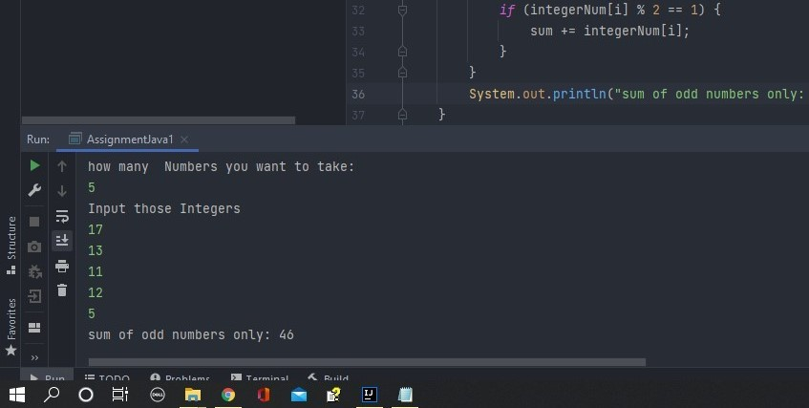

Q4. Write a Java program that reads two integers and checks whether they are multiplied or not.

Code

import java.util.Scanner;

public class AssignmentJava1 {

public static void main(String[] args) {

//Question 4:

Scanner scan = new Scanner(System.in);

System.out.println("\nTake two integer Numbers:\n");

System.out.print("Take first number: ");

int num1= scan.nextInt();

System.out.print("Take Second number: ");

int num2= scan.nextInt();

if(num1%num2==0||num2%num1==0){

System.out.println("They are multiplied");

}

else {

System.out.println("They are not multiplied");

}

}

}

-------------------------------------------------------------------------------------------------------

Output of Q4:

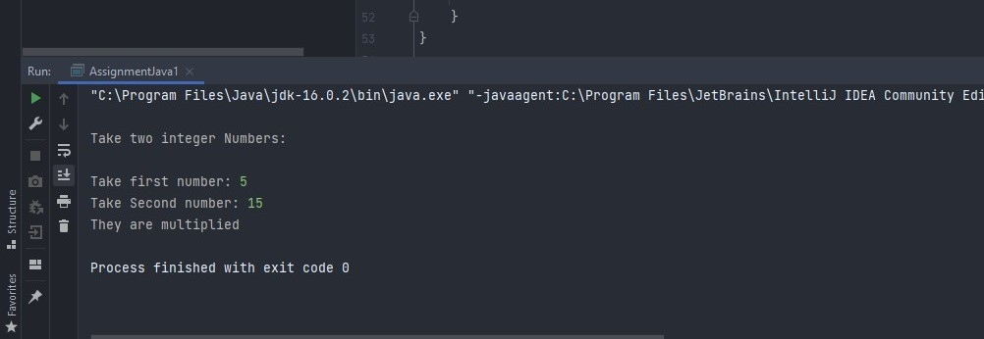

Q5. Write a Java program that reads an integer between 1 and 12 and print the month of the year in English.

Code

import java.util.Scanner;

public class AssignmentJava1 {

public static void main(String[] args) {

Scanner scan = new Scanner(System.in);

// Question 5:

System.out.println("\nTake any integer Number(Month Number) in between 1-12:");

int monthName= scan.nextInt()

switch(monthName){

case 1:

System.out.println("Janurary");

break;

case 2:

System.out.println("February");

break;

case 3:

System.out.println("March");

break;

case 4:

System.out.println("April");

break;

case 5:

System.out.println("May");

break;

case 6:

System.out.println("June");

break;

case 7:

System.out.println("July");

break;

case 8:

System.out.println("August");

break;

case 9:

System.out.println("September");

break;

case 10:

System.out.println("October");

break;

case 11:

System.out.println("November");

break;

case 12:

System.out.println("December");

break;

default:

System.out.println("Please Enter a number between 1 to 12");

}

}

}

-------------------------------------------------------------------------------------------------------

Output of Q5:

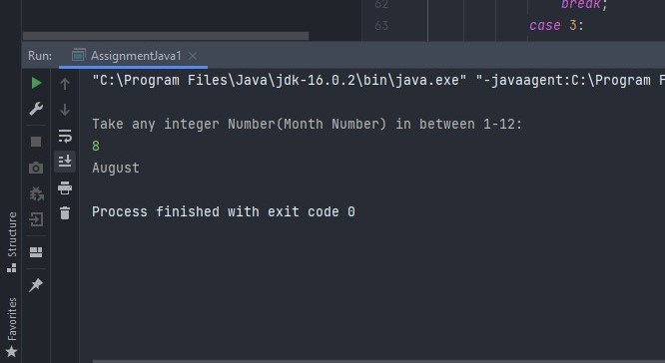

Q6 Write a java program that read 5 numbers and counts the number of positive numbers.

Code

import java.util.Scanner;

public class AssignmentJava1 {

public static void main(String[] args) {

Scanner scan = new Scanner(System.in);

//Question 6:

System.out.println("\nHow many Numbers you want to take:");

int n= scan.nextInt();

System.out.println("Input those Integers ");

int[] posisitiveNegetiveNum= new int[n];

int countpositive= 0;

int countnegetive=0;

for (int i = 0; i <posisitiveNegetiveNum.length; i++) {

posisitiveNegetiveNum[i]= scan.nextInt();

if (posisitiveNegetiveNum[i]>=0) {

countpositive += 1;

}

else{

countnegetive +=1;

}

}

System.out.println("sum of positive numbers only: "+countpositive);

System.out.println("sum of negetive numbers only: "+countnegetive);

}

}

-------------------------------------------------------------------------------------------------------

OutPUT of Q6.

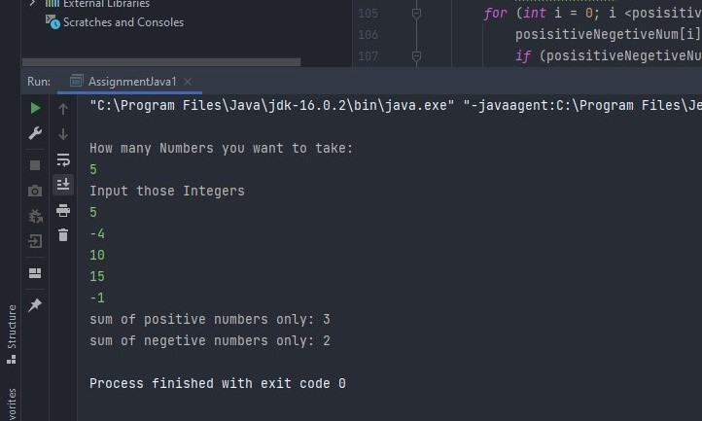

Q7 Write a java program that read 5 numbers and counts the number of positive numbers.

Code:

import java.util.Scanner;

public class AssignmentJava1 {

public static void main(String[] args) {

Scanner scan = new Scanner(System.in);

//Question 7:

System.out.println("\nHow many Numbers you want to take:");

int n= scan.nextInt();

System.out.println("Input those Integers ");

int[] posisitiveNegetiveNum2= new int[n];

int countpositive2= 0;

int sumposivite=0;

double avgOfPositive=0;

for (int i = 0; i <posisitiveNegetiveNum2.length; i++) {

posisitiveNegetiveNum2[i]= scan.nextInt();

if (posisitiveNegetiveNum2[i]>=0) {

countpositive2 += 1;

sumposivite+=posisitiveNegetiveNum2[i];

}

avgOfPositive= (sumposivite/countpositive2);

}

System.out.println("Average of sum of only positive Numbers: "+ avgOfPositive);

}

}

--------------------------------------------------------------------------------------------------------

Output of Q7:

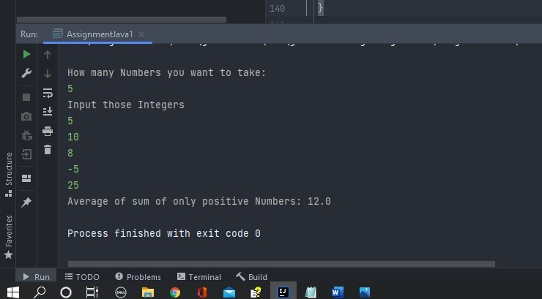

Q8 Write a java program that read 5 numbers and sum of all odd values between them. (same code as of question no 3 had)

Code

import java.util.Scanner;

public class AssignmentJava1 {

public static void main(String[] args) {

Scanner scan = new Scanner(System.in);

// Question 3:

System.out.println("\nhow many Numbers you want to take:");

int y= scan.nextInt();

System.out.println("Input those Integers ");

int[] integerNum = new int[y];

int sum = 0;

for (int i = 0; i <integerNum.length; i++) {

integerNum[i]= scan.nextInt();

if (integerNum[i] % 2 == 1) {

sum += integerNum[i];

}

}

System.out.println("sum of odd numbers only: "+sum);

}

}

---------------------------------------------------------------------------------------------------------

Output of Q8:

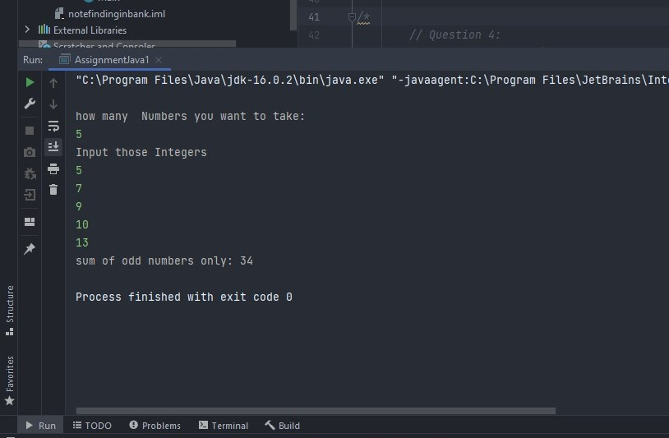

Q9 Write java program that converts Centigrade to Fahrenheit.

Code

import java.util.Scanner;

public class AssignmentJava1 {

public static void main(String[] args) {

Scanner scan = new Scanner(System.in);

//Question 9:

System.out.println("\nTake temp in Celsius:");

float cel = scan.nextFloat();

//formula given for refrence (fahrenheit=(9*Celsius+(32*5) )/5)

float fahr=(9*cel+(32*5f) )/5f;

System.out.println(" Convert Celsius in fahrenheit: "+ fahr);

}

}

--------------------------------------------------------------------------------------------------------------------------------------

Output of Q9

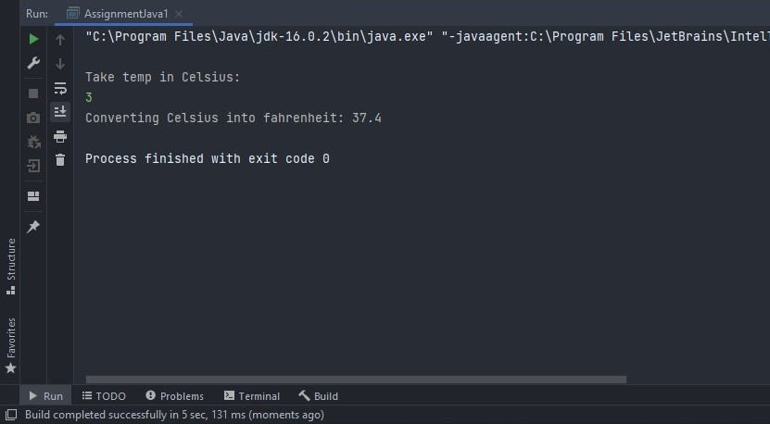

Q10 Write java program that converts Centigrade to Fahrenheit.

Code

import java.util.Scanner;

public class AssignmentJava1 {

public static void main(String[] args) {

Scanner scan = new Scanner(System.in);

// Question 10:

System.out.println("\nTake Kilometer per Hour:");

float kmph= scan.nextFloat();

// formula (miles per hour= km per hour * 0.6213712 )

float mileph= kmph*0.6213712f;

System.out.println("Converting kilometer per hour to miles per hour: "+mileph+" miles per hour");

}

}

--------------------------------------------------------------------------------------------------------------------------------------

Output of Q10

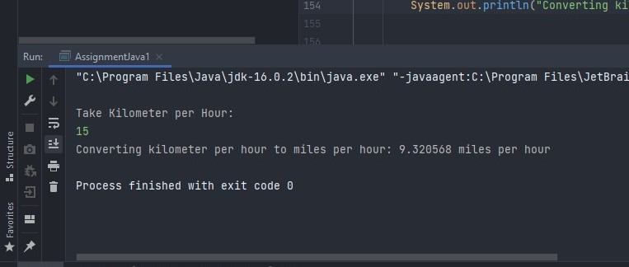

Q11 Write a java program to check two given integers, and print true if one of

them is 30 or if their sum is 30 else print false.

Code

import java.util.Scanner;

public class AssignmentJava1 {

public static void main(String[] args) {

Scanner scan = new Scanner(System.in);

//Question 11:

System.out.println("\nTake two integers:");

System.out.print("\nNumber one: ");

int number1= scan.nextInt();

System.out.print("\nNumber two: ");

int number2= scan.nextInt();

if(number1+number2==30 ||((number1==30 && number2==0) )){

System.out.println("True");

}

else {

System.out.println("False");

}

}

}

------------------------------------------------------------------------------------------------------------------------------------

Output of Q11 (a)

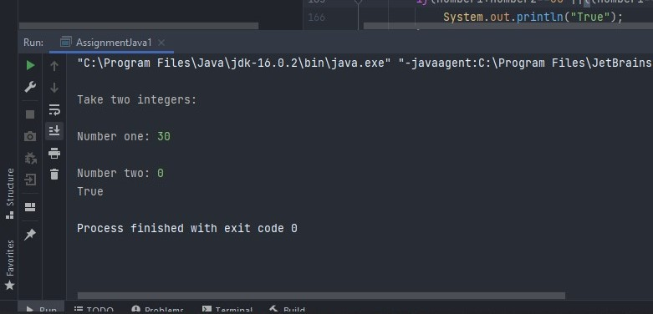

Output of Q11 (b)

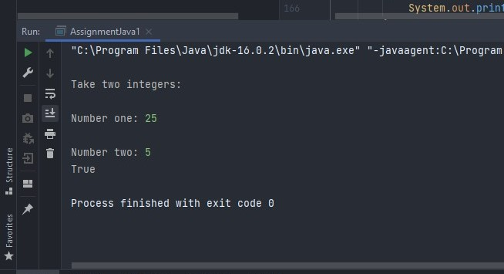

Output of Q11 (c)

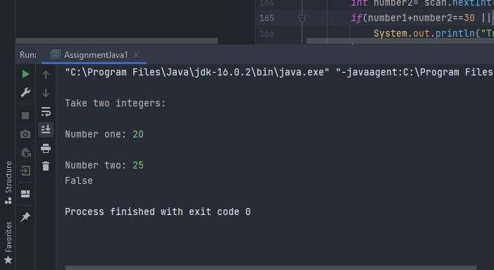

Q12 Write a java program that takes hours and minutes as input, and calculates the total number of minutes.

Code

import java.util.Scanner;

public class AssignmentJava1 {

public static void main(String[] args) {

Scanner scan = new Scanner(System.in);

// Question 12:

System.out.println("\nTake time in hour and min:");

System.out.print("Hours: ");

int timehour= scan.nextInt();

System.out.print("Minutes: ");

int timemin= scan.nextInt();

int totaltimeinmin=((timehour*60)+timemin);

System.out.println("Total time in minutes: "+totaltimeinmin +" min");

}

}

------------------------------------------------------------------------------------------------------------------------------------

Output of Q12

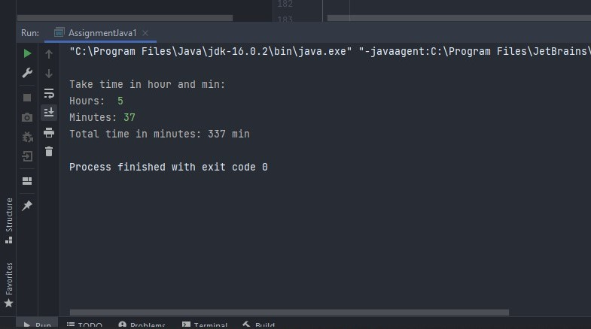

Q13 Write a java program to integral quotient and remainder of a division.

Code

import java.util.Scanner;

public class AssignmentJava1 {

public static void main(String[] args) {

Scanner scan = new Scanner(System.in);

// Question 13:

System.out.println("\nTake Numerator and Denominator to get quotient and remainder");

System.out.print("\nNumerator: ");

int numerator= scan.nextInt();

System.out.print("Denominator: ");

int denominator= scan.nextInt();

int quotient= numerator/denominator;

int remainder= numerator%denominator;

System.out.println("Quotient: "+ quotient+",");

System.out.println("Remainder: "+ remainder);

}

}

Output of Q13.

