**Miniproject: Brief Report**

**(ECE 4039- Motion and Geometry Based Methods in Computer Vision)**

Name: Shreya K.R

Registration Numbers: 140907759

**Title**: Child Safety Monitoring System

**Objective**: In the video used, a person is climbing on to certain objects and climbing down. This animated person represents a child in a real life situation. A yellow circle will track the person. The frame numbers, wherever the person climbs above a fixed vertical threshold, will be returned.

**Dataset** (video) used:

The video of the animated person climbing up onto and down from objects was downloaded from the **CMU Graphics Lab Motion Capture Database**. The video was found in sub-category Locomotion and was titled ‘Walk on uneven terrain.’ The rolling ball video used to initially test the mean shift tracker was downloaded from YouTube and cropped.

**Approach**:

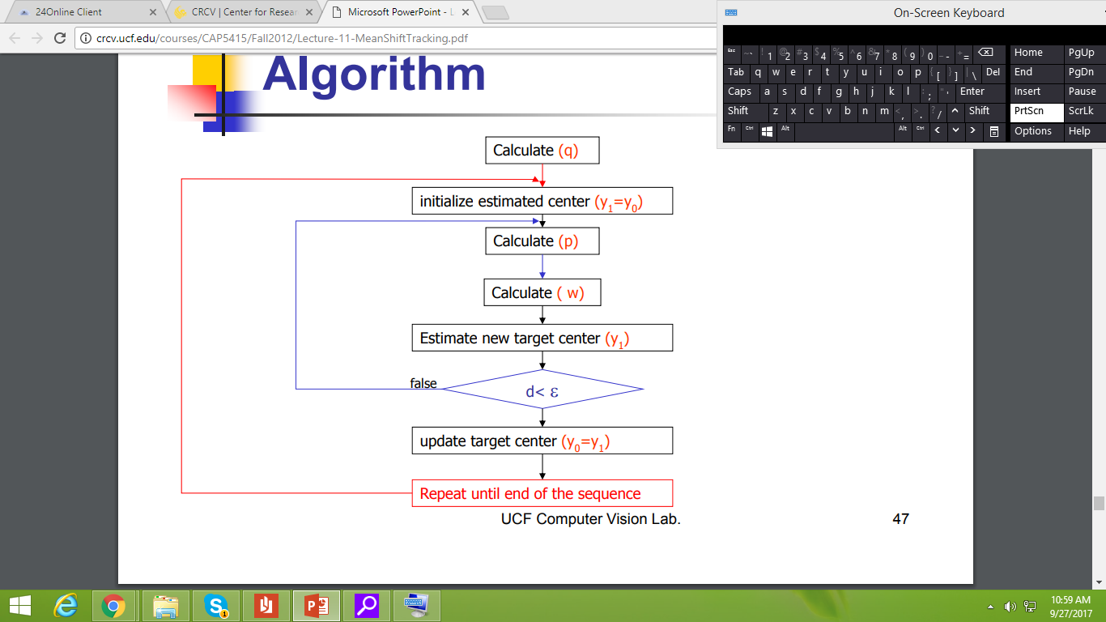

Fig: Mean Shift Tracking Algorithm

For each frame of the video

* **Q** is the pdf of an elliptical region, containing the object to be tracked, in the first frame.
* **P** is the pdf of consequent rectangular regions in the subsequent frames, which have to be matched with the original pdf **q** for tracking.
* **W** is the weight assigned to each pixel in a rectangular region, while calculating the weighted mean.
* The distance **d** is the inverse of the Bhattacharya coefficient between the pdf’s p and q. The lower the similarity, the higher the distance. The value of the Bhattacharya coefficient should be at least **0.9** for two regions to be considered a match.

**EQUATIONS USED and FUNCTIONS DEVELOPED:**

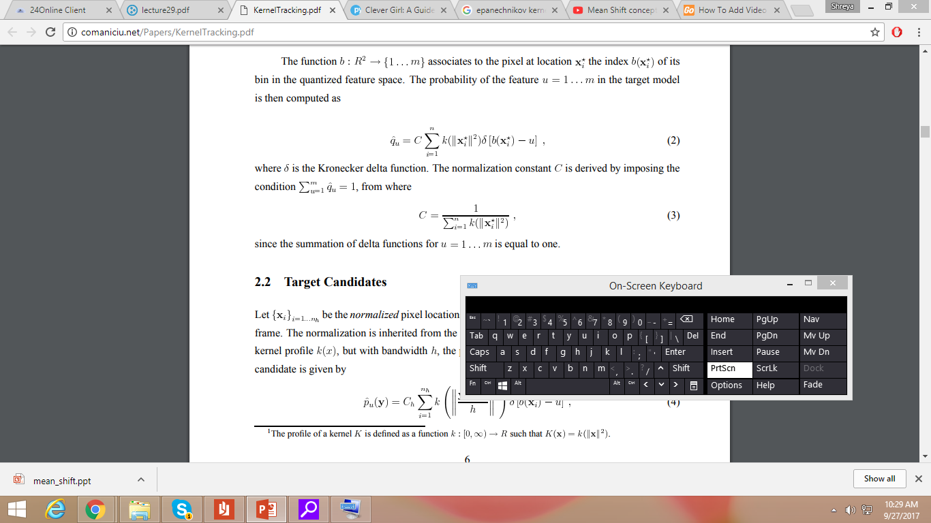

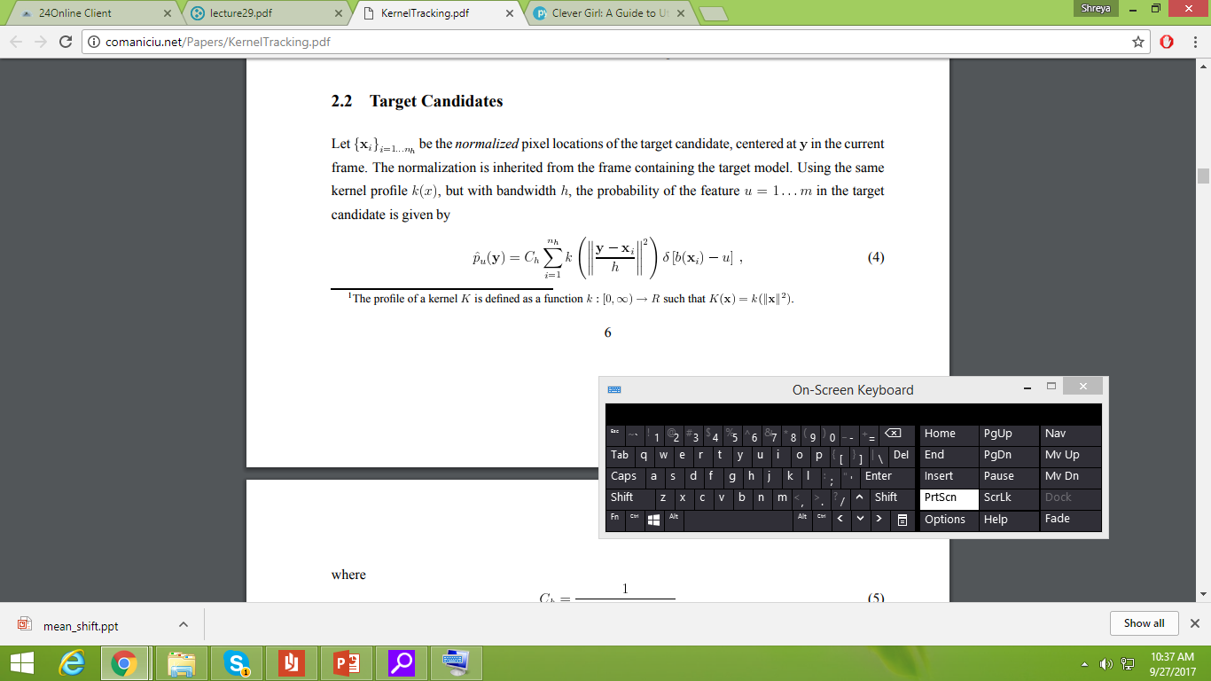

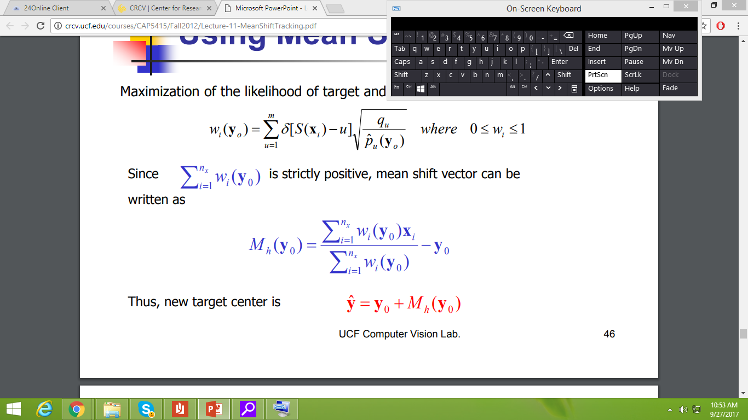

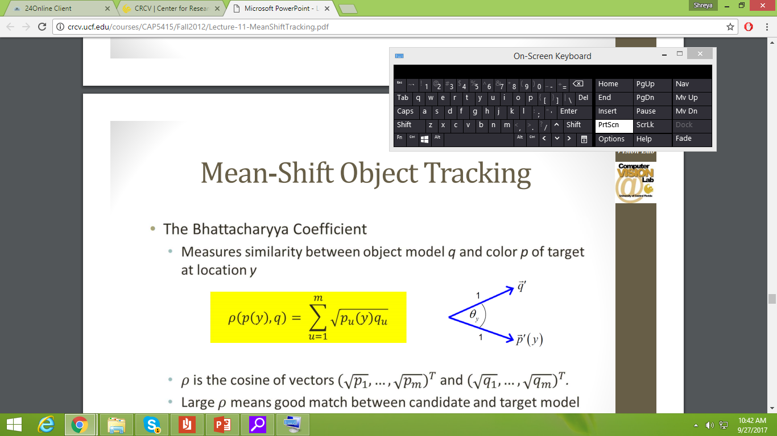





Finally **cv1.m** is the main function, and **trackingrect.m** function displays a circular tracking window around the object as it moves.

* 6. To find the new region center (performed by **meanshift.m** function)
* 4. To find the similarity between the pdf’s of two regions. Max value is 1. (Performed by **bcharya.m** function)
* 2. Equation to calculate object pdf in subsequent frames (by **quantpdf.m** function and **epkernel.m** function)
* 1. Equation to calculate object pdf in frame 1 (performed by **initial1.m** function, **quantpdf.m** function and **epkernel.m** function)
* 5. To find the mean shift vector (performed by **meanshift.m** function)
* 3. To find the weight corresponding to each pixel (performed by **meanshift.m** function)

**Output**:

The developed mean shift tracker was first tested with a simple animation of a ball rolling down a hill. The results to this can be viewed at: <https://www.youtube.com/watch?v=bPns5X9ef0M>

The mean shift tracker was then tried on a video of a person climbing onto higher surfaces and getting down again and again. This symbolizes a child climbing on to higher surfaces. The frame numbers every time the person crossed a set vertical threshold were returned.

The results for the video of the walk in irregular terrain can be viewed at: <https://www.youtube.com/watch?v=2yAoOCdNFE4>

The screenshots for tracking the rolling ball are as follows:

**Output**:

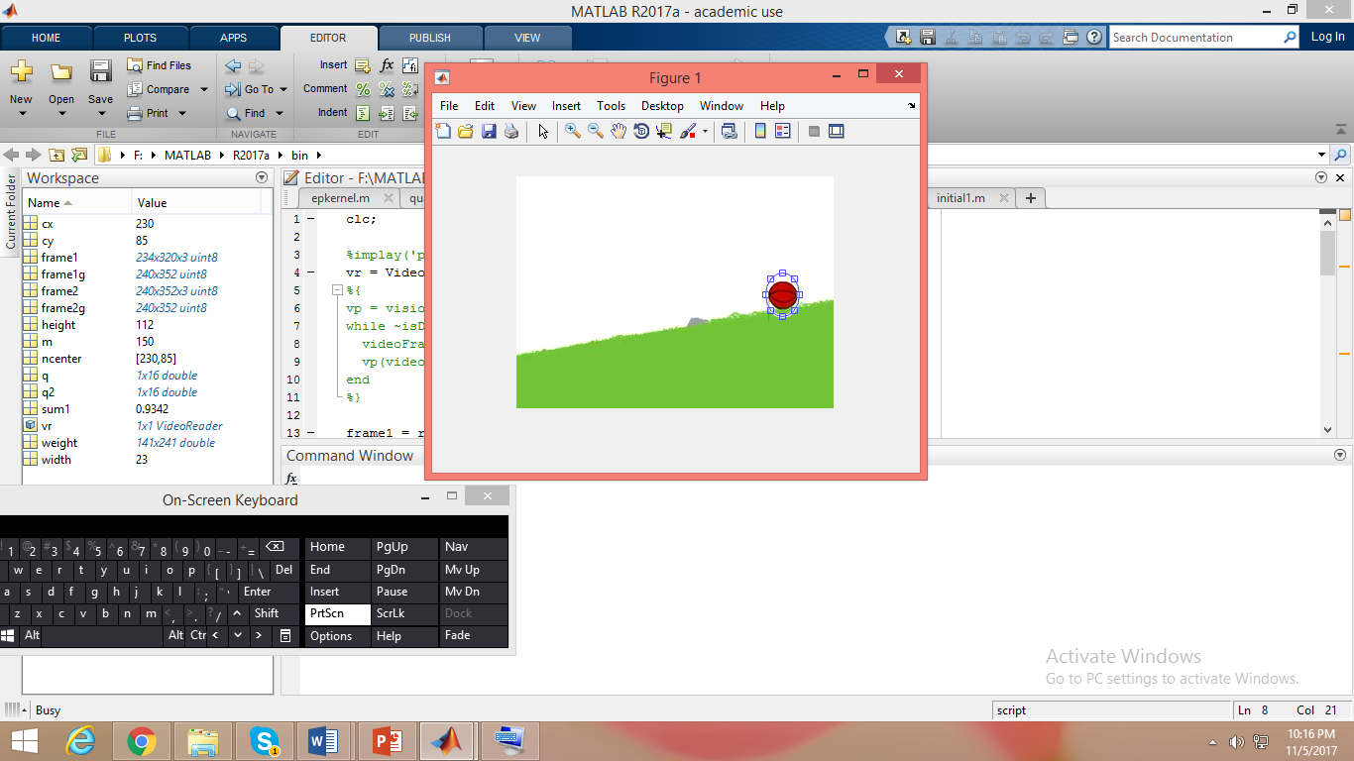 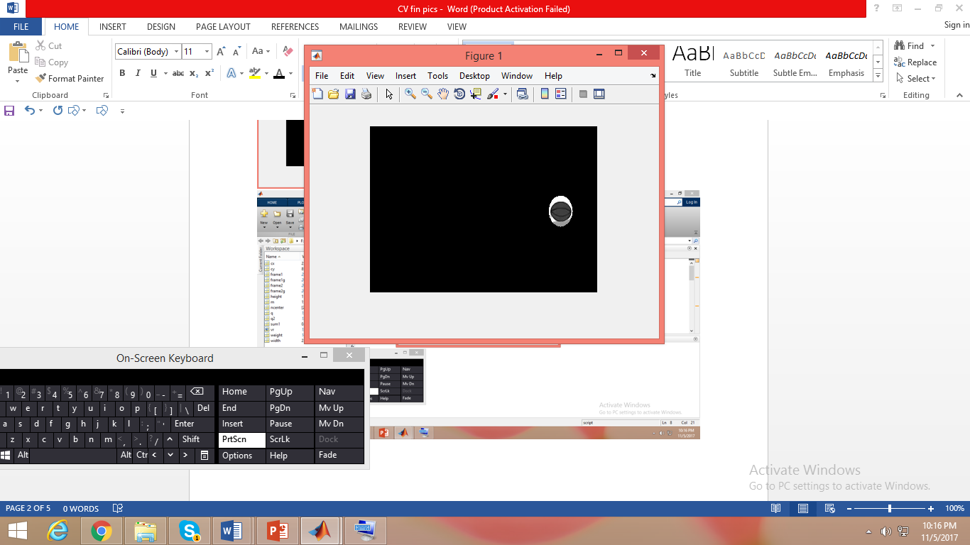

Initially, the user selects an elliptical region, with the ball in it. A mask is created to select the region of interest.

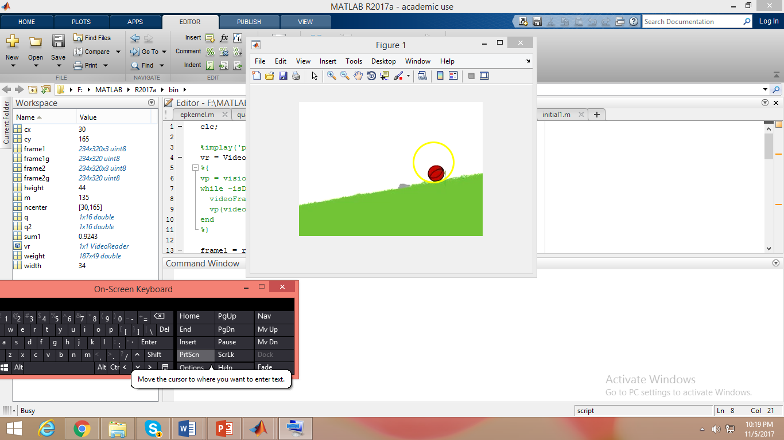 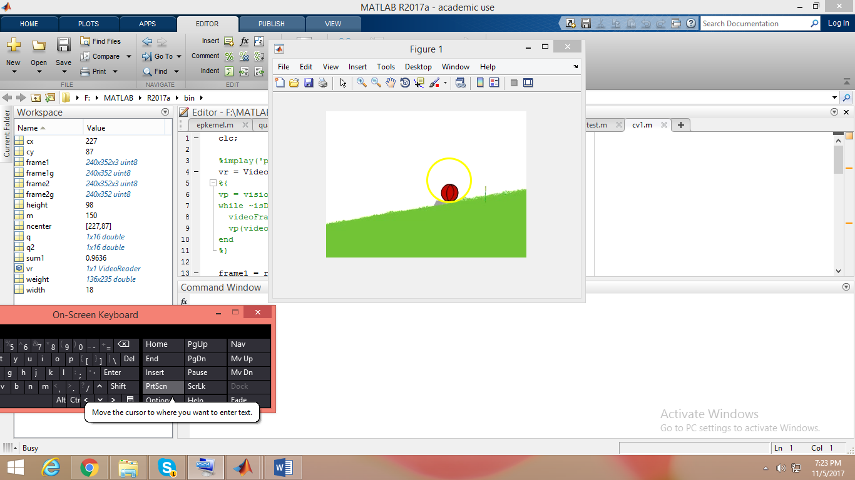

A yellow circle tracks the motion of the ball in the images, above and below sequentially.

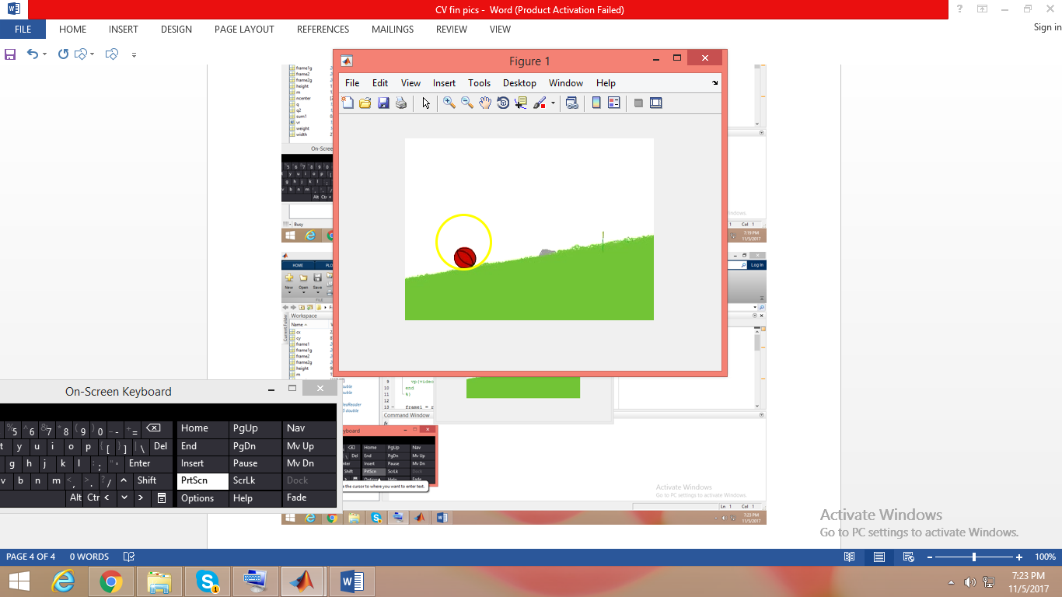 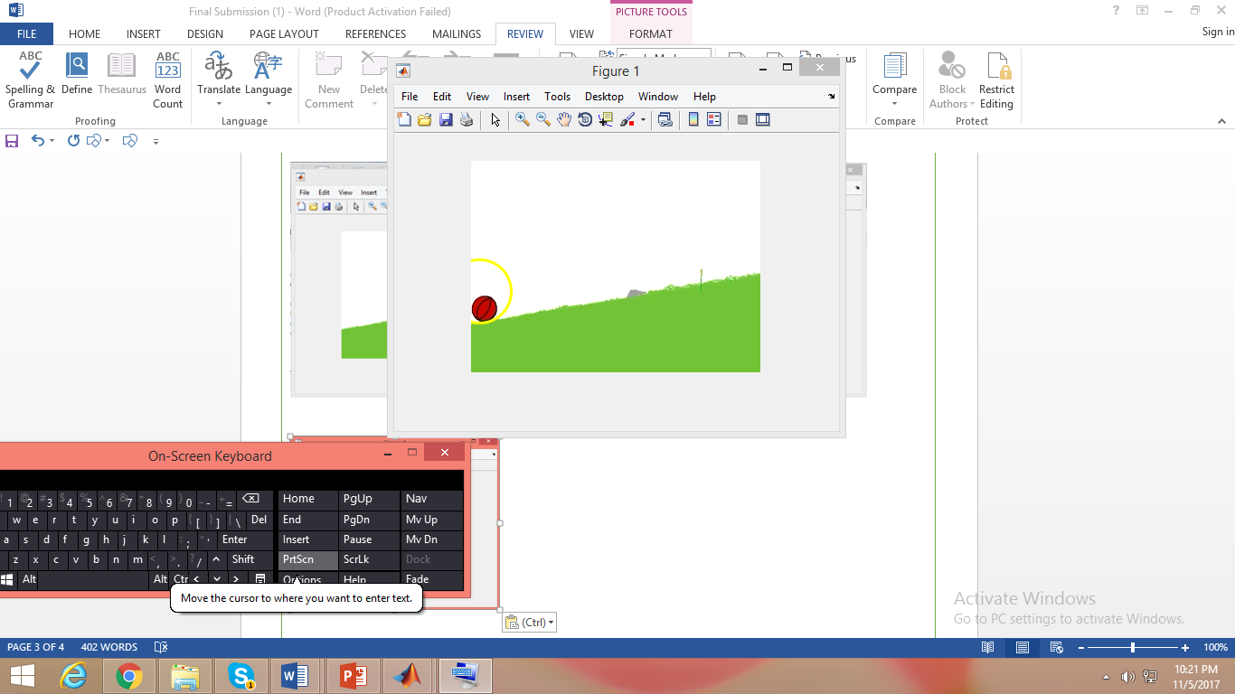

The screenshots for the results of the walk on the unregulated terrain are as follows:

**Output**:

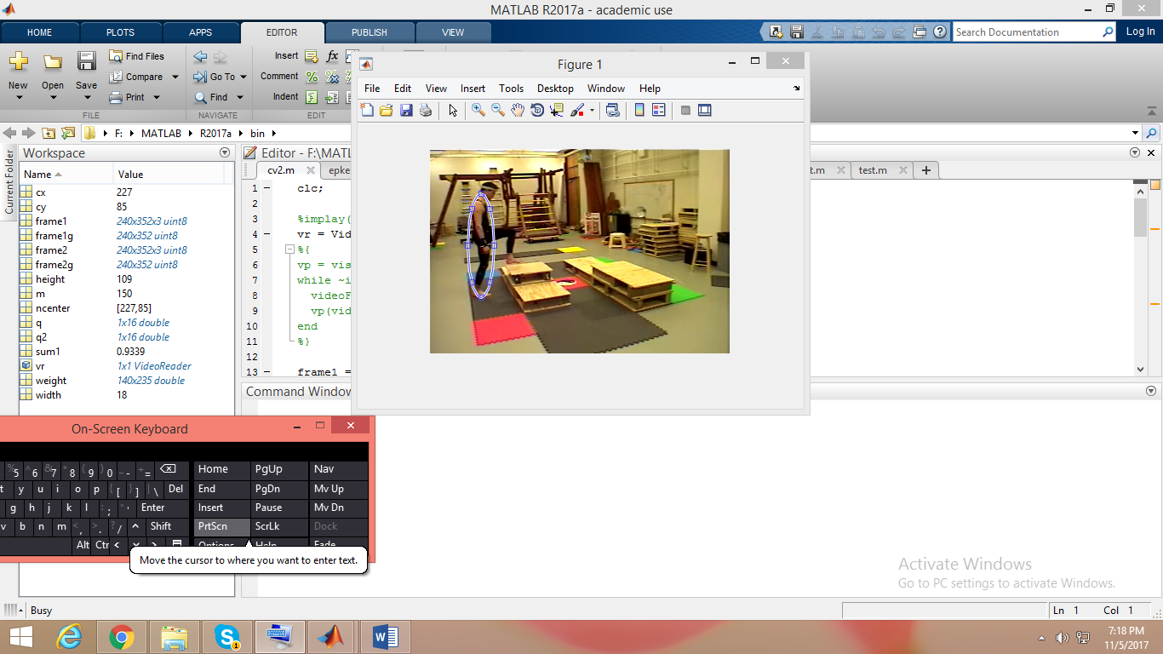 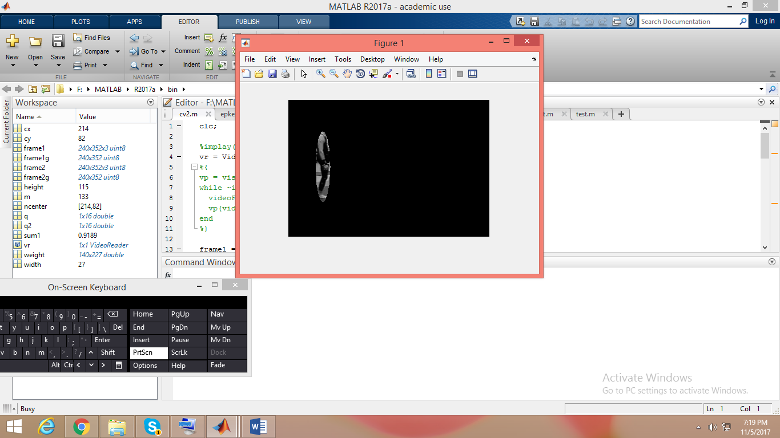

Initially, the user selects an elliptical region, with the person in it. A mask is created to select the region of interest.

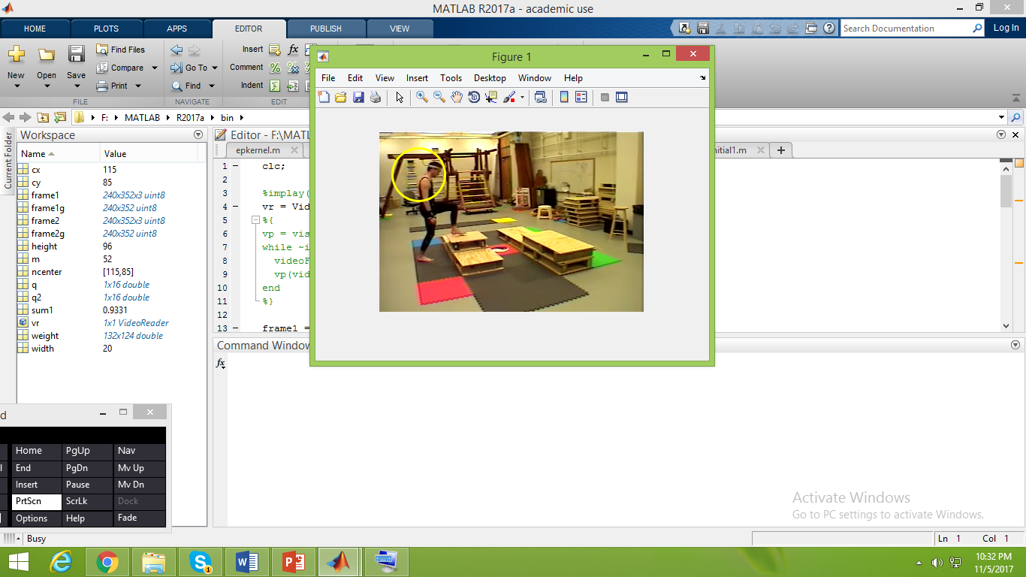 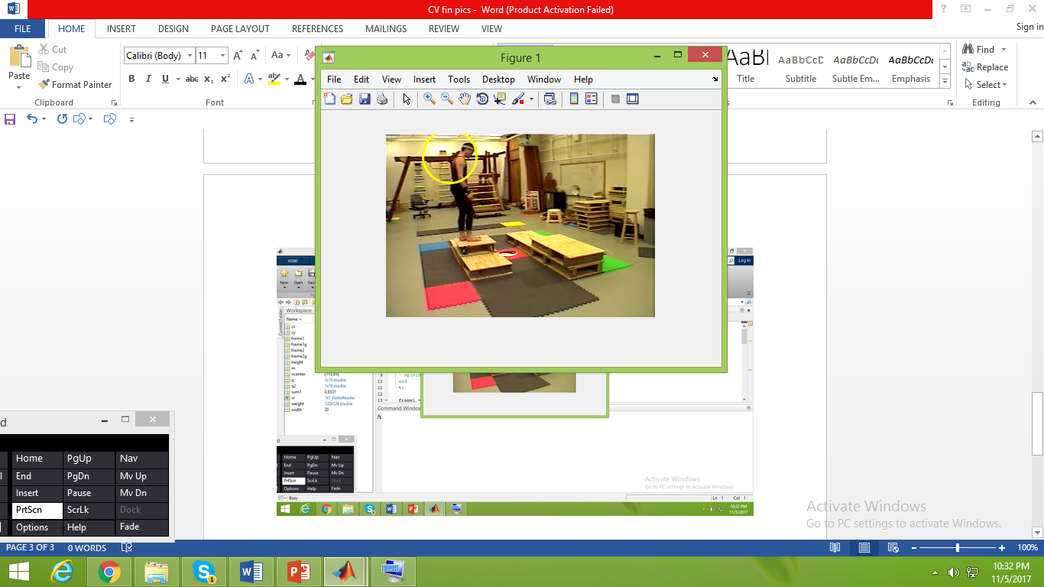

A yellow circle tracks the motion of the person in the images, above and below sequentially. The frame numbers corresponding to times when he crosses a physical threshold are returned. 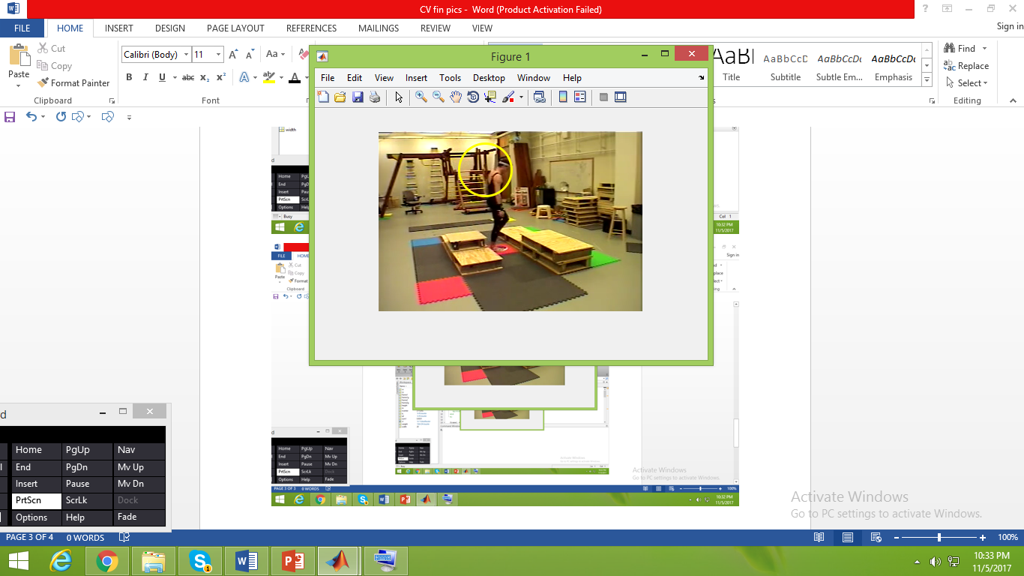 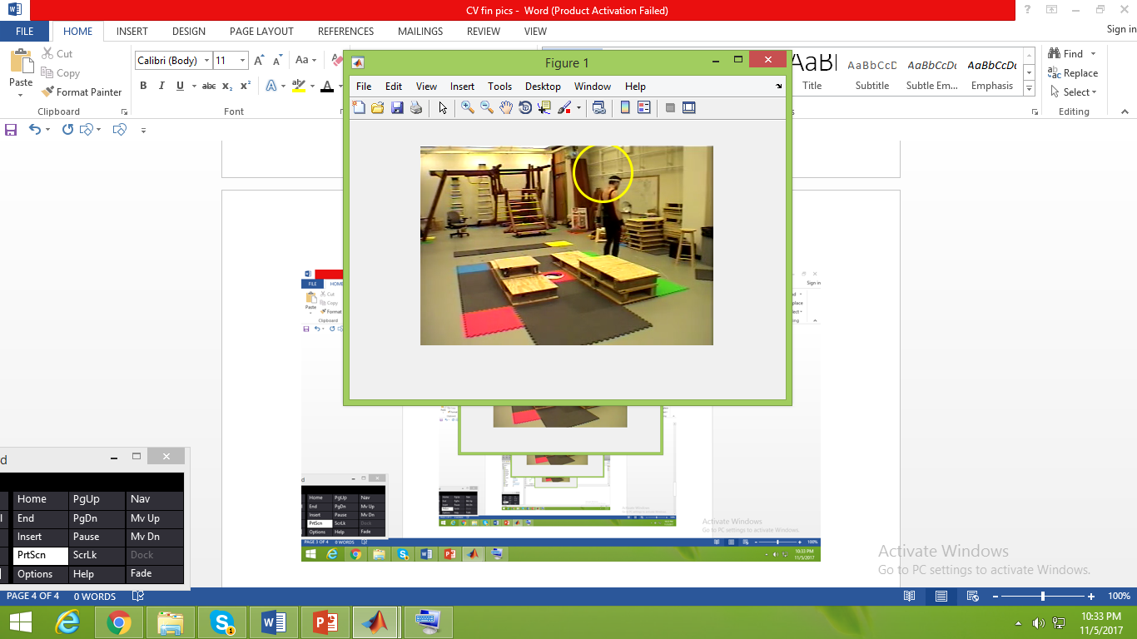

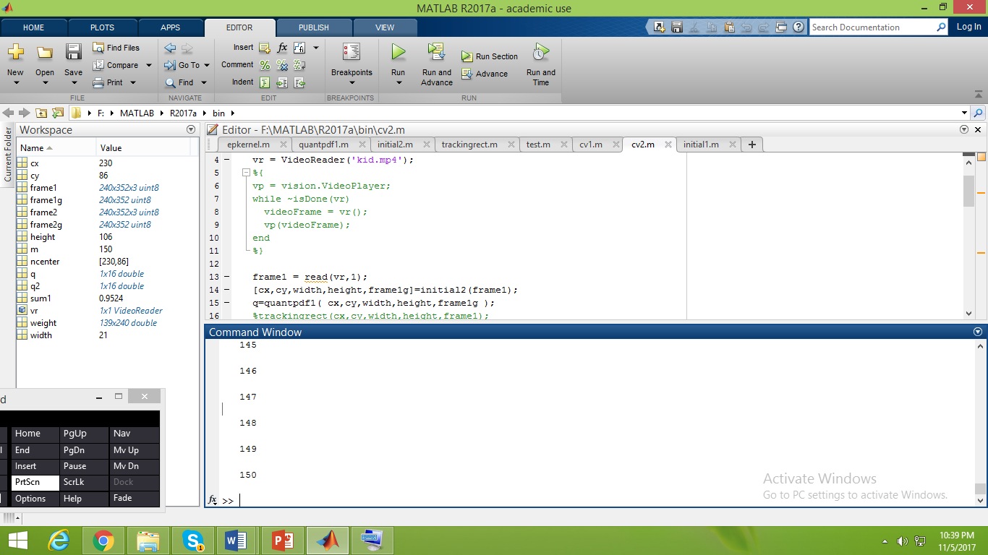

References:

[1] Comaniciu, Dorin, Visvanathan Ramesh, and Peter Meer. "Kernel-based object tracking." *IEEE Transactions on pattern analysis and machine intelligence* 25.5 (2003): 564-577.

[2] <http://crcv.ucf.edu/courses/CAP5415/Fall2012/Lecture-11-MeanShiftTracking.pdf>

[3] <http://efavdb.com/mean-shift/>