XML Assignment
1) Consider the following XML , By using a SAX approach display the count of books published in 1980’s.
<?xml version="1.0"?>
<bookstore>
<book pubyear="2000">
<title>Everyday Italian</title>
<author>Giada De Laurentiis</author>
<price>30.00</price>
</book>
<book pubyear="1988">
<title>Harry Potter</title>
<author>J K. Rowling</author>
<price>29.99</price>
</book>
<book pubyear="1985">
<title>XQuery Kick Start</title>
<author>James McGovern</author>
<author>Per Bothner</author>
<author>Kurt Cagle</author>
<author>James Linn</author>
<author>Vaidyanathan Nagarajan</author>
<price>49.99</price>
</book>
<book pubyear="1983">
<title>Learning XML</title>
<author>Erik T. Ray</author>
<price>39.95</price>
</book>
</bookstore>
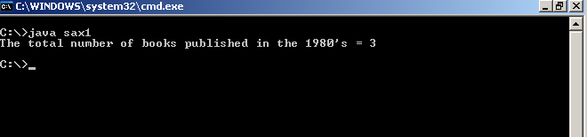

2) Consider following XML Document
<?xml version="1.0" encoding="utf-8"?>
<company name ="Applied Physics Laboratory" shortName ="JHU/APL" mission ="Enhancing national security">
<head name="Richard Roca" phone="410-778-1234"/>
<department name ="Air and Missile Defense" mission="Enhance the perational">
<group name="A1E" numStaff ="20"/>
<group name="A1F" numStaff="15"/>
<group name="A1G" numStaff="25"/>
</department>
<department name ="Research and Technology" mission="Assure that">
<group name="RSI" numStaff ="15"/>
<group name="RSS" numStaff="10"/>
</department>
</company>
By using Dom Approach display company details and department details along with total staff of each department.

OUTPUT :

