1.Arithmetic Operations Flowchart :-

1. Flowchart 0f Area of Square :-

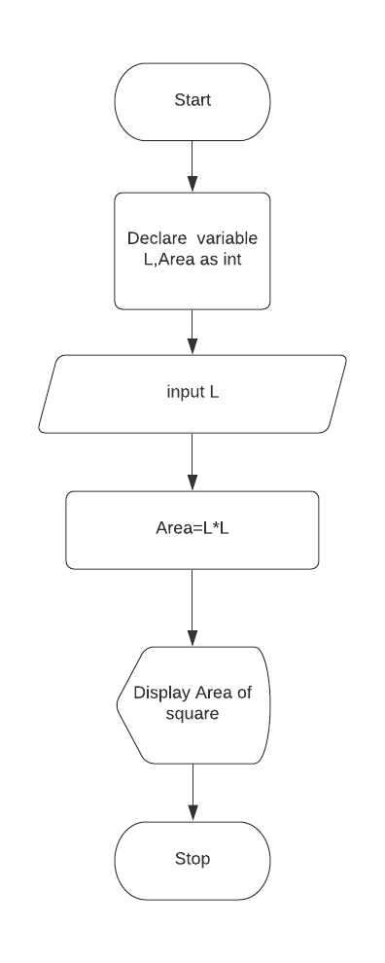

2.Flowchart of to simple intrest :-

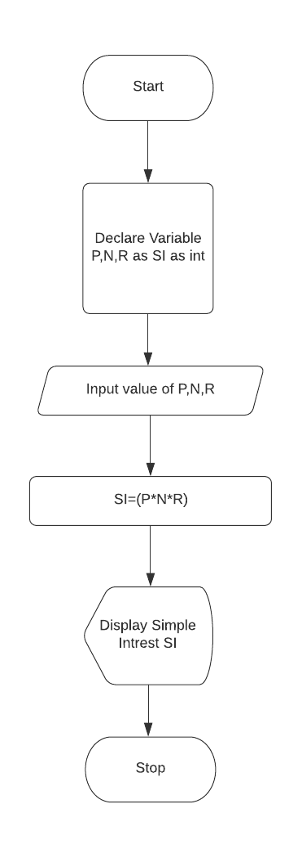

2.Looping Operations Flowchart :-

1.Flowchart to Display N numbers :-

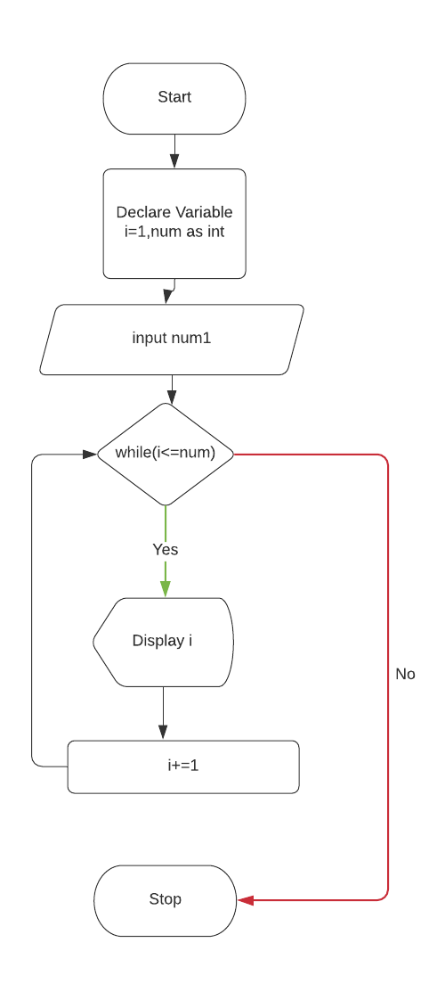

2.Flowchart of to display even numbers :-

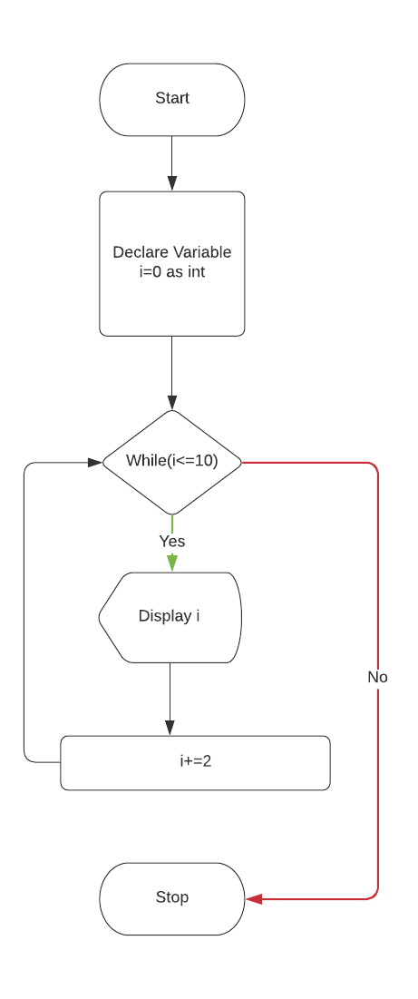

3. Decision Operations Flowchart :-

1. Flowchart of to find smallest number of two numbers :-

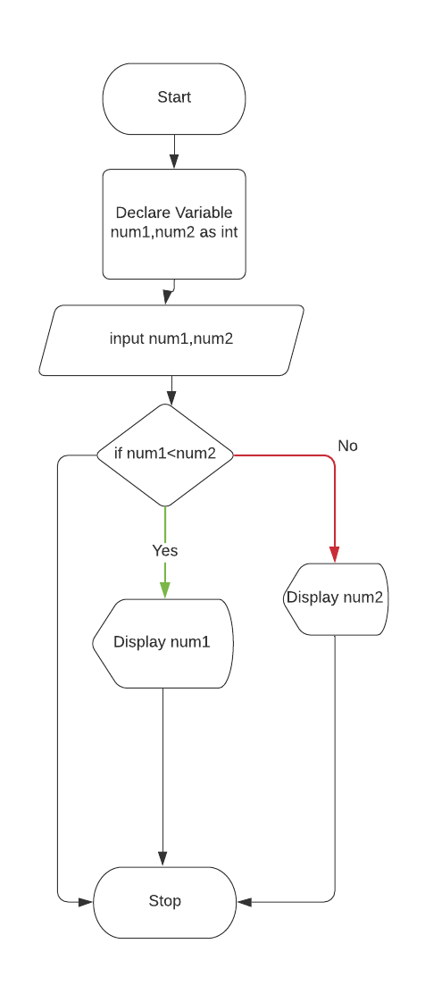

2. Flowchart of to find Positive or negative numbers :-

