TRACEX

***(Defining Crime Redefining Justice****)*

**1Seema Bhuravane, 2Shreya Lale, 3Tamanpreet Singh, 4Darshan Mahadik**

1Asst.Professor, 2 BE Student, 3 BE Student, 4 BE Student

1Information Technology,

1K.C. College of Engineering and Management Studies and Research, Thane, India

***Abstract:***  The paper presents a novel application aimed at enhancing the process of creating facial composite sketches for criminal identification. It addresses the inefficiencies and inaccuracies associated with existing methods such as hand-drawn sketches and limited-feature composite applications. The proposed application introduces several innovative features to overcome these limitations. Firstly, it allows users to upload hand-drawn individual facial features, which are then converted into the application's component set. Additionally, users can upload previous hand-drawn sketches for identification purposes, leveraging deep learning algorithms for improved accuracy. Furthermore, the application suggests relevant facial features based on user selections, thereby enhancing efficiency in composite creation. By offering a more realistic and user-friendly approach, this application has the potential to significantly improve law enforcement's ability to identify suspects.

***Keywords* -** ***Facial Composite Sketch, Criminal Identification, Hand-drawn, Deep Learning, Law Enforcement.***

*________________________________________________________________________________________________________*

1. **INTRODUCTION**

Facial composite sketching, traditionally reliant on eyewitness descriptions, faces challenges in today's rapidly evolving law enforcement landscape. The process of matching hand-drawn sketches against vast databases is both time-consuming and prone to inaccuracies. Prior efforts to modernize this process focused on digitizing hand-drawn sketches, yet fell short due to constrained facial feature libraries and unrealistic aesthetics. These limitations prompted the development of a novel application aimed at revolutionizing facial composite sketching for law enforcement.

This innovative tool surpasses traditional methods by offering customizable feature uploads. Users have the capability to directly choose the facial features, such as eyes, noses, and mouths, from the application. These user-generated elements are seamlessly integrated into the system's component library, expanding the range of available features beyond pre-defined sets. Furthermore, the application facilitates the integration of legacy sketches, allowing law enforcement to upload existing hand-drawn sketches. Leveraging powerful deep learning algorithms, the application analyzes these sketches and suggests potential matches within the database, thereby enhancing efficiency in suspect identification.

By amalgamating human expertise with state-of-the-art deep learning technology, this application presents a more realistic, user-friendly, and efficient approach to facial composite sketching. Such advancements empower law enforcement agencies to produce highly accurate suspect composites, ultimately facilitating faster identification and apprehension of criminals.

1. **LITERATURE SURVEY**

There are lot of studies on face sketch construction and recognition using various approaches. Dr. Charlie Frowd along with Yasmeen Bashir, Kamran Nawaz and Anna Petkovic designed a standalone application for constructing and identifying the facial composites, the initial system was found to be time consuming and confusing as the traditional method, later switching to a new approach in which the victim was given option of faces and was made to selected similar face resembling the suspect and at the end the system would combine all the selected face and try to predict automatically the criminal’s facial composite. The Results where promising and 10 out of 12 composite faces where named correctly out of which the results 21.3% when the witness was helped by the department person to construct the faces and 17.1% when the witness tried constructing faces by themselves.

Xiaoou Tang and Xiaogang Wang proposed a recognition method of photo-sketch synthesized using a Multiscale Markov Random Field Model the project could synthesis a give sketch into photo or a given photo in to sketch and then search the database for a relevant match for this the model divided the face sketch in to patches. In this they first synthesized the available photos in to sketch and then trained the model making the model to decrease the difference between photos and sketch this enhanced the overall efficiency of the recognition model. For testing this they took few samples in which the photos where synthesized in to sketch and the same faces where drawn from sketch artist and then the model was trained from 60% data and remaining 40% data for testing the model. The overall results where impressive but not up to the mark as expected.

Another proposed method was sketch to photo matching proposed by Anil K Jain and Brendan Klare which used SIFT Descriptor, the method proposed displayed result based on the measured SIFT Descriptor distance between the face photos in the database and the sketches. The algorithm first converts the face photos using linear transformation which was based on Tang and Wang proposed model and then the sketch was used to measure the SIFT descriptor distance compared to the face photo and in some cases distance between images in the databases too where measured for better accuracy. The experimental result shows that the dataset used where very similar to the those used by Tang in their experiment and the addition in the algorithm was the measurement of the descriptor which gave a better result and accuracy from the model proposed by Tang and Wang.

The common issue with all the proposed algorithm where that they compared the face sketches with human face which were usually front facing making it easier to be mapped both in drawn sketch and human face photograph, but when a photograph or sketch collected had their faces in different direction the algorithms were less likely to map it and match with a face from the database which is front facing.

There are even system been proposed for composite face construction but most system used facial features which where been taken from photographs and then been selected by the operator as per described by the witness and at last complied to form a single human face making it much more complicated for human as well as any algorithm to match it with a criminal face as every facial feature was been taken from the separate face photograph having various dissimilarity and when combined together made it harder to recognize.

Thus, all the previous approaches proved either inefficient or time consuming and complicated. Our application as mentioned above would not only overcome the limitations of the mentioned proposed techniques but would also fill in the gap between the traditional hand-drawn face sketch technique and new modernized composite face sketch technique by letting user to upload the hand-drawn face sketches and facial features.

1. **PROPOSED METHOD**

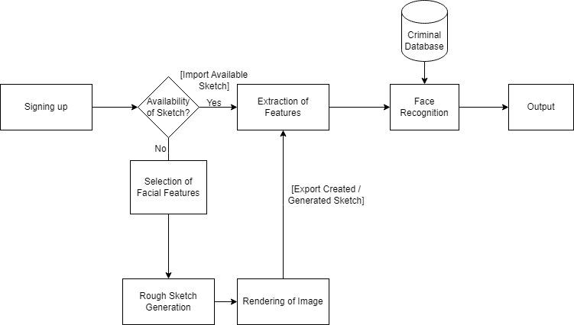

**Fig. 3.1 System Flow**

The above diagram represents the basic system flow of the application. It starts with a secure login requiring two-step verification. Then, users can either upload a hand-drawn sketch or create a new one using the drag-and-drop feature to build a composite sketch. Regardless of the method used, the image goes through a processing stage. Here, image processing and computer vision algorithms extract features from the image. Finally, the system compares these extracted features to a database of photographs and displays a similarity score between the sketch and potential matches.

The application prioritizes security by employing a two-step verification process during login. User credentials are verified, and the platform performs a check by retrieving the user's MAC address, IP address. This retrieved information is compared against data collected during installation to ensure authorized access. Any mismatch results in a console lock, preventing unauthorized users from accessing the platform.

TRACEX can be simplified into two major parts for understanding;

a) Construction

b) Recognition

1. **Construction**

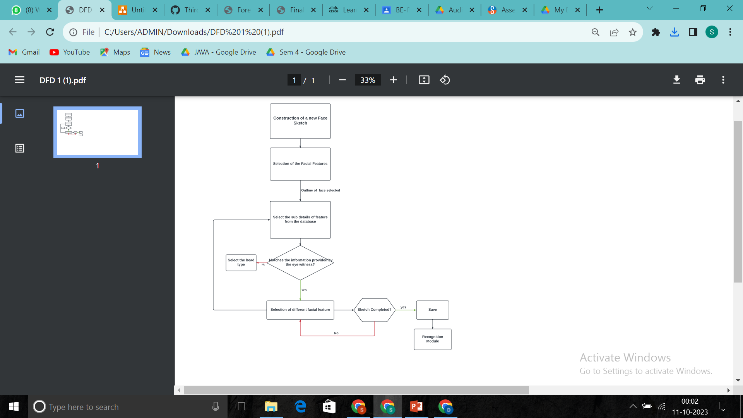

**Fig. 3.2 Flowchart for Sketch Construction**

Once logged in, users can create a facial sketch on a provided canvas. The canvas offers a variety of facial feature options for selection. Users can choose a specific facial feature category (eyes, nose, etc.) from a predefined set. Within the chosen category, drag-and-drop functionality allows users to select specific features (eye shape, nose size, etc.).

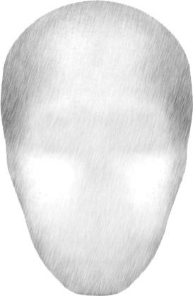 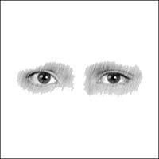 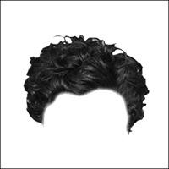

If a chosen feature doesn't match the witness's description, users can easily substitute it with another option. This process is repeated until all facial features are selected and positioned on the canvas to create a composite sketch of the suspect. The completed sketch can then be saved as a JPG image for sharing on social media or other platforms. The application offers an optional face prediction module to analyze the created sketch and suggest potential suspect matches.

1. **Recognition**

To ensure data security, the sketch is uploaded to a cloud platform for facial feature comparison This process assists in identifying suspects through facial recognition. First, upon uploading the sketch, the system analyzes it to pinpoint facial features. This extraction process, akin to learning, identifies and maps the characteristics within the sketch for comparison. Next, the extracted features are compared against a database of facial photographs from criminal records. Finally, if a match is found, the platform displays the matching photograph alongside the sketch. Additionally, it presents the similarity percentage between the two images and other relevant details about the person from the records.

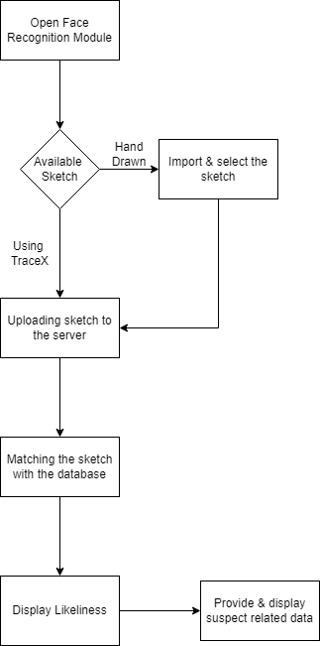

**Fig. 3.3 Flowchart for Sketch Recognition**

**Algorithm:**

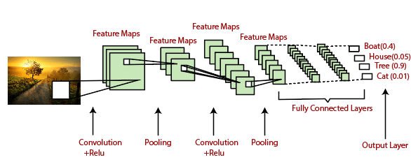

Convolutional Neural Networks (CNNs) are the workhorses behind face mapping and feature extractions in TRACEX. These deep learning algorithm act like expert image analysts.

Here's the List:

1. **Image Preprocessing:** Before diving in, the CNN gets the image prepped for analysis, like resizing it to a standard format.
2. **Feature Extraction:** The core magic happens here. The CNN, trained on a massive dataset of faces, analyzes the image layer by layer. At each layer, it extracts increasingly complex features, like the shape of eyes, nose, and overall face structure.
3. **Face Map Creation:** These extracted features become a unique "map" of the face, capturing its essence without directly copying the image pixels. This map emphasizes the key characteristics that distinguish one face from another.

CNNs excel at this task because they can automatically learn these features from vast amounts of data, eliminating the need for manual programming. This translates to high accuracy and robustness, even with variations in lighting, pose, and facial expressions.

1. **IMPLEMENTATION**



**Fig. 4.1 Login and Authentication**

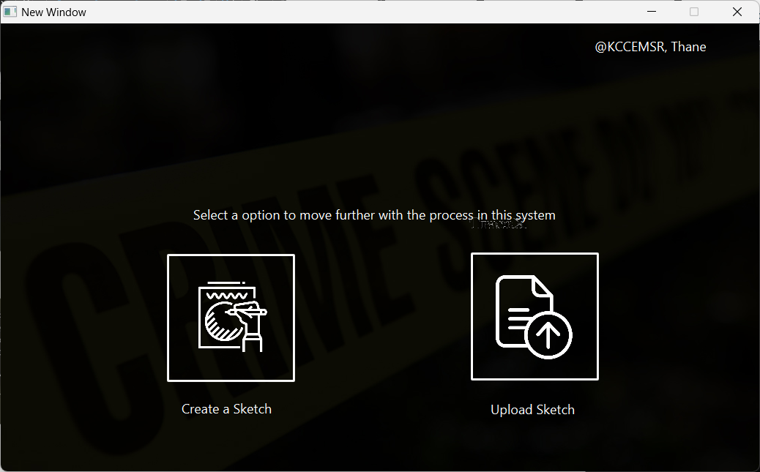

**Fig. 4.2 Home Page**

**Fig. 4.3 Canvas**

**Fig. 4.4 Upload Dashboard**

**Fig. 4.5 Upload Image**

**Fig. 4.6 Final Output**

1. **RESULT ANALYSIS**

| **TC**  **Sr. no** | **Description** | **Expected Output** | **Actual Output** | **Pass/Fail** |
| --- | --- | --- | --- | --- |
| **1.** | Login and Authentication | Successful login of the user and accurate authentication of the system should be processed. | The User logins using credentials successfully and authentication is done through the MAC address, IP address of the user’s system along with the key generated. | Pass |
| **2.** | User selects "Create Sketch" option | User interface displays a canvas with pre-defined facial feature categories (eyes, nose, mouth, etc.) on the side panel. | User interface displays a canvas with a blank face outline and categorized facial feature options on the side panel. | Pass |
| **3.** | User selects various facial features from the category and clicks on the canvas. | A selection of various eye shapes, Hair, Face cuts, Noses, etc. appears on the canvas for further selection. | User is able to construct the sketch of the suspect using various facial features available in the canvas. | Pass |
| **4.** | User uploads a completed composite sketch for suspect identification. | The application processes the sketch and displays search results with potential matching faces from a database. | After the construction of the sketch user saves the .png, .jpg file and then is further directed to the upload dashboard. | Pass |
| **5.** | User tries to upload an image which is external to TraceX. | The uploaded image should appear on the canvas. | The uploaded image appears on the canvas for viewing. | Pass |
| **6.** | The uploaded sketch has a high resemblance to a suspect in the database. | The application should display the matching suspect's face image with a high confidence score. | The application displays the matching suspect's face image with a high confidence score (e.g., 90%) along with the details of the suspect saved in the database. | Pass |
| **7.** | The uploaded sketch for suspect identification has low resolution or poor image quality. | The application should somehow try to give some resemblance to the provided image. | The application helps in the detection of the suspect whether the image is completed or partially completed despite of its quality. | Pass |
| **8.** | The application fails to identify any matches from the database. | The image which is been uploaded may not have any previous records in the application database. | The image does not have any previous records and gets saved for future enhancements. | Pass |

1. **CONCLUSION**

This research presents a significant advancement in the field of forensic sketch production and recognition. By combining deep learning algorithms, cloud infrastructure, and user-friendly interfaces, our solution addresses longstanding challenges in this area. The application leverages cutting-edge deep convolutional neural networks to enhance suspect identification accuracy and streamline sketch creation through a drag-and-drop interface. This practical technology prioritizes security, privacy, and backward compatibility, making it well-suited for real-world law enforcement applications. This research offers a powerful tool to accelerate and improve forensic investigations, bridging the gap between traditional sketch methods and modern criminal identification technology. The system's impressive accuracy of in identifying individuals from sketches further highlights its potential impact.

1. **FUTURE SCOPE**

The future of this project is promising due to its numerous avenues for growth. First, continued development of the deep learning models could lead to even higher suspect identification accuracy. Generative Adversarial Networks (GANs) could be implemented to enhance the realism of composite sketches by enabling sketch-to-photo synthesis. Expanding the system's reach and inclusivity can be achieved by incorporating a more diverse and extensive library of images and sketches representing various geographic locations and demographics. Furthermore, integrating live video feeds with real-time facial recognition technology could assist law enforcement in identifying suspects in dynamic situations. Collaboration between forensic artists and law enforcement organizations during real-world deployment and testing is crucial for refining the system's usability and ensuring it aligns with specific operational needs. Additionally, exploring applications in other fields such as border security and missing person searches unveils exciting possibilities for wider adoption. In conclusion, this project lays the foundation for a new era in forensic science, where cutting-edge technology and human expertise work together to expedite and strengthen the pursuit of justice.

# **REFERENCES**

[1] Durdona, Irgasheva, Islomov Shahboz, Davronova Lola, and Rustamova Sanobar. “Face Sketch Recognition Threat Model.” In 2020 International Conference on Information Science and Communications Technologies (ICISCT), pp. 1-3. IEEE, 2022.

[2] Bin Sheng, Ping Li, Chenhao Gao, Kwan-Liu Ma, "Deep Neural Representation Guided Face Sketch Synthesis", IEEE Trans. Vis. Comput. Graph., vol. 25, no. 12, pp. 3216-3230, Dec.2021

[3] N. Wang, X. Gao, and J. Li, “Random sampling for fast face sketch synthesis,” Pattern Recognit., vol. 76, pp. 215–227, 2020.

[4] S. S. Lin, C. C. Morace, C. H. Lin, L. F. Hsu, and T. Y. Lee, “Generation of escher arts with dual perception,” IEEE Trans. Vis. Comput. Graph., vol. 24, no. 2, pp. 1103–1113, Feb.2019

[5] Y. J. Huang, W. C. Lin, I. C. Yeh, and T. Y. Lee, “Geometric and textural blending for 3d model stylization,” IEEE Trans. Vis. Comput. Graph., vol. 24, no. 2, pp. 1114– 1126, Feb.2018.

[6] N. Wang, X. Gao, and J. Li, “Random sampling for fast face sketch synthesis,” Pattern Recognit., vol. 76, pp. 215–227, 2018.

[7] N. Wang, X. Gao, L. Sun, and J. Li, “Bayesian face sketch synthesis,” IEEE Trans. Image Process., vol. 26, no. 3, pp. 1264–1274, Mar.2017.