Assignment no.1

Name – Shreya Kunal Somwanshi
Roll no – 4
[prn no -12620030031]

HackBridge

Inter-College Hackathon Resource Network
A Distributed Database Management System (DDBMS) Project

1. Problem Statement
College students participating in hackathons often struggle to find teammates with complementary skills, especially when those teammates study at a different institution. Most existing platforms only search within a single college's own records, so a student looking for a "Machine Learning" partner has no way of discovering suitable candidates from other colleges. This project, HackBridge, addresses that gap by treating each participating college as an independent database node and using distributed database techniques to search, combine, and rank student data across all nodes at once, without ever merging the colleges' data into one central database.
The core challenge is to design a system that can query multiple physically separate MySQL databases, integrate the results transparently for the end user, and demonstrate the key principles of a Distributed Database Management System — namely fragmentation, distributed query processing, and data replication — while still remaining simple enough to build and evaluate as an academic project.

1.1 Objectives
- To design a distributed database architecture where each college maintains its own independent MySQL database.
- To allow students to register, list their skills, and search for teammates across all colleges through a single interface.
- To implement distributed queries that fetch and merge results from multiple database nodes.
- To demonstrate core DDBMS concepts: horizontal fragmentation, distributed joins, replication, and location transparency.
- To build a simple skill-matching feature that ranks candidates by compatibility.

1.2 Scope
The system covers three simulated college databases, each storing student, skill, team, hackathon, mentor, and project data. It supports student registration, team formation, cross-college search, and hackathon discovery. The project is limited to a local, simulated distributed environment (three MySQL instances on one machine via XAMPP) rather than a true geographically distributed deployment, which is a reasonable and common simplification for an academic DDBMS project.

2. Theory
A Distributed Database Management System (DDBMS) manages a database that is spread across multiple physical locations, while presenting it to the user as a single logical database. HackBridge simulates this by giving each college its own MySQL database and issuing queries that operate across all of them. The theoretical concepts demonstrated in this project are explained below.
Horizontal Fragmentation: Instead of storing all students in one large table, the student data is split row-wise by college. College A's students live in college_A_db, College B's in college_B_db, and so on. Each fragment holds the same table structure but a different subset of rows, which is the definition of horizontal fragmentation.
Distributed Query Processing: A single logical request from a user, such as "find all students who know Python," cannot be answered by one database alone. The system breaks the request into identical sub-queries, sends one to each college node, and merges the individual result sets into a single combined answer using UNION.
Distributed Join: Sometimes a query needs to combine data from more than one table, such as students, their skills, and their teams. Since all three tables for a given college live on the same node, the join happens locally on that node. The same join is then repeated on every other node, and the partial results are unioned together to produce a global answer.
Data Replication: Certain reference data, such as the master list of skills, is duplicated identically on every college node so that each node can process queries independently without depending on the others. This project verifies that replicated data stays consistent across nodes using a dedicated consistency-check query.
Location Transparency: A key benefit of a DDBMS is that end users do not need to know where the data physically resides. A student searching for "Python developers" simply gets a combined result; they are unaware that the answer was assembled from three separate databases behind the scenes.

3. ER Diagram
An ER Diagram (ERD) is a graphical representation of the data and relationships between different entities in a database. It is mainly used during database design to understand how data is organized before creating tables.

3.1 Main Components and Symbols

Component | Symbol | Meaning
Entity | ▭ Rectangle | Represents a real-world object or thing
Weak Entity | ▤ Double Rectangle | Entity that depends on another entity
Attribute | ◯ Oval | Describes an entity
Key Attribute | ⭕ Oval with underlined name | Uniquely identifies an entity
Multivalued Attribute | Double Oval | Attribute having multiple values
Derived Attribute | Dashed Oval | Attribute calculated from other attributes
Relationship | ◇ Diamond | Shows association between entities
Identifying Relationship | Double Diamond | Relationship involving a weak entity
Connection | Line | Connects entities, attributes and relationships
Cardinality | 1:1, 1:N, M:N | Shows number of entities participating in a relationship

3.2 Types of Attributes

1. Simple Attribute
An attribute that cannot be divided into smaller parts.
Example: Age, Gender, Salary
Symbol: Oval

2. Composite Attribute
An attribute that can be divided into smaller sub-attributes.
Example:
Name → First Name + Middle Name + Last Name
Address → City + State + PIN Code
Symbol: Main oval connected to smaller ovals.

3. Single-Valued Attribute
An attribute that has only one value for each entity.
Example:
Student has one Date of Birth.
Symbol: Single Oval

4. Multivalued Attribute
An attribute that can have more than one value for an entity.
Example:
A student can have multiple Phone Numbers.
Symbol: Double Oval

5. Derived Attribute
An attribute whose value is calculated from another attribute.
Example:
Age can be calculated from Date of Birth.
Symbol: Dashed Oval

6. Key Attribute
An attribute that uniquely identifies each entity.
Example:
Student_ID uniquely identifies a student.
Symbol: Oval with the attribute name underlined.

7. Null/Optional Attribute
An attribute that may not have a value for some entities.
Example: Middle Name, Apartment Number

The entity-relationship model below shows the core entities of HackBridge and how they relate to one another. Each college node replicates this same schema locally.

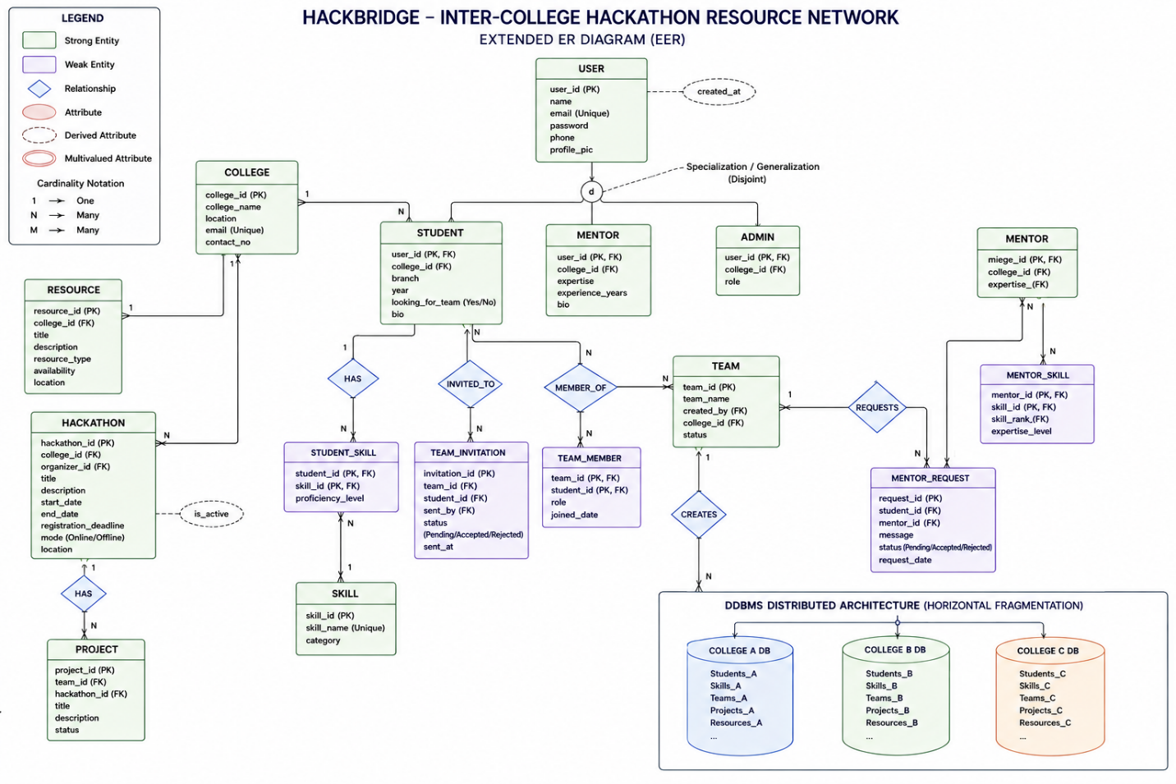

Fig 1: Simplified ER diagram of the HackBridge schema (repeated identically on each college's database node).

Key entities: College, Student, Skill, StudentSkill (junction table linking students to skills), Team, TeamMember (junction table linking students to teams), Hackathon, Project, Mentor, and Resource. This same schema is created inside college_A_db, college_B_db, and college_C_db to realize the horizontal fragmentation described above.

4. Conclusion
The HackBridge project demonstrates how a distributed database management system can support real-world, cross-institutional applications rather than treating a database as one large monolithic store. By splitting student data horizontally across three independent MySQL instances representing different colleges, and by using UNION-based distributed queries and joins to unify the results, the project successfully replicates the core mechanics of a DDBMS: fragmentation, distributed query execution, distributed joins, replication, and location transparency.
While the current implementation uses simple SQL-based scoring in place of true AI-based matching, it lays a practical foundation that could be extended with more advanced ranking algorithms in the future. Overall, the project shows that even with a relatively simple technology stack — PHP, MySQL, HTML, CSS, and JavaScript — it is possible to build a functional distributed system that solves a genuine problem: helping students collaborate on hackathon teams beyond the boundaries of their own institution

