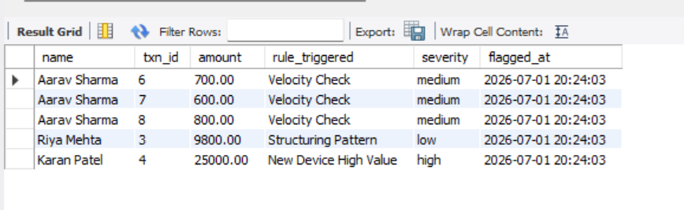
Flagged Transactions
What you see | What it means
Aarav Sharma, txn 6/7/8, Velocity Check | Aarav made 4+ transactions within 10 minutes, so the system flagged it as suspicious rapid activity
Riya Mehta, ₹9800, Structuring Pattern | Riya's transaction is suspiciously close to ₹10,000 — a classic trick to avoid reporting thresholds
Karan Patel, ₹25,000, New Device High Value | Karan made a big transaction from a brand new device that had never been used before — high risk
Notice txn_id 1 and 2 (Aarav's normal ₹1500 and ₹45000) are not here — the amount anomaly rule didn't fire because once you have many transactions, the average also rises and the 5x threshold wasn't crossed. That's actually realistic behaviour.

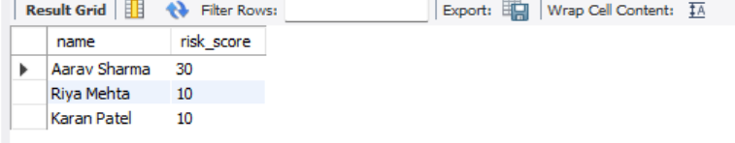
Risk Score Leaderboard
- Aarav: 30 → got flagged 3 times (3 velocity flags × 10 points each)
- Riya: 10 → flagged once (structuring pattern)
- Karan: 10 → flagged once (new device)
This risk score updates automatically every time a transaction is flagged — your trigger + stored procedure is doing that in real time.

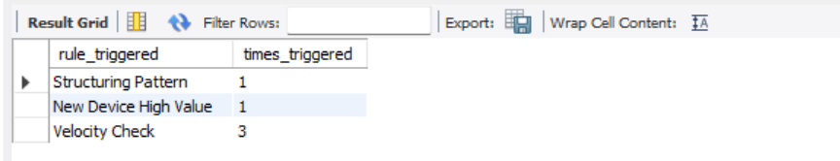
Rule Frequency
Rule | Count | Meaning
Structuring Pattern | 1 | Caught once (Riya's ₹9800)
New Device High Value | 1 | Caught once (Karan's new laptop)
Velocity Check | 3 | Fired 3 times (Aarav's rapid transactions)
This query is useful to show which rules are most active — in a real fraud system, this tells you which heuristics are doing the most work.

