DBMS PROJECT REPORT
Open-Ended Assignment
SHRUTU
Insider Threat Monitoring System
A real-time web application using Flask, MySQL 8 and Socket.IO
Course / Subject: Database Management Systems (DBMS) Project
Submitted by: Shreya Marde
Roll Number: [enter roll number]
Institution / Department: [enter institution / department]
Guide / Instructor: [enter guide / instructor]
Date of submission: 29 September 2026
Live application: https://shrutu-insider-threat.onrender.com
Source code: github.com/shreyamarde/insider-threat-monitor (private)

Abstract
Insider threats — employees or other trusted users who misuse their legitimate access — are among the hardest security problems for an organisation to detect, because the actions look like normal work. This project, SHRUTU (Insider Threat Monitoring System), is a working web application that records every meaningful action of every employee in a relational database, scores each action with an explainable rule-based risk engine, and pushes real-time alerts to a security manager's dashboard the moment suspicious behaviour is detected, without the manager refreshing the page.
The system is built as a three-tier web application: an HTML5/CSS3/JavaScript front end (with Chart.js charts and a Socket.IO client), a Python 3 / Flask 3 application tier (Flask-SQLAlchemy, Flask-Login, Flask-WTF and Flask-SocketIO), and a MySQL 8 database of nine normalised tables (users, departments, records, activity_logs, alerts, risk_scores, risk_events, login_attempts and risk_rules) connected by thirteen foreign keys. Activity insertion, risk-score update, explanation records and alert creation happen inside a single ACID transaction. The application provides role-based access for employees and managers, employee account management, thirteen configurable detection rules (failed logins, off-hours access, confidential and restricted record access, mass data export, privilege escalation and more), alert acknowledgement and resolution with a complete audit trail, charts and search/filter reports. It is covered by 52 automated tests (all passing) and is deployed publicly on Render with a managed MySQL database on Aiven. The expected outcome — verified end to end — is that a suspicious employee action is stored, explained and shown as an alert on the manager's screen within about one second.
Keywords: insider threat, DBMS, MySQL, relational schema, normalisation, transactions, Flask, Socket.IO, risk scoring, role-based access control, audit trail

Table of Contents
Abstract 1
Table of Contents 2
1. Introduction 4
1.1 Background and motivation 4
1.2 Problem statement 4
1.3 Objectives 5
1.4 Scope 5
1.5 Limitations 5
2. System Analysis 7
2.1 Existing system and its drawbacks 7
2.2 Proposed system and improvements 7
2.3 Feasibility study 8
2.4 Requirements specification 9
2.5 Use-case model 10
3. System Design 12
3.1 Architecture 12
3.2 Data Flow Diagrams 13
3.3 Entity–Relationship design 17
3.4 Schema design 19
3.5 Normalisation 24
3.6 Risk engine design 25
3.7 Real-time notification design 26
3.8 Security design 28
4. Implementation 29
4.1 Technologies used 29
4.2 Project structure 29
4.3 Key modules — coding snapshots 30
4.4 Database creation 34
4.5 Sample queries executed from the front end 39
4.6 Deployment 44
5. Testing 45
5.1 Unit testing 45
5.2 Integration testing 46
5.3 System testing (end-to-end) 47
5.4 Security and validation checks 47
5.5 Automated test run 48
6. Results and Snapshots 49
6.1 Web application screenshots 49
6.2 Sample queries and outputs from the DBMS 66
7. Conclusion 71
7.1 Summary of achievements 71
7.2 Benefits 71
7.3 Limitations 71
8. Future Enhancements 72
9. Bibliography / References 73
10. Appendix 74
Appendix A — Complete database creation script (schema.sql) 74
Appendix B — Source code of key modules 77
Appendix C — User manual 95
Appendix D — REST API endpoints 96

1. Introduction

1.1 Background and motivation
Most security tools look outwards — firewalls, antivirus and intrusion detection systems try to keep attackers out. An insider, however, already has a valid account, a password and permission to use the company's applications. When an insider copies payroll data before leaving, browses restricted board documents, or probes pages meant only for administrators, conventional perimeter defences see nothing unusual. Industry surveys consistently report that a large share of data breaches involve insiders, whether malicious, careless or using stolen credentials.
The only reliable way to detect such behaviour is to record what users actually do inside applications and analyse it: who accessed which record, when, from where, how often, and whether that is normal for them. This is fundamentally a database problem — the activity must be captured reliably, stored in a well-designed schema, queried efficiently over time windows, and linked to users, alerts and explanations. That makes insider-threat monitoring an ideal open-ended DBMS project: it exercises schema design, keys and constraints, normalisation, joins and aggregates, transactions and concurrency, and shows how a database sits at the centre of a real application.
The project started from a small prototype (a Flask login page and a static dashboard template). It has been redesigned and rebuilt into a complete system named SHRUTU, with a proper MySQL schema, an employee portal, a manager console, a risk engine and real-time notifications.

1.2 Problem statement
Organisations need a system that automatically answers the question "Is any employee misusing their access right now — and why do we think so?" Specifically, the problems to solve are:
- Employee actions inside business applications are not recorded centrally, so misuse is discovered late or never.
- Where logs exist, they are raw text that a manager must read manually; there is no scoring, prioritisation or alerting.
- Black-box risk scores are not trusted — a manager must be able to see exactly which actions increased an employee's risk and by how much.
- Managers find out about incidents only when they refresh a report; there is no real-time notification.
- The monitoring system itself must be accountable: managers' own actions (creating accounts, resetting passwords, closing alerts) must be audited.
- Access control must be enforced on the server, so that an employee cannot reach manager pages or other departments' data by typing a URL.

1.3 Objectives
- Design a normalised relational database (MySQL 8) for users, business records, activity logs, login attempts, alerts, risk scores, risk explanations and configurable rules, with primary keys, foreign keys, unique constraints and indexes.
- Build a secure web application with two roles — employee and manager — and server-side role-based access control.
- Log every meaningful action automatically through one central function, capturing time, IP address, user agent, status and resource.
- Implement an explainable, configurable rule-based risk engine with scores capped at 100 and four levels (LOW, MEDIUM, HIGH, CRITICAL).
- Generate alerts for suspicious behaviour and deliver them to managers in real time using WebSockets (Socket.IO).
- Provide manager tools: employee management, live activity feed, alert acknowledgement/resolution, risk overview, audit logs, charts, search and filters.
- Keep the database consistent by performing activity, score, explanation and alert writes inside a single transaction.
- Verify the system with automated unit, integration and system tests, and deploy it publicly.

1.4 Scope
The system covers the complete monitoring life-cycle for one organisation: account management, authentication, day-to-day record work by employees, automatic activity logging, risk evaluation, alerting, real-time notification, investigation and audit. The business data used to generate realistic activity is a set of company records (reports, invoices, contracts, personnel files, technical documents) classified as PUBLIC, INTERNAL, CONFIDENTIAL or RESTRICTED and owned by six departments. The application runs in any modern browser, including on mobile, and is deployed on the internet.

1.5 Limitations
- Monitoring is limited to actions performed inside this application; e-mail, USB devices, file servers and other systems are not monitored.
- The risk engine is rule-based. It is explainable and predictable, but it does not learn each employee's behaviour automatically (a machine-learning model is listed as future work).
- "New location" detection compares IP addresses only; it does not use geo-location.
- The free hosting tier sleeps after 15 minutes without visitors, so the first request afterwards takes about a minute.
- Socket.IO rooms are kept in the memory of one server process, so the deployment runs a single worker; scaling to several servers would need a message queue such as Redis.

2. System Analysis

2.1 Existing system and its drawbacks
Two "existing systems" were studied: the typical manual practice in small and medium organisations, and the project's own initial prototype.

2.1.1 Manual / conventional practice
In many organisations application access is either not logged at all or written to plain server log files. Reviewing them is a manual, after-the-fact activity, usually done only after an incident has already been reported. Commercial User and Entity Behaviour Analytics (UEBA) and SIEM products solve this, but they are expensive, complex to deploy and far beyond the needs and budget of a small organisation or an educational setting.

2.1.2 Initial prototype
The project began as a Flask prototype with a login page for administrators and a dashboard template. Analysis of that code showed:
Table 2.1: Drawbacks of the initial prototype
Area | Drawback found in the prototype
Functionality | Only admin login worked. The dashboard expected employees, alerts and device counts but the route never queried the database, so every number was always 0.
Monitoring | No activity logging, no risk calculation, no alerts — the core purpose was not implemented.
Roles | No employee interface; the employee page referenced a route (/submit_activity) that did not exist.
Security | Flask secret key and MySQL root password hard-coded in source code; debug mode on; no CSRF protection; role stored but never checked.
Deployment | Static files placed in the wrong folder (CSS would not load); empty requirements.txt; no database schema script; no version control.
Real time | None — data could only be seen by refreshing a page.

2.2 Proposed system and improvements
SHRUTU replaces manual log review with an automated pipeline: every action → database → rule engine → alert → real-time notification. The main improvements are summarised below.
Table 2.2: Comparison of existing and proposed system
Aspect | Existing situation | Proposed system (SHRUTU)
Activity capture | Not recorded / raw text logs | Every action stored in activity_logs with time, IP, user agent, resource, status and risk
Detection | Manual reading of logs | 13 configurable rules evaluated automatically on every action
Explainability | None | risk_events table stores the points, rule and reason for every score change
Alerting | After-the-fact reports | Alerts inserted in the same transaction and pushed to managers over WebSocket within ~1 s
Access control | Role not enforced | Server-side RBAC decorators; unauthorised attempts are blocked (403) and themselves raise alerts
Accountability | No audit of administrators | Every manager action (create, disable, reset, acknowledge, resolve, rule change) is audited
Data integrity | No schema script | Normalised MySQL schema with 13 foreign keys, unique constraints, indexes and transactions
Cost | Commercial UEBA/SIEM is expensive | Built entirely with free, open-source tools; hosted on free tiers

2.3 Feasibility study

2.3.1 Technical feasibility
All required technologies are mature, free and well documented: Python 3 and Flask for the web tier, SQLAlchemy as the ORM, MySQL 8 (InnoDB) for transactional storage with foreign keys, Flask-SocketIO for WebSockets and Chart.js for charts. The system runs on an ordinary laptop (tested on Windows 11 with Python 3.14 and MySQL 8.0.41) and on a Linux cloud server (Render, Python 3.14, gunicorn). The development team needed only standard DBMS and web-programming knowledge. The project is therefore technically feasible, which was confirmed by the working implementation and 52 passing automated tests.

2.3.2 Economic feasibility
Table 2.3: Cost estimate
Item | Technology / service | Cost
Programming language & framework | Python 3, Flask 3 and extensions | Free (open source)
Database server | MySQL 8 Community Edition (local); Aiven for MySQL free plan (cloud) | Free
Front-end libraries | Chart.js, Socket.IO client, Google Font Inter | Free
Hosting | Render free web service (HTTPS included) | Free
Source control | Git + private GitHub repository | Free
Development tools | VS Code, MySQL Workbench, web browser | Free
Total |  | ₹ 0

Because the whole stack is open source and the hosting uses free tiers, the system has no licence or infrastructure cost, making it economically feasible for small organisations and for academic use. Upgrading to always-on paid tiers would cost roughly USD 5–7 per month.

2.3.3 Operational feasibility
The interface is a familiar web dashboard with a dark/light theme and works on desktops and phones. Employees need no training: monitoring is automatic and invisible to them apart from a notice that the system is monitored. Managers see prioritised, colour-coded alerts with plain-English reasons (for example "Accessed 17 records within 5 minutes") and act with one click (Acknowledge / Resolve). Detection thresholds can be tuned from a Settings screen without changing code. The system is therefore operationally feasible.

2.4 Requirements specification

2.4.1 Functional requirements
Table 2.4: Functional requirements
ID | Requirement
FR-1 | Users log in with employee ID and password; managers and employees are redirected to their own dashboards.
FR-2 | Accounts created or reset by a manager must change their temporary password at first login.
FR-3 | Employees can search, view, add, edit and export records they are permitted to access.
FR-4 | Every meaningful action (login, logout, failed login, search, view, add, update, export, unauthorised access, password change, all manager actions) is logged automatically.
FR-5 | Each activity is evaluated by the risk engine; risk points and reasons are stored; the employee's score (0–100) and level are updated.
FR-6 | Alerts are created for suspicious behaviour and pushed to all connected managers in real time.
FR-7 | Managers can create employees, edit details, enable/disable accounts and reset passwords.
FR-8 | Managers can view the live activity feed, alerts, risk overview, charts, audit logs and login attempts, with search and filters.
FR-9 | Managers can acknowledge and resolve alerts; alerts are never deleted.
FR-10 | Managers can tune detection rules (points, threshold, time window, severity, enabled).
FR-11 | The system shows which employees are online (heartbeat-based presence).

2.4.2 Non-functional requirements
Table 2.5: Non-functional requirements
Category | Requirement
Security | Hashed passwords (scrypt), CSRF protection, server-side RBAC, account lockout, session timeout, security headers, no secrets in source code.
Integrity | Referential integrity through foreign keys; multi-table writes in one transaction; audit data never deleted.
Performance | Indexes on timestamps, user and employee IDs; alert delivered to managers within about one second.
Usability | Responsive UI (desktop and mobile), dark/light theme, colour + text labels for severity (not colour alone).
Explainability | Every risk point must have a stored human-readable reason.
Maintainability | Modular code (models / routes / services), configuration in one file, 52 automated tests.

2.5 Use-case model
Figure 2.1 shows the two actors and their use cases. Every employee use case «includes» automatic activity logging and risk evaluation, which in turn «triggers» the manager's real-time alerts.

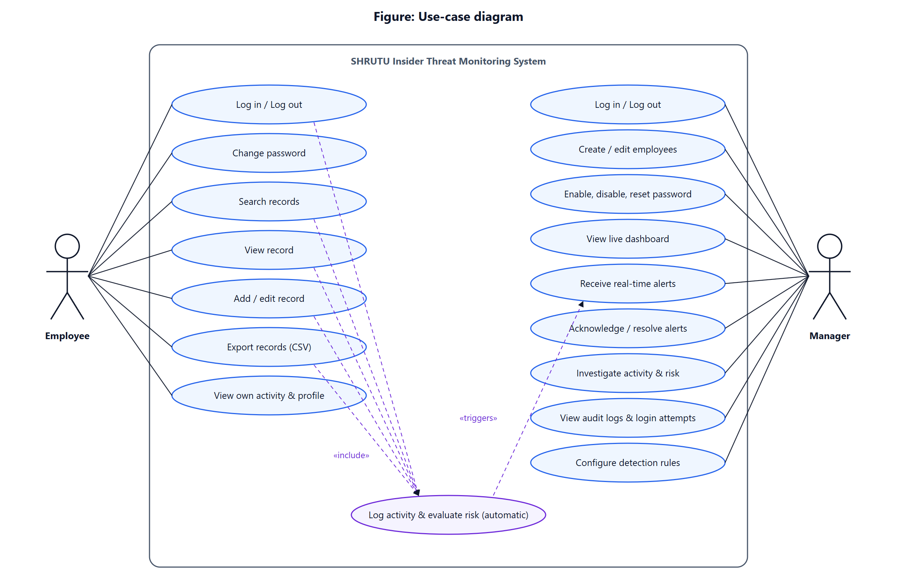
Figure 2.1: Use-case diagram

3. System Design

3.1 Architecture
SHRUTU follows a classic three-tier architecture (Figure 3.1). The presentation tier is the browser: Jinja2-rendered HTML pages, JavaScript that calls the REST API with fetch(), Chart.js charts, and a Socket.IO client for live events. The application tier is a Flask 3 server organised into blueprints (auth, employee, manager, api), a security layer, a services layer containing the business logic, and SQLAlchemy ORM models. The database tier is MySQL 8, reached through the PyMySQL driver over TLS in production.
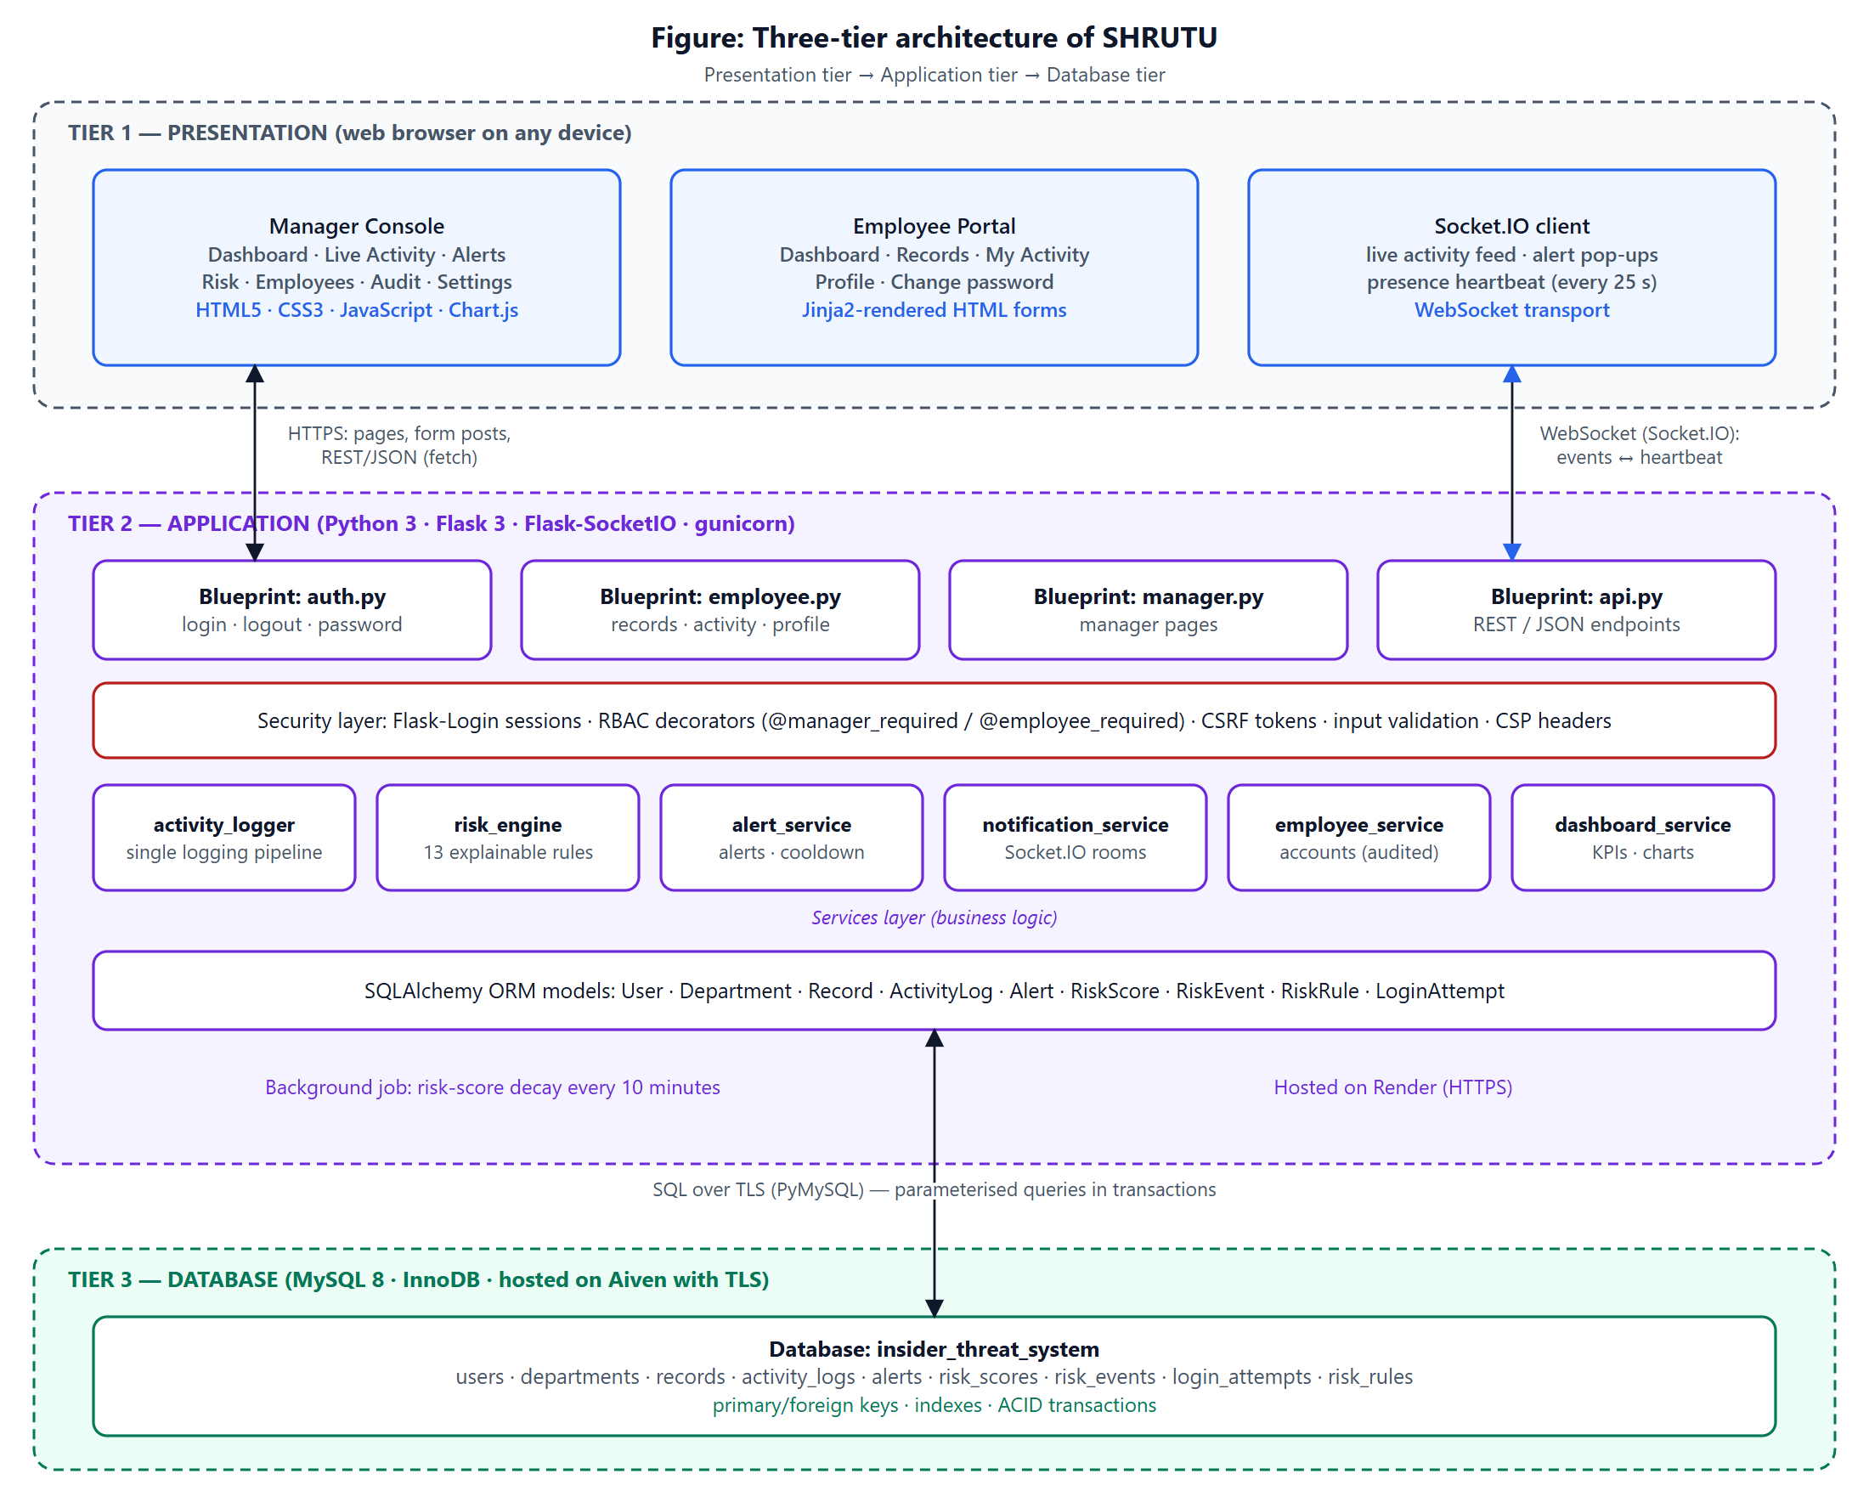
Figure 3.1: Three-tier architecture of SHRUTU
The most important design decision is the single monitoring pipeline: every route that performs a meaningful action calls one function, log_activity(), which inserts the activity, evaluates the rules, updates the score, writes the explanations and creates alerts inside one database transaction, and only after COMMIT emits Socket.IO events. This guarantees that every notification a manager sees corresponds to data that is already safely stored.

3.2 Data Flow Diagrams

3.2.1 Level 0 — Context diagram
At the highest level the system exchanges data with two external entities, Employee and Manager (Figure 3.2).
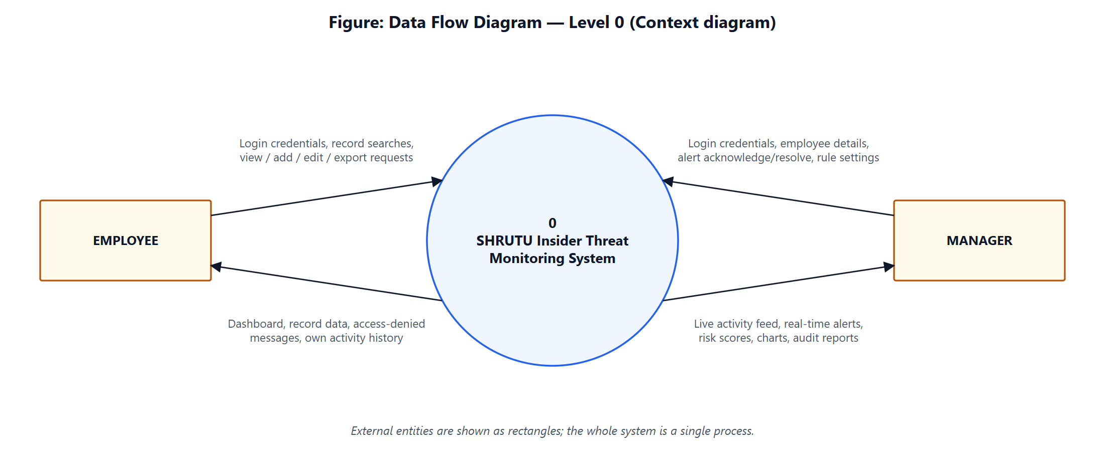
Figure 3.2: DFD Level 0 (context diagram)

3.2.2 Level 1
Level 1 (Figure 3.3) decomposes the system into eight processes and seven data stores. Processes 1.0, 2.0 and 7.0 handle user-facing work; 3.0 to 6.0 form the monitoring pipeline; 8.0 serves the manager's monitoring, reporting and alert handling.

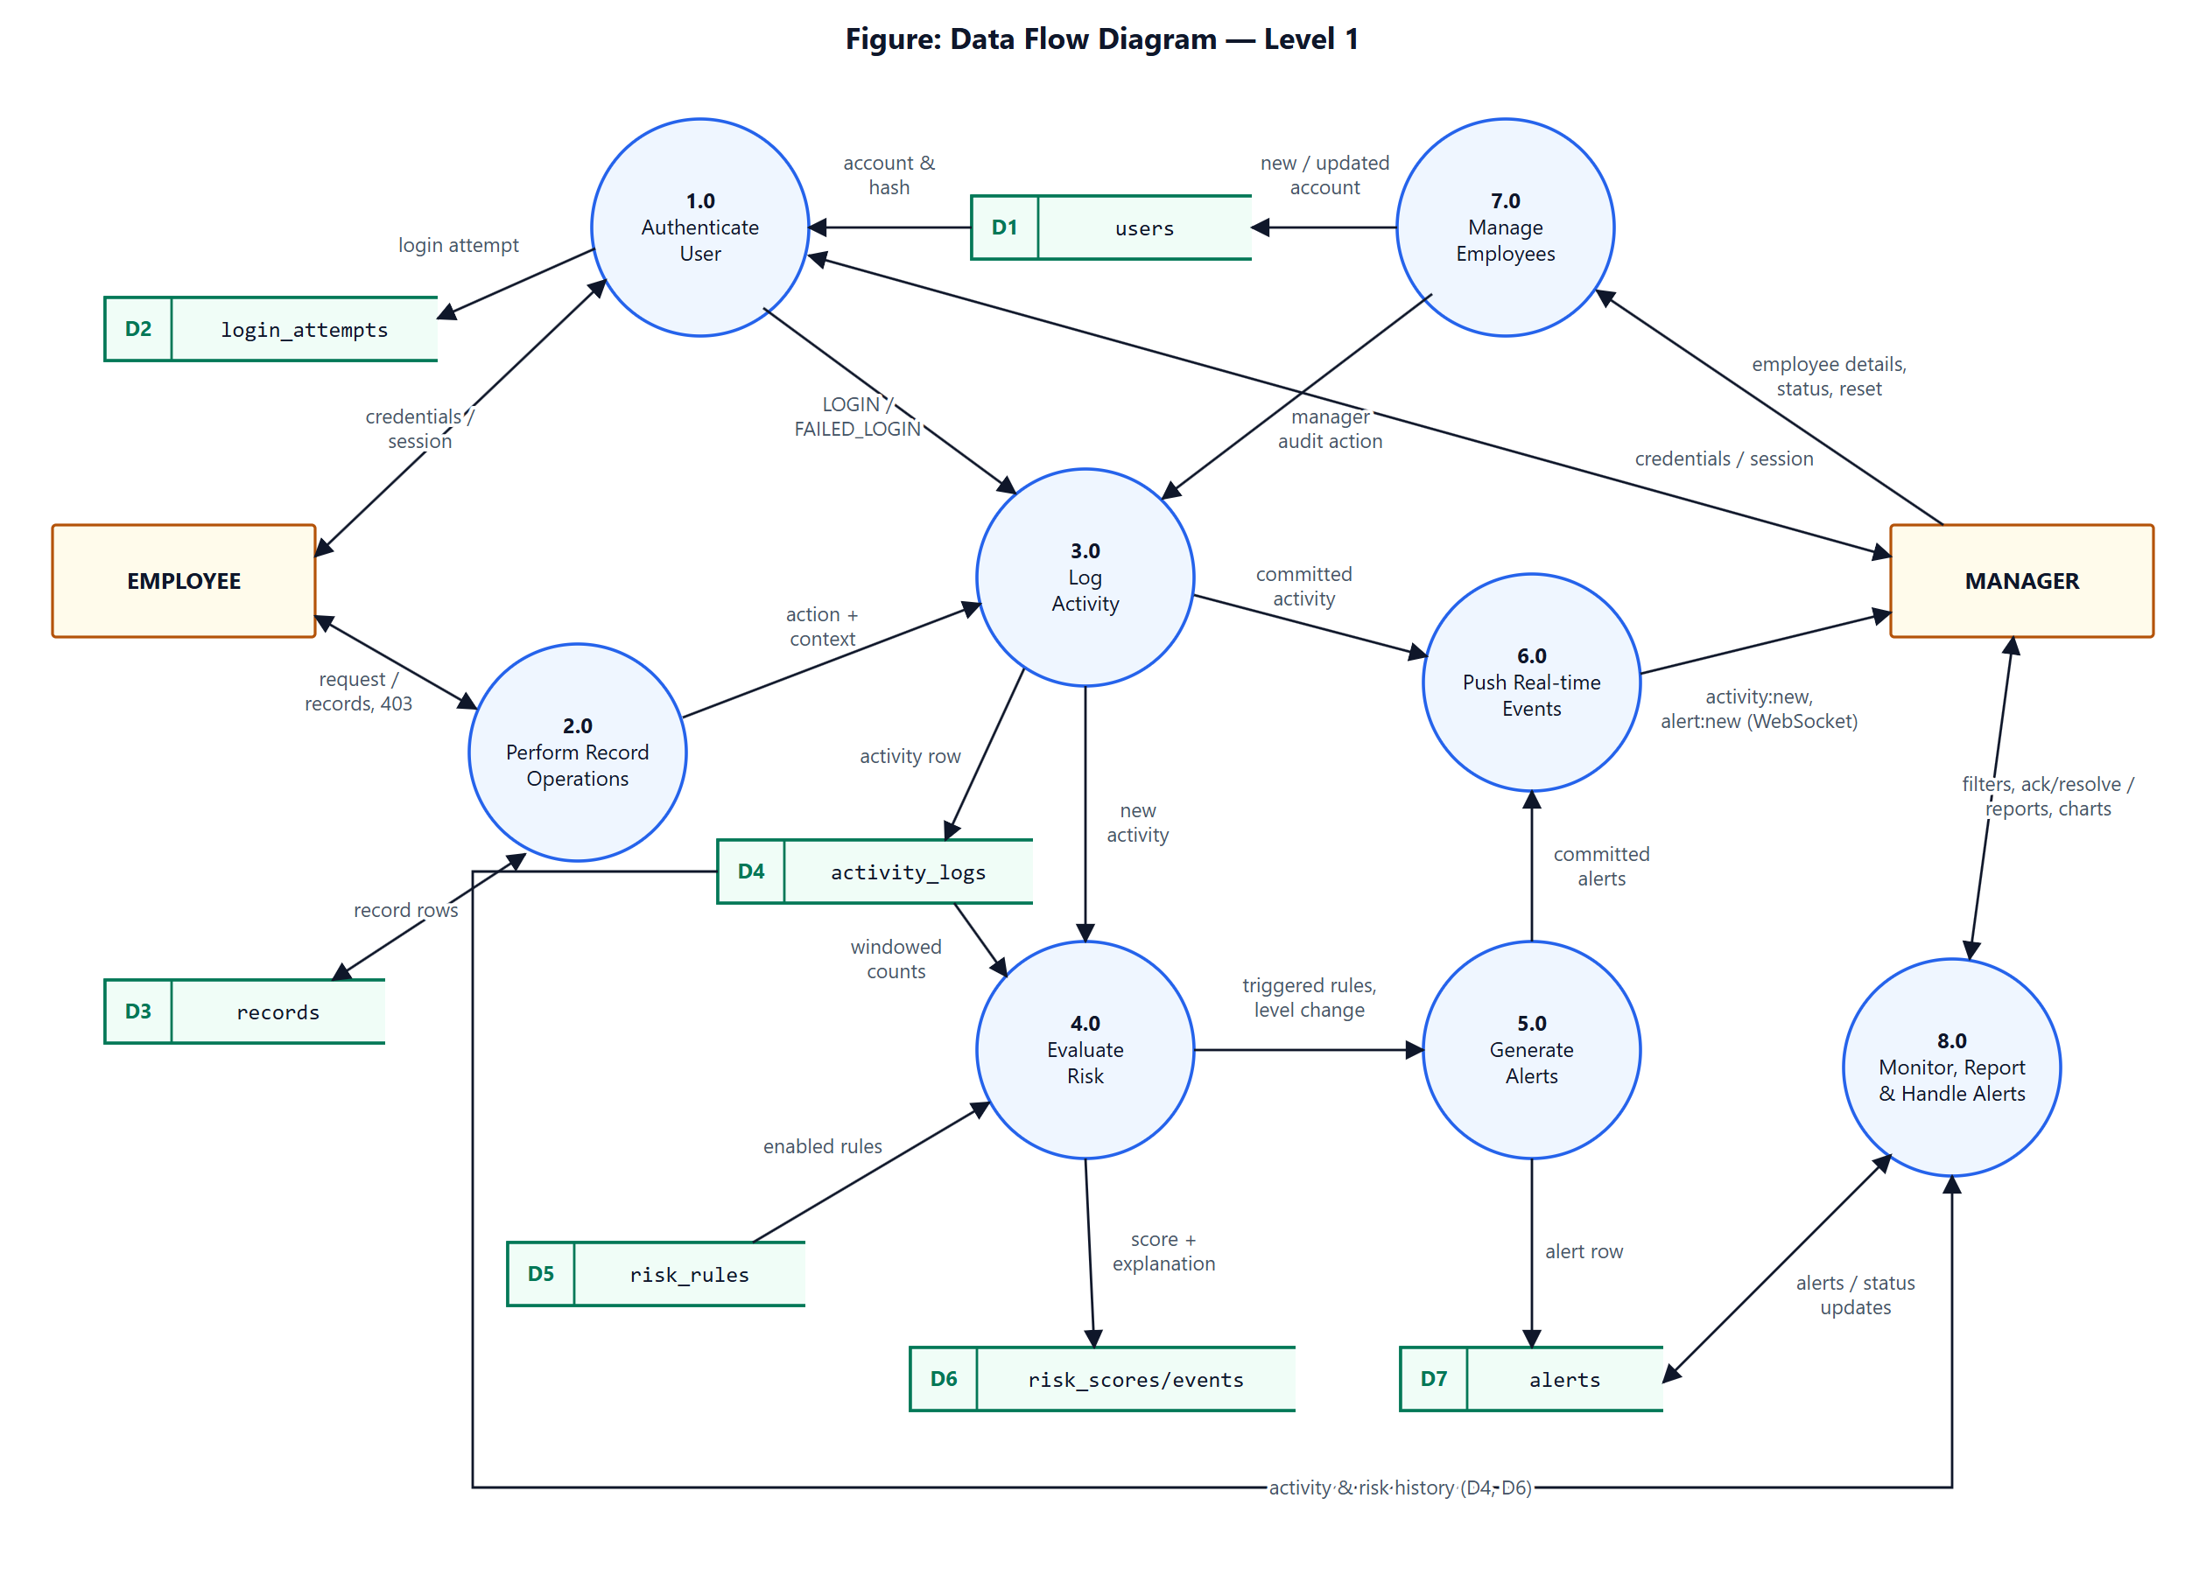
Figure 3.3: DFD Level 1

Table 3.1: Level 1 processes
Process | Description | Data stores
1.0 Authenticate User | Verifies employee ID and password hash, applies lockout, records the attempt and starts the session. | D1 users, D2 login_attempts
2.0 Perform Record Operations | Search, view, add, edit and export records after a permission check. | D3 records
3.0 Log Activity | Stores every action with context (IP, user agent, time, status). | D4 activity_logs
4.0 Evaluate Risk | Loads enabled rules, counts recent activity in time windows, applies points and levels. | D4, D5 risk_rules, D6 risk_scores/risk_events
5.0 Generate Alerts | Creates alerts for rules with a severity, respecting cooldown, plus level-escalation alerts. | D7 alerts
6.0 Push Real-time Events | Emits activity and alert events to the managers' Socket.IO room after commit. | —
7.0 Manage Employees | Creates and updates accounts, enables/disables, resets passwords (all audited). | D1 users
8.0 Monitor, Report & Handle Alerts | Dashboards, charts, filters, investigation, acknowledge/resolve. | D4, D6, D7

3.2.3 Level 2 — the monitoring pipeline
Figure 3.4 expands processes 3.0–6.0. The route handler passes the action to 3.1, which captures the request context; 3.2 inserts and flushes the activity to obtain its primary key; 4.1–4.3 evaluate the rules and update the score; 5.1–5.2 create alerts; 3.3 commits; and 6.1 notifies managers. A database error at any step rolls back the whole transaction and the bare activity is stored separately so that no evidence is lost.

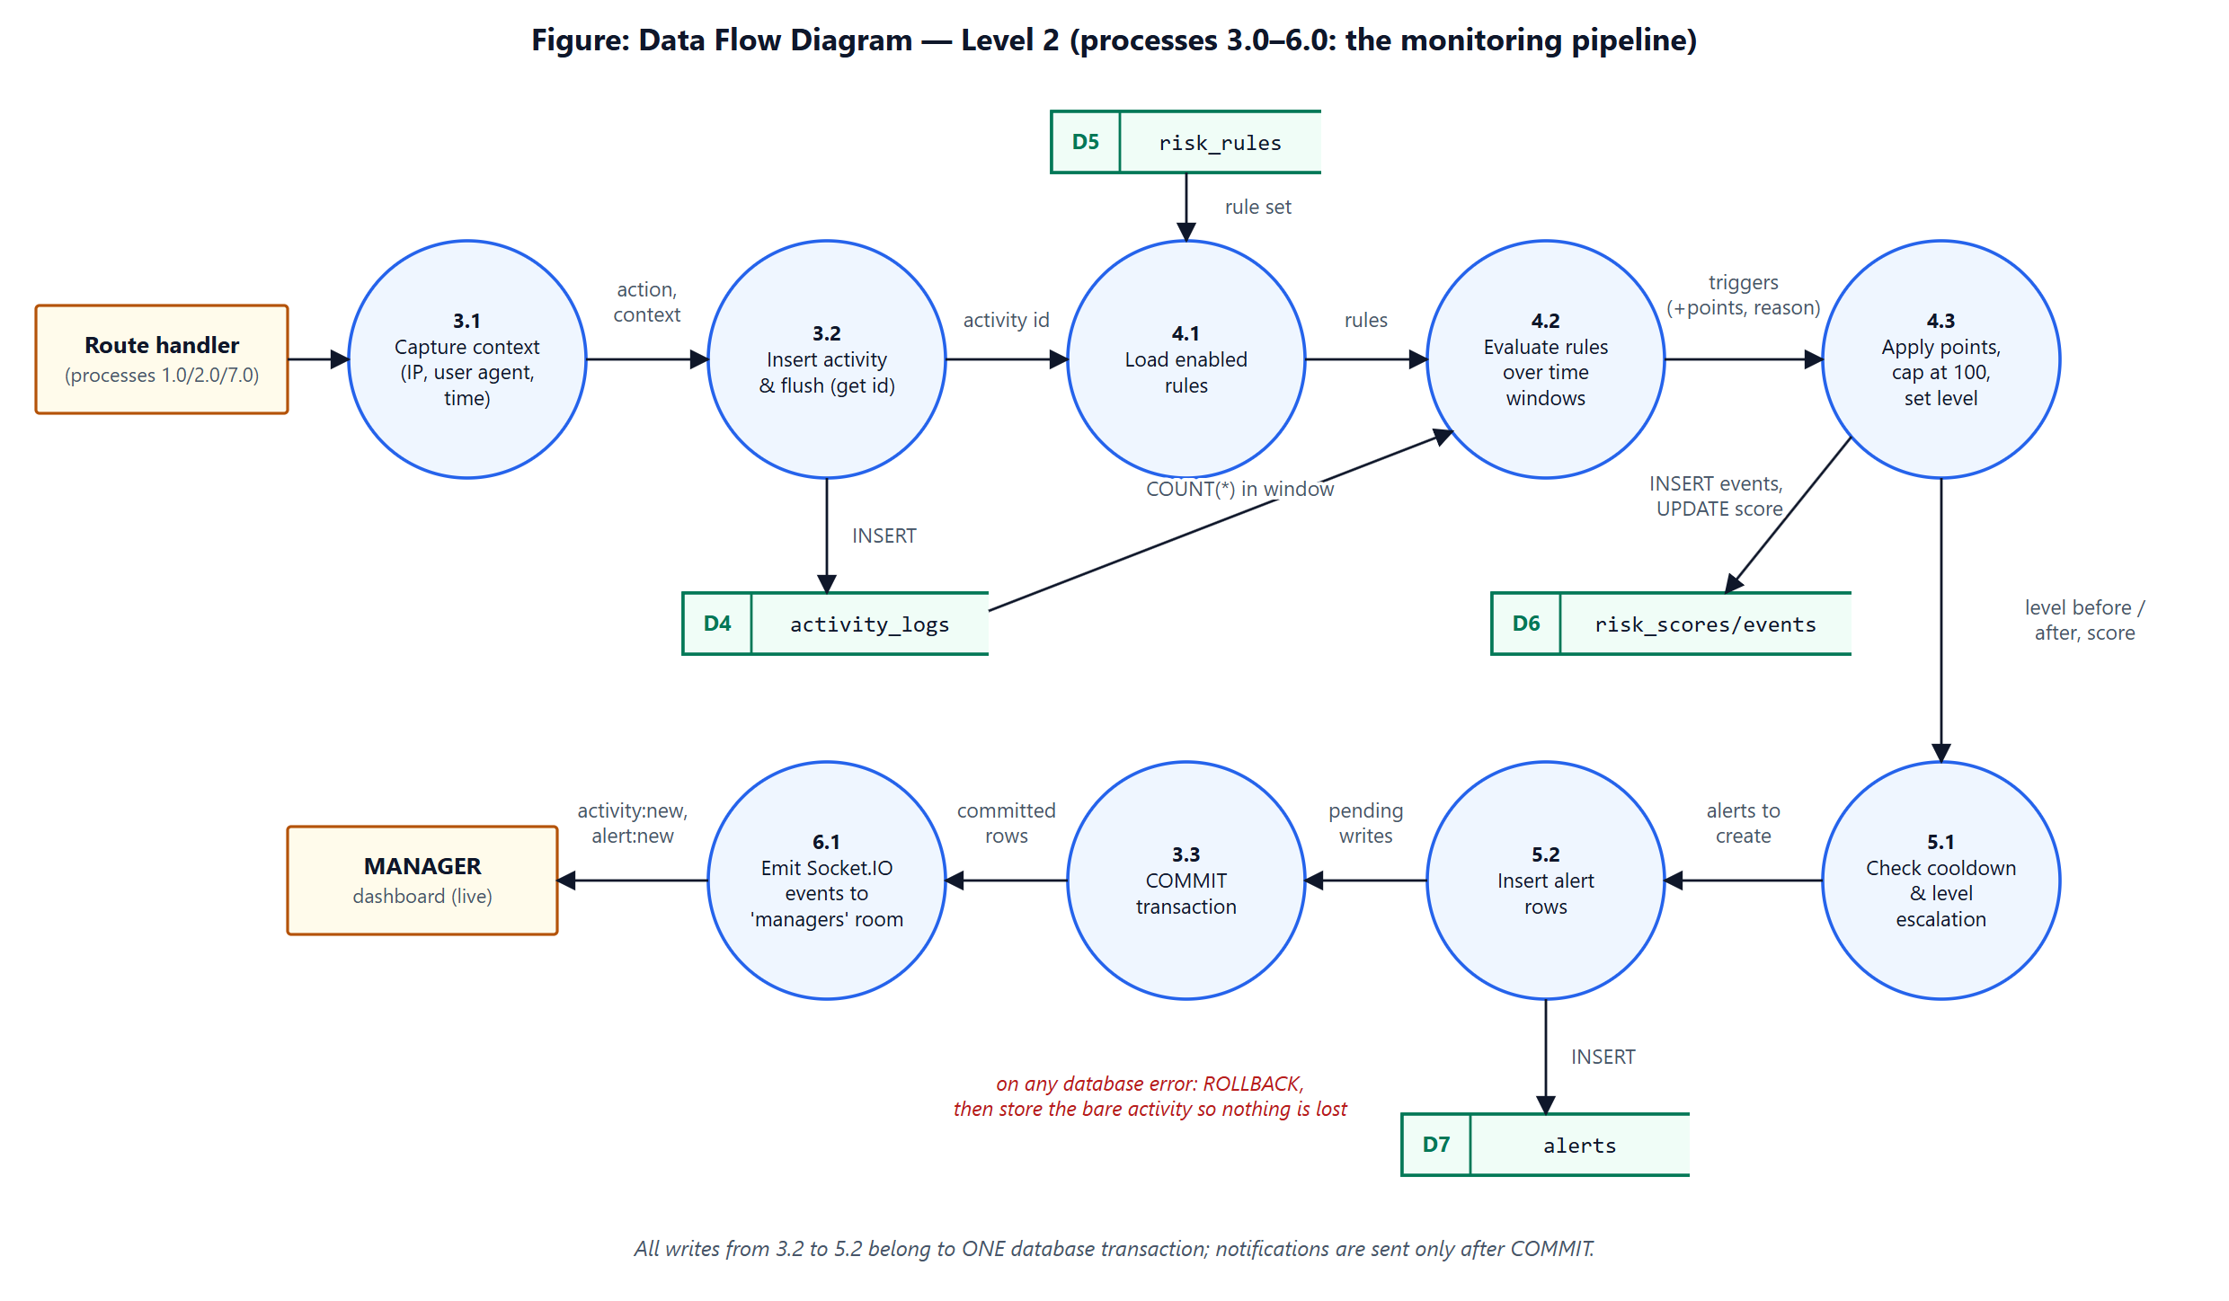
Figure 3.4: DFD Level 2 (monitoring pipeline)

3.3 Entity–Relationship design
The conceptual model contains nine entities (Figure 3.5). USER is the central entity: every user belongs to one DEPARTMENT, has exactly one RISK_SCORE, makes LOGIN_ATTEMPTs, performs ACTIVITY_LOGs, creates RECORDs and is the subject of ALERTs, while managers HANDLE (acknowledge/resolve) alerts. An ACTIVITY_LOG TRIGGERS alerts and CAUSES RISK_EVENTs, and each RISK_EVENT APPLIES one RISK_RULE. USER also has a recursive CREATED_BY relationship (the manager who created an account).

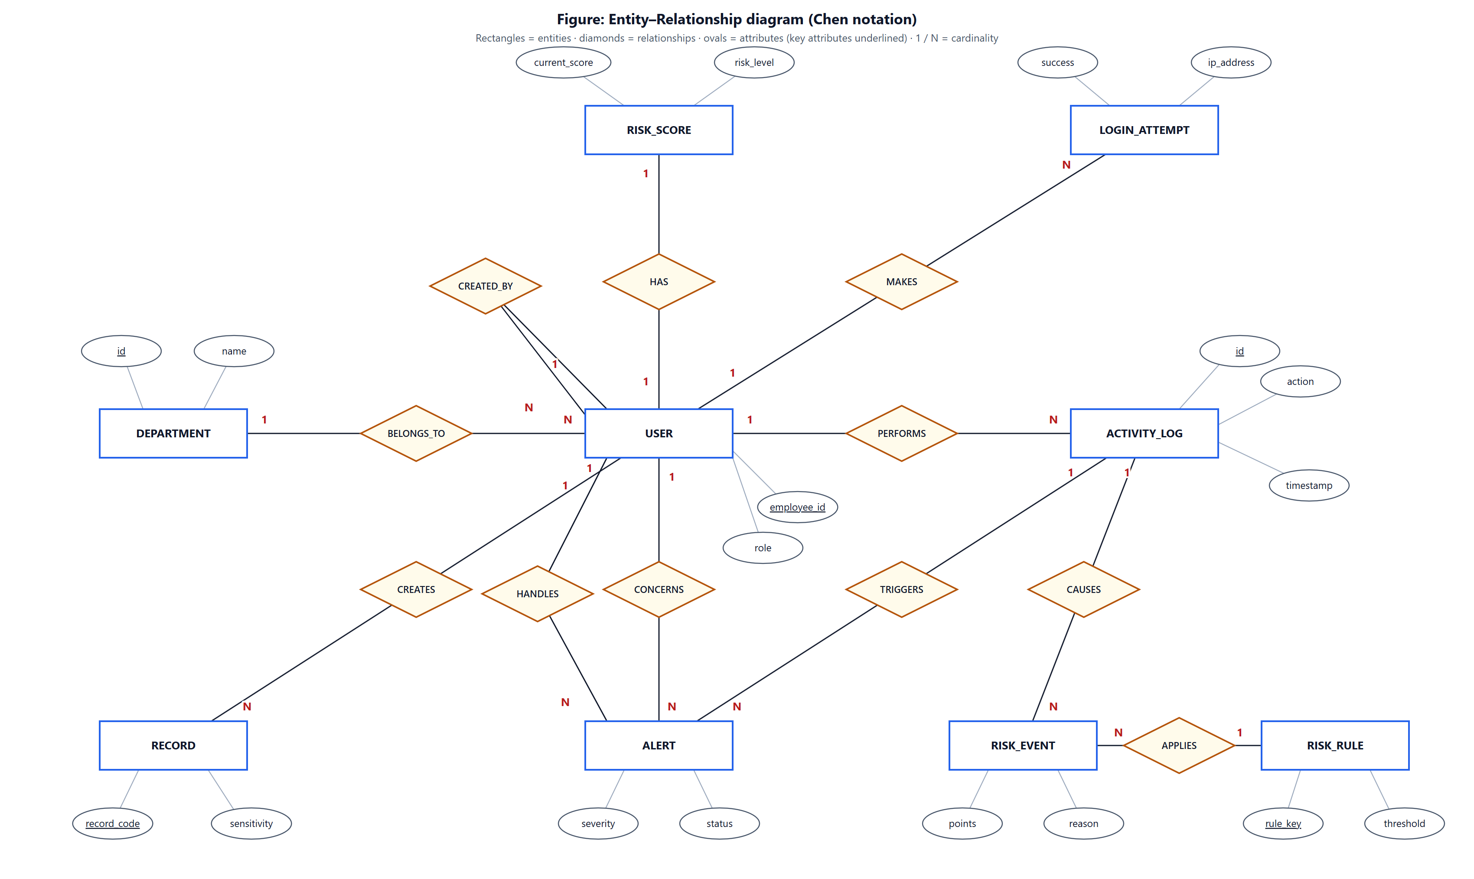
Figure 3.5: Entity–Relationship diagram (Chen notation)

Table 3.2: Relationships and their implementation
Relationship | Entities | Cardinality | Implemented by
BELONGS_TO | DEPARTMENT – USER | 1 : N | users.department → departments.name
HAS | USER – RISK_SCORE | 1 : 1 | risk_scores.user_id (FK + UNIQUE)
MAKES | USER – LOGIN_ATTEMPT | 1 : N | login_attempts.user_id (nullable for unknown IDs)
PERFORMS | USER – ACTIVITY_LOG | 1 : N | activity_logs.user_id
CREATES | USER – RECORD | 1 : N | records.created_by, records.updated_by
CONCERNS | USER – ALERT | 1 : N | alerts.user_id
HANDLES | USER (manager) – ALERT | 1 : N | alerts.acknowledged_by, alerts.resolved_by
TRIGGERS | ACTIVITY_LOG – ALERT | 1 : N | alerts.activity_id
CAUSES | ACTIVITY_LOG – RISK_EVENT | 1 : N | risk_events.activity_id
APPLIES | RISK_RULE – RISK_EVENT | 1 : N | risk_events.rule_key (logical link)
CREATED_BY | USER – USER (recursive) | 1 : N | users.created_by → users.id

3.4 Schema design
The logical design maps each entity to a table. Surrogate integer primary keys (INT or BIGINT AUTO_INCREMENT for fast-growing log tables) are used everywhere; natural identifiers such as employee_id, email, record_code and rule_key are enforced with UNIQUE constraints. Enumerated domains use MySQL ENUM columns. Figure 3.6 shows the physical schema, and Tables 3.3–3.11 describe each table.

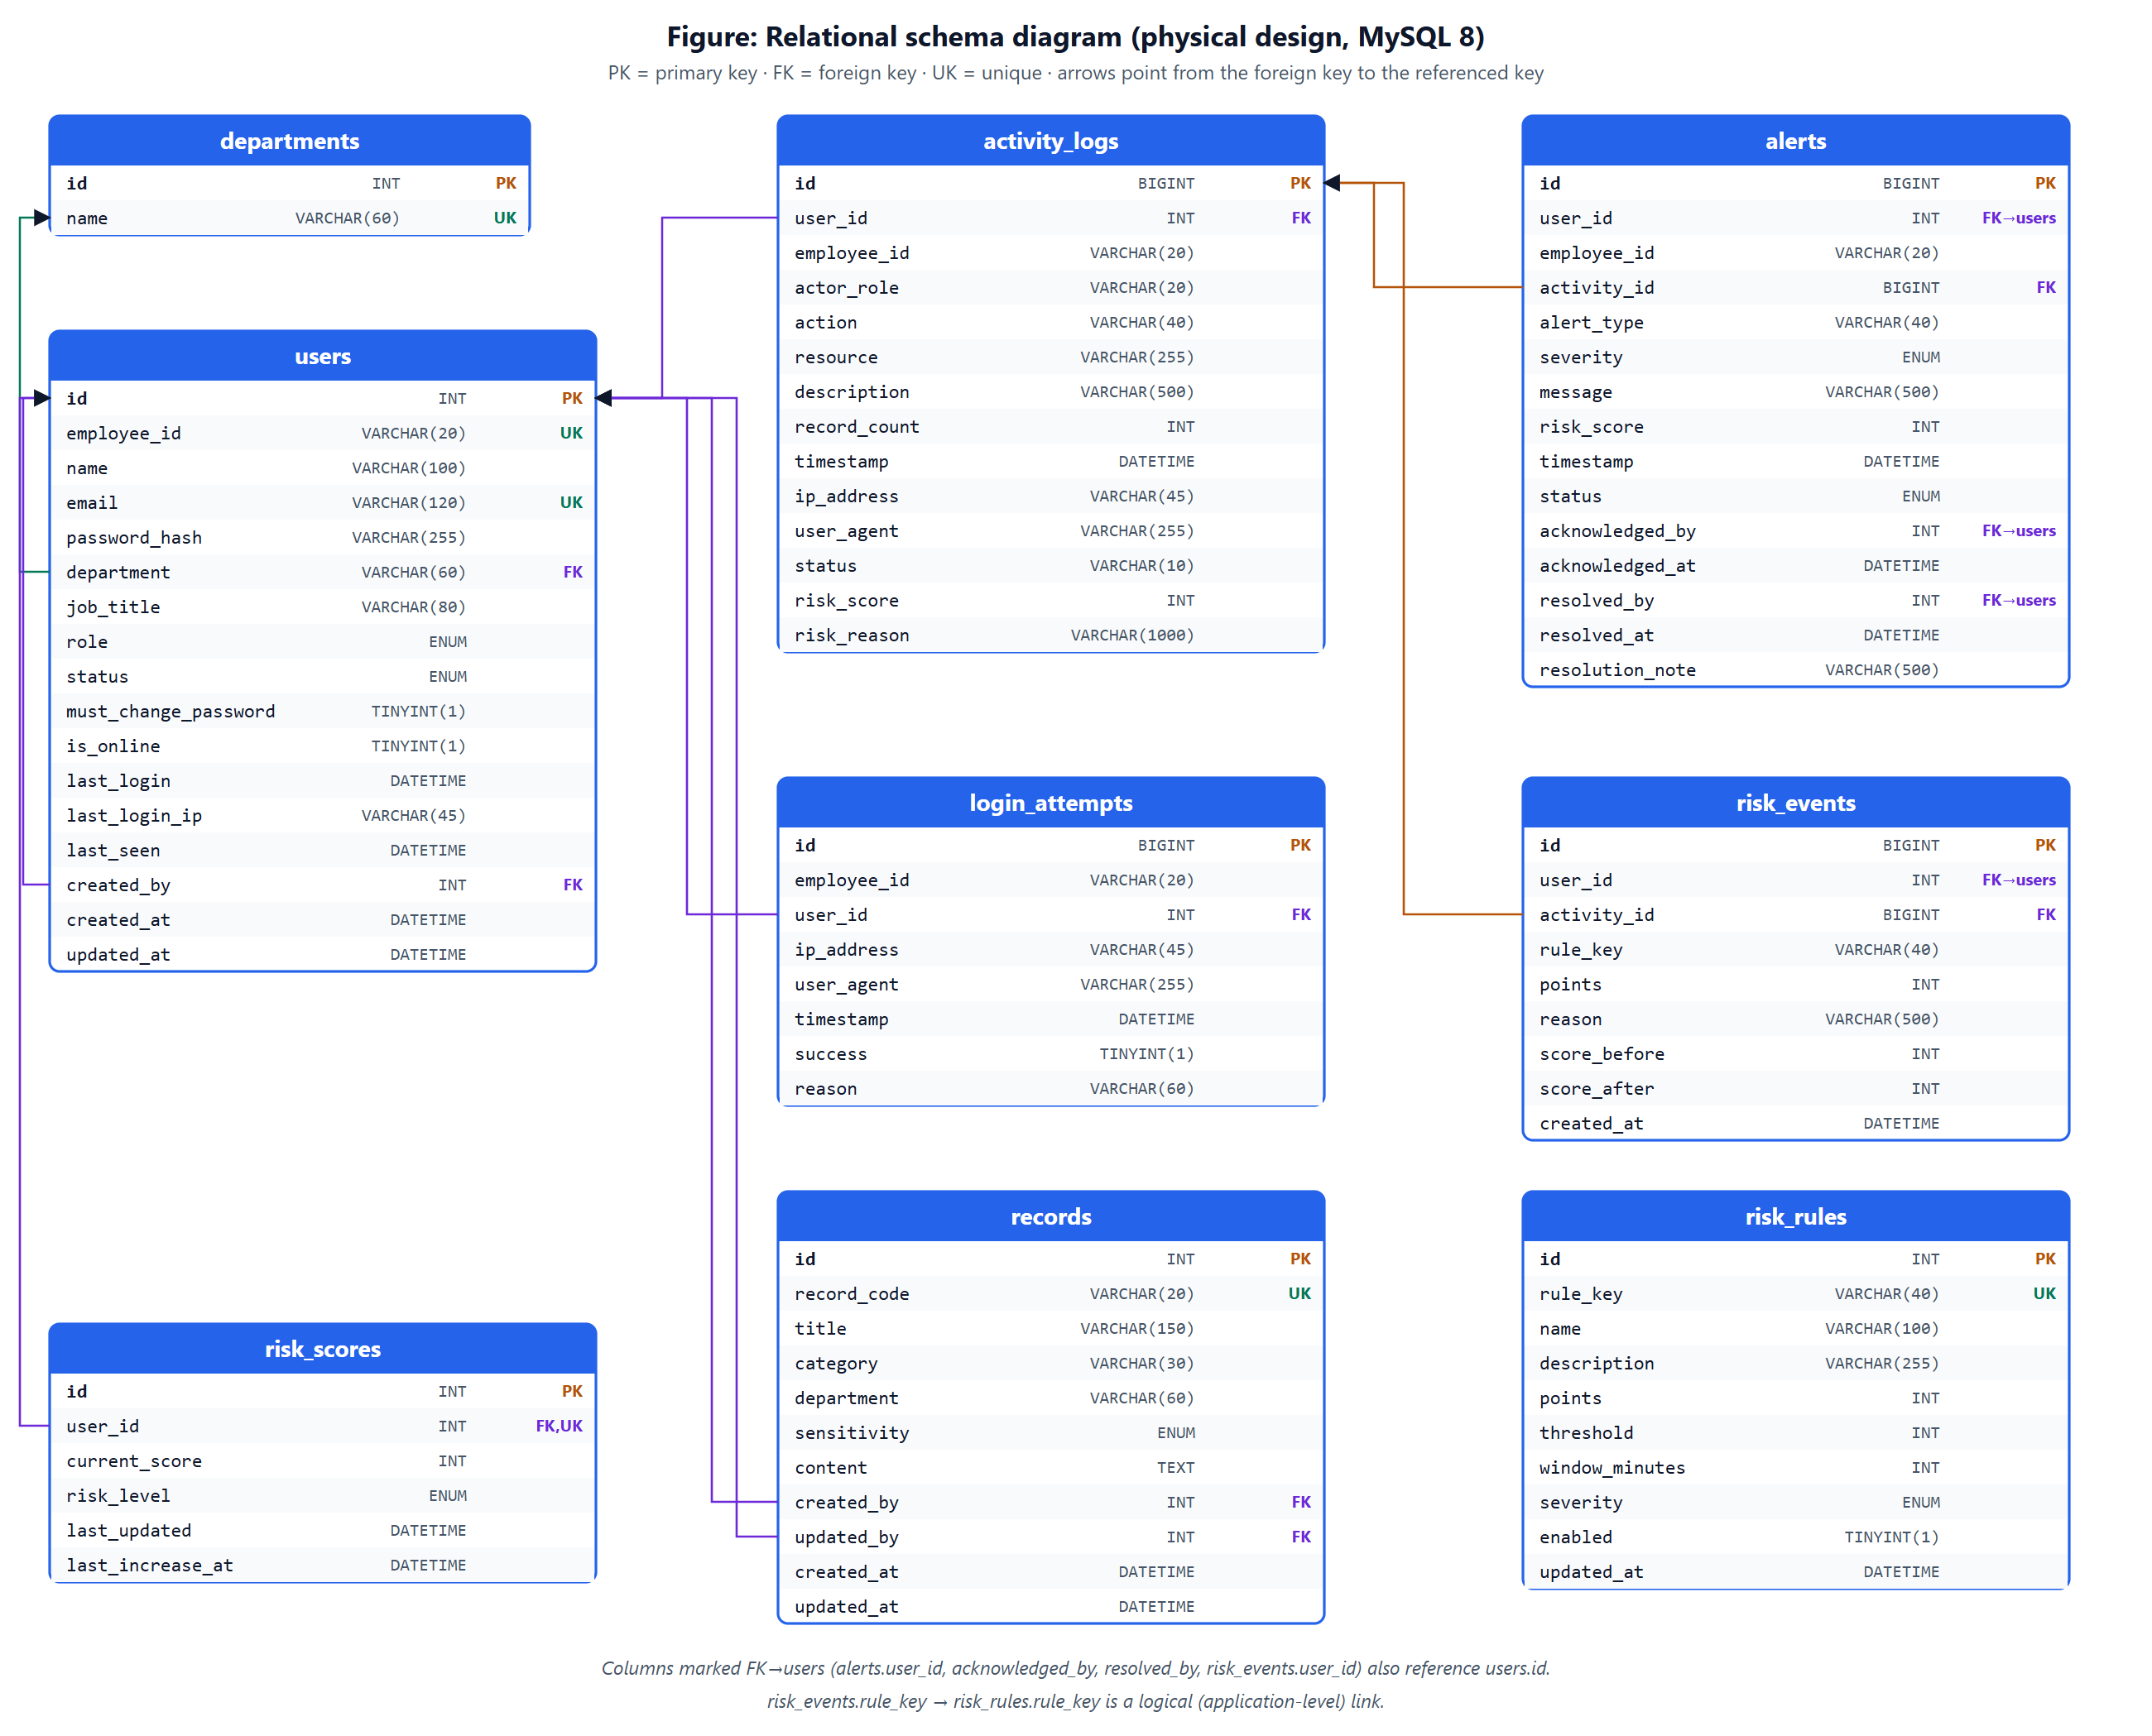
Figure 3.6: Relational schema diagram (physical design)

Table 3.3: Table users — Employees and managers
Column | Data type | Constraint | Description
id | INT AUTO_INCREMENT | PK | Surrogate key
employee_id | VARCHAR(20) | UNIQUE, NOT NULL | Login ID, e.g. EMP1001
name | VARCHAR(100) | NOT NULL | Full name
email | VARCHAR(120) | UNIQUE, NOT NULL | E-mail address
password_hash | VARCHAR(255) | NOT NULL | Werkzeug scrypt hash (never plain text)
department | VARCHAR(60) | FK → departments.name | Department
job_title | VARCHAR(80) | NULL | Designation
role | ENUM('employee','manager') | NOT NULL | Access role
status | ENUM('active','disabled') | NOT NULL | Disabled accounts cannot log in
must_change_password | TINYINT(1) | NOT NULL | Temporary password flag
is_online / last_seen | TINYINT(1) / DATETIME |  | Presence tracking
last_login / last_login_ip | DATETIME / VARCHAR(45) |  | Last successful login
created_by | INT | FK → users.id | Manager who created the account
created_at / updated_at | DATETIME | NOT NULL | Timestamps

Table 3.4: Table departments — Lookup of departments
Column | Data type | Constraint | Description
id | INT | PK
name | VARCHAR(60) | UNIQUE | Finance, Human Resources, Engineering, IT & Security, Sales, Legal

Table 3.5: Table records — Business records (the monitored resource)
Column | Data type | Constraint | Description
id | INT | PK
record_code | VARCHAR(20) | UNIQUE | e.g. FIN-0004
title / category | VARCHAR | NOT NULL
department | VARCHAR(60) | INDEX | Owning department or 'General'
sensitivity | ENUM(PUBLIC, INTERNAL, CONFIDENTIAL, RESTRICTED) | NOT NULL | Classification used by the access policy
content | TEXT | NOT NULL
created_by / updated_by | INT | FK → users.id
created_at / updated_at | DATETIME

Table 3.6: Table activity_logs — Every action of every user
Column | Data type | Constraint | Description
id | BIGINT | PK
user_id | INT | FK → users.id (NULL for unknown IDs)
employee_id | VARCHAR(20) | INDEX | Kept even for failed logins of unknown IDs
actor_role | VARCHAR(20) |  | employee / manager
action | VARCHAR(40) | INDEX | LOGIN, SEARCH, VIEW_RECORD, EXPORT_DATA, UNAUTHORIZED_ACCESS, …
resource / description | VARCHAR(255) / VARCHAR(500) |  | What was accessed
record_count | INT |  | Records touched (for mass-access rule)
timestamp | DATETIME | INDEX
ip_address / user_agent | VARCHAR |  | Request context
status | VARCHAR(10) |  | SUCCESS / FAILED / DENIED
risk_score / risk_reason | INT / VARCHAR(1000) |  | Points added by this action and why

Table 3.7: Table alerts — Suspicious events (never deleted)
Column | Data type | Constraint | Description
id | BIGINT | PK
user_id | INT | FK → users.id
employee_id | VARCHAR(20) | INDEX
activity_id | BIGINT | FK → activity_logs.id | Triggering activity
alert_type | VARCHAR(40) |  | Rule key
severity | ENUM(LOW, MEDIUM, HIGH, CRITICAL)
message | VARCHAR(500) |  | Human-readable reason
risk_score | INT |  | Score at alert time
status | ENUM(NEW, ACKNOWLEDGED, RESOLVED) | INDEX
acknowledged_by / resolved_by | INT | FK → users.id | Handling manager
acknowledged_at / resolved_at | DATETIME
resolution_note | VARCHAR(500)

Table 3.8: Table risk_scores — Current score per user
Column | Data type | Constraint | Description
id | INT | PK
user_id | INT | FK → users.id, UNIQUE | One row per user (1:1)
current_score | INT |  | 0–100
risk_level | ENUM(LOW, MEDIUM, HIGH, CRITICAL)
last_updated / last_increase_at | DATETIME |  | Used for decay

Table 3.9: Table risk_events — Explanation of every score change
Column | Data type | Constraint | Description
id | BIGINT | PK
user_id | INT | FK → users.id
activity_id | BIGINT | FK → activity_logs.id
rule_key | VARCHAR(40) |  | Rule that fired
points | INT
reason | VARCHAR(500) |  | e.g. "Accessed 17 records within 5 minutes"
score_before / score_after | INT
created_at | DATETIME | INDEX

Table 3.10: Table login_attempts — Authentication attempts
Column | Data type | Constraint | Description
id | BIGINT | PK
employee_id | VARCHAR(20) | INDEX
user_id | INT | FK → users.id (nullable)
ip_address / user_agent | VARCHAR | INDEX (ip, time)
timestamp | DATETIME
success | TINYINT(1)
reason | VARCHAR(60) |  | INVALID_PASSWORD, LOCKED_OUT, ACCOUNT_DISABLED, …

Table 3.11: Table risk_rules — Configurable detection rules
Column | Data type | Constraint | Description
id | INT | PK
rule_key | VARCHAR(40) | UNIQUE
name / description | VARCHAR
points | INT |  | Points added
threshold / window_minutes | INT |  | e.g. 15 records in 5 minutes
severity | ENUM(NONE, LOW, MEDIUM, HIGH, CRITICAL) |  | Alert severity
enabled | TINYINT(1)

3.5 Normalisation
The schema was derived by normalising a single, flat "monitoring event" relation that a naive design might use:
Unnormalised relation
EVENT(event_id, employee_id, employee_name, email, department, role, action, record_code, record_title,
record_department, sensitivity, time, ip, alert_type, alert_severity, alert_status, handled_by_name,
current_risk_score, risk_level, rule_name, rule_points)

First Normal Form (1NF)
A single event could raise several alerts and several rule points, giving repeating groups (alert_type₁, alert_type₂, …). These were moved into separate relations with one value per cell, and every relation received a primary key: ALERT(alert_id, event_id, alert_type, severity, status, …) and RISK_EVENT(risk_event_id, event_id, rule_key, points, reason, …).

Second Normal Form (2NF)
With surrogate single-column keys there are no partial dependencies on part of a composite key. The candidate composite key (employee_id, time) of the activity relation was replaced by the surrogate id, so every non-key attribute depends on the whole key.

Third Normal Form (3NF)
Transitive dependencies were removed: employee_id → name, email, department, role moved to USERS; record_code → title, record_department, sensitivity moved to RECORDS; rule_key → rule_name, points, threshold moved to RISK_RULES; employee_id → current_risk_score, risk_level moved to RISK_SCORES (1:1); and departments became a lookup table referenced by foreign key. Each table now describes one entity and every non-key attribute depends only on its key.

Deliberate, documented exceptions
- activity_logs.employee_id, alerts.employee_id and login_attempts.employee_id repeat the typed employee ID next to the user_id foreign key. This is intentional: failed logins with an unknown ID have no user row, and audit evidence must remain readable even if an account is later renamed.
- alerts.risk_score and risk_events.score_before/score_after are historical snapshots (the value at that moment), not derived data, so they do not violate 3NF.
- activity_logs.risk_reason is a denormalised summary of the related risk_events rows kept for fast display in the live feed; risk_events remains the authoritative explanation.

3.6 Risk engine design
Rules are stored as data in risk_rules (Table 3.12). When an activity arrives, each enabled rule runs a small query — usually a COUNT or SUM over the employee's recent activity within the rule's time window — and, if it fires, returns points, a reason and an alert severity. Scores are capped at 100 and mapped to levels: 0–29 LOW, 30–59 MEDIUM, 60–79 HIGH, 80–100 CRITICAL. Aggregate rules fire once per window, the same alert type is not repeated within a 10-minute cooldown, and scores decay by 2 points per hour of normal behaviour.
Table 3.12: Detection rules (default configuration)
Rule | Points | Fires when | Alert
FAILED_LOGIN | +10 | any failed login | —
REPEATED_FAILED_LOGIN | +20 | ≥ 3 failed logins for one ID in 10 min | HIGH
NEW_LOCATION | +10 | login from an IP never used by this employee | MEDIUM
OFF_HOURS | +15 | activity outside 09:00–19:00 Mon–Fri (once per hour) | MEDIUM
SENSITIVE_ACCESS | +15 | viewing / editing a CONFIDENTIAL record | MEDIUM
UNAUTHORIZED_ACCESS | +30 | opening a record or page outside permissions | HIGH
PRIVILEGE_ESCALATION | +10 | employee tries a manager-only page or API | HIGH
REPEATED_UNAUTHORIZED | +25 | ≥ 3 unauthorised attempts in 15 min | CRITICAL
MASS_RECORD_ACCESS | +20 | ≥ 15 records viewed/exported in 5 min | HIGH
REPEATED_SEARCH | +10 | ≥ 10 searches in 5 min | LOW
RAPID_ACTIONS | +15 | ≥ 20 actions in 1 min | MEDIUM
UNUSUAL_FREQUENCY | +15 | > 3× the employee's normal hourly rate (7-day baseline) | MEDIUM
SUSPICIOUS_BURST | +25 | ≥ 3 risk-scored events (not failed logins) in 10 min | HIGH

3.7 Real-time notification design
Figure 3.7 traces a suspicious action from the employee's browser to the manager's screen. Socket.IO connections are authenticated with the same session cookie as HTTP requests. The server places every manager socket in a private room called managers; employees are never subscribed to it, so they cannot receive monitoring data even by modifying client code.

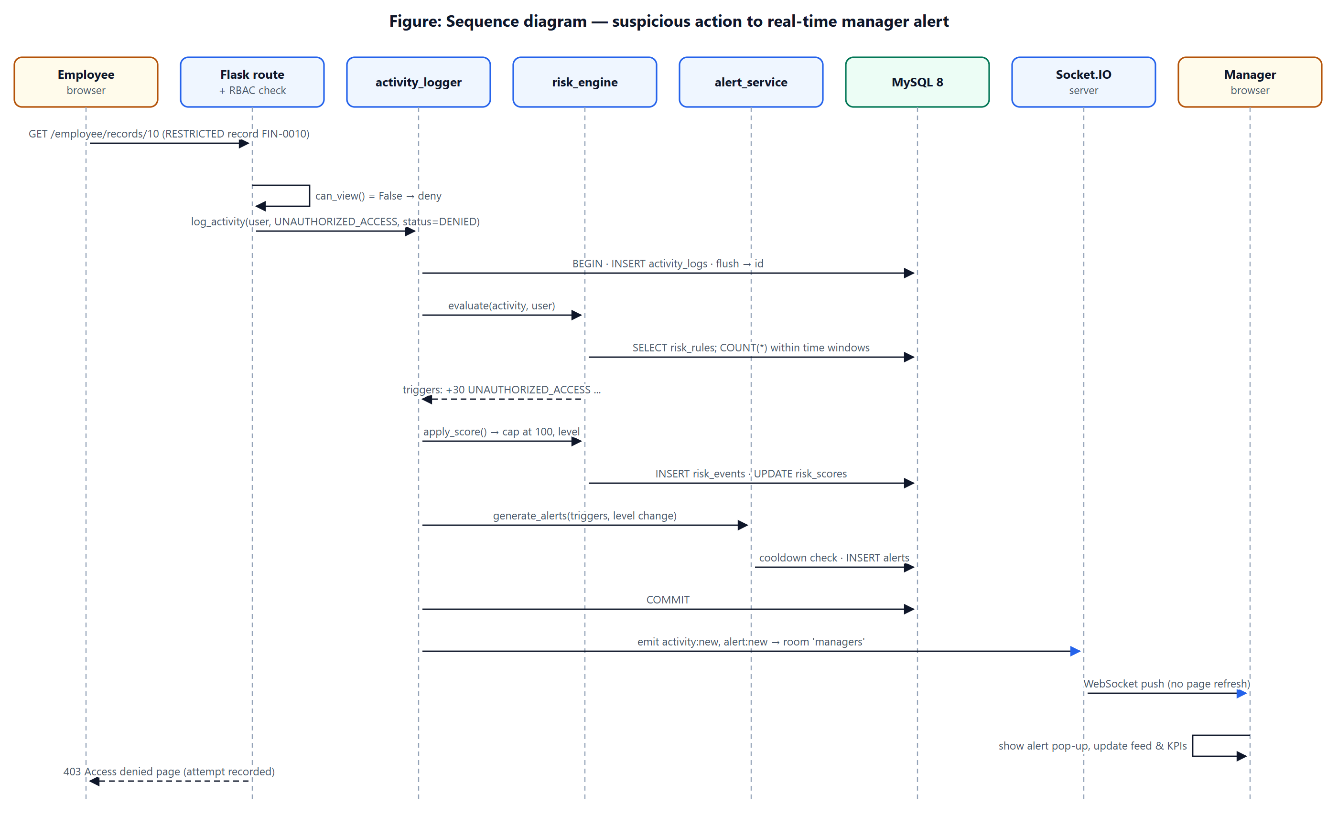
Figure 3.7: Sequence diagram: suspicious action to real-time alert

3.8 Security design
- Authentication: passwords hashed with scrypt; generic error messages; lockout after 5 failures per ID or 20 per IP in 15 minutes; session cleared on login (prevents fixation).
- Authorisation: @login_required, @manager_required, @employee_required decorators on every route and API; record-level policy by department and classification.
- Session security: HttpOnly, SameSite=Lax (and Secure over HTTPS) cookies; 30-minute idle timeout; disabled accounts lose their session immediately.
- Input handling: server-side validation of every field; SQLAlchemy parameter binding prevents SQL injection; Jinja2 auto-escaping prevents XSS.
- Browser protections: CSRF tokens on forms and API writes; Content-Security-Policy without inline scripts; X-Frame-Options DENY.
- Secrets: database credentials and secret key only in environment variables (.env, git-ignored); database connections over TLS in production.

4. Implementation

4.1 Technologies used
Table 4.1: Technologies used
Layer | Technology | Purpose
Front end | HTML5, CSS3 (custom design system, dark/light), JavaScript (ES2020) | User interface
Front end | Jinja2 templates | Server-side rendering of pages and forms
Front end | Chart.js 4, Socket.IO client 4 | Charts; real-time events
Back end | Python 3.14, Flask 3.1 | Web framework and routing
Back end | Flask-SQLAlchemy 3.1 / SQLAlchemy 2.1 | ORM, transactions, query building
Back end | Flask-Login, Flask-WTF, Werkzeug | Sessions, CSRF protection, password hashing
Back end | Flask-SocketIO 5 + simple-websocket | WebSocket server (real-time alerts)
Database | MySQL 8.0 (local) / MySQL 8.4 on Aiven (cloud), InnoDB | Relational storage with foreign keys and ACID transactions
Database driver | PyMySQL | Python ↔ MySQL connection (TLS)
Testing | pytest 9 | Unit, integration and real-time tests
Deployment | gunicorn, Render (web), Aiven (MySQL), Git/GitHub | Public hosting and source control
Tools | VS Code, MySQL Workbench / CLI, Microsoft Edge DevTools | Development and debugging

4.2 Project structure
insider-threat-monitor/
├── app.py application factory, error handling, security headers
├── config.py configuration (environment variables + monitoring policy)
├── extensions.py db, login_manager, csrf, socketio objects
├── init_db.py creates the database from schema.sql and loads seed.sql
├── seed_extra.py adds 10 more demo employees with realistic history
├── wsgi.py production entry point (gunicorn)
├── database/ schema.sql · seed.sql
├── models/ user.py · activity.py · alert.py · risk.py · record.py
├── routes/ auth.py · employee.py · manager.py · api.py
├── services/ activity_logger.py · risk_engine.py · alert_service.py · notification_service.py
│ employee_service.py · dashboard_service.py · record_access.py
├── utils/ security.py · validators.py · helpers.py
├── templates/ login.html · layout.html · employee/*.html · manager/*.html · errors/error.html
├── static/ css/app.css · css/login.css · js/*.js (common, realtime, charts, page scripts)
└── tests/ 52 automated tests (pytest)

Table 4.2: Size of the implementation
Component | Size
Python back end (models, routes, services, utils, app) | ≈ 3,000 lines in 29 files
Jinja2 templates | 21 files, ≈ 1,050 lines
JavaScript / CSS | ≈ 1,120 / ≈ 620 lines
SQL (schema + seed) | ≈ 530 lines
Automated tests | 52 tests, ≈ 710 lines
HTTP endpoints | 47 routes (25 REST API endpoints)

4.3 Key modules — coding snapshots

4.3.1 Central activity logger (one transaction)
log_activity() is the heart of the system. It inserts the activity, runs the risk engine, stores the explanation, updates the score and creates alerts in one transaction, and emits real-time events only after COMMIT. If anything fails the transaction is rolled back and the bare activity is stored so that evidence is never lost.
Listing 4.1 — services/activity_logger.py
def log_activity(user, action, resource=None, description=None, risk_score=0, *,
status="SUCCESS", employee_id=None, record_count=0, context=None):
"""
Record `action` performed by `user` (None for unknown login IDs) and run it
through the risk pipeline. `risk_score` is an optional base score added on
top of whatever the rules decide. Returns the stored ActivityLog.
"""
emp_id = user.employee_id if user is not None else (employee_id or "UNKNOWN")
activity = ActivityLog(
user_id=user.id if user is not None else None,
employee_id=emp_id[:20],
actor_role=user.role if user is not None else None,
action=action,
resource=(resource or "")[:255] or None,
description=(description or "")[:500] or None,
record_count=record_count or 0,
timestamp=now(),
ip_address=client_ip(),
user_agent=client_user_agent(),
status=status,
)
alerts = []
try:
db.session.add(activity)
db.session.flush() # gives the activity an id so rules/alerts can reference it

triggers = risk_engine.evaluate(activity, user, context)
if risk_score:
triggers.insert(0, risk_engine.Trigger("BASE_SCORE", int(risk_score),
f"Base score for {action}", "NONE"))
cap = current_app.config["RISK_SCORE_CAP"]
activity.risk_score = min(cap, sum(t.points for t in triggers))
activity.risk_reason = "; ".join(f"+{t.points} {t.reason}" for t in triggers)[:1000] or None

level_before = level_after = score = None
if user is not None and activity.risk_score > 0:
level_before, level_after, score = risk_engine.apply_score(user, activity, triggers)

alerts = alert_service.generate_alerts(user, activity, triggers, level_before, level_after, score)
db.session.commit()
except SQLAlchemyError:
db.session.rollback()
log.exception("Risk pipeline failed for %s %s — storing the bare activity", emp_id, action)
alerts = []
activity = _store_bare(user, emp_id, action, resource, description, status, record_count)
if activity is None:
return None

notification_service.emit_activity(activity)
for alert in alerts:
notification_service.emit_alert(alert)
return activity

4.3.2 Risk engine — example rules and scoring
Listing 4.2 — services/risk_engine.py (mass-access rule and score update)
def _mass_record_access(a, user, ctx, rule):
if a.action not in RECORD_ACCESS_ACTIONS:
return None
since = a.timestamp - timedelta(minutes=rule.window_minutes)
total = db.session.query(db.func.coalesce(db.func.sum(ActivityLog.record_count), 0)).filter(
ActivityLog.employee_id == a.employee_id, ActivityLog.timestamp >= since,
ActivityLog.action.in_(RECORD_ACCESS_ACTIONS), ActivityLog.status == "SUCCESS").scalar()
if total < rule.threshold or _fired_recently(user, a.employee_id, rule.rule_key, since):
return None
return Trigger(rule.rule_key, rule.points,
f"Accessed {int(total)} records within {rule.window_minutes} minutes", rule.severity)

def apply_score(user, activity, triggers):
"""Add trigger points to the user's score and record why. Returns (level_before, level_after, score)."""
cap = current_app.config["RISK_SCORE_CAP"]
rs = get_or_create_score(user)
level_before = rs.risk_level
score = rs.current_score
for t in triggers:
if t.points <= 0:
continue
after = min(cap, score + t.points)
db.session.add(RiskEvent(user_id=user.id, activity_id=activity.id, rule_key=t.rule_key,
points=t.points, reason=t.reason, score_before=score, score_after=after,
created_at=activity.timestamp))
score = after
if score != rs.current_score:
rs.current_score = score
rs.risk_level = risk_level_for(score)
rs.last_updated = activity.timestamp
rs.last_increase_at = activity.timestamp
return level_before, rs.risk_level, score

4.3.3 Role-based access control
Authorisation is enforced on the server. When an employee requests a manager URL, the decorator logs an UNAUTHORIZED_ACCESS activity (which the risk engine scores and alerts on) and returns 403.
Listing 4.3 — utils/security.py
def manager_required(view):
@wraps(view)
def wrapped(*args, **kwargs):
if not current_user.is_authenticated:
return login_manager.unauthorized()
if not current_user.is_manager:
# an employee probing manager URLs is itself a monitored event
from services.activity_logger import log_activity
log_activity(current_user, "UNAUTHORIZED_ACCESS", resource=request.path,
description=f"Blocked {request.method} to manager-only resource",
status="DENIED")
return forbidden()
return view(*args, **kwargs)
return wrapped

4.3.4 Login with lockout
Listing 4.4 — routes/auth.py (login)
@auth_bp.route("/login", methods=["POST"])
def login():
employee_id = normalize_employee_id(request.form.get("employee_id"))
password = request.form.get("password") or ""
if not employee_id or not password:
return render_template("login.html", error="Enter your employee ID and password.",
employee_id=employee_id), 400

ip = client_ip()
user = User.query.filter_by(employee_id=employee_id).first()

if _is_locked_out(employee_id, ip):
minutes = current_app.config["LOGIN_LOCKOUT_MINUTES"]
return _fail(employee_id, user, "LOCKED_OUT", "Login blocked: too many failed attempts",
f"Too many failed attempts. Try again in {minutes} minutes.", 429)

if user is None:
return _fail(employee_id, None, "UNKNOWN_EMPLOYEE_ID", "Login with unknown employee ID", GENERIC_LOGIN_ERROR)
if not user.check_password(password):
return _fail(employee_id, user, "INVALID_PASSWORD", "Incorrect password", GENERIC_LOGIN_ERROR)
if user.status != "active":
return _fail(employee_id, user, "ACCOUNT_DISABLED", "Login attempt on a disabled account",
"This account is disabled. Please contact your manager.", 403)

# ---- success
session.clear() # prevent session fixation
login_user(user)
session.permanent = True
user.last_login = now()
user.last_login_ip = ip
user.last_seen = now()
user.is_online = True
_record_attempt(employee_id, user, True, "SUCCESS")
action = "MANAGER_LOGIN" if user.is_manager else "LOGIN"
log_activity(user, action, resource="/login", description="Signed in")
emit_presence(user)

if user.must_change_password:
flash("Please set a new password before continuing.", "info")
return redirect(url_for("auth.change_password"))
target = request.args.get("next")
return redirect(target if is_safe_next(target) else home_url_for(user))

4.3.5 Record access policy
Listing 4.5 — services/record_access.py
def viewable_filter(user):
return and_(
Record.sensitivity != "RESTRICTED",
or_(Record.sensitivity == "PUBLIC", Record.department.in_([user.department, SHARED_DEPARTMENT])),
)

def can_view(user, record):
if record.sensitivity == "RESTRICTED":
return False
return record.sensitivity == "PUBLIC" or record.department in (user.department, SHARED_DEPARTMENT)

def can_edit(user, record):
return record.department == user.department and record.sensitivity != "RESTRICTED"

def denial_reason(user, record):
if record.sensitivity == "RESTRICTED":
return f"{record.record_code} is a RESTRICTED record"
return f"{record.record_code} belongs to the {record.department} department"

4.3.6 Real-time notifications (server and browser)
Listing 4.6 — services/notification_service.py
def emit_activity(activity):
_emit("activity:new", activity.to_feed_dict(), MANAGERS_ROOM)

def emit_alert(alert):
_emit("alert:new", alert.to_dict(), MANAGERS_ROOM)

def emit_alert_update(alert):
_emit("alert:updated", alert.to_dict(), MANAGERS_ROOM)

def emit_presence(user):
_emit("presence", {
"user_id": user.id,
"employee_id": user.employee_id,
"name": user.name,
"online": user.online,
"last_seen": iso(user.last_seen),
"last_login": iso(user.last_login),
}, MANAGERS_ROOM)

@socketio.on("connect")
def on_connect(auth=None):
if not current_user.is_authenticated:
return False # reject anonymous sockets
join_room(f"user:{current_user.id}")
if current_user.is_manager:
join_room(MANAGERS_ROOM)
try:
touch_presence(current_user)
except Exception:
db.session.rollback()
log.exception("Presence update failed on connect")
return True

Listing 4.7 — static/js/realtime.js (manager browser)
socket.on("alert:new", (a) => {
newAlerts.unshift(a);
renderCount((Number(countEl?.textContent) || 0) + 1);
renderList();
queueToast(a);
emit("itm:alert", a);
});
socket.on("alert:updated", (a) => { loadNewAlerts(); emit("itm:alert-changed", a); });
socket.on("activity:new", (a) => emit("itm:activity", a));
socket.on("presence", (p) => emit("itm:presence", p));

4.4 Database creation
The database is created by database/schema.sql (complete listing in Appendix A) and filled with demo data by database/seed.sql and seed_extra.py. It can be run from the MySQL command line or with the helper script, which reads the credentials from .env:
Database creation commands and output
> mysql -u root -p < database/schema.sql
> mysql -u root -p insider_threat_system < database/seed.sql
-- or --
> python init_db.py
Creating schema in `insider_threat_system` ...
Loading demo data ...
Added 10 demo employees (EMP1007–EMP1016).
users 17 rows records 40 rows
activity_logs ~130 rows alerts ~20 rows
risk_scores 17 rows risk_events ~25 rows
login_attempts ~35 rows risk_rules 13 rows

Listing 4.8 — DDL of activity_logs and alerts (from schema.sql)
CREATE TABLE activity_logs (
id BIGINT AUTO_INCREMENT PRIMARY KEY,
user_id INT NULL,
employee_id VARCHAR(20) NOT NULL,
actor_role VARCHAR(20) NULL,
action VARCHAR(40) NOT NULL,
resource VARCHAR(255) NULL,
description VARCHAR(500) NULL,
record_count INT NOT NULL DEFAULT 0,
timestamp DATETIME NOT NULL DEFAULT CURRENT_TIMESTAMP,
ip_address VARCHAR(45) NULL,
user_agent VARCHAR(255) NULL,
status VARCHAR(10) NOT NULL DEFAULT 'SUCCESS',
risk_score INT NOT NULL DEFAULT 0,
risk_reason VARCHAR(1000) NULL,
INDEX ix_activity_user_time (user_id, timestamp),
INDEX ix_activity_employee_time (employee_id, timestamp),
INDEX ix_activity_action (action),
INDEX ix_activity_timestamp (timestamp),
CONSTRAINT fk_activity_user FOREIGN KEY (user_id) REFERENCES users(id) ON DELETE SET NULL
) ENGINE=InnoDB;

-- ---------------------------------------------------------------------
-- Alerts: never deleted, kept as an audit trail
-- ---------------------------------------------------------------------
CREATE TABLE alerts (
id BIGINT AUTO_INCREMENT PRIMARY KEY,
user_id INT NULL,
employee_id VARCHAR(20) NOT NULL,
activity_id BIGINT NULL,
alert_type VARCHAR(40) NOT NULL,
severity ENUM('LOW','MEDIUM','HIGH','CRITICAL') NOT NULL,
message VARCHAR(500) NOT NULL,
risk_score INT NOT NULL DEFAULT 0,
timestamp DATETIME NOT NULL DEFAULT CURRENT_TIMESTAMP,
status ENUM('NEW','ACKNOWLEDGED','RESOLVED') NOT NULL DEFAULT 'NEW',
acknowledged_by INT NULL,
acknowledged_at DATETIME NULL,
resolved_by INT NULL,
resolved_at DATETIME NULL,
resolution_note VARCHAR(500) NULL,
INDEX ix_alerts_user (user_id),
INDEX ix_alerts_employee (employee_id),
INDEX ix_alerts_status (status),
INDEX ix_alerts_timestamp (timestamp),
CONSTRAINT fk_alerts_user FOREIGN KEY (user_id) REFERENCES users(id) ON DELETE SET NULL,
CONSTRAINT fk_alerts_activity FOREIGN KEY (activity_id) REFERENCES activity_logs(id) ON DELETE SET NULL,
CONSTRAINT fk_alerts_ack_by FOREIGN KEY (acknowledged_by) REFERENCES users(id) ON DELETE SET NULL,
CONSTRAINT fk_alerts_res_by FOREIGN KEY (resolved_by) REFERENCES users(id) ON DELETE SET NULL
) ENGINE=InnoDB;

-- ---------------------------------------------------------------------
-- Current risk score per user
-- ---------------------------------------------------------------------
CREATE TABLE risk_scores (
id INT AUTO_INCREMENT PRIMARY KEY,
user_id INT NOT NULL UNIQUE,
current_score INT NOT NULL DEFAULT 0,
risk_level ENUM('LOW','MEDIUM','HIGH','CRITICAL') NOT NULL DEFAULT 'LOW',
last_updated DATETIME NOT NULL DEFAULT CURRENT_TIMESTAMP,
last_increase_at DATETIME NULL,
CONSTRAINT fk_risk_scores_user FOREIGN KEY (user_id) REFERENCES users(id) ON DELETE CASCADE
) ENGINE=InnoDB;

-- ---------------------------------------------------------------------
-- Risk events: WHY a score changed (explainability)
-- ---------------------------------------------------------------------
CREATE TABLE risk_events (
id BIGINT AUTO_INCREMENT PRIMARY KEY,
user_id INT NOT NULL,
activity_id BIGINT NULL,
rule_key VARCHAR(40) NOT NULL,
points INT NOT NULL,
reason VARCHAR(500) NOT NULL,
score_before INT NOT NULL,
score_after INT NOT NULL,
created_at DATETIME NOT NULL DEFAULT CURRENT_TIMESTAMP,
INDEX ix_risk_events_user_time (user_id, created_at),
INDEX ix_risk_events_created (created_at),
CONSTRAINT fk_risk_events_user FOREIGN KEY (user_id) REFERENCES users(id) ON DELETE CASCADE,
CONSTRAINT fk_risk_events_activity FOREIGN KEY (activity_id) REFERENCES activity_logs(id) ON DELETE SET NULL
) ENGINE=InnoDB;

-- ---------------------------------------------------------------------
-- Login attempts (successful and failed)
-- ---------------------------------------------------------------------
CREATE TABLE login_attempts (
id BIGINT AUTO_INCREMENT PRIMARY KEY,
employee_id VARCHAR(20) NOT NULL,
user_id INT NULL,
ip_address VARCHAR(45) NULL,
user_agent VARCHAR(255) NULL,
timestamp DATETIME NOT NULL DEFAULT CURRENT_TIMESTAMP,
success TINYINT(1) NOT NULL,
reason VARCHAR(60) NULL,
INDEX ix_login_attempts_employee_time (employee_id, timestamp),
INDEX ix_login_attempts_ip_time (ip_address, timestamp),
INDEX ix_login_attempts_timestamp (timestamp),
CONSTRAINT fk_login_attempts_user FOREIGN KEY (user_id) REFERENCES users(id) ON DELETE SET NULL
) ENGINE=InnoDB;

-- ---------------------------------------------------------------------
-- Configurable detection rules (editable in Manager > Settings)
-- ---------------------------------------------------------------------
CREATE TABLE risk_rules (
id INT AUTO_INCREMENT PRIMARY KEY,
rule_key VARCHAR(40) NOT NULL UNIQUE,
name VARCHAR(100) NOT NULL,
description VARCHAR(255) NULL,
points INT NOT NULL DEFAULT 0,
threshold INT NOT NULL DEFAULT 1,
window_minutes INT NOT NULL DEFAULT 0,
severity ENUM('NONE','LOW','MEDIUM','HIGH','CRITICAL') NOT NULL DEFAULT 'NONE',
enabled TINYINT(1) NOT NULL DEFAULT 1,
updated_at DATETIME NOT NULL DEFAULT CURRENT_TIMESTAMP ON UPDATE CURRENT_TIMESTAMP
) ENGINE=InnoDB;

-- =====================================================================
-- Reference data required by the application
-- =====================================================================
INSERT INTO departments (name) VALUES
('Finance'), ('Human Resources'), ('Engineering'),
('IT & Security'), ('Sales'), ('Legal');

INSERT INTO risk_rules (rule_key, name, description, points, threshold, window_minutes, severity) VALUES
('FAILED_LOGIN', 'Failed login', 'Each failed login attempt.', 10, 1, 0, 'NONE'),
('REPEATED_FAILED_LOGIN', 'Repeated failed logins', 'Threshold failed logins for one employee ID within the window.', 20, 3, 10, 'HIGH'),
('NEW_LOCATION', 'Login from new location', 'Successful login from an IP address this employee has never used before.', 10, 1, 0, 'MEDIUM'),
('OFF_HOURS', 'Outside working hours', 'Activity outside configured working hours/days (counted once per window).', 15, 1, 60, 'MEDIUM'),
('SENSITIVE_ACCESS', 'Sensitive record access', 'Viewing or editing a CONFIDENTIAL record.', 15, 1, 0, 'MEDIUM'),
('UNAUTHORIZED_ACCESS', 'Unauthorized access attempt', 'Attempt to open a record or page outside the employee''s permissions.', 30, 1, 0, 'HIGH'),
('PRIVILEGE_ESCALATION', 'Privilege escalation attempt', 'Employee attempted to use a manager-only page or API.', 10, 1, 0, 'HIGH'),
('REPEATED_UNAUTHORIZED', 'Repeated unauthorized attempts', 'Threshold unauthorized attempts within the window.', 25, 3, 15, 'CRITICAL'),
('MASS_RECORD_ACCESS', 'Large number of records accessed','Threshold or more records viewed/exported within the window.', 20, 15, 5, 'HIGH'),
('REPEATED_SEARCH', 'Repeated searches', 'Threshold searches within the window.', 10, 10, 5, 'LOW'),
('RAPID_ACTIONS', 'Multiple rapid actions', 'Threshold actions of any kind within the window.', 15, 20, 1, 'MEDIUM'),
('UNUSUAL_FREQUENCY', 'Unusual access frequency', 'Actions in the window exceed threshold x the employee''s normal hourly rate (7-day baseline).', 15, 3, 60, 'MEDIUM'),
('SUSPICIOUS_BURST', 'Multiple suspicious events', 'Threshold risk-scored events (excluding failed logins) within the window.', 25, 3, 10, 'HIGH');
CREATE TABLE alerts (
id BIGINT AUTO_INCREMENT PRIMARY KEY,
user_id INT NULL,
employee_id VARCHAR(20) NOT NULL,
activity_id BIGINT NULL,
alert_type VARCHAR(40) NOT NULL,
severity ENUM('LOW','MEDIUM','HIGH','CRITICAL') NOT NULL,
message VARCHAR(500) NOT NULL,
risk_score INT NOT NULL DEFAULT 0,
timestamp DATETIME NOT NULL DEFAULT CURRENT_TIMESTAMP,
status ENUM('NEW','ACKNOWLEDGED','RESOLVED') NOT NULL DEFAULT 'NEW',
acknowledged_by INT NULL,
acknowledged_at DATETIME NULL,
resolved_by INT NULL,
resolved_at DATETIME NULL,
resolution_note VARCHAR(500) NULL,
INDEX ix_alerts_user (user_id),
INDEX ix_alerts_employee (employee_id),
INDEX ix_alerts_status (status),
INDEX ix_alerts_timestamp (timestamp),
CONSTRAINT fk_alerts_user FOREIGN KEY (user_id) REFERENCES users(id) ON DELETE SET NULL,
CONSTRAINT fk_alerts_activity FOREIGN KEY (activity_id) REFERENCES activity_logs(id) ON DELETE SET NULL,
CONSTRAINT fk_alerts_ack_by FOREIGN KEY (acknowledged_by) REFERENCES users(id) ON DELETE SET NULL,
CONSTRAINT fk_alerts_res_by FOREIGN KEY (resolved_by) REFERENCES users(id) ON DELETE SET NULL
) ENGINE=InnoDB;

-- ---------------------------------------------------------------------
-- Current risk score per user
-- ---------------------------------------------------------------------
CREATE TABLE risk_scores (
id INT AUTO_INCREMENT PRIMARY KEY,
user_id INT NOT NULL UNIQUE,
current_score INT NOT NULL DEFAULT 0,
risk_level ENUM('LOW','MEDIUM','HIGH','CRITICAL') NOT NULL DEFAULT 'LOW',
last_updated DATETIME NOT NULL DEFAULT CURRENT_TIMESTAMP,
last_increase_at DATETIME NULL,
CONSTRAINT fk_risk_scores_user FOREIGN KEY (user_id) REFERENCES users(id) ON DELETE CASCADE
) ENGINE=InnoDB;

-- ---------------------------------------------------------------------
-- Risk events: WHY a score changed (explainability)
-- ---------------------------------------------------------------------
CREATE TABLE risk_events (
id BIGINT AUTO_INCREMENT PRIMARY KEY,
user_id INT NOT NULL,
activity_id BIGINT NULL,
rule_key VARCHAR(40) NOT NULL,
points INT NOT NULL,
reason VARCHAR(500) NOT NULL,
score_before INT NOT NULL,
score_after INT NOT NULL,
created_at DATETIME NOT NULL DEFAULT CURRENT_TIMESTAMP,
INDEX ix_risk_events_user_time (user_id, created_at),
INDEX ix_risk_events_created (created_at),
CONSTRAINT fk_risk_events_user FOREIGN KEY (user_id) REFERENCES users(id) ON DELETE CASCADE,
CONSTRAINT fk_risk_events_activity FOREIGN KEY (activity_id) REFERENCES activity_logs(id) ON DELETE SET NULL
) ENGINE=InnoDB;

-- ---------------------------------------------------------------------
-- Login attempts (successful and failed)
-- ---------------------------------------------------------------------
CREATE TABLE login_attempts (
id BIGINT AUTO_INCREMENT PRIMARY KEY,
employee_id VARCHAR(20) NOT NULL,
user_id INT NULL,
ip_address VARCHAR(45) NULL,
user_agent VARCHAR(255) NULL,
timestamp DATETIME NOT NULL DEFAULT CURRENT_TIMESTAMP,
success TINYINT(1) NOT NULL,
reason VARCHAR(60) NULL,
INDEX ix_login_attempts_employee_time (employee_id, timestamp),
INDEX ix_login_attempts_ip_time (ip_address, timestamp),
INDEX ix_login_attempts_timestamp (timestamp),
CONSTRAINT fk_login_attempts_user FOREIGN KEY (user_id) REFERENCES users(id) ON DELETE SET NULL
) ENGINE=InnoDB;

-- ---------------------------------------------------------------------
-- Configurable detection rules (editable in Manager > Settings)
-- ---------------------------------------------------------------------
CREATE TABLE risk_rules (
id INT AUTO_INCREMENT PRIMARY KEY,
rule_key VARCHAR(40) NOT NULL UNIQUE,
name VARCHAR(100) NOT NULL,
description VARCHAR(255) NULL,
points INT NOT NULL DEFAULT 0,
threshold INT NOT NULL DEFAULT 1,
window_minutes INT NOT NULL DEFAULT 0,
severity ENUM('NONE','LOW','MEDIUM','HIGH','CRITICAL') NOT NULL DEFAULT 'NONE',
enabled TINYINT(1) NOT NULL DEFAULT 1,
updated_at DATETIME NOT NULL DEFAULT CURRENT_TIMESTAMP ON UPDATE CURRENT_TIMESTAMP
) ENGINE=InnoDB;

-- =====================================================================
-- Reference data required by the application
-- =====================================================================
INSERT INTO departments (name) VALUES
('Finance'), ('Human Resources'), ('Engineering'),
('IT & Security'), ('Sales'), ('Legal');

INSERT INTO risk_rules (rule_key, name, description, points, threshold, window_minutes, severity) VALUES
('FAILED_LOGIN', 'Failed login', 'Each failed login attempt.', 10, 1, 0, 'NONE'),
('REPEATED_FAILED_LOGIN', 'Repeated failed logins', 'Threshold failed logins for one employee ID within the window.', 20, 3, 10, 'HIGH'),
('NEW_LOCATION', 'Login from new location', 'Successful login from an IP address this employee has never used before.', 10, 1, 0, 'MEDIUM'),
('OFF_HOURS', 'Outside working hours', 'Activity outside configured working hours/days (counted once per window).', 15, 1, 60, 'MEDIUM'),
('SENSITIVE_ACCESS', 'Sensitive record access', 'Viewing or editing a CONFIDENTIAL record.', 15, 1, 0, 'MEDIUM'),
('UNAUTHORIZED_ACCESS', 'Unauthorized access attempt', 'Attempt to open a record or page outside the employee''s permissions.', 30, 1, 0, 'HIGH'),
('PRIVILEGE_ESCALATION', 'Privilege escalation attempt', 'Employee attempted to use a manager-only page or API.', 10, 1, 0, 'HIGH'),
('REPEATED_UNAUTHORIZED', 'Repeated unauthorized attempts', 'Threshold unauthorized attempts within the window.', 25, 3, 15, 'CRITICAL'),
('MASS_RECORD_ACCESS', 'Large number of records accessed','Threshold or more records viewed/exported within the window.', 20, 15, 5, 'HIGH'),
('REPEATED_SEARCH', 'Repeated searches', 'Threshold searches within the window.', 10, 10, 5, 'LOW'),
('RAPID_ACTIONS', 'Multiple rapid actions', 'Threshold actions of any kind within the window.', 15, 20, 1, 'MEDIUM'),
('UNUSUAL_FREQUENCY', 'Unusual access frequency', 'Actions in the window exceed threshold x the employee''s normal hourly rate (7-day baseline).', 15, 3, 60, 'MEDIUM'),
('SUSPICIOUS_BURST', 'Multiple suspicious events', 'Threshold risk-scored events (excluding failed logins) within the window.', 25, 3, 10, 'HIGH');

Figure 4.1 shows the tables created in MySQL and Figure 4.2 the foreign-key relationships read back from the data dictionary.
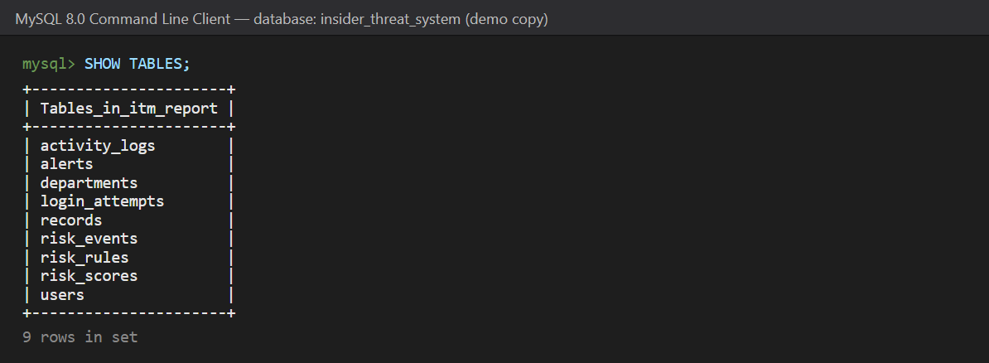
Figure 4.1: SHOW TABLES — the nine tables of the database
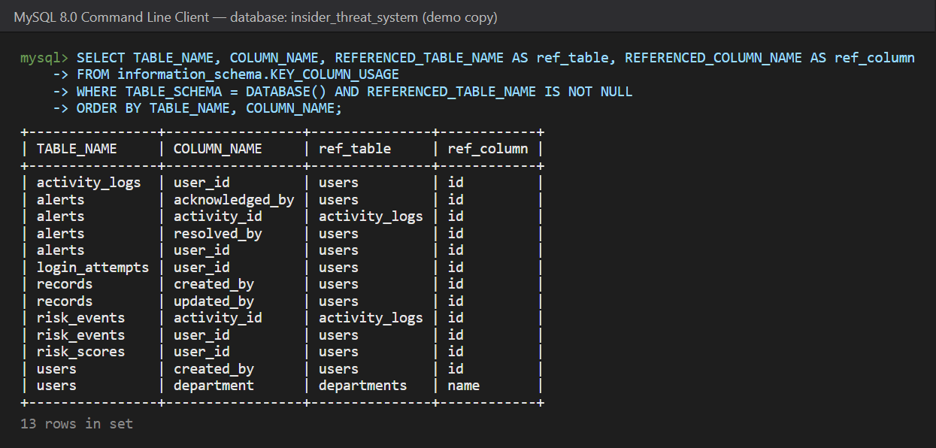
Figure 4.2: Foreign keys verified from information_schema
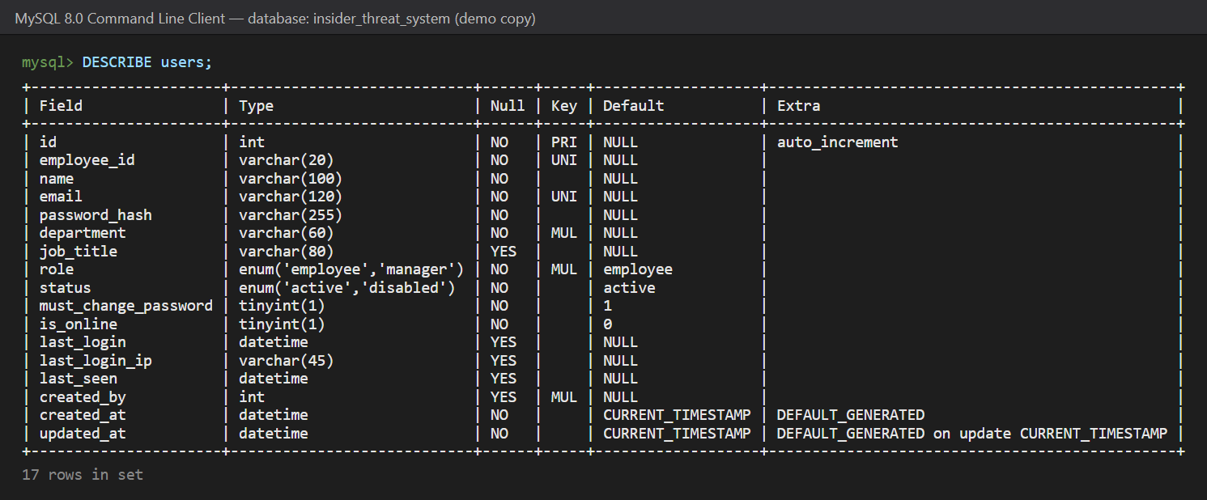
Figure 4.3: DESCRIBE users

4.5 Sample queries executed from the front end
The application never builds SQL by string concatenation; SQLAlchemy generates parameterised statements. To show how front-end actions become database operations, the SQL engine log was captured while performing two actions in the web interface.
(a) Manager creates an employee (Employees → New employee → Create). The backend inserts the user, creates the risk-score row and writes the audit activity in one transaction (Figure 4.5).
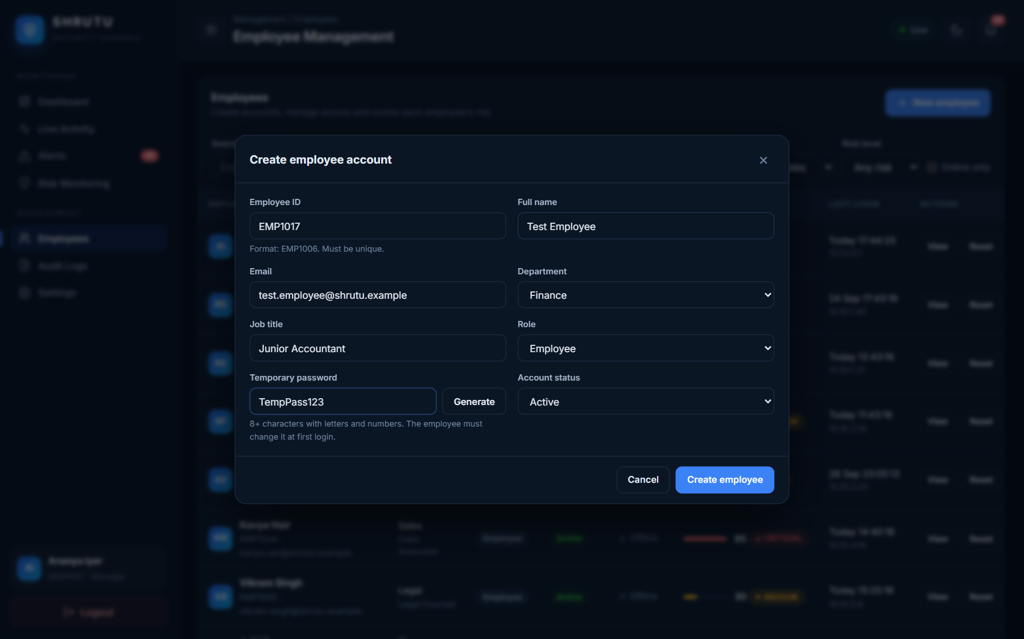
Figure 4.4: Front end: manager's "Create employee account" form

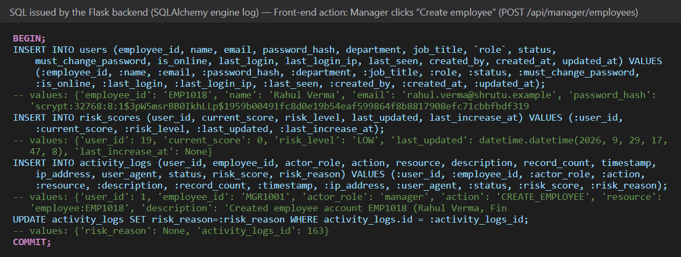
Figure 4.5: SQL generated for the create-employee action

(b) Employee opens a CONFIDENTIAL record. One click produces six writes inside one transaction: the activity row, its risk explanation, the score update from 55 to 70 (MEDIUM → HIGH), and two alerts (Figure 4.7).
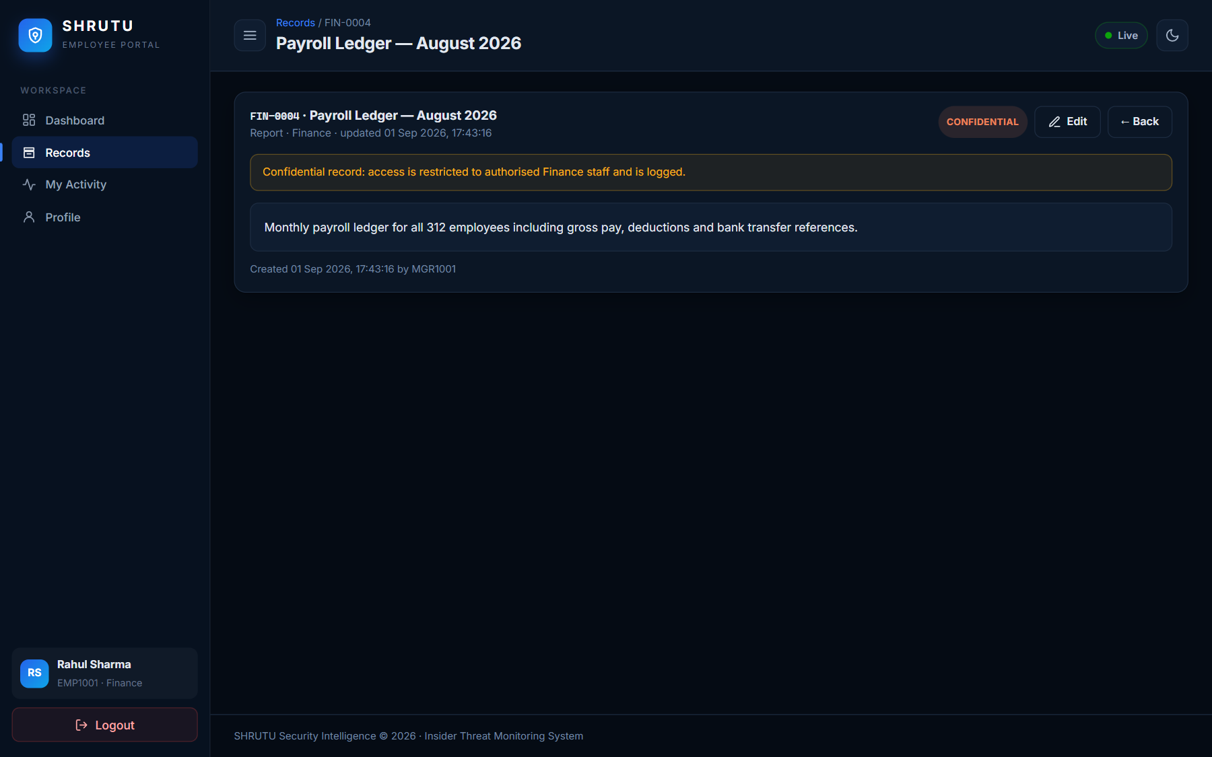
Figure 4.6: Front end: employee viewing a CONFIDENTIAL record

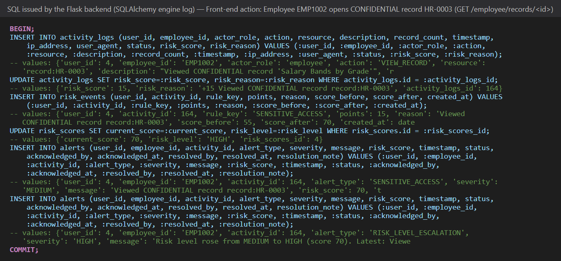
Figure 4.7: SQL generated when a confidential record is opened

Other important queries issued by the application include the windowed counts used by the risk engine and the dashboard aggregates, for example:
Listing 4.9 — representative queries used by the application
-- MASS_RECORD_ACCESS rule: records accessed by one employee in the last 5 minutes
SELECT COALESCE(SUM(record_count), 0) FROM activity_logs
WHERE employee_id = :emp AND timestamp >= NOW() - INTERVAL 5 MINUTE
AND action IN ('VIEW_RECORD','EXPORT_DATA') AND status = 'SUCCESS';

-- Dashboard KPI: employees at HIGH or CRITICAL risk
SELECT COUNT(*) FROM risk_scores r JOIN users u ON u.id = r.user_id
WHERE u.role = 'employee' AND r.risk_level IN ('HIGH','CRITICAL');

-- Alert cooldown check before inserting a new alert
SELECT id FROM alerts
WHERE employee_id = :emp AND alert_type = :type AND status <> 'RESOLVED'
AND timestamp >= NOW() - INTERVAL 10 MINUTE LIMIT 1;

4.6 Deployment
The application is deployed publicly. The source code is in a private GitHub repository; Render builds it from a render.yaml blueprint and runs gunicorn --worker-class gthread -w 1 --threads 100 wsgi:app behind HTTPS. The database is a free Aiven for MySQL 8.4 service in Bangalore, reached over TLS with certificate verification. On the first start the application detects the empty database and creates the schema and demo data automatically. Every git push redeploys the site.
Table 4.3: Deployment summary
Item | Value
Live URL | https://shrutu-insider-threat.onrender.com
Web hosting | Render free web service, Singapore region, Python 3.14
Database | Aiven for MySQL 8.4 (free plan), DigitalOcean Bangalore, TLS required
Secrets | Environment variables in Render (never committed)

5. Testing
Testing was carried out at three levels. Unit and integration tests are automated with pytest (52 tests) and run against an in-memory database so they are fast and repeatable; the Socket.IO tests use Flask-SocketIO's test client to verify that events really reach manager sockets. System testing was performed manually end to end on the real MySQL database in two separate browser sessions (manager and employee). All tests passed (Figure 5.1).

5.1 Unit testing
Table 5.1: Unit test cases
ID | Test case | Input | Expected output | Actual output | Result
U1 | Risk level thresholds | Scores 0, 29, 30, 59, 60, 79, 80, 100 | LOW, LOW, MEDIUM, MEDIUM, HIGH, HIGH, CRITICAL, CRITICAL | As expected | Pass
U2 | Normal activity adds no risk | Employee searches and opens an INTERNAL own-department record | Score 0, level LOW, no alert | Score 0, no alert | Pass
U3 | Sensitive access | Employee opens a CONFIDENTIAL record twice | Score 15 → 30 (MEDIUM); two risk_events; one alert (cooldown) | As expected | Pass
U4 | Unauthorised access | Open RESTRICTED record, then other department's record | Score 60 (HIGH) + RISK_LEVEL_ESCALATION alert | Score 60, escalation alert HIGH | Pass
U5 | Critical & cap | Four unauthorised attempts | CRITICAL, REPEATED_UNAUTHORIZED alert, score never > 100 | Score 100, CRITICAL | Pass
U6 | Repeated failed logins | 3 wrong passwords for known ID and unknown ID EMP4040 | HIGH alert for both; known user score 50 (MEDIUM) | As expected | Pass
U7 | Mass export | Export CSV of ≥ 15 records | MASS_RECORD_ACCESS alert, reason "Accessed N records…" | As expected | Pass
U8 | New location | Login from 203.0.113.9 after using 127.0.0.1 | NEW_LOCATION alert | As expected | Pass
U9 | Off-hours rule | Two searches on Sunday 23:15 | One OFF_HOURS event (once per window) | One event, reason mentions 23:15 Sunday | Pass
U10 | Score decay | Score 70, quiet for 5 hours | Score 60 | 60 | Pass
U11 | Configurable rules | Set SENSITIVE_ACCESS points 40, severity HIGH; points 500 | Rule applied (score 40, HIGH alert); 500 rejected (400) | As expected | Pass
U12 | Extra seed consistency | Run seed_extra twice | 10 employees added once; every score equals sum of its risk events | As expected | Pass

5.2 Integration testing
Table 5.2: Integration test cases
ID | Test case | Input | Expected output | Actual output | Result
I1 | Manager login | MGR1001 / valid password | Redirect to /manager/dashboard; MANAGER_LOGIN logged; login_attempts success row | As expected | Pass
I2 | Employee login & presence | EMP1001 / valid password | Redirect to employee dashboard; user online; LOGIN logged | As expected | Pass
I3 | Invalid password | EMP1001 / wrong password | HTTP 401, generic message, FAILED_LOGIN (+10) and attempt stored | As expected | Pass
I4 | Create employee | POST valid employee JSON | 201; row in users with scrypt hash, must_change_password = 1, risk_scores row, CREATE_EMPLOYEE audit; new user can log in | As expected | Pass
I5 | Duplicate data | Same employee ID; same e-mail | 409 with field employee_id / email | 409 + field | Pass
I6 | Disable employee | PUT status=disabled | Account disabled, DISABLE_EMPLOYEE audited, existing session invalidated | As expected | Pass
I7 | Reset password | POST new temporary password | Old password rejected; new one works and forces change | As expected | Pass
I8 | Acknowledge / resolve alert | PUT acknowledge, then resolve with note | Status and acknowledged_by/at, resolved_by/at, note stored; audit rows; second acknowledge 409; DELETE 405 | As expected | Pass
I9 | Activity filters | action, suspicious, severity, alert_status, employee, role, risk_level | Only matching rows returned | As expected | Pass
I10 | Dashboard numbers | GET /api/manager/dashboard | KPIs and chart totals equal database counts | Equal | Pass
I11 | Real-time delivery | Employee opens RESTRICTED record while manager socket connected | Manager receives activity:new and alert:new with stored IDs | Received | Pass
I12 | Socket authorisation | Anonymous socket; employee socket | Anonymous rejected; employee receives no manager events | As expected | Pass

5.3 System testing (end-to-end)
Table 5.3: System test cases
ID | Test case | Input | Expected output | Actual output | Result
S1 | Manager creates employee from UI | EMP1006/EMP1017, Finance, temporary password | Row in MySQL users, audit entry, appears in list | Created; verified with SELECT | Pass
S2 | First login of new employee | New ID + temporary password (second browser) | Forced password change; LOGIN appears in manager's live feed without refresh | Appeared within ~1 s | Pass
S3 | Normal work | Search, view, search, view | Four feed rows, zero risk points, no alert | As expected | Pass
S4 | Suspicious behaviour | Open FIN-0010 (RESTRICTED), SAL-0002, /manager/employees | Three 403 pages; score to CRITICAL; grouped alert pop-ups on manager screen without refresh | As expected (Figure 6.15) | Pass
S5 | Investigation | Click alert → View activity | Full details incl. IP, user agent, risk reason | As expected | Pass
S6 | Acknowledge | Click Acknowledge | alerts.status = ACKNOWLEDGED, acknowledged_by = MGR1001, counter decreases in all manager tabs | Verified in MySQL | Pass
S7 | Two laptops / public deployment | Manager and employee on different devices via live URL | Same real-time behaviour over HTTPS/WSS | As expected | Pass
S8 | Responsive UI | 390 px mobile viewport; light theme | No horizontal scroll; readable layout | As expected (Figures 6.29–6.30) | Pass

5.4 Security and validation checks
Table 5.4: Security and validation test cases
ID | Test case | Input | Expected output | Actual output | Result
V1 | Brute-force lockout | 5 wrong passwords then correct password | HTTP 429 "Too many attempts"; LOCKED_OUT recorded | As expected | Pass
V2 | Disabled account | Correct password of disabled user | 403 "account disabled"; ACCOUNT_DISABLED attempt | As expected | Pass
V3 | Privilege escalation | Employee requests /manager/dashboard and /api/manager/* | 403; UNAUTHORIZED_ACCESS + PRIVILEGE_ESCALATION alerts | As expected | Pass
V4 | Direct URL to other department record | Employee opens /employee/records/<Sales id> | 403 and alert; not shown in search | As expected | Pass
V5 | Input validation | ID "12", e-mail "nope", department "Space", password "short", name "<script>" | 400 with the offending field; nothing inserted | As expected | Pass
V6 | Employee data isolation | GET /api/employee/activity | Only own rows; no risk_score / risk_reason fields | As expected | Pass
V7 | Logout method | GET /logout | 405 (POST with CSRF token only) | 405 | Pass
V8 | Expired session (API) | API call without session | 401 JSON | 401 | Pass
V9 | Security headers | GET / | CSP default-src 'self', X-Frame-Options DENY | Present | Pass
V10 | Password storage | Inspect users.password_hash | scrypt hash, never plain text; never returned by API | As expected | Pass
V11 | SQL injection | Search text: ' OR 1=1 -- | Treated as literal text (parameter binding) | No extra rows | Pass

5.5 Automated test run
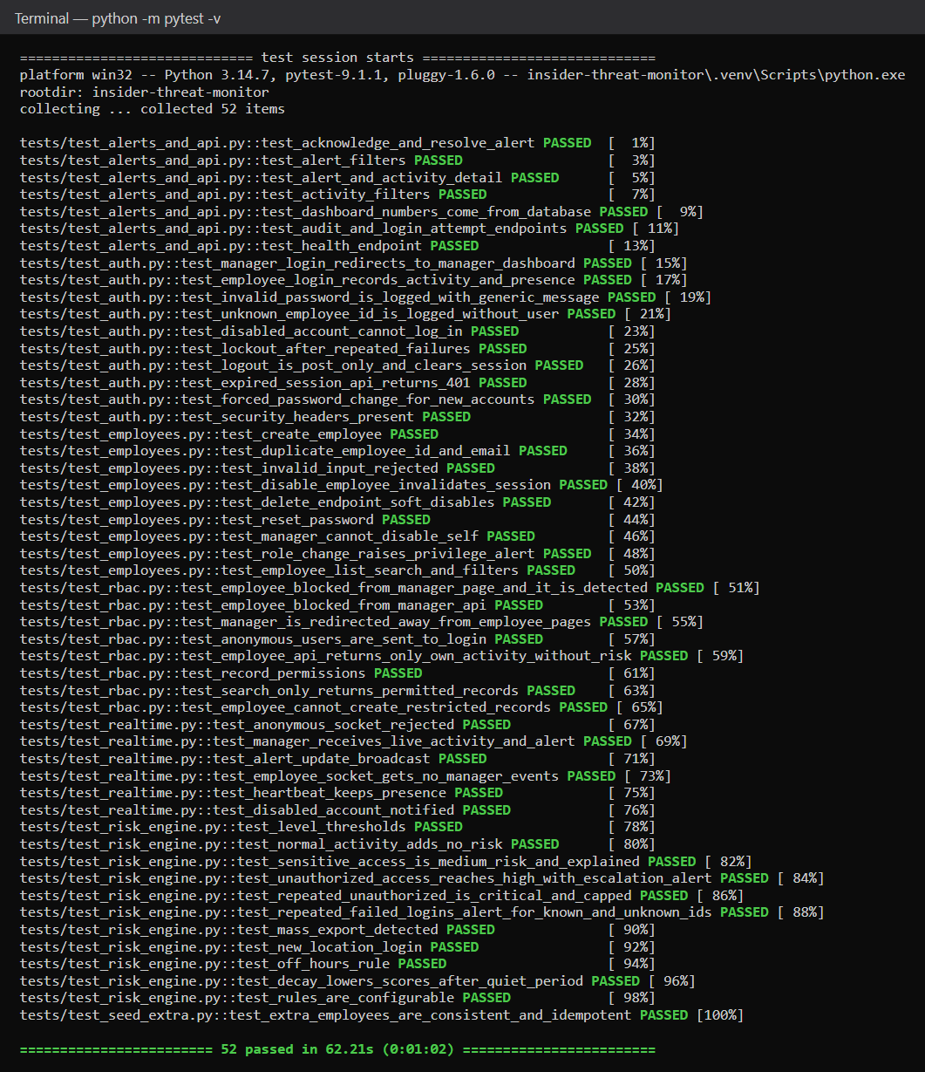
Figure 5.1: Output of the automated test suite (52 passed)

6. Results and Snapshots

6.1 Web application screenshots
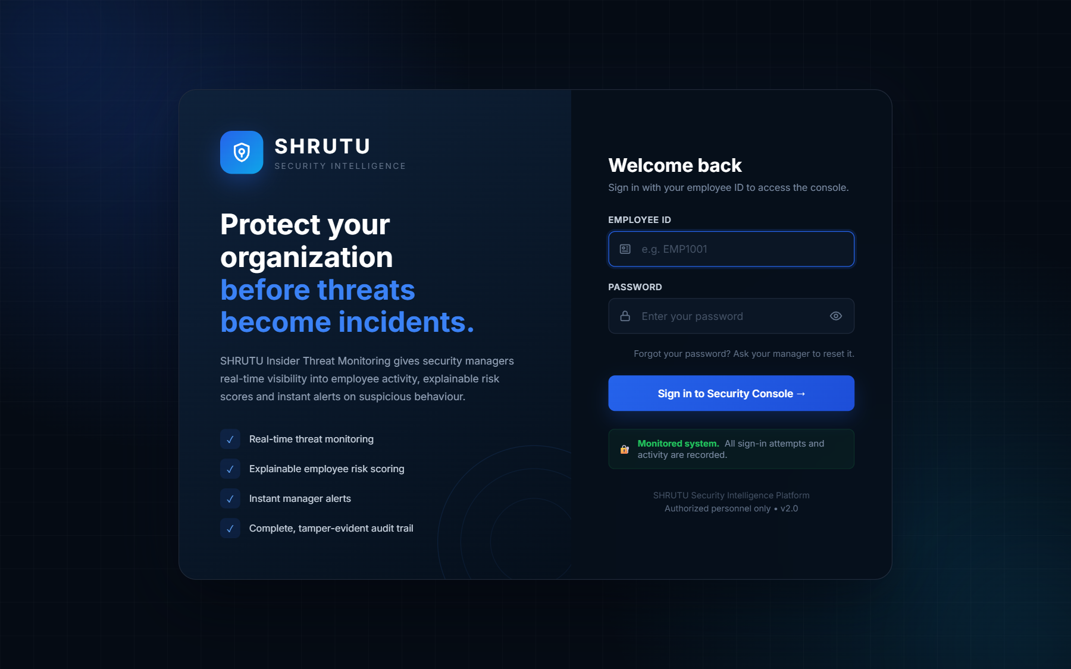
Figure 6.1: Login page
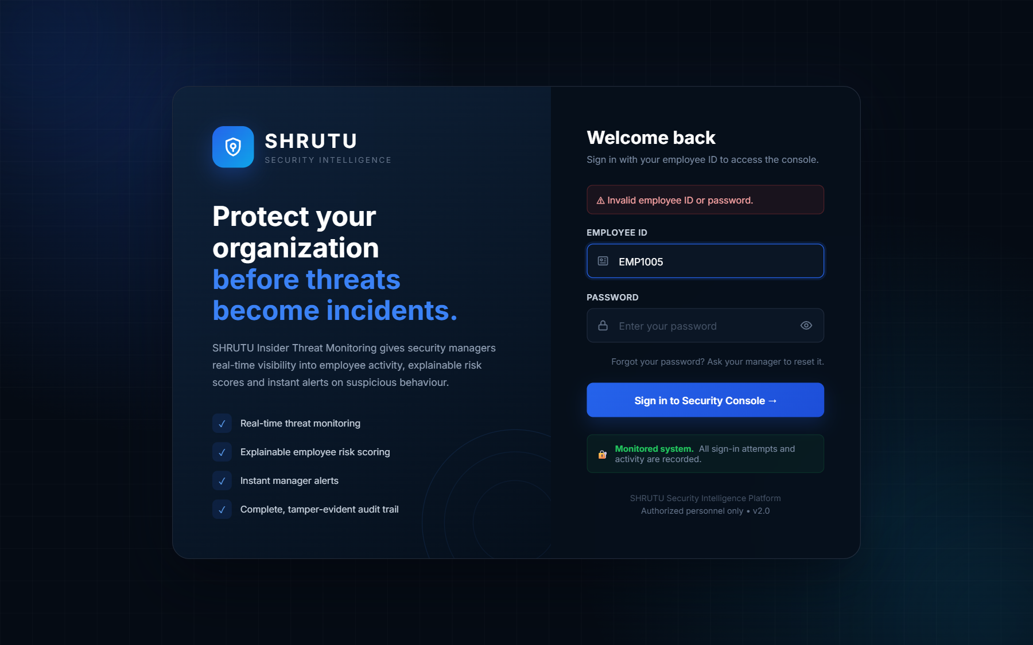
Figure 6.2: Invalid login — generic error message (attempt recorded)

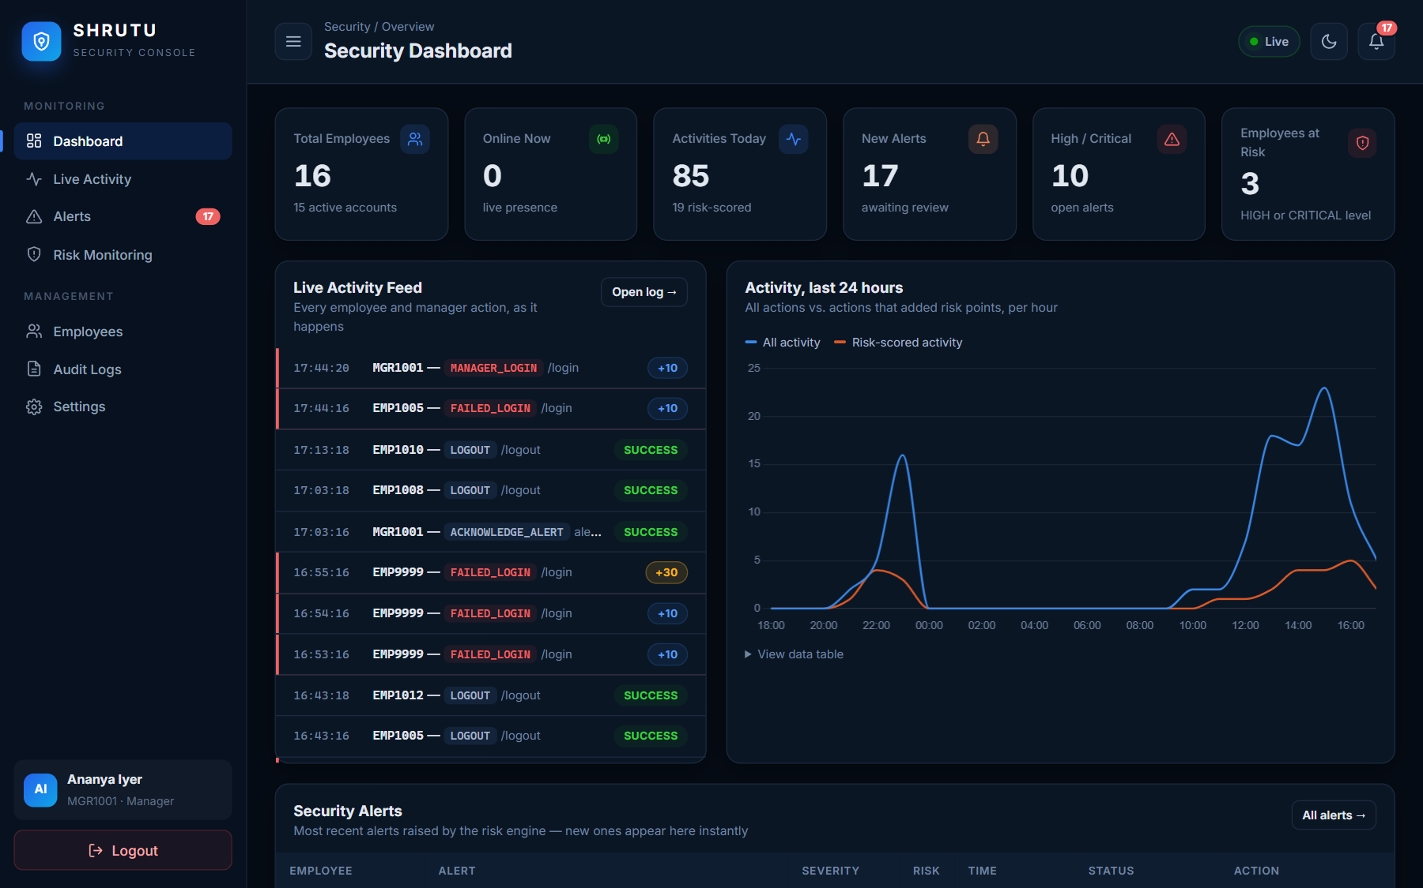
Figure 6.3: Manager Security Dashboard: KPIs, live activity feed and 24-hour activity chart

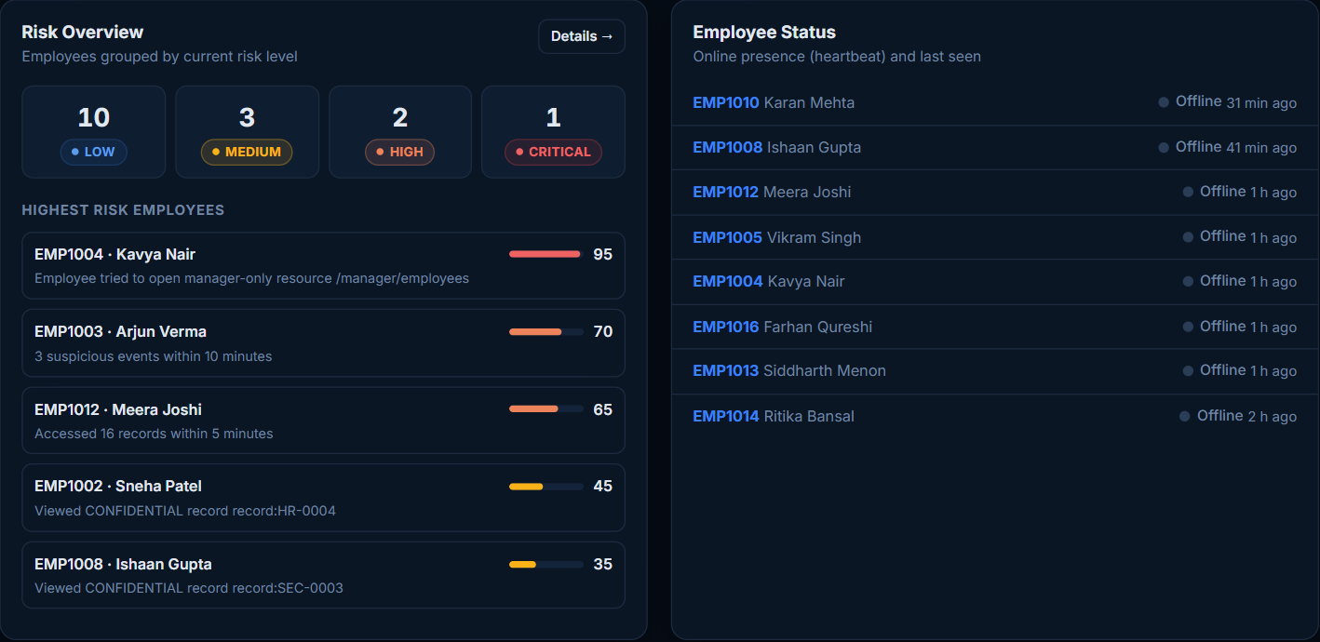
Figure 6.4: Dashboard: risk overview and employee online/offline status
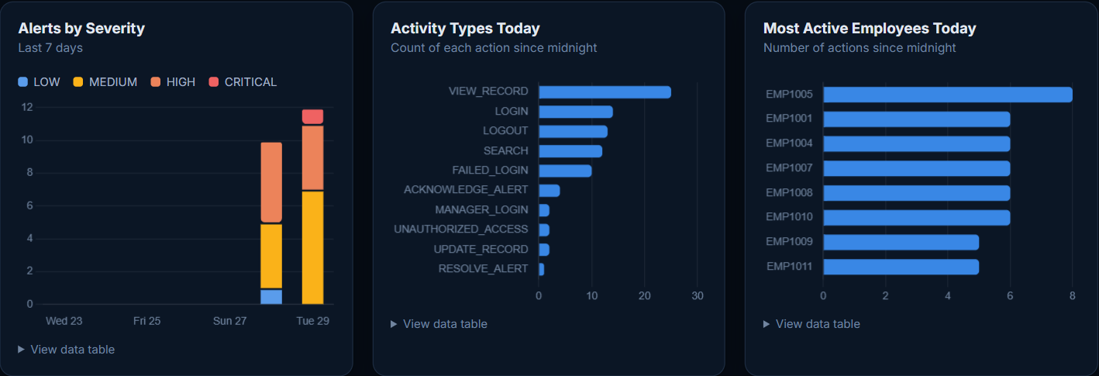
Figure 6.5: Dashboard charts: alerts by severity, activity types, most active employees
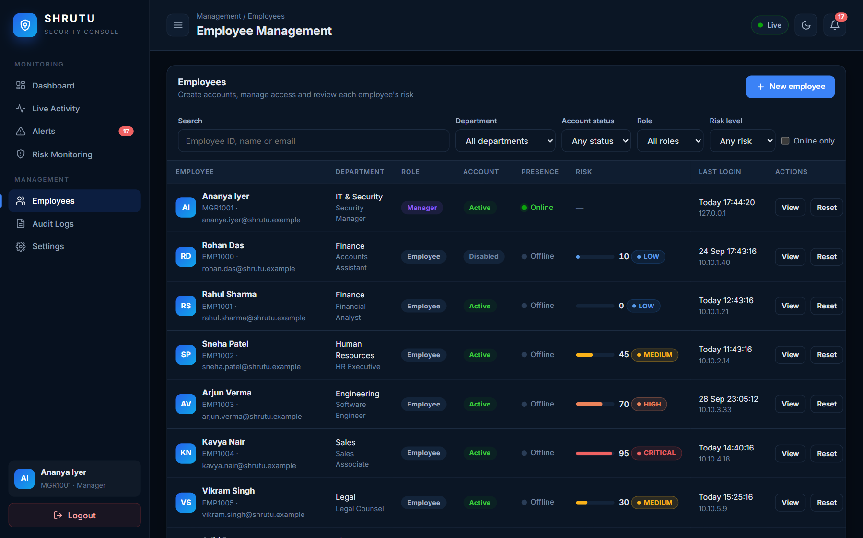
Figure 6.6: Employee management with search and filters
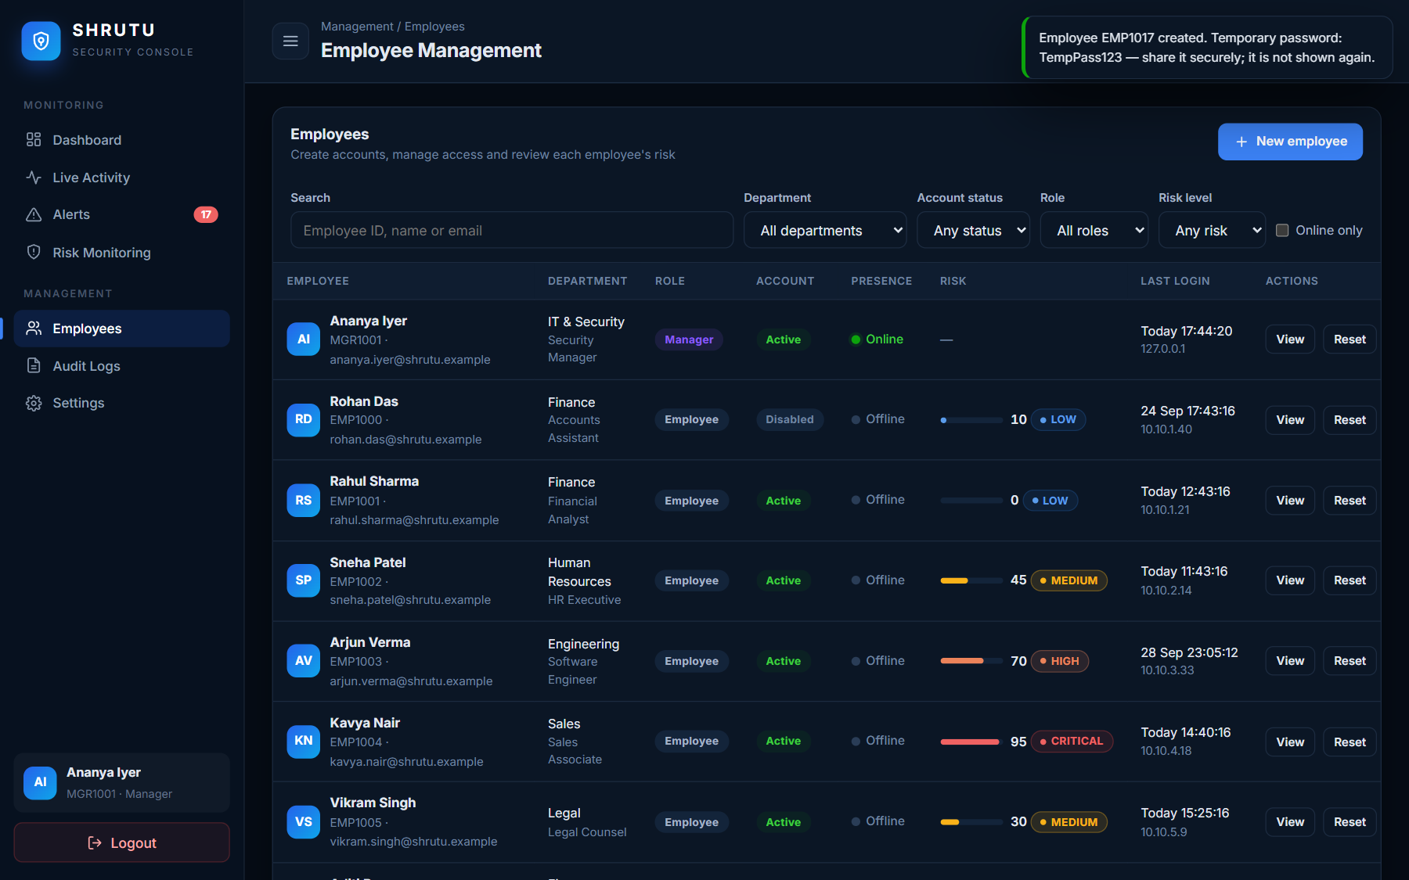
Figure 6.7: Employee created — confirmation
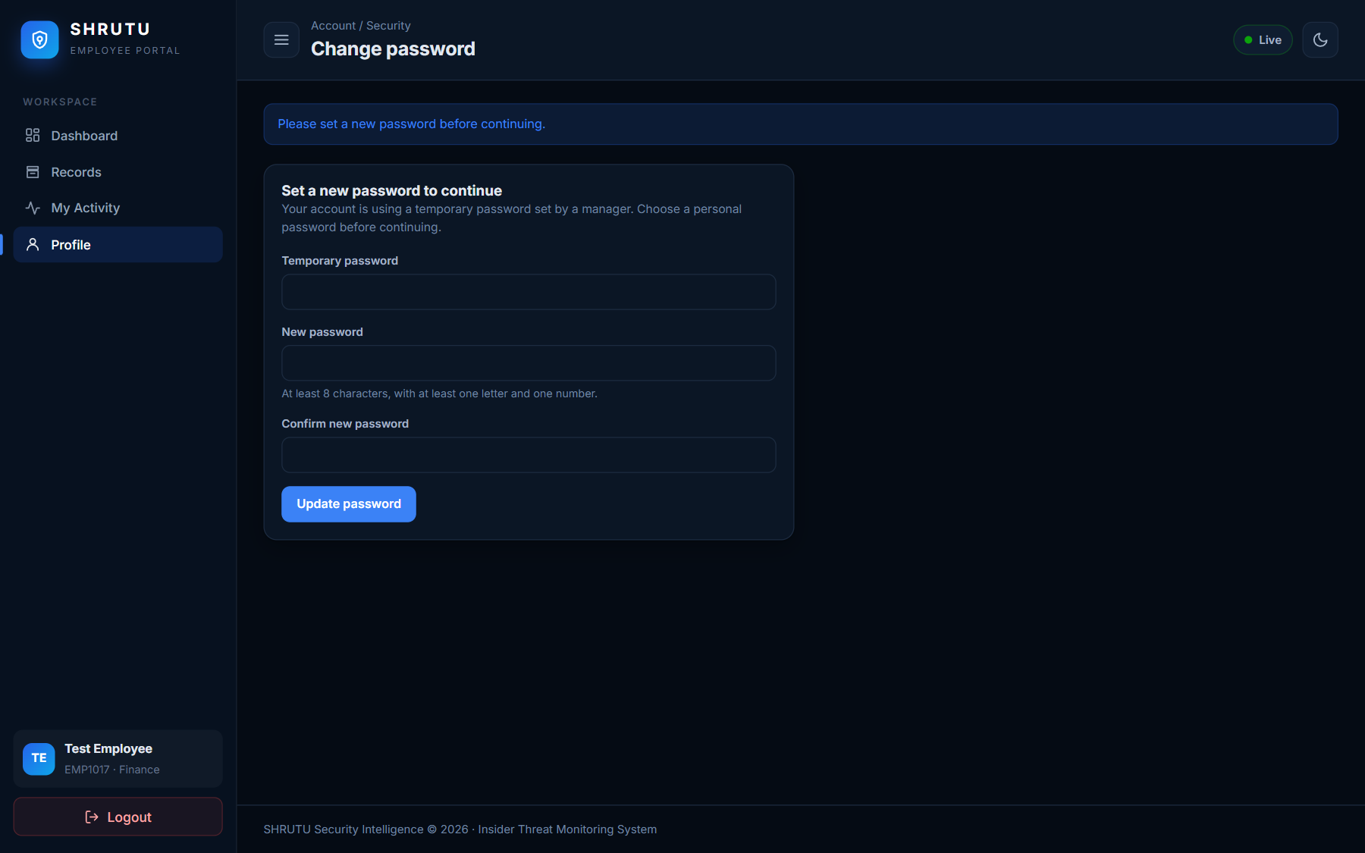
Figure 6.8: New employee must set a new password at first login
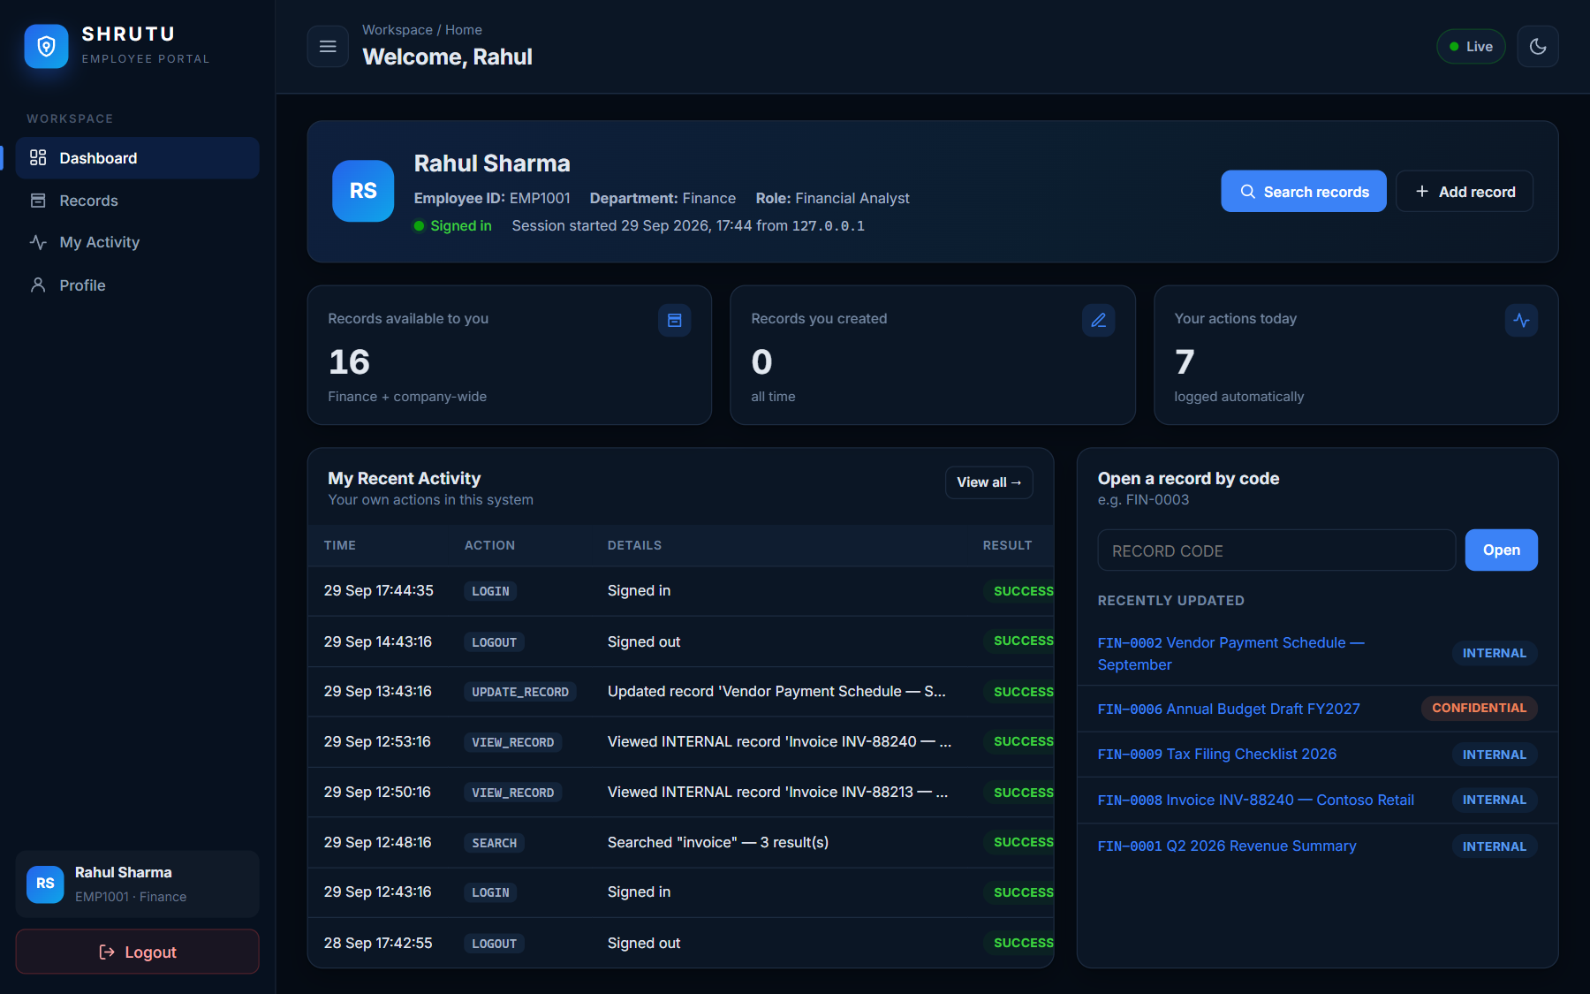
Figure 6.9: Employee dashboard (no risk information is shown to employees)
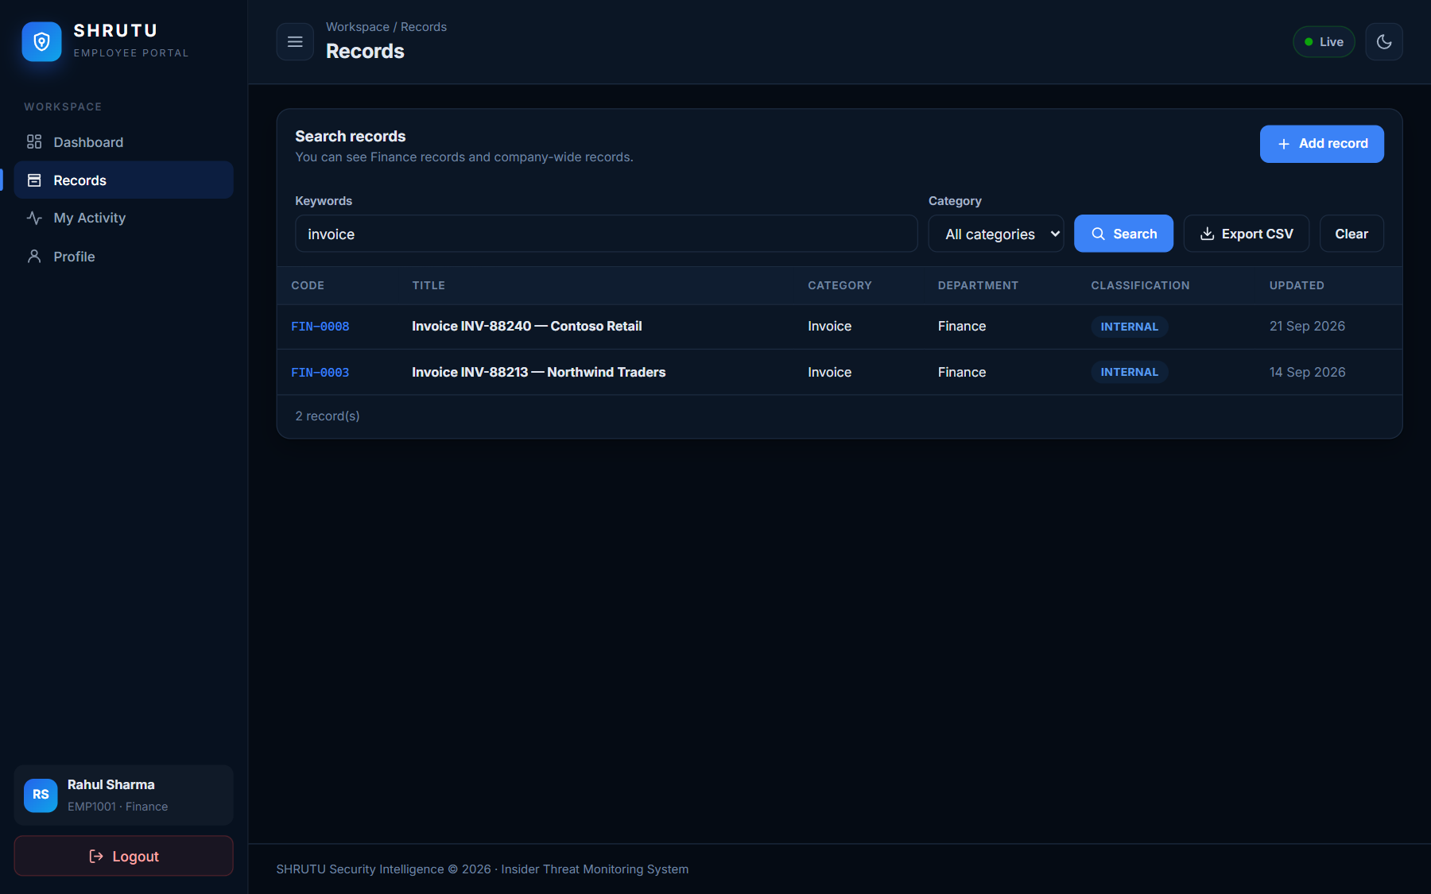
Figure 6.10: Employee record search
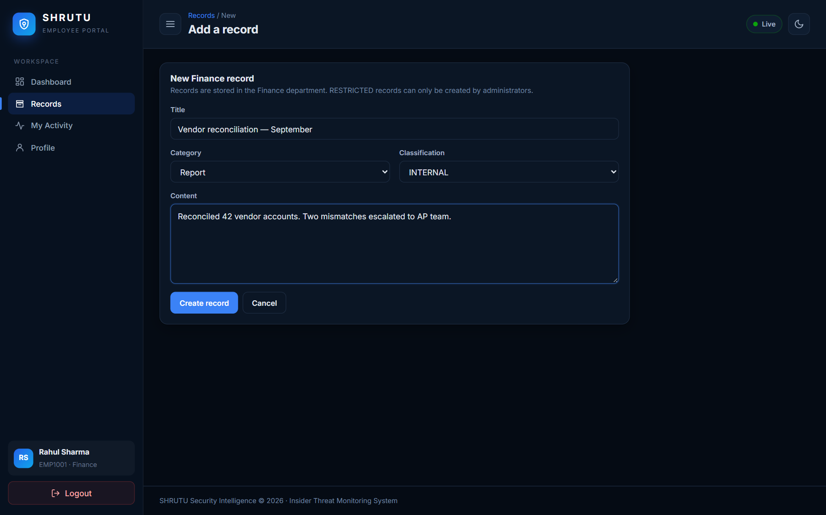
Figure 6.11: Add record form
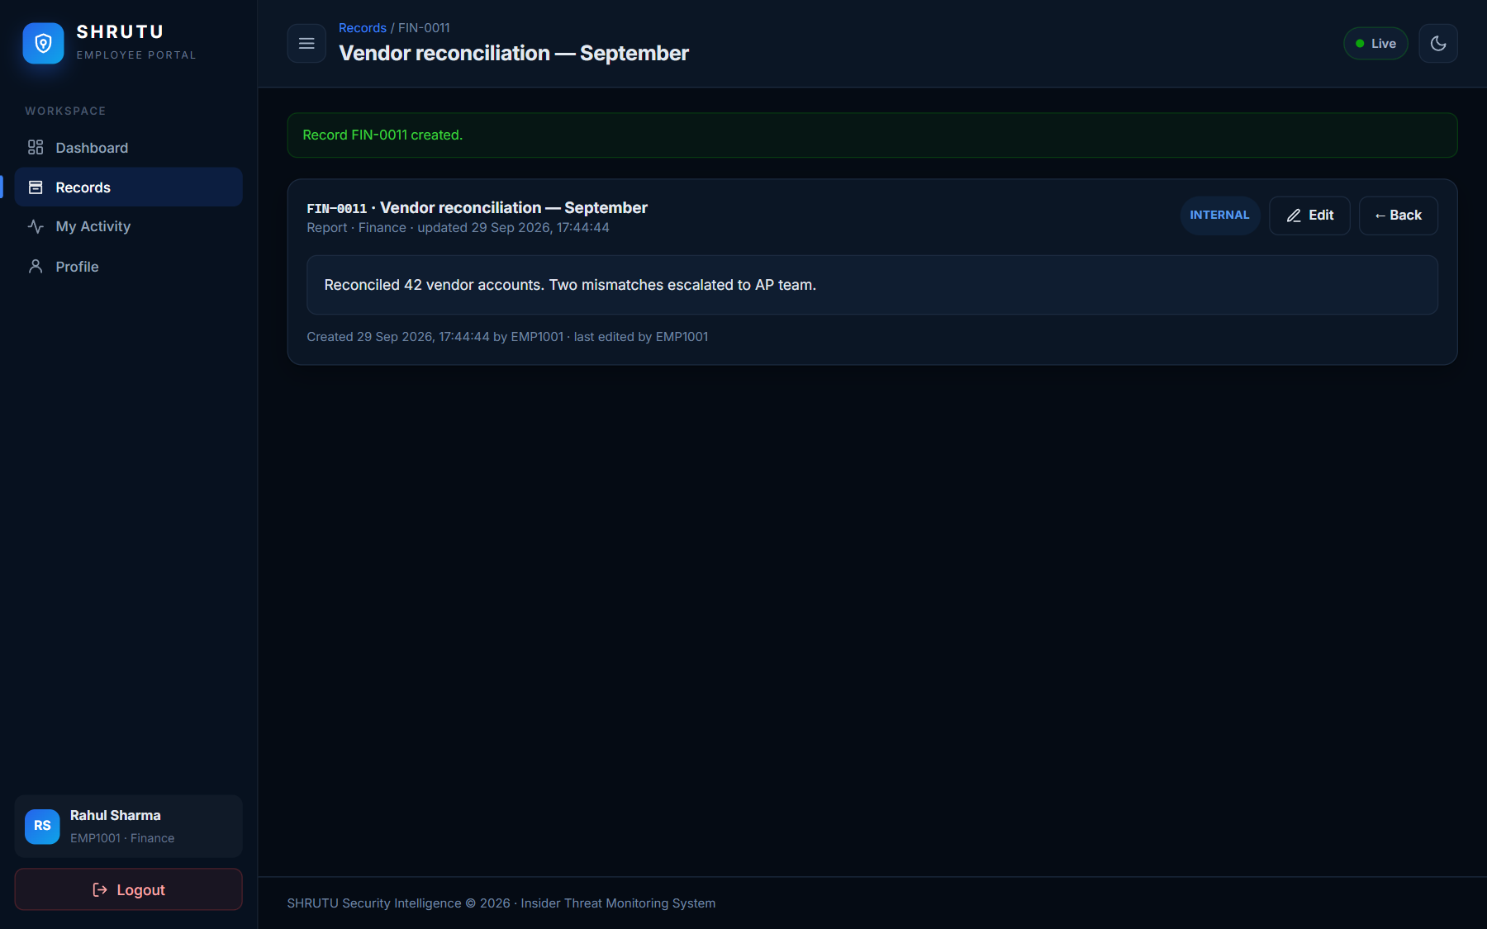
Figure 6.12: Record created
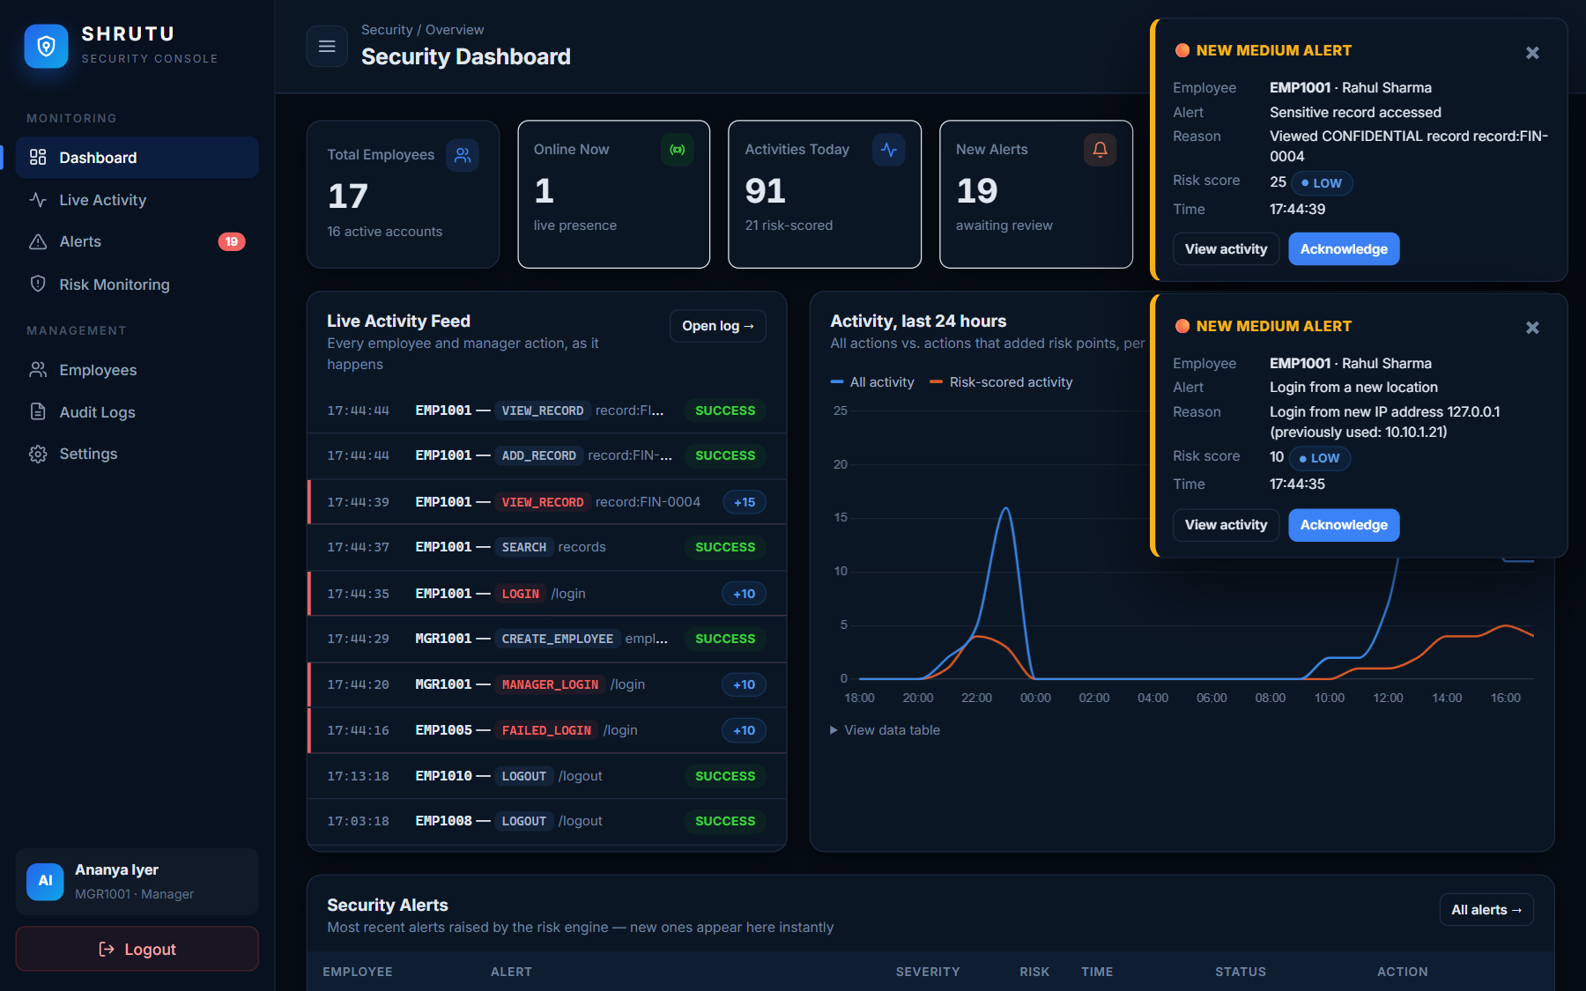
Figure 6.13: Manager's live feed while the employee works
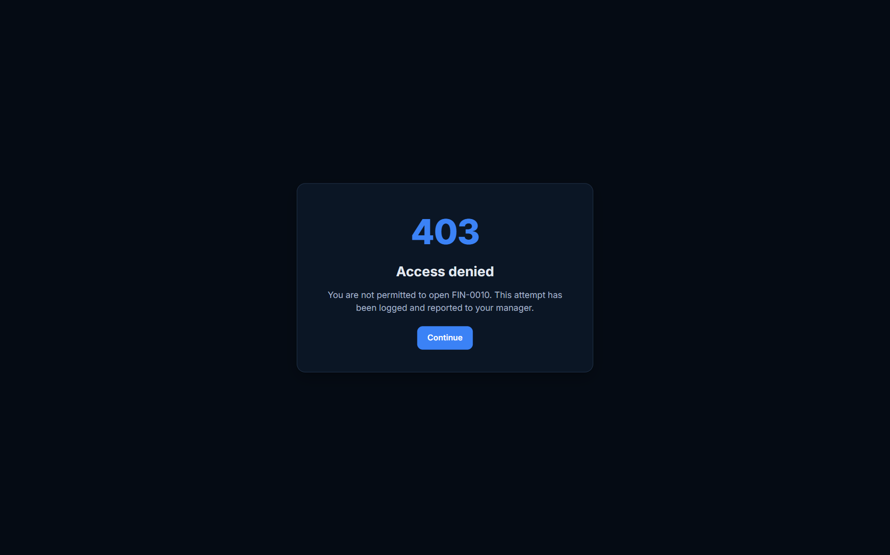
Figure 6.14: Employee blocked from a RESTRICTED record (HTTP 403)

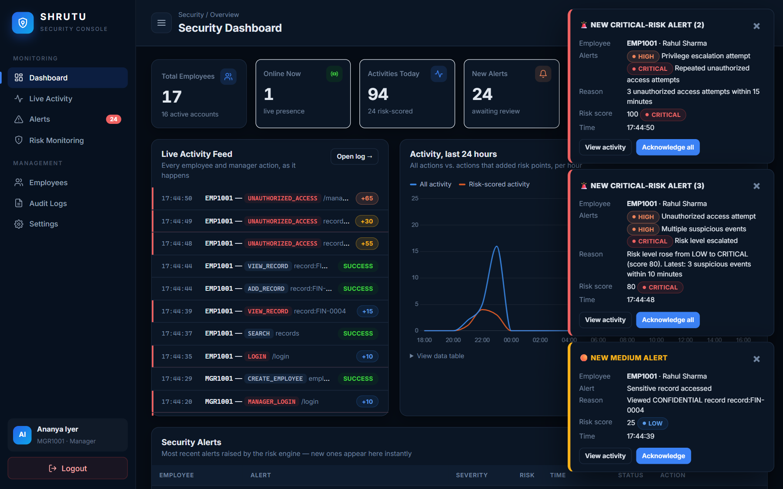
Figure 6.15: Real-time alert pop-ups on the manager's screen — no page refresh

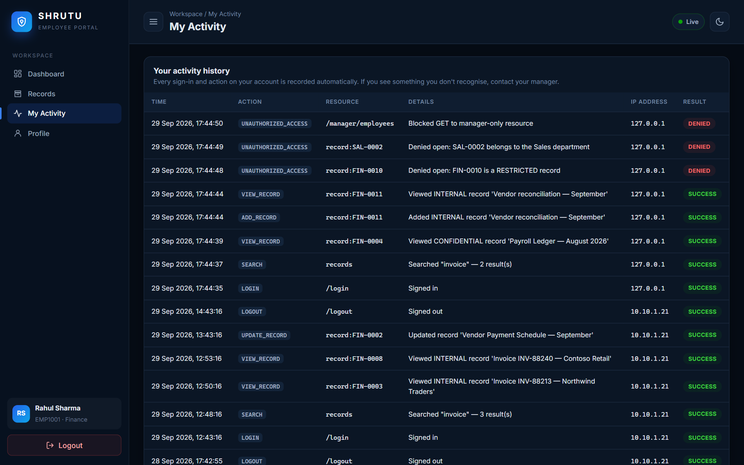
Figure 6.16: Employee: My Activity
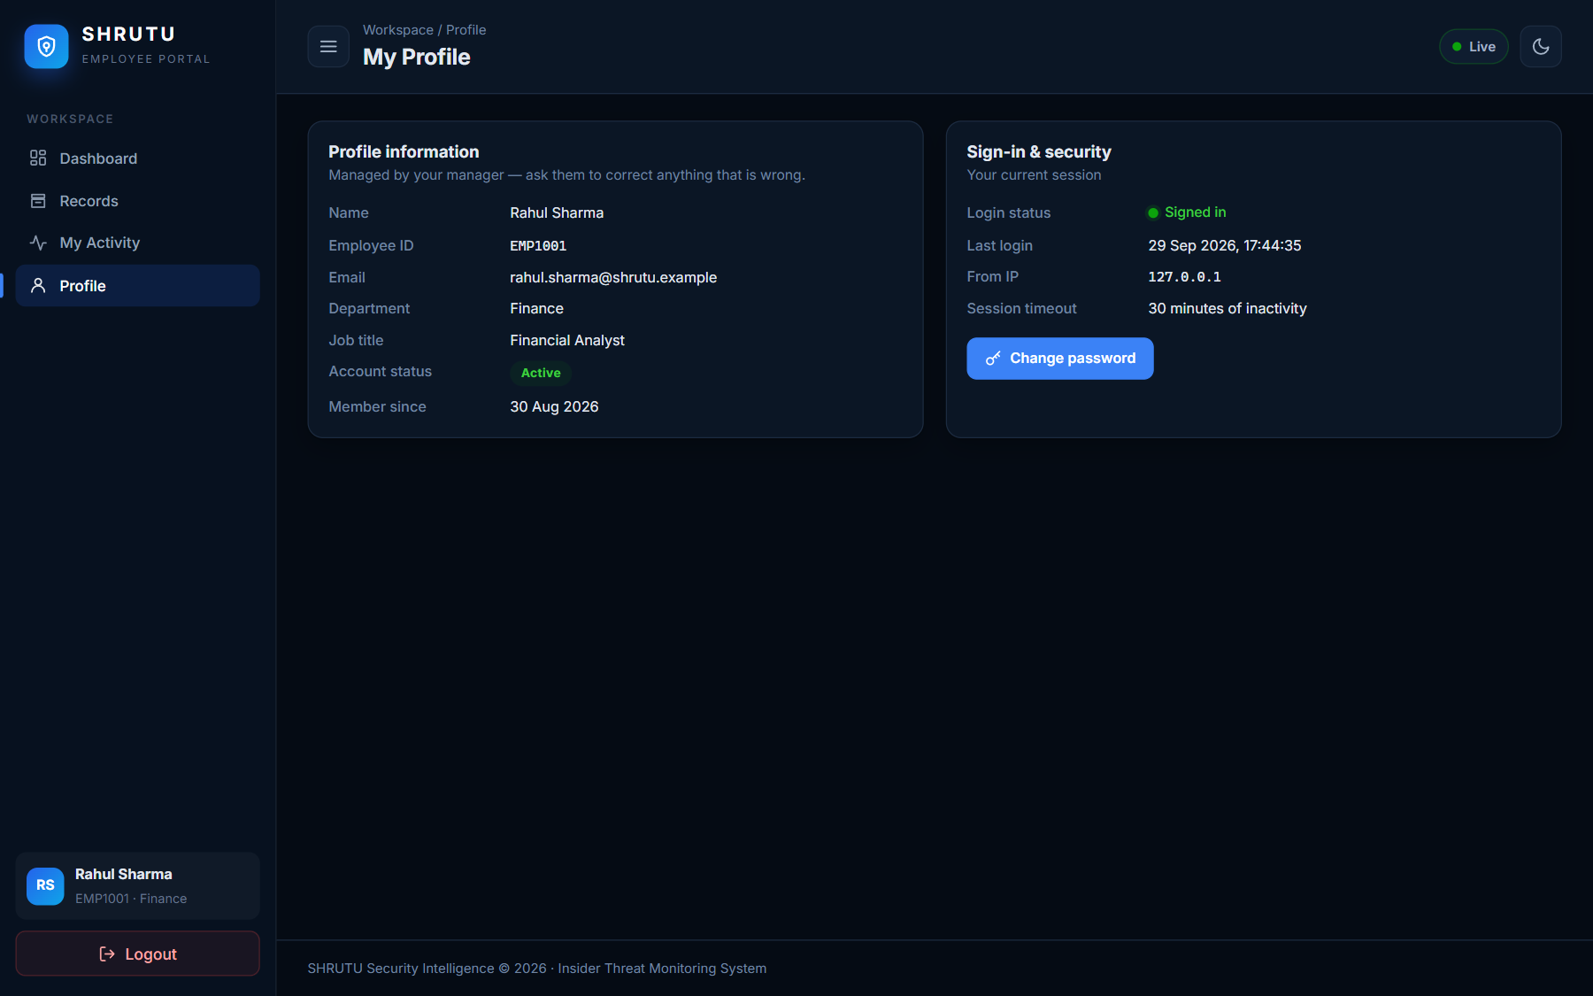
Figure 6.17: Employee profile
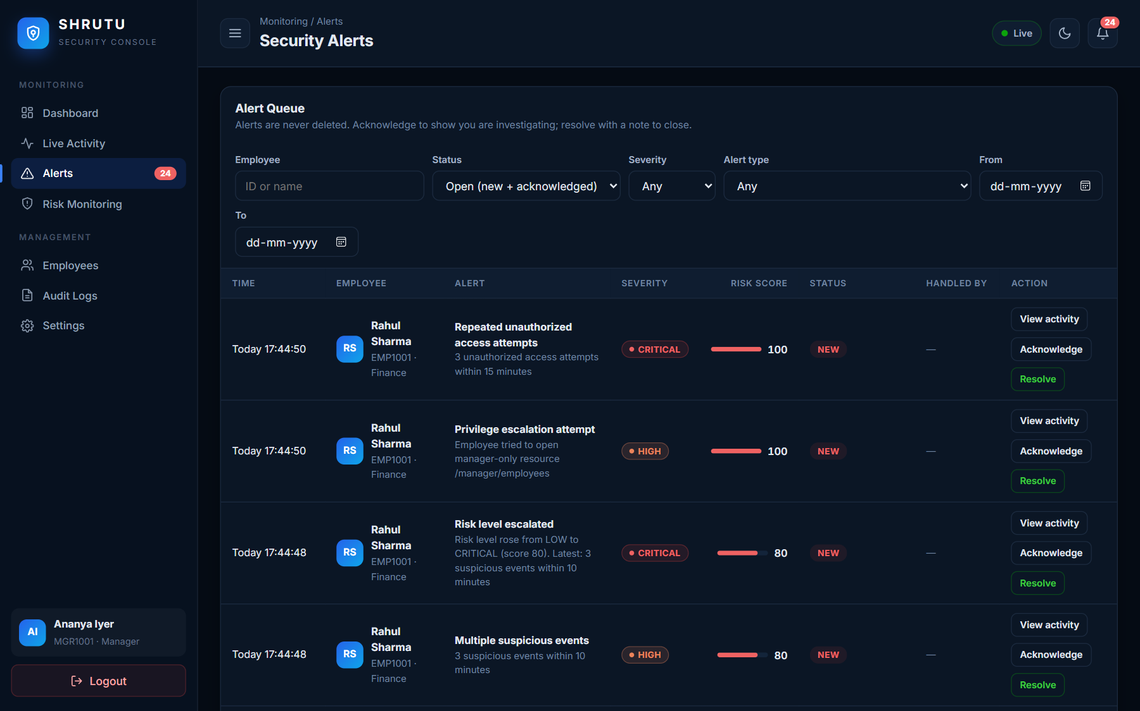
Figure 6.18: Alert queue
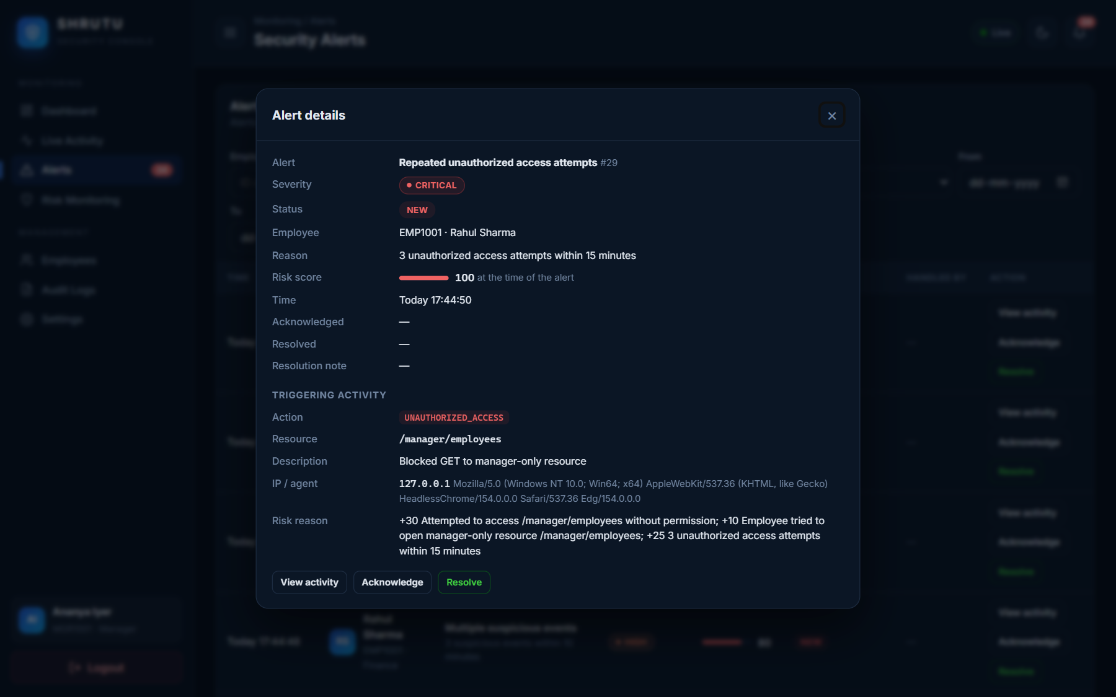
Figure 6.19: Alert details with triggering activity

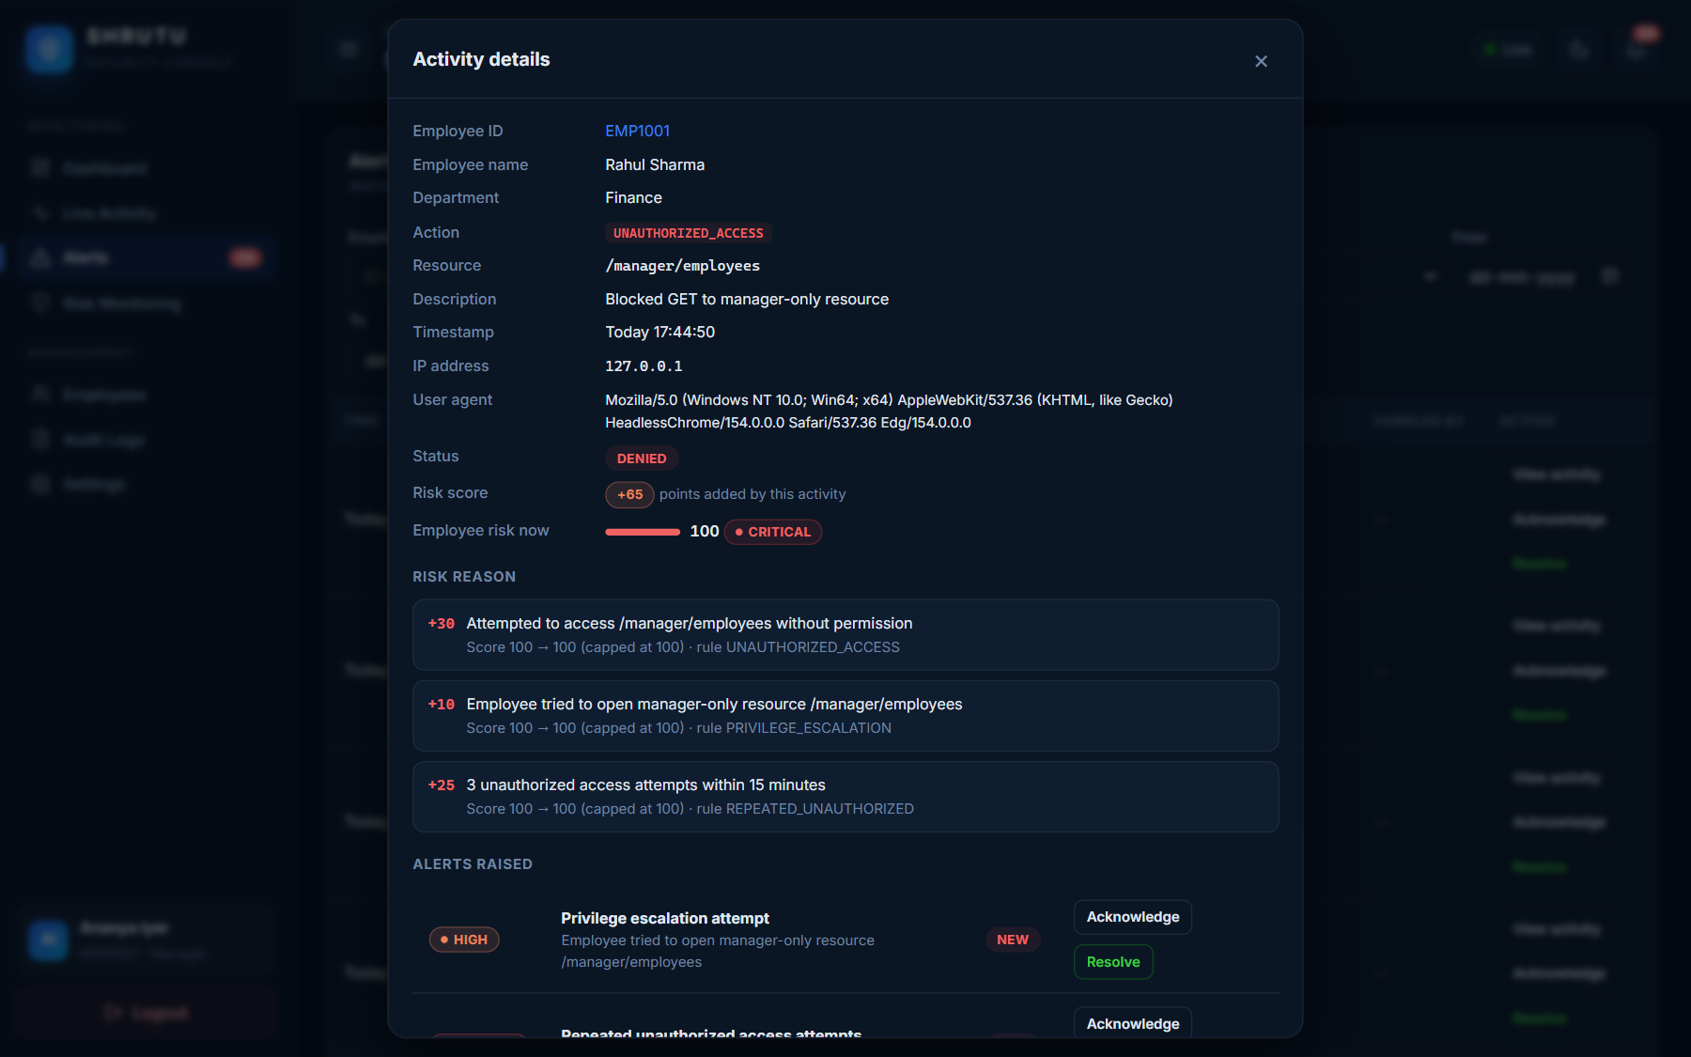
Figure 6.20: Activity details with IP, user agent and point-by-point risk reason

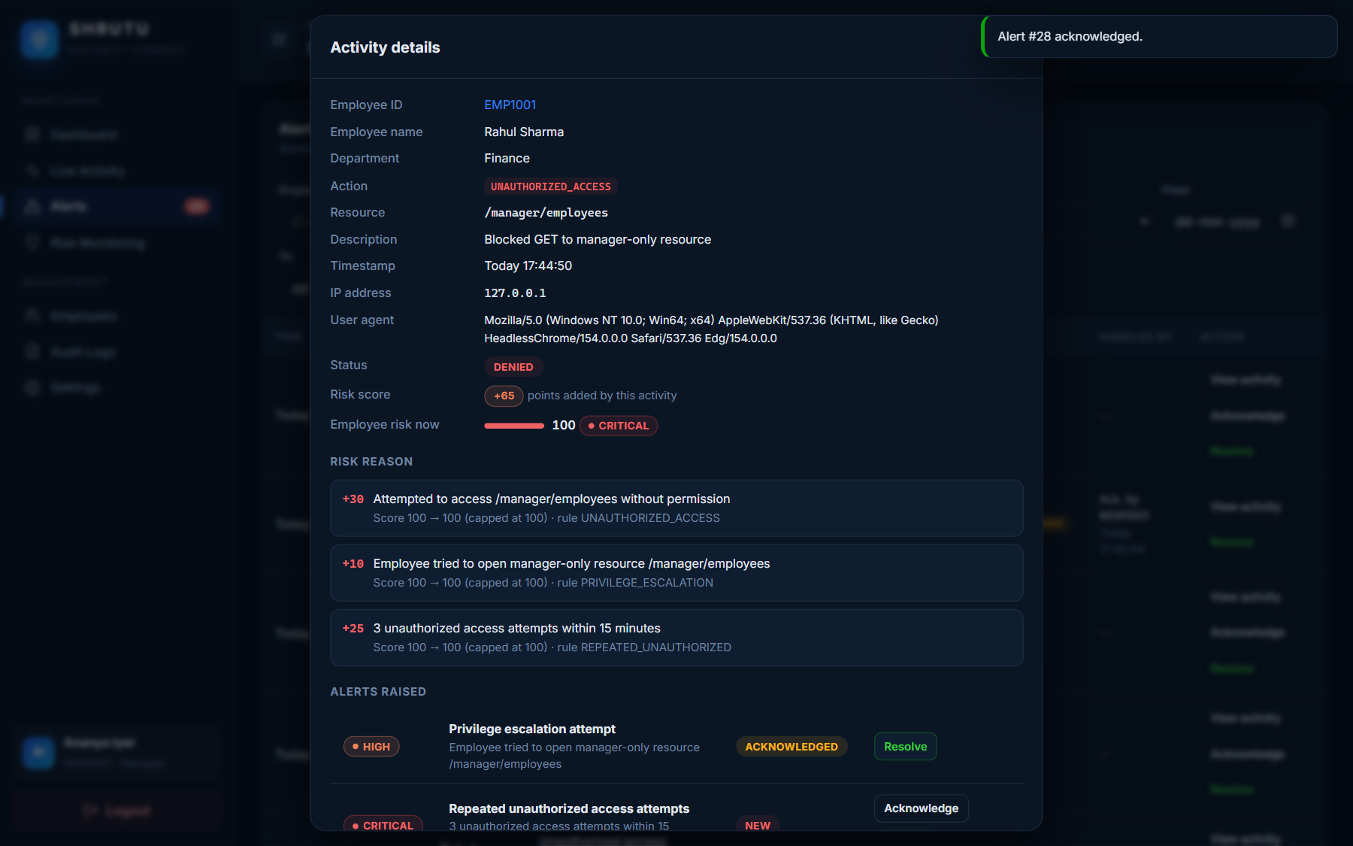
Figure 6.21: Alert acknowledged
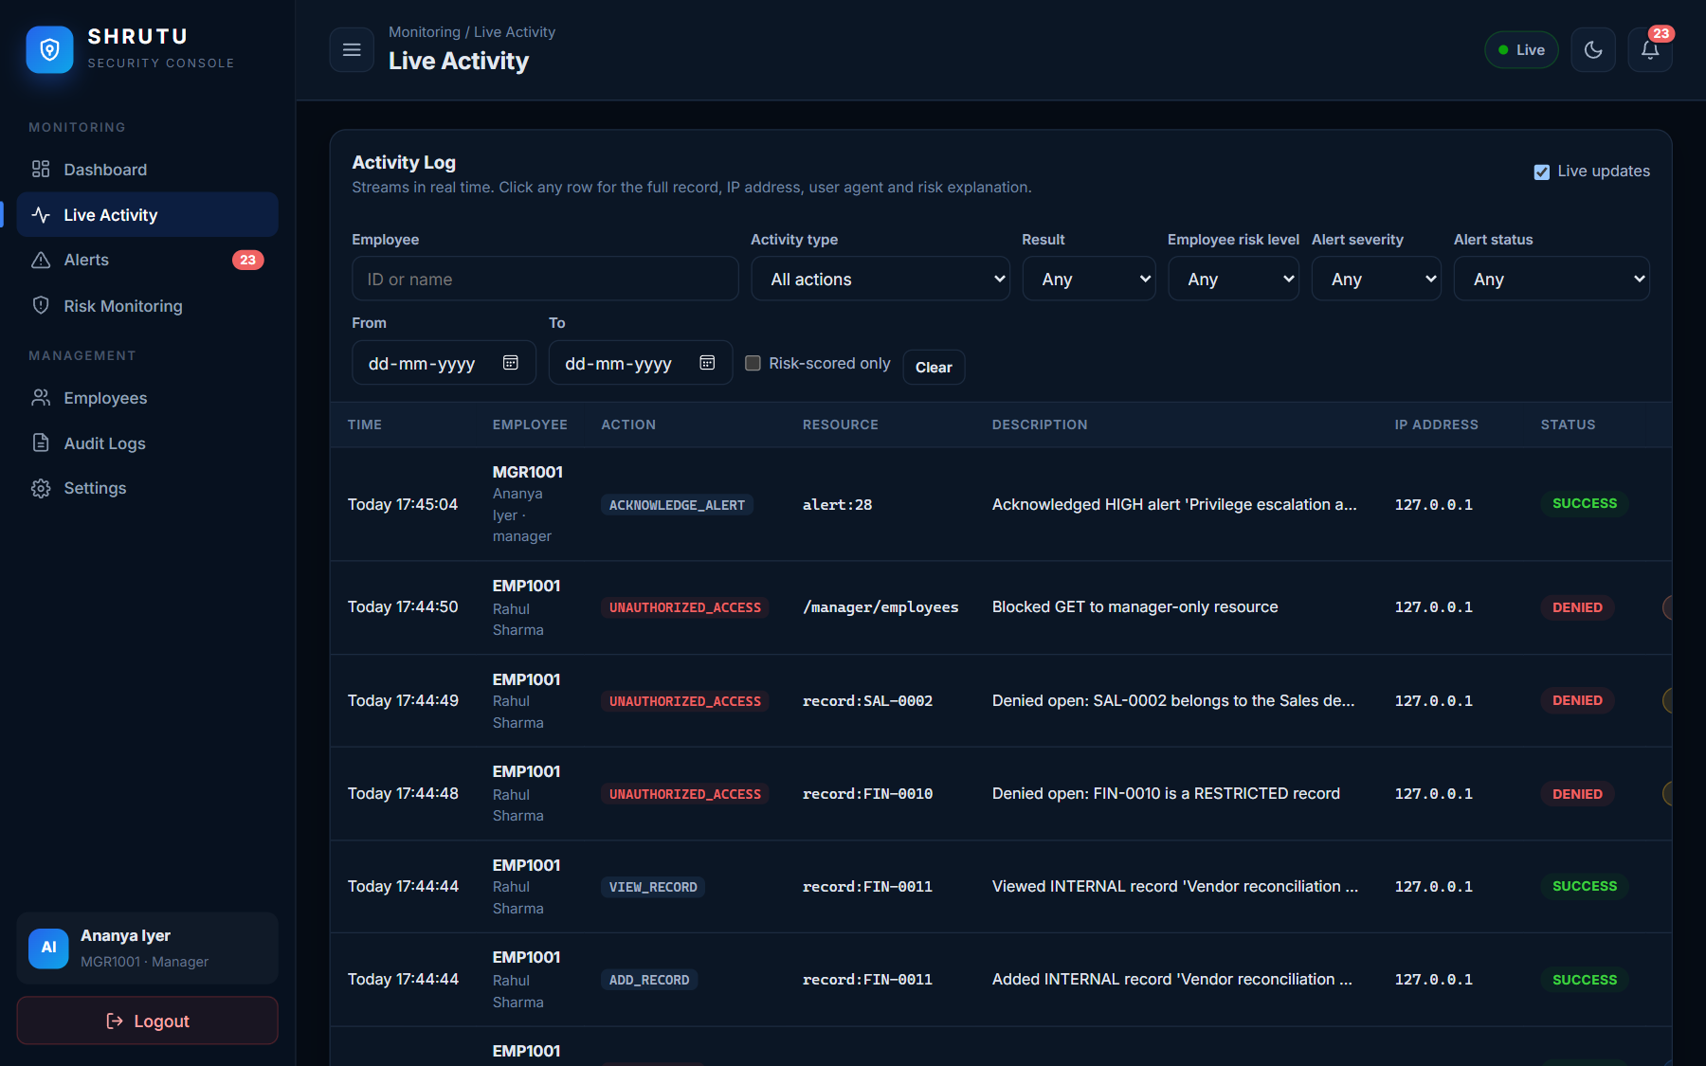
Figure 6.22: Live Activity log
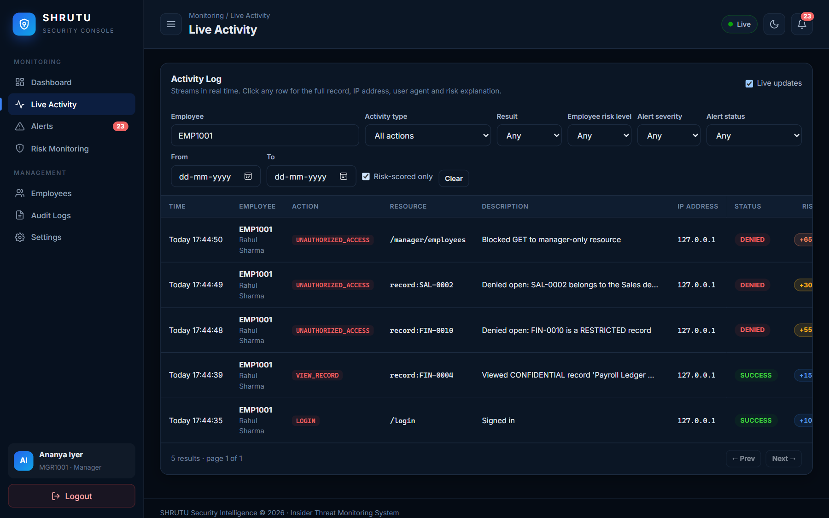
Figure 6.23: Activity log filtered by employee and risk-scored actions
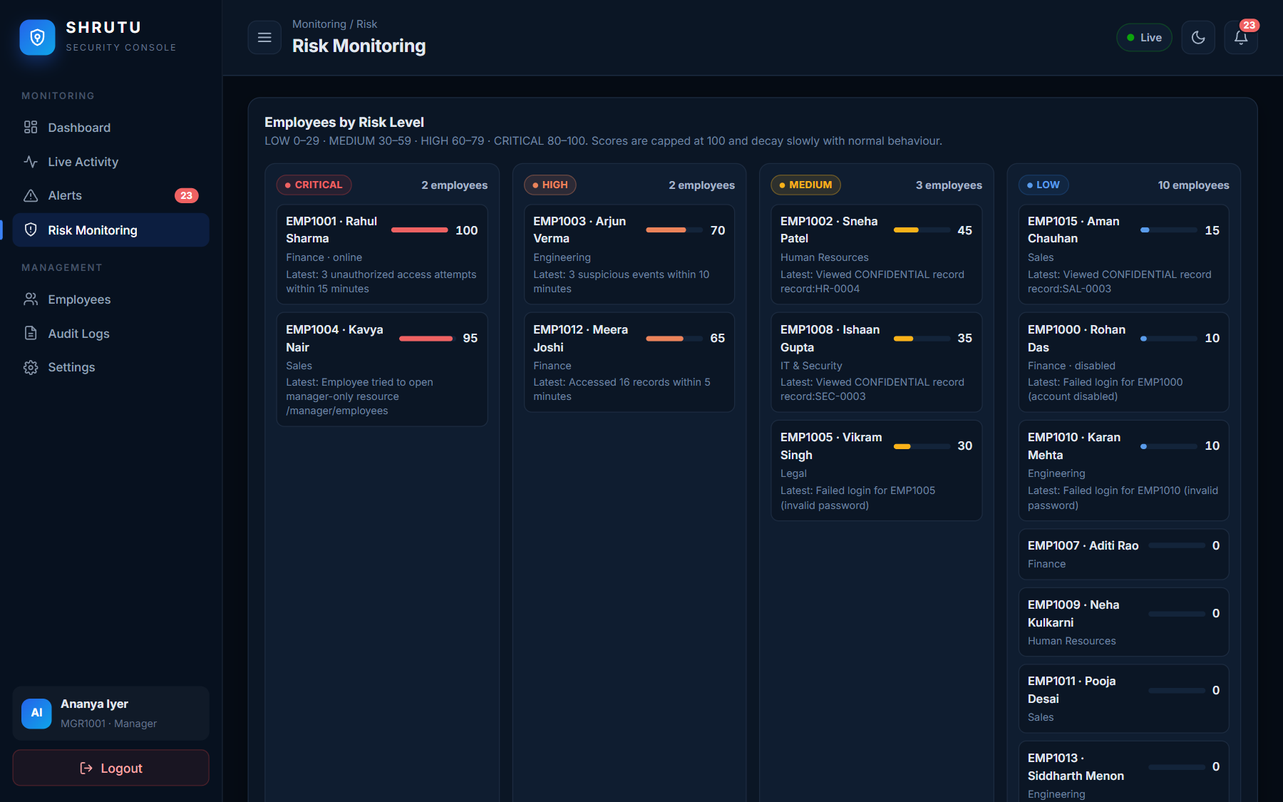
Figure 6.24: Risk Monitoring: employees grouped by level and explained score changes
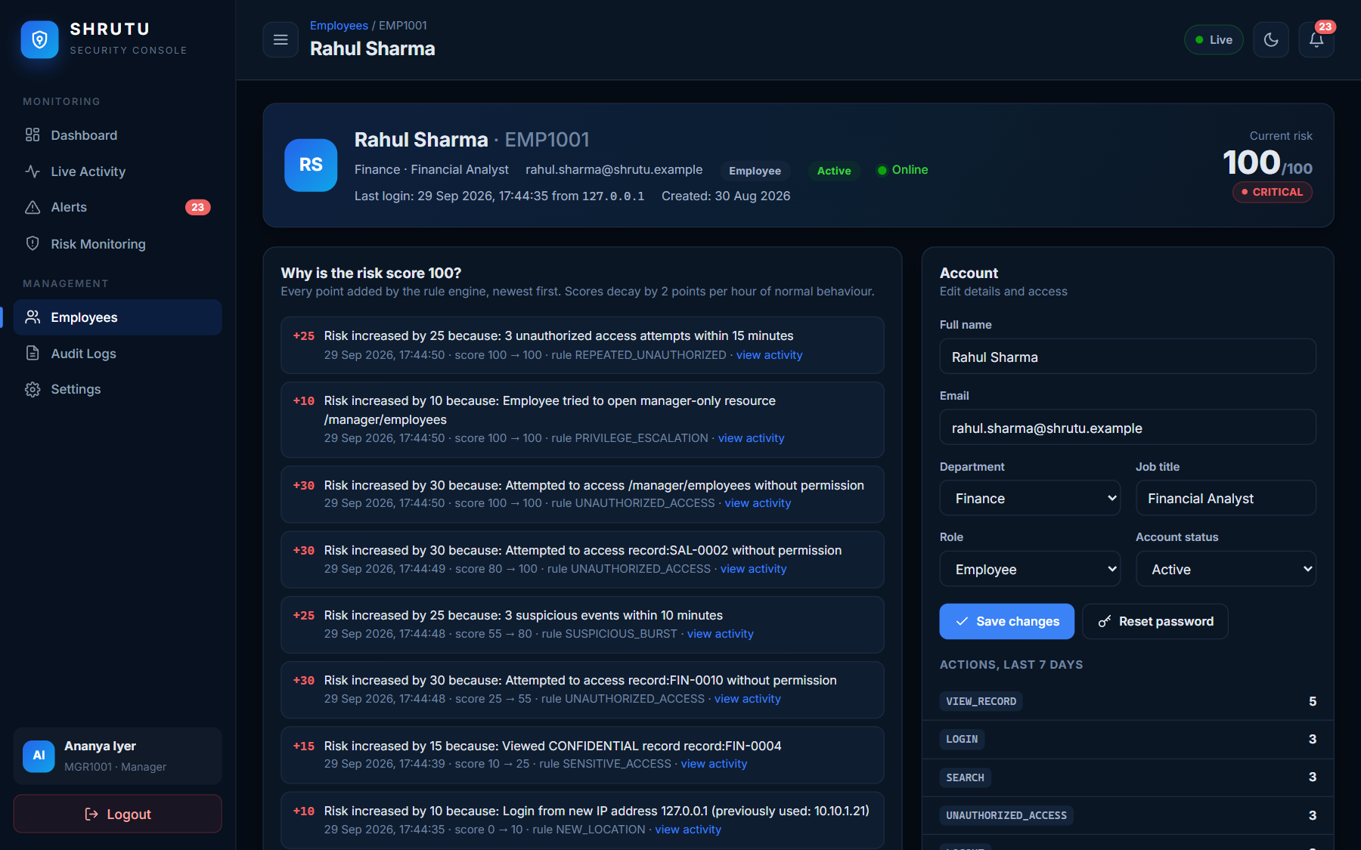
Figure 6.25: Employee detail: why the risk score is what it is
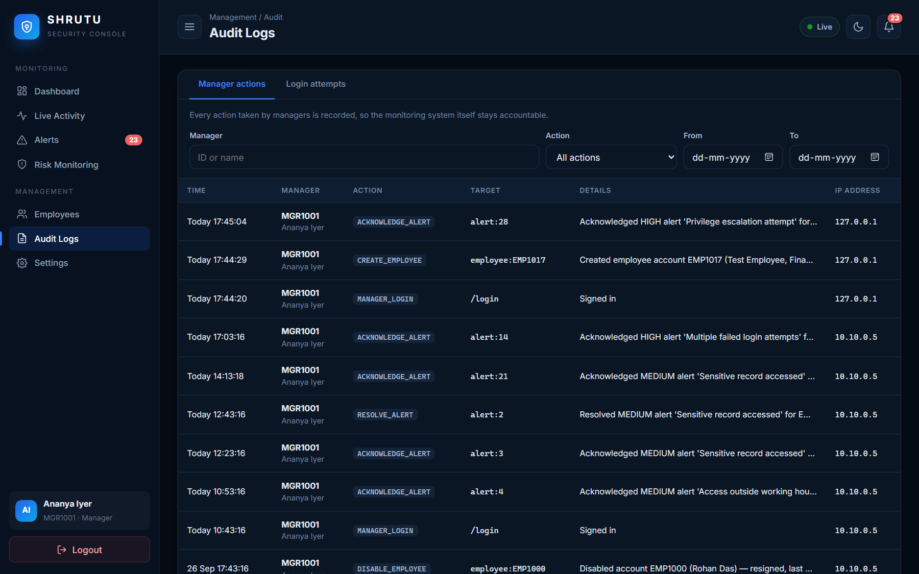
Figure 6.26: Audit log of manager actions
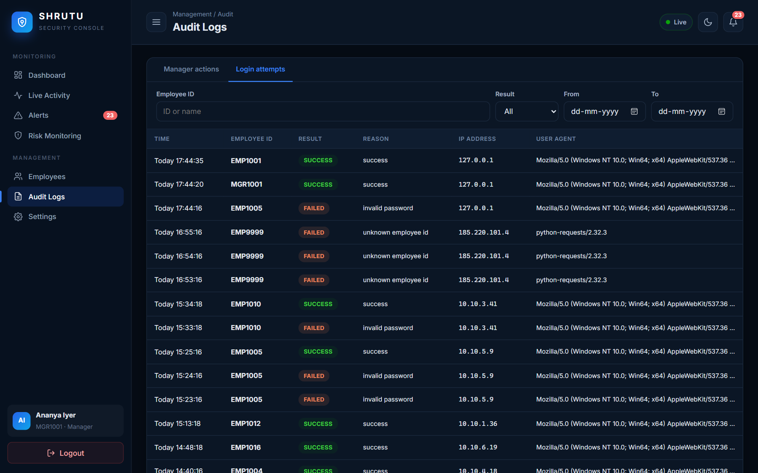
Figure 6.27: Login attempts report
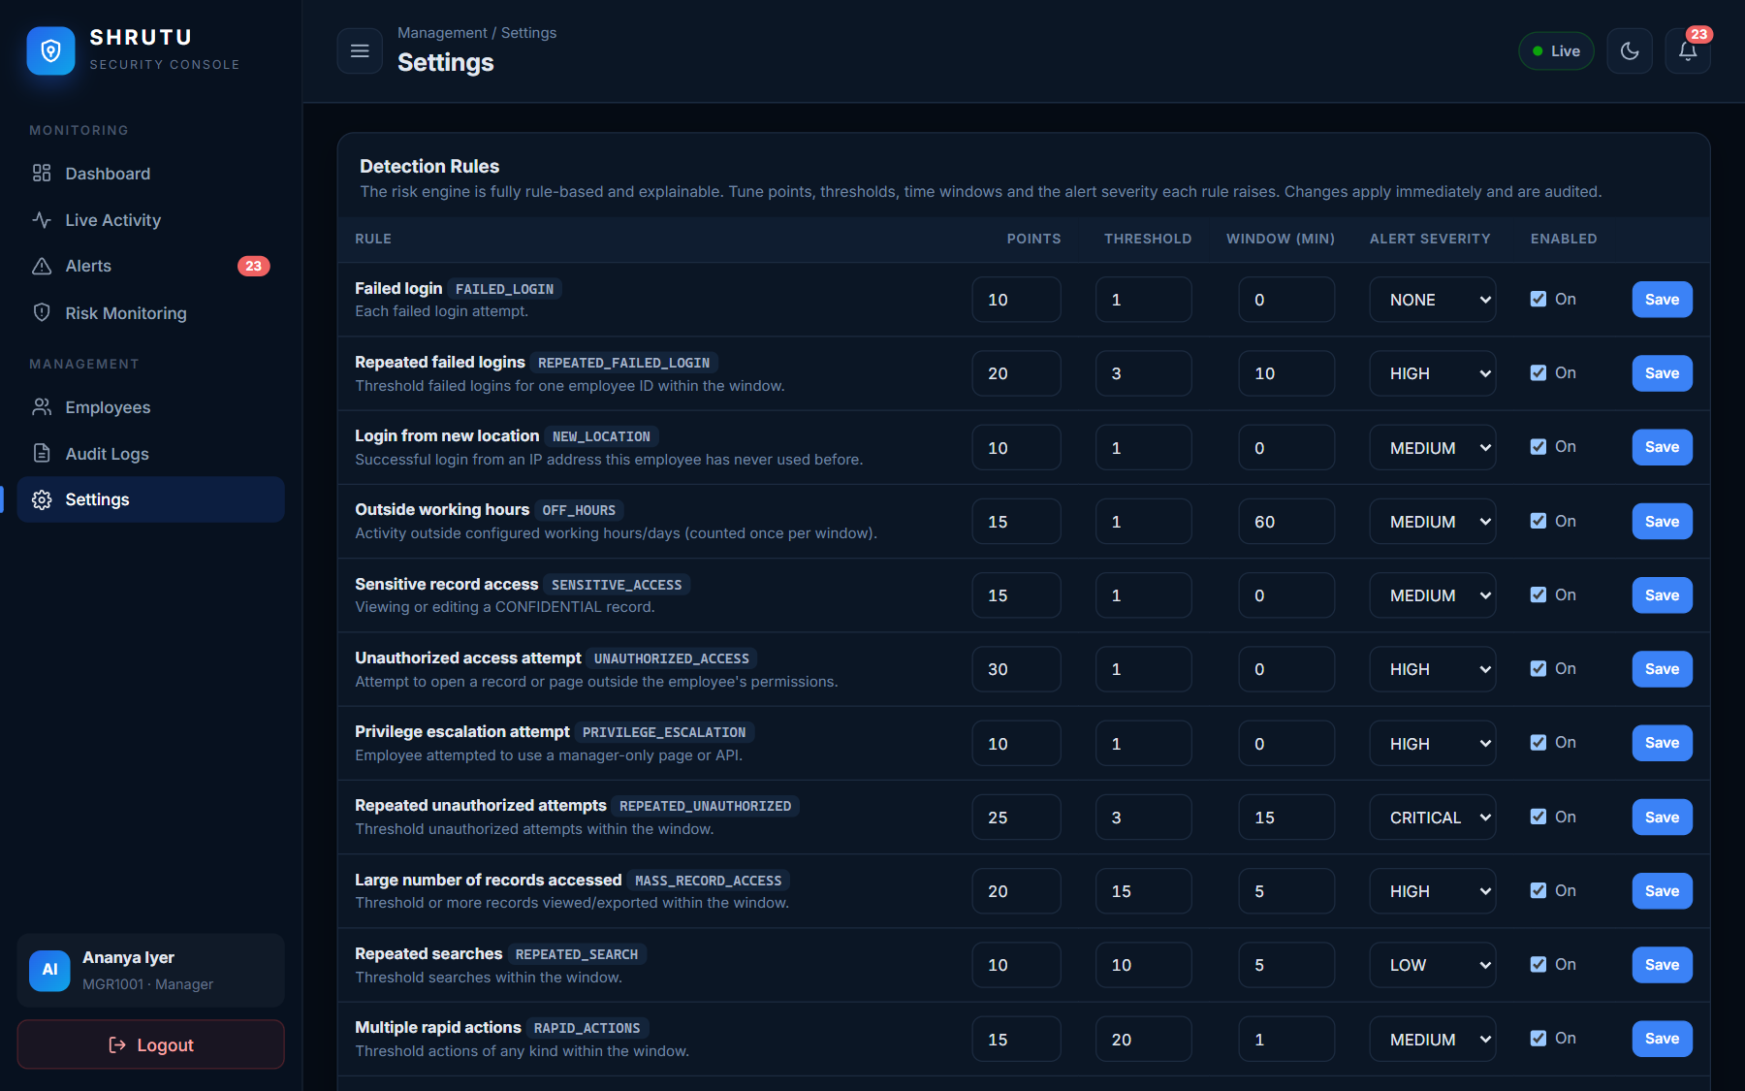
Figure 6.28: Settings: configurable detection rules
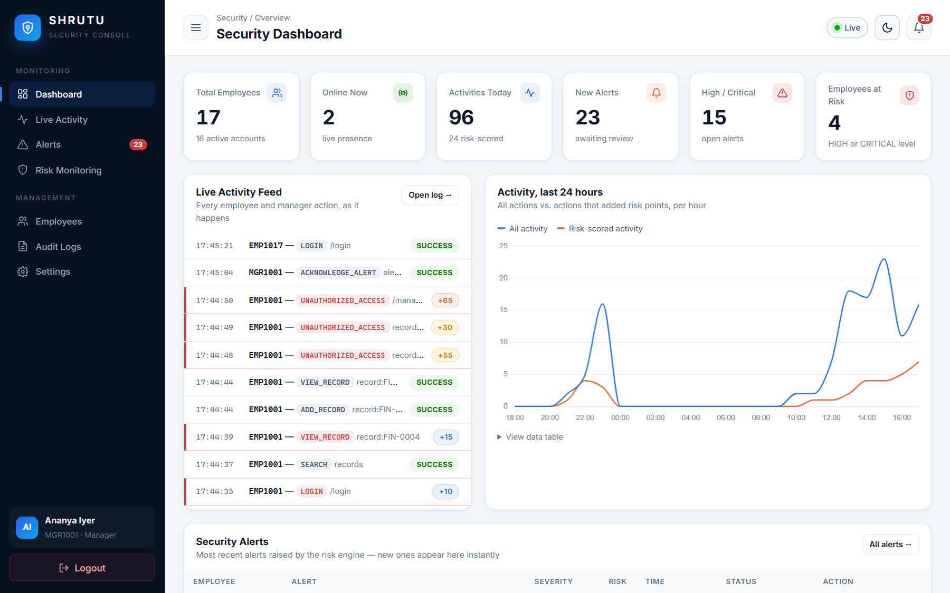
Figure 6.29: Dashboard in light theme
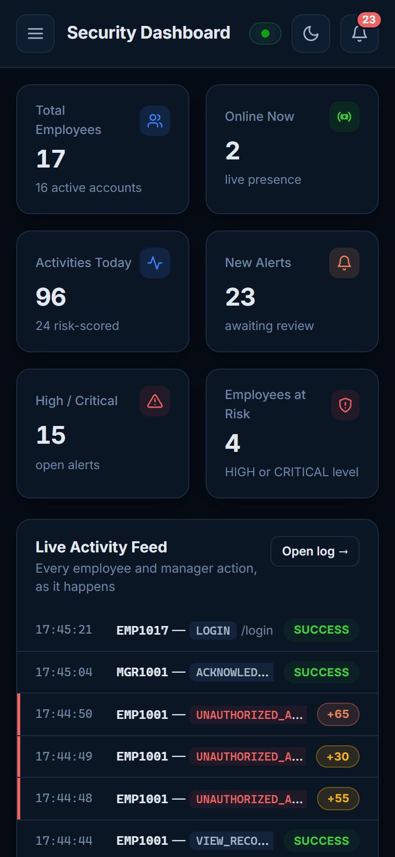
Figure 6.30: Mobile view (390 px wide)

6.2 Sample queries and outputs from the DBMS
The following queries were executed directly in the MySQL 8 command-line client on the project database (demo data). They demonstrate joins, aggregation, grouping with HAVING, sub-queries and the data dictionary.
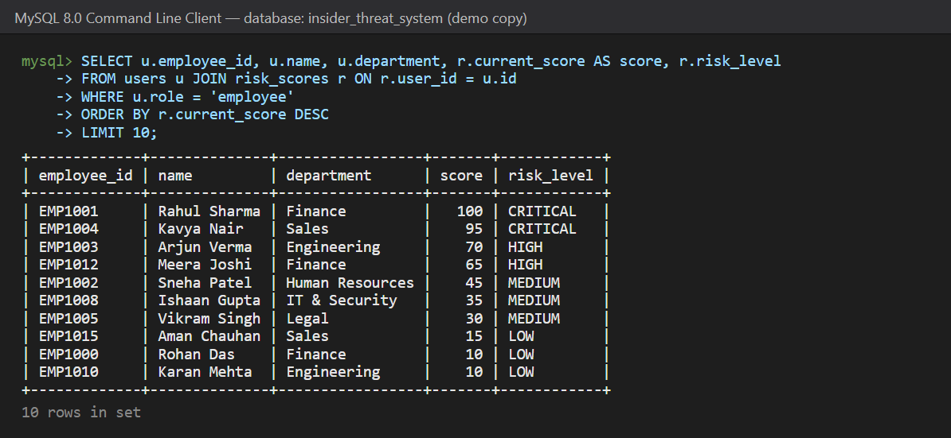
Figure 6.31: Employees ranked by current risk (JOIN users + risk_scores)
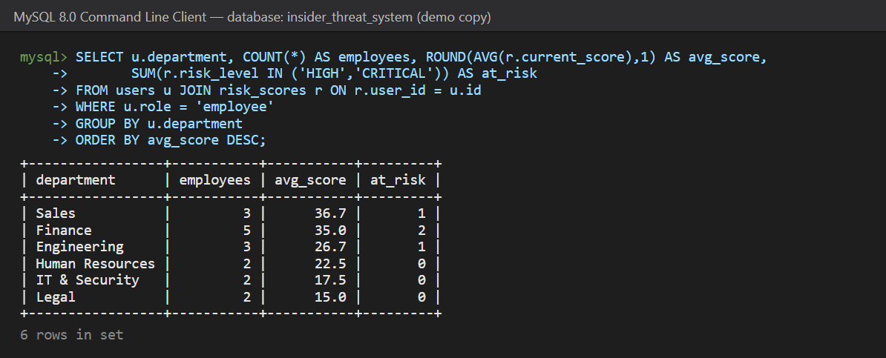
Figure 6.32: Department-wise risk summary (GROUP BY + aggregates)
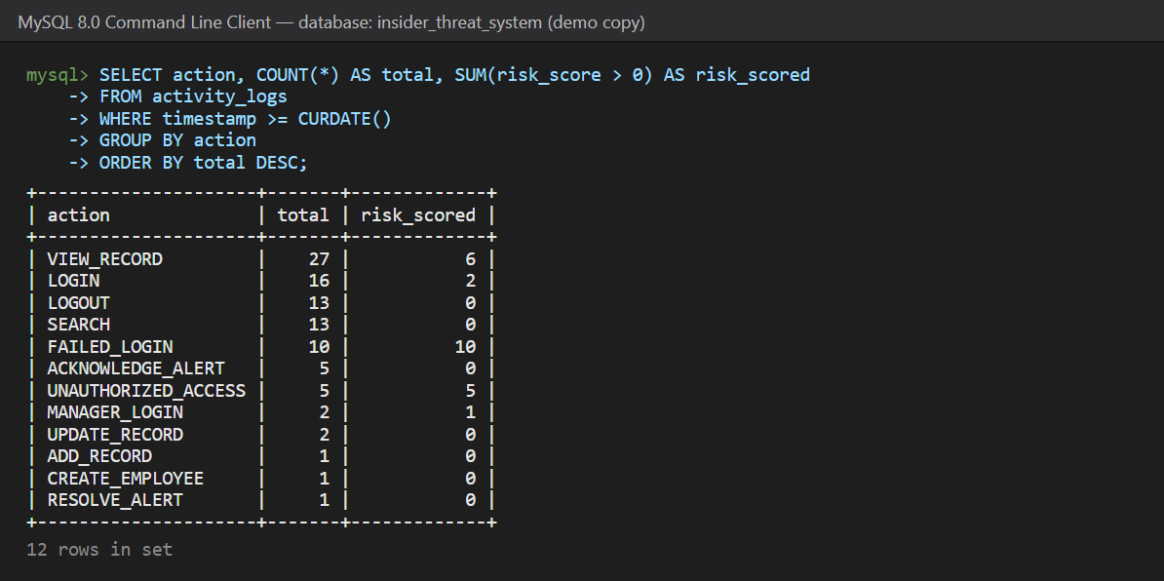
Figure 6.33: Today's activity by action type (used by the dashboard chart)
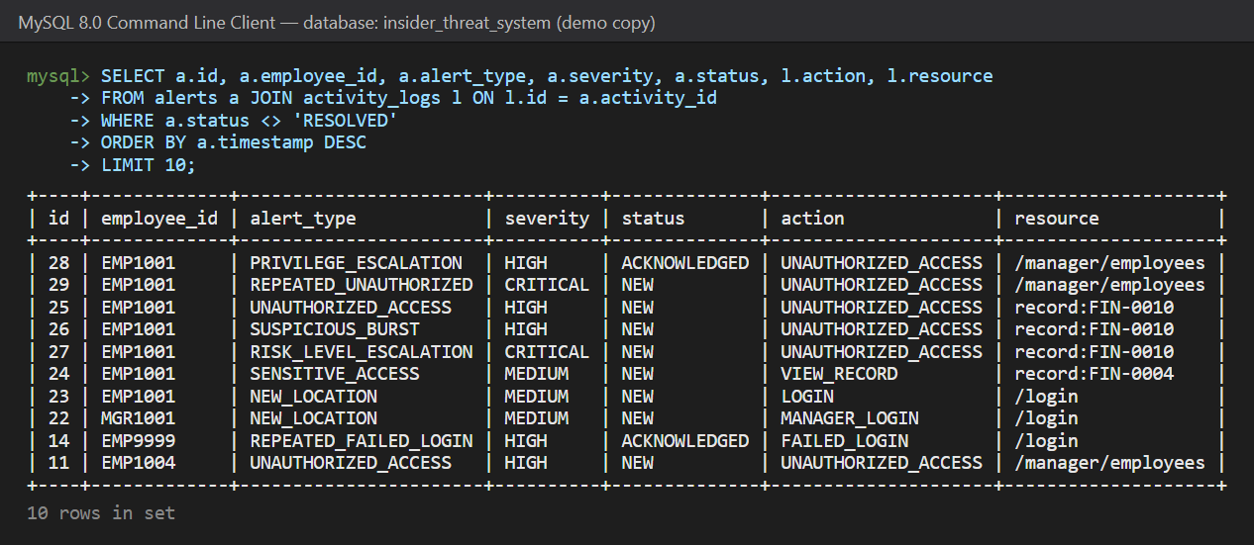
Figure 6.34: Open alerts with their triggering activity (JOIN alerts + activity_logs)
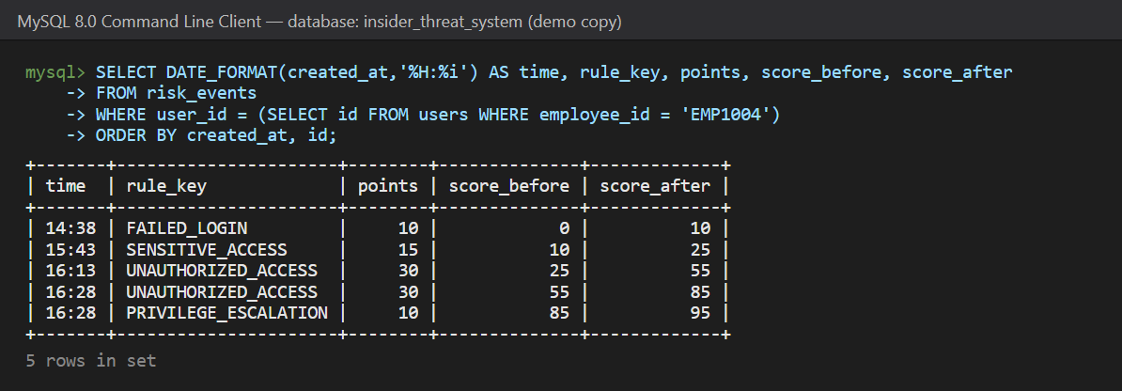
Figure 6.35: Why is EMP1004's score 95? (explainable risk events)
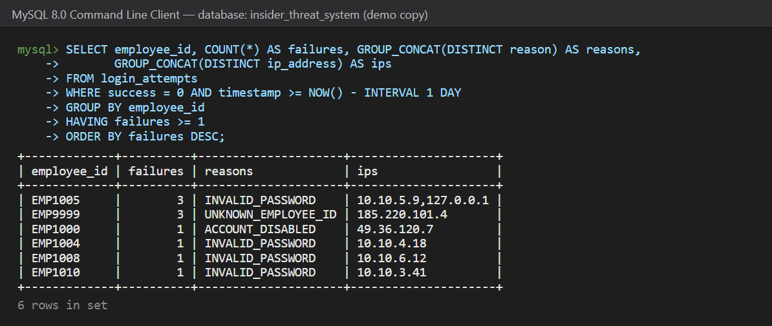
Figure 6.36: Failed login attempts in the last 24 hours (HAVING)
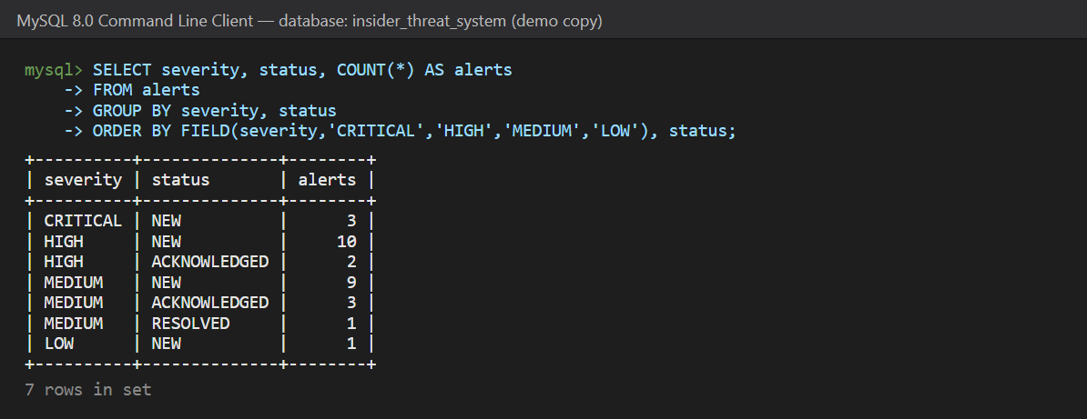
Figure 6.37: Alert counts by severity and status
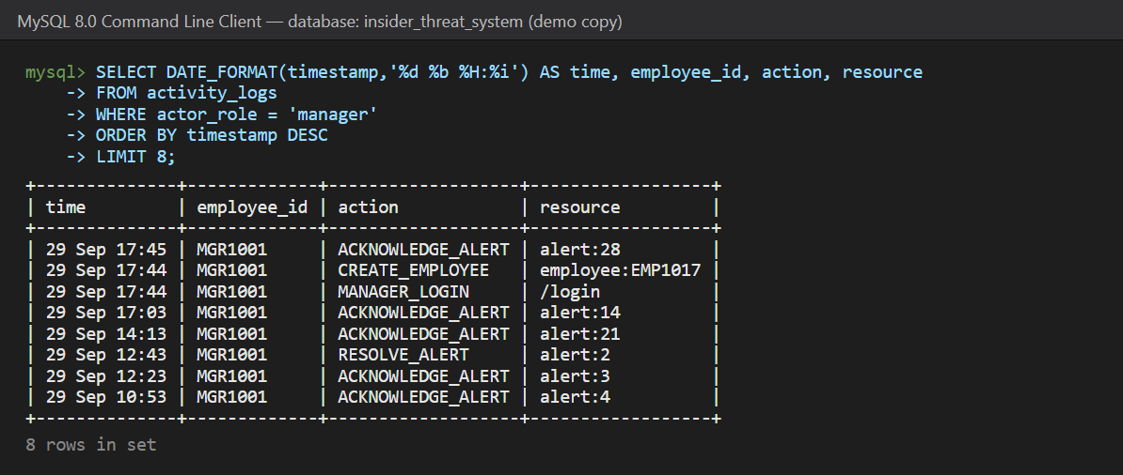
Figure 6.38: Manager audit trail (latest actions)
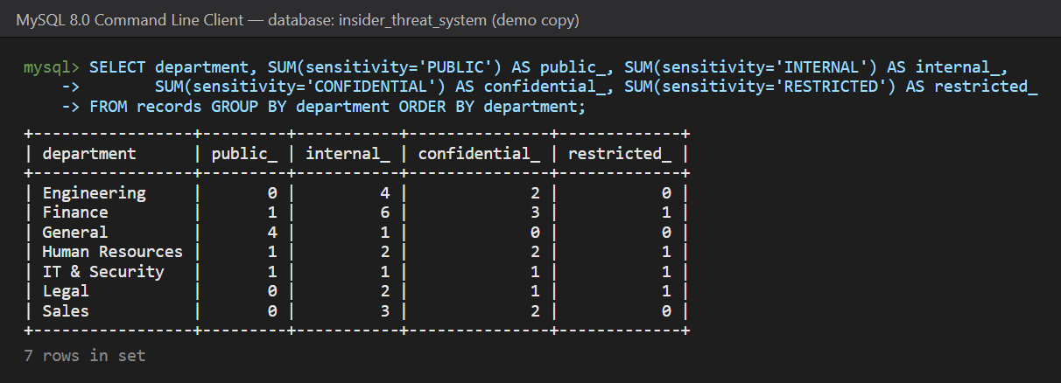
Figure 6.39: Records by department and classification
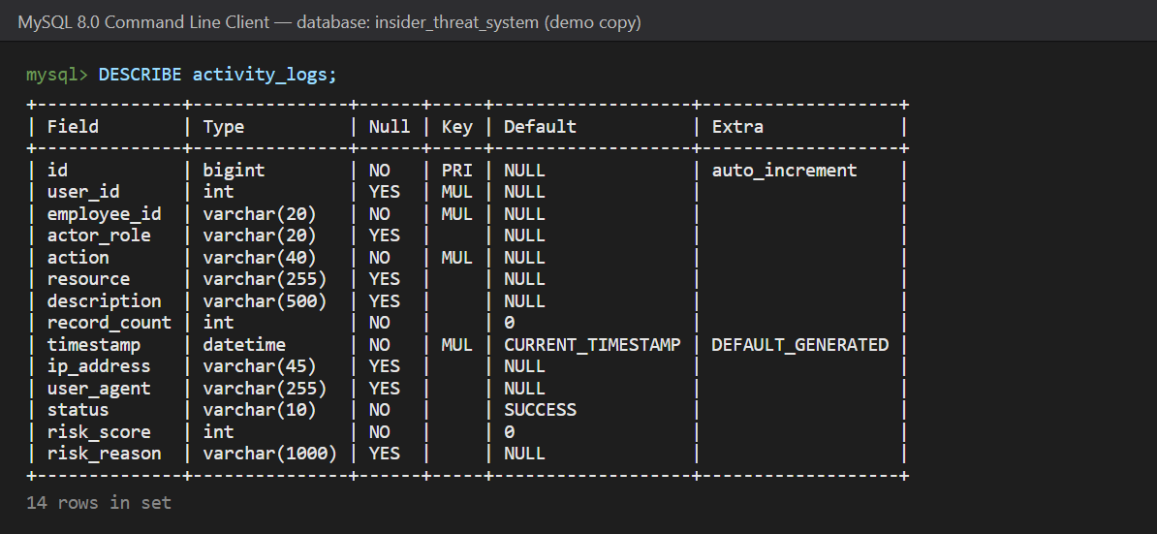
Figure 6.40: Structure of the activity_logs table

7. Conclusion

7.1 Summary of achievements
The project delivered a complete, working insider-threat monitoring system rather than a static prototype. A normalised MySQL schema of nine tables and thirteen foreign keys stores users, business records, activity, login attempts, risk scores with their explanations, configurable rules and alerts. Every employee and manager action flows through a single transactional pipeline that logs it, scores it with thirteen explainable rules, raises alerts and — only after the data is committed — pushes events to managers' browsers in real time. The system provides separate, secure interfaces for employees and managers, employee management, investigation tools, charts, search and filters, and a full audit trail. It passed 52 automated tests and an end-to-end demonstration, and it is deployed publicly with a cloud MySQL database.

7.2 Benefits
- Suspicious behaviour is detected automatically and reported within about a second instead of days later.
- Every alert and every risk point is explained in plain language, so managers can trust and act on the results.
- Server-side access control not only blocks misuse but turns every blocked attempt into evidence.
- The monitoring system is itself accountable: all manager actions are audited and alerts are never deleted.
- Strong data integrity through foreign keys and transactions; no partial or orphaned monitoring data.
- Zero licence and hosting cost, with thresholds tunable by non-programmers.

7.3 Limitations
- Monitors only actions inside this application.
- Rule-based detection needs thresholds tuned per organisation and cannot discover completely new patterns by itself.
- IP-based location check only; no device fingerprinting.
- Single server process for Socket.IO; free hosting tiers sleep when idle.

8. Future Enhancements
- Machine-learning anomaly detection: learn each employee's normal behaviour (time, volume, resources) and flag deviations, alongside the explainable rules.
- Geo-IP and device fingerprinting for real "unusual location / new device" detection.
- Multi-channel escalation: e-mail, SMS or Slack/Teams messages for CRITICAL alerts and an on-call rota.
- Case management: assign alerts to investigators, add comments and attachments, track SLAs.
- Multi-factor authentication for managers, and a separate read-only auditor role.
- Integration with other systems (e-mail gateway, file servers, VPN, cloud storage) through an ingestion API.
- Advanced analytics: department risk trends, weekly reports exported to PDF, peer-group comparison.
- Mobile app for managers with push notifications.
- Scalability: Redis message queue for multiple Socket.IO workers, table partitioning and archiving of old activity logs, Alembic schema migrations.

9. Bibliography / References
- Silberschatz, A., Korth, H. F., & Sudarshan, S. Database System Concepts, 7th ed. McGraw-Hill, 2019.
- Elmasri, R., & Navathe, S. B. Fundamentals of Database Systems, 7th ed. Pearson, 2016.
- Oracle Corporation. MySQL 8.0 Reference Manual. https://dev.mysql.com/doc/refman/8.0/en/
- Pallets Projects. Flask Documentation (3.1). https://flask.palletsprojects.com/
- SQLAlchemy Authors. SQLAlchemy 2.x Documentation. https://docs.sqlalchemy.org/
- Grinberg, M. Flask-SocketIO Documentation. https://flask-socketio.readthedocs.io/
- Flask-Login and Flask-WTF documentation. https://flask-login.readthedocs.io/ ; https://flask-wtf.readthedocs.io/
- Socket.IO Documentation (v4). https://socket.io/docs/v4/
- Chart.js Documentation (v4). https://www.chartjs.org/docs/latest/
- OWASP Foundation. OWASP Top 10 and Authentication / Session Management Cheat Sheets. https://owasp.org/
- CERT Insider Threat Center, Carnegie Mellon University. Common Sense Guide to Mitigating Insider Threats, 7th ed. SEI, 2022.
- Cybersecurity and Infrastructure Security Agency (CISA). Insider Threat Mitigation Guide. 2020.
- Render Documentation. https://render.com/docs ; Aiven for MySQL Documentation. https://aiven.io/docs/products/mysql
- pytest Documentation. https://docs.pytest.org/

10. Appendix

Appendix A — Complete database creation script (schema.sql)
-- =====================================================================
-- SHRUTU Insider Threat Monitoring System — MySQL 8 schema
--
-- Run: mysql -u root -p < database/schema.sql
-- (or) python init_db.py (reads credentials from .env)
--
-- WARNING: re-running this file drops and recreates the tables below
-- (only in the insider_threat_system database).
-- =====================================================================

CREATE DATABASE IF NOT EXISTS insider_threat_system
CHARACTER SET utf8mb4 COLLATE utf8mb4_unicode_ci;
USE insider_threat_system;

SET FOREIGN_KEY_CHECKS = 0;
DROP TABLE IF EXISTS risk_events;
DROP TABLE IF EXISTS alerts;
DROP TABLE IF EXISTS activity_logs;
DROP TABLE IF EXISTS login_attempts;
DROP TABLE IF EXISTS risk_scores;
DROP TABLE IF EXISTS risk_rules;
DROP TABLE IF EXISTS records;
DROP TABLE IF EXISTS users;
DROP TABLE IF EXISTS departments;
SET FOREIGN_KEY_CHECKS = 1;

-- ---------------------------------------------------------------------
-- Departments (lookup)
-- ---------------------------------------------------------------------
CREATE TABLE departments (
id INT AUTO_INCREMENT PRIMARY KEY,
name VARCHAR(60) NOT NULL UNIQUE
) ENGINE=InnoDB;

-- ---------------------------------------------------------------------
-- Users: employees and managers. Passwords are Werkzeug (scrypt) hashes.
-- ---------------------------------------------------------------------
CREATE TABLE users (
id INT AUTO_INCREMENT PRIMARY KEY,
employee_id VARCHAR(20) NOT NULL UNIQUE,
name VARCHAR(100) NOT NULL,
email VARCHAR(120) NOT NULL UNIQUE,
password_hash VARCHAR(255) NOT NULL,
department VARCHAR(60) NOT NULL,
job_title VARCHAR(80) NULL,
role ENUM('employee','manager') NOT NULL DEFAULT 'employee',
status ENUM('active','disabled') NOT NULL DEFAULT 'active',
must_change_password TINYINT(1) NOT NULL DEFAULT 1,
is_online TINYINT(1) NOT NULL DEFAULT 0,
last_login DATETIME NULL,
last_login_ip VARCHAR(45) NULL,
last_seen DATETIME NULL,
created_by INT NULL,
created_at DATETIME NOT NULL DEFAULT CURRENT_TIMESTAMP,
updated_at DATETIME NOT NULL DEFAULT CURRENT_TIMESTAMP ON UPDATE CURRENT_TIMESTAMP,
INDEX ix_users_employee_id (employee_id),
INDEX ix_users_role_status (role, status),
CONSTRAINT fk_users_department FOREIGN KEY (department) REFERENCES departments(name) ON UPDATE CASCADE,
CONSTRAINT fk_users_created_by FOREIGN KEY (created_by) REFERENCES users(id) ON DELETE SET NULL
) ENGINE=InnoDB;

-- ---------------------------------------------------------------------
-- Business records employees work with (the monitored resource)
-- ---------------------------------------------------------------------
CREATE TABLE records (
id INT AUTO_INCREMENT PRIMARY KEY,
record_code VARCHAR(20) NOT NULL UNIQUE,
title VARCHAR(150) NOT NULL,
category VARCHAR(30) NOT NULL DEFAULT 'Other',
department VARCHAR(60) NOT NULL,
sensitivity ENUM('PUBLIC','INTERNAL','CONFIDENTIAL','RESTRICTED') NOT NULL DEFAULT 'INTERNAL',
content TEXT NOT NULL,
created_by INT NULL,
updated_by INT NULL,
created_at DATETIME NOT NULL DEFAULT CURRENT_TIMESTAMP,
updated_at DATETIME NOT NULL DEFAULT CURRENT_TIMESTAMP ON UPDATE CURRENT_TIMESTAMP,
INDEX ix_records_department (department),
CONSTRAINT fk_records_created_by FOREIGN KEY (created_by) REFERENCES users(id) ON DELETE SET NULL,
CONSTRAINT fk_records_updated_by FOREIGN KEY (updated_by) REFERENCES users(id) ON DELETE SET NULL
) ENGINE=InnoDB;

-- ---------------------------------------------------------------------
-- Activity logs: every meaningful action (employees AND managers)
-- ---------------------------------------------------------------------
CREATE TABLE activity_logs (
id BIGINT AUTO_INCREMENT PRIMARY KEY,
user_id INT NULL,
employee_id VARCHAR(20) NOT NULL,
actor_role VARCHAR(20) NULL,
action VARCHAR(40) NOT NULL,
resource VARCHAR(255) NULL,
description VARCHAR(500) NULL,
record_count INT NOT NULL DEFAULT 0,
timestamp DATETIME NOT NULL DEFAULT CURRENT_TIMESTAMP,
ip_address VARCHAR(45) NULL,
user_agent VARCHAR(255) NULL,
status VARCHAR(10) NOT NULL DEFAULT 'SUCCESS',
risk_score INT NOT NULL DEFAULT 0,
risk_reason VARCHAR(1000) NULL,
INDEX ix_activity_user_time (user_id, timestamp),
INDEX ix_activity_employee_time (employee_id, timestamp),
INDEX ix_activity_action (action),
INDEX ix_activity_timestamp (timestamp),
CONSTRAINT fk_activity_user FOREIGN KEY (user_id) REFERENCES users(id) ON DELETE SET NULL
) ENGINE=InnoDB;

-- ---------------------------------------------------------------------
-- Alerts: never deleted, kept as an audit trail
-- ---------------------------------------------------------------------
CREATE TABLE alerts (
id BIGINT AUTO_INCREMENT PRIMARY KEY,
user_id INT NULL,
employee_id VARCHAR(20) NOT NULL,
activity_id BIGINT NULL,
alert_type VARCHAR(40) NOT NULL,
severity ENUM('LOW','MEDIUM','HIGH','CRITICAL') NOT NULL,
message VARCHAR(500) NOT NULL,
risk_score INT NOT NULL DEFAULT 0,
timestamp DATETIME NOT NULL DEFAULT CURRENT_TIMESTAMP,
status ENUM('NEW','ACKNOWLEDGED','RESOLVED') NOT NULL DEFAULT 'NEW',
acknowledged_by INT NULL,
acknowledged_at DATETIME NULL,
resolved_by INT NULL,
resolved_at DATETIME NULL,
resolution_note VARCHAR(500) NULL,
INDEX ix_alerts_user (user_id),
INDEX ix_alerts_employee (employee_id),
INDEX ix_alerts_status (status),
INDEX ix_alerts_timestamp (timestamp),
CONSTRAINT fk_alerts_user FOREIGN KEY (user_id) REFERENCES users(id) ON DELETE SET NULL,
CONSTRAINT fk_alerts_activity FOREIGN KEY (activity_id) REFERENCES activity_logs(id) ON DELETE SET NULL,
CONSTRAINT fk_alerts_ack_by FOREIGN KEY (acknowledged_by) REFERENCES users(id) ON DELETE SET NULL,
CONSTRAINT fk_alerts_res_by FOREIGN KEY (resolved_by) REFERENCES users(id) ON DELETE SET NULL
) ENGINE=InnoDB;

-- ---------------------------------------------------------------------
-- Current risk score per user
-- ---------------------------------------------------------------------
CREATE TABLE risk_scores (
id INT AUTO_INCREMENT PRIMARY KEY,
user_id INT NOT NULL UNIQUE,
current_score INT NOT NULL DEFAULT 0,
risk_level ENUM('LOW','MEDIUM','HIGH','CRITICAL') NOT NULL DEFAULT 'LOW',
last_updated DATETIME NOT NULL DEFAULT CURRENT_TIMESTAMP,
last_increase_at DATETIME NULL,
CONSTRAINT fk_risk_scores_user FOREIGN KEY (user_id) REFERENCES users(id) ON DELETE CASCADE
) ENGINE=InnoDB;

-- ---------------------------------------------------------------------
-- Risk events: WHY a score changed (explainability)
-- ---------------------------------------------------------------------
CREATE TABLE risk_events (
id BIGINT AUTO_INCREMENT PRIMARY KEY,
user_id INT NOT NULL,
activity_id BIGINT NULL,
rule_key VARCHAR(40) NOT NULL,
points INT NOT NULL,
reason VARCHAR(500) NOT NULL,
score_before INT NOT NULL,
score_after INT NOT NULL,
created_at DATETIME NOT NULL DEFAULT CURRENT_TIMESTAMP,
INDEX ix_risk_events_user_time (user_id, created_at),
INDEX ix_risk_events_created (created_at),
CONSTRAINT fk_risk_events_user FOREIGN KEY (user_id) REFERENCES users(id) ON DELETE CASCADE,
CONSTRAINT fk_risk_events_activity FOREIGN KEY (activity_id) REFERENCES activity_logs(id) ON DELETE SET NULL
) ENGINE=InnoDB;

-- ---------------------------------------------------------------------
-- Login attempts (successful and failed)
-- ---------------------------------------------------------------------
CREATE TABLE login_attempts (
id BIGINT AUTO_INCREMENT PRIMARY KEY,
employee_id VARCHAR(20) NOT NULL,
user_id INT NULL,
ip_address VARCHAR(45) NULL,
user_agent VARCHAR(255) NULL,
timestamp DATETIME NOT NULL DEFAULT CURRENT_TIMESTAMP,
success TINYINT(1) NOT NULL,
reason VARCHAR(60) NULL,
INDEX ix_login_attempts_employee_time (employee_id, timestamp),
INDEX ix_login_attempts_ip_time (ip_address, timestamp),
INDEX ix_login_attempts_timestamp (timestamp),
CONSTRAINT fk_login_attempts_user FOREIGN KEY (user_id) REFERENCES users(id) ON DELETE SET NULL
) ENGINE=InnoDB;

-- ---------------------------------------------------------------------
-- Configurable detection rules (editable in Manager > Settings)
-- ---------------------------------------------------------------------
CREATE TABLE risk_rules (
id INT AUTO_INCREMENT PRIMARY KEY,
rule_key VARCHAR(40) NOT NULL UNIQUE,
name VARCHAR(100) NOT NULL,
description VARCHAR(255) NULL,
points INT NOT NULL DEFAULT 0,
threshold INT NOT NULL DEFAULT 1,
window_minutes INT NOT NULL DEFAULT 0,
severity ENUM('NONE','LOW','MEDIUM','HIGH','CRITICAL') NOT NULL DEFAULT 'NONE',
enabled TINYINT(1) NOT NULL DEFAULT 1,
updated_at DATETIME NOT NULL DEFAULT CURRENT_TIMESTAMP ON UPDATE CURRENT_TIMESTAMP
) ENGINE=InnoDB;

-- =====================================================================
-- Reference data required by the application
-- =====================================================================
INSERT INTO departments (name) VALUES
('Finance'), ('Human Resources'), ('Engineering'),
('IT & Security'), ('Sales'), ('Legal');

INSERT INTO risk_rules (rule_key, name, description, points, threshold, window_minutes, severity) VALUES
('FAILED_LOGIN', 'Failed login', 'Each failed login attempt.', 10, 1, 0, 'NONE'),
('REPEATED_FAILED_LOGIN', 'Repeated failed logins', 'Threshold failed logins for one employee ID within the window.', 20, 3, 10, 'HIGH'),
('NEW_LOCATION', 'Login from new location', 'Successful login from an IP address this employee has never used before.', 10, 1, 0, 'MEDIUM'),
('OFF_HOURS', 'Outside working hours', 'Activity outside configured working hours/days (counted once per window).', 15, 1, 60, 'MEDIUM'),
('SENSITIVE_ACCESS', 'Sensitive record access', 'Viewing or editing a CONFIDENTIAL record.', 15, 1, 0, 'MEDIUM'),
('UNAUTHORIZED_ACCESS', 'Unauthorized access attempt', 'Attempt to open a record or page outside the employee''s permissions.', 30, 1, 0, 'HIGH'),
('PRIVILEGE_ESCALATION', 'Privilege escalation attempt', 'Employee attempted to use a manager-only page or API.', 10, 1, 0, 'HIGH'),
('REPEATED_UNAUTHORIZED', 'Repeated unauthorized attempts', 'Threshold unauthorized attempts within the window.', 25, 3, 15, 'CRITICAL'),
('MASS_RECORD_ACCESS', 'Large number of records accessed','Threshold or more records viewed/exported within the window.', 20, 15, 5, 'HIGH'),
('REPEATED_SEARCH', 'Repeated searches', 'Threshold searches within the window.', 10, 10, 5, 'LOW'),
('RAPID_ACTIONS', 'Multiple rapid actions', 'Threshold actions of any kind within the window.', 15, 20, 1, 'MEDIUM'),
('UNUSUAL_FREQUENCY', 'Unusual access frequency', 'Actions in the window exceed threshold x the employee''s normal hourly rate (7-day baseline).', 15, 3, 60, 'MEDIUM'),
('SUSPICIOUS_BURST', 'Multiple suspicious events', 'Threshold risk-scored events (excluding failed logins) within the window.', 25, 3, 10, 'HIGH');

Appendix B — Source code of key modules
The complete source code (≈ 7,000 lines) is available in the project repository. The listings below cover the database models and the core monitoring logic.

B.1 models/user.py
from flask import current_app
from flask_login import UserMixin
from werkzeug.security import check_password_hash, generate_password_hash

from extensions import db
from utils.helpers import iso, now

ROLES = ("employee", "manager")
ACCOUNT_STATUSES = ("active", "disabled")

class Department(db.Model):
__tablename__ = "departments"

id = db.Column(db.Integer, primary_key=True)
name = db.Column(db.String(60), unique=True, nullable=False)

class User(UserMixin, db.Model):
__tablename__ = "users"

id = db.Column(db.Integer, primary_key=True)
employee_id = db.Column(db.String(20), unique=True, nullable=False, index=True)
name = db.Column(db.String(100), nullable=False)
email = db.Column(db.String(120), unique=True, nullable=False)
password_hash = db.Column(db.String(255), nullable=False)
department = db.Column(db.String(60), db.ForeignKey("departments.name"), nullable=False)
job_title = db.Column(db.String(80))
role = db.Column(db.Enum(*ROLES, name="user_role"), nullable=False, default="employee")
status = db.Column(db.Enum(*ACCOUNT_STATUSES, name="account_status"), nullable=False, default="active")
must_change_password = db.Column(db.Boolean, nullable=False, default=True)
is_online = db.Column(db.Boolean, nullable=False, default=False)
last_login = db.Column(db.DateTime)
last_login_ip = db.Column(db.String(45))
last_seen = db.Column(db.DateTime)
created_by = db.Column(db.Integer, db.ForeignKey("users.id", ondelete="SET NULL"))
created_at = db.Column(db.DateTime, nullable=False, default=now)
updated_at = db.Column(db.DateTime, nullable=False, default=now, onupdate=now)

risk = db.relationship("RiskScore", uselist=False, back_populates="user", lazy="joined")

# ------------------------------------------------------------ passwords
def set_password(self, raw_password):
self.password_hash = generate_password_hash(raw_password)

def check_password(self, raw_password):
return check_password_hash(self.password_hash, raw_password)

# -------------------------------------------------------------- helpers
@property
def is_manager(self):
return self.role == "manager"

@property
def is_active(self): # used by Flask-Login: disabled accounts cannot hold a session
return self.status == "active"

@property
def online(self):
if not self.is_online or not self.last_seen:
return False
timeout = current_app.config["PRESENCE_TIMEOUT_SECONDS"]
return (now() - self.last_seen).total_seconds() <= timeout

@property
def initials(self):
parts = [p for p in self.name.split() if p]
return "".join(p[0] for p in parts[:2]).upper() or "?"

def to_public_dict(self):
"""Safe for the employee themself (no risk data, never the password hash)."""
return {
"employee_id": self.employee_id,
"name": self.name,
"email": self.email,
"department": self.department,
"job_title": self.job_title,
"role": self.role,
"status": self.status,
"last_login": iso(self.last_login),
"created_at": iso(self.created_at),
}

def to_manager_dict(self):
"""Full monitoring view for managers (still never the password hash)."""
data = self.to_public_dict()
data.update({
"id": self.id,
"online": self.online,
"last_seen": iso(self.last_seen),
"last_login_ip": self.last_login_ip,
"must_change_password": self.must_change_password,
"updated_at": iso(self.updated_at),
"risk_score": self.risk.current_score if self.risk else 0,
"risk_level": self.risk.risk_level if self.risk else "LOW",
})
return data

class LoginAttempt(db.Model):
__tablename__ = "login_attempts"

id = db.Column(db.BigInteger().with_variant(db.Integer, "sqlite"), primary_key=True)
employee_id = db.Column(db.String(20), nullable=False, index=True)
user_id = db.Column(db.Integer, db.ForeignKey("users.id", ondelete="SET NULL"))
ip_address = db.Column(db.String(45))
user_agent = db.Column(db.String(255))
timestamp = db.Column(db.DateTime, nullable=False, default=now, index=True)
success = db.Column(db.Boolean, nullable=False)
reason = db.Column(db.String(60))

def to_dict(self):
return {
"id": self.id,
"employee_id": self.employee_id,
"ip_address": self.ip_address,
"user_agent": self.user_agent,
"timestamp": iso(self.timestamp),
"success": self.success,
"reason": self.reason,
}

B.2 models/activity.py
from extensions import db
from utils.helpers import iso, now

BigId = db.BigInteger().with_variant(db.Integer, "sqlite")

# Actions performed by employees
EMPLOYEE_ACTIONS = (
"LOGIN", "LOGOUT", "FAILED_LOGIN", "SEARCH", "VIEW_RECORD", "ADD_RECORD",
"UPDATE_RECORD", "EXPORT_DATA", "UNAUTHORIZED_ACCESS", "PASSWORD_CHANGE",
)
# Actions performed by managers (audit trail)
MANAGER_ACTIONS = (
"MANAGER_LOGIN", "CREATE_EMPLOYEE", "UPDATE_EMPLOYEE", "DISABLE_EMPLOYEE",
"ENABLE_EMPLOYEE", "RESET_PASSWORD", "ACKNOWLEDGE_ALERT", "RESOLVE_ALERT",
"UPDATE_RULE",
)
ACTIVITY_STATUSES = ("SUCCESS", "FAILED", "DENIED")

class ActivityLog(db.Model):
__tablename__ = "activity_logs"

id = db.Column(BigId, primary_key=True)
user_id = db.Column(db.Integer, db.ForeignKey("users.id", ondelete="SET NULL"), index=True)
employee_id = db.Column(db.String(20), nullable=False, index=True)
actor_role = db.Column(db.String(20)) # employee / manager / NULL for unknown IDs
action = db.Column(db.String(40), nullable=False, index=True)
resource = db.Column(db.String(255))
description = db.Column(db.String(500))
record_count = db.Column(db.Integer, nullable=False, default=0)
timestamp = db.Column(db.DateTime, nullable=False, default=now, index=True)
ip_address = db.Column(db.String(45))
user_agent = db.Column(db.String(255))
status = db.Column(db.String(10), nullable=False, default="SUCCESS")
risk_score = db.Column(db.Integer, nullable=False, default=0)
risk_reason = db.Column(db.String(1000))

user = db.relationship("User", lazy="joined")

def to_feed_dict(self):
"""Compact form pushed over Socket.IO to the manager live feed."""
return {
"id": self.id,
"timestamp": iso(self.timestamp),
"employee_id": self.employee_id,
"name": self.user.name if self.user else None,
"actor_role": self.actor_role,
"action": self.action,
"resource": self.resource,
"status": self.status,
"risk_score": self.risk_score,
}

def to_manager_dict(self):
data = self.to_feed_dict()
data.update({
"description": self.description,
"record_count": self.record_count,
"ip_address": self.ip_address,
"user_agent": self.user_agent,
"risk_reason": self.risk_reason,
"department": self.user.department if self.user else None,
})
return data

def to_employee_dict(self):
"""What an employee may see about their own actions: no risk information."""
return {
"timestamp": iso(self.timestamp),
"action": self.action,
"resource": self.resource,
"description": self.description,
"status": self.status,
"ip_address": self.ip_address,
}

B.3 models/alert.py
from extensions import db
from utils.helpers import iso, now

SEVERITIES = ("LOW", "MEDIUM", "HIGH", "CRITICAL")
ALERT_STATUSES = ("NEW", "ACKNOWLEDGED", "RESOLVED")

ALERT_TITLES = {
"REPEATED_FAILED_LOGIN": "Multiple failed login attempts",
"NEW_LOCATION": "Login from a new location",
"OFF_HOURS": "Access outside working hours",
"SENSITIVE_ACCESS": "Sensitive record accessed",
"UNAUTHORIZED_ACCESS": "Unauthorized access attempt",
"PRIVILEGE_ESCALATION": "Privilege escalation attempt",
"REPEATED_UNAUTHORIZED": "Repeated unauthorized access attempts",
"MASS_RECORD_ACCESS": "Large number of records accessed",
"REPEATED_SEARCH": "Repeated searches",
"RAPID_ACTIONS": "Multiple rapid actions",
"UNUSUAL_FREQUENCY": "Unusual access frequency",
"SUSPICIOUS_BURST": "Multiple suspicious events",
"RISK_LEVEL_ESCALATION": "Risk level escalated",
"PRIVILEGE_CHANGE": "Account privileges changed",
}

class Alert(db.Model):
__tablename__ = "alerts"

id = db.Column(db.BigInteger().with_variant(db.Integer, "sqlite"), primary_key=True)
user_id = db.Column(db.Integer, db.ForeignKey("users.id", ondelete="SET NULL"), index=True)
employee_id = db.Column(db.String(20), nullable=False, index=True)
activity_id = db.Column(db.BigInteger, db.ForeignKey("activity_logs.id", ondelete="SET NULL"))
alert_type = db.Column(db.String(40), nullable=False)
severity = db.Column(db.Enum(*SEVERITIES, name="alert_severity"), nullable=False)
message = db.Column(db.String(500), nullable=False)
risk_score = db.Column(db.Integer, nullable=False, default=0)
timestamp = db.Column(db.DateTime, nullable=False, default=now, index=True)
status = db.Column(db.Enum(*ALERT_STATUSES, name="alert_status"), nullable=False, default="NEW", index=True)
acknowledged_by = db.Column(db.Integer, db.ForeignKey("users.id", ondelete="SET NULL"))
acknowledged_at = db.Column(db.DateTime)
resolved_by = db.Column(db.Integer, db.ForeignKey("users.id", ondelete="SET NULL"))
resolved_at = db.Column(db.DateTime)
resolution_note = db.Column(db.String(500))

user = db.relationship("User", foreign_keys=[user_id], lazy="joined")
acknowledger = db.relationship("User", foreign_keys=[acknowledged_by])
resolver = db.relationship("User", foreign_keys=[resolved_by])
activity = db.relationship("ActivityLog")

@property
def title(self):
return ALERT_TITLES.get(self.alert_type, self.alert_type.replace("_", " ").title())

def to_dict(self):
return {
"id": self.id,
"employee_id": self.employee_id,
"name": self.user.name if self.user else None,
"department": self.user.department if self.user else None,
"activity_id": self.activity_id,
"alert_type": self.alert_type,
"title": self.title,
"severity": self.severity,
"message": self.message,
"risk_score": self.risk_score,
"risk_level": self.user.risk.risk_level if self.user and self.user.risk else None,
"timestamp": iso(self.timestamp),
"status": self.status,
"acknowledged_by": self.acknowledger.employee_id if self.acknowledger else None,
"acknowledged_at": iso(self.acknowledged_at),
"resolved_by": self.resolver.employee_id if self.resolver else None,
"resolved_at": iso(self.resolved_at),
"resolution_note": self.resolution_note,
}

B.4 models/risk.py
from extensions import db
from utils.helpers import iso, now

RISK_LEVELS = ("LOW", "MEDIUM", "HIGH", "CRITICAL")
RULE_SEVERITIES = ("NONE", "LOW", "MEDIUM", "HIGH", "CRITICAL")

class RiskScore(db.Model):
"""Current cumulative risk of one user (one row per user)."""
__tablename__ = "risk_scores"

id = db.Column(db.Integer, primary_key=True)
user_id = db.Column(db.Integer, db.ForeignKey("users.id", ondelete="CASCADE"), unique=True, nullable=False)
current_score = db.Column(db.Integer, nullable=False, default=0)
risk_level = db.Column(db.Enum(*RISK_LEVELS, name="risk_level"), nullable=False, default="LOW")
last_updated = db.Column(db.DateTime, nullable=False, default=now)
last_increase_at = db.Column(db.DateTime)

user = db.relationship("User", back_populates="risk")

class RiskEvent(db.Model):
"""Explains every change to a risk score ("why did it go up?")."""
__tablename__ = "risk_events"

id = db.Column(db.BigInteger().with_variant(db.Integer, "sqlite"), primary_key=True)
user_id = db.Column(db.Integer, db.ForeignKey("users.id", ondelete="CASCADE"), nullable=False, index=True)
activity_id = db.Column(db.BigInteger, db.ForeignKey("activity_logs.id", ondelete="SET NULL"))
rule_key = db.Column(db.String(40), nullable=False)
points = db.Column(db.Integer, nullable=False)
reason = db.Column(db.String(500), nullable=False)
score_before = db.Column(db.Integer, nullable=False)
score_after = db.Column(db.Integer, nullable=False)
created_at = db.Column(db.DateTime, nullable=False, default=now, index=True)

user = db.relationship("User")

def to_dict(self):
return {
"id": self.id,
"employee_id": self.user.employee_id if self.user else None,
"name": self.user.name if self.user else None,
"activity_id": self.activity_id,
"rule_key": self.rule_key,
"points": self.points,
"reason": self.reason,
"score_before": self.score_before,
"score_after": self.score_after,
"created_at": iso(self.created_at),
}

class RiskRule(db.Model):
"""Configurable detection rule: managers can tune points/thresholds in Settings."""
__tablename__ = "risk_rules"

id = db.Column(db.Integer, primary_key=True)
rule_key = db.Column(db.String(40), unique=True, nullable=False)
name = db.Column(db.String(100), nullable=False)
description = db.Column(db.String(255))
points = db.Column(db.Integer, nullable=False, default=0)
threshold = db.Column(db.Integer, nullable=False, default=1)
window_minutes = db.Column(db.Integer, nullable=False, default=0)
severity = db.Column(db.Enum(*RULE_SEVERITIES, name="rule_severity"), nullable=False, default="NONE")
enabled = db.Column(db.Boolean, nullable=False, default=True)
updated_at = db.Column(db.DateTime, nullable=False, default=now, onupdate=now)

def to_dict(self):
return {
"id": self.id,
"rule_key": self.rule_key,
"name": self.name,
"description": self.description,
"points": self.points,
"threshold": self.threshold,
"window_minutes": self.window_minutes,
"severity": self.severity,
"enabled": self.enabled,
"updated_at": iso(self.updated_at),
}

B.5 models/record.py
"""
Business records: the "normal work" employees do inside the application.
Access to them is what the monitoring system watches.
"""
from extensions import db
from utils.helpers import iso, now

SENSITIVITY_LEVELS = ("PUBLIC", "INTERNAL", "CONFIDENTIAL", "RESTRICTED")
RECORD_CATEGORIES = ("Report", "Contract", "Customer", "Invoice", "Policy", "Personnel", "Technical", "Other")
SHARED_DEPARTMENT = "General" # company-wide records

class Record(db.Model):
__tablename__ = "records"

id = db.Column(db.Integer, primary_key=True)
record_code = db.Column(db.String(20), unique=True, nullable=False)
title = db.Column(db.String(150), nullable=False)
category = db.Column(db.String(30), nullable=False, default="Other")
department = db.Column(db.String(60), nullable=False, index=True)
sensitivity = db.Column(db.Enum(*SENSITIVITY_LEVELS, name="record_sensitivity"), nullable=False, default="INTERNAL")
content = db.Column(db.Text, nullable=False)
created_by = db.Column(db.Integer, db.ForeignKey("users.id", ondelete="SET NULL"))
updated_by = db.Column(db.Integer, db.ForeignKey("users.id", ondelete="SET NULL"))
created_at = db.Column(db.DateTime, nullable=False, default=now)
updated_at = db.Column(db.DateTime, nullable=False, default=now, onupdate=now)

creator = db.relationship("User", foreign_keys=[created_by])
updater = db.relationship("User", foreign_keys=[updated_by])

@property
def is_sensitive(self):
return self.sensitivity == "CONFIDENTIAL"

def to_dict(self):
return {
"id": self.id,
"record_code": self.record_code,
"title": self.title,
"category": self.category,
"department": self.department,
"sensitivity": self.sensitivity,
"content": self.content,
"created_at": iso(self.created_at),
"updated_at": iso(self.updated_at),
}

B.6 services/activity_logger.py
"""
Centralised activity logging — the single entry point of the monitoring pipeline.

Employee action -> route -> log_activity()
1. insert activity_logs row
2. risk engine evaluates it
3. risk_scores / risk_events updated
4. alerts created if rules with a severity fired
5. COMMIT (all of the above in one transaction)
6. Socket.IO push to managers (only after the data is safely stored)
"""
import logging

from flask import current_app
from sqlalchemy.exc import SQLAlchemyError

from extensions import db
from models import ActivityLog
from services import alert_service, notification_service, risk_engine
from utils.helpers import client_ip, client_user_agent, now

log = logging.getLogger(__name__)

def log_activity(user, action, resource=None, description=None, risk_score=0, *,
status="SUCCESS", employee_id=None, record_count=0, context=None):
"""
Record `action` performed by `user` (None for unknown login IDs) and run it
through the risk pipeline. `risk_score` is an optional base score added on
top of whatever the rules decide. Returns the stored ActivityLog.
"""
emp_id = user.employee_id if user is not None else (employee_id or "UNKNOWN")
activity = ActivityLog(
user_id=user.id if user is not None else None,
employee_id=emp_id[:20],
actor_role=user.role if user is not None else None,
action=action,
resource=(resource or "")[:255] or None,
description=(description or "")[:500] or None,
record_count=record_count or 0,
timestamp=now(),
ip_address=client_ip(),
user_agent=client_user_agent(),
status=status,
)
alerts = []
try:
db.session.add(activity)
db.session.flush() # gives the activity an id so rules/alerts can reference it

triggers = risk_engine.evaluate(activity, user, context)
if risk_score:
triggers.insert(0, risk_engine.Trigger("BASE_SCORE", int(risk_score),
f"Base score for {action}", "NONE"))
cap = current_app.config["RISK_SCORE_CAP"]
activity.risk_score = min(cap, sum(t.points for t in triggers))
activity.risk_reason = "; ".join(f"+{t.points} {t.reason}" for t in triggers)[:1000] or None

level_before = level_after = score = None
if user is not None and activity.risk_score > 0:
level_before, level_after, score = risk_engine.apply_score(user, activity, triggers)

alerts = alert_service.generate_alerts(user, activity, triggers, level_before, level_after, score)
db.session.commit()
except SQLAlchemyError:
db.session.rollback()
log.exception("Risk pipeline failed for %s %s — storing the bare activity", emp_id, action)
alerts = []
activity = _store_bare(user, emp_id, action, resource, description, status, record_count)
if activity is None:
return None

notification_service.emit_activity(activity)
for alert in alerts:
notification_service.emit_alert(alert)
return activity

def _store_bare(user, emp_id, action, resource, description, status, record_count):
"""Fallback so an activity is never silently lost if scoring fails."""
try:
activity = ActivityLog(user_id=user.id if user is not None else None, employee_id=emp_id[:20],
actor_role=user.role if user is not None else None, action=action,
resource=(resource or "")[:255] or None,
description=(description or "")[:500] or None,
record_count=record_count or 0, timestamp=now(), ip_address=client_ip(),
user_agent=client_user_agent(), status=status)
db.session.add(activity)
db.session.commit()
return activity
except SQLAlchemyError:
db.session.rollback()
log.exception("Could not store activity %s for %s", action, emp_id)
return None

B.7 services/risk_engine.py
"""
Explainable, rule-based risk engine.

Every activity is evaluated against the enabled rules in the `risk_rules`
table. Each rule that fires produces a Trigger with the number of points it
adds and a human readable reason. Points are added to the employee's
cumulative score (capped at 100) and every change is written to
`risk_events`, so a manager can always see *why* a score went up.

Rule thresholds, windows, points and alert severities are data, not code:
managers can tune them from Manager > Settings.
"""
from dataclasses import dataclass
from datetime import timedelta

from flask import current_app, g

from extensions import db
from models import ActivityLog, Alert, RiskEvent, RiskRule, RiskScore
from utils.helpers import now, risk_level_for

LEVEL_ORDER = {"LOW": 0, "MEDIUM": 1, "HIGH": 2, "CRITICAL": 3}

# rule_key, name, description, points, threshold, window_minutes, severity
# (kept in sync with the INSERT in database/schema.sql)
DEFAULT_RULES = [
("FAILED_LOGIN", "Failed login", "Each failed login attempt.", 10, 1, 0, "NONE"),
("REPEATED_FAILED_LOGIN", "Repeated failed logins", "Threshold failed logins for one employee ID within the window.", 20, 3, 10, "HIGH"),
("NEW_LOCATION", "Login from new location", "Successful login from an IP address this employee has never used before.", 10, 1, 0, "MEDIUM"),
("OFF_HOURS", "Outside working hours", "Activity outside configured working hours/days (counted once per window).", 15, 1, 60, "MEDIUM"),
("SENSITIVE_ACCESS", "Sensitive record access", "Viewing or editing a CONFIDENTIAL record.", 15, 1, 0, "MEDIUM"),
("UNAUTHORIZED_ACCESS", "Unauthorized access attempt", "Attempt to open a record or page outside the employee's permissions.", 30, 1, 0, "HIGH"),
("PRIVILEGE_ESCALATION", "Privilege escalation attempt", "Employee attempted to use a manager-only page or API.", 10, 1, 0, "HIGH"),
("REPEATED_UNAUTHORIZED", "Repeated unauthorized attempts", "Threshold unauthorized attempts within the window.", 25, 3, 15, "CRITICAL"),
("MASS_RECORD_ACCESS", "Large number of records accessed", "Threshold or more records viewed/exported within the window.", 20, 15, 5, "HIGH"),
("REPEATED_SEARCH", "Repeated searches", "Threshold searches within the window.", 10, 10, 5, "LOW"),
("RAPID_ACTIONS", "Multiple rapid actions", "Threshold actions of any kind within the window.", 15, 20, 1, "MEDIUM"),
("UNUSUAL_FREQUENCY", "Unusual access frequency", "Actions in the window exceed threshold x the employee's normal hourly rate (7-day baseline).", 15, 3, 60, "MEDIUM"),
("SUSPICIOUS_BURST", "Multiple suspicious events", "Threshold risk-scored events (excluding failed logins) within the window.", 25, 3, 10, "HIGH"),
]

DATA_ACTIONS = {"SEARCH", "VIEW_RECORD", "ADD_RECORD", "UPDATE_RECORD", "EXPORT_DATA"}
RECORD_ACCESS_ACTIONS = ("VIEW_RECORD", "EXPORT_DATA")
LOGIN_RULES = {"FAILED_LOGIN", "REPEATED_FAILED_LOGIN", "NEW_LOCATION"}
MANAGER_PATH_PREFIXES = ("/manager", "/api/manager")
DAY_NAMES = ["Monday", "Tuesday", "Wednesday", "Thursday", "Friday", "Saturday", "Sunday"]

@dataclass
class Trigger:
rule_key: str
points: int
reason: str
severity: str # NONE / LOW / MEDIUM / HIGH / CRITICAL

# ---------------------------------------------------------------- rule store

def ensure_default_rules():
"""Insert any default rule that is missing (never overwrites tuned values)."""
existing = {key for (key,) in db.session.query(RiskRule.rule_key).all()}
added = False
for key, name, desc, points, threshold, window, severity in DEFAULT_RULES:
if key not in existing:
db.session.add(RiskRule(rule_key=key, name=name, description=desc, points=points,
threshold=threshold, window_minutes=window, severity=severity))
added = True
if added:
db.session.commit()

def active_rules():
"""Enabled rules keyed by rule_key, cached for the current request."""
if "risk_rules" not in g:
g.risk_rules = {r.rule_key: r for r in RiskRule.query.filter_by(enabled=True).all()}
return g.risk_rules

# ------------------------------------------------------------ query helpers

def _count_actions(employee_id, since, actions=None, extra=None):
q = ActivityLog.query.filter(ActivityLog.employee_id == employee_id, ActivityLog.timestamp >= since)
if actions:
q = q.filter(ActivityLog.action.in_(actions))
if extra is not None:
q = q.filter(extra)
return q.count()

def _fired_recently(user, employee_id, rule_key, since):
"""Aggregate rules fire once per window, then stay quiet until it passes."""
if user is not None:
return db.session.query(RiskEvent.id).filter(
RiskEvent.user_id == user.id, RiskEvent.rule_key == rule_key,
RiskEvent.created_at >= since).first() is not None
return db.session.query(Alert.id).filter(
Alert.employee_id == employee_id, Alert.alert_type == rule_key,
Alert.timestamp >= since).first() is not None

def _is_off_hours(ts):
cfg = current_app.config
return ts.weekday() not in cfg["WORK_DAYS"] or not (cfg["WORK_HOURS_START"] <= ts.hour < cfg["WORK_HOURS_END"])

# ------------------------------------------------------------------ rules
# Each rule: (activity, user, context, rule) -> Trigger | None

def _failed_login(a, user, ctx, rule):
if a.action != "FAILED_LOGIN":
return None
why = ctx.get("failure_reason", "invalid credentials")
return Trigger(rule.rule_key, rule.points, f"Failed login for {a.employee_id} ({why})", rule.severity)

def _repeated_failed_login(a, user, ctx, rule):
if a.action != "FAILED_LOGIN":
return None
since = a.timestamp - timedelta(minutes=rule.window_minutes)
failures = _count_actions(a.employee_id, since, ["FAILED_LOGIN"])
if failures < rule.threshold or _fired_recently(user, a.employee_id, rule.rule_key, since):
return None
return Trigger(rule.rule_key, rule.points,
f"{failures} failed login attempts for {a.employee_id} within {rule.window_minutes} minutes",
rule.severity)

def _new_location(a, user, ctx, rule):
if a.action not in ("LOGIN", "MANAGER_LOGIN") or user is None or not a.ip_address:
return None
since = a.timestamp - timedelta(days=90)
previous = db.session.query(ActivityLog.ip_address).filter(
ActivityLog.user_id == user.id, ActivityLog.action.in_(["LOGIN", "MANAGER_LOGIN"]),
ActivityLog.timestamp >= since, ActivityLog.id != a.id).distinct().all()
known = {ip for (ip,) in previous if ip}
if not known or a.ip_address in known: # first ever login is not "unusual"
return None
shown = ", ".join(sorted(known)[:3])
return Trigger(rule.rule_key, rule.points,
f"Login from new IP address {a.ip_address} (previously used: {shown})", rule.severity)

def _off_hours(a, user, ctx, rule):
if a.action not in DATA_ACTIONS | {"LOGIN"} or not _is_off_hours(a.timestamp):
return None
since = a.timestamp - timedelta(minutes=max(rule.window_minutes, 1))
if _fired_recently(user, a.employee_id, rule.rule_key, since):
return None
cfg = current_app.config
return Trigger(rule.rule_key, rule.points,
f"{a.action.replace('_', ' ').title()} at {a.timestamp:%H:%M} on {DAY_NAMES[a.timestamp.weekday()]} "
f"is outside working hours ({cfg['WORK_HOURS_START']:02d}:00–{cfg['WORK_HOURS_END']:02d}:00, Mon–Fri)",
rule.severity)

def _sensitive_access(a, user, ctx, rule):
if a.action not in ("VIEW_RECORD", "UPDATE_RECORD") or ctx.get("sensitivity") != "CONFIDENTIAL":
return None
verb = "Viewed" if a.action == "VIEW_RECORD" else "Modified"
return Trigger(rule.rule_key, rule.points, f"{verb} CONFIDENTIAL record {a.resource}", rule.severity)

def _unauthorized(a, user, ctx, rule):
if a.action != "UNAUTHORIZED_ACCESS":
return None
return Trigger(rule.rule_key, rule.points,
f"Attempted to access {a.resource} without permission", rule.severity)

def _privilege_escalation(a, user, ctx, rule):
if a.action != "UNAUTHORIZED_ACCESS" or not (a.resource or "").startswith(MANAGER_PATH_PREFIXES):
return None
return Trigger(rule.rule_key, rule.points,
f"Employee tried to open manager-only resource {a.resource}", rule.severity)

def _repeated_unauthorized(a, user, ctx, rule):
if a.action != "UNAUTHORIZED_ACCESS":
return None
since = a.timestamp - timedelta(minutes=rule.window_minutes)
attempts = _count_actions(a.employee_id, since, ["UNAUTHORIZED_ACCESS"])
if attempts < rule.threshold or _fired_recently(user, a.employee_id, rule.rule_key, since):
return None
return Trigger(rule.rule_key, rule.points,
f"{attempts} unauthorized access attempts within {rule.window_minutes} minutes", rule.severity)

def _mass_record_access(a, user, ctx, rule):
if a.action not in RECORD_ACCESS_ACTIONS:
return None
since = a.timestamp - timedelta(minutes=rule.window_minutes)
total = db.session.query(db.func.coalesce(db.func.sum(ActivityLog.record_count), 0)).filter(
ActivityLog.employee_id == a.employee_id, ActivityLog.timestamp >= since,
ActivityLog.action.in_(RECORD_ACCESS_ACTIONS), ActivityLog.status == "SUCCESS").scalar()
if total < rule.threshold or _fired_recently(user, a.employee_id, rule.rule_key, since):
return None
return Trigger(rule.rule_key, rule.points,
f"Accessed {int(total)} records within {rule.window_minutes} minutes", rule.severity)

def _repeated_search(a, user, ctx, rule):
if a.action != "SEARCH":
return None
since = a.timestamp - timedelta(minutes=rule.window_minutes)
searches = _count_actions(a.employee_id, since, ["SEARCH"])
if searches < rule.threshold or _fired_recently(user, a.employee_id, rule.rule_key, since):
return None
return Trigger(rule.rule_key, rule.points,
f"{searches} searches within {rule.window_minutes} minutes", rule.severity)

def _rapid_actions(a, user, ctx, rule):
since = a.timestamp - timedelta(minutes=max(rule.window_minutes, 1))
actions = _count_actions(a.employee_id, since)
if actions < rule.threshold or _fired_recently(user, a.employee_id, rule.rule_key, since):
return None
return Trigger(rule.rule_key, rule.points,
f"{actions} actions within {max(rule.window_minutes, 1)} minute(s)", rule.severity)

def _unusual_frequency(a, user, ctx, rule):
window = max(rule.window_minutes, 1)
since = a.timestamp - timedelta(minutes=window)
recent = _count_actions(a.employee_id, since)
if recent < current_app.config["UNUSUAL_FREQUENCY_MIN_ACTIONS"]:
return None
baseline_rows = db.session.query(ActivityLog.timestamp).filter(
ActivityLog.employee_id == a.employee_id,
ActivityLog.timestamp >= a.timestamp - timedelta(days=7),
ActivityLog.timestamp < since).all()
if not baseline_rows:
return None # no history yet, nothing to compare against
active_hours = {ts.replace(minute=0, second=0) for (ts,) in baseline_rows}
normal_rate = len(baseline_rows) / len(active_hours) * (window / 60)
if recent <= rule.threshold * normal_rate or _fired_recently(user, a.employee_id, rule.rule_key, since):
return None
return Trigger(rule.rule_key, rule.points,
f"{recent} actions in the last {window} minutes vs a normal rate of ~{normal_rate:.0f}",
rule.severity)

RULES = [
("FAILED_LOGIN", _failed_login),
("REPEATED_FAILED_LOGIN", _repeated_failed_login),
("NEW_LOCATION", _new_location),
("OFF_HOURS", _off_hours),
("SENSITIVE_ACCESS", _sensitive_access),
("UNAUTHORIZED_ACCESS", _unauthorized),
("PRIVILEGE_ESCALATION", _privilege_escalation),
("REPEATED_UNAUTHORIZED", _repeated_unauthorized),
("MASS_RECORD_ACCESS", _mass_record_access),
("REPEATED_SEARCH", _repeated_search),
("RAPID_ACTIONS", _rapid_actions),
("UNUSUAL_FREQUENCY", _unusual_frequency),
]

# --------------------------------------------------------------- evaluation

def evaluate(activity, user, context=None):
"""Return the list of Triggers fired by this (already flushed) activity."""
ctx = context or {}
rules = active_rules()
is_employee = user is not None and user.role == "employee"
triggers = []
for key, check in RULES:
rule = rules.get(key)
if rule is None:
continue
if not is_employee and key not in LOGIN_RULES:
continue # managers / unknown IDs are only evaluated for login behaviour
trig = check(activity, user, ctx, rule)
if trig:
triggers.append(trig)

# Failed logins escalate through their own rule, so typos never count as a "burst".
burst = rules.get("SUSPICIOUS_BURST")
if (burst and is_employee and activity.action != "FAILED_LOGIN"
and any(t.points > 0 for t in triggers)):
since = activity.timestamp - timedelta(minutes=burst.window_minutes)
earlier = _count_actions(activity.employee_id, since,
extra=db.and_(ActivityLog.risk_score > 0, ActivityLog.id != activity.id,
ActivityLog.action != "FAILED_LOGIN"))
if earlier + 1 >= burst.threshold and not _fired_recently(user, activity.employee_id, burst.rule_key, since):
triggers.append(Trigger(burst.rule_key, burst.points,
f"{earlier + 1} suspicious events within {burst.window_minutes} minutes",
burst.severity))
return triggers

def get_or_create_score(user):
if user.risk is None:
user.risk = RiskScore(user_id=user.id, current_score=0, risk_level="LOW", last_updated=now())
db.session.add(user.risk)
return user.risk

def apply_score(user, activity, triggers):
"""Add trigger points to the user's score and record why. Returns (level_before, level_after, score)."""
cap = current_app.config["RISK_SCORE_CAP"]
rs = get_or_create_score(user)
level_before = rs.risk_level
score = rs.current_score
for t in triggers:
if t.points <= 0:
continue
after = min(cap, score + t.points)
db.session.add(RiskEvent(user_id=user.id, activity_id=activity.id, rule_key=t.rule_key,
points=t.points, reason=t.reason, score_before=score, score_after=after,
created_at=activity.timestamp))
score = after
if score != rs.current_score:
rs.current_score = score
rs.risk_level = risk_level_for(score)
rs.last_updated = activity.timestamp
rs.last_increase_at = activity.timestamp
return level_before, rs.risk_level, score

def apply_decay():
"""Slowly lower scores of employees with no recent risky behaviour."""
cfg = current_app.config
per_hour = cfg["RISK_DECAY_PER_HOUR"]
if per_hour <= 0:
return 0
current = now()
grace = current - timedelta(minutes=cfg["RISK_DECAY_GRACE_MINUTES"])
changed = 0
for rs in RiskScore.query.filter(RiskScore.current_score > 0).all():
if rs.last_increase_at and rs.last_increase_at > grace:
continue
hours = (current - rs.last_updated).total_seconds() / 3600
decrease = int(hours * per_hour)
if decrease < 1:
continue
rs.current_score = max(0, rs.current_score - decrease)
rs.risk_level = risk_level_for(rs.current_score)
rs.last_updated = rs.last_updated + timedelta(hours=decrease / per_hour)
changed += 1
if changed:
db.session.commit()
return changed

B.8 services/alert_service.py
"""
Alert generation and lifecycle (NEW -> ACKNOWLEDGED -> RESOLVED).
Alerts are never deleted: they form part of the audit trail.
"""
from datetime import timedelta

from flask import current_app

from extensions import db
from models import Alert
from services.risk_engine import LEVEL_ORDER
from utils.helpers import now

def _in_cooldown(employee_id, alert_type, at):
since = at - timedelta(minutes=current_app.config["ALERT_COOLDOWN_MINUTES"])
return db.session.query(Alert.id).filter(
Alert.employee_id == employee_id, Alert.alert_type == alert_type,
Alert.status != "RESOLVED", Alert.timestamp >= since).first() is not None

def generate_alerts(user, activity, triggers, level_before=None, level_after=None, score=None):
"""Create alerts for triggered rules that carry a severity. Returns new Alert objects (not committed)."""
employee_id = activity.employee_id
risk_score = score if score is not None else (user.risk.current_score if user and user.risk else activity.risk_score)
created = []
for t in triggers:
if t.severity == "NONE" or _in_cooldown(employee_id, t.rule_key, activity.timestamp):
continue
alert = Alert(user_id=user.id if user else None, employee_id=employee_id, activity_id=activity.id,
alert_type=t.rule_key, severity=t.severity, message=t.reason[:500],
risk_score=risk_score, timestamp=activity.timestamp, status="NEW")
db.session.add(alert)
created.append(alert)

escalated = (user is not None and level_before and level_after
and LEVEL_ORDER[level_after] > LEVEL_ORDER[level_before]
and level_after in ("HIGH", "CRITICAL"))
if escalated:
latest = triggers[-1].reason if triggers else activity.action
alert = Alert(user_id=user.id, employee_id=employee_id, activity_id=activity.id,
alert_type="RISK_LEVEL_ESCALATION", severity=level_after,
message=f"Risk level rose from {level_before} to {level_after} (score {risk_score}). "
f"Latest: {latest}"[:500],
risk_score=risk_score, timestamp=activity.timestamp, status="NEW")
db.session.add(alert)
created.append(alert)
return created

def raise_alert(user, alert_type, severity, message, activity=None):
"""Create a single alert outside the rule engine (e.g. privilege changes)."""
alert = Alert(user_id=user.id, employee_id=user.employee_id,
activity_id=activity.id if activity else None, alert_type=alert_type,
severity=severity, message=message[:500],
risk_score=user.risk.current_score if user.risk else 0,
timestamp=now(), status="NEW")
db.session.add(alert)
return alert

class AlertStateError(ValueError):
pass

def acknowledge(alert, manager):
if alert.status != "NEW":
raise AlertStateError(f"Alert is already {alert.status.lower()}.")
alert.status = "ACKNOWLEDGED"
alert.acknowledged_by = manager.id
alert.acknowledged_at = now()

def resolve(alert, manager, note=None):
if alert.status == "RESOLVED":
raise AlertStateError("Alert is already resolved.")
if alert.status == "NEW": # resolving implies it was seen
alert.acknowledged_by = manager.id
alert.acknowledged_at = now()
alert.status = "RESOLVED"
alert.resolved_by = manager.id
alert.resolved_at = now()
alert.resolution_note = (note or "").strip()[:500] or None

B.9 utils/security.py
"""
Role-based access control. Authorization is always enforced here on the
server; hiding buttons in the UI is only cosmetic.
"""
from functools import wraps

from flask import abort, jsonify, redirect, request, url_for
from flask_login import current_user

from extensions import login_manager
from utils.helpers import wants_json

def forbidden(message="You do not have permission to access this resource."):
if wants_json():
response = jsonify({"error": "forbidden", "message": message})
response.status_code = 403
return response
abort(403)

def login_required(view):
@wraps(view)
def wrapped(*args, **kwargs):
if not current_user.is_authenticated:
return login_manager.unauthorized()
return view(*args, **kwargs)
return wrapped

def manager_required(view):
@wraps(view)
def wrapped(*args, **kwargs):
if not current_user.is_authenticated:
return login_manager.unauthorized()
if not current_user.is_manager:
# an employee probing manager URLs is itself a monitored event
from services.activity_logger import log_activity
log_activity(current_user, "UNAUTHORIZED_ACCESS", resource=request.path,
description=f"Blocked {request.method} to manager-only resource",
status="DENIED")
return forbidden()
return view(*args, **kwargs)
return wrapped

def employee_required(view):
@wraps(view)
def wrapped(*args, **kwargs):
if not current_user.is_authenticated:
return login_manager.unauthorized()
if current_user.is_manager:
if wants_json():
return forbidden("This endpoint is for employee accounts.")
return redirect(url_for("manager.dashboard"))
return view(*args, **kwargs)
return wrapped

def home_url_for(user):
return url_for("manager.dashboard") if user.is_manager else url_for("employee.dashboard")

def is_safe_next(target):
return bool(target) and target.startswith("/") and not target.startswith("//") and "\\" not in target

B.10 routes/auth.py
"""Authentication: login (with lockout), logout, password change."""
from datetime import timedelta

from flask import (Blueprint, current_app, flash, redirect, render_template, request,
session, url_for)
from flask_login import current_user, login_user, logout_user

from extensions import db
from models import LoginAttempt, User
from services.activity_logger import log_activity
from services.notification_service import emit_presence
from utils.helpers import client_ip, client_user_agent, now
from utils.security import home_url_for, is_safe_next, login_required
from utils.validators import normalize_employee_id, validate_password

auth_bp = Blueprint("auth", __name__)

GENERIC_LOGIN_ERROR = "Invalid employee ID or password."

def _recent_failures(**filters):
since = now() - timedelta(minutes=current_app.config["LOGIN_LOCKOUT_MINUTES"])
return LoginAttempt.query.filter_by(success=False, **filters).filter(LoginAttempt.timestamp >= since).count()

def _is_locked_out(employee_id, ip):
cfg = current_app.config
return (_recent_failures(employee_id=employee_id) >= cfg["LOGIN_MAX_FAILURES"]
or _recent_failures(ip_address=ip) >= cfg["LOGIN_IP_MAX_FAILURES"])

def _record_attempt(employee_id, user, success, reason):
db.session.add(LoginAttempt(employee_id=employee_id[:20] or "UNKNOWN", user_id=user.id if user else None,
ip_address=client_ip(), user_agent=client_user_agent(),
timestamp=now(), success=success, reason=reason))

def _fail(employee_id, user, reason, description, message, status_code=401):
"""Store the failed attempt + FAILED_LOGIN activity (committed together by log_activity)."""
_record_attempt(employee_id, user, False, reason)
log_activity(user, "FAILED_LOGIN", resource="/login", description=description, status="FAILED",
employee_id=employee_id or "UNKNOWN", context={"failure_reason": reason.lower().replace("_", " ")})
return render_template("login.html", error=message, employee_id=employee_id), status_code

@auth_bp.route("/")
def login_page():
if current_user.is_authenticated:
return redirect(home_url_for(current_user))
return render_template("login.html")

@auth_bp.route("/login", methods=["POST"])
def login():
employee_id = normalize_employee_id(request.form.get("employee_id"))
password = request.form.get("password") or ""
if not employee_id or not password:
return render_template("login.html", error="Enter your employee ID and password.",
employee_id=employee_id), 400

ip = client_ip()
user = User.query.filter_by(employee_id=employee_id).first()

if _is_locked_out(employee_id, ip):
minutes = current_app.config["LOGIN_LOCKOUT_MINUTES"]
return _fail(employee_id, user, "LOCKED_OUT", "Login blocked: too many failed attempts",
f"Too many failed attempts. Try again in {minutes} minutes.", 429)

if user is None:
return _fail(employee_id, None, "UNKNOWN_EMPLOYEE_ID", "Login with unknown employee ID", GENERIC_LOGIN_ERROR)
if not user.check_password(password):
return _fail(employee_id, user, "INVALID_PASSWORD", "Incorrect password", GENERIC_LOGIN_ERROR)
if user.status != "active":
return _fail(employee_id, user, "ACCOUNT_DISABLED", "Login attempt on a disabled account",
"This account is disabled. Please contact your manager.", 403)

# ---- success
session.clear() # prevent session fixation
login_user(user)
session.permanent = True
user.last_login = now()
user.last_login_ip = ip
user.last_seen = now()
user.is_online = True
_record_attempt(employee_id, user, True, "SUCCESS")
action = "MANAGER_LOGIN" if user.is_manager else "LOGIN"
log_activity(user, action, resource="/login", description="Signed in")
emit_presence(user)

if user.must_change_password:
flash("Please set a new password before continuing.", "info")
return redirect(url_for("auth.change_password"))
target = request.args.get("next")
return redirect(target if is_safe_next(target) else home_url_for(user))

@auth_bp.route("/logout", methods=["POST"])
@login_required
def logout():
user = current_user._get_current_object()
log_activity(user, "LOGOUT", resource="/logout", description="Signed out")
user.is_online = False
db.session.commit()
emit_presence(user)
logout_user()
session.clear()
flash("You have been signed out securely.", "success")
return redirect(url_for("auth.login_page"))

@auth_bp.route("/change-password", methods=["GET", "POST"])
@login_required
def change_password():
forced = current_user.must_change_password
if request.method == "POST":
current_pw = request.form.get("current_password") or ""
new_pw = request.form.get("new_password") or ""
confirm = request.form.get("confirm_password") or ""
error = None
if not current_user.check_password(current_pw):
error = "Your current password is incorrect."
elif new_pw != confirm:
error = "The new passwords do not match."
elif new_pw == current_pw:
error = "The new password must be different from the current one."
else:
error = validate_password(new_pw, current_app.config["PASSWORD_MIN_LENGTH"])
if error:
flash(error, "error")
return render_template("change_password.html", forced=forced), 400

current_user.set_password(new_pw)
current_user.must_change_password = False
log_activity(current_user._get_current_object(), "PASSWORD_CHANGE", resource="/change-password",
description="Changed own password" + (" (first login)" if forced else ""))
flash("Password updated successfully.", "success")
return redirect(home_url_for(current_user))
return render_template("change_password.html", forced=forced)

B.11 templates/login.html (interface)
<!DOCTYPE html>
<html lang="en">
<head>
<meta charset="UTF-8">
<meta name="viewport" content="width=device-width, initial-scale=1.0">
<title>SHRUTU | Sign in</title>
<link rel="icon" href="{{ url_for('static', filename='images/logo.svg') }}" type="image/svg+xml">
<link rel="preconnect" href="https://fonts.googleapis.com">
<link href="https://fonts.googleapis.com/css2?family=Inter:wght@400;500;600;700&display=swap" rel="stylesheet">
<link rel="stylesheet" href="{{ url_for('static', filename='css/login.css') }}">
</head>
<body>
<div class="glow glow-one"></div>
<div class="glow glow-two"></div>

<div class="login-container">
<section class="brand-section">
<div class="brand">
<div class="brand-icon">{% include "partials/logo_mark.html" %}</div>
<div>
<div class="brand-name">SHRUTU</div>
<div class="brand-subtitle">SECURITY INTELLIGENCE</div>
</div>
</div>
<h1 class="welcome-title">Protect your organization<br><span>before threats become incidents.</span></h1>
<p class="description">
SHRUTU Insider Threat Monitoring gives security managers real-time visibility into
employee activity, explainable risk scores and instant alerts on suspicious behaviour.
</p>
<div class="features">
<div class="feature"><div class="feature-icon">✓</div>Real-time threat monitoring</div>
<div class="feature"><div class="feature-icon">✓</div>Explainable employee risk scoring</div>
<div class="feature"><div class="feature-icon">✓</div>Instant manager alerts</div>
<div class="feature"><div class="feature-icon">✓</div>Complete, tamper-evident audit trail</div>
</div>
<div class="security-orbit"></div>
</section>

<section class="login-section">
<div class="login-heading">
<h2>Welcome back</h2>
<p>Sign in with your employee ID to access the console.</p>
</div>

{% with messages = get_flashed_messages(with_categories=true) %}
{% for category, message in messages %}
<div class="flash {{ category }}" role="status">{{ message }}</div>
{% endfor %}
{% endwith %}
{% if error %}
<div class="error-message" role="alert">⚠ {{ error }}</div>
{% endif %}

<form method="POST" action="{{ url_for('auth.login', next=request.args.get('next')) }}" autocomplete="on" novalidate>
<input type="hidden" name="csrf_token" value="{{ csrf_token() }}">
<div class="form-group">
<label for="employee_id">EMPLOYEE ID</label>
<div class="input-wrapper">
<span class="input-icon">
<svg viewBox="0 0 24 24" fill="none" stroke="currentColor" stroke-width="2" stroke-linecap="round" stroke-linejoin="round"><rect x="3" y="4" width="18" height="16" rx="2"/><circle cx="9" cy="10" r="2"/><path d="M15 8h2M15 12h2M7 16h10"/></svg>
</span>
<input type="text" id="employee_id" name="employee_id" class="uppercase" placeholder="e.g. EMP1001"
value="{{ employee_id or '' }}" maxlength="20" required autocomplete="username" autofocus>
</div>
</div>
<div class="form-group">
<label for="password">PASSWORD</label>
<div class="input-wrapper">
<span class="input-icon">
<svg viewBox="0 0 24 24" fill="none" stroke="currentColor" stroke-width="2" stroke-linecap="round" stroke-linejoin="round"><rect x="4" y="11" width="16" height="10" rx="2"/><path d="M8 11V7a4 4 0 0 1 8 0v4"/></svg>
</span>
<input type="password" id="password" name="password" placeholder="Enter your password"
required autocomplete="current-password" maxlength="128">
<button type="button" class="password-toggle" id="password-toggle" aria-label="Show password">
<svg viewBox="0 0 24 24" fill="none" stroke="currentColor" stroke-width="2" stroke-linecap="round" stroke-linejoin="round"><path d="M2 12s3.5-7 10-7 10 7 10 7-3.5 7-10 7S2 12 2 12z"/><circle cx="12" cy="12" r="3"/></svg>
</button>
</div>
</div>
<div class="login-options">Forgot your password? Ask your manager to reset it.</div>
<button type="submit" class="login-button">Sign in to Security Console →</button>
</form>

<div class="security-message">
<span>🔐</span>
<span><strong>Monitored system.</strong>&nbsp; All sign-in attempts and activity are recorded.</span>
</div>
<div class="footer">
SHRUTU Security Intelligence Platform<br>
<span>Authorized personnel only • v2.0</span>
</div>
</section>
</div>
<script src="{{ url_for('static', filename='js/login.js') }}"></script>
</body>
</html>

Appendix C — User manual

C.1 Running the project locally
python -m venv .venv
.venv\Scripts\activate
pip install -r requirements.txt
copy .env.example .env (set MYSQL_PASSWORD and SECRET_KEY)
python init_db.py (creates the database and demo data)
python app.py (open http://127.0.0.1:5000)
python -m pytest -q (runs the 52 automated tests)

C.2 Demo accounts (local installation)
Table 10.1: Demo accounts
Role | Employee ID | Password | Notes
Manager | MGR1001 | Manager@123 | Ananya Iyer, IT & Security
Employee | EMP1001 – EMP1005, EMP1007 – EMP1016 | Employee@123 | Different seeded risk levels (LOW → CRITICAL)
Employee | EMP1000 | Employee@123 | Disabled account — login is refused

On the public deployment the demo passwords are replaced by private values set in the hosting environment.

C.3 Manager workflow
- Dashboard — watch KPIs, live feed and alerts.
- Alerts — click a row to investigate; Acknowledge while investigating; Resolve with a note to close.
- Employees — create accounts, edit, disable/enable, reset passwords.
- Risk Monitoring — see who is at which level and why.
- Audit Logs — review manager actions and all login attempts.
- Settings — tune the detection rules.

C.4 Employee workflow
- Log in with the employee ID; set a new password on first login.
- Records — search, open by code, add, edit and export records of your department.
- My Activity — review your own history; Profile — change password.

Appendix D — REST API endpoints
Table 10.2: REST API endpoints
Method | Endpoint | Role | Purpose
POST | /login, /logout | public / any | Authentication
GET | /api/health | public | Database status
GET | /api/manager/dashboard, /stats, /presence | manager | KPIs, charts, feed, presence
GET / POST | /api/manager/employees | manager | List (filters) / create employee
GET / PUT / DELETE | /api/manager/employees/<id> | manager | Details / update / disable
PUT | /api/manager/employees/<id>/status | manager | Enable or disable
POST | /api/manager/employees/<id>/reset-password | manager | Reset password
GET | /api/manager/activities[/<id>] | manager | Activity log (filters) / detail
GET | /api/manager/alerts[/<id>] | manager | Alerts (filters) / detail
PUT | /api/manager/alerts/<id>/acknowledge | /resolve | manager | Handle alert
GET | /api/manager/risk, /audit, /login-attempts | manager | Risk overview, audit, attempts
GET / PUT | /api/manager/rules[/<id>] | manager | Detection rules
GET | /api/employee/activity, /profile | employee | Own data only

