**How to run the application - only Front-End.**

a) Clone the project from the git repository

b) Make sure that you have npm, node.js and angular installed in your local machine.

c) Import angular project from DemoFE folder

d) Run "ng update" command inside the DemoFE directory to download angular dependencies.

e) Then go to file project directory and run "ng serve".

f) The application will be up at port 4200

-------------------------------------------------------------------------------------------------------------------------------------------

Things covered as part of the assignment:

1. login using a student id and password .
2. redirection to student details page upon login.
3. redirection to university details page upon clicking universityId hyperlink.

**Use-cases**:

--------------------------------------------------------------------------------------------------------------------

* Open the following link in browser - <http://localhost:4200/> -this would be the home page.



* On clicking the login button, you would be redirected to <http://localhost:4200/login>

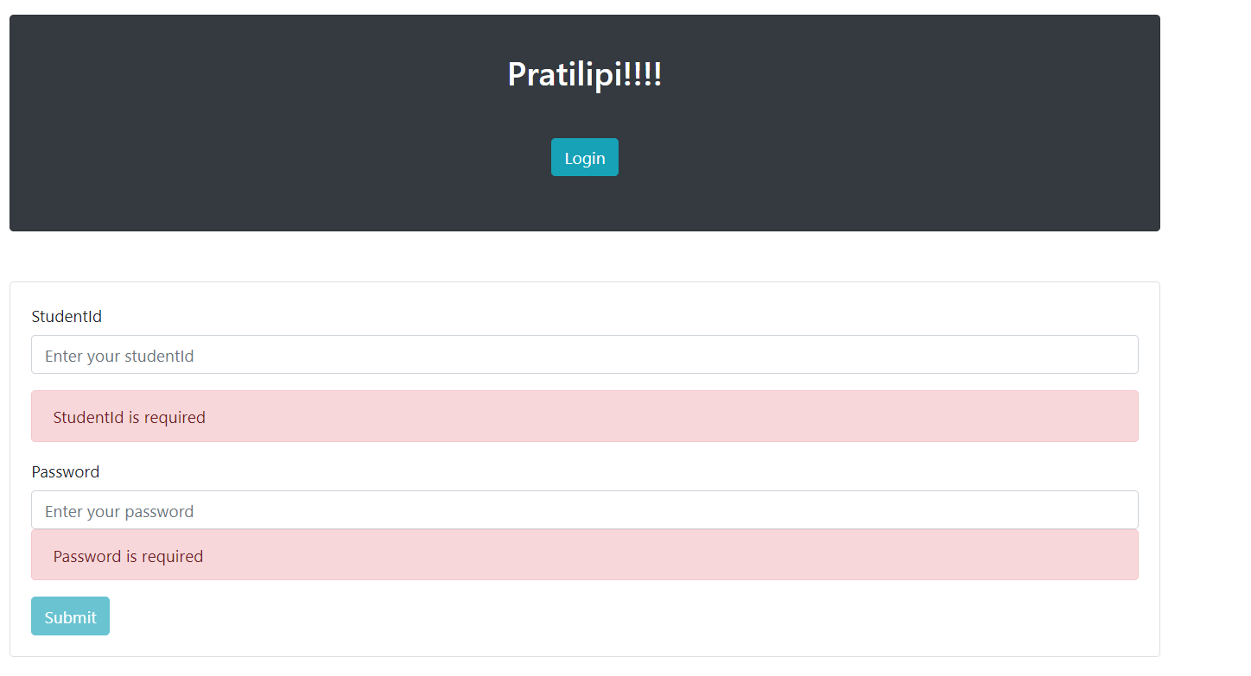

* Upon providing the studentId and password you would be redirected to [http://localhost:4200/student/{studentId}](http://localhost:4200/student/%7bstudentId%7d)

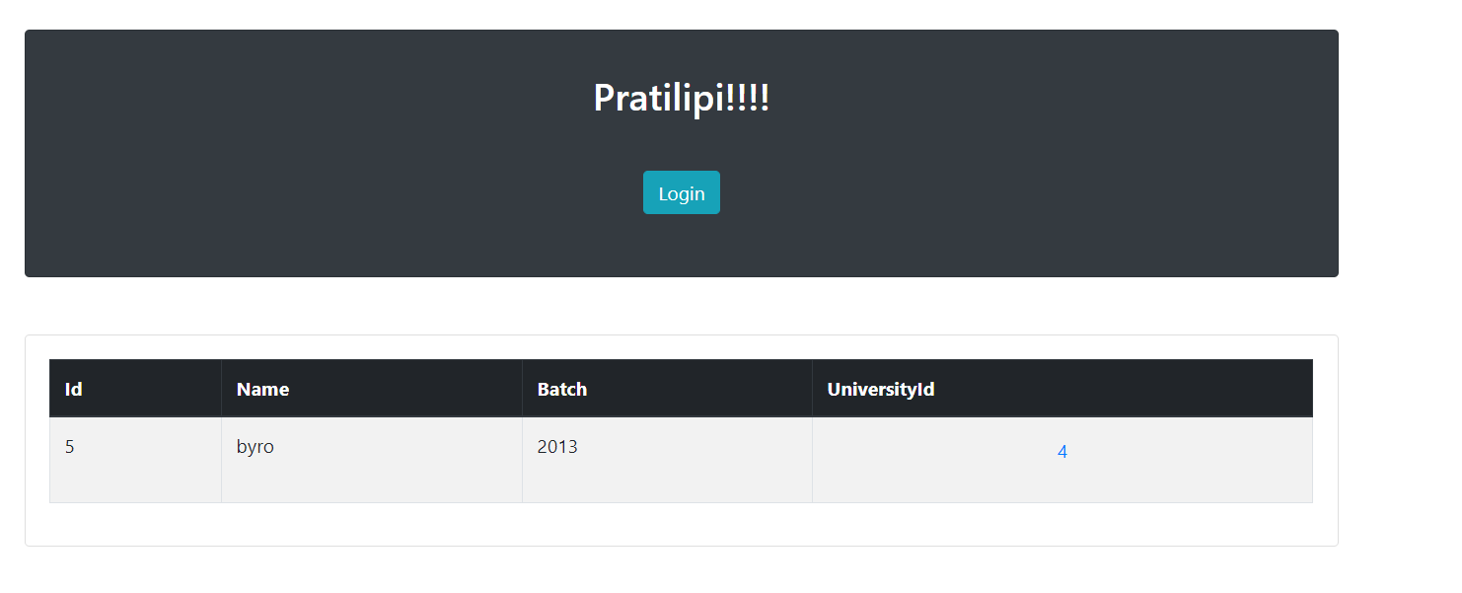

**Note**:

Before entering the details make sure you have the corresponding studentId present in the database.

* We can click on the universityId hyperlink to go the university details page, i.e it would be redirected to

[http://localhost:4200/student/studentId/university/{universityId}](http://localhost:4200/student/studentId/university/%7buniversityId%7d%20)

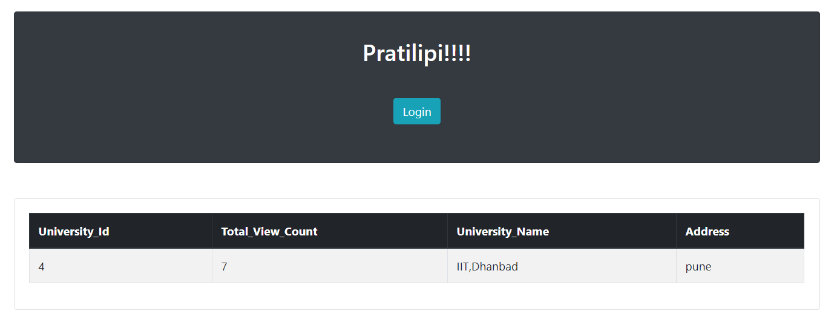

**Note**:

* Make sure you have the corresponding universityId present in the database.