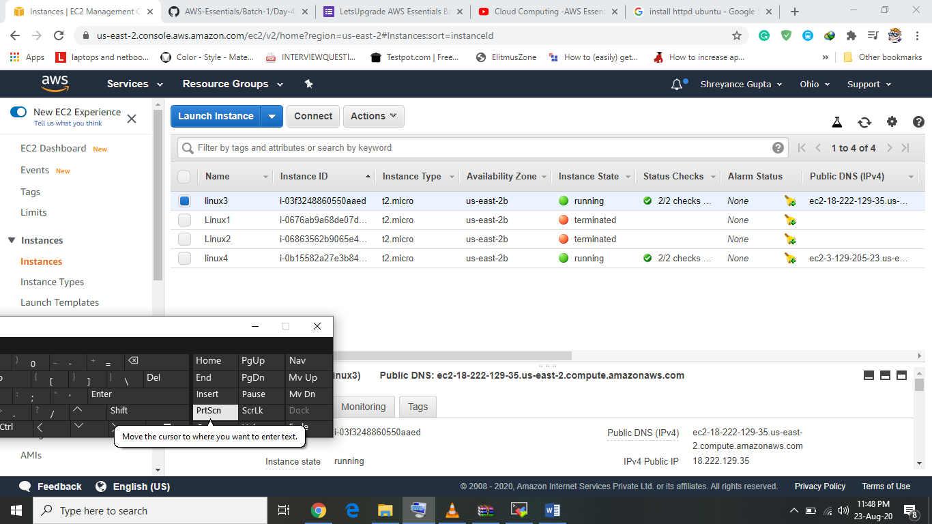

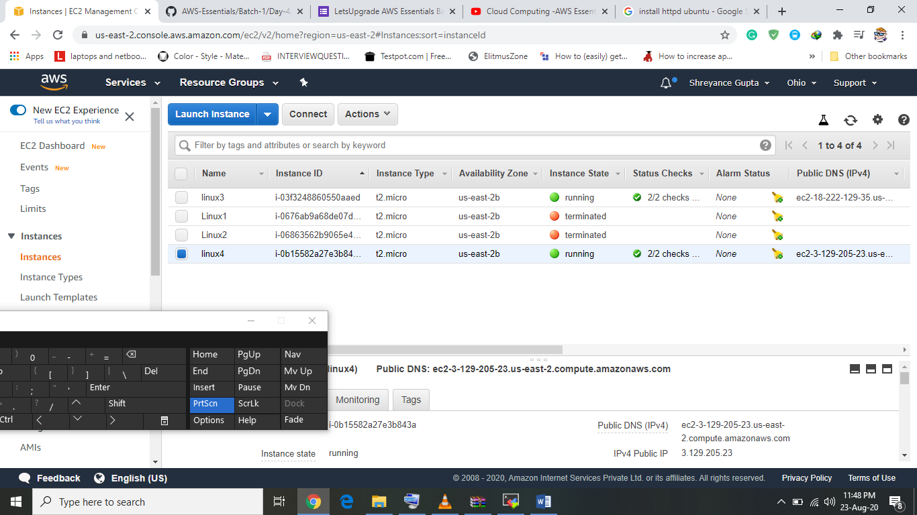

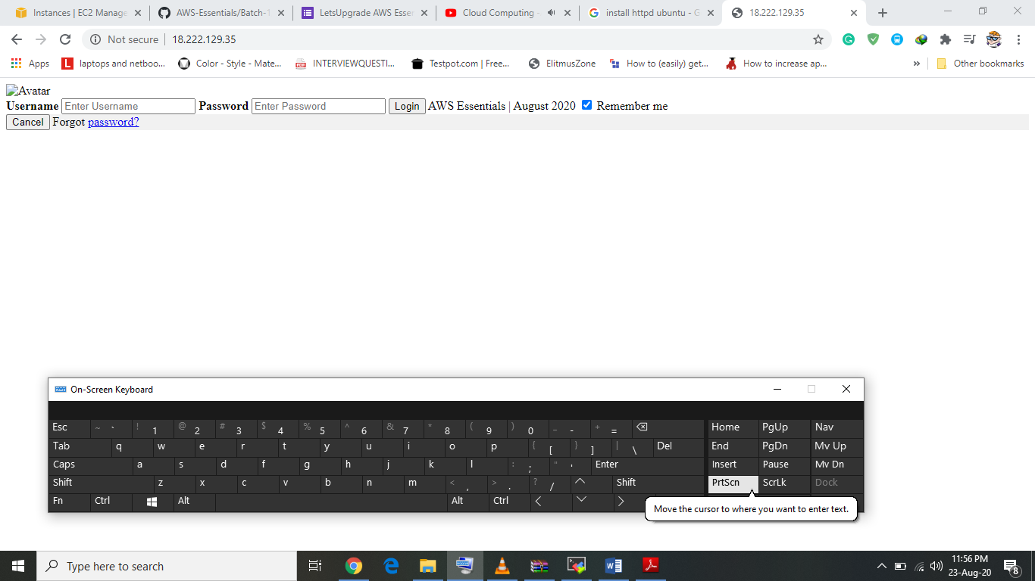

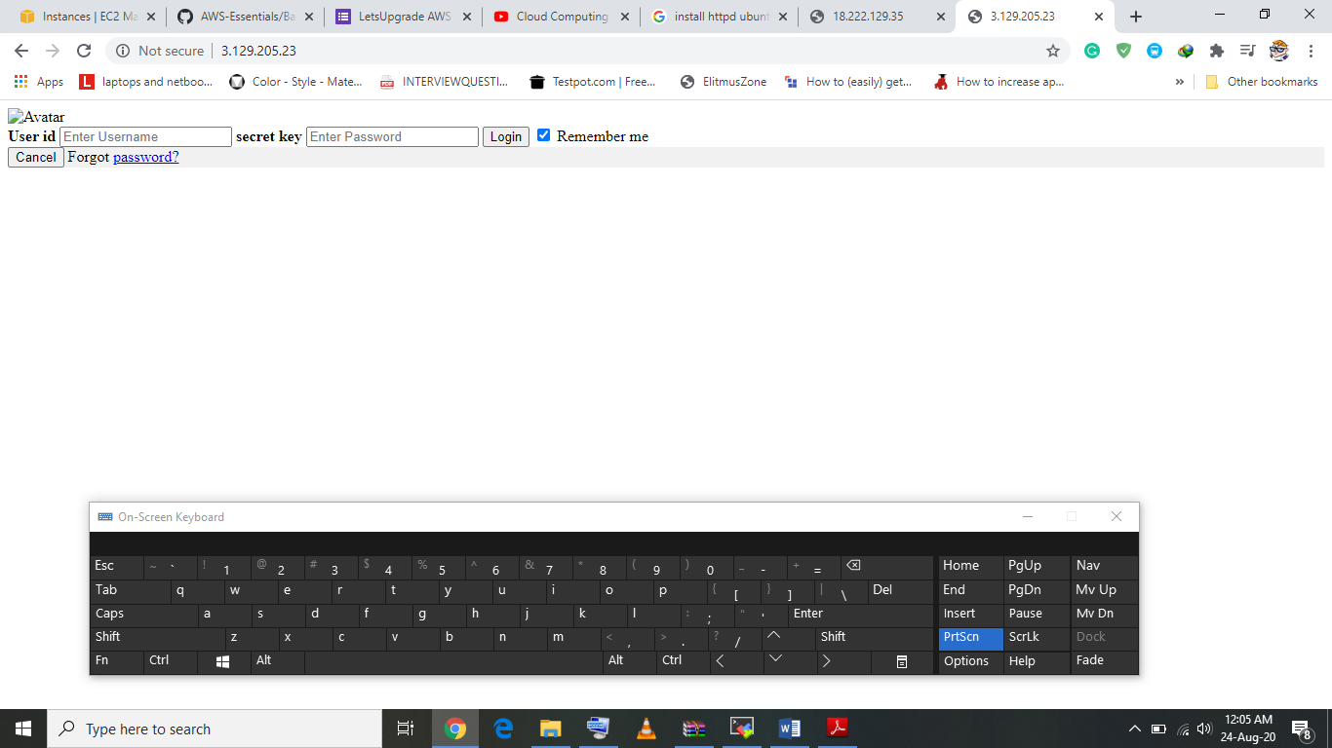

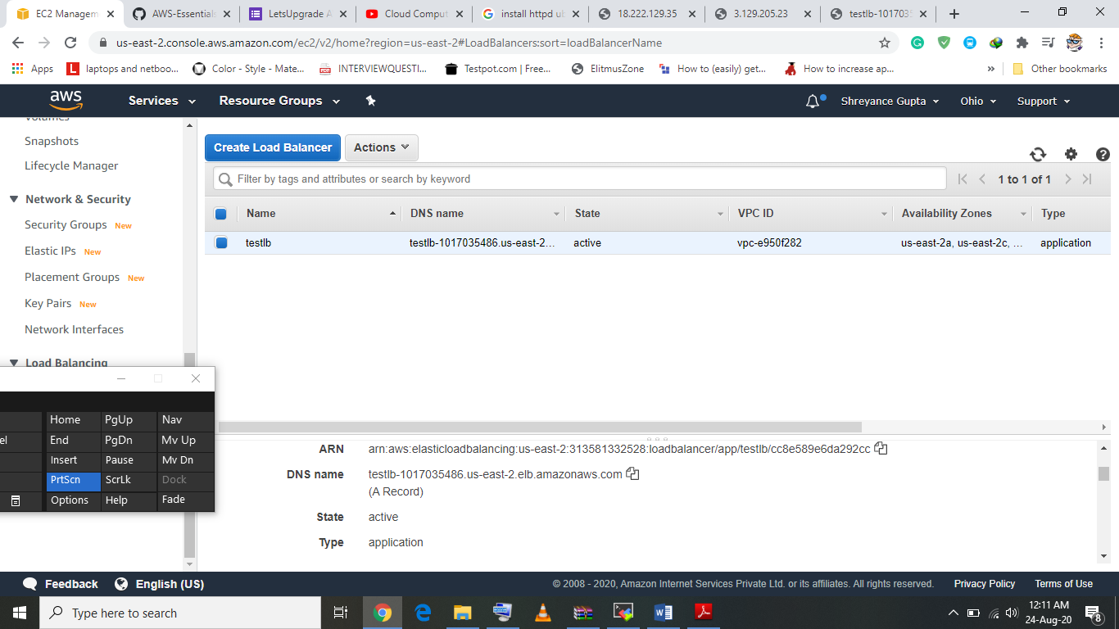

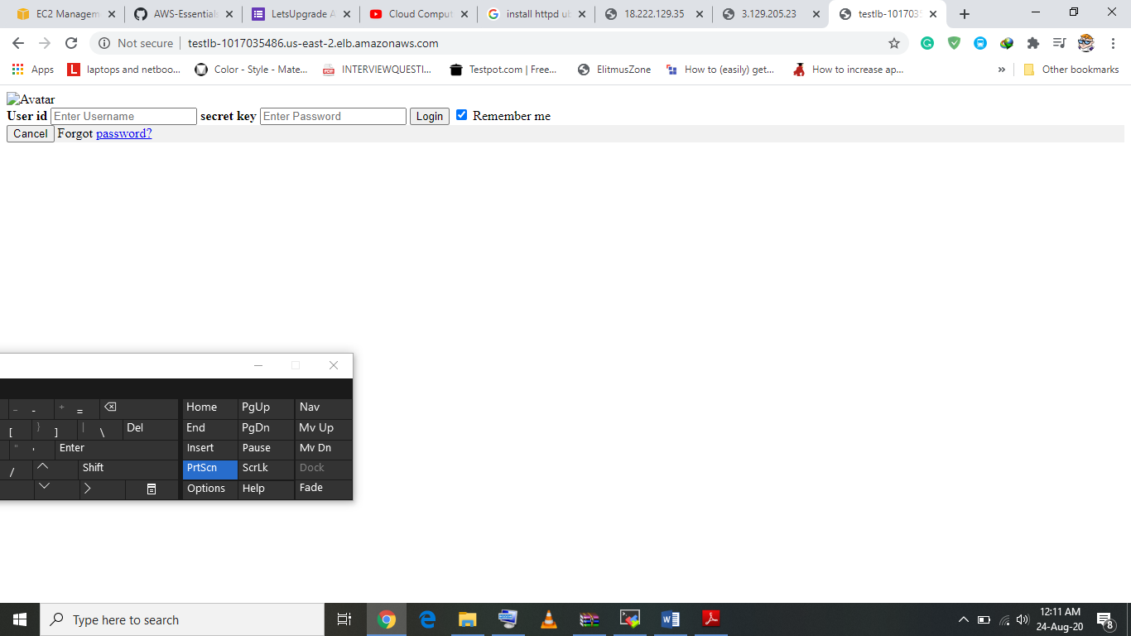

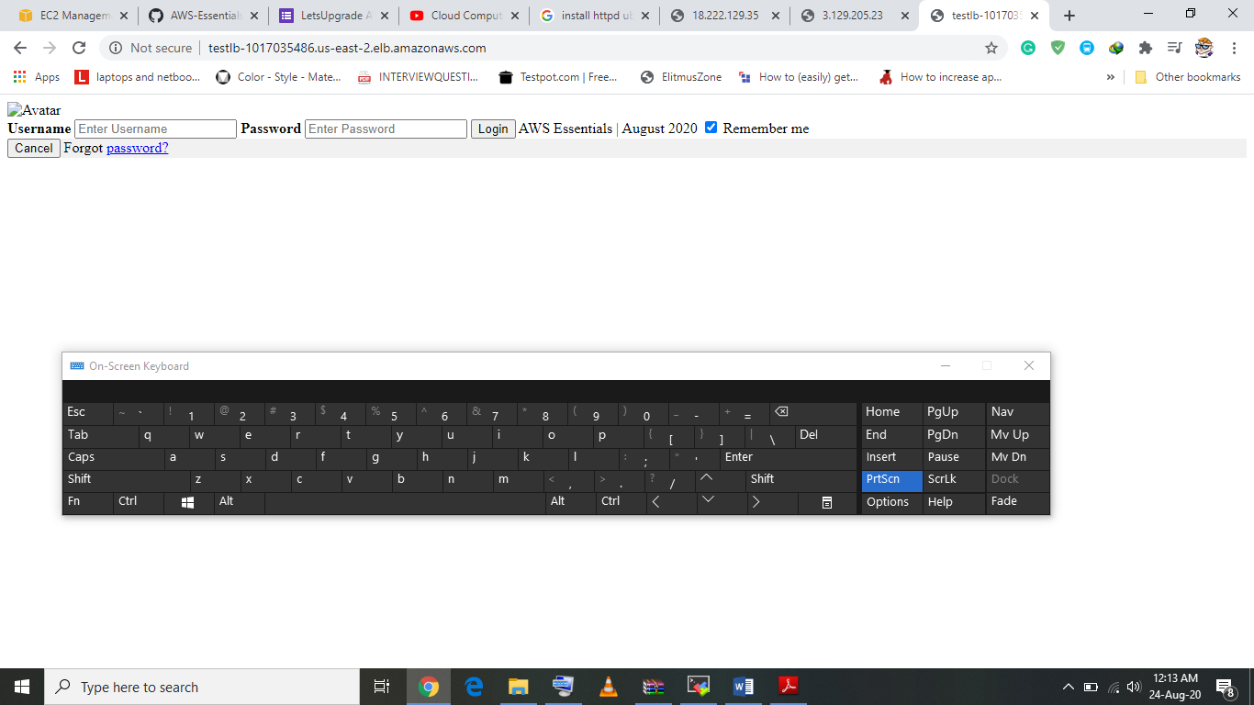

<form action="action_page.php" method="post">

<div class="imgcontainer">

<img src="img_avatar2.png" alt="Avatar" class="avatar">

</div>

<div class="container">

<label for="uname"><b>User id</b></label>

<input type="text" placeholder="Enter Username" name="uname" required>

<label for="psw"><b> secret key</b></label>

<input type="password" placeholder="Enter Password" name="psw" required>

<button type="submit">Login</button>

<label>

<input type="checkbox" checked="checked" name="remember"> Remember me

</label>

</div>

<div class="container" style="background-color:#f1f1f1">

<button type="button" class="cancelbtn">Cancel</button>

<span class="psw">Forgot <a href="#">password?</a></span>

</div>

</form>

service httpd start

cd /var/www/html/