ALS :Amyotrophic lateral sclerosis

1.Definition
ALS is a fatal neurodegenerative disease affecting motor neurons responsible for voluntary muscle movement.

2. Epidemiology
- Incidence: ~2 per 100,000/year
- Usually onset between 55–75 years
- Slightly more common in males
- Average survival: 3–5 years after diagnosis
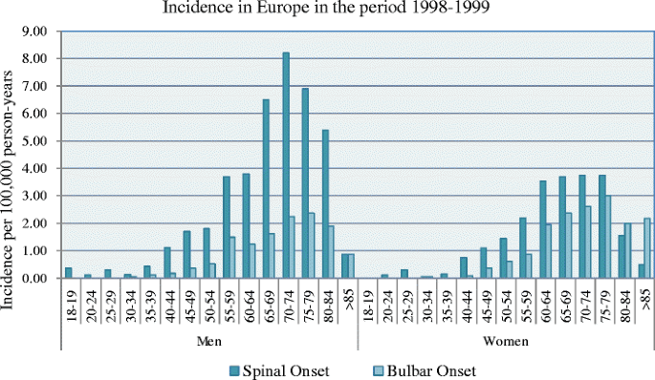

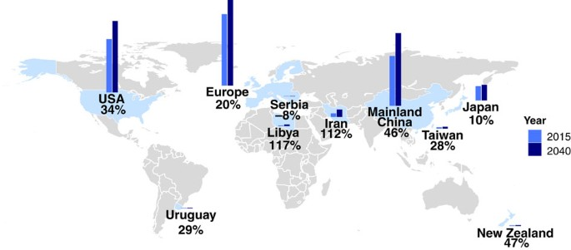

3. Risk Factors

Non-modifiable
- Increasing age
- Male sex
- Family history
- Genetic mutations

Modifiable
- Smoking
- Pesticide exposure
- Heavy metals
- Military service (association under investigation)

4. Brain Regions Affected
- Primary Motor Cortex
- Corticospinal Tract
- Brainstem Motor Nuclei
- Spinal Cord Anterior Horn Cells
- Corticobulbar Tracts
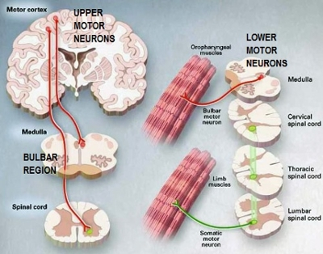

5. Anatomy
Healthy motor neuron
↓
Degenerating motor neuron
↓
Muscle denervation
↓
Muscle atrophy
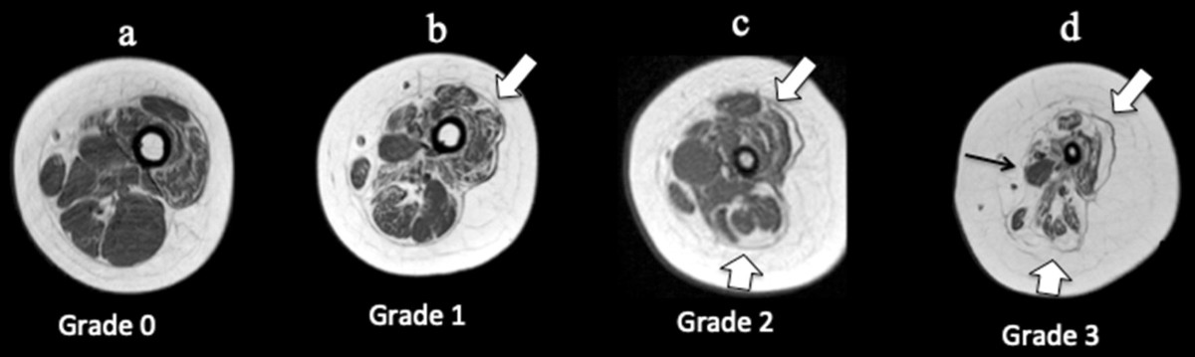

6. Pathophysiology

Motor Neuron Degeneration
Loss of upper and lower motor neurons
↓
Muscle weakness
↓
Paralysis

Protein Aggregation
- TDP-43
- SOD1
- FUS
↓
Protein misfolding
↓
Neuronal death

Glutamate Excitotoxicity
Excess glutamate
↓
Calcium overload
↓
Motor neuron death

Mitochondrial Dysfunction
↓
Oxidative stress
↓
Energy failure

Neuroinflammation
- Activated microglia
- Activated astrocytes
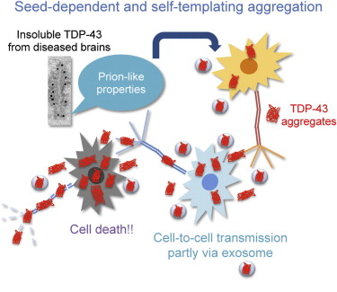

7. Genetics
Important genes
- C9orf72
- SOD1
- TARDBP
- FUS
- OPTN

8. Symptoms

Upper Motor Neuron Signs
- Hyperreflexia
- Spasticity
- Babinski sign

Lower Motor Neuron Signs
- Muscle wasting
- Fasciculations
- Weakness
- Hypotonia

Bulbar Symptoms
- Dysarthria
- Dysphagia
- Difficulty chewing

Respiratory Symptoms
- Dyspnea
- Respiratory failure

9. Clinical Stages
- Early ALS
- Regional weakness
- Generalized weakness
- Respiratory involvement
- End-stage disease

10. Diagnosis
- Clinical examination
- EMG
- Nerve conduction studies
- MRI (exclude other diseases)
- El Escorial Criteria

11. Neuroimaging
MRI findings
- Corticospinal tract degeneration
- Motor cortex atrophy

12. Biomarkers
- Neurofilament Light Chain (NfL)
- TDP-43
- CSF biomarkers
- Blood biomarkers

13. Treatment
FDA-approved medications
- Riluzole
- Edaravone
Supportive care
- Physiotherapy
- Occupational therapy
- Speech therapy
- Non-invasive ventilation
- Nutritional support

14. Latest Research
- Gene therapy
- Antisense oligonucleotides
- Stem cells
- AI-assisted diagnosis
- Biomarkers

15. Future Directions
- CRISPR
- Gene replacement
- Neuroprotection
- Personalized medicine
- Digital biomarkers

16. References
- PubMed
- Nature Reviews Neurology
- Neuron
- Lancet Neurology
- Brain
- ALS Association
- WHO

