NEURO- DISORDER DATABASE

ALZHEIMER’S DISEASE

1. Definition
Alzheimer's disease is a chronic, irreversible neurodegenerative disorder that progressively destroys neurons and synapses in the cerebral cortex and hippocampus. It mainly affects older adults but may also occur as early-onset Alzheimer's disease before the age of 65.

2. Epidemiology
- Most common cause of dementia
- Represents 60–70% of dementia cases
- More common after age 65
- Women are affected more frequently than men
- Prevalence doubles approximately every five years after age 65
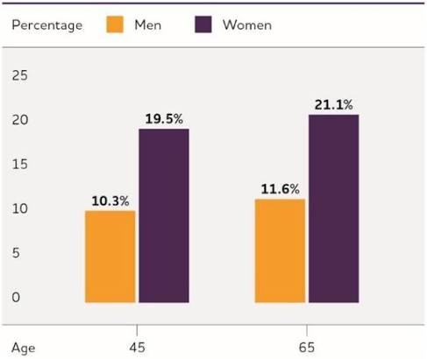
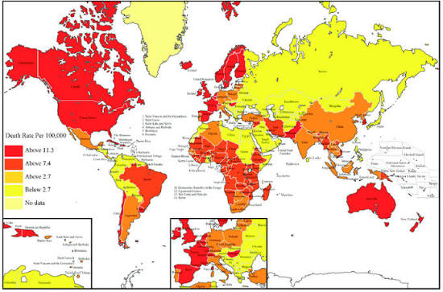

3. Risk Factors

Non-modifiable
- Increasing age
- Family history
- APOE ε4 genotype
- APP mutation
- PSEN1 mutation
- PSEN2 mutation
- Down syndrome
- Female sex

Modifiable
- Hypertension
- Diabetes mellitus
- Obesity
- Smoking
- Physical inactivity
- Poor diet
- Chronic stress
- Sleep disturbances
- Hearing loss
- Social isolation
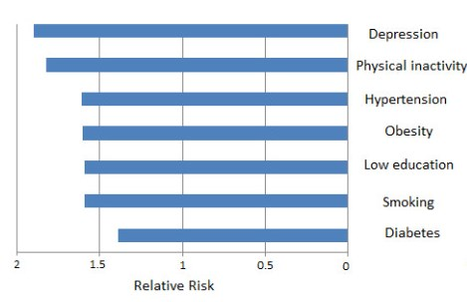

4. Brain Regions Affected

Hippocampus
Responsible for:
- Memory formation
- Spatial navigation
Usually the first region affected.

Entorhinal Cortex
Responsible for:
- Memory consolidation
- Communication between hippocampus and cortex
One of the earliest affected regions.

Temporal Lobe
Functions
- Language
- Memory
- Object recognition

Parietal Lobe
Functions
- Spatial awareness
- Sensory integration

Frontal Lobe
Functions
- Planning
- Decision making
- Executive function

Amygdala
Functions
- Emotion
- Fear
- Emotional memory

Basal Forebrain
Contains cholinergic neurons.
Loss of acetylcholine contributes to cognitive decline.

Later disease stages
- Whole cerebral cortex
- White matter degeneration
- Severe cortical atrophy

5. Anatomy: Healthy vs Alzheimer's Brain
Healthy Brain
↓
Mild Alzheimer's
↓
Moderate Alzheimer's
↓
Severe Alzheimer's
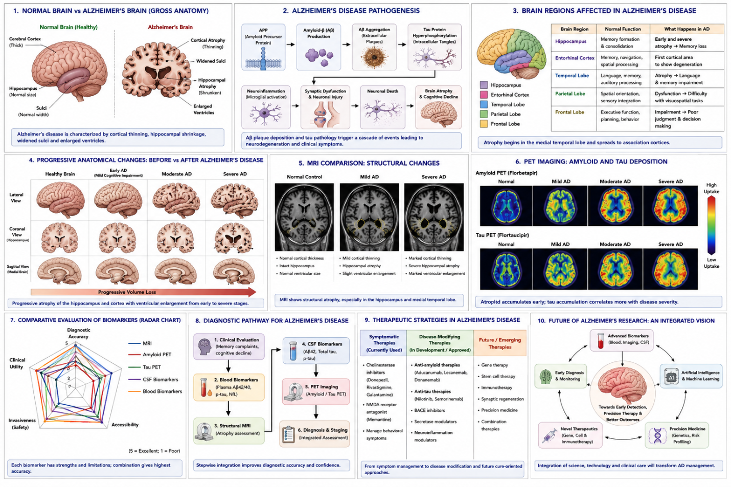

6. Pathophysiology

Amyloid Cascade
APP
↓
β-secretase
↓
γ-secretase
↓
Amyloid β
↓
Aggregation
↓
Extracellular plaques
↓
Neuronal toxicity

Tau Pathology
Normal Tau
↓
Hyperphosphorylation
↓
Microtubule instability
↓
Neurofibrillary tangles
↓
Axonal transport failure
↓
Cell death

Neuroinflammation
Activation of
- Microglia
- Astrocytes
Release of
- IL-1β
- TNF-α
- IL-6
Causing chronic inflammation.

Synaptic Dysfunction
Loss of
- Synapses
- Neurotransmitter release
- Plasticity
- Long-term potentiation (LTP)

Neuronal Death
Results in
- Brain atrophy
- Memory impairment
- Cognitive decline

7. Genetics

APP
Amyloid precursor protein mutation leading to increased amyloid production.

PSEN1
Component of γ-secretase.
Most common cause of familial Alzheimer's disease.

PSEN2
Less common familial mutation.

APOE ε4
Strongest genetic risk factor for late-onset Alzheimer's disease.

Suggested diagram
Genes involved in Alzheimer's disease

8. Symptoms

Cognitive
- Memory loss
- Difficulty learning
- Disorientation
- Poor judgment

Language
- Word-finding difficulty
- Aphasia
- Reduced vocabulary

Behavioral
- Anxiety
- Depression
- Aggression
- Personality changes
- Social withdrawal

Executive Dysfunction
- Poor planning
- Reduced attention
- Difficulty solving problems

Advanced Stage
- Dysphagia
- Incontinence
- Bedridden state
- Complete dependency

9. Clinical Stages

Preclinical Alzheimer's
No symptoms
Only biomarkers positive.

Mild Cognitive Impairment
Memory complaints
Daily activities mostly preserved.

Mild Alzheimer's
Forgetfulness
Word-finding difficulty
Difficulty performing complex tasks

Moderate Alzheimer's
Behavioral changes
Confusion
Requires assistance

Severe Alzheimer's
Loss of speech
Unable to recognize family
Completely dependent

10. Diagnosis

Clinical Assessment
History
Neurological examination
Cognitive testing

Cognitive Tests
- MMSE
- MoCA
- ADAS-Cog
- Clinical Dementia Rating (CDR)

11. Neuroimaging

MRI
Findings
- Hippocampal atrophy
- Cortical thinning
- Enlarged ventricles

CT
Used to exclude stroke or tumors.

FDG-PET
Reduced glucose metabolism in temporal and parietal cortex.

Amyloid PET
Visualizes amyloid plaques.

Tau PET
Visualizes tau accumulation.

12. Biomarkers

Cerebrospinal Fluid
↓ Aβ42
↑ Total Tau
↑ Phosphorylated Tau

Blood Biomarkers
- Plasma pTau217
- Plasma pTau181
- Neurofilament Light Chain (NfL)

13. Treatment

FDA-approved medications

Cholinesterase inhibitors
- Donepezil
- Rivastigmine
- Galantamine

NMDA antagonist
- Memantine

Disease-modifying therapies
- Lecanemab
- Donanemab (where approved)

Non-pharmacological
- Exercise
- Mediterranean diet
- Cognitive training
- Sleep hygiene
- Social engagement

14. Latest Research
- Anti-amyloid monoclonal antibodies
- Plasma biomarkers for early diagnosis
- CRISPR-based therapeutic approaches
- Stem cell therapy research
- AI-assisted MRI diagnosis
- Multi-omics approaches
- Microglia-targeted therapies

15. Future Directions
- Precision medicine
- Gene therapy
- AI-assisted diagnosis
- Digital biomarkers
- Personalized therapeutics
- Nanomedicine
- Brain organoids
- Blood-based screening tests

16. References
- PubMed
- Nature Reviews Neurology
- Nature Neuroscience
- Neuron
- The Lancet Neurology
- Alzheimer's & Dementia
- New England Journal of Medicine
- National Institute on Aging (NIA)
- World Health Organization (WHO)

