Attention-Deficit/Hyperactivity Disorder (ADHD)
ADHD is a neurodevelopmental disorder characterized by persistent patterns of inattention, hyperactivity, and impulsivity that interfere with daily functioning.

Brain Regions
- Prefrontal cortex
- Basal ganglia
- Cerebellum
- Anterior cingulate cortex
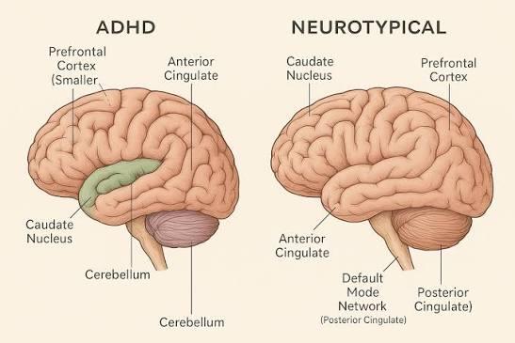

Pathophysiology
- Dopamine dysfunction
- Norepinephrine imbalance
- Delayed cortical maturation
- Executive dysfunction
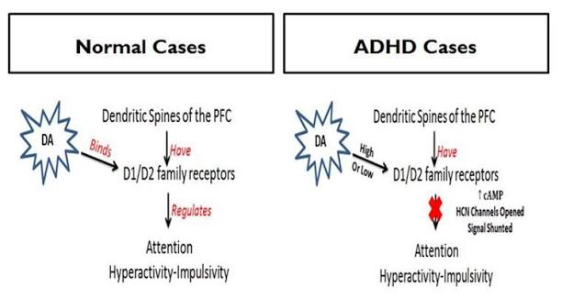

Genetics
- DRD4
- DAT1 (SLC6A3)
- SNAP25
- DRD5

Symptoms

Inattention
- Distractibility
- Forgetfulness
- Poor concentration

Hyperactivity
- Fidgeting
- Excessive talking
- Restlessness

Impulsivity
- Interrupting others
- Difficulty waiting turns

Diagnosis
- DSM-5 criteria
- Vanderbilt Scale
- Conners Rating Scale

Treatment
- Methylphenidate
- Amphetamine
- Atomoxetine
- Behavioral therapy

