Depression (Major Depressive Disorder)
Major Depressive Disorder (MDD) is a common psychiatric disorder characterized by persistent low mood, loss of interest or pleasure (anhedonia), cognitive impairment, and physical symptoms lasting at least two weeks.

Brain Regions
- Prefrontal cortex
- Amygdala
- Hippocampus
- Anterior cingulate cortex
- Nucleus accumbens

Pathophysiology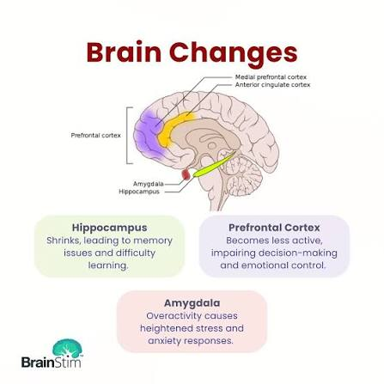
- Reduced serotonin
- Reduced norepinephrine
- Reduced dopamine
- HPA axis dysregulation
- Neuroinflammation
- Reduced BDNF
- Hippocampal atrophy
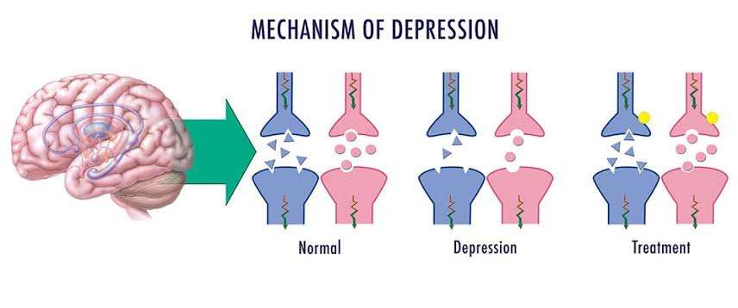

Genetics
- SLC6A4
- BDNF
- FKBP5
- TPH2

Symptoms
- Persistent sadness
- Loss of interest
- Sleep disturbances
- Appetite changes
- Fatigue
- Poor concentration
- Feelings of worthlessness
- Suicidal thoughts (in some patients)

Diagnosis
- DSM-5 criteria
- PHQ-9
- Hamilton Depression Rating Scale (HAM-D)

Treatment
- SSRIs
- SNRIs
- Cognitive Behavioral Therapy (CBT)
- Interpersonal Therapy
- Electroconvulsive Therapy (ECT)
- Repetitive Transcranial Magnetic Stimulation (rTMS)
- Ketamine/esketamine (selected patients)

