Epilepsy

1. Definition

Epilepsy is a chronic neurological disorder characterized by recurrent, unprovoked seizures caused by abnormal, excessive, and synchronized electrical activity in the brain. It affects people of all ages and has many causes, including genetic disorders, brain injury, infections, tumors, and developmental abnormalities..Epilepsy is diagnosed when a person experiences two or more unprovoked seizures or has a high probability of future seizures.

2. Epidemiology
- Approximately 50 million people worldwide
- One of the most common neurological disorders
- Can occur at any age
- Higher incidence in children and older adults

3. Risk Factors
- Genetics
- Brain trauma
- Stroke
- Brain tumors
- CNS infections
- Developmental disorders
- Alzheimer's disease

4. Brain Regions Affected
Depending on seizure type
- Temporal lobe
- Frontal lobe
- Parietal lobe
- Occipital lobe
- Hippocampus
- Thalamus

5. Normal vs Seizure Brain Activity
Normal neurons
↓
Controlled firing
↓
Balanced excitation/inhibition
↓
Seizure
↓
Hyperexcitable neurons
↓
Synchronous electrical discharge
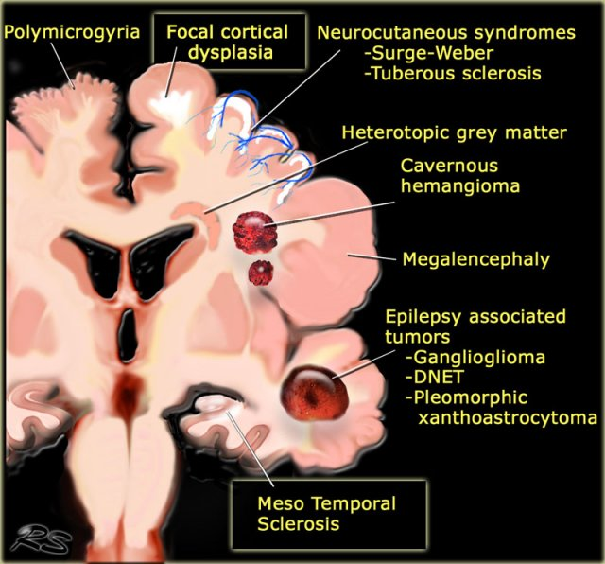

6. Pathophysiology

Excitation–Inhibition Imbalance
↑ Glutamate
↓
↓ GABA
↓
Neuronal hyperexcitability
↓
Seizure

Ion Channel Dysfunction
- Sodium channels
- Potassium channels
- Calcium channels

Synaptic Plasticity Changes
Abnormal neuronal circuits
↓
Recurrent seizures

Neuroinflammation
Activated glial cells
↓
Inflammatory cytokines
↓
Increased seizure susceptibility

7. Genetics
Important genes
- SCN1A
- SCN2A
- KCNQ2
- DEPDC5
- GABRA1

8. Classification

Focal Seizures
- Aware
- Impaired awareness

Generalized Seizures
- Tonic-clonic
- Absence
- Myoclonic
- Atonic
- Tonic
- Clonic
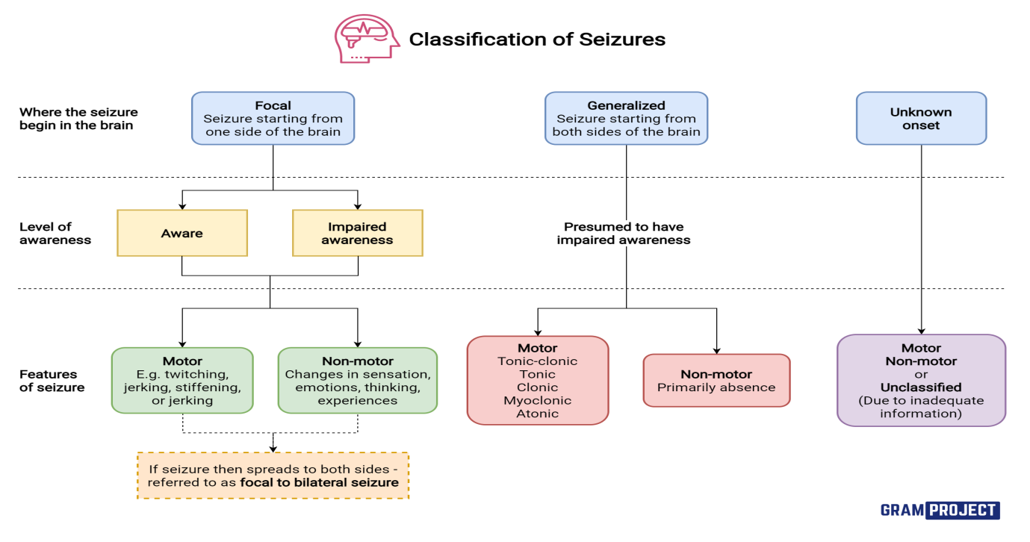

9. Symptoms
Motor
- Jerking
- Stiffening
- Loss of consciousness
Sensory
- Tingling
- Visual changes
- Auditory hallucinations
Autonomic
- Sweating
- Tachycardia
Psychological
- Fear
- Déjà vu
- Confusion

10. Diagnosis
- EEG
- Video EEG
- MRI
- CT
- PET
- SPECT
- Blood investigations

11. Neuroimaging
MRI
- Hippocampal sclerosis
- Cortical dysplasia
- Tumors
PET
- Hypometabolism
SPECT
- Increased blood flow during seizures

12. Biomarkers
Current research
- Neurofilament Light Chain
- Inflammatory cytokines
- miRNA
- EEG biomarkers

13. Treatment

Anti-Seizure Medications
- Valproate
- Levetiracetam
- Lamotrigine
- Carbamazepine
- Phenytoin
- Topiramate

Surgery
- Temporal lobectomy
- Lesionectomy

Neuromodulation
- Vagus Nerve Stimulation (VNS)
- Deep Brain Stimulation (DBS)
- Responsive Neurostimulation (RNS)

Lifestyle
- Ketogenic diet
- Sleep hygiene
- Avoid seizure triggers

14. Latest Research
Summarize recent work (2024–2026) on:
- AI-based seizure prediction
- Wearable seizure detection
- Gene therapy
- Stem cell therapy
- Closed-loop neurostimulation
- Blood biomarkers

15. Future Directions
- Precision medicine
- AI-assisted diagnosis
- Digital EEG biomarkers
- Personalized anti-seizure therapy
- Brain-computer interfaces

16. References
- PubMed
- Nature Reviews Neurology
- Neuron
- Brain
- Lancet Neurology
- International League Against Epilepsy (ILAE)
- WHO

