HUNTINGTON’SDISEASE

1. Definition
Huntington's disease is a progressive neurodegenerative disorder characterized by involuntary movements (chorea), psychiatric symptoms, and cognitive impairment. It results from a mutation in the HTT gene, causing production of an abnormal huntingtin protein that gradually damages neurons.

2. Epidemiology
- Rare disorder
- Prevalence: approximately 5–10 per 100,000 people in populations of European ancestry
- Equal frequency in males and females
- Typical onset: 30–50 years
- Juvenile Huntington's disease: onset before age 20 (less common)
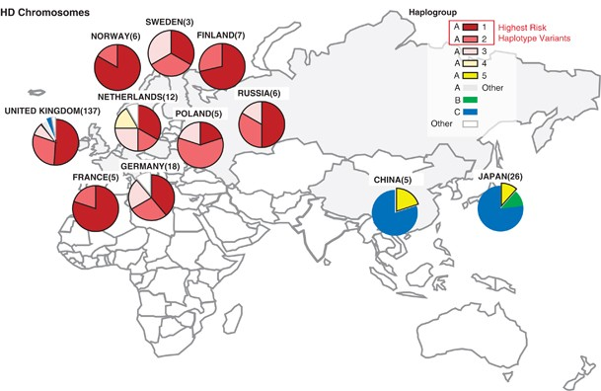
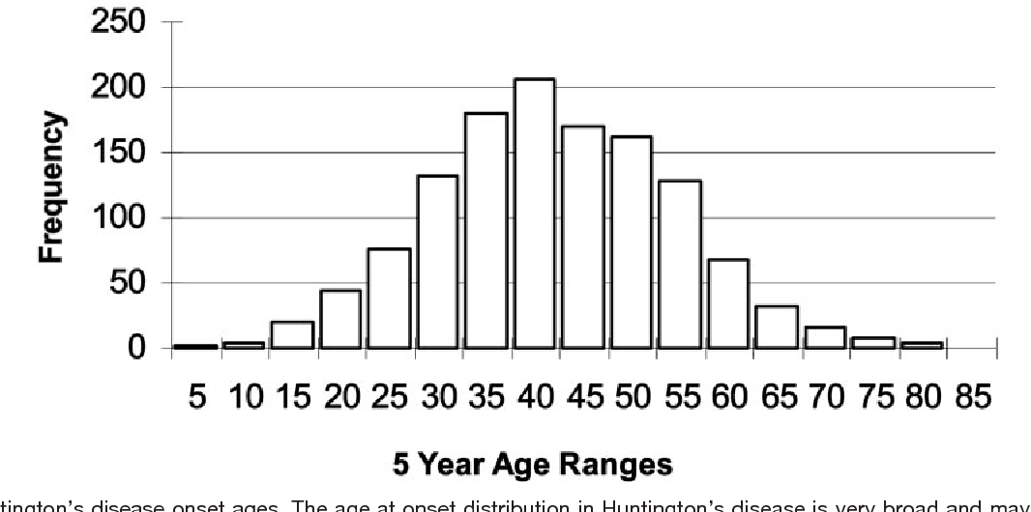

3. Risk Factors

Non-modifiable
- HTT gene mutation
- Family history
- Number of CAG repeats (greater repeats often mean earlier onset)

Modifiable
No confirmed lifestyle factors are known to prevent Huntington's disease because it is a genetic disorder, although exercise, good nutrition, and supportive care may improve quality of life.
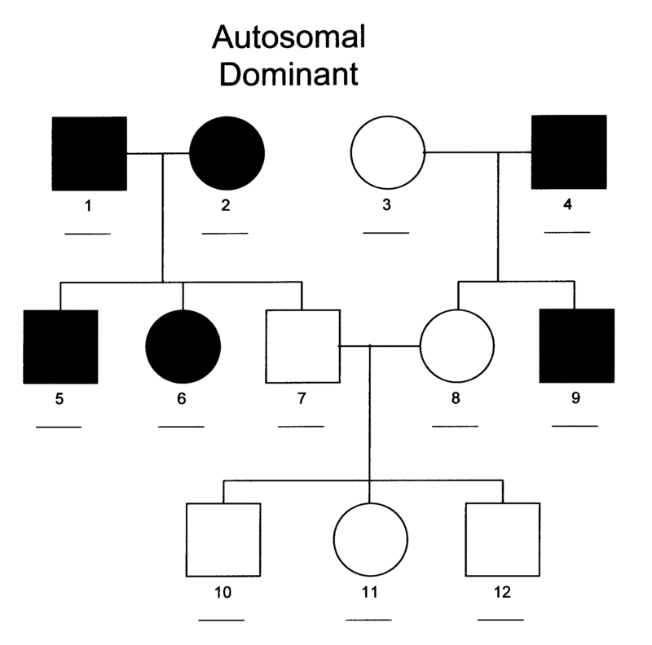

4. Brain Regions Affected

Caudate Nucleus
One of the earliest and most severely affected regions.
Functions:
- Movement control
- Learning
- Cognition

Putamen
Responsible for:
- Motor coordination
- Habit learning

Globus Pallidus
Regulates voluntary movement.

Cerebral Cortex
Progressive degeneration causes:
- Cognitive decline
- Executive dysfunction

Thalamus
Motor information relay becomes disrupted.

Later Disease Stages
Degeneration spreads throughout:
- Basal ganglia
- Cerebral cortex
- White matter
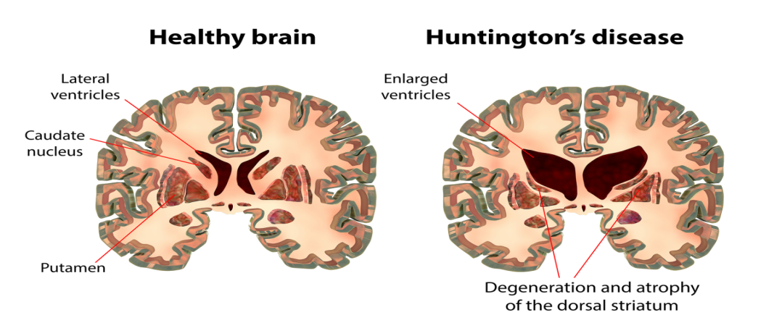

5. Anatomy: Healthy vs Huntington's Brain
Discuss:
Healthy Brain
↓
Early Huntington's Disease
↓
Advanced Huntington's Disease
Key changes:
- Atrophy of the caudate nucleus
- Atrophy of the putamen
- Enlarged lateral ventricles
- Cortical thinning

6. Pathophysiology

HTT Gene Mutation
Normal HTT Gene
↓
CAG repeat expansion
↓
Mutant huntingtin protein
↓
Protein misfolding
↓
Protein aggregation
↓
Neuronal dysfunction
↓
Cell death

Protein Aggregation
Mutant huntingtin accumulates inside neurons, disrupting normal cellular function.

Excitotoxicity
Excess glutamate activity
↓
Calcium overload
↓
Neuronal injury
↓
Cell death

Mitochondrial Dysfunction
- Reduced ATP production
- Increased oxidative stress
- Energy failure

Neuroinflammation
Activation of:
- Microglia
- Astrocytes
Release of inflammatory mediators contributing to neuronal degeneration.

Neuronal Loss
Most severe in:
- Medium spiny neurons
- Caudate nucleus
- Putamen
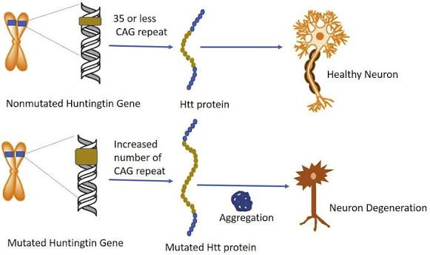

7. Genetics

HTT Gene
Located on chromosome 4.
Encodes the huntingtin protein.

CAG Repeat Expansion
Normal:
- 10–26 repeats
Intermediate:
- 27–35 repeats
Reduced penetrance:
- 36–39 repeats
Disease-causing:
- 40 or more repeats
Greater repeat numbers are often associated with earlier disease onset (anticipation).

Inheritance
- Autosomal dominant
- Each child of an affected parent has a 50% chance of inheriting the mutation

8. Symptoms

Motor Symptoms
- Chorea (involuntary dance-like movements)
- Dystonia
- Poor coordination
- Balance problems
- Gait disturbances
- Difficulty swallowing (dysphagia)
- Difficulty speaking (dysarthria)

Cognitive Symptoms
- Memory impairment
- Reduced attention
- Poor judgment
- Executive dysfunction
- Dementia (later stages)

Psychiatric Symptoms
- Depression
- Anxiety
- Irritability
- Obsessive behaviors
- Aggression
- Apathy
- Psychosis (less common)

9. Clinical Stages

Preclinical Stage
Positive genetic test
No obvious symptoms

Early Stage
- Mild chorea
- Mood changes
- Difficulty concentrating

Middle Stage
- Significant motor impairment
- Cognitive decline
- Increasing dependence

Advanced Stage
- Severe motor disability
- Inability to walk
- Severe dementia
- Complete dependence

10. Diagnosis

Clinical Assessment
- Family history
- Neurological examination
- Psychiatric assessment
- Cognitive evaluation

Genetic Testing
Detection of CAG repeat expansion in the HTT gene.
This is the definitive diagnostic test.

Cognitive Testing
- Mini-Mental State Examination (MMSE)
- Montreal Cognitive Assessment (MoCA)

11. Neuroimaging

MRI
Findings:
- Caudate atrophy
- Putamen atrophy
- Enlarged ventricles
- Cortical atrophy

CT Scan
May demonstrate caudate atrophy in later disease stages.

PET Scan
Reduced glucose metabolism in the basal ganglia and cortex.

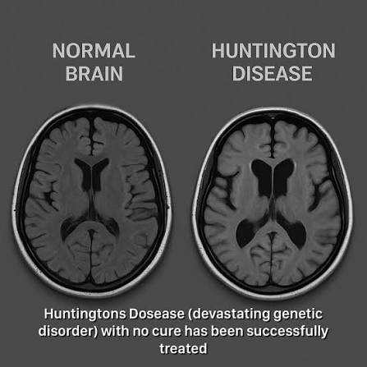

12. Biomarkers
Current research focuses on:
- Mutant huntingtin protein in CSF
- Neurofilament Light Chain (NfL)
- Plasma biomarkers
- MRI volumetric measurements
No routine clinical biomarker is currently used for monitoring disease progression.

13. Treatment

Medications for Chorea
- Tetrabenazine
- Deutetrabenazine

Antipsychotics
- Risperidone
- Olanzapine

Antidepressants
Selective serotonin reuptake inhibitors (SSRIs) may help manage depression and anxiety.

Supportive Therapy
- Physiotherapy
- Occupational therapy
- Speech therapy
- Nutritional support
- Psychological counseling

14. Latest Research
- Huntingtin-lowering therapies (antisense oligonucleotides)
- Gene-editing approaches (CRISPR)
- RNA interference (RNAi)
- Stem cell therapy
- Neuroprotective drugs
- AI-assisted disease progression prediction
- Biomarker development using blood and CSF

15. Future Directions
- Gene silencing therapies
- CRISPR-based gene editing
- RNA-targeted therapeutics
- Stem cell transplantation
- Personalized medicine
- Digital biomarkers
- AI for early disease prediction

16. References
- PubMed
- Nature Reviews Neurology
- Nature Neuroscience
- Neuron
- The Lancet Neurology
- Brain
- Journal of Huntington's Disease
- National Institute of Neurological Disorders and Stroke (NINDS)
- Huntington's Disease Society of America (HDSA)
- World Health Organization (WHO)

