PARKINSON’S DISEASE

1. Definition
Parkinson's disease is a chronic, progressive neurodegenerative disorder primarily affecting the motor system. It results from the selective loss of dopamine-producing neurons in the substantia nigra and the accumulation of α-synuclein protein aggregates (Lewy bodies).

2. Epidemiology
- Second most common neurodegenerative disorder
- Affects approximately 1% of people over 60 years
- More common in men than women
- Average age of onset: 60 years
- Early-onset Parkinson's disease can occur before age 50
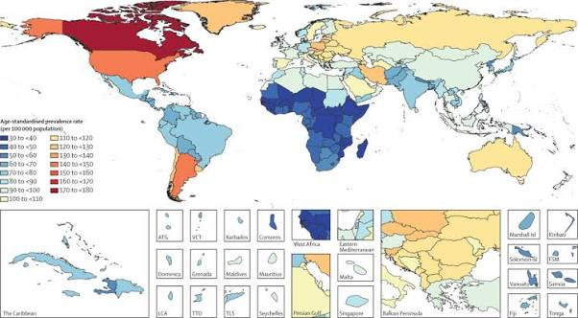
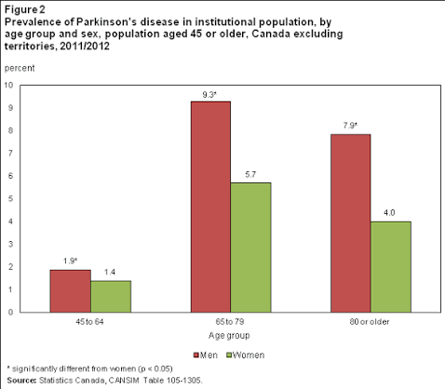

3. Risk Factors

Non-modifiable
- Increasing age
- Family history
- Male sex
- Genetic mutations

Modifiable
- Pesticide exposure
- Herbicides
- Heavy metals
- Head injury
- Rural living
- Air pollution
Protective factors (associated in some studies)
- Regular exercise
- Coffee/caffeine consumption
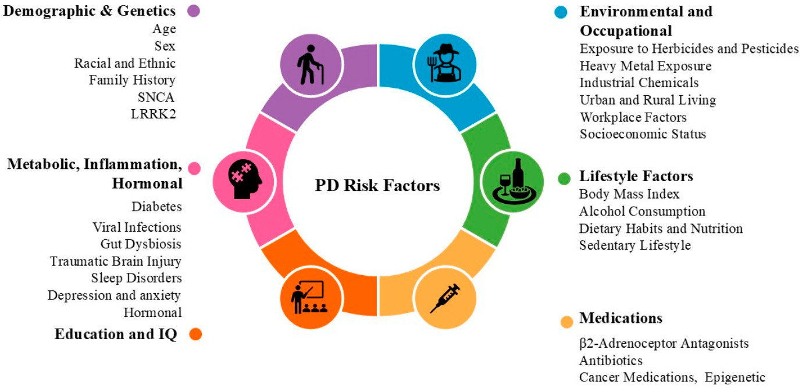

4. Brain Regions Affected

Substantia Nigra Pars Compacta
Primary site of dopaminergic neuron degeneration.

Basal Ganglia
Includes:
- Caudate nucleus
- Putamen
- Globus pallidus
Responsible for motor control.

Striatum
Receives dopamine from substantia nigra.
Loss of dopamine causes impaired movement.

Thalamus
Relays motor information to the cerebral cortex.

Motor Cortex
Controls voluntary movement.

Brainstem
Contains nuclei involved in sleep and autonomic regulation.

Later Disease Stages
Degeneration extends to:
- Cortex
- Limbic system
- Autonomic nervous system

5. Anatomy: Healthy vs Parkinson's Brain
Healthy Brain
↓
Early Parkinson's
↓
Advanced Parkinson's
Key changes:
- Loss of pigmented neurons in substantia nigra
- Reduced dopamine levels
- Presence of Lewy bodies
- Changes in basal ganglia circuitry
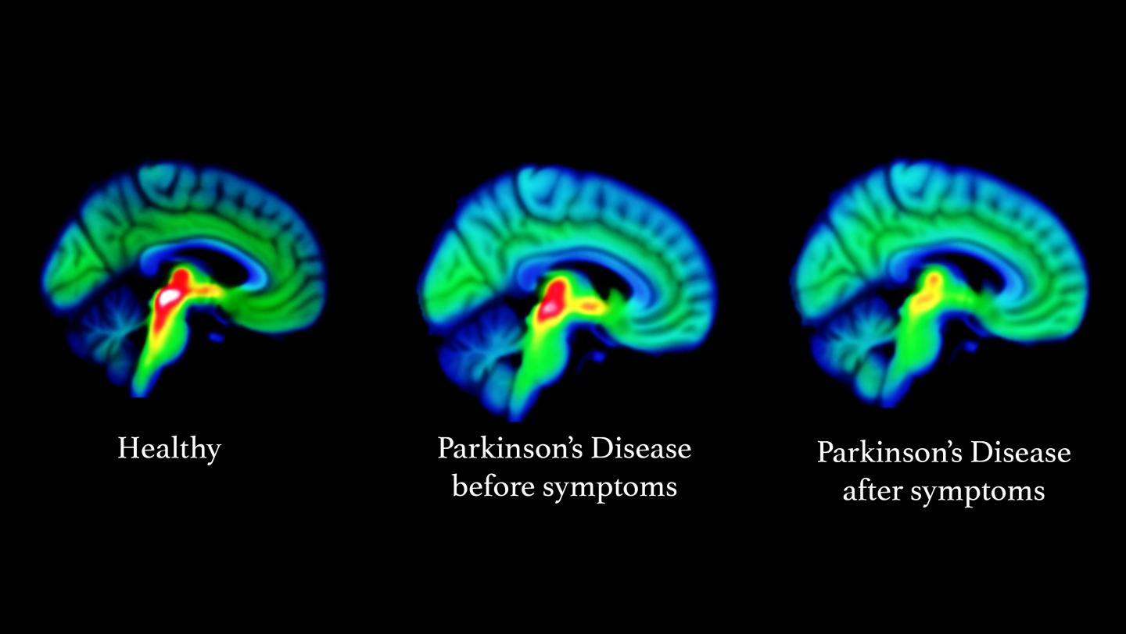

6. Pathophysiology

Dopamine Loss
Degeneration of dopaminergic neurons
↓
Reduced dopamine release
↓
Impaired basal ganglia signaling
↓
Motor dysfunction

α-Synuclein Aggregation
Normal α-synuclein
↓
Misfolding
↓
Aggregation
↓
Lewy bodies
↓
Neuronal dysfunction
↓
Cell death

Mitochondrial Dysfunction
Reduced ATP production
↓
Oxidative stress
↓
Neuronal damage

Neuroinflammation
Activation of:
- Microglia
- Astrocytes
Release of inflammatory cytokines contributing to disease progression.

Oxidative Stress
- Reactive oxygen species (ROS)
- Lipid peroxidation
- DNA damage
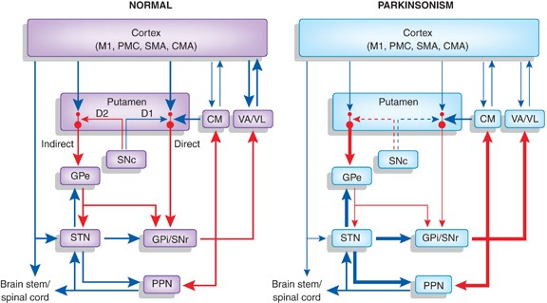

7. Genetics
Important genes:

SNCA
Encodes α-synuclein.
Mutations cause abnormal protein aggregation.

LRRK2
Most common genetic cause of familial Parkinson's disease.

PARK2 (Parkin)
Associated with early-onset Parkinson's disease.

PINK1
Maintains mitochondrial quality control.

DJ-1
Protects against oxidative stress.

GBA
Mutations increase Parkinson's disease risk.

8. Symptoms

Motor Symptoms
- Resting tremor
- Bradykinesia
- Rigidity
- Postural instability
- Shuffling gait
- Freezing of gait
- Reduced facial expression (masked facies)
- Micrographia (small handwriting)

Non-Motor Symptoms
- Depression
- Anxiety
- Constipation
- Sleep disorders
- Loss of smell (hyposmia)
- Fatigue
- Cognitive impairment
- Dementia (later stages)

Autonomic Symptoms
- Orthostatic hypotension
- Urinary dysfunction
- Excessive sweating
- Sexual dysfunction

9. Clinical Stages

Prodromal Stage
- Loss of smell
- REM sleep behavior disorder
- Constipation

Early Parkinson's Disease
- Mild unilateral symptoms
- Minimal disability

Moderate Disease
- Bilateral symptoms
- Balance impairment

Advanced Disease
- Severe motor disability
- Cognitive decline
- Dependence on caregivers
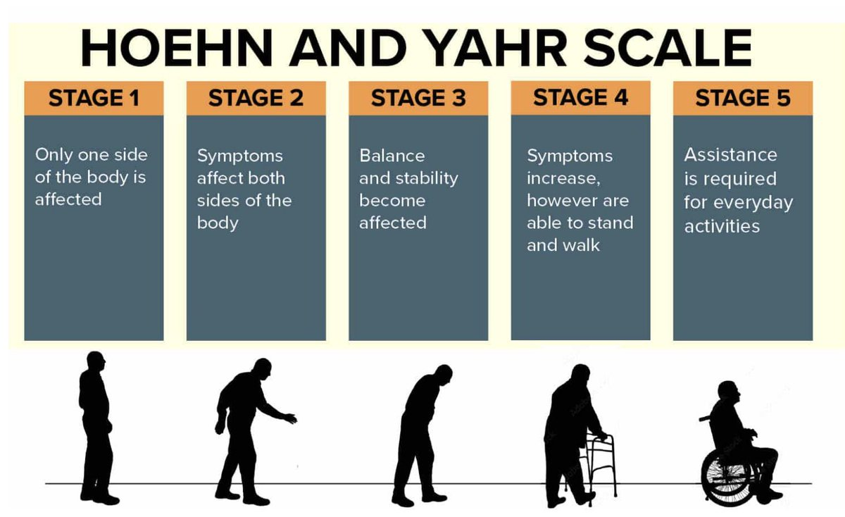

10. Diagnosis

Clinical Examination
Neurological assessment
Medical history
Motor examination

Diagnostic Criteria
- Bradykinesia (required)
- Resting tremor
- Rigidity

Rating Scales
- Unified Parkinson's Disease Rating Scale (UPDRS)
- Hoehn and Yahr Scale
- MDS-UPDRS

11. Neuroimaging

MRI
Usually normal in early Parkinson's disease.
Used to exclude other causes.

DaTscan (Dopamine Transporter Scan)
Shows reduced dopamine transporter activity.

PET
Evaluates dopamine metabolism.

Transcranial Ultrasound
May show increased echogenicity of substantia nigra.

12. Biomarkers
Current research biomarkers include:
- α-Synuclein in CSF
- Neurofilament Light Chain (NfL)
- DJ-1 protein
- Blood inflammatory markers
No single biomarker is currently definitive for routine diagnosis.

13. Treatment

Medications

Dopamine Replacement
- Levodopa + Carbidopa

Dopamine Agonists
- Pramipexole
- Ropinirole
- Rotigotine

MAO-B Inhibitors
- Selegiline
- Rasagiline
- Safinamide

COMT Inhibitors
- Entacapone
- Opicapone

Amantadine
Used for dyskinesia.

Surgical Treatment

Deep Brain Stimulation (DBS)
Targets:
- Subthalamic nucleus (STN)
- Globus pallidus internus (GPi)

Non-pharmacological Therapy
- Physiotherapy
- Occupational therapy
- Speech therapy
- Exercise programs
- Nutritional support

14. Latest Research
- α-Synuclein-targeted immunotherapy
- Stem cell transplantation
- Gene therapy
- AI-assisted diagnosis using gait analysis
- Wearable devices for disease monitoring
- Biomarker discovery using blood and CSF
- Neuroprotective drug trials

15. Future Directions
- Disease-modifying therapies
- Precision medicine
- Gene editing (CRISPR)
- Stem cell replacement therapy
- AI-based early diagnosis
- Digital biomarkers
- Personalized rehabilitation
- Brain-computer interfaces

16. References
- PubMed
- Nature Reviews Neurology
- Nature Neuroscience
- Neuron
- The Lancet Neurology Movement Disorders
- Parkinsonism & Related Disorders
- National Institute of Neurological Disorders and Stroke (NINDS)
- World Health Organization (WHO)

