Stroke

Stroke is an acute neurological emergency caused by interruption of cerebral blood flow, leading to brain cell death. It is classified as ischemic stroke (blocked artery) or hemorrhagic stroke (ruptured blood vessel).
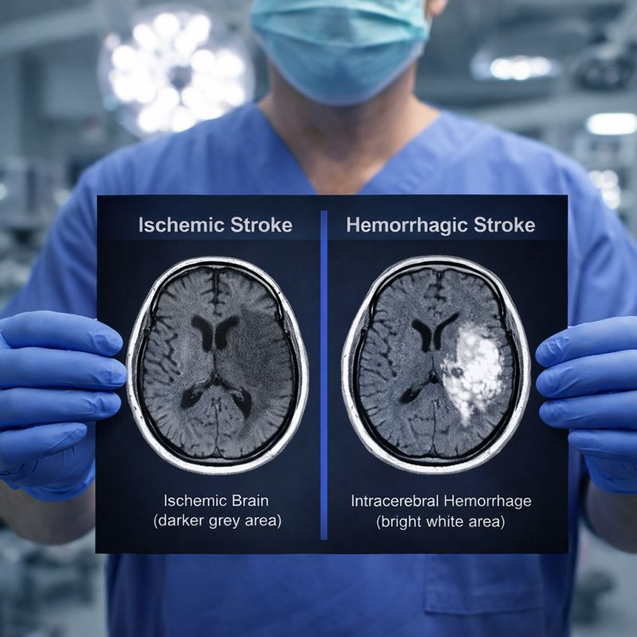

Brain Regions
- Middle cerebral artery territory
- Anterior cerebral artery territory
- Posterior cerebral artery territory
- Brainstem
- Cerebellum
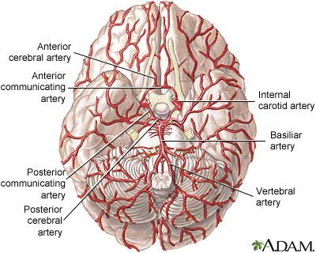

Pathophysiology
Reduced blood flow
↓
Oxygen deprivation
↓
ATP depletion
↓
Excitotoxicity
↓
Cell death
↓
Inflammation
↓
Brain infarction

Symptoms
- Facial drooping
- Arm weakness
- Speech difficulty
- Vision loss
- Hemiplegia
- Aphasia
- Ataxia

Diagnosis
- CT
- MRI
- CT angiography
- NIH Stroke Scale
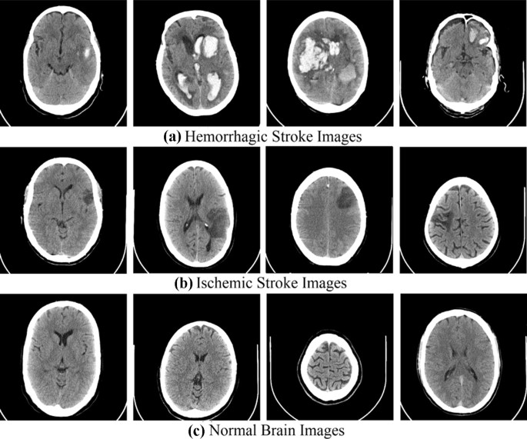

Treatment
- Alteplase (tPA)
- Mechanical thrombectomy
- Antiplatelet therapy
- Blood pressure management
- Rehabilitation

