KernelLens: Intelligent Linux Kernel Log Anomaly Detection, Temporal Correlation, and Evidence-Grounded Root Cause Analysis
Shreyans Chowdry , Swapnil Jain
School of Computer Science and Engineering , Vellore Institute of Technology (VIT)
Vellore , Tamil Nadu , India
shreyans.chowdry2024@vitstudent.ac.in , swapnil.jain2024@vitstudent.ac.in
Abstract: Linux kernel and system logs record the behavior of memory management, storage, filesystems, processes, networking and hardware, but the events that explain an incident are interleaved with large volumes of repetitive, benign messages. This paper presents KernelLens, a multi-stage diagnostic pipeline that parses logs into Drain3 templates, flags suspicious events with a Random Forest classifier, groups flagged events into incident clusters through temporal-semantic correlation (TF-IDF cosine similarity and connected components), and passes the reduced context to a root-cause analysis (RCA) stage whose structured output must cite log events as evidence. A deterministic local reasoning engine provides an offline alternative to an external language model. On a curated 85-sample LogHub benchmark, a chronological 80/20 hold-out whose test partition is entirely anomalous yields 76.47% recall and 100.00% precision, which we report as a detection rate rather than as general accuracy. In a small proof-of-concept experiment on 21 Darwin/macOS logs, domain adaptation raised F1 from 0.3333 to 0.7273. On a 34-event mixed workload, the anomaly filter retained 16 events (a 52.94% event-count reduction), correlation produced two incident clusters, and the diagnostic result cited five evidence events. The offline pipeline required 900.12 ms per batch, mostly in the ML stage. Live external-LLM latency was not measured, and the evaluation is limited by small curated datasets and the absence of baseline comparisons.
Index Terms: kernel log analysis, anomaly detection, log parsing, event correlation, root-cause analysis, Random Forest, temporal-semantic correlation, LLM-assisted diagnosis

I. Introduction
Linux systems continuously emit kernel and system logs that record the behavior of memory management, storage and filesystems, process scheduling, networking, hardware drivers, services and security subsystems [1], [2]. Operators rely on these records to diagnose failures, but the volume is large and the content is heterogeneous and highly repetitive. The messages that explain an incident, such as an out-of-memory kill or a filesystem error, are interleaved with many benign periodic messages, so locating the causally relevant events by manual inspection is slow and error-prone.
The difficulty is not merely collecting logs. Diagnosis involves three distinct questions. Anomaly detection asks whether an individual event is suspicious. Incident correlation asks which suspicious events belong to the same incident. Root-cause analysis (RCA) asks which explanation best accounts for the correlated evidence. A classifier that labels individual events answers only the first question and does not by itself provide an incident-level, causal interpretation.
Large language models (LLMs) have recently been applied to incident root-causing and log analysis [3], [4]. However, supplying large volumes of raw logs to a language model introduces irrelevant context, enlarges the prompt, and can make the resulting reasoning less focused and harder to verify, particularly when explanations are not tied to specific log lines.
This paper presents KernelLens, a multi-stage diagnostic pipeline for Linux kernel and system logs that progressively reduces and structures telemetry before root-cause reasoning. Logs are parsed into templates with Drain3, individual events are scored by a Random Forest classifier, flagged events are grouped into incidents by temporal-semantic correlation, and the reduced context is passed to an RCA stage that must return a structured result citing log events as evidence. The evaluation reported here is a feasibility study on small curated datasets and includes no comparison against other systems, so we make no claim of superiority over prior work. The contributions are as follows.
- An end-to-end diagnostic pipeline for Linux kernel and system logs that combines template mining, supervised anomaly detection, temporal-semantic correlation and root-cause reasoning.
- A lightweight Random Forest anomaly detector built on Drain3 template TF-IDF, recurrence, severity and structural metadata features.
- An unsupervised temporal-semantic correlation mechanism, based on TF-IDF similarity and graph clustering, that groups anomalous events into incident clusters.
- An upstream event-filtering step that removes events before downstream diagnostic reasoning, evaluated by event-count reduction.
- A structured RCA interface that requires explicit evidence references and returns troubleshooting commands as non-executed guidance, with a deterministic local fallback for offline operation.
- An empirical evaluation of classifier performance, small-scale domain adaptation, event filtering, pipeline stages and latency, together with an explicit account of its limitations.

II. Related Work

A. System and Kernel Log Analysis
System logs have long served as a primary data source for failure analysis. Oliner and Stearley presented an empirical study of system logs from five supercomputers [1], and Xu et al. applied principal component analysis to features extracted from console logs to detect system problems [2]. LogHub [5] collects public system log datasets, including Linux, BGL, HDFS and macOS logs, and is widely used as a benchmark source; the curated samples used in this work are drawn from the BGL, HDFS and Linux subsets and from locally collected macOS logs.

B. Log Parsing and Template Mining
Drain [6] parses logs online using a fixed-depth parse tree, and Drain3 [7] is an extended implementation intended for production use. Template mining maps messages that differ only in parameter values to a shared template. KernelLens reuses Drain3 as its parser and does not propose a new parsing algorithm.

C. Log Anomaly Detection
He et al. reviewed and benchmarked supervised and unsupervised log anomaly detection methods and released an open-source toolkit [8]. Deep learning approaches model sequences of log events: DeepLog uses an LSTM over log keys and builds workflows to support diagnosis [9], LogAnomaly adds semantic template vectors to detect sequential and quantitative anomalies [10], and LogRobust uses semantic vectors with an attention-based Bi-LSTM to handle unstable logs [11]. These methods operate on event sequences. KernelLens instead scores individual events with a Random Forest [12], a lighter-weight design that does not model sequence order; the trade-offs are discussed in Sections IX and X.

D. Event Correlation and Incident Diagnosis
LogCluster clusters log sequences and consults a knowledge base so that engineers examine fewer representative sequences [13]. Log3C clusters log sequences and correlates the clusters with system KPIs to identify impactful problems [14]. KernelLens correlates individual anomalous events by temporal proximity and semantic similarity using graph connected components, and it uses no KPI data.

E. LLM-Assisted System Diagnosis
Ahmed et al. evaluated GPT-3.x models for recommending root causes and mitigation steps on more than 40,000 incidents at Microsoft [3], and LogPrompt applies prompt strategies to LLMs for zero-shot, interpretable log analysis [4]. KernelLens differs in constraining the reasoning input through upstream filtering and clustering, and in requiring evidence references in a validated output schema. Whether this design improves the quality of LLM output was not evaluated in this study.

III. System Architecture
Fig. 1 shows the KernelLens architecture. Log sources (dmesg, journalctl, local log files and synthetic scenarios) feed a collector that emits timestamped structured records. The Drain3 parser assigns each record to a template, producing structured events that carry the template, the extracted parameters and a log_event_id. A Random Forest classifier estimates an anomaly probability for each event and retains those above a threshold. The temporal-semantic correlator links retained events into a graph whose connected components are the incident clusters. For each incident, a reduced diagnostic context is serialized and passed to the RCA engine, which is either an external LLM reached through a configured API or a deterministic local reasoning fallback. The engine returns a cause, evidence references, a confidence value and troubleshooting commands. Incident, evidence and troubleshooting records are persisted and exposed through an interactive dashboard.

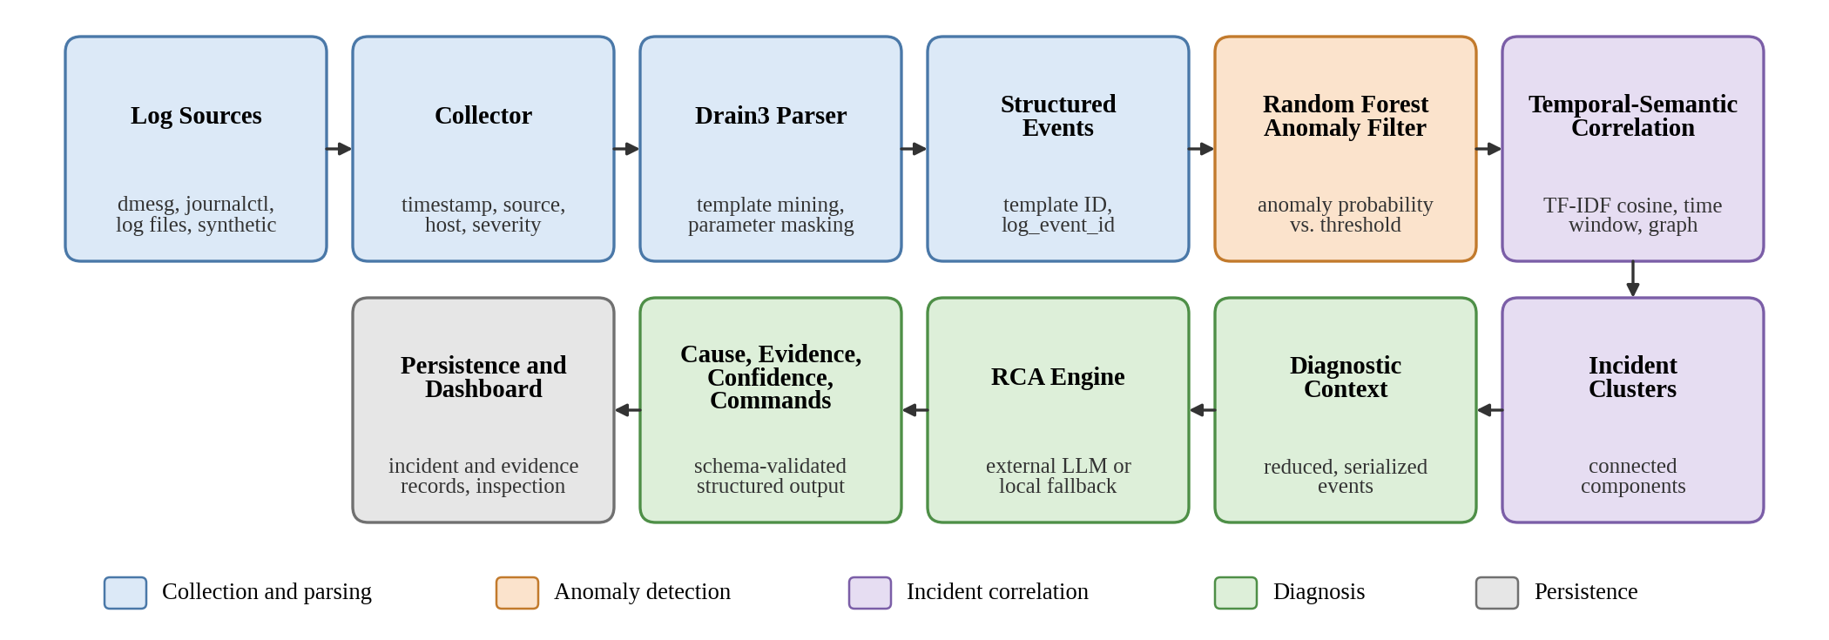
Fig. 1. KernelLens system architecture. Events pass through collection, Drain3 parsing, Random Forest anomaly filtering and temporal-semantic correlation before the reduced diagnostic context reaches the RCA engine and the persistence and dashboard layer.

Three terms are used consistently. An anomaly is a suspicious individual log event identified by the anomaly classifier. An incident is a group of related anomalous events produced by correlation. A root cause is the most plausible causal explanation inferred from the correlated diagnostic context. Anomaly detection operates on single events, correlation operates on sets of anomalous events, and root-cause analysis operates on the resulting incident context; the stages are not interchangeable.

IV. Log Collection and Parsing

A. Collection
The collector ingests logs from dmesg, journalctl, local log files and synthetic diagnostic scenarios. Each log line is converted to a structured event that records its timestamp, originating source, host, severity and message text, and each event receives a log_event_id that later serves as the evidence reference. The timestamp is used by the correlation stage as a temporal constraint, and severity is used as a classifier feature.

B. Template Mining and Normalization
Drain3 mines templates from the message text and replaces variable fields with wildcard placeholders, so that messages differing only in parameter values map to the same template and template identifier. The implementation masks several parameter categories before template matching: IPv4 and IPv6 addresses, hexadecimal addresses, device paths, process identifiers, memory quantities, sector, block and inode numbers, UUIDs, and other numeric values. For example, two out-of-memory kill messages that differ only in process identifier, process name and memory size are expected to share a template. The number of extracted parameters is retained as a feature. The masking rules are rule-based, and no claim is made that they cover all kernel message formats.

V. Machine Learning Anomaly Detection

A. Feature Extraction
Each event is represented by a feature vector with five groups. (i) Textual: 128 TF-IDF features computed over the Drain3 template string using unigrams and bigrams. (ii) Frequency: the normalized occurrence ratio of the template, defined as its count divided by the total number of events. (iii) Recurrence: the log-transformed time since the template last occurred, log(1 + Δt), together with novelty information. (iv) Severity: a numerical weight from 0.0 for debug to 4.0 for critical and emergency messages. (v) Structure: the number of parameters extracted by the parser. Features are scaled with a StandardScaler with mean centering disabled (with_mean=False), the usual choice for sparse inputs. Feature extraction and classification are implemented with scikit-learn [15].

B. Random Forest Classifier
The classifier is a Random Forest [12] with the configuration in Table I, and class weights are balanced to offset label imbalance. The forest outputs an anomaly probability p(x) for event x, and the event is flagged according to (1). The deployed configuration uses θ = 0.65 where applicable, whereas the pipeline-stage experiment of Section VIII-E applied a probability threshold of 0.50.
a(x) = 1 if p(x) ≥ θ; 0 otherwise (1)
The classifier is trained on the small curated labeled samples described in Section VIII-A. It should therefore be regarded as a feasibility-scale component and not as a model trained on large-scale log corpora.
TABLE I
Random Forest Classifier Configuration
Parameter | Value
n_estimators | 100
max_depth | 12
min_samples_split | 2
class_weight | balanced
random_state | 42
TF-IDF features | 128 (unigrams, bigrams)
Feature scaling | StandardScaler (with_mean=False)
Probability threshold | 0.65 (deployed); 0.50 (Sec. VIII-E)

VI. Temporal-Semantic Event Correlation
The correlation stage is algorithmic and contains no separately trained neural model. Its role differs from that of the classifier: the classifier answers “Is this event suspicious?”, whereas correlation answers “Which suspicious events belong to the same incident?”.
Only events flagged by the classifier enter the correlator. For each event, a text representation is formed from the Drain3 template together with entities extracted by regular expressions, namely devices, process names, services, process identifiers and subsystem or domain keywords. These texts are vectorized with TF-IDF [16] over unigrams and bigrams with sublinear term-frequency scaling. The semantic similarity of events i and j is the cosine of their vectors v_{i} and v_{j}, given by (2).
s(i, j) = (v_{i} · v_{j}) / (‖v_{i}‖ ‖v_{j}‖) (2)
An undirected edge joins two events when they lie within a temporal window and are sufficiently similar, as in (3), with Δt = 60 s and τ = 0.08.
(i, j) ∈ E ⇔ |t_{i} − t_{j}| ≤ Δt and s(i, j) ≥ τ (3)
Incident clusters are the connected components of the resulting graph, found by breadth-first search. Because connectivity is transitive, two events can be placed in the same incident through a chain of intermediate events even when they are not directly similar, which can group loosely related events. The threshold τ is low, and the sensitivity of cluster quality to τ and Δt was not evaluated.

VII. Root-Cause Analysis and Evidence Grounding

A. Structured Output
For each incident cluster, KernelLens serializes a reduced diagnostic context containing the clustered events and their identifiers and passes it to the RCA engine. The engine must return a structured result validated with a Pydantic schema. The result has four fields: a cause, given as a non-empty string of at least five characters; a list of evidence items, each referencing a log_event_id of an event in the supplied context; a confidence value constrained to [0, 1]; and a list of troubleshooting commands, each with the command text and a rationale. A field validator rejects any result whose evidence list is empty. The commands produced in the evaluated scenarios are read-only diagnostics (for example dmesg and free -h), and commands are guidance for the operator that the system never executes automatically.

B. Reasoning Backends
Two backends produce the structured result. The first calls Google Gemini through a configured API; this integration is implemented but was not exercised in the reported experiments. The second is a deterministic local reasoning fallback that derives a cause, evidence references and commands from the incident context without network access, and it is used when an external LLM is unavailable. All RCA results in this paper come from the local fallback, because no live API key was available in the benchmark environment. The schema constrains the form of the output and ensures that at least one event is cited, but it does not verify that the stated cause is correct. The effect of evidence grounding on hallucination was not measured, and reducing unsupported reasoning is a design objective and not an established result.

VIII. Experimental Evaluation

A. Datasets and Protocol
Two labeled datasets are used. The first is a curated LogHub [5] benchmark of 85 samples drawn from the BGL, HDFS and Linux subsets, with 40 normal and 45 anomalous samples (Table II, Fig. 2). The second is a curated set of 21 Darwin/macOS logs (11 normal, 10 anomalous) whose anomalies include Jetsam memory kills, sandbox denials and a kernel panic. Pipeline experiments use synthetic scenarios generated by the project: a 34-event mixed workload composed of a normal baseline (6 events), a storage fault cascade (8), an out-of-memory killer cascade (9), a segfault storm (5) and thermal throttling (6), and each scenario on its own.
TABLE II
Evaluation Dataset Composition
Subset | Total | Normal | Anomalous | Use
BGL | 18 | 10 | 8 | Classifier
HDFS | 20 | 12 | 8 | Classifier
Linux | 47 | 18 | 29 | Classifier
LogHub total | 85 | 40 | 45 | Classifier
macOS (Darwin) | 21 | 11 | 10 | Domain adaptation

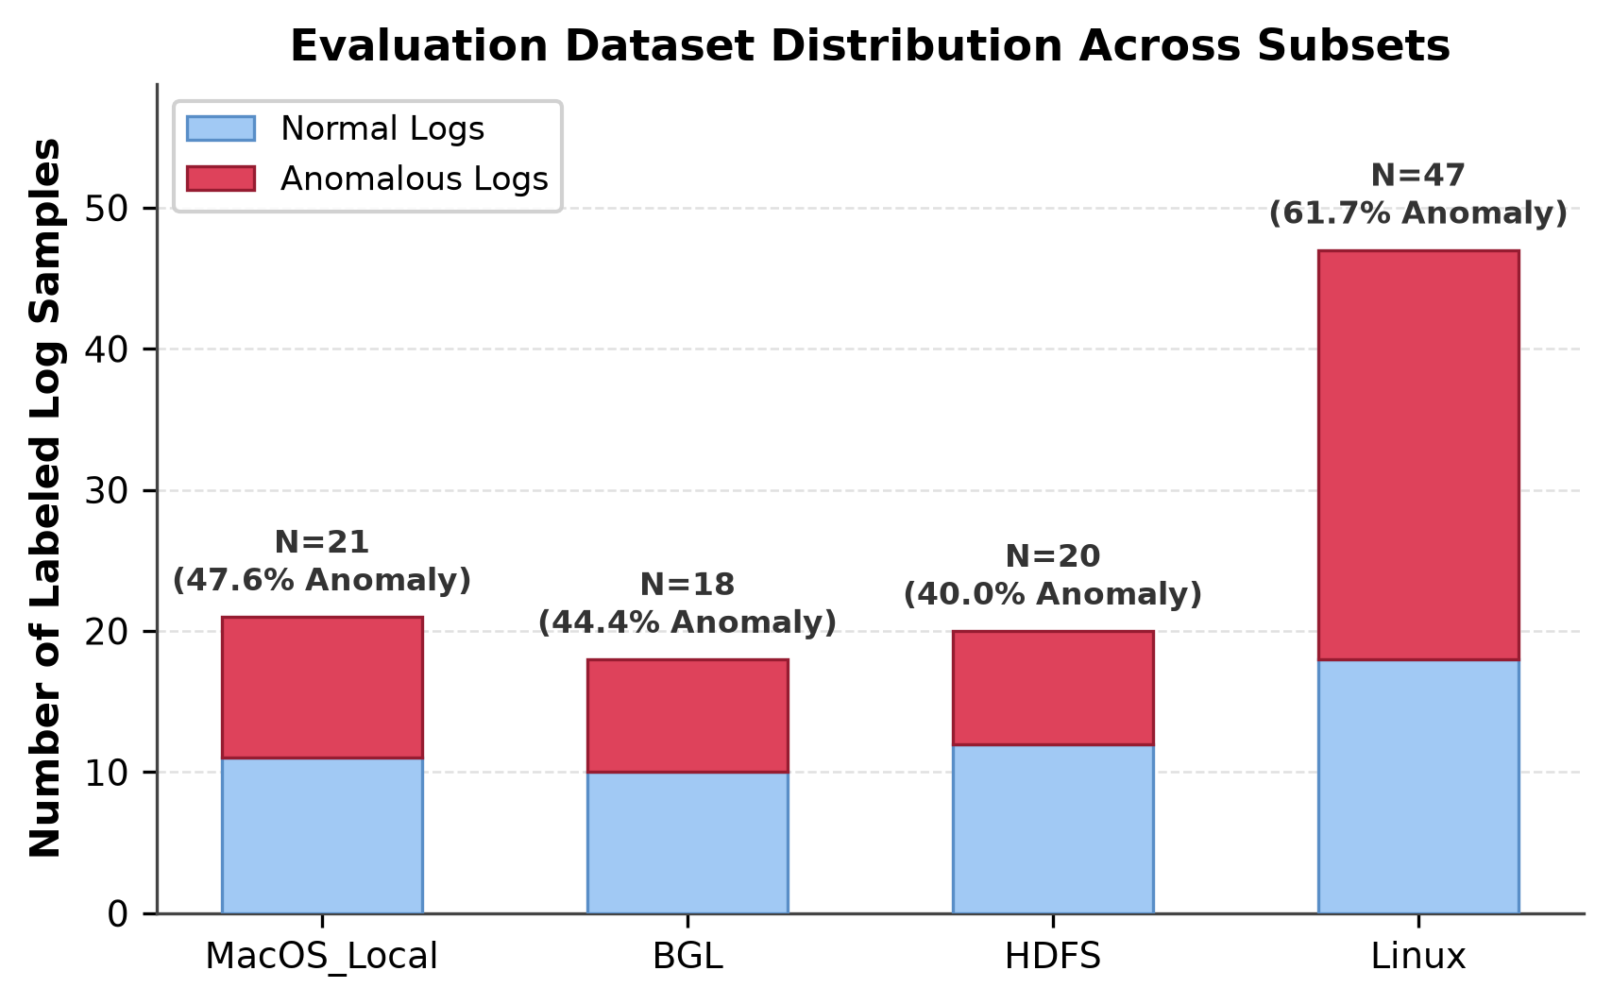
Fig. 2. Class distribution of the curated datasets: the macOS local logs used for domain adaptation and the BGL, HDFS and Linux subsets of the LogHub benchmark.

The classifier is evaluated with an 80/20 split using test_size = 0.20 and shuffle = False, which gives 68 training and 17 test samples. In the dataset ordering, all normal samples precede all anomalous samples, so the training portion contains the 40 normal and 28 anomalous samples and the 17 test samples are all anomalous. This is a sequential hold-out and not a balanced or randomly sampled test set, and Section VIII-B discusses the consequences. Metrics are accuracy, precision, recall, F1 and ROC-AUC. Hardware specifications of the benchmark machine were not recorded and are not reported. The evaluation ran on the production code path: the research branch differs from the development branch only by the removal of one unused import (parse_log) that caused a circular-import failure when the stored model artifact was loaded, and no algorithm, model weight or pipeline behavior was intentionally modified.

B. Classifier Evaluation
Table III and Fig. 3 report the results. On the sequential hold-out, the model detected 13 of the 17 anomalous test samples, giving a recall and accuracy of 76.47%, a precision of 100.00% and an F1 of 86.67%. Because the partition contains no normal samples, no false positive or true negative is possible: precision is 100% by construction, accuracy equals recall, and the reported ROC-AUC of 1.00 says nothing about class separation since only one class is present. These numbers therefore describe the detection rate on anomalous events that follow the training sequence. They do not estimate the false-positive rate on normal events, performance on a balanced test set, or accuracy on real-world Linux logs. The stored default model artifact reports lower values (64.71% accuracy and recall, F1 of 78.57%), equivalent to 11 of 17 detections. The protocol behind this artifact is not characterized further here, and a difference of two detections out of 17 is too small to support conclusions.
TABLE III
Classifier Evaluation on the Sequential Hold-Out (%)
Model | Acc. | Prec. | Rec. | F1 | ROC-AUC
Hold-out (n = 17) | 76.47 | 100.00 | 76.47 | 86.67 | 1.00†
Stored artifact | 64.71 | 100.00 | 64.71 | 78.57 | 1.00†
† The test set contains only anomalous samples, so precision and ROC-AUC are not informative about class separation. The ROC-AUC of the stored artifact is read from Fig. 3.

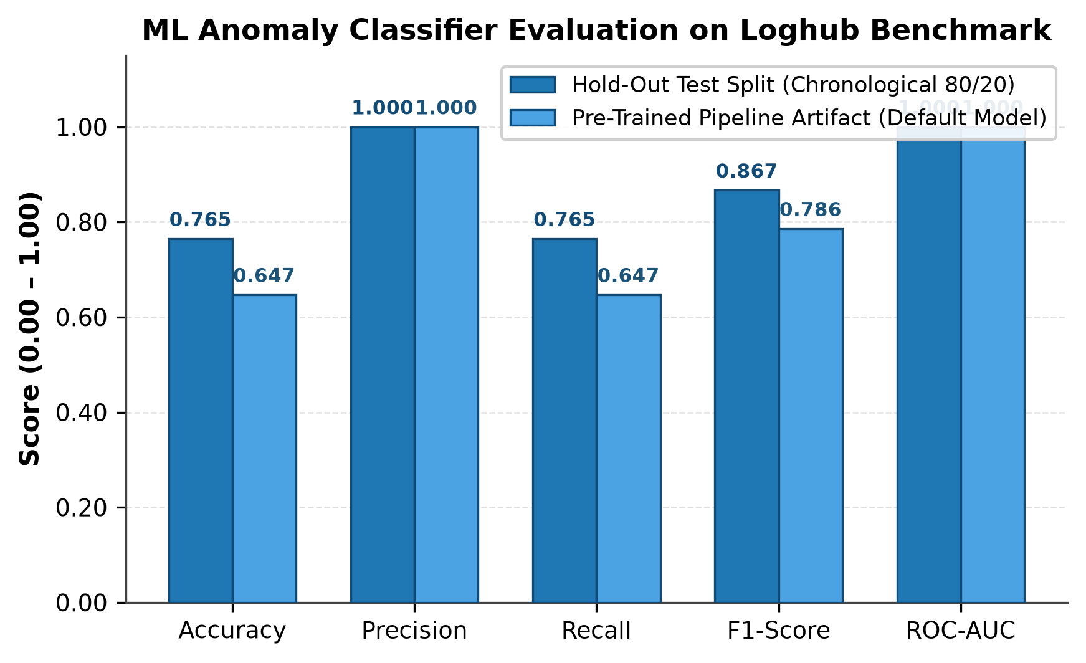
Fig. 3. Classifier metrics on the curated LogHub benchmark for the chronological 80/20 hold-out (dark bars) and the stored default model artifact (light bars). The hold-out partition contains only anomalous samples, so precision and ROC-AUC are not informative about class separation.

C. Domain Adaptation
A small domain-adaptation experiment uses the 21 macOS logs. A stratified 50/50 split (random_state = 42) gives 10 training and 11 hold-out samples. The base model is trained only on the LogHub benchmark and evaluated zero-shot. The adapted model is trained on the LogHub benchmark plus the 10 local training samples with 5x oversampling. Table IV gives the results. Zero-shot, the base model reached an F1 of 0.3333 with perfect precision and a recall of 0.2000. After adaptation, recall rose to 0.8000 while precision fell to 0.6667, and F1 improved by +0.3939 to 0.7273. With five anomalous samples in the hold-out set, the recall values correspond to one and four detections, and the reported precision implies two false alarms among the six normal samples. At this scale a single sample shifts recall by 0.20. The result shows that a few in-domain samples can change behavior on Darwin-specific messages, plausibly because their vocabulary (for example jetsam and launchd) is absent from the Linux-centric training data. It is a proof of concept and provides no evidence of broad cross-platform generalization, statistical significance or fleet-scale transferability.
TABLE IV
Domain Adaptation on the macOS Hold-Out Set
Model | Acc. | Prec. | Rec. | F1
Base (zero-shot) | 0.6364 | 1.0000 | 0.2000 | 0.3333
Domain-adapted | 0.7273 | 0.6667 | 0.8000 | 0.7273
Hold-out size is 11 samples. F1 change: +0.3939.

D. Event Filtering
Event filtering is quantified as the reduction in event count between raw input and classifier-retained anomalies, as in (4), where N_{raw} is the number of raw events and N_{ret} the number retained. This is an event-count measure. Token counts were not measured, so it must not be read as a reduction in prompt tokens.
R = (N_{raw} − N_{ret}) / N_{raw} × 100% (4)
Table V and Fig. 4 give the results. For the 34-event mixed workload the classifier retained 16 events, a 52.94% reduction, and for the out-of-memory scenario it retained 4 of 9 events (55.56%). The other scenarios show the range of behavior: all 8 events of the storage fault cascade were retained (0%), 4 of 5 in the segfault storm (20%), and none of the 6 thermal-throttling events (100%). A high ratio is useful only if the discarded events are irrelevant, and this experiment does not assess whether the discarded events were causally irrelevant.
TABLE V
Event Filtering Results
Workload | Raw | Retained | Reduction (%)
Mixed workload | 34 | 16 | 52.94
OOM killer cascade | 9 | 4 | 55.56
Storage fault cascade | 8 | 8 | 0.00
Segfault storm | 5 | 4 | 20.00
Thermal throttling | 6 | 0 | 100.00
Event-count reduction from raw events to ML-retained anomalies, not token reduction.

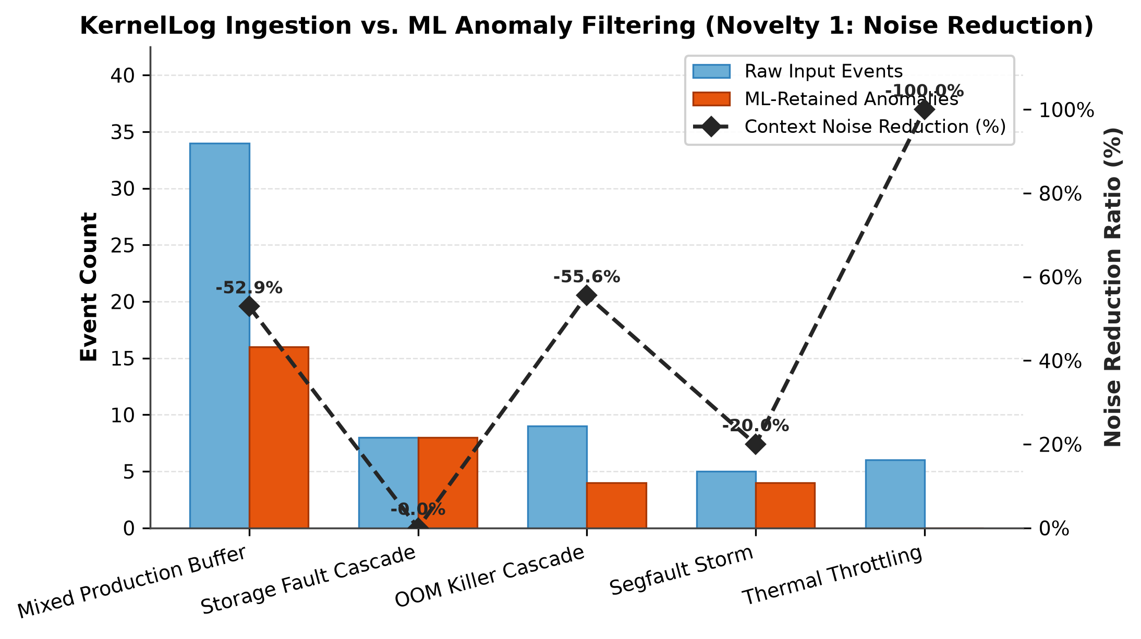
Fig. 4. Raw input events and classifier-retained anomalies for five scenarios, with the event-count reduction ratio on the right axis. Labels on the reduction line carry a minus sign to denote a decrease in event count.

E. Pipeline Stage Analysis
Fig. 5 traces the mixed workload through the pipeline. The workload contains 34 raw events. Drain3 maps them to 28 unique templates; this number counts distinct templates and is not the result of filtering events, since several events can share a template. The classifier, applying a probability threshold of 0.50 in this experiment, retains 16 anomalous events, and it is the only stage that removes events. The correlator organizes these 16 events into two incident clusters without changing the event count, so the 16-to-16 transition reflects grouping and not reduction. Finally, the diagnostic result for the primary incident cluster cites 5 evidence events. The stages therefore do not form a monotone filtering funnel, and the percentages in Fig. 5 are relative to the 34 raw events.

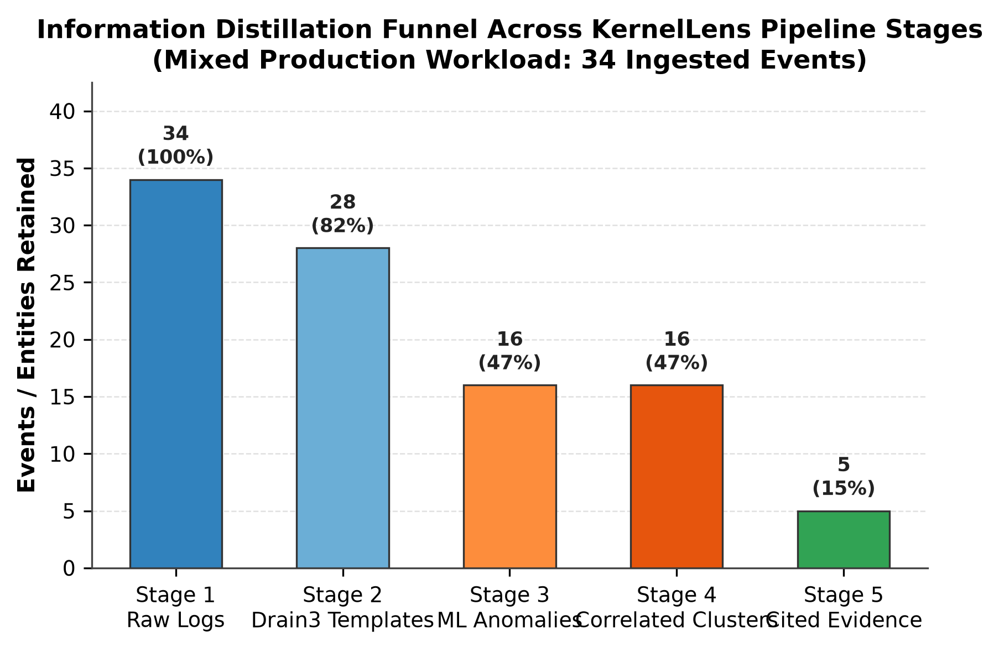
Fig. 5. Counts at each KernelLens stage for the 34-event mixed workload: raw events (34), unique Drain3 templates (28), ML-retained anomalous events (16), anomalous events assigned to two correlated incident clusters (16), and evidence events cited in the diagnostic result (5). The template count is a distinct-template count and not a filtered subset of events.

F. Latency
Table VI reports per-stage latency averaged over 15 iterations for the 34-event workload, executed in memory with the local deterministic RCA fallback. The ML stage, which includes feature extraction and Random Forest inference, took 881.23 ms and accounts for roughly 98% of the 900.12 ms end-to-end time, while every other stage took under 10 ms. The 0.39 ± 0.11 ms RCA figure is the latency of the deterministic local fallback in the offline benchmark. It is not the latency of an external LLM, live Gemini latency was not benchmarked, and the figure should not be used to estimate it.
TABLE VI
Pipeline Latency for a 34-Event Batch
Stage | Latency (ms)
Drain3 parsing | 9.71 ± 2.29
ML anomaly stage (features + RF) | 881.23 ± 149.18
Semantic correlation | 8.46 ± 1.16
Context serialization | 0.32 ± 0.09
Local deterministic RCA | 0.39 ± 0.11
Total | 900.12 ± 149.49
Mean ± the dispersion reported by the benchmark script over 15 iterations. The RCA stage is the local fallback, not a live LLM.

IX. Results and Discussion
Taken together, the results support the feasibility of the pipeline structure and not the superiority of any component. Upstream filtering reduced the number of events passed to later stages, by 52.94% in the mixed workload and 55.56% in the out-of-memory scenario, although the ratio ranged from 0% to 100% across scenarios and is measured in events and not in tokens.
Temporal-semantic correlation provides incident-level structure that the classifier alone does not: the 16 anomalous events of the mixed workload were organized into two clusters. Because that workload combines several failure scenarios, the cluster count and its correspondence to the underlying scenarios were not validated against labeled incidents, so this observation is descriptive.
The structured RCA interface ties the final explanation to specific events. The diagnostic result for the primary incident cites five log events, and the schema rejects results without evidence. The deterministic fallback offers an offline diagnostic path with sub-millisecond reasoning time, but it is a deterministic engine and is not equivalent to a live external LLM, whose output quality, latency and hallucination behavior remain unevaluated.
The classifier result is bounded by the small curated dataset and the anomaly-only sequential hold-out, and the domain-adaptation result rests on 21 macOS samples. Both indicate feasibility but cannot establish generalization. Because no baselines were run, the evaluation does not show that KernelLens outperforms existing log anomaly detectors or LLM-based diagnosis systems such as those in Section II.

X. Limitations
The benchmark datasets are small curated samples (85 LogHub samples and 21 macOS samples). The classifier hold-out is sequential and consists entirely of anomalous samples owing to dataset ordering, so false-positive behavior was not measured. Live Gemini inference latency was not measured, and the deterministic RCA fallback is not equivalent to a live external LLM. No large-scale production fleet evaluation was performed, no statistical significance testing was performed, and no direct comparison against competing log anomaly detection systems was carried out. Event reduction is measured by event count and not by token count. The correlation engine uses TF-IDF and graph clustering rather than neural embeddings, and its parameters were not tuned or ablated here. The experiments do not by themselves establish readiness for production deployment.

XI. Conclusion
KernelLens is an integrated diagnostic pipeline that combines Drain3 template parsing, supervised anomaly filtering, temporal-semantic correlation, evidence-grounded root-cause analysis, a deterministic local fallback and persistent incident records. In the reported experiments, the anomaly filter reduced a 34-event mixed workload to 16 events, correlation organized them into two incident clusters, and the diagnostic result cited five evidence events, with an offline end-to-end time of 900.12 ms per batch dominated by the ML stage. These results indicate that the pipeline is feasible at small scale, but they are limited by small curated datasets, a sequential anomaly-only classifier hold-out, a 21-sample domain-adaptation experiment, and the absence of baselines and live LLM measurements. Future work includes larger multi-system datasets, balanced evaluation protocols, stronger baselines, live LLM benchmarking of latency and groundedness, learned semantic embeddings for correlation, online streaming evaluation, and larger-scale deployment studies.

References
[1] A. Oliner and J. Stearley, "What supercomputers say: A study of five system logs," in Proc. 37th Annu. IEEE/IFIP Int. Conf. Dependable Syst. Netw. (DSN), 2007, pp. 575-584.
[2] W. Xu, L. Huang, A. Fox, D. Patterson, and M. I. Jordan, "Detecting large-scale system problems by mining console logs," in Proc. ACM SIGOPS 22nd Symp. Oper. Syst. Principles (SOSP), 2009, pp. 117-132, doi: 10.1145/1629575.1629587.
[3] T. Ahmed, S. Ghosh, C. Bansal, T. Zimmermann, X. Zhang, and S. Rajmohan, "Recommending root-cause and mitigation steps for cloud incidents using large language models," in Proc. IEEE/ACM 45th Int. Conf. Softw. Eng. (ICSE), 2023, arXiv:2301.03797.
[4] Y. Liu et al., "Interpretable online log analysis using large language models with prompt strategies," in Proc. IEEE/ACM Int. Conf. Program Comprehension (ICPC), 2024, pp. 35-46.
[5] J. Zhu, S. He, P. He, J. Liu, and M. R. Lyu, "Loghub: A large collection of system log datasets for AI-driven log analytics," in Proc. IEEE Int. Symp. Softw. Rel. Eng. (ISSRE), 2023, arXiv:2008.06448.
[6] P. He, J. Zhu, Z. Zheng, and M. R. Lyu, "Drain: An online log parsing approach with fixed depth tree," in Proc. IEEE Int. Conf. Web Services (ICWS), 2017, pp. 33-40, doi: 10.1109/ICWS.2017.13.
[7] "Drain3: Streaming log template miner," software repository. [Online]. Available: https://github.com/logpai/Drain3
[8] S. He, J. Zhu, P. He, and M. R. Lyu, "Experience report: System log analysis for anomaly detection," in Proc. IEEE 27th Int. Symp. Softw. Rel. Eng. (ISSRE), 2016, pp. 207-218, doi: 10.1109/ISSRE.2016.21.
[9] M. Du, F. Li, G. Zheng, and V. Srikumar, "DeepLog: Anomaly detection and diagnosis from system logs through deep learning," in Proc. ACM SIGSAC Conf. Comput. Commun. Secur. (CCS), 2017, pp. 1285-1298, doi: 10.1145/3133956.3134015.
[10] W. Meng et al., "LogAnomaly: Unsupervised detection of sequential and quantitative anomalies in unstructured logs," in Proc. 28th Int. Joint Conf. Artif. Intell. (IJCAI), 2019, pp. 4739-4745, doi: 10.24963/ijcai.2019/658.
[11] X. Zhang et al., "Robust log-based anomaly detection on unstable log data," in Proc. 27th ACM Joint Meeting Eur. Softw. Eng. Conf. Symp. Found. Softw. Eng. (ESEC/FSE), 2019, pp. 807-817, doi: 10.1145/3338906.3338931.
[12] L. Breiman, "Random forests," Mach. Learn., vol. 45, no. 1, pp. 5-32, 2001.
[13] Q. Lin, H. Zhang, J.-G. Lou, Y. Zhang, and X. Chen, "Log clustering based problem identification for online service systems," in Proc. IEEE/ACM 38th Int. Conf. Softw. Eng. Companion (ICSE-C), 2016, pp. 102-111.
[14] S. He, Q. Lin, J.-G. Lou, H. Zhang, M. R. Lyu, and D. Zhang, "Identifying impactful service system problems via log analysis," in Proc. 26th ACM Joint Meeting Eur. Softw. Eng. Conf. Symp. Found. Softw. Eng. (ESEC/FSE), 2018, pp. 60-70, doi: 10.1145/3236024.3236083.
[15] F. Pedregosa et al., "Scikit-learn: Machine learning in Python," J. Mach. Learn. Res., vol. 12, pp. 2825-2830, 2011.
[16] G. Salton and C. Buckley, "Term-weighting approaches in automatic text retrieval," Inf. Process. Manag., vol. 24, no. 5, pp. 513-523, 1988.

