VELLORE INSTITUTE OF TECHNOLOGY, VELLORE
SCHOOL OF COMPUTER SCIENCE AND ENGINEERING

BCSE308L – COMPUTER NETWORKS LABORATORY
PROJECT REPORT

ScamShield: Robust Detection of Obfuscated UPI Payment Scams in Multilingual Code-Mixed SMS over a Custom Reliable Network Protocol

Submitted by
Shreyans Chowdry – 24BDS0114
Swapnil Jain – 24BAI0248
Ayushmaan Nayak – 24BCE2612

Under the guidance of
Kopperundevi N,
Assistant Professor Senior Grade II

OCTOBER, 2026

ABSTRACT
Payment scams delivered by SMS target users of the Unified Payments Interface (UPI) in many languages, and scammers deliberately disguise the words that filters look for: look-alike Unicode characters, leetspeak, separators, invisible characters and words rewritten in another script. This project, ScamShield, studies the problem end to end. We built UPI-MixSMS, an 11,979-message corpus of English and code-mixed SMS in which each language keeps its own script, together with a five-level, script-aware disguise scheme whose strongest level is cross-script transliteration. Eleven word, subword and character models were compared with paired significance tests. Character representations degraded significantly less than word and subword ones in 20 of 24 tests; the multilingual transformer XLM-R, one of the two most accurate models on clean text (0.870 macro-F1), missed 52% of scams once they were transliterated, up from 6%. A script-aware canonicaliser in front of a character n-gram model, trained jointly with real public SMS, keeps macro-F1 between 0.81 and 0.79 across all disguise levels, scores 0.878 on real smishing messages and runs in about 1 ms. The detector is deployed as a networked system: our own CRC-32-protected protocol over TCP and over UDP with Go-Back-N and Selective Repeat, AIMD congestion control, a DNS client and server on raw sockets, and CIDR checks of every link, each measured under emulated loss, corruption and congestion. An Android application checks every incoming SMS on the phone with results identical to the server.
Keywords: SMS phishing, multilingual code-mixing, adversarial text, character n-grams, UPI, ARQ, congestion control, DNS, CRC.

TABLE OF CONTENTS

ABSTRACT 2
CHAPTER 1 INTRODUCTION 4
1.1 Background 4
1.2 Problem Statement 4
1.3 Objectives & Novelty 5
CHAPTER 2 LITERATURE SURVEY 7
2.1 Existing Systems / Related Work 7
2.2 Research Gap 8
CHAPTER 3 SYSTEM DESIGN 9
3.1 Proposed System Architecture 9
3.2 Module Description 10
3.3 Mapping to the Course Syllabus 13
CHAPTER 4 IMPLEMENTATION, RESULTS AND CONCLUSION 15
4.1 Implementation Details 15
4.2 Screenshots 20
4.3 Current Progress and Challenges 26
4.4 Conclusion and Future Enhancements 27
REFERENCES 28

CHAPTER 1

INTRODUCTION

1.1 Background
Real-time account-to-account payment systems such as the Unified Payments Interface (UPI) have made sending money as easy as sending a text message, and fraud has followed the same channel. Most UPI scams begin with an SMS: a fake KYC deadline (“your account will be blocked tonight”), a “refund” that is really a collect request asking for the UPI PIN, a lottery prize that needs a small registration fee, a threat to disconnect electricity, or a part-time job that pays for liking videos. The message pushes the victim to a link, a phone number or an approval screen, and the money moves before the victim realises what happened.
Two properties make these messages hard to filter automatically. First, they are multilingual and code-mixed: many users read and write SMS in their own language and script with English banking vocabulary (KYC, PIN, link, refund) mixed into the same sentence, and sometimes into the same word, as in Tamil case suffixes attached to English nouns (link-ஐ). Second, they are adversarial: senders deliberately disguise the words that a filter looks for, writing P1N, K.Y.C, a Cyrillic е inside rеfund, invisible zero-width characters, a letter borrowed from a neighbouring script that looks identical, or an English word spelt phonetically in a native script. A keyword or word-level filter trained on clean English text sees none of these as the words it knows.
The verdict also has to be delivered somewhere. A phone that receives the SMS must either classify it locally or send it to a server over an unreliable mobile link, and the strongest evidence about a link inside an SMS often lives in the network itself: what the domain resolves to in DNS, how long that answer may be cached, and whether the returned address belongs to a private or reserved block. This makes scam detection a natural Computer Networks problem as well as a text-classification one, and the project treats it that way from the start.

1.2 Problem Statement
Design, implement and evaluate a networked system that detects UPI payment-scam SMS written in English or in code-mixed form with other languages in their native scripts, and that stays accurate when the scammer disguises the text at the character level. Concretely, the project must:
- measure how word-level, subword-level and character-level classifiers degrade as messages are disguised with increasing intensity, up to rewriting words in another script (transliteration);
- test the hypothesis that character-level representations degrade significantly less than word and subword representations;
- provide a defence that does not require retraining, and a deployable detector that is accurate, calibrated and fast enough for a phone;
- deliver the detector over the network with its own application protocol, reliable transport over UDP, error detection, congestion control, DNS and IP-address analysis, and measure each of these mechanisms under loss, corruption and congestion;
- provide a phone application that checks every incoming SMS and warns the user, giving the same answers as the server.

1.3 Objectives & Novelty
Objectives
- Build UPI-MixSMS, a multilingual code-mixed UPI SMS corpus with 23 message intents, deliberate hard negatives and a template-disjoint train/test split.
- Define a graded, script-aware obfuscation scheme (levels L0–L4) and two threat models (targeted and uniform).
- Compare eleven word, subword and character models on macro-F1, scams missed (false-negative rate), calibration and latency, with paired significance tests.
- Evaluate two defences (adversarial training and script-aware canonicalisation) and validate on real public SMS corpora.
- Implement the ScamShield Protocol (SSP) with CRC-32 over TCP and over UDP with Stop-and-Wait, Go-Back-N and Selective Repeat, RTO estimation and AIMD congestion control.
- Implement a DNS client and authoritative server on raw sockets and CIDR analysis of every link, and fuse this network evidence with the text model.
- Measure every network mechanism (N1–N6) through an impaired-link emulator.
- Ship a web application and an Android application that run the same model with verified identical results.
Novelty
- A multilingual benchmark in native scripts. Earlier code-mixed scam work uses romanised text only. UPI-MixSMS keeps each language in its own script, and every language-specific component sits behind one script registry, so adding a language is a data change, not a code change.
- Disguise attacks that work on any script, including confusable letters, look-alike characters from other Unicode blocks and transliteration in both directions as a measured attack.
- Script-aware canonicalisation that undoes most disguises before classification without retraining the model.
- Text verdicts backed by network evidence: DNS answers, TTLs and the CIDR block a link resolves into.
- One model on phone and server with identical answers, behind a CRC-protected protocol whose reliability and congestion behaviour is measured.

CHAPTER 2

LITERATURE SURVEY

2.1 Existing Systems / Related Work
SMS spam and smishing detection
The UCI SMS Spam Collection [1] established SMS spam filtering as a benchmark task and showed that simple bag-of-words classifiers such as Naive Bayes and SVMs work well on clean English messages. Smishing-specific work by Mishra and Soni combines message content with URL behaviour [2] and released a labelled smishing corpus [3]. Handset-collected corpora such as ExAIS [4] capture realistic distributions of genuine messages. All of these corpora are English and contain little payment-system-specific fraud.
Adversarial and visual text perturbation
Character-level black-box attacks such as DeepWordBug [5] and TextBugger [6] swap, insert and delete characters or substitute look-alikes, and reduce the accuracy of word-based classifiers sharply. VIPER [7] replaces characters with visually similar Unicode code points. Defences include a word-recognition model in front of the classifier [8] and folding confusable characters using the Unicode security data [9]. These studies are on English benchmarks.
Code-mixed and multilingual models
Word-level language identification and the Code-Mixing Index (CMI) [10] quantify how mixed a text is, and GLUECoS [11] benchmarks NLP tasks on code-switched data, mostly romanised. Multilingual encoders include mBERT [12], its distilled version DistilmBERT [13], XLM-R [14] and MuRIL [15], which adds transliterated Indian-language text to pre-training. Tokenizer-free models such as CANINE [16] and character CNNs [17] read characters directly and are natural candidates for robustness to character-level noise.
Networking foundations
The protocol stack follows the textbook treatment of framing, error control, sliding-window ARQ and congestion control [18], [19], [20]: cyclic redundancy checks [21], Hamming codes [22] and the Internet checksum [23]; retransmission-timer estimation by Jacobson [24] as standardised in RFC 6298 [25] with Karn’s rule [26]; additive-increase multiplicative-decrease congestion control [27]; the Gilbert burst-loss channel [28]; DNS as specified in RFC 1035 [29]; and the special-purpose IP address registry of RFC 6890 [30].
Table 2.1: Summary of related work
Work | Focus | Limitation for this problem
UCI SMS Spam [1] | English SMS spam benchmark | Clean English text, no payment fraud, no disguise
Mishra & Soni [2], [3] | Smishing: content + URL behaviour | English only; no code-mixing or adversarial text
DeepWordBug, TextBugger [5], [6] | Character-level attacks | English benchmarks; Latin script only
VIPER [7] | Visual (homoglyph) attacks | No native scripts, no transliteration
GLUECoS [11] | Code-switched NLP benchmark | Mostly romanised text; no scam task
XLM-R, MuRIL [14], [15] | Multilingual encoders | Robustness to disguise not studied; ~100 ms/message on CPU
Textbook protocols [19], [20] | ARQ, CRC, DNS, AIMD | Not combined with an application-level classifier

2.2 Research Gap
No existing work studies scam SMS detection when three conditions hold at once: the messages are code-mixed with native scripts, they are deliberately disguised at the character level, and the detector must be delivered over a network. In particular:
- public SMS corpora are English and contain neither UPI-specific fraud nor code-mixed text, so a model trained on them misses most UPI scams (shown in Chapter 4);
- adversarial-text studies do not cover native scripts, look-alike characters across Unicode blocks, or transliteration as an attack;
- it is not known whether large multilingual transformers stay robust under such disguises, or whether cheaper character models are a better choice for a phone;
- scam detectors are evaluated as stand-alone classifiers; the network path that carries the verdict and the network evidence about links (DNS, CIDR) are ignored.
ScamShield addresses each gap: a native-script multilingual benchmark with a graded disguise scheme, a controlled comparison with significance tests, a script-aware defence, joint training with real SMS, and a complete measured network stack with a phone client.

CHAPTER 3

SYSTEM DESIGN

3.1 Proposed System Architecture
Figure 3.1 shows the overall architecture. An SMS arrives on the Android phone, where a broadcast receiver passes it to the on-device detector; if the message is a scam a notification is raised. In server mode the phone instead wraps the message in an SSP frame and sends it over TCP (or over UDP with our reliability layer) to the ScamShield server. The server runs the same detector and, for every link in the message, queries our DNS server and checks the answer against the special-purpose CIDR blocks. The verdict, its probability and human-readable reasons travel back in a response frame. For the experiments, an impaired-link emulator sits between client and server and injects loss, bit errors, delay and congestion.
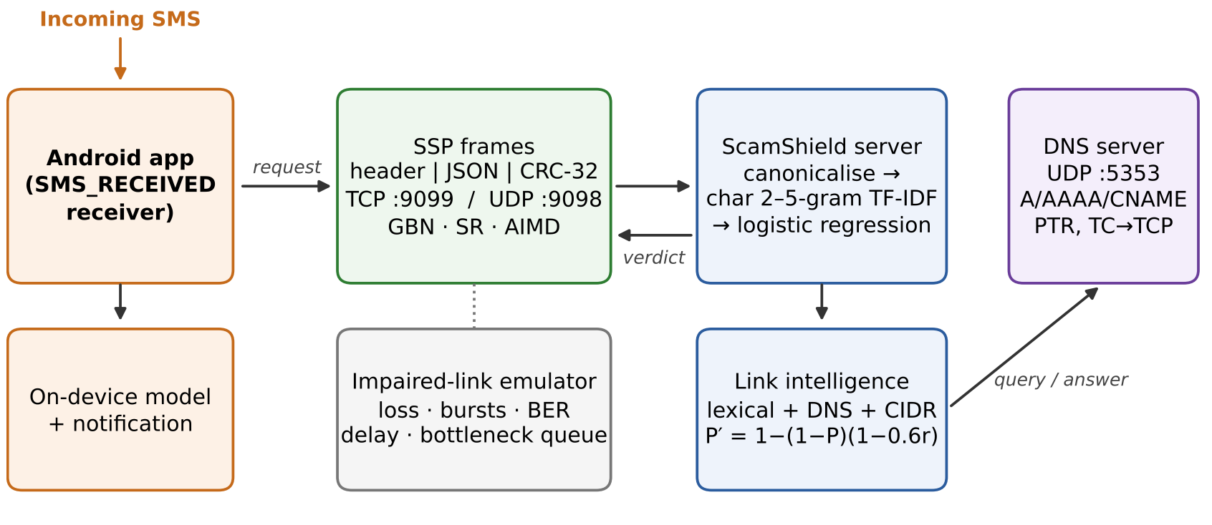
Figure 3.1: Overall architecture of ScamShield: Android client, SSP over TCP/UDP, server with detector and link intelligence, DNS server, and the impaired-link emulator used in experiments.
Figure 3.2 shows the detection pipeline inside the phone and the server. The text path identifies the language of every word, canonicalises the text, and scores it with a character n-gram model. The link path extracts URLs, applies lexical checks, resolves the host in DNS and matches the answer against CIDR blocks to produce a link risk r. The two are fused into the final probability.
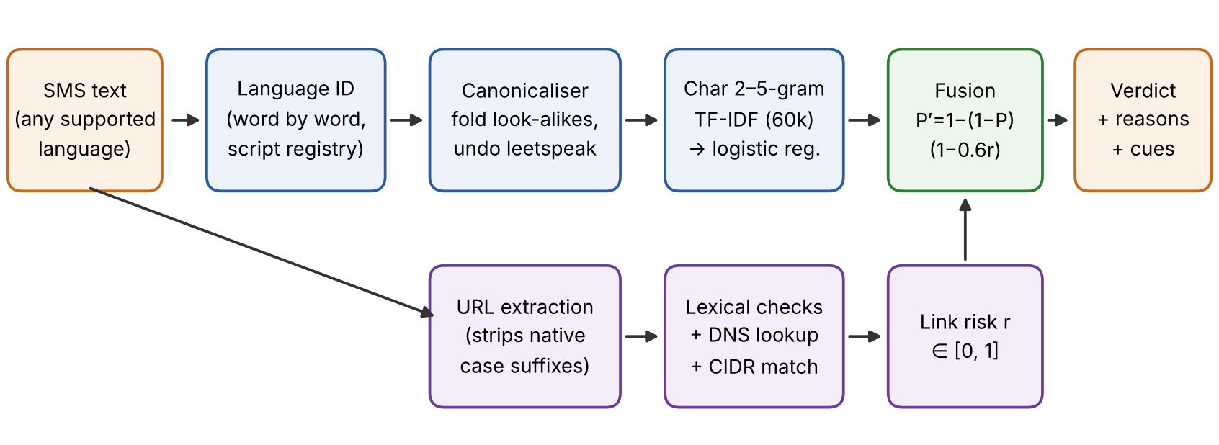
Figure 3.2: Detection pipeline: language identification, canonicalisation and the character n-gram model on the text path; URL extraction, lexical, DNS and CIDR checks on the link path; probability fusion.

3.2 Module Description
Module 1 – Dataset generator and script registry
scripts.py registers every supported native script (currently Devanagari and Tamil) with its Unicode range, confusable letters, look-alike characters, loanword spellings and romanisation rules. data/templates*.py hold parallel templates for 23 intents (11 scam, 7 genuine, 5 promotional) in English and each code-mixed setting, and data/generator.py fills slots (banks, apps, UPI IDs, amounts, links), adds natural variation and produces a template-disjoint split. The result is UPI-MixSMS with 11,979 messages: 3,990 English, 3,996 Hindi–English and 3,993 Tamil–English.
Module 2 – Automatic language identification
langid.py tags every token as English, native script, romanised native, mix (an English stem with a native suffix) or language-independent (numbers, URLs, IDs), and derives the message label and the Code-Mixing Index. The user never selects a language; on clean messages the identifier is 100% accurate.
Module 3 – Obfuscation engine
obfuscation.py disguises messages at five levels (Table 3.1). Latin-script words and native-script words get their own operator families; native operators are generic and read the tables of whichever script the word is in. Salient fraud words are disguised twice as often, and URLs, UPI IDs and numbers are never touched.
Table 3.1: Obfuscation levels and operators
Level | p | Latin-script words | Native-script words | Example
L0 clean | 0 | – | – | KYC, तुरंत
L1 light | 0.15 | vowel drop, repeats, case, swaps, phonetic | confusable letters, vowel length, virama | KYYC, तूरंत
L2 moderate | 0.30 | + leetspeak, separators | + separators between graphemes | K.Y.C, तु.रं.त
L3 heavy | 0.45 | + Cyrillic/Greek homoglyphs, zero-width, insert/delete | + look-alikes from other blocks, ZWJ, grapheme deletion | КYC, તुरंત
L4 cross-script | 0.60 | + English word in native script | + native word in Latin letters | केवाईसी, turant

Module 4 – Script-aware canonicaliser
The defence applies NFKC normalisation, removes zero-width characters, folds Cyrillic/Greek look-alikes to Latin and native look-alikes back to native letters, removes separators inside words, undoes leetspeak, maps native-script spellings of English loanwords back to English, squeezes repeated letters and lower-cases the text. It needs no retraining.
Module 5 – Detection models
Eleven models in three families: word models (Naive Bayes, random forest, logistic regression, linear SVM on word 1–2-grams, and a BiGRU), subword transformers (DistilmBERT, XLM-R, MuRIL) and character models (logistic regression and SVM on character 2–5-grams, and a character CNN).
Module 6 – Production detector and link fusion
detector.py holds the deployed model: canonicalised text, character 2–5-gram TF-IDF (60,000 features) and multinomial logistic regression, trained on UPI-MixSMS, disguised copies of half of it and real public SMS. Its probability is fused with the link risk using Equation (3.1). Rule-based cues (PIN to receive money, OTP sharing, urgency, threats, fees, remote-access apps) explain the verdict in plain language without changing the score. The model is exported to JSON for the phone.
P′(scam) = 1 − (1 − P(scam)) · (1 − 0.6 r) (3.1)
Module 7 – ScamShield Protocol (SSP)
net/protocol.py defines a binary frame (Table 3.2) with a 16-byte big-endian header, a UTF-8 JSON payload and a CRC-32 trailer. Over TCP, frames are reassembled from the byte stream using the LEN field; over UDP, one datagram carries one frame. A frame with a bad CRC is dropped.
Table 3.2: SSP frame format
Field | Bytes | Purpose
MAGIC | 2 | 0x5353 (“SS”), frame synchronisation
VER | 1 | protocol version
TYPE | 1 | CLASSIFY_REQ/RESP, DATA, ACK, NAK, PING, PONG, ERROR, FIN
FLAGS | 1 | SYN / FIN / RETX / JSON flags
WIN | 1 | advertised receive window
SEQ | 4 | sequence number
ACK | 4 | cumulative or selective acknowledgement
LEN | 2 | payload length in bytes
Payload | LEN | UTF-8 JSON (message text or verdict)
CRC-32 | 4 | computed over header and payload

Module 8 – Reliable transport over UDP
net/arq.py implements Stop-and-Wait, Go-Back-N (cumulative ACKs, one timer) and Selective Repeat (per-frame ACKs and timers, receiver buffering) with advertised receive windows, Jacobson/Karels RTO estimation (Equation 3.2), Karn’s rule, exponential back-off and optional AIMD congestion control.
RTO = SRTT + 4 · RTTVAR, RTO ≥ 100 ms (3.2)
Module 9 – Error detection and correction
net/errorcodes.py implements even parity, the Internet checksum (RFC 1071), CRC-16-CCITT, CRC-32 (IEEE 802.3) and Hamming(7,4) so their detection power can be compared on real SSP frames.
Module 10 – Impaired-link emulator
net/channel.py is a UDP proxy that injects Bernoulli or Gilbert–Elliott burst loss, bit errors, delay with order-preserving jitter, and a bottleneck link with a drop-tail queue. All impairments are seeded so experiments are repeatable.
Module 11 – DNS client and server
net/dns.py builds and parses RFC 1035 messages on raw UDP sockets (name compression; A, AAAA, CNAME, NS, PTR and TXT records), checks transaction IDs, retries, falls back to TCP when the TC bit is set and caches answers for their TTL. The authoritative server answers a demo zone, chases CNAMEs and truncates answers over 512 bytes.
Module 12 – CIDR analysis and link intelligence
net/cidr.py parses IPv4/IPv6 addresses and performs longest-prefix matching against the special-purpose registry (private, loopback, link-local, CGNAT, reserved). net/urlintel.py extracts URLs (handling native case suffixes, excluding UPI IDs) and combines lexical features (shortener, raw IP host, risky TLD, a bank name in a non-official domain, plain HTTP) with network features (NXDOMAIN, TTL under 120 s, private or reserved address) into a link risk between 0 and 1.
Module 13 – Web application
app/ is a FastAPI application with four tabs: Check a message, Disguise lab, Network (frame builder with bit flipping, DNS resolver, subnet calculator) and Results. Starting it also starts the SSP TCP/UDP services and the DNS server.
Module 14 – Android application
A Kotlin/Jetpack Compose app with an SMS_RECEIVED broadcast receiver, an exact Kotlin port of the canonicaliser, language identifier, TF-IDF and logistic regression, link checks, message history and high-priority notifications. Supported scripts are read from the exported model, so a new language needs no app code change. Server mode sends SSP frames over TCP and falls back to on-device checks when the server is unreachable.

3.3 Mapping to the Course Syllabus
Every networking module corresponds to a topic of the theory course (BCSE308L) and an experiment of the laboratory course (BCSE308P), as summarised in Table 3.3.
Table 3.3: Mapping of ScamShield to the course syllabus
Syllabus topic | Theory / Lab | ScamShield component
Layered architecture, protocols | Module 1 | App → SSP → TCP or ARQ-over-UDP → IP
Transmission impairments, performance | Module 2 | Impaired-link emulator; goodput, latency and efficiency (N2–N5)
Error detection and correction | Module 3 / Lab 2 | Parity, checksum, CRC-16/32, Hamming(7,4); CRC on every frame (N1)
Flow control, sliding window | Module 3 / Lab 3 | Stop-and-Wait, Go-Back-N, Selective Repeat (N2, N3)
IPv4/IPv6, classless addressing | Module 4 / Lab 4 | CIDR matching of every link; subnet calculator
Socket programming | Lab 6 | TCP and UDP servers; Python and Android clients
TCP, UDP, congestion control | Module 6 / Lab 8 | AIMD, slow start, RTO estimation, Karn’s rule (N4, N5)
DNS | Module 7 / Lab 9 | DNS client and server on raw sockets, PTR lookups, TCP fallback (N6)
Contemporary issues: security | Module 8 | Smishing detection, integrity through CRC, DNS-based link reputation

CHAPTER 4

IMPLEMENTATION, RESULTS AND CONCLUSION

4.1 Implementation Details
Technology stack
Table 4.1: Technology stack
Layer | Technology
Data, models, experiments | Python 3, NumPy, pandas, scikit-learn, PyTorch, Hugging Face Transformers, matplotlib
Networking | Python asyncio and raw sockets (no networking libraries): SSP, ARQ, emulator, DNS, CIDR
Web application | FastAPI + Uvicorn backend; HTML, CSS and JavaScript front end with Chart.js
Mobile application | Kotlin, Jetpack Compose, Android SDK 35 (minimum Android 8.0), Gradle; Paparazzi for screenshot tests
Testing | pytest (14 tests), JUnit parity tests between Kotlin and Python
Version control | Git and GitHub (shreyans-chowdry/cn)

Experimental setup
All detection results use the template-disjoint test set of 3,939 messages, so every test message is a phrasing never seen in training. Each disguise level is applied with three random seeds under two threat models: targeted, where only scam messages are disguised (the attacker controls only scam text), and uniform, where every message is disguised (testing false alarms on noisy genuine SMS). The primary metric is macro-F1 over the three classes; we also report the scam false-negative rate (FNR, scams missed), the false-positive rate (FPR), expected calibration error (ECE) [31] and CPU latency per message. The hypothesis is tested with a paired bootstrap of 1,000 resamples [32] and an exact McNemar test [33]. Transformers were fine-tuned for one epoch on a 2-core CPU, so their absolute numbers are conservative. Network experiments run on localhost through the emulator; the comparison between mechanisms is what matters.
Results: clean performance
Table 4.2: Clean performance on the template-disjoint test set
Model | Type | Macro-F1 | Scams missed | ECE | ms / message
Word Naive Bayes | word | 0.845 | 11.4% | 0.137 | 0.6
Word LR | word | 0.835 | 11.8% | 0.071 | 1.4
Word SVM | word | 0.807 | 11.7% | 0.080 | 4.4
Word BiGRU | word | 0.688 | 24.8% | 0.211 | 2.7
DistilmBERT | subword | 0.709 | 0.5% | 0.229 | 65
XLM-R | subword | 0.870 | 5.6% | 0.132 | 97
MuRIL | subword | 0.872 | 3.4% | 0.116 | 108
Char LR | char | 0.784 | 10.1% | 0.066 | 1.5
Char SVM | char | 0.771 | 10.5% | 0.126 | 5.0
Char CNN | char | 0.581 | 31.3% | 0.295 | 2.3
ScamShield (deployed) | char + defence | 0.810 | 9.5% | 0.051 | ≈ 1

MuRIL and XLM-R are the most accurate on clean text, followed by the word n-gram models. Character logistic regression is the best calibrated model and 45–75 times faster than the transformers. Most errors are hard negatives: genuine OTP advisories, AutoPay mandates and bank loan offers that share the scam vocabulary.
Results: robustness to disguise
Figure 4.1 plots macro-F1 against the disguise level. Under the uniform threat every word and subword model degrades steadily from L0 to L4 (XLM-R −0.255, MuRIL −0.178, Word LR −0.143) while character models lose less (Char LR −0.097, Char SVM −0.081). Under the targeted threat the transformers start missing scams: XLM-R goes from missing 5.6% of scams to 51.5% at L4, MuRIL from 3.4% to 24.7% and Word LR from 11.8% to 27.9%, while Char LR stays under 12% up to L3 and reaches 18.9% at L4. Transliteration (L4) is the strongest attack for every model. DistilmBERT learns to treat any disguise as a sign of a scam: it rarely misses a scam, but its false alarms rise from 25% to 41% when genuine messages are disguised too.
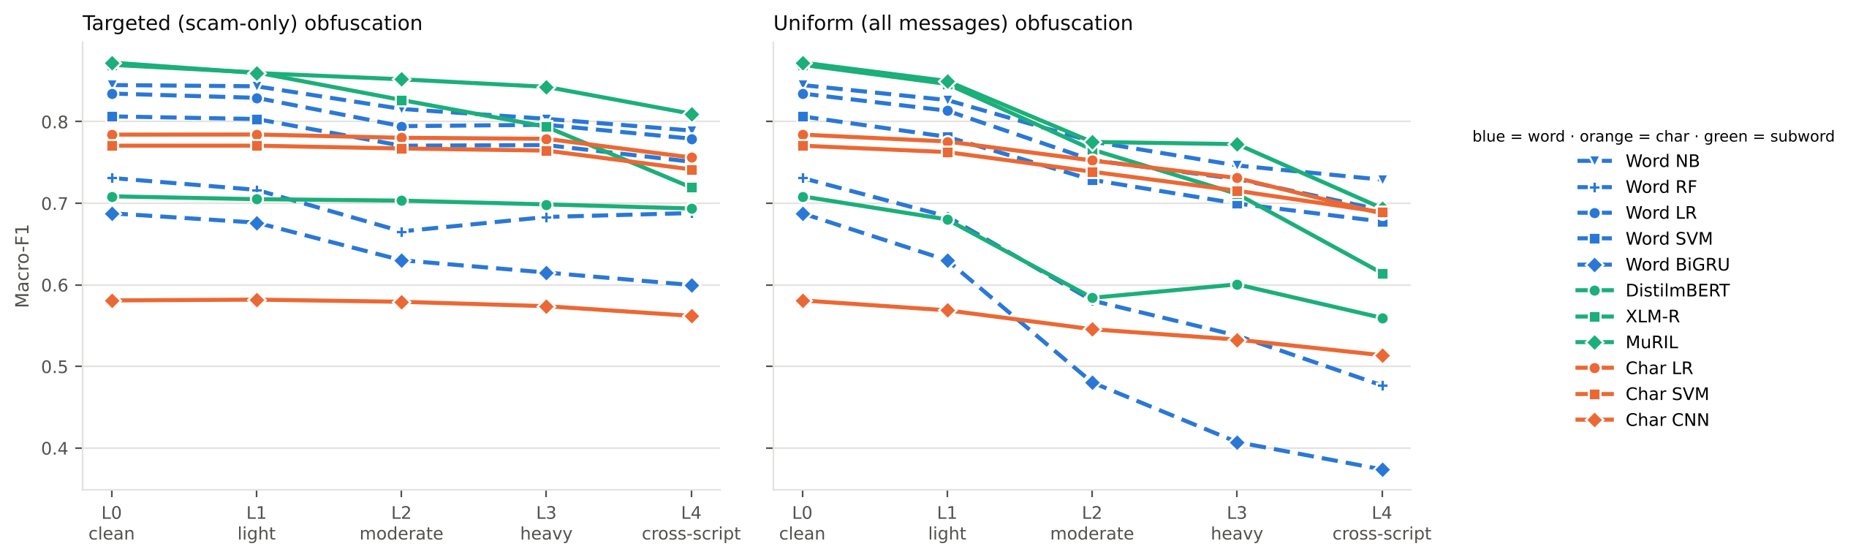
Figure 4.1: Macro-F1 versus disguise level under the targeted and uniform threat models. Blue: word models; orange: character models; green: subword transformers.
Results: character versus word representations
Table 4.3: Paired degradation tests (Δdrop < 0 means the character model lost less)
Character vs word / subword | Threat, level | Δdrop | p
Char LR vs Word LR | targeted, L4 | −0.026 | < 0.001
Char LR vs Word LR | uniform, L4 | −0.049 | < 0.001
Char SVM vs Word SVM | uniform, L4 | −0.054 | < 0.001
Char CNN vs BiGRU | uniform, L4 | −0.162 | < 0.001
Char LR vs XLM-R | targeted, L4 | −0.123 | < 0.001
Char LR vs XLM-R | uniform, L4 | −0.162 | < 0.001
Char LR vs MuRIL | targeted, L4 | −0.035 | < 0.001
Char LR vs MuRIL | uniform, L4 | −0.085 | < 0.001

The hypothesis holds in 20 of 24 paired tests at p < 0.01, including all 8 against the word models and all 8 against XLM-R and MuRIL. The four exceptions are the character CNN under the targeted threat, where the BiGRU’s score rose slightly, and DistilmBERT under the targeted threat, whose flat curve comes from its disguise-as-scam bias.
Results: transfer between languages and defences
Trained on one language setting and tested on the other two, character models transfer best: Char SVM loses 0.034 and Char LR 0.049, while word models lose about 0.11 and the BiGRU collapses (0.30). Script-aware canonicalisation is the strongest defence for word models and needs no retraining: at L3, Word Naive Bayes scores 0.856 with it, 0.824 with adversarial training and 0.803 with neither. Adversarial training lowers the scams missed by Word LR at L3 from 22.8% to 14.3% and generalises to the unseen L4 attack. The deployed detector combines both with real SMS and is the most stable model: 0.810, 0.805, 0.798, 0.795 and 0.787 macro-F1 for L0–L4.
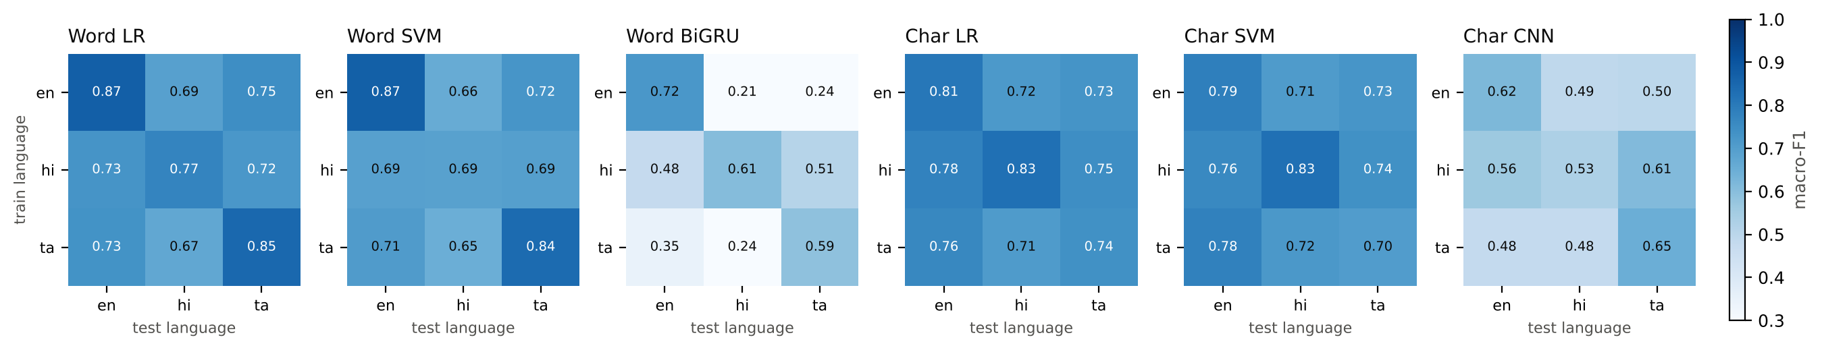
Figure 4.2: Transfer between language settings: each model trained on one setting (rows) and tested on every setting (columns), clean and at L2.
Results: real SMS corpora
Table 4.4: Macro-F1 across corpora (training data in rows)
Trained on | English | Hindi–English | Tamil–English | Real smishing
UPI-MixSMS only | 0.812 | 0.794 | 0.782 | 0.148
Public corpora only | 0.439 | 0.363 | 0.350 | 0.883
Both | 0.818 | 0.798 | 0.827 | 0.882
ScamShield (deployed) | 0.833 | 0.793 | 0.800 | 0.878

Neither data source is enough on its own. A model trained only on our corpus flags 84% of real genuine SMS as scams; a model trained only on English public corpora misses 69–89% of UPI scams because those corpora contain neither UPI fraud nor code-mixed text. Joint training works on both, which is why the deployed detector uses both.
Results: network mechanisms (N1–N6)
Table 4.5: Network experiment results
Experiment | Result
N1 Error detection | CRC-32 and CRC-16 caught 100% of corrupted frames; parity missed every even-bit error and ~50% of bursts; the Internet checksum missed 3.2% of 2-bit errors; Hamming(7,4) recovered the header at BER 10⁻² in 94.5% of cases (28.4% uncoded).
N2 ARQ under loss (W = 8, RTT ≈ 10 ms) | 0% loss: Go-Back-N ≈ Selective Repeat ≈ 590 msg/s, Stop-and-Wait 78. Efficiency at 10% loss: Selective Repeat 0.80 vs Go-Back-N 0.52; at 20%: 0.66 vs 0.39.
N3 Window size | Goodput rises from 37 msg/s at W = 1 to 159–181 msg/s at W = 16–32 as the window covers the bandwidth–delay product.
N4 Congestion (400 pkt/s, queue 12) | Fixed W = 48: ~1,040 drops, 61 msg/s. AIMD: 120 msg/s at 95% efficiency. Matched W = 4: 198 msg/s, no drops.
N5 TCP vs UDP | Transport only: UDP 0.28 ms, TCP 0.61 ms per request. With the model: ~3 ms either way (1.7 ms inference), 290–360 msg/s in batches.
N6 DNS | Cached lookup 0.20 ms vs 21.1 ms over the network; TC bit triggers TCP fallback; at 30% loss, 0–3 retries give 52/72/82/90% success.

Figure 4.3 shows why Selective Repeat matters on lossy mobile links: Go-Back-N keeps similar goodput but retransmits three to four times as many frames, which costs airtime and battery.
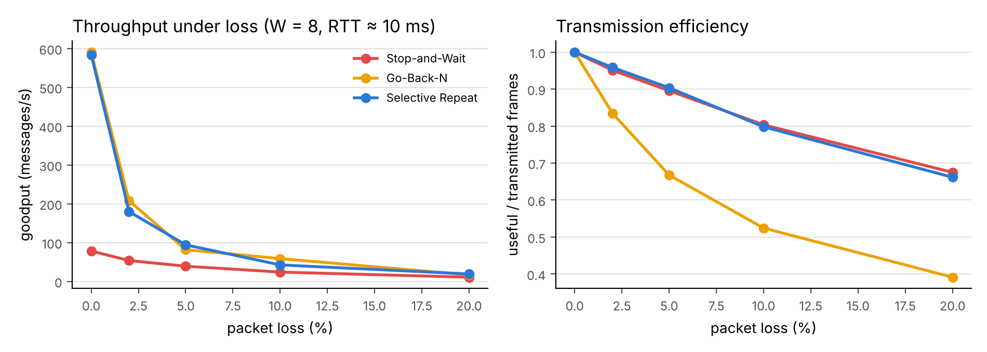
Figure 4.3: Goodput and transmission efficiency of Stop-and-Wait, Go-Back-N and Selective Repeat versus packet loss.
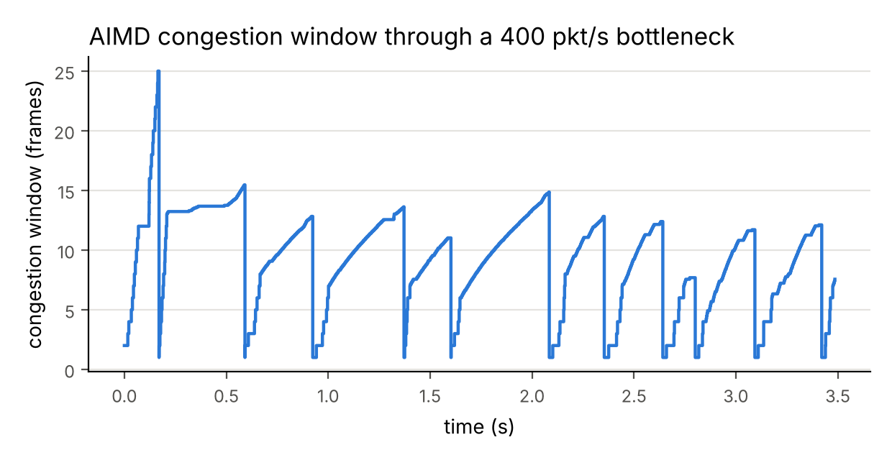
Figure 4.4: AIMD congestion window through the emulated 400 packets/s bottleneck: slow start, multiplicative decrease on loss and additive increase (sawtooth).
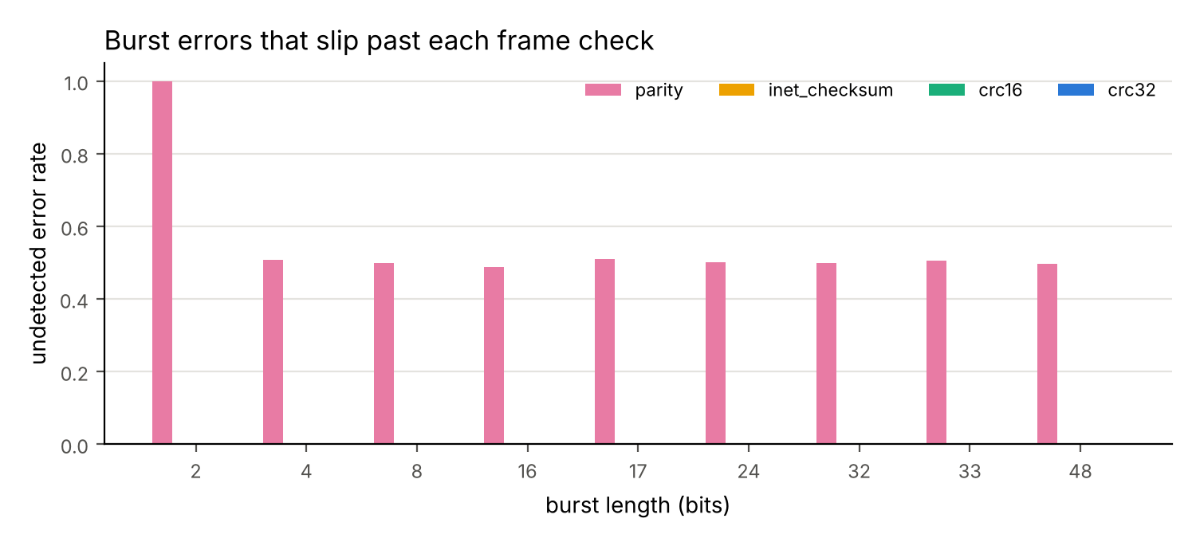
Figure 4.5: Undetected-error rate of parity, Internet checksum, CRC-16 and CRC-32 on real SSP frames for random errors and bursts.

4.2 Screenshots
The following screenshots are evidence of the working system: the test suites and Android build, the networked services answering real requests, the web application and the Android application.
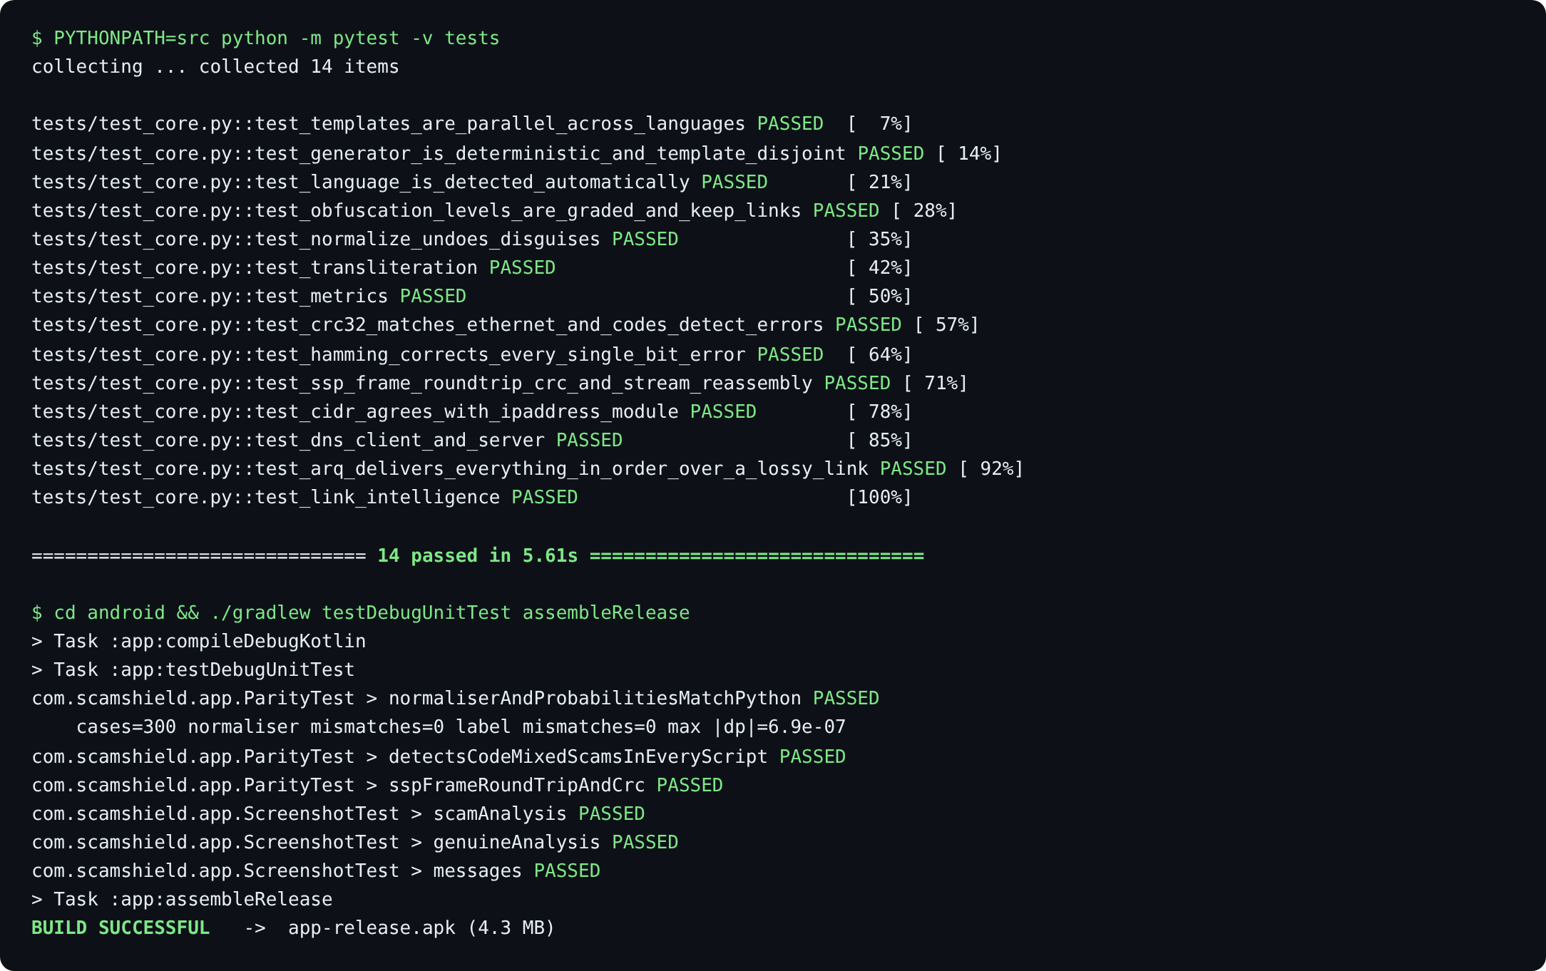
Figure 4.6: All 14 Python tests pass, and the Android build passes its parity test (300 messages, 0 differences from Python) and screenshot tests before producing the release APK.
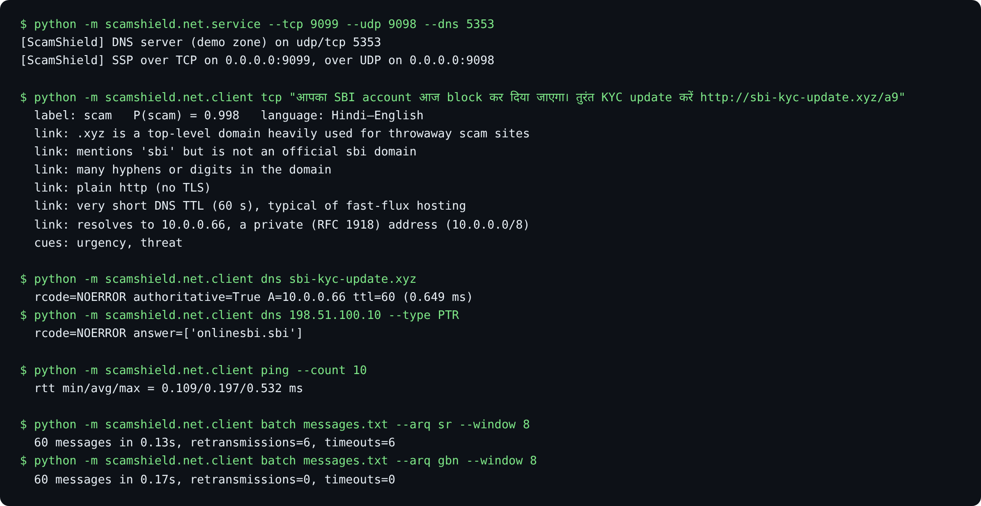
Figure 4.7: The SSP server classifies a code-mixed scam over TCP with link evidence from our DNS server and CIDR check; DNS forward and reverse lookups, RTT measurement and reliable UDP batches with Selective Repeat and Go-Back-N.
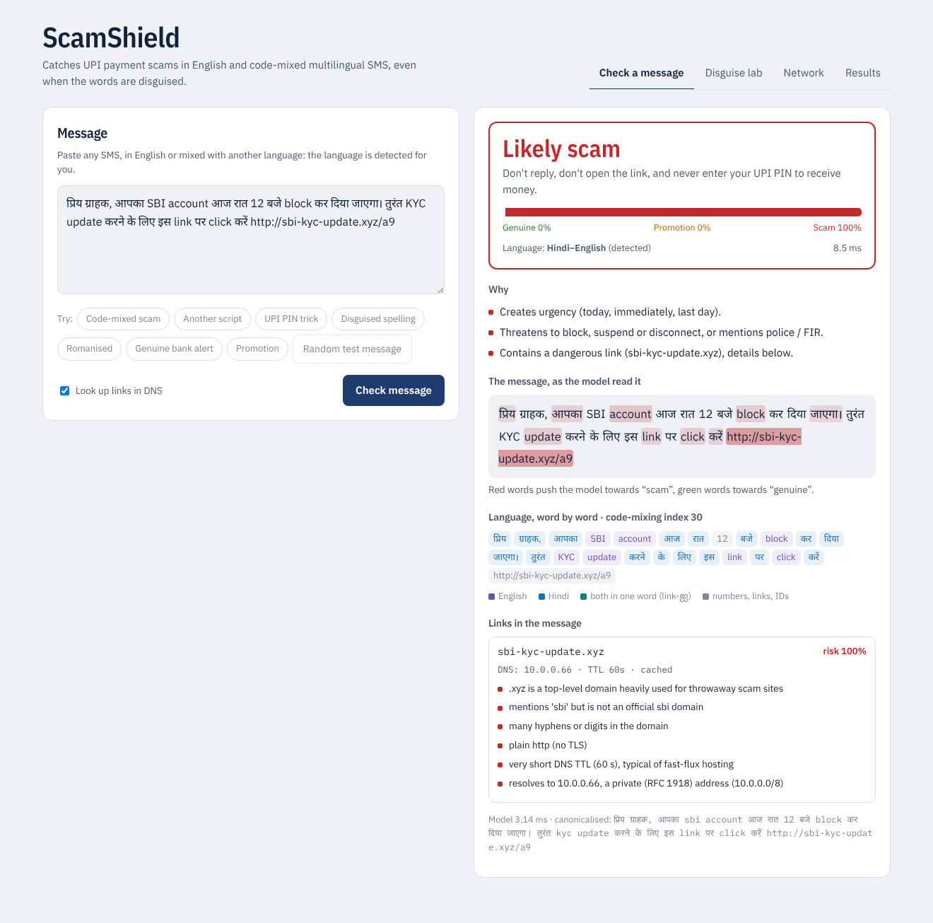
Figure 4.8: Web application, Check a message: verdict, reasons, words that drove the verdict, word-by-word language identification and the link card with its DNS answer and private-address detection.
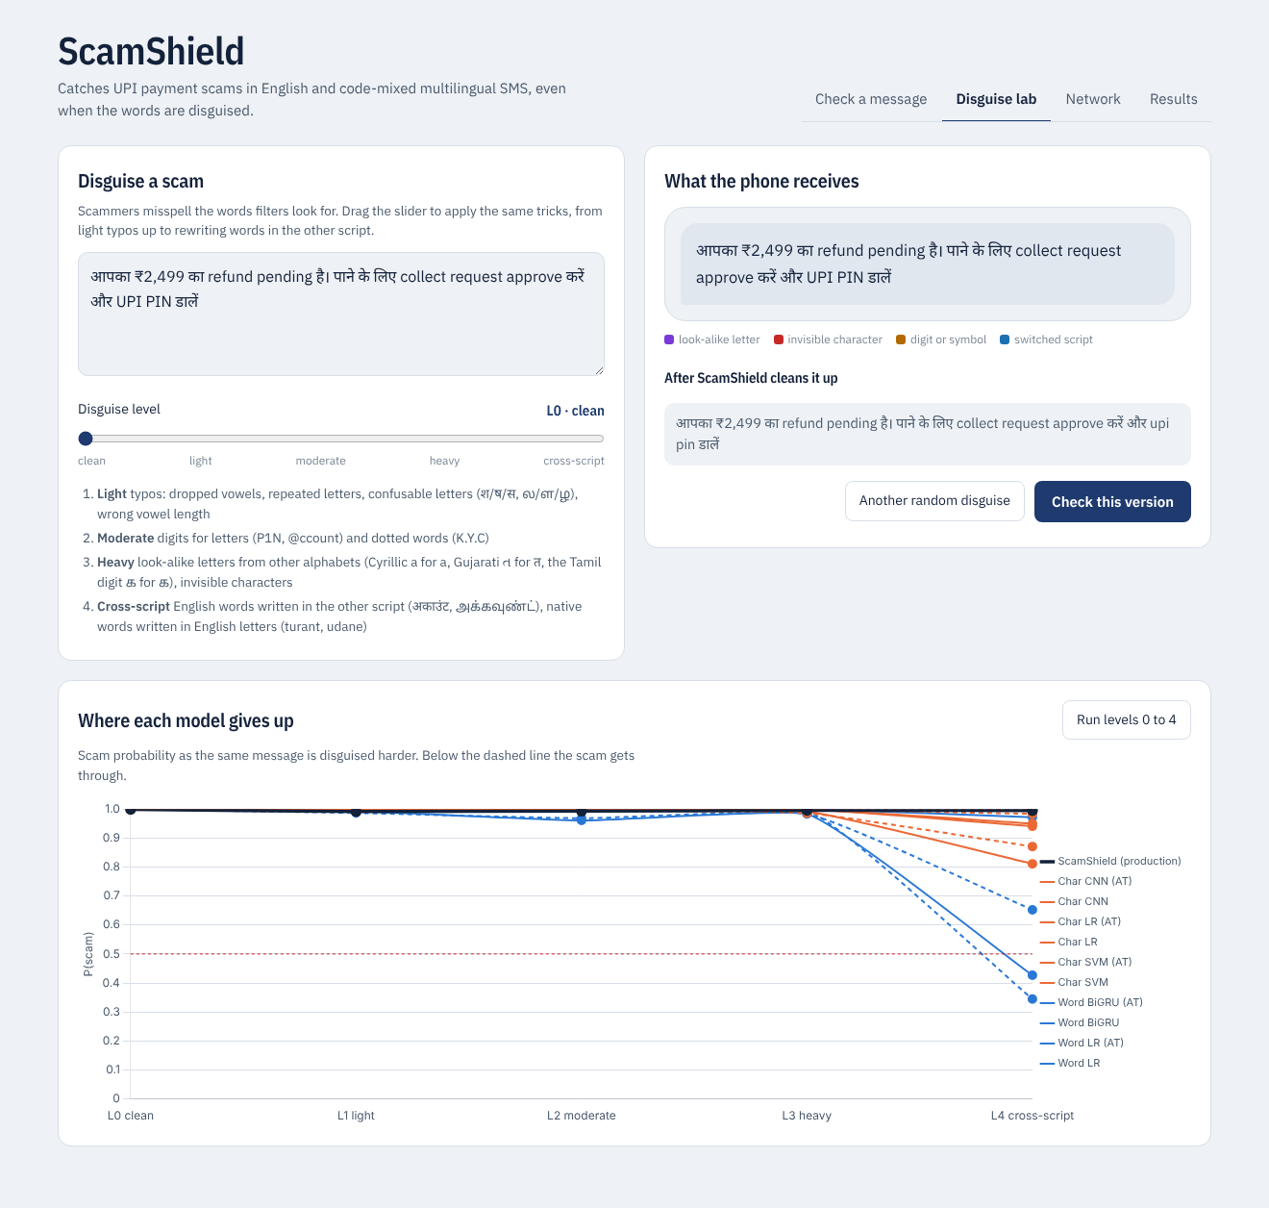
Figure 4.9: Web application, Disguise lab: the same scam disguised from L0 to L4 and the scam probability of every model; word models fall below the threshold at L4 while the deployed detector holds.
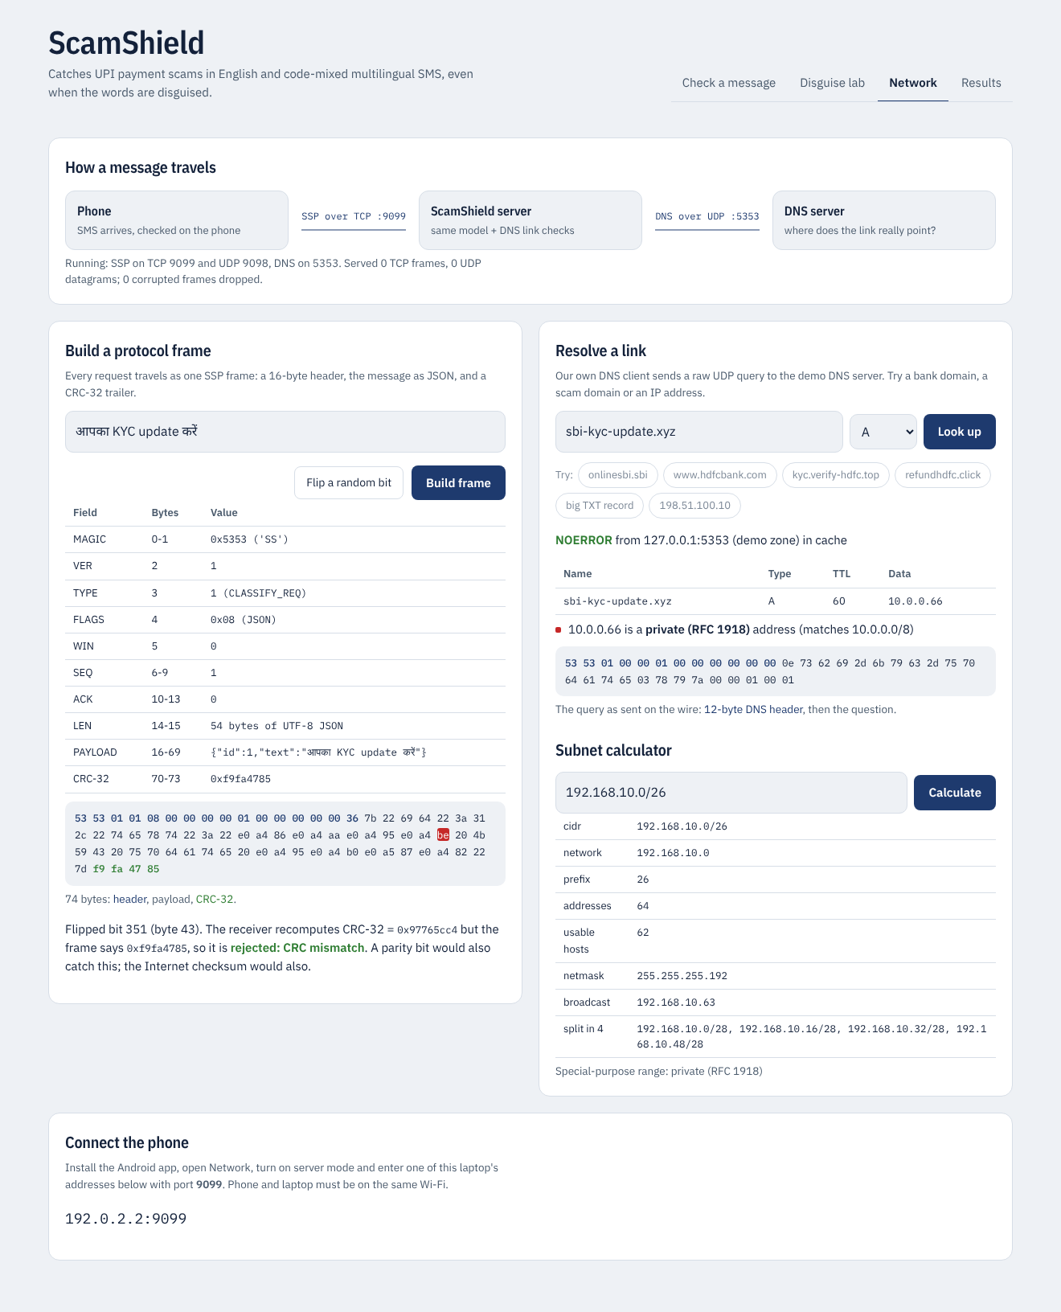
Figure 4.10: Web application, Network tab: an SSP frame field by field with one bit flipped and rejected by the CRC-32 check, a DNS lookup with the raw query bytes, and the subnet calculator.
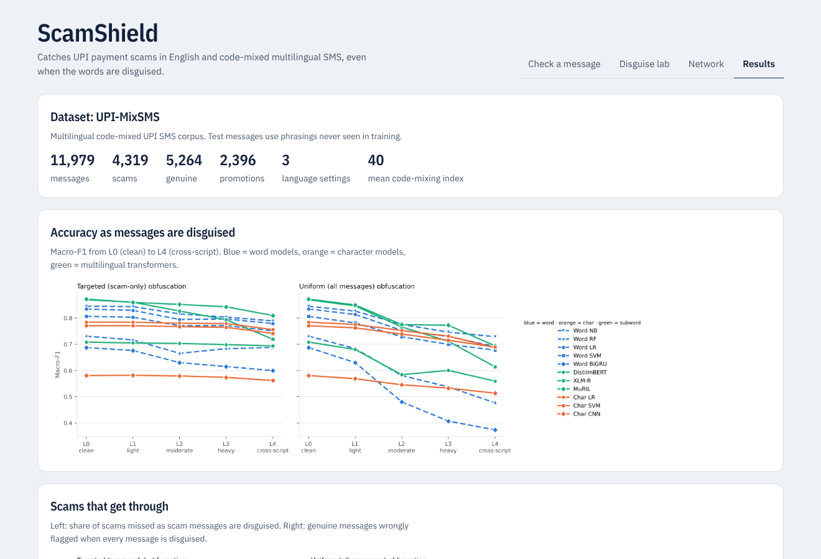
Figure 4.11: Web application, Results tab: dataset summary and the experiment figures.
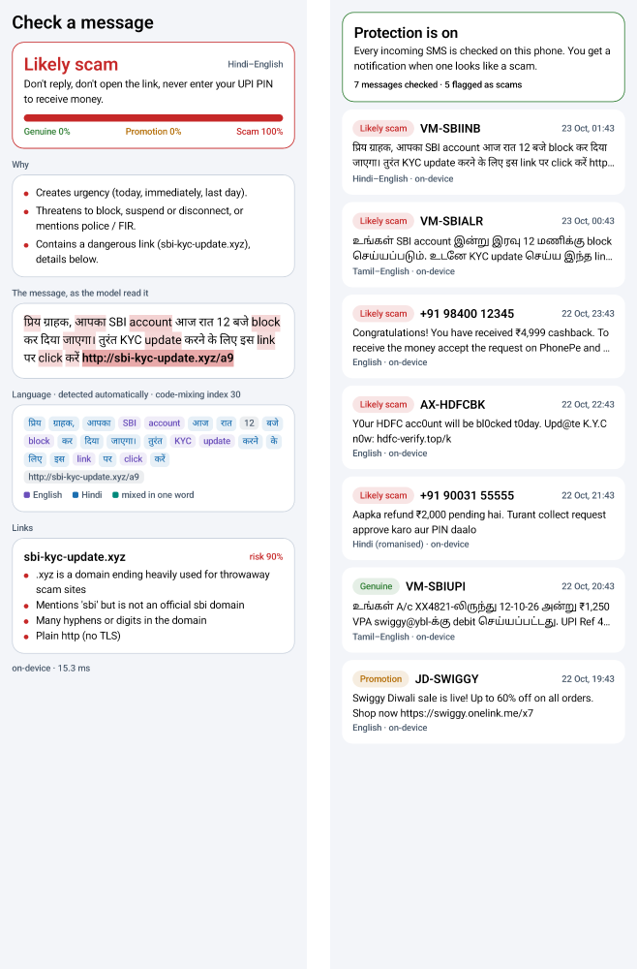
Figure 4.12: Android app. Left: analysis of a code-mixed scam with the detected language, reasons and the dangerous link. Right: message history with verdicts for English and code-mixed SMS in two scripts.

4.3 Current Progress and Challenges
Completed modules
Table 4.6: Status of modules
Module | Status
Dataset generator, script registry, language identification | Complete (English, Hindi–English, Tamil–English)
Obfuscation engine and canonicaliser | Complete; tested
Eleven detection models and all experiments | Complete (transformers: standard training; DistilmBERT also adversarial)
Deployed detector with link fusion and cues | Complete; exported to the phone
SSP, ARQ, AIMD, error codes, emulator | Complete; experiments N1–N5
DNS client/server, CIDR, link intelligence | Complete; experiment N6
Web application (four tabs) | Complete
Android application, parity and screenshot tests, APK | Complete
IEEE paper, presentation, team guide | Complete

Pending work
- Rerunning the tokenizer-free character transformer (CANINE) and the transformer transfer experiments on the current corpus, which need a GPU.
- Adversarial training for XLM-R and MuRIL.
- Evaluation on consented real code-mixed payment SMS, and tests over a real mobile network instead of the emulator.
Challenges encountered and how they were solved
- Indic text splitting. Python’s \w character class does not match Devanagari and Tamil vowel signs, so words were split in the middle. A custom tokeniser covering the Indic Unicode blocks fixed this.
- Mixed tokens. Words such as an English stem with a native suffix (PIN-ஐ) broke both the obfuscator and the canonicaliser; stems and suffixes are now handled separately.
- Go-Back-N spurious retransmissions. The emulator reordered packets because its timers drifted; using absolute deadlines restored first-in-first-out delivery, and the minimum RTO was raised to 100 ms.
- Selective Repeat slower than expected. Per-frame back-off grew without bound; it is now capped and cleared when new data is acknowledged.
- Memory limits. Transformer training on a CPU machine was killed by the memory limit when other builds ran in parallel; the runs were scheduled one at a time.
- Phone-server consistency. Small differences in Unicode handling between Kotlin and Python changed some predictions; a 300-message parity test now guarantees identical canonicalisation and labels.
- Data leakage. The translated public test set contained translations of training messages; splits are now grouped so every translation of a message stays on one side.

4.4 Conclusion and Future Enhancements
ScamShield shows that character-level representations hold up significantly better than word-level and subword representations, including the multilingual transformers XLM-R and MuRIL, when code-mixed UPI scams are disguised at the character level. Cross-script transliteration is the strongest attack, and some pretrained models learn to treat any disguise as a scam, so robustness must be judged under both threat models. A script-aware canonicaliser in front of a character n-gram model, trained jointly on synthetic and real SMS, gives a robust, calibrated detector that runs in about a millisecond, identically on a phone and on a server.
On the networking side, the project implements and measures a complete stack: a CRC-protected application protocol over TCP and reliable UDP, Stop-and-Wait, Go-Back-N and Selective Repeat with RTO estimation, AIMD congestion control, a DNS client and server, and CIDR analysis of every link. The measurements reproduce the textbook trade-offs: CRC catches errors that parity and checksums miss, Selective Repeat is far more efficient than Go-Back-N under loss, and AIMD avoids the collapse that a large fixed window causes at a bottleneck.
Future enhancements
- Add more languages and scripts through the script registry (templates plus one script table each).
- Use attackers that search for the weakest spelling instead of random disguises.
- Collect consented real code-mixed payment SMS for evaluation.
- Run the protocol over real mobile networks and add TLS for confidentiality.
- Publish the Android app and add user feedback to improve the model over time.

REFERENCES
[1] T. A. Almeida, J. M. G. Hidalgo, and A. Yamakami, “Contributions to the study of SMS spam filtering: New collection and results,” in Proc. ACM Symp. Document Engineering (DocEng), 2011, pp. 259–262.
[2] S. Mishra and D. Soni, “Smishing Detector: A security model to detect smishing through SMS content analysis and URL behavior analysis,” Future Generation Computer Systems, vol. 108, pp. 803–815, 2020.
[3] S. Mishra and D. Soni, “SMS phishing dataset for machine learning and pattern recognition,” Mendeley Data, v1, 2022.
[4] O. Abayomi-Alli, S. Misra, and A. Abayomi-Alli, “A deep learning method for automatic SMS spam classification: Performance of learning algorithms on indigenous dataset,” Concurrency and Computation: Practice and Experience, vol. 34, no. 17, 2022.
[5] J. Gao, J. Lanchantin, M. L. Soffa, and Y. Qi, “Black-box generation of adversarial text sequences to evade deep learning classifiers,” in Proc. IEEE Security and Privacy Workshops, 2018, pp. 50–56.
[6] J. Li, S. Ji, T. Du, B. Li, and T. Wang, “TextBugger: Generating adversarial text against real-world applications,” in Proc. NDSS, 2019.
[7] S. Eger et al., “Text processing like humans do: Visually attacking and shielding NLP systems,” in Proc. NAACL-HLT, 2019, pp. 1634–1647.
[8] D. Pruthi, B. Dhingra, and Z. C. Lipton, “Combating adversarial misspellings with robust word recognition,” in Proc. ACL, 2019, pp. 5582–5591.
[9] M. Davis and M. Suignard, “Unicode security mechanisms,” Unicode Technical Standard #39, The Unicode Consortium.
[10] A. Das and B. Gambäck, “Identifying languages at the word level in code-mixed Indian social media text,” in Proc. ICON, 2014, pp. 378–387.
[11] S. Khanuja, S. Dandapat, A. Srinivasan, S. Sitaram, and M. Choudhury, “GLUECoS: An evaluation benchmark for code-switched NLP,” in Proc. ACL, 2020, pp. 3575–3585.
[12] J. Devlin, M.-W. Chang, K. Lee, and K. Toutanova, “BERT: Pre-training of deep bidirectional transformers for language understanding,” in Proc. NAACL-HLT, 2019, pp. 4171–4186.
[13] V. Sanh, L. Debut, J. Chaumond, and T. Wolf, “DistilBERT, a distilled version of BERT: Smaller, faster, cheaper and lighter,” arXiv:1910.01108, 2019.
[14] A. Conneau et al., “Unsupervised cross-lingual representation learning at scale,” in Proc. ACL, 2020, pp. 8440–8451.
[15] S. Khanuja et al., “MuRIL: Multilingual representations for Indian languages,” arXiv:2103.10730, 2021.
[16] J. H. Clark, D. Garrette, I. Turc, and J. Wieting, “CANINE: Pre-training an efficient tokenization-free encoder for language representation,” Trans. ACL, vol. 10, pp. 73–91, 2022.
[17] X. Zhang, J. Zhao, and Y. LeCun, “Character-level convolutional networks for text classification,” in Proc. NeurIPS, 2015, pp. 649–657.
[18] A. S. Tanenbaum and D. J. Wetherall, Computer Networks, 5th ed. Boston, MA, USA: Pearson, 2011.
[19] J. F. Kurose and K. W. Ross, Computer Networking: A Top-Down Approach, 8th ed. Hoboken, NJ, USA: Pearson, 2021.
[20] B. A. Forouzan, Data Communications and Networking, 5th ed. New York, NY, USA: McGraw-Hill, 2013.
[21] W. W. Peterson and D. T. Brown, “Cyclic codes for error detection,” Proc. IRE, vol. 49, no. 1, pp. 228–235, 1961.
[22] R. W. Hamming, “Error detecting and error correcting codes,” Bell Syst. Tech. J., vol. 29, no. 2, pp. 147–160, 1950.
[23] R. Braden, D. Borman, and C. Partridge, “Computing the Internet checksum,” RFC 1071, 1988.
[24] V. Jacobson, “Congestion avoidance and control,” in Proc. ACM SIGCOMM, 1988, pp. 314–329.
[25] V. Paxson, M. Allman, J. Chu, and M. Sargent, “Computing TCP’s retransmission timer,” RFC 6298, 2011.
[26] P. Karn and C. Partridge, “Improving round-trip time estimates in reliable transport protocols,” in Proc. ACM SIGCOMM, 1987, pp. 2–7.
[27] D.-M. Chiu and R. Jain, “Analysis of the increase and decrease algorithms for congestion avoidance in computer networks,” Computer Networks and ISDN Systems, vol. 17, no. 1, pp. 1–14, 1989.
[28] E. N. Gilbert, “Capacity of a burst-noise channel,” Bell Syst. Tech. J., vol. 39, no. 5, pp. 1253–1265, 1960.
[29] P. Mockapetris, “Domain names — implementation and specification,” RFC 1035, 1987.
[30] M. Cotton, L. Vegoda, R. Bonica, and B. Haberman, “Special-purpose IP address registries,” RFC 6890, 2013.
[31] C. Guo, G. Pleiss, Y. Sun, and K. Q. Weinberger, “On calibration of modern neural networks,” in Proc. ICML, 2017, pp. 1321–1330.
[32] B. Efron and R. J. Tibshirani, An Introduction to the Bootstrap. New York, NY, USA: Chapman & Hall, 1993.
[33] Q. McNemar, “Note on the sampling error of the difference between correlated proportions or percentages,” Psychometrika, vol. 12, no. 2, pp. 153–157, 1947.

