ScamShield: Robust Detection of Obfuscated UPI Payment Scams in Multilingual Code-Mixed SMS, Served over a Custom Reliable Network Protocol
Shreyans Chowdry  School of Computer Science and Engineering  Vellore Institute of Technology  Vellore, India  24BDS0114 | Swapnil Jain  School of Computer Science and Engineering  Vellore Institute of Technology  Vellore, India  24BAI0248 | Ayushmaan Nayak  School of Computer Science and Engineering  Vellore Institute of Technology  Vellore, India  24BCE2612

Abstract—Payment scams delivered over SMS target users of the Unified Payments Interface (UPI) in many languages and are deliberately disguised to slip past keyword and word-level filters: look-alike Unicode characters, leetspeak, separators, invisible characters and, for multilingual users, words switched into another script. We study this problem end to end with a language-agnostic design. First, we build UPI-MixSMS, an 11,979-message corpus of English and code-mixed SMS in which each language keeps its own script and English banking terms are mixed in; the current release covers two code-mixed languages in two scripts. It comes with a template-disjoint test split and a graded, script-aware obfuscation scheme (L0–L4) whose strongest level is cross-script transliteration. Eleven word, subword and character models are compared on macro-F1, scam false-negative rate, calibration and latency. Character representations degrade significantly less than word and subword representations (20 of 24 paired tests at p < 0.01). XLM-R and MuRIL are the most accurate on clean text (0.870 and 0.872), but under transliteration XLM-R misses 52% of scams, up from 6%. A script-aware canonicaliser in front of a character n-gram model, trained jointly with real public SMS, loses only 0.023 macro-F1 from clean text to L4, scores 0.878 on a held-out real smishing corpus and runs in about 1 ms. Second, we deploy the detector as a networked system: a CRC-32-protected application protocol (SSP) over TCP and over UDP with Go-Back-N/Selective-Repeat ARQ and AIMD congestion control, a DNS client and server written on raw sockets, and CIDR analysis of every link, all measured under emulated loss, corruption and congestion. An Android app classifies incoming SMS on the device with results identical to the server model.
Index Terms—SMS phishing, multilingual code-mixing, adversarial text, character n-grams, UPI, ARQ, congestion control, DNS, CRC.

I. Introduction
Real-time account-to-account payment systems have made sending money as easy as sending a text message, and fraud has followed. UPI scams usually begin with an SMS: a fake KYC deadline, a “refund” that is really a collect request asking for the UPI PIN, a lottery prize that needs a small fee, or a threat to disconnect electricity. Two properties make these messages hard to filter. They are multilingual: many users write and receive messages in their own language and script mixed with English banking vocabulary (KYC, PIN, link, refund) inside a single sentence, and sometimes inside a single word. And they are adversarial: senders deliberately disguise the words a filter looks for, writing P1N, K.Y.C, a Cyrillic е in rеfund, a look-alike character from a neighbouring script, or an English word spelt in a native script.
Most SMS spam work evaluates on clean English corpora [1], [2], while adversarial-text work studies perturbations on English benchmarks [3], [4], [5]. Code-mixed NLP work largely uses romanised text [6]. We ask how scam detectors behave when all three conditions hold at once, and we treat detection as a networked service rather than a stand-alone classifier, because in practice the verdict must travel between a phone and a server over unreliable links, and the strongest evidence about a link in an SMS lives in the network itself (DNS answers and the address blocks they point into).
Our contributions are:
- UPI-MixSMS, a multilingual code-mixed UPI SMS corpus in native scripts with 23 intents, deliberate hard negatives, automatic token-level language identification and a template-disjoint split, built on a script registry so that a new language is a data change, not a code change.
- A graded, script-aware obfuscation scheme (L0–L4) whose operators are generic over scripts, with cross-script transliteration in both directions as the strongest level, under targeted and uniform threat models.
- A controlled comparison of word, subword and character models with paired significance tests of the hypothesis that character representations degrade less, plus cross-language transfer, two defences and external validation on real SMS corpora.
- A deployed networked system: a CRC-protected application protocol over TCP and reliable UDP (Stop-and-Wait, Go-Back-N, Selective Repeat, AIMD), DNS and CIDR link intelligence fused with the text model, and an Android app with verified on-device parity, each mechanism measured under emulated impairments.

II. Related Work

A. SMS Spam and Smishing Detection
The UCI SMS Spam Collection [1] established SMS spam filtering as a benchmark task, and smishing-specific corpora and detectors combine message content with URL behaviour [7], [2]. Handset-collected corpora such as ExAIS [8] capture realistic ham distributions. These corpora are English and contain little payment-system-specific fraud, which our external-validity experiments confirm.

B. Adversarial and Visual Text Perturbation
Character-level black-box attacks such as DeepWordBug [3] and TextBugger [4] swap, insert and delete characters or substitute look-alikes; VIPER [5] replaces characters with visually similar Unicode code points. Defences include word recognition before classification [9] and confusable folding guided by Unicode security data [10]. We generalise these operators to native scripts and add cross-script transliteration.

C. Code-Mixed and Multilingual Representations
Word-level language identification and the Code-Mixing Index (CMI) [11] quantify mixing; GLUECoS [6] benchmarks code-switched NLP. Multilingual encoders include mBERT [12], its distilled variant [13], XLM-R [14] and MuRIL [15], which adds transliterated text to pre-training. Tokenizer-free models such as CANINE [16] and character CNNs [17] operate on characters directly and are natural candidates for robustness to character-level noise.

D. Networking Foundations
Our protocol stack follows the textbook treatments of framing, error control, sliding-window ARQ and congestion control [18], [19], [20]: CRC [21], Hamming codes [22] and the Internet checksum [23]; retransmission timing after Jacobson [24], RFC 6298 [25] and Karn’s rule [26]; AIMD [27]; burst loss after Gilbert [28]; DNS per RFC 1035 [29]; and special-purpose address blocks per RFC 6890 [30].

III. Dataset and Threat Model

A. UPI-MixSMS
Messages belong to three classes: scam (the positive class for false-negative rate), legit (debit and credit alerts, OTPs, AutoPay mandates, genuine collect requests, personal payment chats, security advisories, bill confirmations) and promo (cashback, sales, bank loan offers, recharge plans, reward points). Eleven scam intents cover KYC/PAN blocking, refund and cashback collect-request PIN fraud, lottery prizes, “wrong transfer” refunds, task-based job lures, electricity disconnection, customs parcel threats, fake customer support (remote-access apps, OTP, CVV), instant-loan fees, reward-point phishing and “scan to receive” QR fraud. Genuine messages deliberately reuse scam vocabulary (“do not share your OTP”, advisories that mention KYC and links, real AutoPay approvals), so vocabulary alone cannot separate the classes.
The corpus is multilingual by design: English plus one code-mixed setting per supported language, each written in its own script, with banking terms kept in Latin script. Everything language-specific (templates, script tables, cue words) sits behind one script registry. The current release has two code-mixed settings, Hindi–English in Devanagari and Tamil–English in Tamil script, which also exercise two styles of mixing: English words followed by native postpositions (account में) and native case suffixes attached inside the English word (link-ஐ). Each of the 23 intents has three to four templates written in parallel in all three settings (219 templates). Slots are filled with realistic bank and app names, UPI IDs, amounts, phone numbers, references and look-alike or shortened links; genuine messages also use shorteners, so a shortener alone does not reveal a scam. Natural variation includes informal English spellings, formal and colloquial native registers, and English loanwords occasionally typed in the native script. After de-duplication the corpus has 11,979 messages (5,264 legit, 4,319 scam, 2,396 promo; about 4,000 per language setting). The two code-mixed settings have mean CMIs of 39.0 and 40.6. One template per intent is held out for test in every language, giving 3,939 test, 6,834 training and 1,206 validation messages (Table I).
Language is never given to the models or selected by the user. A token-level identifier tags each token as a registered native script, English, romanised native, mix (an English stem with a native suffix, counted for both languages) or language-independent (numbers, URLs, IDs); the message label follows from the token mix and is 100% accurate on clean UPI-MixSMS.
TABLE I
UPI-MixSMS composition
Setting | Script | Messages | CMI | Native tokens
English | Latin | 3,990 | 0 | –
Hindi–English | Devanagari + Latin | 3,996 | 39.0 | 56%
Tamil–English | Tamil + Latin | 3,993 | 40.6 | 49%

B. Obfuscation Levels and Threat Models
Each eligible token (not a URL, UPI ID or number) is perturbed with probability p, and salient fraud words in any language with probability 2p. Operators are chosen by the token’s script (Table II): one family for Latin script and one generic family for every registered native script, parameterised by that script’s confusable letters, vowel signs, virama, look-alike characters and romanisation rules. For a Latin stem with a native suffix (PIN-ஐ), only the stem is perturbed. Measured normalised character edit rates are 2.8%, 7.8%, 11.7% and 27.4% for L1–L4. Under the targeted threat only scam messages are disguised, since an attacker controls only scam text; under the uniform threat every message is disguised, which stresses false alarms. Three obfuscation seeds are used per condition.
TABLE II
Obfuscation levels and script-aware operators
Level | p | Latin-script tokens | Native-script tokens
L1 light | 0.15 | vowel drop, repeat, case, swap, phonetic respelling | confusable letters, vowel-length swaps, virama dropped or added
L2 moderate | 0.30 | + leetspeak, separators (K.Y.C) | + separators between graphemes
L3 heavy | 0.45 | + Cyrillic/Greek homoglyphs, zero-width, insert/delete | + look-alike characters from other blocks, ZWJ/ZWNJ, grapheme deletion
L4 cross-script | 0.60 | + English word written in the native script | + native word transliterated to Latin

IV. Detection Models and Defences

A. Models
Word models: Naive Bayes, random forest, logistic regression (LR) and linear SVM on word 1–2-gram features with an Indic-aware tokeniser (the standard \w class splits Indic words at vowel signs), and a BiGRU trained from scratch. Character models: LR and SVM on char_wb 2–5-gram TF-IDF and a character CNN with parallel 3/5/7 convolutions [17]. Subword models: DistilmBERT [13], XLM-R [14] and MuRIL [15]. Transformers are fine-tuned for one epoch on CPU with class-weighted loss; XLM-R and MuRIL use frozen input embeddings to fit memory. A tokenizer-free character transformer (CANINE [16]) is implemented but was not run on the current corpus because of the CPU budget.

B. Defences
Adversarial training replaces each training message with probability 0.5 by an L1–L3 disguised copy, so L4 transliteration is never seen in training. Script-aware canonicalisation requires no retraining: NFKC normalisation, zero-width removal, Cyrillic/Greek look-alikes folded to Latin, native look-alike characters folded back, in-word separators removed in every script, leetspeak undone, native-script spellings of English loanwords mapped back, letter runs squeezed and lower-casing. It has no access to the attack’s random choices and cannot undo native-to-Latin transliteration. It reduces the residual edit rate at L3 from 11.7% to 5.4%.

C. Production Detector and Link Fusion
The deployed detector is a char 2–5-gram TF-IDF (60k features) on canonicalised text followed by multinomial LR (C = 10, class-balanced). It is trained on UPI-MixSMS, a disguised copy (L1–L4) of half of it, the Mishra–Soni training split [7] and genuine messages from UCI [1] and ExAIS [8]. A link-risk score r ∈ [0, 1] from Section V-D is fused with the text probability:
P′(scam) = 1 − (1 − P(scam)) (1 − 0.6 r), (1)
with the other classes rescaled; the verdict is scam if P′(scam) ≥ 0.5. Multilingual rule cues (PIN to receive money, OTP sharing, urgency, threats, fees, remote-access apps) explain verdicts to the user but never change scores.

V. Networked System
Fig. 1 shows the deployed system. Every networking component is implemented from raw sockets without networking libraries, so each mechanism can be instrumented and measured.
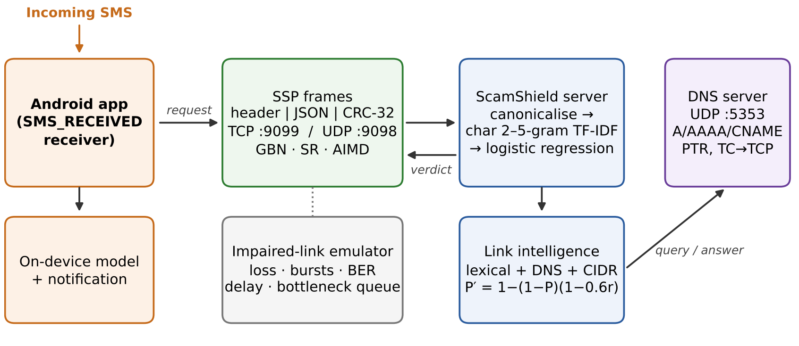
Fig. 1. ScamShield architecture. The phone classifies SMS on the device or sends them to the server as SSP frames over TCP or reliable UDP; the server fuses the text verdict with DNS and CIDR evidence about each link.

A. ScamShield Protocol (SSP)
SSP is a binary application-layer protocol (Table III). A 16-byte big-endian header is followed by a UTF-8 JSON payload and a CRC-32 (IEEE 802.3 polynomial) computed over header and payload; frames with a bad CRC are dropped. Frame types are CLASSIFY_REQ/RESP, DATA, ACK, NAK, PING/PONG, ERROR and FIN. Over TCP, frames are sent back to back and reassembled from the byte stream by the LEN field; over UDP, one datagram carries one frame.
TABLE III
SSP frame format
Field | Bytes | Purpose
MAGIC | 2 | 0x5353 (“SS”), frame sync
VER, TYPE | 1 + 1 | version, frame type
FLAGS, WIN | 1 + 1 | SYN/FIN/RETX flags; advertised window
SEQ, ACK | 4 + 4 | sequence and cumulative/selective ACK
LEN | 2 | payload length
Payload | LEN | UTF-8 JSON (message, verdict)
CRC-32 | 4 | over header and payload

B. Reliable Transport over UDP
Above UDP we implement Stop-and-Wait, Go-Back-N (cumulative ACKs, one timer, the whole window resent on timeout) and Selective Repeat (per-frame ACKs and timers, out-of-order frames buffered), with advertised receive windows for flow control. The retransmission timeout follows Jacobson/Karels [24], [25]:
RTO = SRTT + 4·RTTVAR, RTO ≥ 100 ms, (2)
with Karn’s rule [26], exponential back-off cleared when new data is acknowledged, and a 15-retry abort. Optional AIMD congestion control [27] adds slow start, congestion avoidance and, on timeout, cwnd ← 1 and ssthresh ← cwnd/2, at most once per window.

C. Impaired-Link Emulator
A UDP proxy injects Bernoulli or Gilbert–Elliott burst loss [28], bit errors, one-way delay with FIFO-preserving jitter, and a bottleneck link with a drop-tail queue, all with deterministic seeds.

D. DNS and CIDR Link Intelligence
Our DNS client implements the RFC 1035 wire format [29] with name compression, A/AAAA/CNAME/NS/PTR/TXT records, transaction-ID checks, retries, TCP fallback when the TC bit is set, and positive and negative TTL caching. The authoritative server answers a demo zone, chases CNAMEs and truncates answers over 512 bytes. URLs extracted from a message (handling native case suffixes and excluding UPI IDs) receive lexical features (shortener, raw IP host, punycode, risky TLD, a brand name in a non-official domain, deep subdomains, plain HTTP) and network features: NXDOMAIN, TTL < 120 s, and resolution into a special-purpose block [30] (private, loopback, link-local, CGNAT, reserved) by longest-prefix match. The capped sum of feature weights gives r in (1).

E. Android Client
A Kotlin/Jetpack Compose app registers an SMS_RECEIVED receiver, joins multi-part messages, classifies them on the device with a Kotlin port of the canonicaliser, language identifier, analyser, TF-IDF and LR, and posts a high-priority notification for scams. The supported scripts are read from the exported model, so a new language needs no app code change. In server mode the app sends CLASSIFY_REQ frames over TCP and falls back to on-device checks when the server is unreachable.

VI. Experimental Setup
The primary metric is macro-F1 over the three classes; we also report the scam false-negative rate (FNR, scams missed), the scam false-positive rate (FPR), top-label expected calibration error (ECE, 15 bins) [31] and single-message CPU latency (median of 200). For the hypothesis we compare the degradation of a character model A and a word or subword model B,
Δdrop = [F1_{A}(L0) − F1_{A}(Lk)] − [F1_{B}(L0) − F1_{B}(Lk)], (3)
with a paired bootstrap of 1,000 resamples [32] for a one-sided p (A degrades less) and an exact McNemar test [33] on the attacked predictions. Network experiments N1–N6 run on localhost through the emulator on a 2-core CPU; comparisons between mechanisms, not absolute throughput, are the object of study.

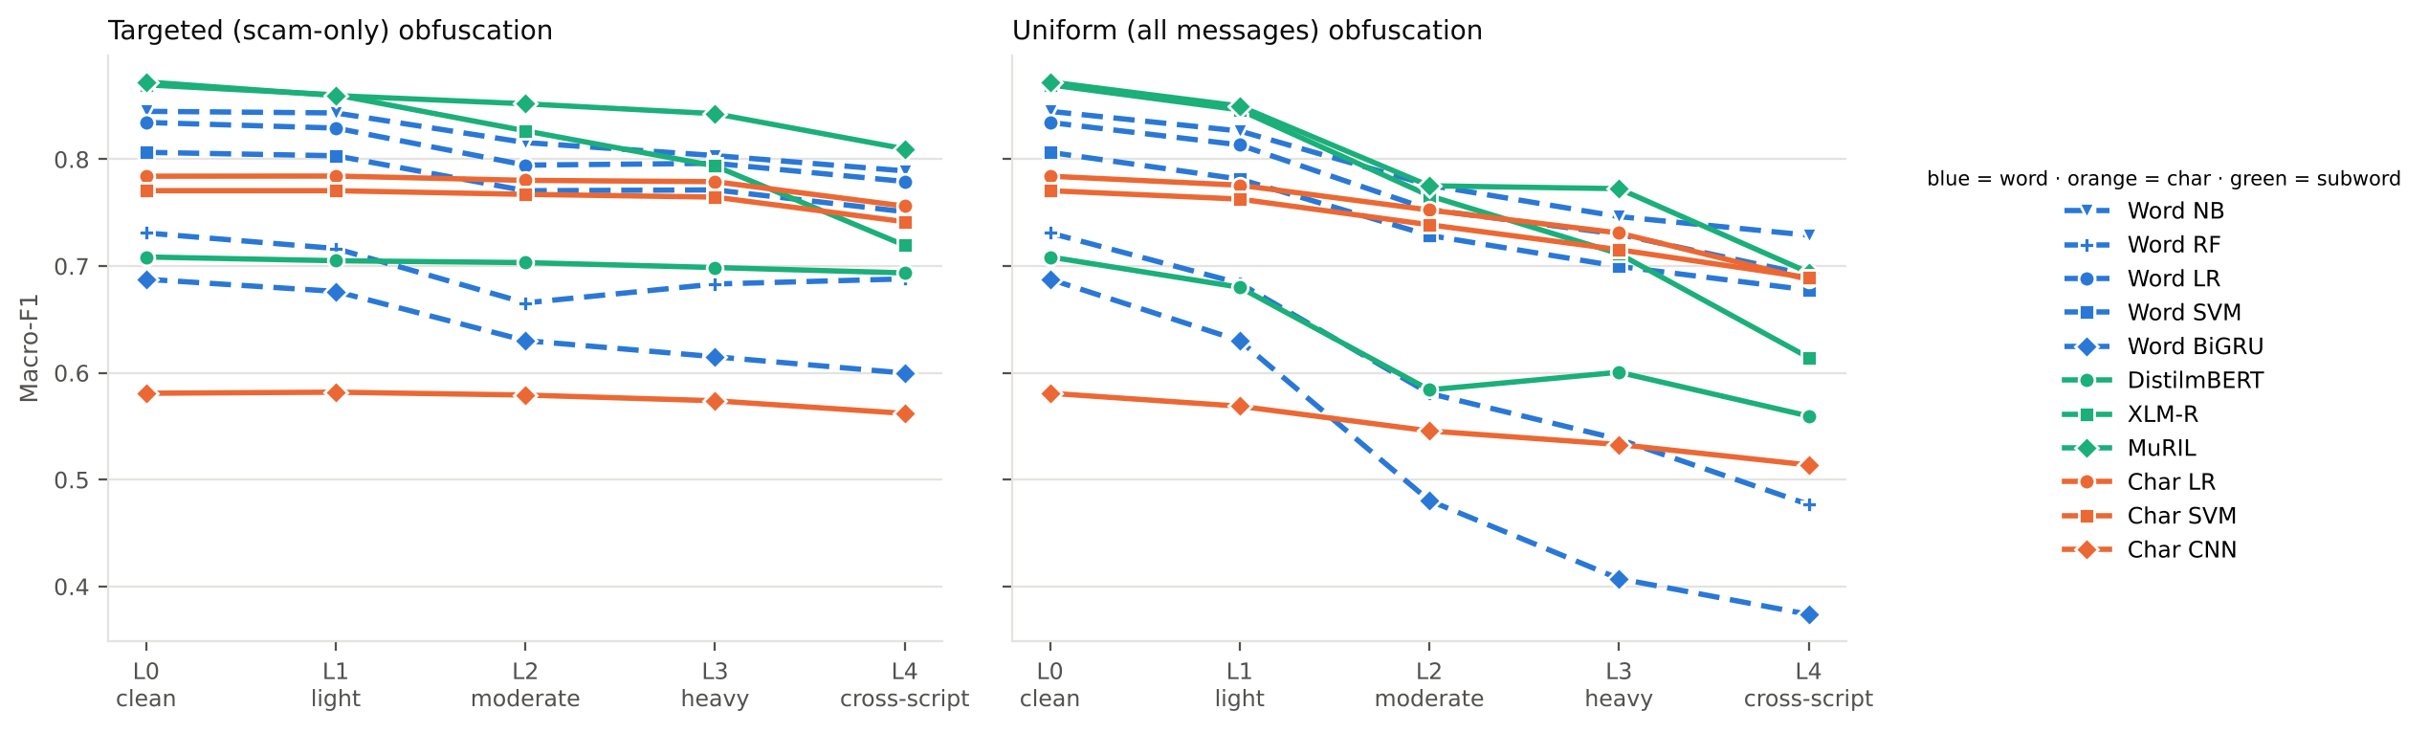
Fig. 2. Macro-F1 versus obfuscation level under the targeted (scam-only) and uniform (all messages) threat models. Blue: word models; orange: character models; green: subword transformers.

TABLE IV
Clean performance on the template-disjoint test set
Model | Repr. | Macro-F1 | FNR | ECE | ms
Word NB | word | 0.845 | 0.114 | 0.137 | 0.6
Word LR | word | 0.835 | 0.118 | 0.071 | 1.4
Word SVM | word | 0.807 | 0.117 | 0.080 | 4.4
Word BiGRU | word | 0.688 | 0.248 | 0.211 | 2.7
DistilmBERT | subword | 0.709 | 0.005 | 0.229 | 65
XLM-R | subword | 0.870 | 0.056 | 0.132 | 97
MuRIL | subword | 0.872 | 0.034 | 0.116 | 108
Char LR | char | 0.784 | 0.101 | 0.066 | 1.5
Char SVM | char | 0.771 | 0.105 | 0.126 | 5.0
Char CNN | char | 0.581 | 0.313 | 0.295 | 2.3
Production | char | 0.810 | 0.095 | 0.051 | ~1

VII. Results

A. Clean Performance
Table IV summarises clean results. MuRIL and XLM-R are the most accurate (0.872 and 0.870), followed by the word n-gram models (0.81–0.85) and the character n-gram models (0.77–0.78). Character LR is the best-calibrated model (ECE 0.066) and 45–75× faster than the transformers. Most errors are hard negatives: models flag 14–40% of genuine and promotional messages as scams, mostly advisories, AutoPay mandates and bank loan offers that share scam vocabulary. Every language setting is learnable: MuRIL scores 0.893, 0.857 and 0.867 on English and the two code-mixed settings.

B. Robustness to Obfuscation
Fig. 2 plots macro-F1 against obfuscation level. Under the uniform threat every word and subword model degrades steadily from L0 to L4 (Word LR −0.143, MuRIL −0.178, XLM-R −0.255) while the character models lose less (Char LR −0.097, Char SVM −0.081). Under the targeted threat the word and subword models start missing scams: Word LR’s FNR rises from 0.118 to 0.279, MuRIL’s from 0.034 to 0.247, and XLM-R goes from missing 5.6% of scams to missing 51.5%. Char LR stays below 12% up to L3 and reaches 18.9% at L4. Cross-script transliteration (L4) is the strongest attack for every model. DistilmBERT learns that disguise itself signals a scam: its targeted FNR stays below 6%, but under the uniform threat its FPR rises from 0.254 to 0.410, so a flat targeted curve does not imply robustness.

C. Character versus Word Representations
Table V reports representative paired tests. The hypothesis holds in 20 of 24 tests at p < 0.01. Char LR and Char SVM degrade significantly less than their word counterparts in all 8 tests, and Char LR degrades significantly less than both multilingual transformers in all 8 tests; the largest effect is against XLM-R under uniform L4 (Δdrop = −0.162). The four exceptions are the character CNN under the targeted threat, where the BiGRU’s score rises slightly, and DistilmBERT under the targeted threat, whose flat curve reflects the disguise-as-scam bias above.
TABLE V
Paired degradation tests (Δdrop < 0 favours the character model)
A vs B | Threat, level | Δdrop | p
Char LR vs Word LR | targeted, L4 | −0.026 | < 0.001
Char LR vs Word LR | uniform, L4 | −0.049 | < 0.001
Char SVM vs Word SVM | uniform, L4 | −0.054 | < 0.001
Char CNN vs BiGRU | uniform, L4 | −0.162 | < 0.001
Char LR vs XLM-R | targeted, L4 | −0.123 | < 0.001
Char LR vs XLM-R | uniform, L4 | −0.162 | < 0.001
Char LR vs MuRIL | targeted, L4 | −0.035 | < 0.001
Char LR vs MuRIL | uniform, L4 | −0.085 | < 0.001

D. Cross-Language Transfer
Training on one language setting and testing on the other two, character n-gram models transfer best: Char SVM loses 0.034 and Char LR 0.049 against their in-language scores, while Word LR and Word SVM lose 0.115 and 0.112 and the from-scratch BiGRU collapses (0.301). Banking vocabulary stays in Latin script in every setting, and character n-grams pick it up across languages and scripts; the ordering holds at L2.

E. Defences
Script-aware canonicalisation is the strongest defence for word models and needs no retraining: at L3, Word NB scores 0.856 with it against 0.824 with adversarial training and 0.803 with neither, and Word LR 0.839 / 0.821 / 0.796. It also raises clean scores, because it folds natural spelling variation. Adversarial training lowers the L3 FNR of Word LR from 0.228 to 0.143, rescues the BiGRU (0.688 → 0.752 clean), generalises to the unseen L4 attack (Word LR 0.779 → 0.809) and raises DistilmBERT at every level (0.709 → 0.744 clean). The production detector, which combines both with real SMS, is the most stable: 0.810, 0.805, 0.798, 0.795 and 0.787 for L0–L4, with ECE ≤ 0.059.

F. External Validity on Real SMS
Table VI shows that neither data source suffices on its own. A model trained only on UPI-MixSMS flags 84% of genuine messages in the held-out Mishra–Soni corpus as scams (macro-F1 0.148). A model trained only on public corpora misses 69–89% of UPI scams, since English-only corpora contain neither payment-system fraud nor code-mixed text. Joint training works on both, and the production detector reaches 0.878 on Mishra–Soni with a genuine-message FPR of 0.5%. Link fusion does not change the FNR on UPI-MixSMS (10.4%), because the text model already catches nearly every scam that carries a link; its value is explanatory and for links in otherwise innocent text.
TABLE VI
Cross-corpus macro-F1 (training data in rows)
Train on | en | hi | ta | Mishra–Soni
UPI-MixSMS only | 0.812 | 0.794 | 0.782 | 0.148
Public corpora only | 0.439 | 0.363 | 0.350 | 0.883
Joint | 0.818 | 0.798 | 0.827 | 0.882
Production (+ L1–L4) | 0.833 | 0.793 | 0.800 | 0.878

G. Network Mechanisms
N1, error detection. Over 3,000 trials per condition on real SSP frames, CRC-32 and CRC-16 detected every corrupted frame. A parity bit missed every even-weight error and about half of all bursts of length 4–48, and the Internet checksum missed 3.2% of random 2-bit errors. Hamming(7,4) recovered the 16-byte header at a bit-error rate of 10⁻² in 94.5% of cases against 28.4% uncoded, at 75% bit overhead.
N2, ARQ under loss (Fig. 3). With W = 8 and an RTT of about 10 ms, Go-Back-N and Selective Repeat each deliver about 590 messages/s at 0% loss against 78 for Stop-and-Wait. As loss rises, Go-Back-N keeps similar goodput but retransmits 3–4× more frames: efficiency (useful over transmitted frames) at 10% loss is 0.52 for Go-Back-N against 0.80 for Selective Repeat, and 0.39 against 0.66 at 20%.
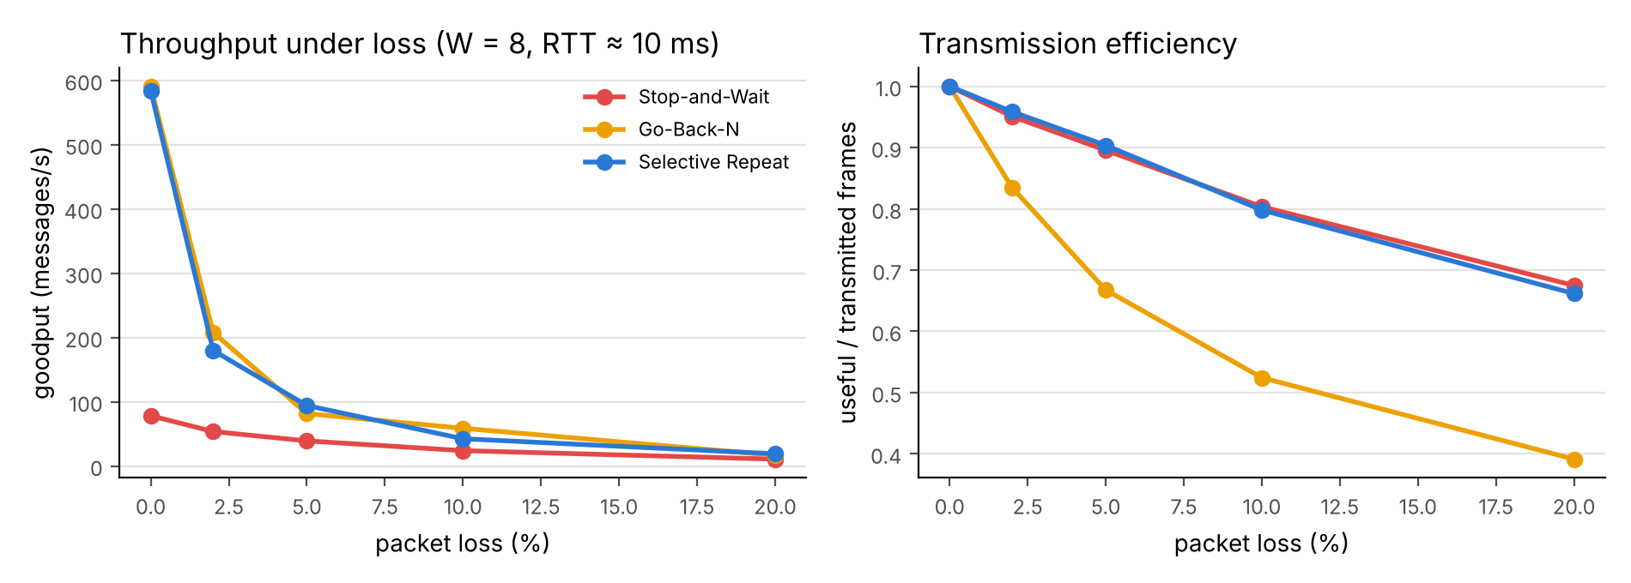
Fig. 3. Goodput and transmission efficiency of Stop-and-Wait, Go-Back-N and Selective Repeat versus packet loss.
N3, window size. At 2% loss and a 20 ms RTT, goodput rises from 37 messages/s at W = 1 to 159–181 at W = 16–32 as the window covers the bandwidth–delay product.
N4, congestion (Fig. 4). Through a 400 packets/s bottleneck with a 12-packet queue, a fixed window of 48 overflows the queue (about 1,040 drops, 61 messages/s). AIMD finds a working point on its own (120 messages/s, mean of two seeds) with 95% efficiency; a window matched to the bandwidth–delay product (W = 4) is best at 198 messages/s with no drops.
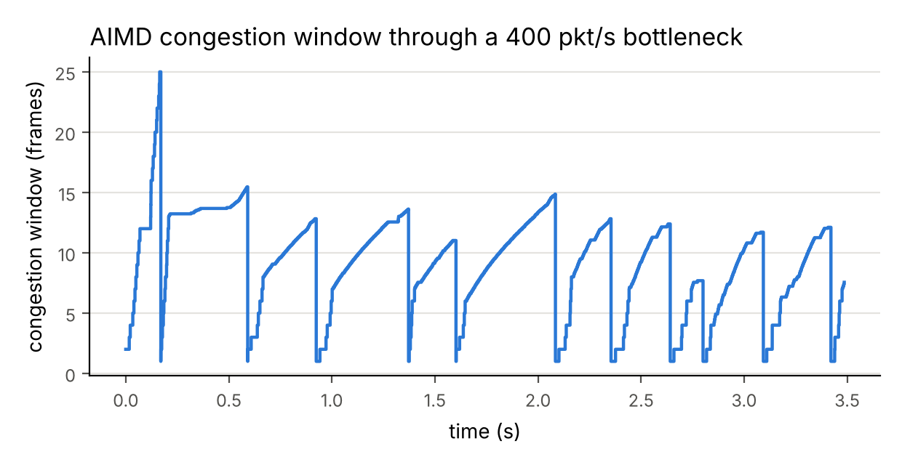
Fig. 4. AIMD congestion window (sawtooth) through the emulated bottleneck.
N5, TCP versus UDP. With a transport-only stub, a UDP request/response takes 0.28 ms median against 0.61 ms over a persistent TCP connection. With the production detector the model dominates: about 3 ms per round trip, of which 1.7 ms is inference, and 290–360 messages/s for pipelined batches over either transport.
N6, DNS. A cached lookup takes 0.20 ms against 21.1 ms over the network; an answer larger than 512 bytes sets the TC bit and is re-fetched over TCP; at 30% loss, zero to three retries raise resolution success from 52% to 90% while mean latency rises from 32 ms to 163 ms.

H. On-Device Parity
On 300 clean, disguised and public messages, the Kotlin canonicaliser output is identical to Python on all 300, predicted labels are identical, and the largest probability difference is 7×10⁻⁷. The APK is 4.3 MB and an on-device check takes a few milliseconds, so the phone can classify every incoming SMS without a network round trip.

VIII. Discussion and Limitations
The results support a practical design rule: for an adversary who edits characters, character-level evidence plus a script-aware canonicaliser is more robust, better calibrated and two orders of magnitude cheaper than a multilingual transformer, even though the transformer wins on clean text. Because every language-specific component sits behind one script registry, the same pipeline extends to a new language by adding its templates and script tables. Robustness must be judged under both threat models, because a model can look robust under the targeted threat simply by treating noise as evidence of fraud. On the networking side, Selective Repeat’s efficiency advantage matters on lossy mobile links where retransmissions cost battery and airtime, and AIMD protects a shared bottleneck that a fixed large window would overrun.
UPI-MixSMS is synthetic and template-based; the controlled design isolates the effect of obfuscation, but absolute scores do not transfer to live traffic, which the external experiments quantify with real but English-only corpora. The current release covers two code-mixed languages, and real users vary more in dialect and spelling. Transformers were fine-tuned for one epoch on CPU, so their absolute numbers are conservative; XLM-R and MuRIL were not adversarially trained, and the character transformer and the transformer cross-language runs were not repeated on this corpus. The obfuscator is random rather than an optimising adversary. Network experiments run on localhost through an emulator, and DNS checks use a demo zone because scam domains in the public corpora no longer resolve.

IX. Conclusion
Character-level representations hold up significantly better than word-level and subword representations, including XLM-R and MuRIL, when multilingual code-mixed UPI scams are disguised at the character level; cross-script transliteration remains the strongest attack, and some pretrained models learn to treat any disguise as a scam. A script-aware canonicaliser in front of a character n-gram model, trained jointly on synthetic and real SMS and backed by DNS and CIDR link intelligence, gives a robust, calibrated, millisecond-latency detector that runs identically on a phone and behind a CRC-protected protocol over TCP and reliable UDP. Future work includes more languages and scripts through the same registry, optimising adversaries, and evaluation on consented real-world payment SMS.

References
[1] T. A. Almeida, J. M. G. Hidalgo, and A. Yamakami, “Contributions to the study of SMS spam filtering: New collection and results,” in Proc. 11th ACM Symp. Document Engineering (DocEng), 2011, pp. 259–262.
[2] S. Mishra and D. Soni, “Smishing Detector: A security model to detect smishing through SMS content analysis and URL behavior analysis,” Future Generation Computer Systems, vol. 108, pp. 803–815, 2020.
[3] J. Gao, J. Lanchantin, M. L. Soffa, and Y. Qi, “Black-box generation of adversarial text sequences to evade deep learning classifiers,” in Proc. IEEE Security and Privacy Workshops (SPW), 2018, pp. 50–56.
[4] J. Li, S. Ji, T. Du, B. Li, and T. Wang, “TextBugger: Generating adversarial text against real-world applications,” in Proc. Network and Distributed System Security Symp. (NDSS), 2019.
[5] S. Eger et al., “Text processing like humans do: Visually attacking and shielding NLP systems,” in Proc. NAACL-HLT, 2019, pp. 1634–1647.
[6] S. Khanuja, S. Dandapat, A. Srinivasan, S. Sitaram, and M. Choudhury, “GLUECoS: An evaluation benchmark for code-switched NLP,” in Proc. ACL, 2020, pp. 3575–3585.
[7] S. Mishra and D. Soni, “SMS phishing dataset for machine learning and pattern recognition,” Mendeley Data, v1, 2022.
[8] O. Abayomi-Alli, S. Misra, and A. Abayomi-Alli, “A deep learning method for automatic SMS spam classification: Performance of learning algorithms on indigenous dataset,” Concurrency and Computation: Practice and Experience, vol. 34, no. 17, 2022.
[9] D. Pruthi, B. Dhingra, and Z. C. Lipton, “Combating adversarial misspellings with robust word recognition,” in Proc. ACL, 2019, pp. 5582–5591.
[10] M. Davis and M. Suignard, “Unicode security mechanisms,” Unicode Technical Standard #39, The Unicode Consortium.
[11] A. Das and B. Gambäck, “Identifying languages at the word level in code-mixed Indian social media text,” in Proc. 11th Int. Conf. Natural Language Processing (ICON), 2014, pp. 378–387.
[12] J. Devlin, M.-W. Chang, K. Lee, and K. Toutanova, “BERT: Pre-training of deep bidirectional transformers for language understanding,” in Proc. NAACL-HLT, 2019, pp. 4171–4186.
[13] V. Sanh, L. Debut, J. Chaumond, and T. Wolf, “DistilBERT, a distilled version of BERT: Smaller, faster, cheaper and lighter,” arXiv:1910.01108, 2019.
[14] A. Conneau et al., “Unsupervised cross-lingual representation learning at scale,” in Proc. ACL, 2020, pp. 8440–8451.
[15] S. Khanuja et al., “MuRIL: Multilingual representations for Indian languages,” arXiv:2103.10730, 2021.
[16] J. H. Clark, D. Garrette, I. Turc, and J. Wieting, “CANINE: Pre-training an efficient tokenization-free encoder for language representation,” Trans. ACL, vol. 10, pp. 73–91, 2022.
[17] X. Zhang, J. Zhao, and Y. LeCun, “Character-level convolutional networks for text classification,” in Proc. NeurIPS, 2015, pp. 649–657.
[18] A. S. Tanenbaum and D. J. Wetherall, Computer Networks, 5th ed. Boston, MA, USA: Pearson, 2011.
[19] J. F. Kurose and K. W. Ross, Computer Networking: A Top-Down Approach, 8th ed. Hoboken, NJ, USA: Pearson, 2021.
[20] B. A. Forouzan, Data Communications and Networking, 5th ed. New York, NY, USA: McGraw-Hill, 2013.
[21] W. W. Peterson and D. T. Brown, “Cyclic codes for error detection,” Proc. IRE, vol. 49, no. 1, pp. 228–235, 1961.
[22] R. W. Hamming, “Error detecting and error correcting codes,” Bell Syst. Tech. J., vol. 29, no. 2, pp. 147–160, 1950.
[23] R. Braden, D. Borman, and C. Partridge, “Computing the Internet checksum,” RFC 1071, 1988.
[24] V. Jacobson, “Congestion avoidance and control,” in Proc. ACM SIGCOMM, 1988, pp. 314–329.
[25] V. Paxson, M. Allman, J. Chu, and M. Sargent, “Computing TCP’s retransmission timer,” RFC 6298, 2011.
[26] P. Karn and C. Partridge, “Improving round-trip time estimates in reliable transport protocols,” in Proc. ACM SIGCOMM, 1987, pp. 2–7.
[27] D.-M. Chiu and R. Jain, “Analysis of the increase and decrease algorithms for congestion avoidance in computer networks,” Computer Networks and ISDN Systems, vol. 17, no. 1, pp. 1–14, 1989.
[28] E. N. Gilbert, “Capacity of a burst-noise channel,” Bell Syst. Tech. J., vol. 39, no. 5, pp. 1253–1265, 1960.
[29] P. Mockapetris, “Domain names — implementation and specification,” RFC 1035, 1987.
[30] M. Cotton, L. Vegoda, R. Bonica, and B. Haberman, “Special-purpose IP address registries,” RFC 6890, 2013.
[31] C. Guo, G. Pleiss, Y. Sun, and K. Q. Weinberger, “On calibration of modern neural networks,” in Proc. ICML, 2017, pp. 1321–1330.
[32] B. Efron and R. J. Tibshirani, An Introduction to the Bootstrap. New York, NY, USA: Chapman & Hall, 1993.
[33] Q. McNemar, “Note on the sampling error of the difference between correlated proportions or percentages,” Psychometrika, vol. 12, no. 2, pp. 153–157, 1947.

