RL Libraries vs Manual DDPG
Summary of the Stable-Baselines3 (SB3) and RL4CO experiments, compared with the manual DDPG.
All graphs are in runs/rl_libraries_deck/figs/ and are generated by runs/plot_rl_libraries_deck.py.

1. SB3 actor training
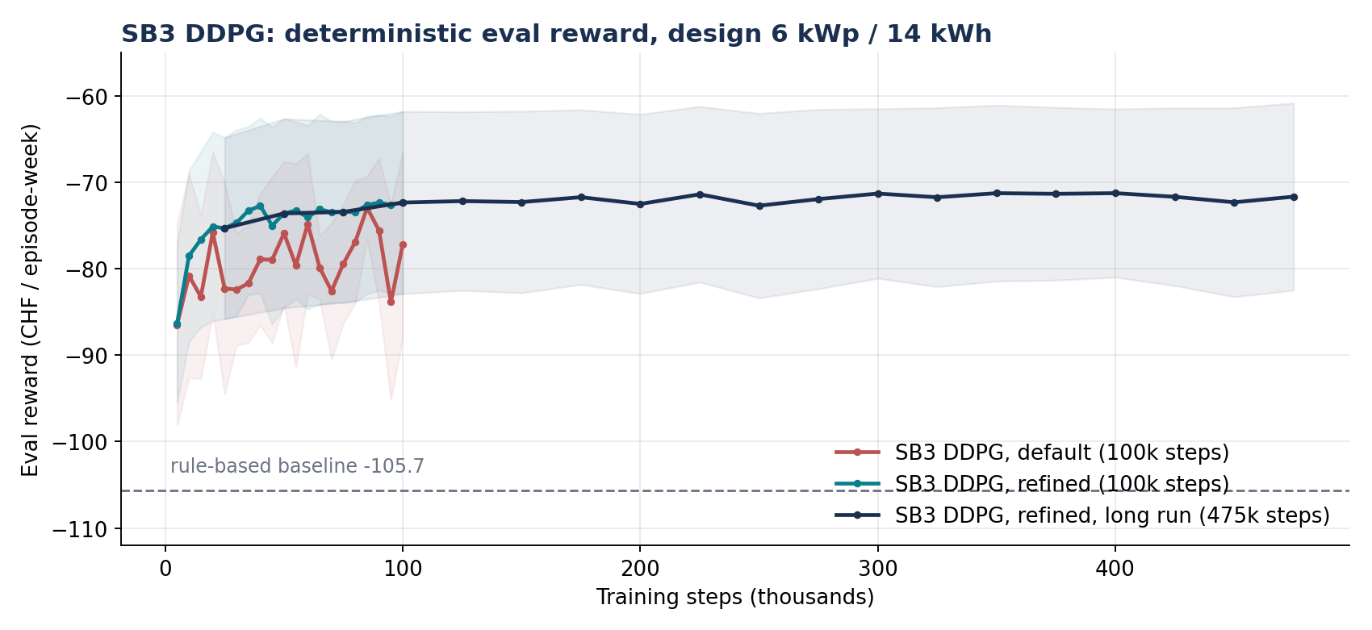
SB3 DDPG eval reward vs training steps, fixed design 6 kWp / 14 kWh.
Eval is a deterministic policy at 6 kWp / 14 kWh, 20 fixed episodes for the refined runs and 10 for the default run (the same first 10 seeds). Reward is in CHF per week, higher is better.
Run | Steps | Final eval | Best
Default (10 eps) | 100k | -77.2 ± 10.8 | -73.0
Refined (20 eps) | 100k | -72.4 ± 10.5 | -72.4
Refined, long (20 eps) | 475k | -71.7 ± 10.8 | -71.3

• References: rule-based -105.7, untrained actor -109, idle -112, random -231.
• Curve shape: SB3 rises from -86 to about -72 within 40k steps, then flattens. The long run adds only about 0.7.
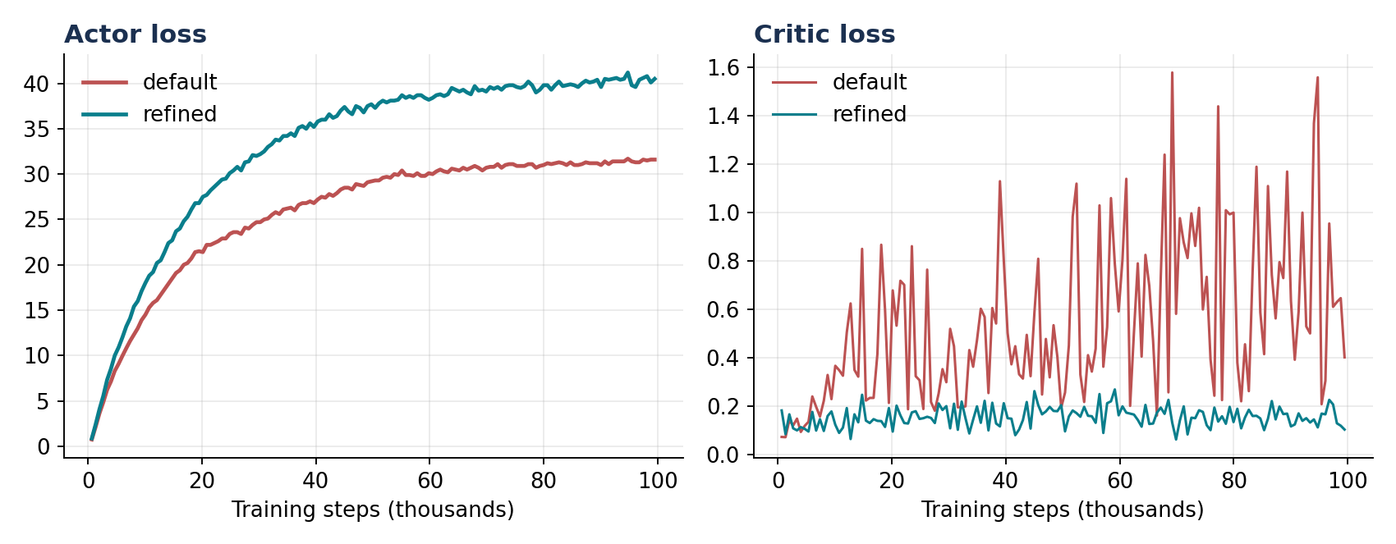
SB3 actor and critic loss, default vs refined.
• Losses: the refined critic loss stays near 0.15. The default run's critic loss swings between 0.1 and 1.6.
• Reading actor loss: actor loss is minus the critic's Q-value, so a larger value means a higher estimated return, not a worse actor.

2. Default vs refined SB3
Both runs use the same seed (42), 100k steps, 256x256 network, buffer 100k, batch 256, tau 0.005, gamma 0.99, exploration noise 0.2 and the same fixed design. The only code difference is the learning rate:
 | Default | Refined
Actor learning rate | 1e-3 | 1e-4
Critic learning rate | 1e-3 | 1e-3
Eval episodes | 10 | 20 (first 10 are the same seeds)

• What changed: the refined run uses the repo's split learning rates (actor 1e-4, critic 1e-3); the default run uses SB3's single rate of 1e-3 for both.
• Effect: on the same 10 eval episodes the final reward is -77.2 (default) vs -70.4 (refined), about 6.8 CHF better. Over the last 10 checkpoints the mean reward wobbles by 3.3 (default) vs 1.1 (refined).
• Losses and training reward: the default critic loss is noisy (0.1 to 1.6) while the refined one stays near 0.15. Training reward with exploration on is about -93 (default) vs -117 (refined), yet the deterministic eval is better for refined, so training reward with noise is not a good guide.

3. Manual DDPG, fixed design
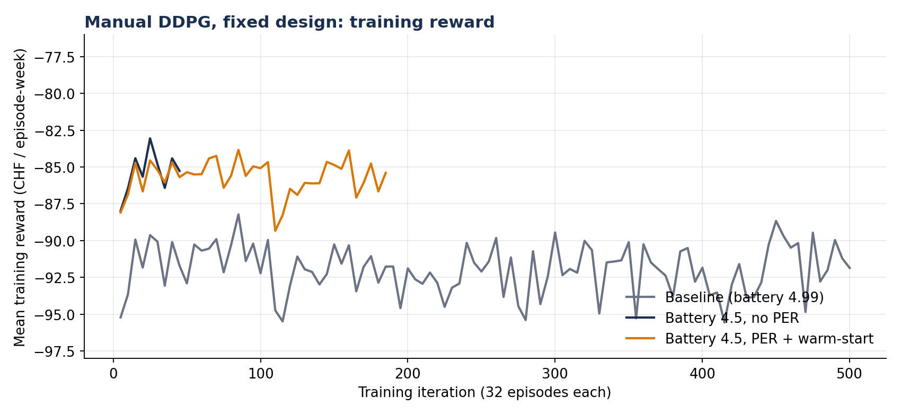
Manual DDPG training reward on the fixed design (noisy, exploration on).
• Baseline: -91.9 at iteration 500. The first 10 iterations averaged -94.3 and the last 10 averaged -91.9, so there is almost no improvement.
• Battery 4.5 with PER and warm-start: about -85 at iteration 185, then stopped.
• Battery 4.5 without PER: stopped at iteration 45, around -85.

4. Library DDPG vs manual DDPG
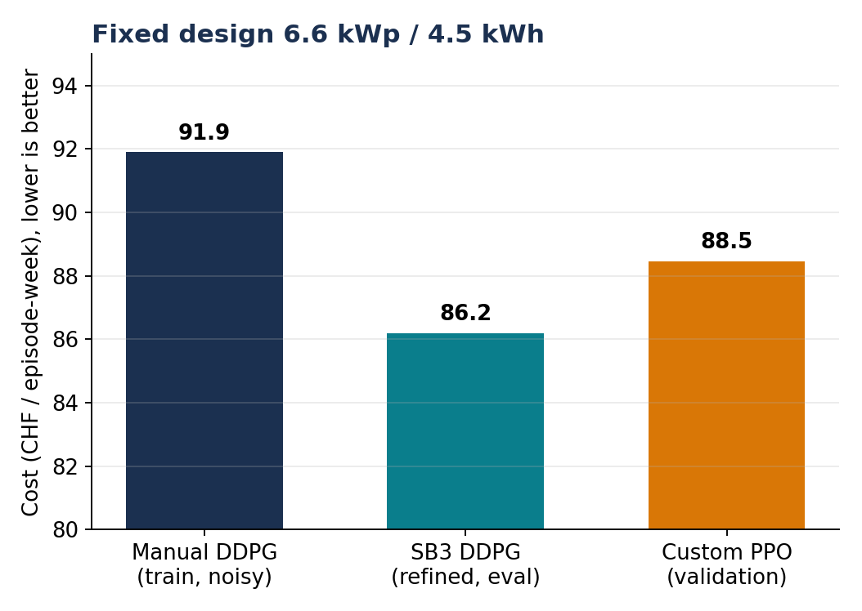
Cost at 6.6 kWp / 4.5 kWh (lower is better).
• At 6.6 kWp / 4.5 kWh: SB3 refined 86.2 CHF (100 episodes), manual DDPG 91.9 CHF (training reward), custom PPO 88.5 CHF (validation).
• At 6 kWp / 14 kWh: SB3 refined 75.6 CHF reward vs rule-based 105.7.

5. Co-design runs
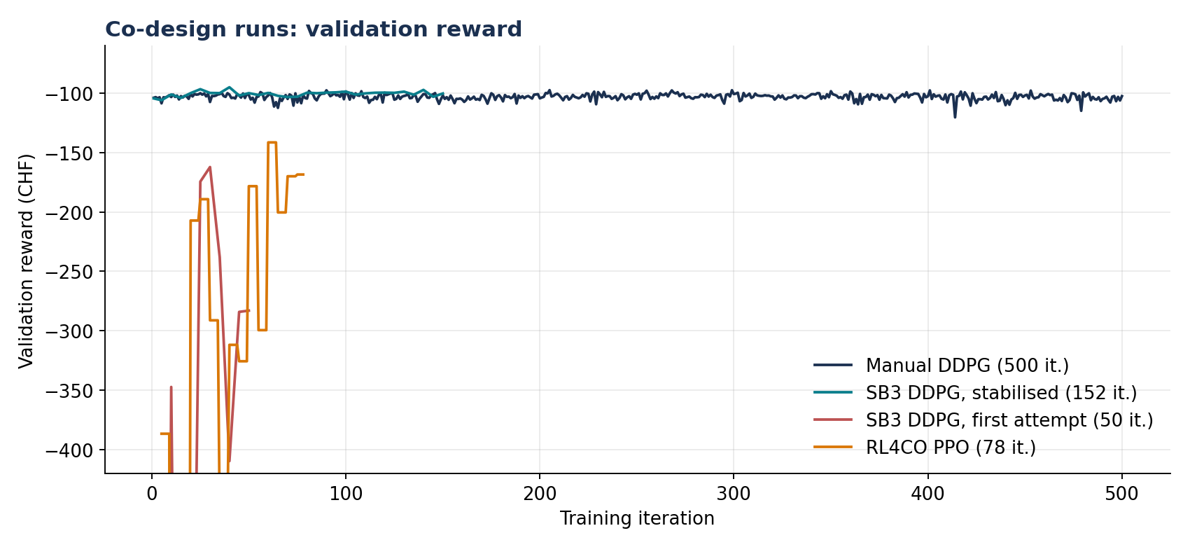
Co-design validation reward for manual DDPG, SB3 and RL4CO PPO.
Values are the mean of the last 5 validation points.
Run | Iterations | Validation reward
Manual DDPG | 500 | -104.3
SB3, stabilised | 152 | -100.2
SB3, first try | 50 | -275.4 (unstable)
RL4CO PPO | 78 | -168.8 (unstable)

The SB3 and RL4CO runs stopped early and never reached 500 iterations.

6. Why RL4CO PPO struggled in co-design
The run stopped at 78 of 500 iterations, so this is unstable and unconverged, not proven to fail. Likely causes, strongest first:
• Design distribution blew up: the RL4CO script reused the design-distribution setup of the first SB3 attempt (entropy weight 5.0 at the start). Iteration 1 sampled designs with a mean of 3939 kWp PV and 118 kWh battery, giving a mean reward of -13,505 (std 66,000). 25 of 78 iterations had a mean reward below -1000, with a median of -635, against about -103 for the manual DDPG. The stabilised SB3 run avoided this with entropy weight 0.01, a narrow initial design range (log-mean 0 to 1, log-std 1), a 10% design warm-up and rewards scaled by 0.01. None of these were applied to RL4CO.
• Whole episode as one action: RL4CO's PPO is built for combinatorial problems where one solution gets one reward. Here the whole 168-hour control trajectory is a single action, and the advantage (episode return minus V(design)) is applied to all 168 hourly actions. The per-hour rewards are discarded, there is no GAE, and the credit assignment is very noisy.
• Weak baseline and unscaled returns: the critic only sees the design, so it can't explain the large return swings between scenarios. The PPO value loss stayed in the hundreds to thousands, and the returns are not normalised or scaled.
• Policy barely learned: the policy entropy barely moved (308.9 to 307.4), so the policy hardly changed. The improvement in validation reward (about -387 to -169) tracks the design mean falling from about 50 kWp to about 10 to 20 kWp, not better control.
• Not built for this problem: RL4CO is a library for combinatorial optimisation (routing, scheduling). It has no co-design support. Only its PPO loss is used here, with a hand-written stand-in environment and the design learner copied from the SB3 script, so it gets no real advantage for co-design.
Next step: apply the same design-distribution fixes and reward scaling as the stabilised SB3 run, then rerun before drawing conclusions.

7. Caveats
• Wrong design label: the old fixed_design_sb3_vs_custom.png labels both curves as 6 kWp / 14 kWh, but the manual DDPG check ran at 6.6 kWp / 4.5 kWh. It was not reused.
• Evaluated off its training design: the refined SB3 policy was trained at 6 / 14 and evaluated at 6.6 / 4.5, giving -86.2.
• Not like for like: SB3 eval, manual training reward and custom PPO validation use different scenarios and metrics, so the gaps are indicative only. A fair comparison needs a deterministic eval of the manual actor; no checkpoint was saved.
• Manual actor eval missing: the deterministic eval of the manual fixed-design actor (100 episodes) was never logged, so the manual vs SB3 gap rests on a noisy training reward and is not a fair comparison yet.
• Battery label: the first manual run uses the old deck's "battery 4.99" label, but the script now says 4.5.

