Activity Day 1

1. Display the name of movies, movie type is starts with Drama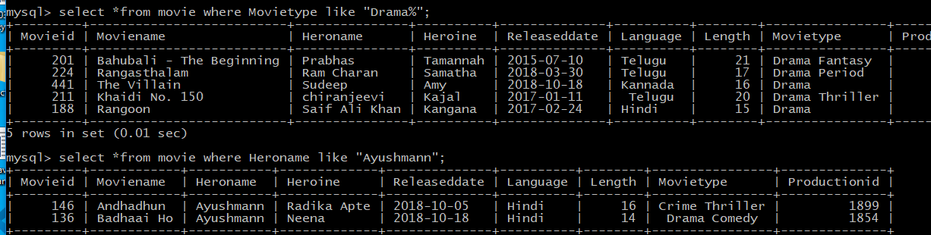
2. Display the movies acted by actor Ayushmann.



1. Display the count of movies, having length above 18.

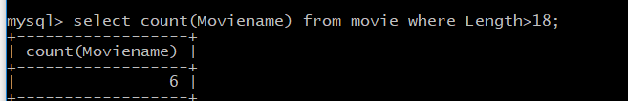

1. Display the movie having minimum length.

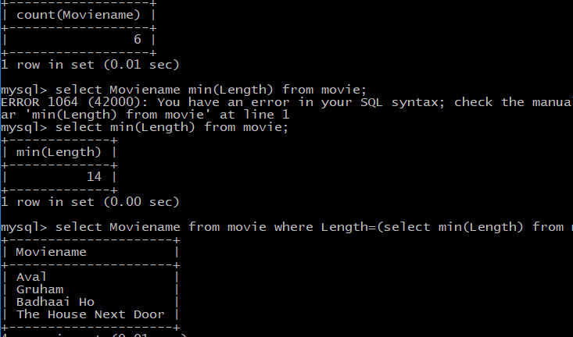

1. Display all the details of movie, the language that first name starts with ‘T’

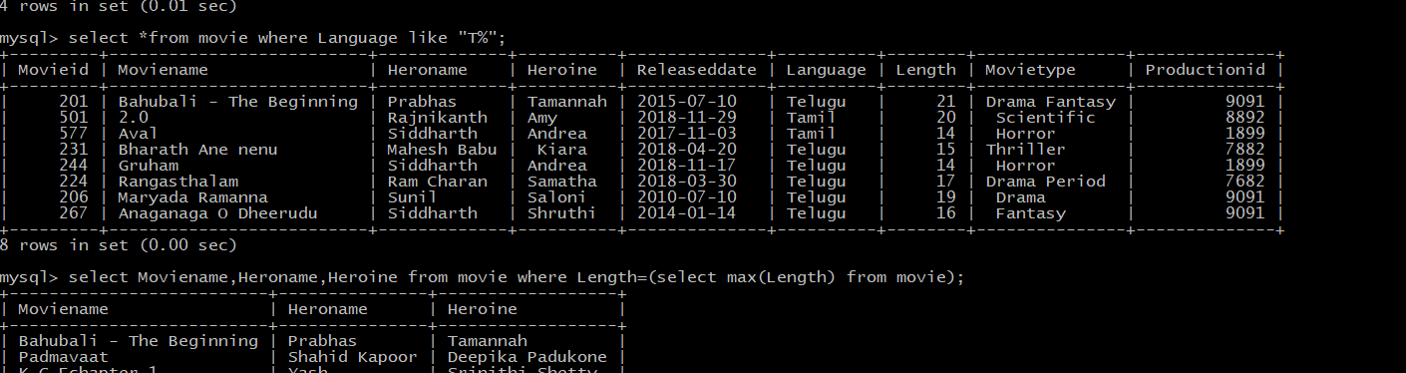

1. Display the movie name, hero name, heroine name whose having maximum length.



1. Display the movie name, hero name, heroine name the movie released after 15 march 2018.

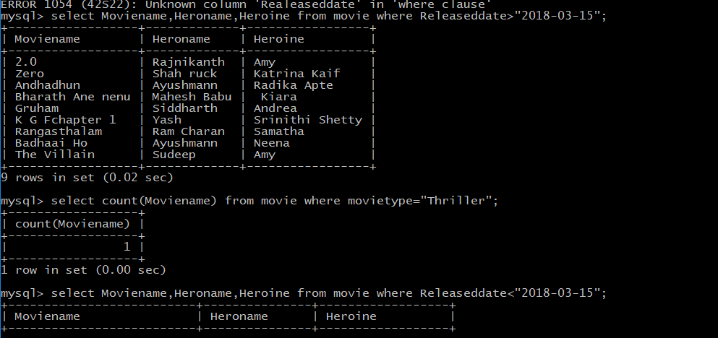

1. Display the count of thriller movies.



1. Display the count of movies whose released before 15 march 2018.



1. Display the release date of the movie name ‘Zero’.

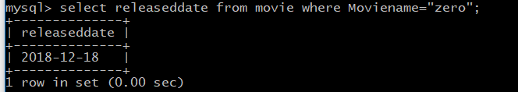

11.Display the actor name that acted with ‘Amy’.

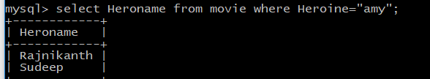

12.Display the Count of maximum movies released in a month of October.

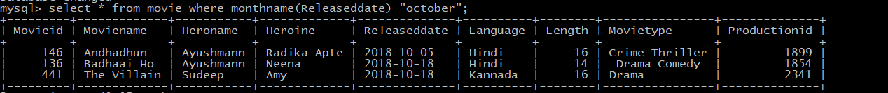

13.Display the movienames whose production id for different languages

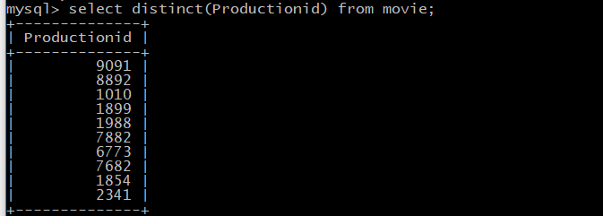

Advanced Queries

1.Write the query to display productionid, production name with total number movies produced by each.

Query: select p.productionid, m.moviename, count(m.productionid) from movies as m inner join productions as p on p.productionid=m.productionid group by p.productionid;

2.Write the query to display production name, owner name have produced more than 2 movies.

Query: select p.Ownername,p.Productionid ,p.Productionname, count(m.Movienname) from productions as p left join movie as m ON p.Productionid = m.Productionid group by p.Productionid having count(Movienname)>=2;

3.Write the query to display production name, owner name have produced maximum movies

Query: select p.Productionid ,p.Productionname, max(mv.Moviename) from productions as p left join movies as mv ON p.Productionid = mv.Productionid group by p.Productionid ORDER BY 'Productionid' DESC LIMIT 1;

4.Write the query to display the moviename, heroname and productionname acted in the producer name= ’Subaskaran’.

Query: select p.Productionname, m.Moviename, m.Heroname, m.language from productions as p left join movies as m on p.productionid = m.Productionid where language !='Subaskaran';

5.Write the query to display the moviename, heroname whose productionid ends with 82.

Query: select p.Productionname, m.Moviename, m.Heroname, m.language, m.productionid from productions as p left join movies as m on p.productionid = m.Productionid where p.productionid like "%82";

6.Write the query to display the productionname, ownername who has not produced the movie.

Query: select p.Productionname, p.Ownername from productions as p left join movie as m on p.Productionid = m.Productionid group by p.productionid having count(m.Movienname)=0;

7.Write the query to display the productionname, ownername who has not produced the ‘hindi’ movie.

Query: select p.Productionname, m.Moviename, m.Heroname, m.language from productions as p left join movies as m on p.productionid = m.Productionid where language !='hindi';