**Q1:** Azure DevOps: 1. Create new private project. 2. Create 5 Sprint and add the current date for Sprint 1 and immediate next date for other Sprints. 3. Create 5 Epics and assigned to yourself. 4. Each Epic must be assigned to each Sprint. 5. Marked all Epics as Done state.

**Answer:**

Project name: **Project_Shreyansh**

Create 5 Sprints: **Done,** start Date -14/04/21 end Date-18/04/21(5 Sprints, 5 Days)

Added date for Respective Sprints: **Done**

Assign to yourself: **Done**

Each Epic Assigned to Each Sprint**: Done**

Marked all Epic as Done State: **Done**

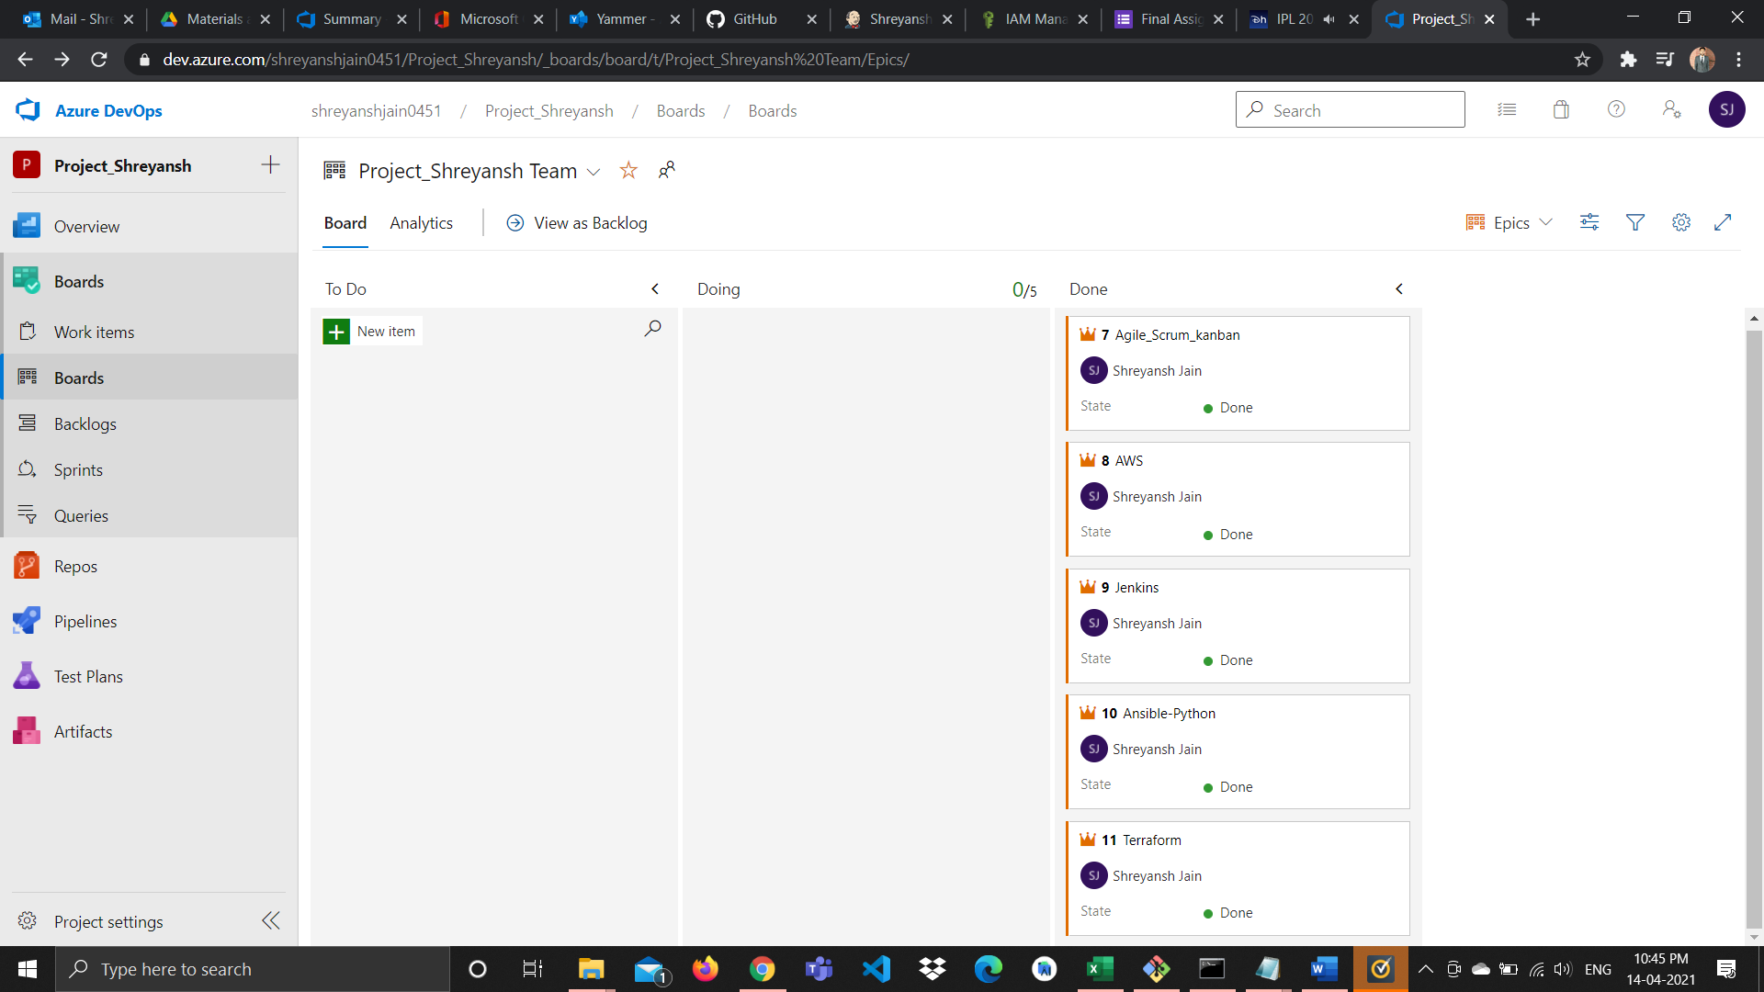

**Q2:** Jenkins: 1. Create Jenkins Freestyle projects jobs as first_lastnmae. 2. Add in command echo "My First Job". 3. Build it

Answer:

Create Jenkins Freestyle project as First_lastname: **Done**

Add Command: **Done**

**Date Created: April 14, 2021, 5:55 PM**

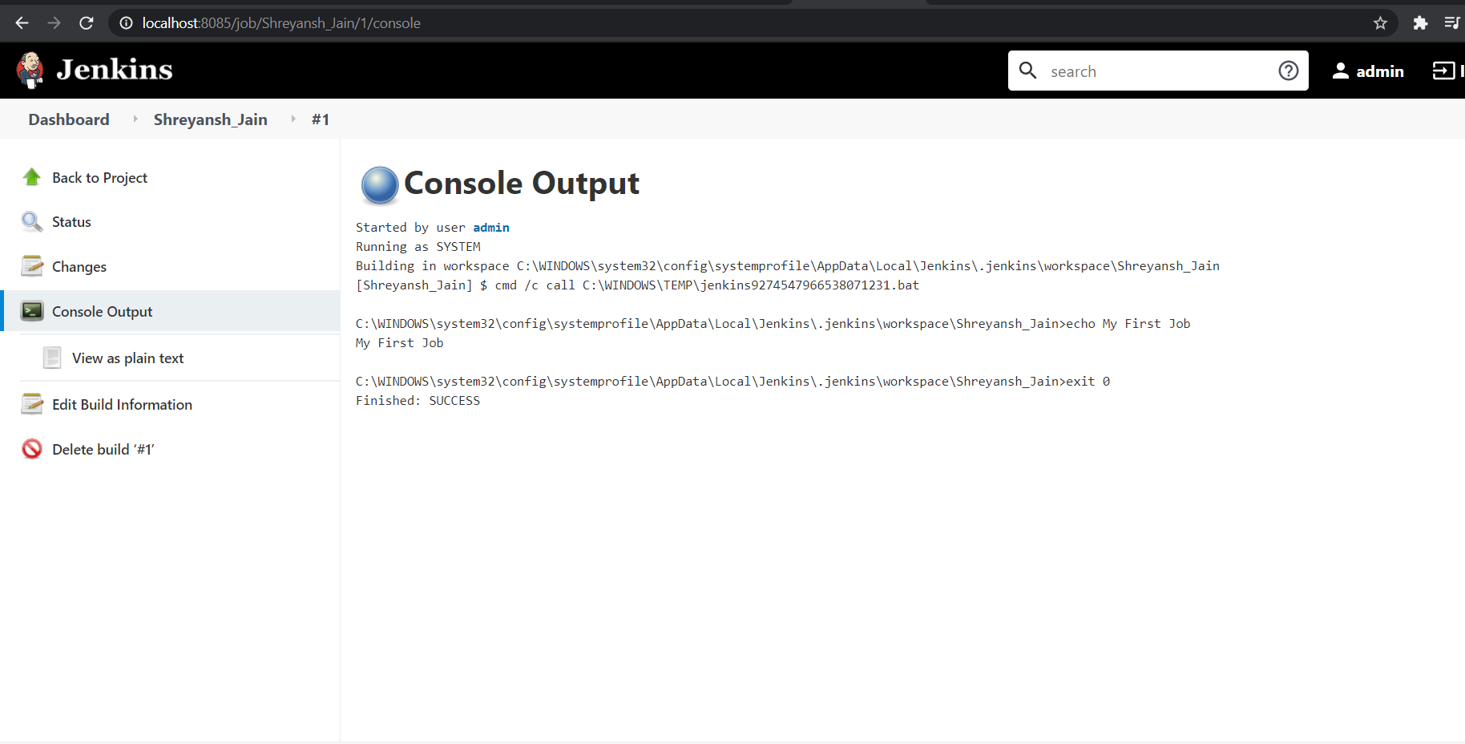

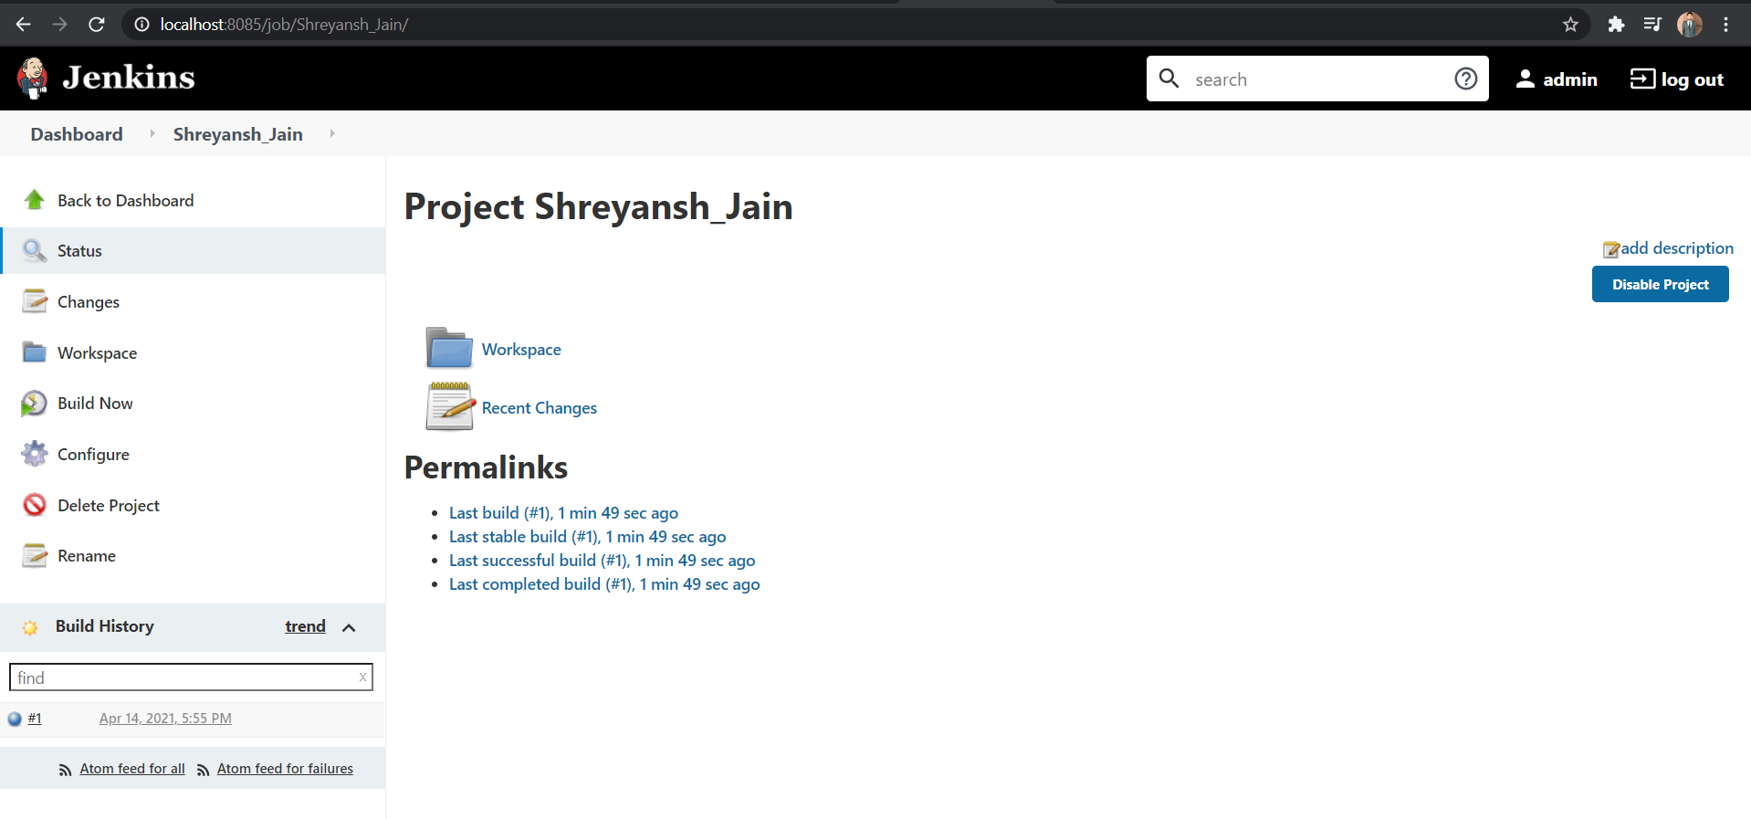

**Q3**: AWS: 1. Create IAM Policy as myadminpolicy (copy the existing policy rule form existing administrator policy as json and pest it). 2. Create IAM Group as myadmingroup and assign policy to it. 3. Create new user as yourfirstnameandlastname and assigned to myadmingroup group.

**Answer:**

Create IAM myadminPolicy: **Done**

Create IAM Group And Assign Policy To it: **Done**

Create new user as yourfirstnameandlastname and assigned to myadmingroup group: **Done**

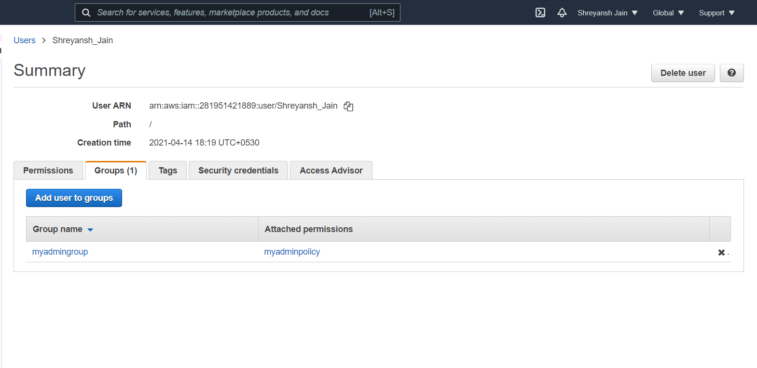

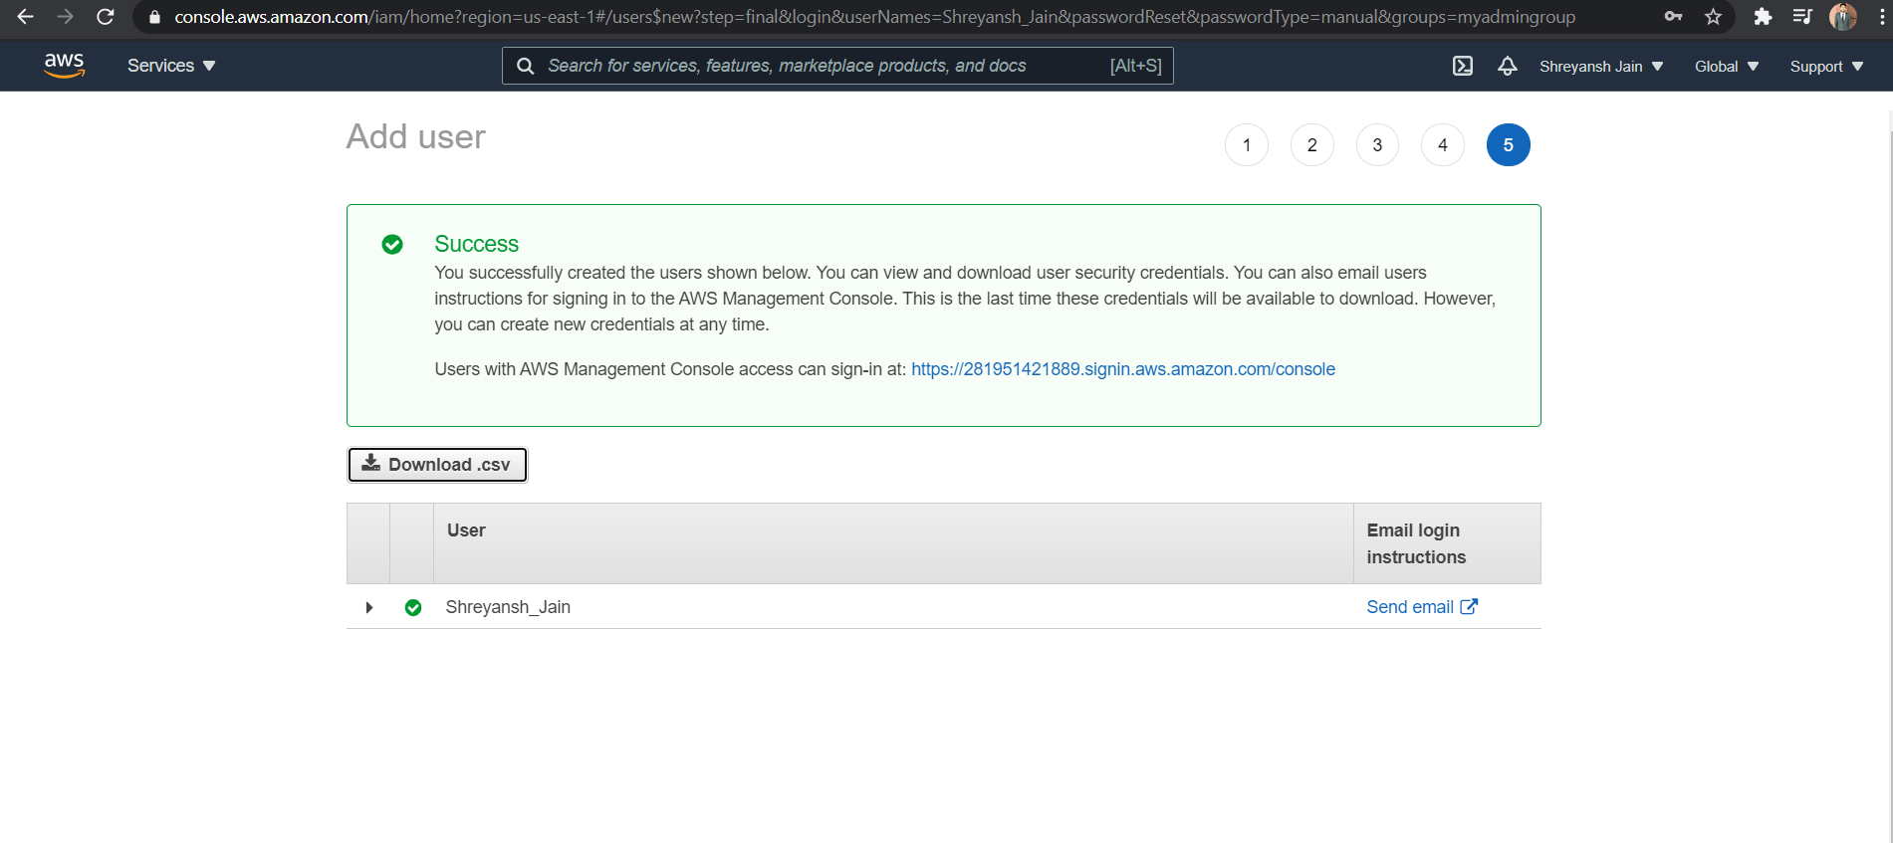

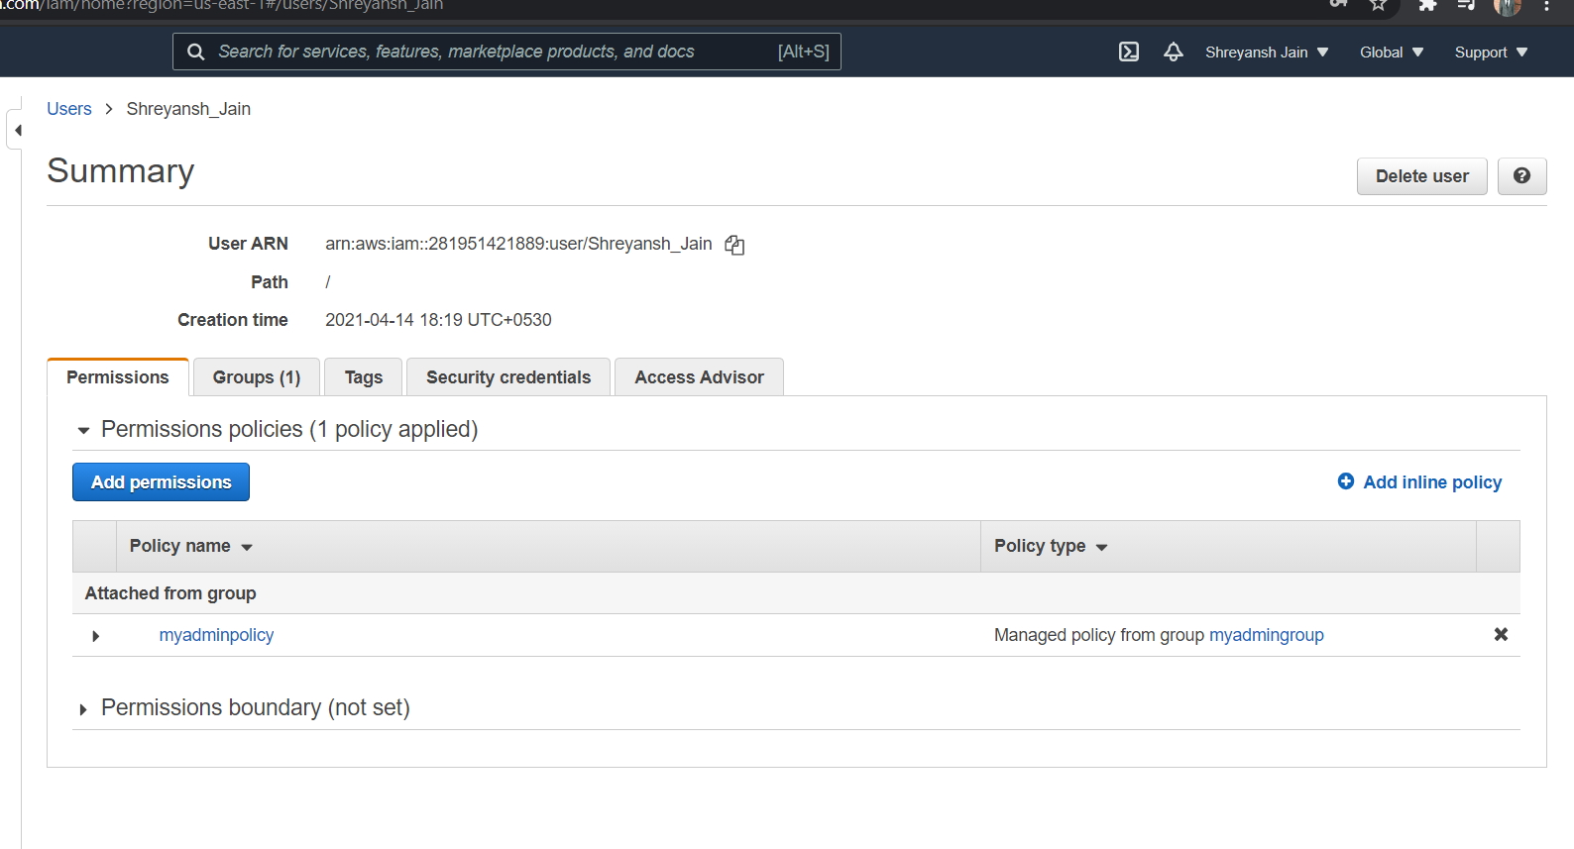

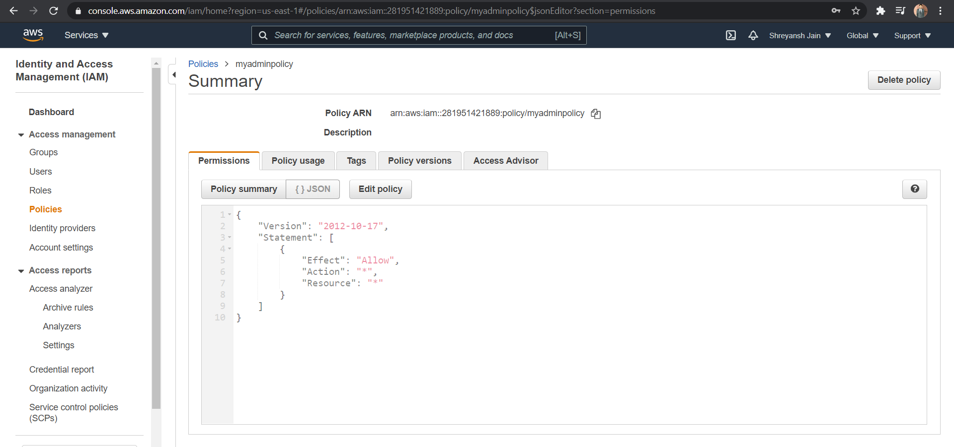

**Q4:** Terraform: 1. terraform init 2. terraform plan 3. terraform apply 4. terraform destroy Note: do this for any one of demo code shared in Day5.

Answer:

