**Database**

**Task:**

**1.**Create Table Name : Student and Exam

1. create Database give a name classroom.

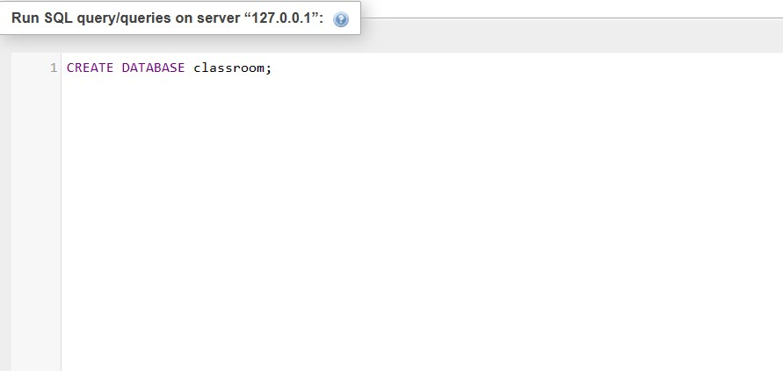

1. create table name student.

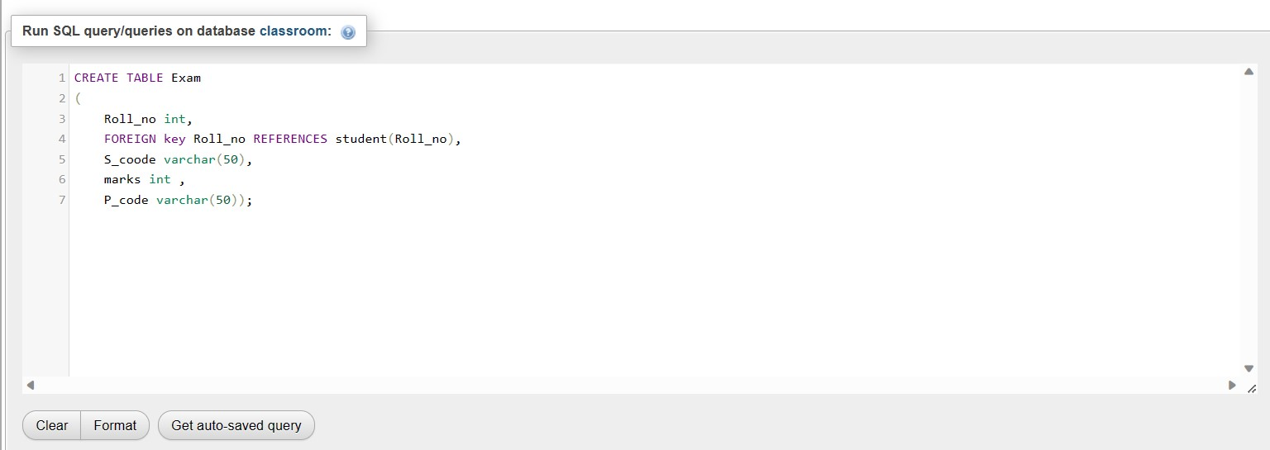

1. Output of student:

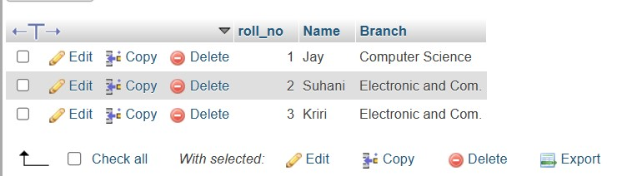

D. Create one more table name Exam.

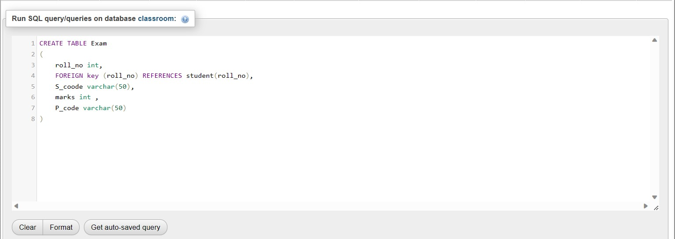

1. Output of Exam:

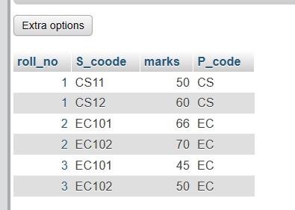

Task 2. Create table given below:

**A.** 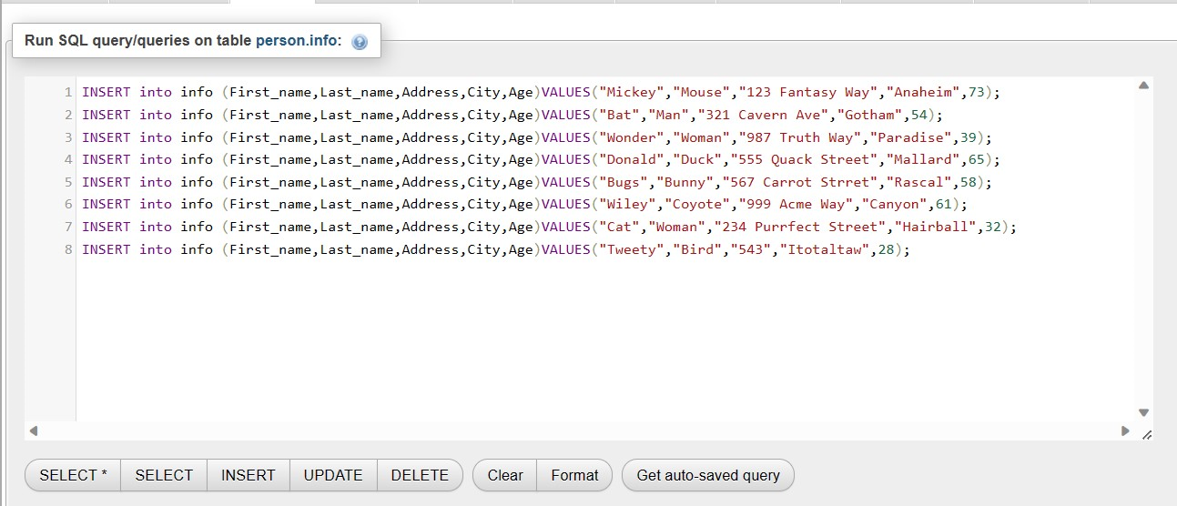

**B. Output**

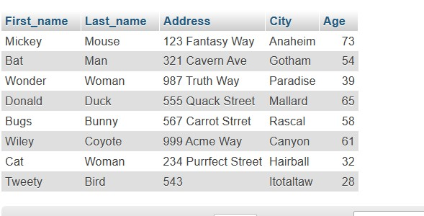

**3. Crete table given below : Employee and incentive**

1. Creating table employee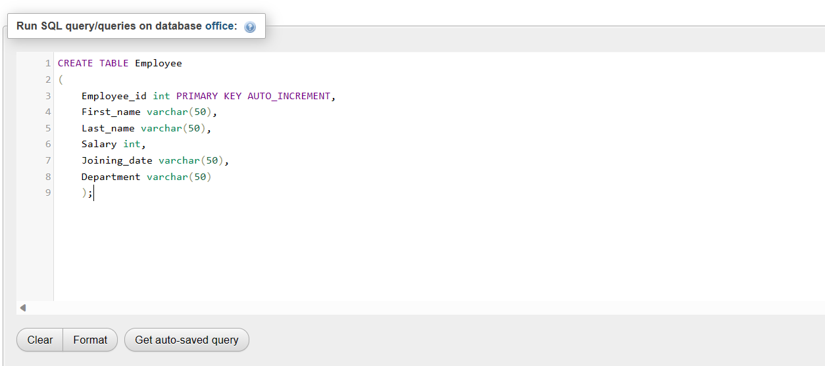

2. Creating table incentive:

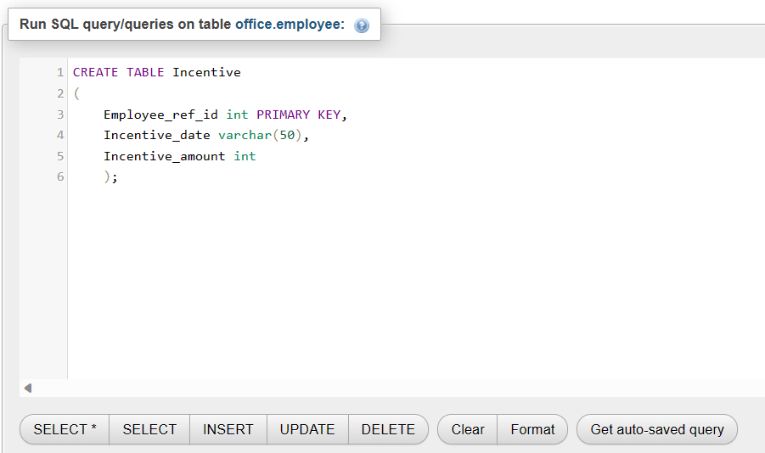

3. inserting details in table :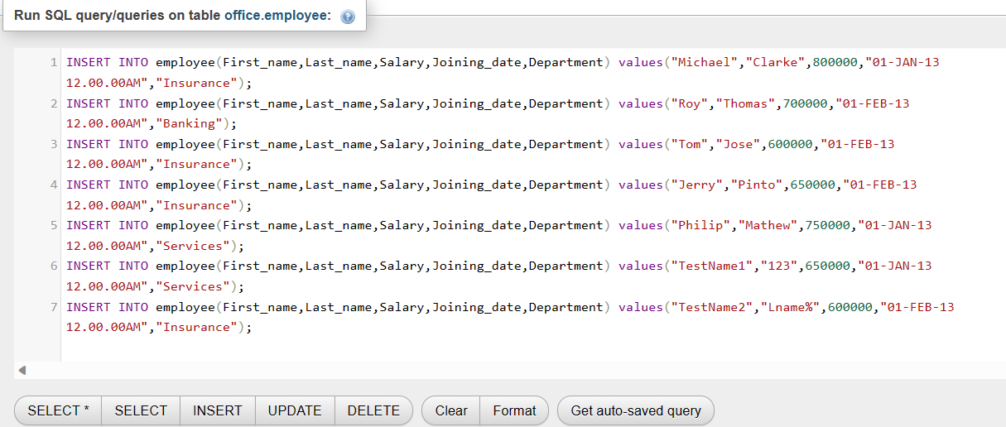

4. inserting values in incentive table: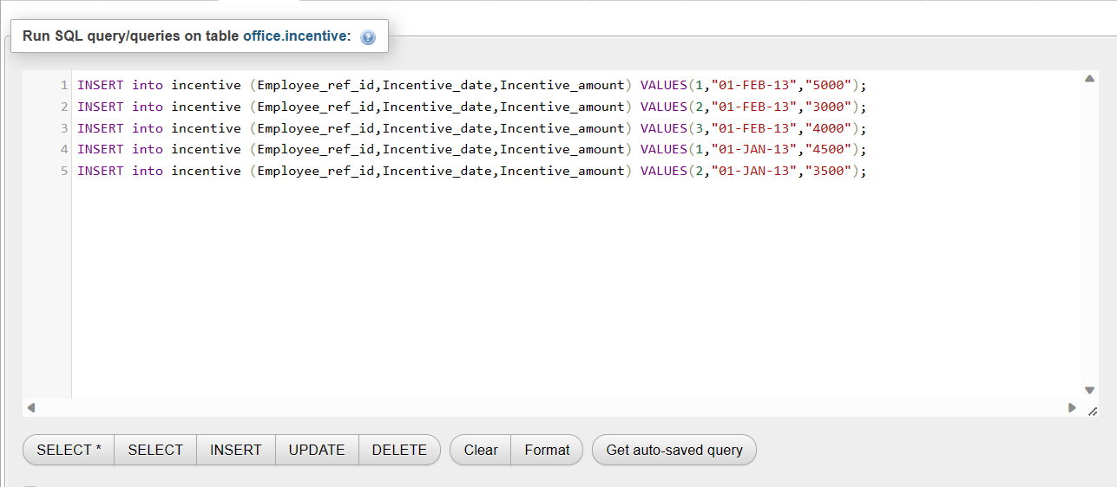

5. output of 3

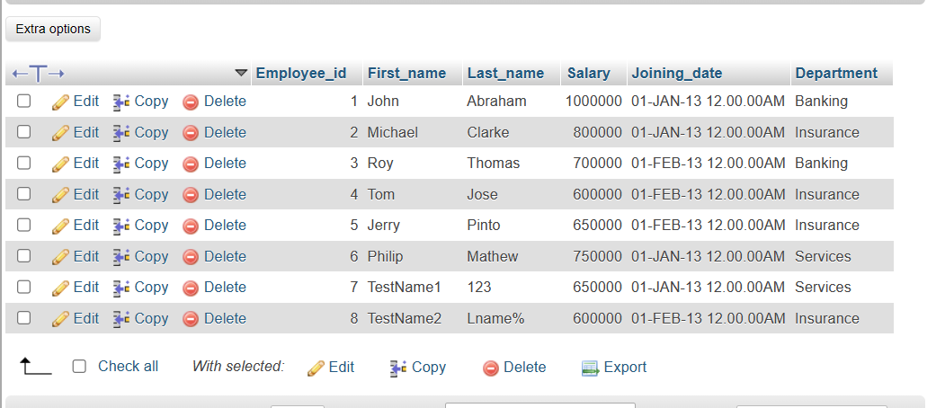

1. Get first name from employee table using alias name “Employee Name”.

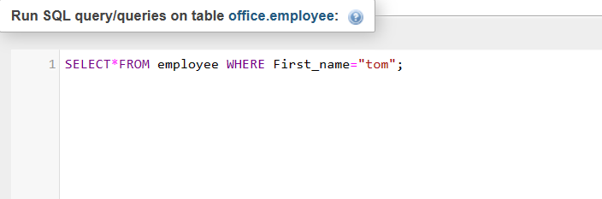

Output :

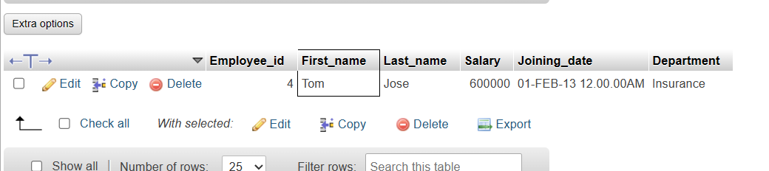

1. Get first name, salary, joining date from employee table.

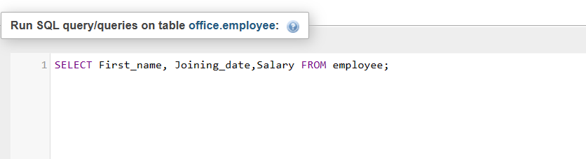

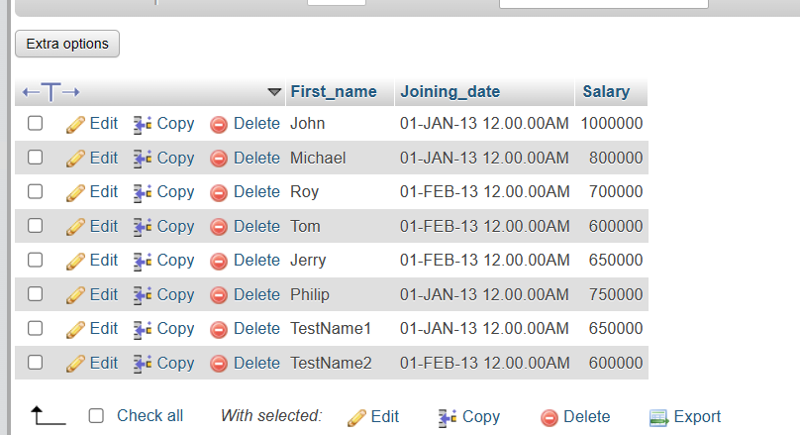

1. Get all employee details in ascending order:

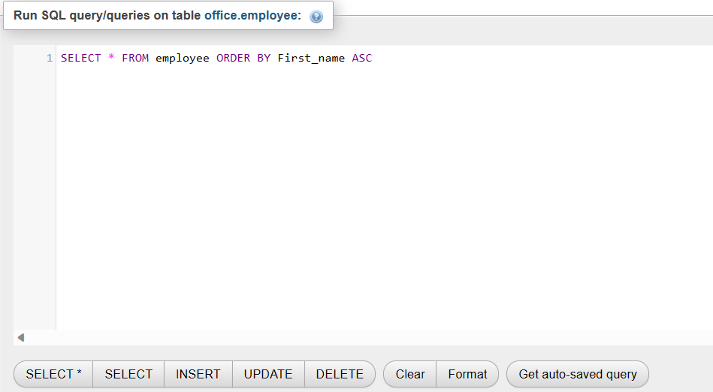

Output :

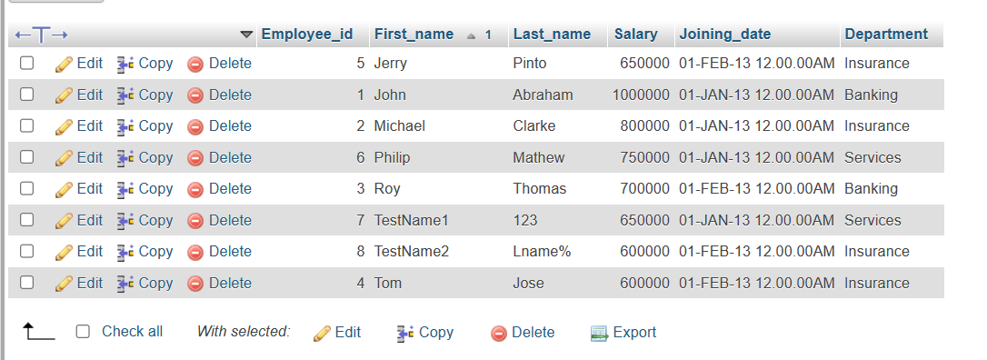

Salary in descending order:

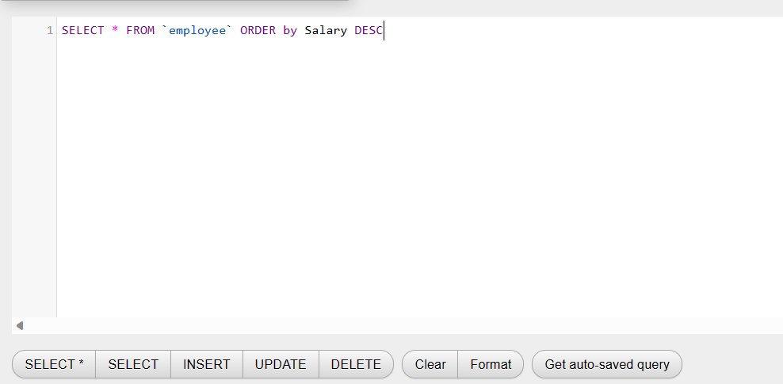

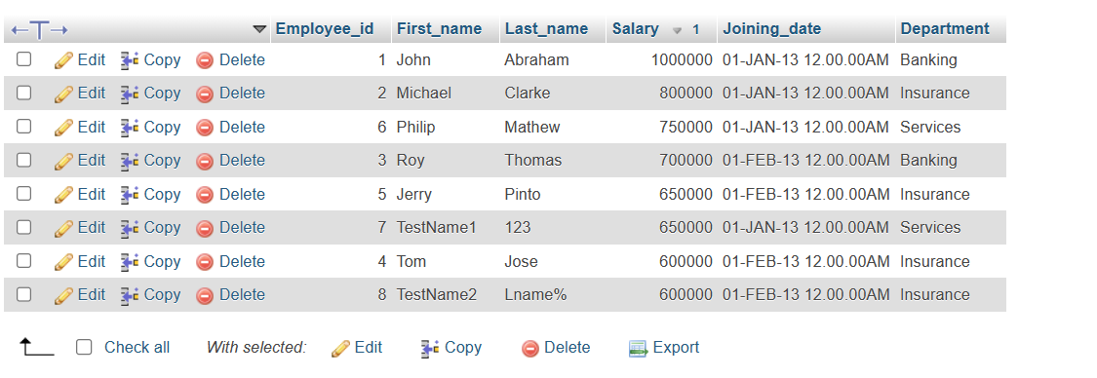

1. Get employee Details from employee table whose name start with “j”:

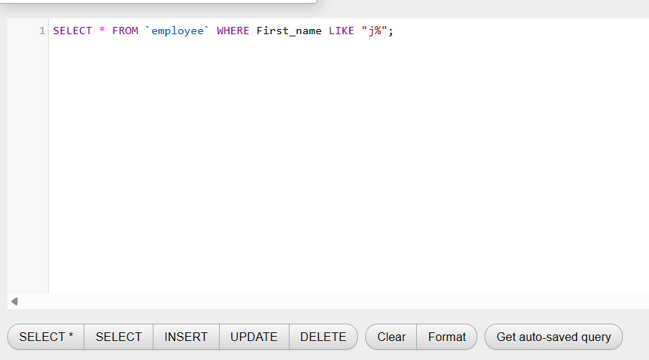

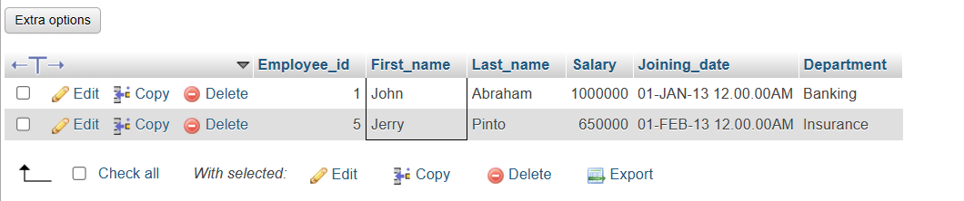

1. Get department wise maximum salary:

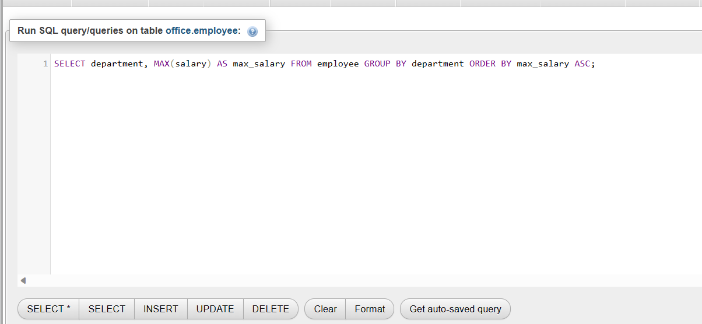

Output:

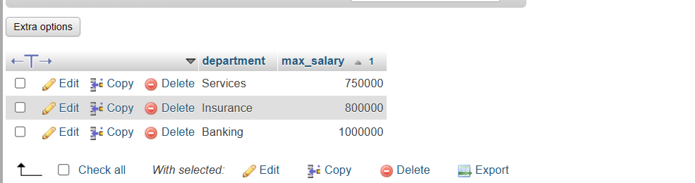

1. Select name and incentive amount from employee

And incentive amount for those employee who have incentive and incentives amount greater than 3000

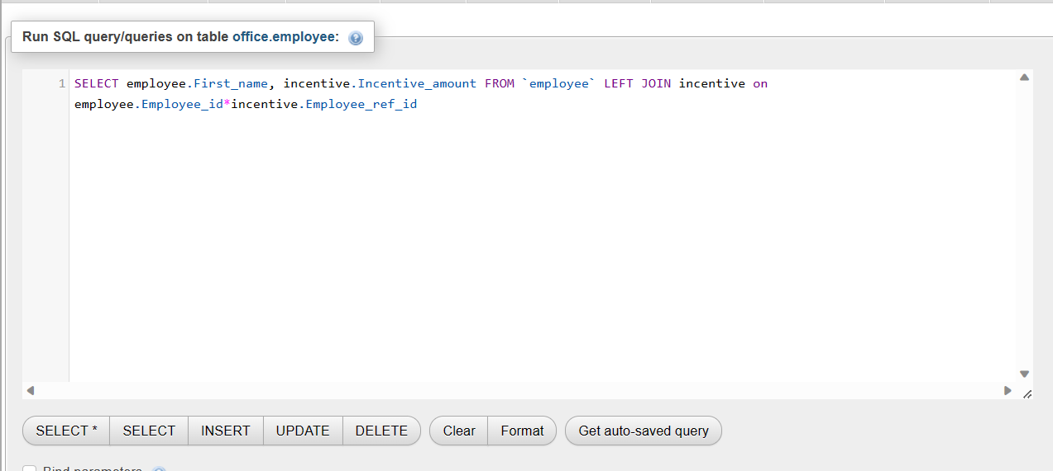

Output: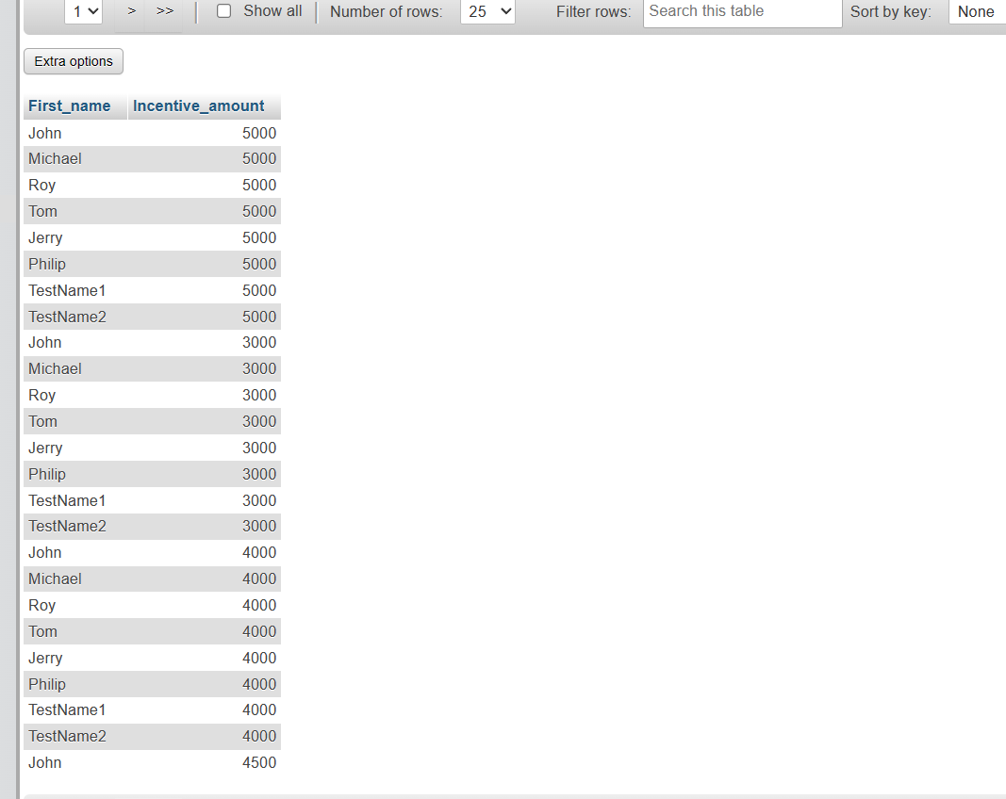

**4. Create table given below: Salesperson or Customer:**

1. Names and cities of all salesperson in London with commission above 0.12

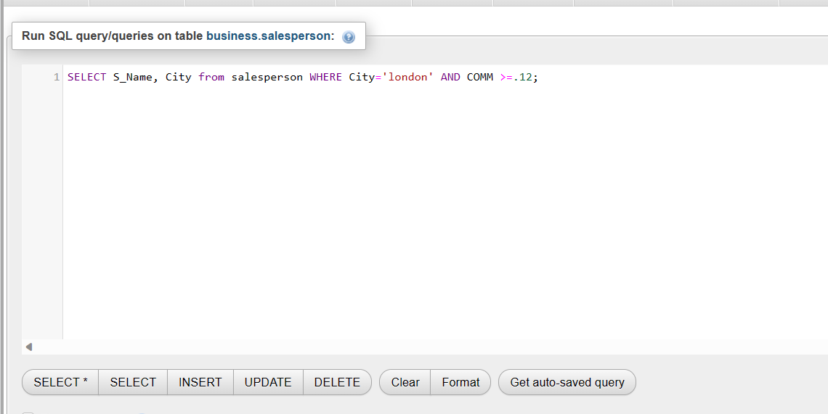

Output

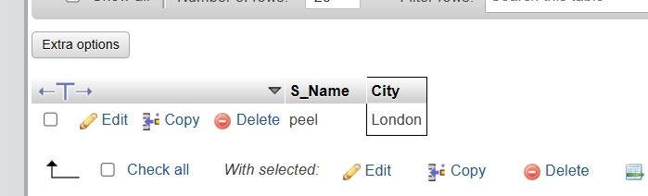

1. All salesperson either in Barcelona or London.

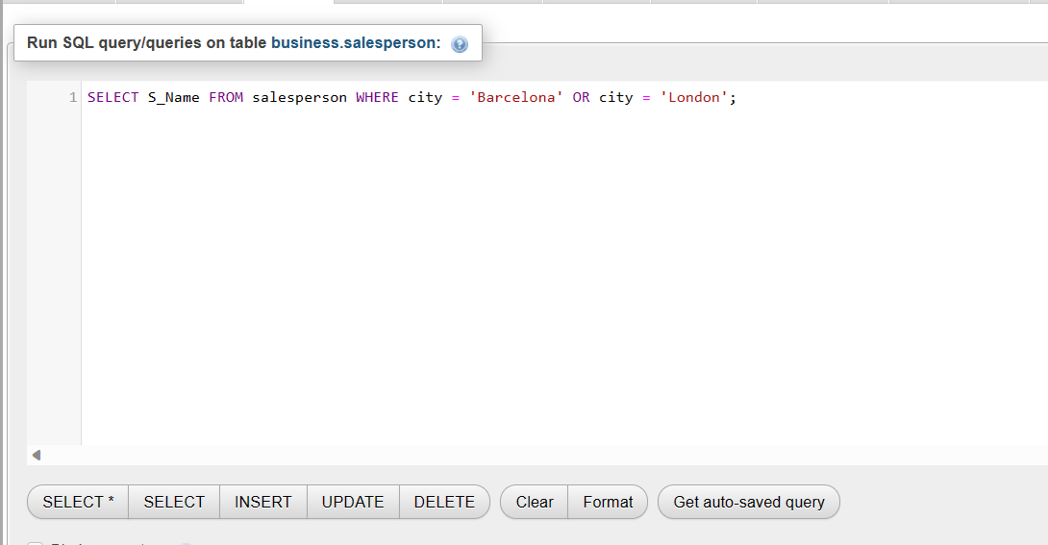

Output

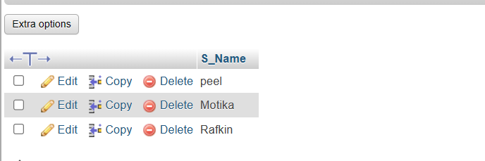

1. All salesperson commission between 0.10 and 0.12. (Boundary should be excluded)

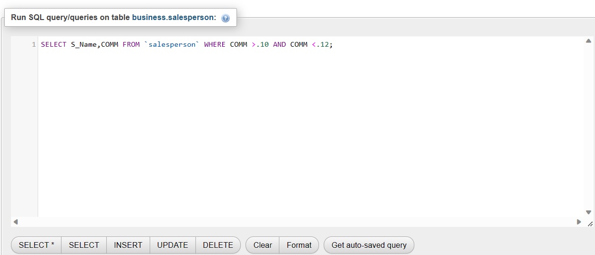

Output:

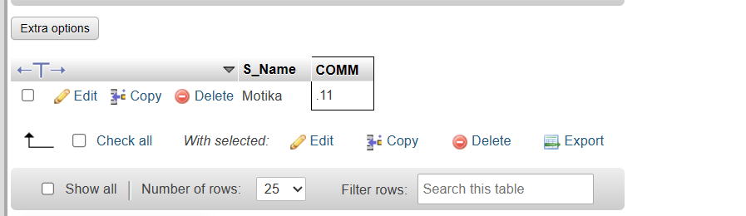

1. All customer excluding those with rating <=100 unless they are located in rome.

