Software Engineering Assingment

**Module:1(SDLC)**

## Q.1 What is Software? What is Software Engineering?

## Ans.

## Software :

Software is a set of instructions, data or programs used to operate computers and execute specific tasks. It is the opposite of hardware, which describes the physical aspects of a computer. Software is a generic- term used to refer to applications, scripts and programs that run on a device

## Software Engineering

Software engineering is the discipline and practice of designing, developing, testing, and maintaining software systems. It involves the systematic application of engineering principles, techniques, and tools to create reliable, efficient, and scalable software solutions.

Additionally, software engineering also involves considering non-functional requirements like performance, security, reliability, and scalability. Software engineers strive to build software that is not only functional but also performs well under various conditions and can handle large amounts of data and user traffic.

In summary, software engineering is the application of engineering principles to create high-quality software systems that meet user needs, adhere to industry standards, and can be developed, tested, and maintained efficiently. It encompasses a range of technical and collaborative skills to deliver software solutions that drive innovation and solve real-world problems.

## Q.2 Explain types of software?

## Ans.

There are major two types of software.

1.System software

Software that enables the computer system to operate and provides a platform for running other software. Examples include device drivers, utility programs, and programming language interpreters.

2.Application software

Software designed for specific tasks or applications, typically used by end-users. Examples include word processors, spreadsheets, web browsers, media players, and graphic design tools.

## Q.3 What is SDLC? Explain each phase of SDLC.

Ans. The software development lifecycle (SDLC) is the cost-effective and time-efficient process that development teams use to design and build high-quality software. The goal of SDLC is to minimize project risks through forward planning so that software meets customer expectations during production and beyond.

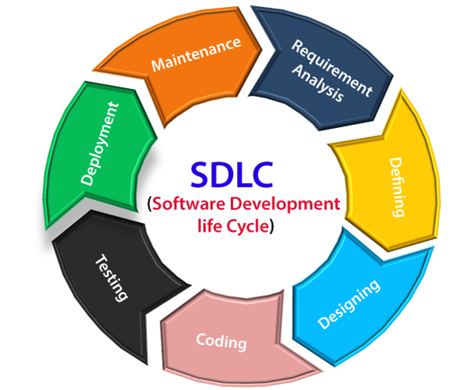

This is Software Development Life Cycle.

1. Analysis: In this phase, the development team works with stakeholders to gather and analyze requirements for the software. This involves identifying the needs of end-users, defining system functionalities, and documenting requirements in a detailed manner.
2. **System Design**: Once the requirements are understood, the system design phase begins. It involves creating a blueprint of the software system, including the architecture, database structure, user interface design, and overall system structure. System designers may use various techniques like flowcharts, data flow diagrams, and wireframes to visualize the system design.
3. **Implementation:** In this phase, the development team starts coding the software according to the design specifications. Programmers write the source code using programming languages and integrate different modules or components of the software. This phase also includes unit testing to identify and fix any bugs or issues in individual modules.
4. **Testing:** The testing phase involves verifying and validating the software to ensure that it meets the specified requirements. This includes testing the system as a whole (integration testing), testing individual components (unit testing), and conducting system-level tests to check for errors, functionality, performance, and security. Different testing techniques like functional testing, performance testing, and user acceptance testing are used to ensure the software meets quality standards.
5. Deployment: Once the software passes all the testing phases, it is ready for deployment. The deployment phase involves preparing the software for installation on the target environment, including hardware setup, configuring databases, and installing necessary software dependencies. The software is then deployed to the production environment, making it available for end-users.
6. **Maintenance:** After deployment, the software enters the maintenance phase. This phase involves addressing any issues, bugs, or feature requests that arise during the software's operation. Regular updates, patches, and improvements are made to keep the software functioning properly and up to date. Maintenance activities can include bug fixing, performance optimization, security enhancements, and adding new features based on user feedback..

## Q.4 What is DFD? Create a DFD diagram of flipkart.

## Ans.

DFD stands for data flow diagram. It is a graphical or visual representation using a standardized set of symbols and notations to describe a business's operations through data movement. They are often elements of a formal methodology such as Structured Systems Analysis and Design Method (SSADM).

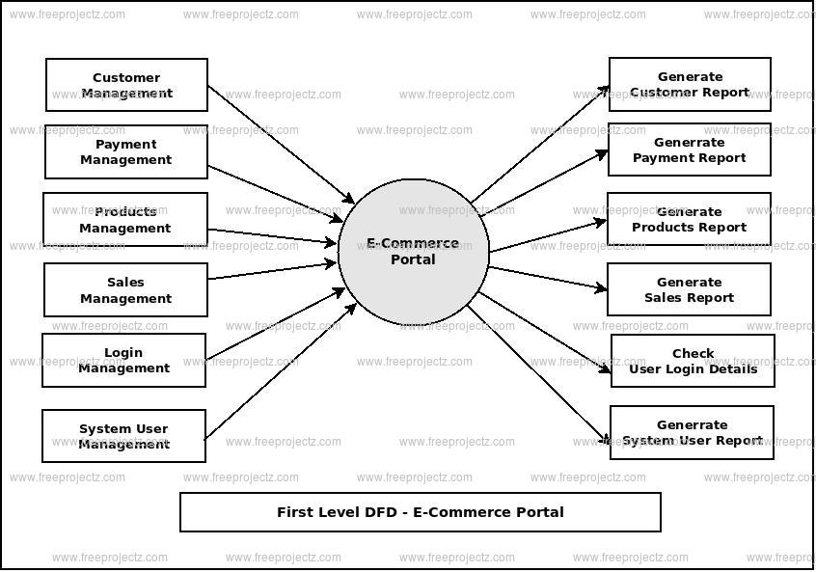

## Q.5 What is Flow Chart? Creat a flowchart to make addition of two numbers.

## Ans.

## A flowchart is a diagram that shows an overview of a program . Flowcharts normally use standard symbols to represent the different types of instructions . These symbols are used to construct the flowchart and show the step-by-step solution to the problem. Flowcharts are sometimes known as flow diagrams. C Program Practicals: Flowchart to Add two numbers.

%3CmxGraphModel%3E%3Croot%3E%3CmxCell%20id%3D%220%22%2F%3E%3CmxCell%20id%3D%221%22%20parent%3D%220%22%2F%3E%3CmxCell%20id%3D%222%22%20value%3D%22%26lt%3Bh1%20style%3D%26quot%3B%26quot%3B%26gt%3B%26lt%3Bfont%20style%3D%26quot%3Bfont-size%3A%2020px%3B%26quot%3B%26gt%3BS%26lt%3B%2Ffont%26gt%3B%26lt%3Bfont%20style%3D%26quot%3Bfont-size%3A%2020px%3B%26quot%3B%26gt%3BTART%26lt%3B%2Ffont%26gt%3B%26lt%3B%2Fh1%26gt%3B%22%20style%3D%22ellipse%3BwhiteSpace%3Dwrap%3Bhtml%3D1%3B%22%20vertex%3D%221%22%20parent%3D%221%22%3E%3CmxGeometry%20x%3D%22320%22%20y%3D%2240%22%20width%3D%22140%22%20height%3D%2270%22%20as%3D%22geometry%22%2F%3E%3C%2FmxCell%3E%3CmxCell%20id%3D%223%22%20value%3D%22%22%20style%3D%22endArrow%3Dclassic%3Bhtml%3D1%3Brounded%3D0%3BexitX%3D0.5%3BexitY%3D1%3BexitDx%3D0%3BexitDy%3D0%3B%22%20edge%3D%221%22%20source%3D%222%22%20target%3D%224%22%20parent%3D%221%22%3E%3CmxGeometry%20width%3D%2250%22%20height%3D%2250%22%20relative%3D%221%22%20as%3D%22geometry%22%3E%3CmxPoint%20x%3D%22380%22%20y%3D%22110%22%20as%3D%22sourcePoint%22%2F%3E%3CmxPoint%20x%3D%22440%22%20y%3D%22170%22%20as%3D%22targetPoint%22%2F%3E%3C%2FmxGeometry%3E%3C%2FmxCell%3E%3CmxCell%20id%3D%224%22%20value%3D%22%26lt%3Bh1%26gt%3B%26lt%3Bb%20style%3D%26quot%3Bfont-size%3A%2017px%3B%26quot%3B%26gt%3BInput%20number%20A%2CB%26lt%3B%2Fb%26gt%3B%26lt%3B%2Fh1%26gt%3B%22%20style%3D%22ellipse%3BwhiteSpace%3Dwrap%3Bhtml%3D1%3B%22%20vertex%3D%221%22%20parent%3D%221%22%3E%3CmxGeometry%20x%3D%22290%22%20y%3D%22160%22%20width%3D%22200%22%20height%3D%2280%22%20as%3D%22geometry%22%2F%3E%3C%2FmxCell%3E%3CmxCell%20id%3D%225%22%20value%3D%22%26lt%3Bh1%26gt%3B%26lt%3Bfont%20style%3D%26quot%3Bfont-size%3A%2014px%3B%26quot%3B%26gt%3BSum%20of%20two%20digits%26lt%3Bbr%26gt%3B%26lt%3B%2Ffont%26gt%3B%26lt%3Bfont%20style%3D%26quot%3Bfont-size%3A%2014px%3B

## Q.6 What is Use case Diagram? Create a Use case diagram on bill payment on paytm

## Ans.

Use-case diagrams describe the high-level functions and scope of a system. These diagrams also identify the interactions between the system and its actors. The use cases and actors in use-case diagrams describe what the system does and how the actors use it, but not how the system operates internally.

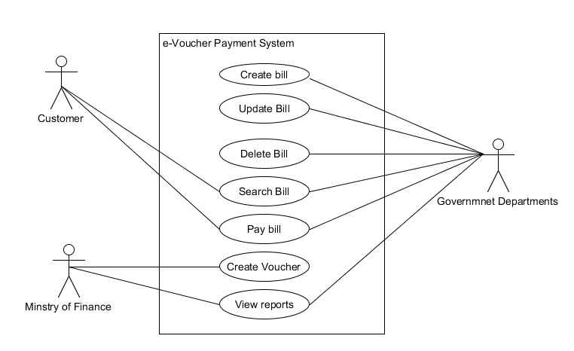

Qq