Project Report
SAP DATA/Analytics Engineer



Shreyansh Kumar
2329066
CS&CE
SAP Program B6_IE

Problem Statement
Candidates were advised to prepare a blueprint document to define and setup fictitious company with all major sub-organizations in FI, MM & SD functional Areas within the company as a general project. Prepare the steps for customization and submit the document as the project report.

1. Company Overview
Company Name: NexGen Electronics Pvt. Ltd.
Industry: Consumer Electronics Manufacturing & Distribution
Head Office: New Delhi, India
Business Description: NexGen Electronics Pvt. Ltd. is a mid-sized manufacturing company specializing in the production and distribution of consumer electronic products such as smartphones, accessories, and smart home devices. The company operates manufacturing plants and distributes products through retail and online channels.

2. Organizational Structure Design

2.1 FI (Financial Accounting)
- Company Code: NG01
- Company Name: NexGen Electronics Pvt. Ltd.
- Currency: INR
- Fiscal Year Variant: April to March
- Chart of Accounts: NGCOA

2.2 MM (Materials Management)
- Plant: NGPL (Delhi Manufacturing Plant)
- Storage Location:
  - RM01 (Raw Material Storage)
  - FG01 (Finished Goods Storage)
- Purchasing Organization: NGPO

2.3 SD (Sales & Distribution)
- Sales Organization: NGSO
- Distribution Channels:
  - ON (Online)
  - RT (Retail)
- Division:
  - EL (Electronics)
  - AC (Accessories)

3. Organizational Structure Diagram
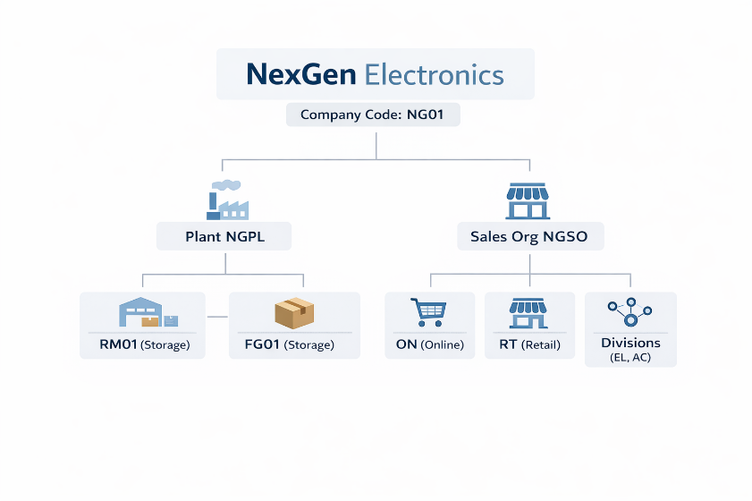

4. SAP Customization Steps

4.1 FI Configuration
- Define Company
  - SPRO → Enterprise Structure → Definition → Financial Accounting → Define Company
- Define Company Code
  - SPRO → Enterprise Structure → Definition → Financial Accounting → Define Company Code
- Assign Company Code to Company
  - SPRO → Enterprise Structure → Assignment → Financial Accounting → Assign Company Code
- Define Chart of Accounts
  - SPRO → Financial Accounting → General Ledger → G/L Accounts → Master Data → Preparations → Define Chart of Accounts
- Assign Chart of Accounts to Company Code
- Define Fiscal Year Variant

4.2 MM Configuration
- Define Plant
  - SPRO → Enterprise Structure → Definition → Logistics → Define Plant
- Define Storage Location
- Assign Plant to Company Code
- Define Purchasing Organization
- Assign Purchasing Organization to Plant

4.3 SD Configuration
- Define Sales Organization
- Define Distribution Channel
- Define Division
- Assign Sales Organization to Company Code
- Assign Distribution Channel to Sales Organization
- Create Customer Master

5. Integration Between Modules
- FI + MM:
  - Procurement transactions update financial accounts
- MM + SD:
  - Inventory impacts sales availability
- SD + FI:
  - Billing updates revenue and receivables

6. Business Process Flow
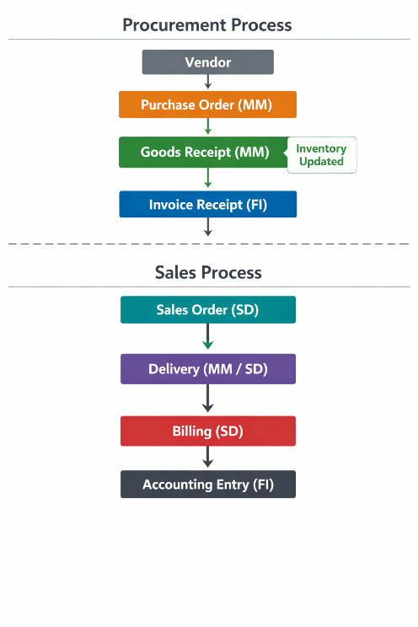

7. Detailed Flow Explanation
- Raw materials are procured from vendors using MM module.
- Goods are received and inventory is updated.
- Invoice is posted and financial accounting is updated.
- Customer places order via SD module.
- Goods are delivered from warehouse.
- Billing is generated.
- Financial entries are recorded in FI.

8. Proposed Solution & Features
The proposed solution involves implementing an integrated SAP ERP system for NexGen Electronics Pvt. Ltd. by configuring the FI (Financial Accounting), MM (Materials Management), and SD (Sales & Distribution) modules.
Key Features:
- End-to-End Integration: Seamless data flow between procurement, inventory, sales, and finance.
- Automated Financial Posting: All transactions in MM and SD automatically update financial records in FI.
- Real-Time Inventory Tracking: Accurate tracking of stock levels across storage locations.
- Centralized Data Management: Single source of truth for all business operations.
- Efficient Procurement Process: Streamlined vendor management and purchasing cycles.
- Multi-Channel Sales Support: Ability to manage both online and retail sales channels.
- Improved Reporting: Availability of real-time financial and operational reports.

9. Technologies Used
- SAP ERP
- SAP FI Module
- SAP MM Module
- SAP SD Module
- SAP GUI(Conceptual)

10. Unique Points
- End-to-end integration (Procurement → Sales → Finance)
- Real-time data updates across modules
- Centralized ERP system
- Reduced manual errors
- Scalable business structure
- Support for multiple sales channels
- Standardized business processes
11. Future Improvements
- Migration to SAP S/4HANA
- Integration with SAP Analytics Cloud
- AI-based demand forecasting
- Cloud-based deployment
- Mobile access to SAP system
- Advanced inventory optimization
- CRM integration for better customer management

12. Conclusion
This project demonstrates the implementation blueprint of SAP ERP for NexGen Electronics Pvt. Ltd. covering FI, MM, and SD modules. The integration between modules ensures seamless business operations from procurement to sales and financial accounting.

