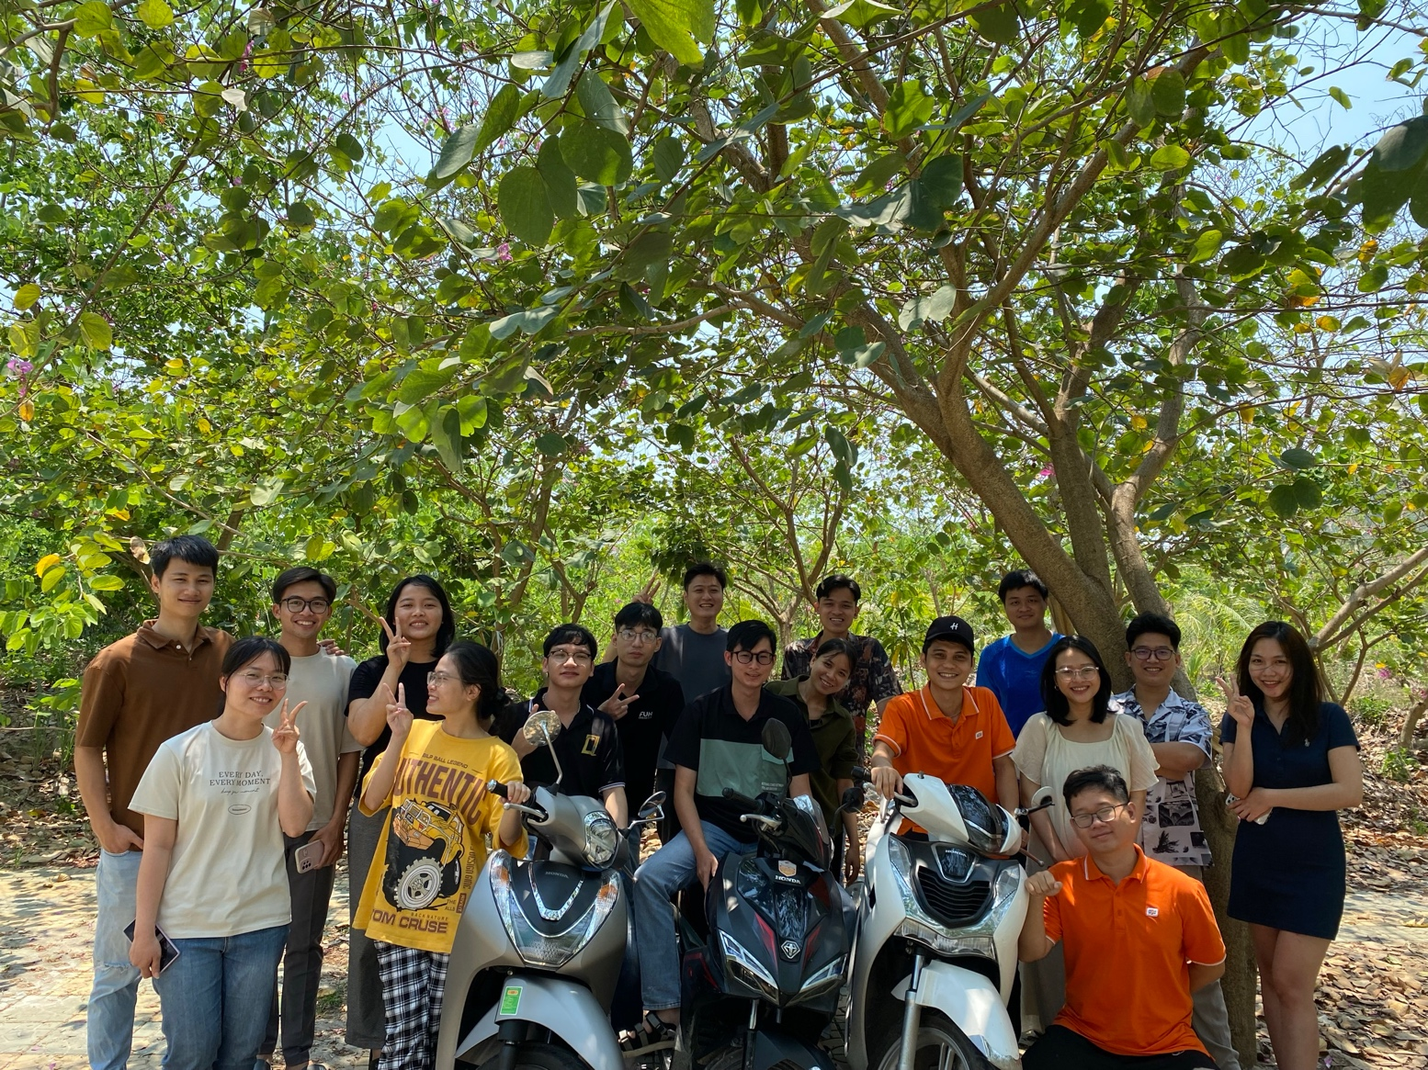

ThanhPD7

LINHVTH8

TaoND3

lamDH7

LoiTV1

VietTH13

MinhNTH16

HieuTH6

DucNM52

NhungNTH3

ThangPLLC

CuongNM9

HuyNVQ6

DanNL

NhungNTH42

VUVTM

VUNT13