**ALY6010 MODULE 1**

**WEEK 1**

**Name : shreyansh Bhalodiya**

**NUID : 002664707**

**R Code screenshot.**

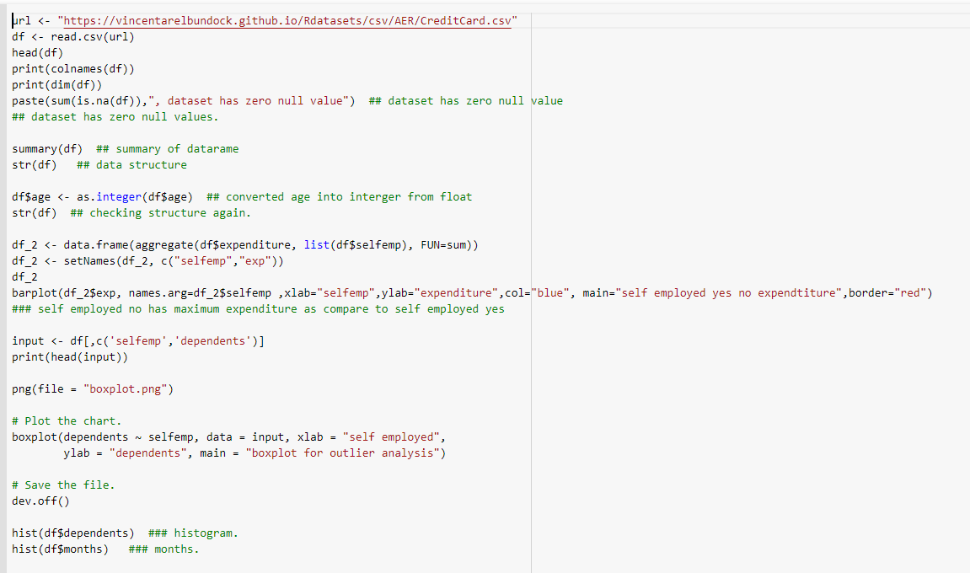

**PTO**

**R Code data frame head and columns names with dimensions and null value analysis.**

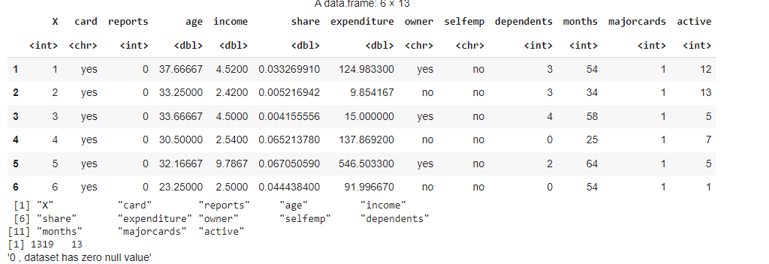

**PTO**

**Dataframe structure before and after setting age column to integers from float.**

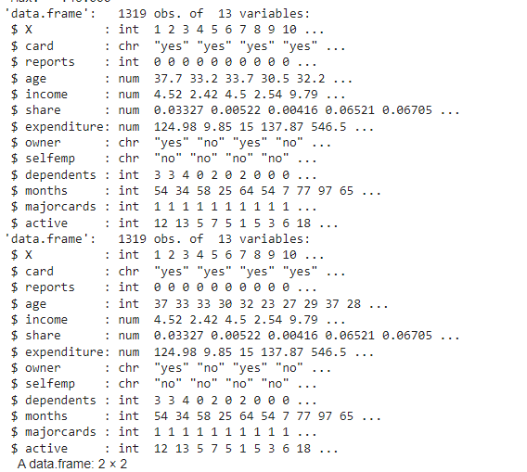

**PTO**

**Grouping self emp with expenditure and sorting self emp and dependents columns for box plot.**

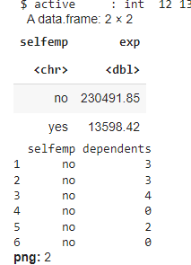

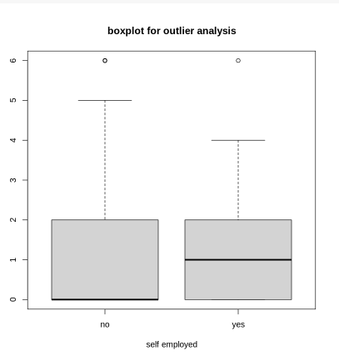

**Summary of dataset**

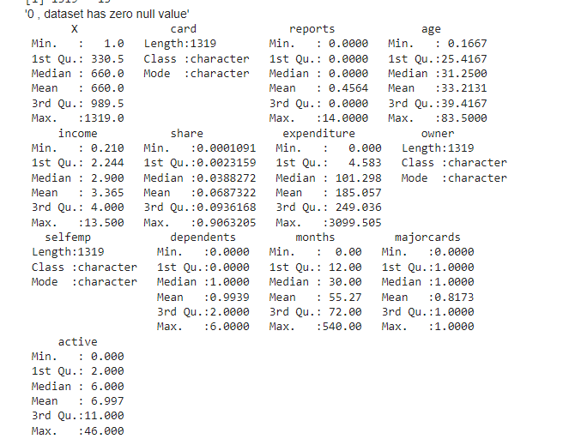

**PTO**

**BAR PLOT OF GROUPED DATA**

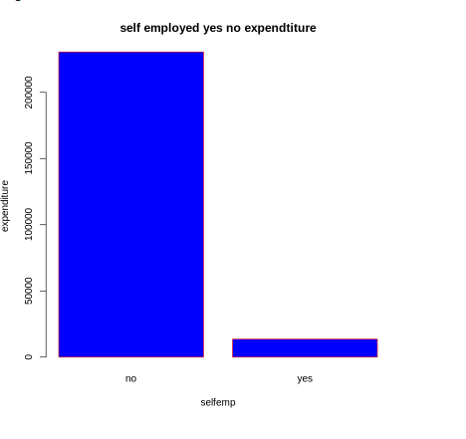

**PTO**

**HISTOGRAMS**

