**ALY6010 MODULE 2**

**WEEK 2**

**Name : shreyansh Bhalodiya**

**NUID : 002664707**

**Dataset Selected:**

**Student Mental health-2.csv**

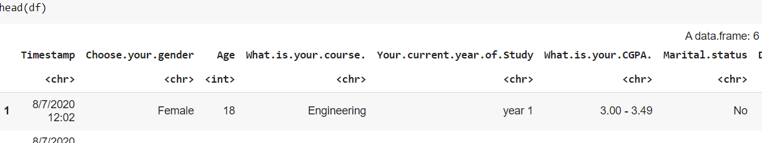

**Dimensions of Dataframe : 101 * 11**

**Renaming long names to short ones which are comfortable to read and using.**

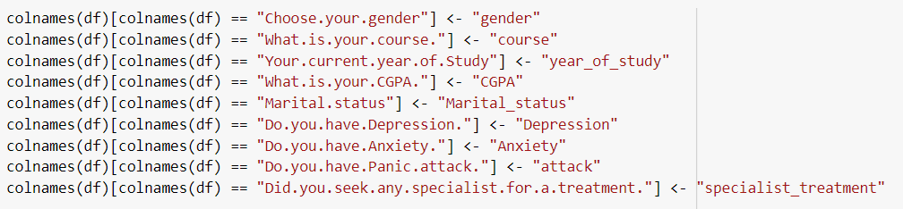

**Renamed columns in Dataframe**

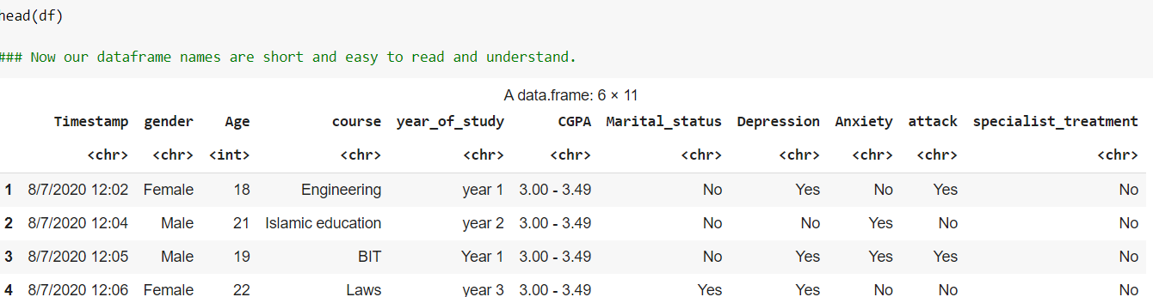

**Let’s Clean our Datafirst and check if there are any outliers.**

* We can clearly see that we have only one null value which we dropped.
* We had age as a numerical column in dataframe hence we checked outliers for the same and found that we don’t have any outliers for the age column.

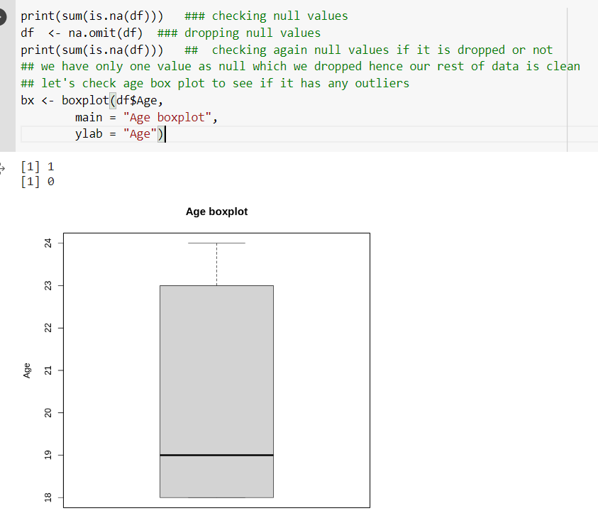

**Checking the Summary of Dataframe**

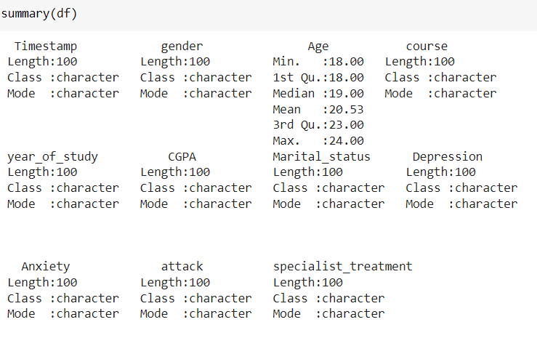

**Now let’s check depression relation with other columns of Dataframe.**

**Depression and CGPA**

For Depression and CGPA we can see that the major population lies between 3-4 CGPA but there is no major relation between depression in this range. Surprisingly, students with good CGPA 3.5-4 are showing more depression and students with less CGPA 0-.2.49 are less depressed.

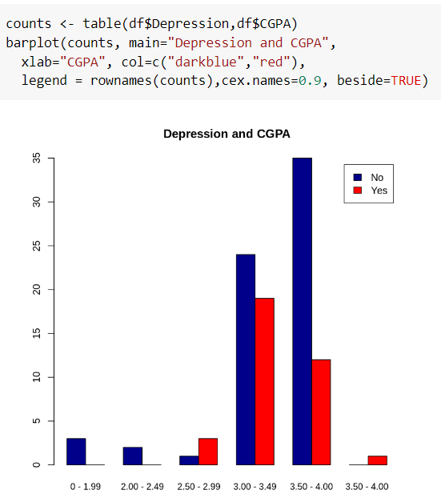

**PTO**

**Depression and Gender**

Here we can clearly see that females are more depressed as compared to men.

64 % of non depressed female are depressed and same ratio for male is 40%

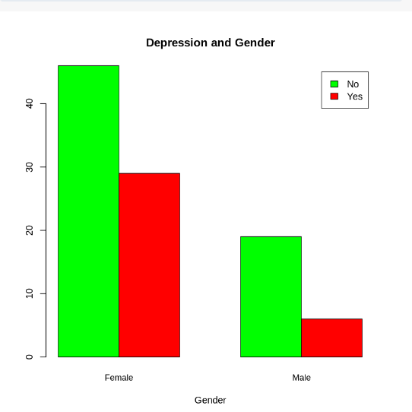

**Depression and Anxiety**

People with anxiety tend to be more depressed as compared to non-anxiety. This should be an ideal scenario real time and the same we can see in data.

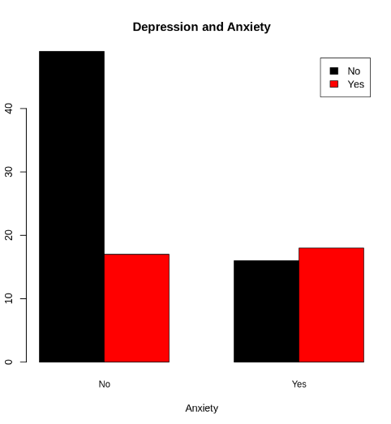

**Number of students is depressed(yes) when we compare with different year of students.**

New students i.e year 1 are more depressed. so as years passed depression yes numbers are getting less for older students.

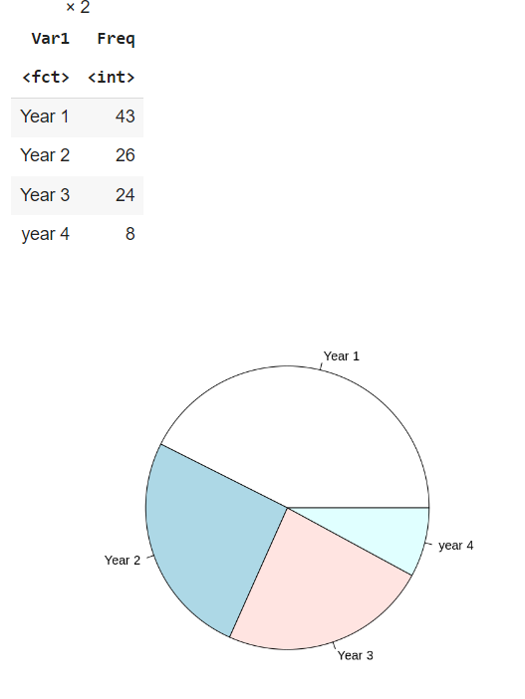

**ABLINE**

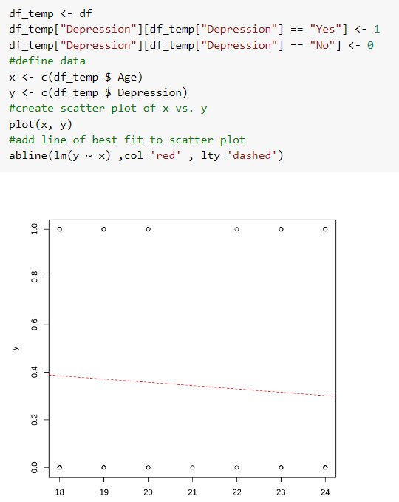

**Data Alignment as the same variable had different names. For example Year 1 and year 1.**

**After rename we can clearly see the difference between first and second output as shown in the screenshot.**

