**ALY6010**

**R-PRACTICE MODULE 4**

**Name: Shreyansh Bhalodiya**

**NUID: 002664707**

**Instructor name: Mohsen Soltanifar**

**PART 1**

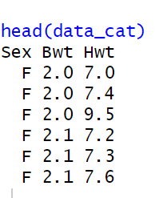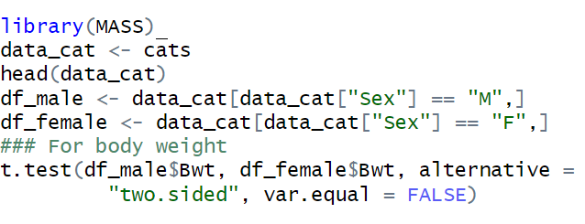

**As we can see that we have a data subset for each gender and then we are conducting two sample t-tests with unequal variance.**

**H0: True difference between body weight of two genders is equal to zero.**

**H1: True difference between body weight for two genders is not equal to zero.**

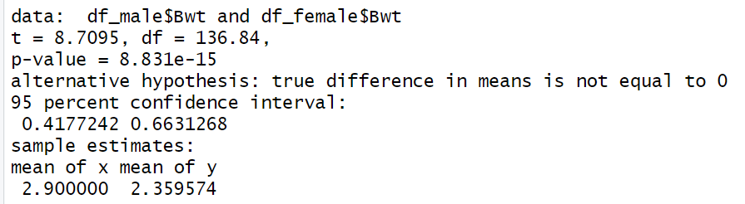

**ANALYSIS**

* We can see that at 95 percent confidence interval we have p-value greater than our sigma value hence our mean difference is not equal to zero and we accept our alternative hypothesis that true mean is not equal to zero and there is a difference between weight of male and female which is the ideal situation in real time scenario.

**PART 2**

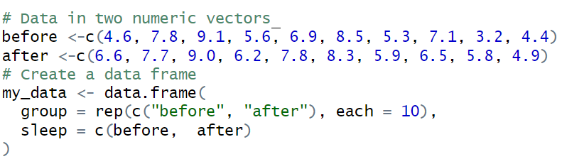

**We have two vectors. The first one is the number of hours of sleep before meditation and the other is the number of hours of sleep after meditation. Our main purpose of doing the following hypothesis test is to identify if meditation has any effect on sleep cycle.**

**Let’s first check with 95% confidence interval**



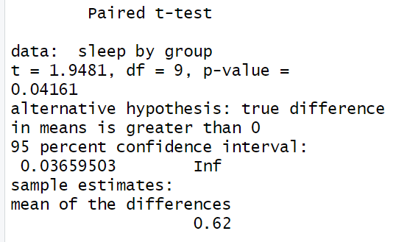

**Analysis**

* **H0: Mean difference is equal to zero.**
* **H1: Mean difference is greater than zero and mean after > mean before.**
* **We can see that our P-value which we got from paired t-test is 0.04161 which is less than 0.05 hence we accept our alternative hypothesis and conclude that the mean of sleep timing after meditation has increased.**

**Let’s first check with 90% confidence interval**



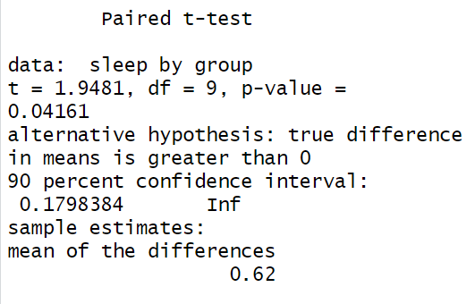

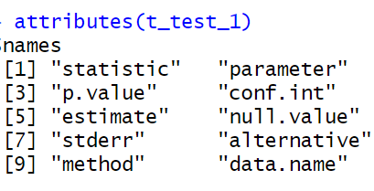

**Conclusion/Analysis:**

* **We got almost the same results with a confidence interval of .90. Hence we conclude that our results remained the same at 90 and 95 percent confidence intervals and we accept that our alternative hypothesis is true and average sleep time after mediation has increased as compared to before meditation hence we conclude that meditation has positive effect on sleep cycle.**