PROJECT REPORT ON
STREAMSCOPE: GENRE DEMAND AND CONTENT-GAP
ANALYSIS OF MOVIELENS 32M USING HADOOP,
PYSPARK, MONGODB, AND DOCKER

BACHELOR OF TECHNOLOGY
IN
ARTIFICIAL INTELLIGENCE AND MACHINE LEARNING

SUBMITTED BY
SHREYANSH PANDEY
[PRN NUMBER]

Under the Guidance of
[NAME OF THE SUBJECT TEACHER]
[DESIGNATION]

SYMBIOSIS INSTITUTE OF TECHNOLOGY
(A CONSTITUENT OF SYMBIOSIS INTERNATIONAL UNIVERSITY)
Pune - 412115
2026-2027

CONTENTS
List of Figures
List of Tables
List of Abbreviations
Abstract
Chapter 1 Introduction
1.1 Background
1.2 Motivation
1.3 Statement of the Problem and Objectives
Chapter 2 Literature Review
2.1 Related Work
2.2 Summary and Research Gap
Chapter 3 Methodology
3.1 Processing Model and Tools
3.2 Dataset
3.3 Procedure and Parameters
Chapter 4 Results and Discussion
Chapter 5 Conclusion
References
Appendix Commands and Queries

LIST OF FIGURES
1 Hadoop, Java, and passwordless SSH on WSL
2 Hadoop 3.3.6 version and storage directories
3 core-site.xml and hdfs-site.xml
4 Processing pipeline
5 MovieLens download, checksums, and line count
6 fsck of ratings.csv, seven blocks, status HEALTHY
7 One live DataNode
8 NameNode UI summary
9 NameNode storage directory
10 Spark 3.5.9 on Java 11
11 PySpark count of ratings on HDFS
12 Genre aggregate produced by PySpark
13 Curated genre file copied out of HDFS
14 MongoDB container started with Docker Compose
Page numbers are filled from the Word page field after the file is opened.

LIST OF TABLES
1 Software and configuration
2 Files stored on HDFS
3 Genre aggregate from PySpark
4 MongoDB collections

LIST OF ABBREVIATIONS
Table A. Abbreviations used in this report
Abbreviation | Meaning
HDFS | Hadoop Distributed File System
CSV | Comma-separated values
OTT | Over-the-top streaming service
TMDB | The Movie Database
JSON | JavaScript Object Notation
UI | User interface
WSL | Windows Subsystem for Linux
API | Application programming interface
YARN | Yet Another Resource Negotiator

ABSTRACT
StreamScope studies which movie genres attract a large volume of ratings and which of those genres are carried by only a small number of titles. The input is the MovieLens 32M collection, 32,000,204 ratings, stored on a single-node HDFS cluster and aggregated with PySpark 3.5.9. The aggregate is a 19-genre table. A Docker container uploads that table into MongoDB and a Streamlit application queries it to draw comparisons. A second MongoDB collection is reserved for unstructured TMDB watch-provider documents so that India subscription coverage can be queried in the same application. The ratings themselves remain on HDFS.
The distribution check shows one live DataNode, safe mode off, and a healthy file-system check of ratings.csv in seven blocks at replication 1. The Spark count of the HDFS file matches the line count of the source file. Drama has the largest rating count, Film-Noir has the highest average rating, and IMAX has the highest number of ratings per movie. Documentary is the thin-interest case, with many titles and few ratings per title. The provider fetch was not confirmed complete, so this report does not quote a coverage percentage.

CHAPTER 1 INTRODUCTION
A streaming catalogue is a matching problem. Viewers show interest in some kinds of titles more than others, and the service only has a finite list of titles it can actually play. If interest and availability are measured separately, a genre can look successful in a ratings file and still be a poor offer on a subscription plan. StreamScope is a small big-data pipeline built to put those two measurements side by side for movie genres.
1.1 Background
MovieLens, published by GroupLens, is a public set of movie ratings rather than a log of plays on Netflix, Prime Video, or any other service. The 32M release contains 32,000,204 ratings and is large enough that a spreadsheet is a poor place to store it and a fair place to start with Hadoop. The file used here is ratings.csv, together with movies.csv for genre labels and links.csv for the TMDB identifiers.
Hadoop's HDFS cuts a large file into blocks and records, on the NameNode, which blocks exist. On this laptop there is one DataNode, so the replication factor is 1. Spark then reads those blocks and computes the genre totals. Docker is used only for the query side: MongoDB holds the small genre table and the provider JSON, and Streamlit draws the charts. Hadoop is not placed inside a container, because a container's localhost is not the laptop's NameNode.
1.2 Motivation
The practical question is not only which genre has the most ratings. Drama can lead the count because it contains the most titles. A more useful comparison is how many ratings each title in that genre carries. A genre with heavy interest spread over few titles is a thin catalogue relative to demand. That comparison can be computed from MovieLens alone. The further question, whether those titles are actually offered on an India subscription plan, needs the provider documents from TMDB.
1.3 Statement of the Problem and Objectives
The problem is to measure, for each MovieLens genre, the rating activity, the number of titles that carry it, and, when provider documents are stored, the fraction of studied titles that have an India flatrate provider. The work is scoped to one laptop. It is not a multi-node cluster, and the ratings are not treated as OTT views or revenue.
The objectives are:
1. Store ratings.csv, movies.csv, and links.csv on HDFS and show that the blocks are healthy on the single DataNode.
2. Use PySpark to count the ratings from hdfs://localhost:9000 and to aggregate interest by genre.
3. Run MongoDB and the Python dashboard in Docker, upload the curated genre table, and query it for charts and tables.
4. Query unstructured TMDB provider JSON from the same database when the fetch has stored HTTP 200 documents.

CHAPTER 2 LITERATURE REVIEW
2.1 Related Work
Harper and Konstan describe the MovieLens releases, how the ratings were collected, and why the sets are used as a shared benchmark rather than as a private viewing log [1]. That distinction matters here. A rating is an explicit score given by a user. It is evidence of interest, not evidence that the user watched the title on a particular streaming plan.
Dean and Ghemawat introduced MapReduce as a way to run a simple computation across records that do not fit a single conventional pass in a convenient way [2]. HDFS, described by Shvachko, Kuang, Radia, and Chansler, separates the file index (the NameNode) from the stored blocks (the DataNodes) [3]. StreamScope uses that split directly. The NameNode records the path /streamscope/raw/movielens/ratings.csv and the seven block ids. The DataNode holds the bytes.
Zaharia and others designed Spark so that a later action can reuse data already read, instead of writing every intermediate result back to disk as a MapReduce job often does [4]. The genre job is one Spark action: join ratings to movies, split the genre string, and aggregate. The result is small enough to store in MongoDB and query from a web page. MongoDB is used because the TMDB response is a nested JSON document, which is the unstructured record the Docker part of the rubric asks to store and query.
2.2 Summary and Research Gap
The cited work explains the dataset and the storage and processing tools. It does not answer the catalogue question for this laptop. Three gaps are specific to StreamScope. First, genre labels overlap, so a total of ratings by genre is not a partition of the 32,000,204 rows. Second, a high rating count can be an effect of a large catalogue, so ratings per movie has to be reported beside the raw count. Third, availability on an India subscription plan is not in MovieLens at all. It has to be joined later through the TMDB identifier. This report completes the first two measurements. The third is implemented as a query, and the document collection was not confirmed complete at 2,000 titles.

CHAPTER 3 METHODOLOGY
3.1 Processing Model and Tools
This project does not train a classifier, so there is no neural model and no train-test accuracy. The model is the pipeline in Figure 4. Each box is one tool, and each arrow is a file or a query. Hadoop stores the raw files. Spark computes the aggregates. MongoDB stores the small results and the provider JSON. Streamlit only displays the query result. Plotly draws the marks. The dashboard does not plot a Spark DataFrame directly.
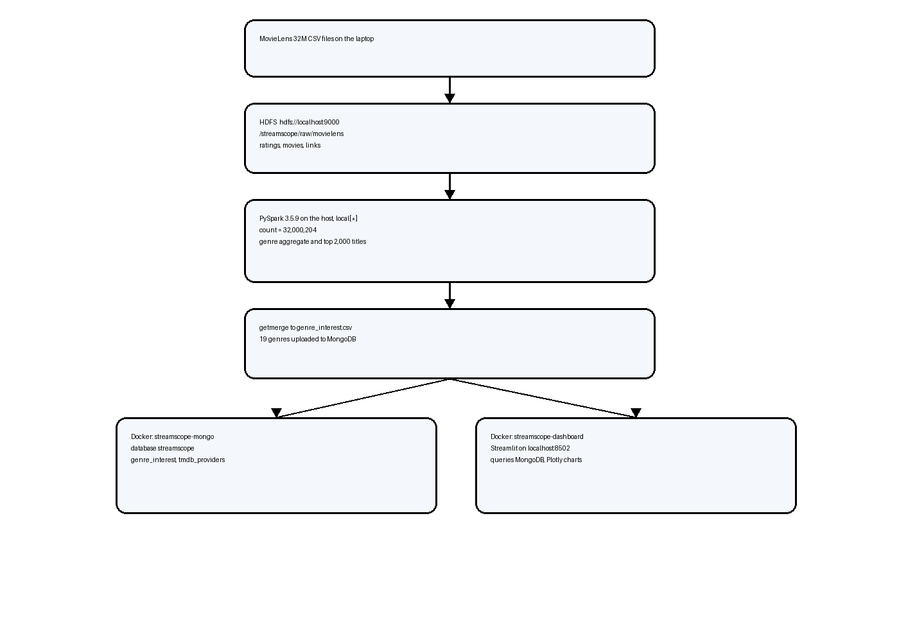
Figure 4. Processing pipeline from the raw files to the two Docker containers.
Table 1. Software and configuration
Component | Setting used
Host | WSL2 Ubuntu on one laptop, user pandey, host LAPTOP-H1S3QUIE
Java | OpenJDK 11.0.32, JAVA_HOME=/usr/lib/jvm/java-11-openjdk-amd64
Hadoop | 3.3.6, HADOOP_HOME=/home/pandey/hadoop
File system | hdfs://localhost:9000
Replication | 1
Block size | 134,217,728 bytes (128 MiB)
NameNode UI | http://localhost:9870
Spark | 3.5.9 for Hadoop 3, Scala 2.12.18, master local[*]
MongoDB | Docker image mongo:7, database streamscope, port 27017
Dashboard | Python 3.11 image, Streamlit on http://localhost:8502

Spark 4 was not used because it requires Java 17. YARN was started once, which showed a ResourceManager and a NodeManager, and was then stopped so that local-mode Spark could use the laptop memory. The SecondaryNameNode only checkpoints the NameNode image. It is not a standby NameNode.
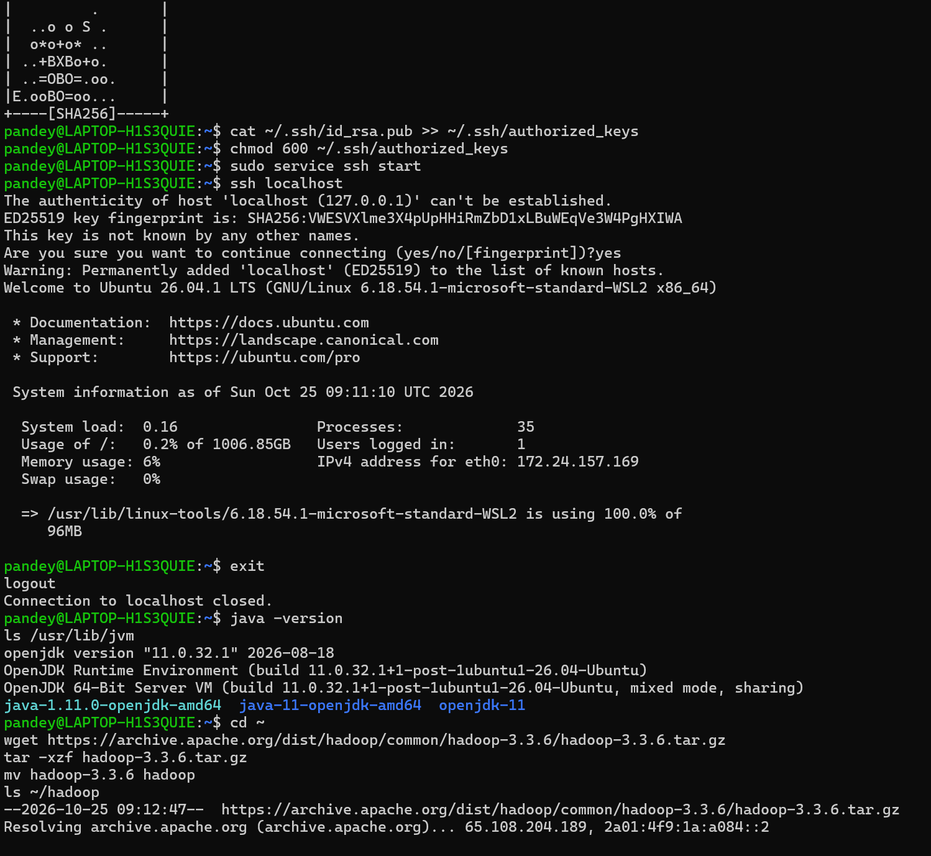
Figure 1. Passwordless SSH to localhost, Java 11, and the Hadoop 3.3.6 download.
Figure 1 is the start of the install. SSH to localhost is required before start-dfs.sh, because the Hadoop scripts start the daemons over SSH even on one machine. java -version fixes the runtime at OpenJDK 11. The tarball is the official 3.3.6 binary.
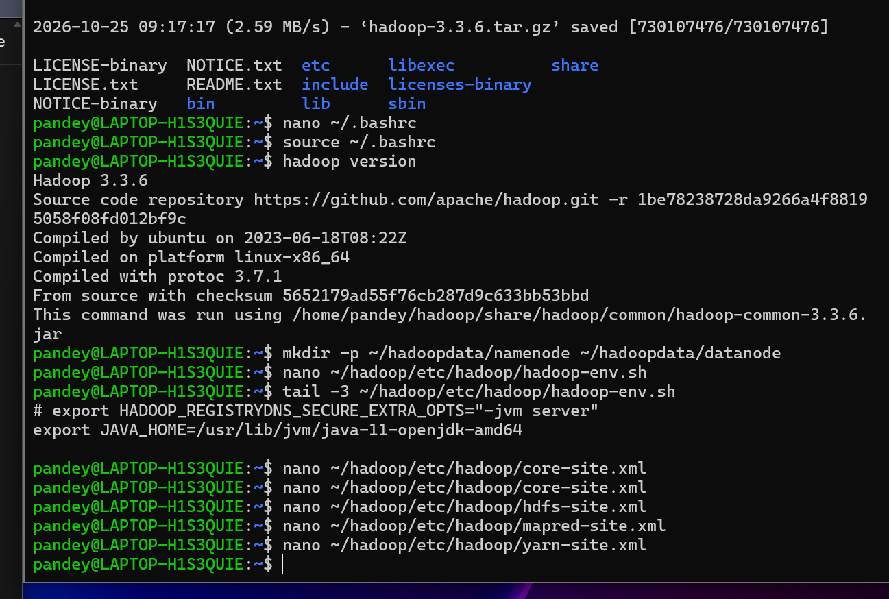
Figure 2. hadoop version, JAVA_HOME, and the NameNode and DataNode directories.
Figure 2 shows that the hadoop command on the path is 3.3.6 and that JAVA_HOME inside hadoop-env.sh points at the same Java 11. The directories ~/hadoopdata/namenode and ~/hadoopdata/datanode were created before formatting, so the NameNode image and the block files have a known location.
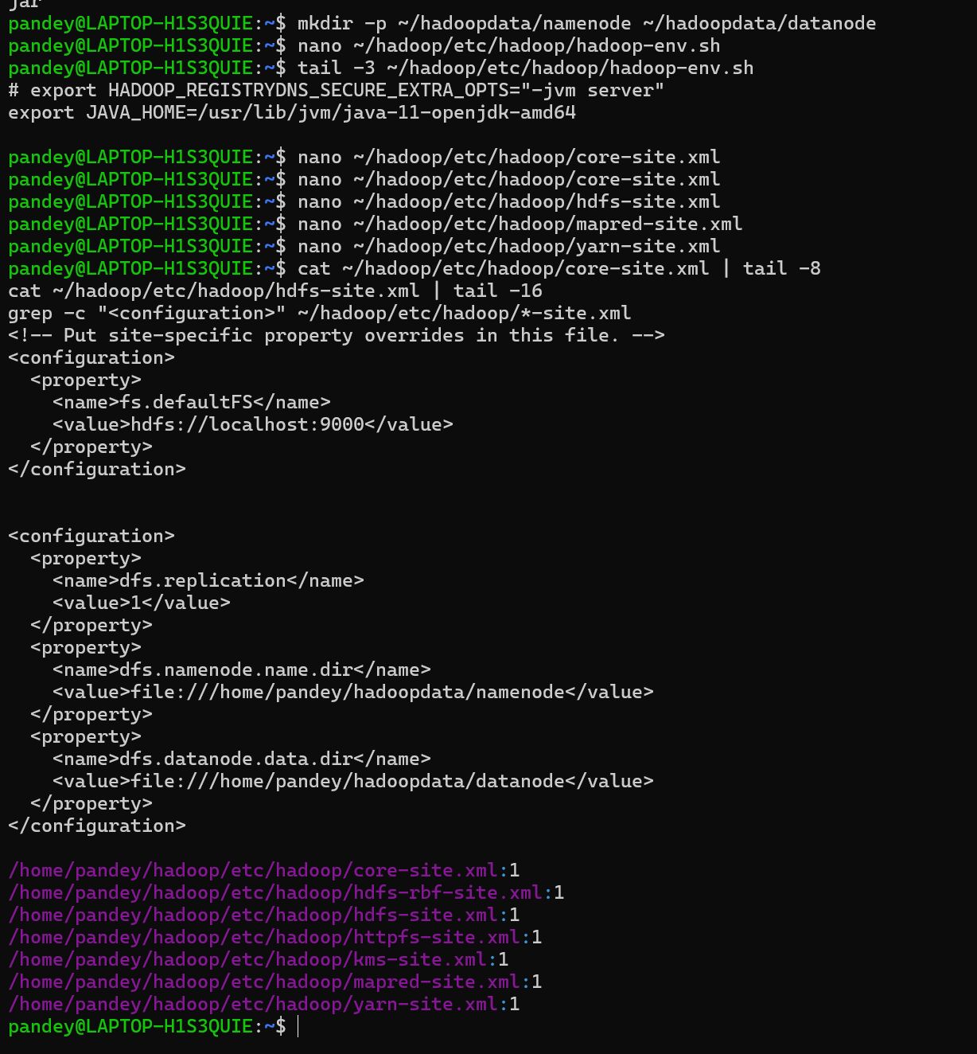
Figure 3. fs.defaultFS, replication 1, and the two storage directories.
Figure 3 is the configuration that makes the cluster single-node. fs.defaultFS sends every path that does not name a host to localhost port 9000. dfs.replication is 1, so a block is complete when the one DataNode has written it. The NameNode directory and the DataNode directory match the folders created in Figure 2. The grep across the site files shows that each XML file actually contains a configuration element.
3.2 Dataset
The dataset is MovieLens 32M from GroupLens [1]. Four CSV files are inside the zip. This project uses ratings, movies, and links. tags.csv was checked and was not loaded into HDFS, because the genre question does not need tags. The provider study keeps the 2,000 titles with the most ratings and a non-null tmdbId.
Table 2. Files stored on HDFS
File | HDFS path | What it contributes | Blocks
ratings.csv | /streamscope/raw/movielens | 32,000,204 ratings; 877,076,222 bytes | 7
movies.csv | /streamscope/raw/movielens | title and pipe-separated genres | 1
links.csv | /streamscope/raw/movielens | movieId to tmdbId | 1

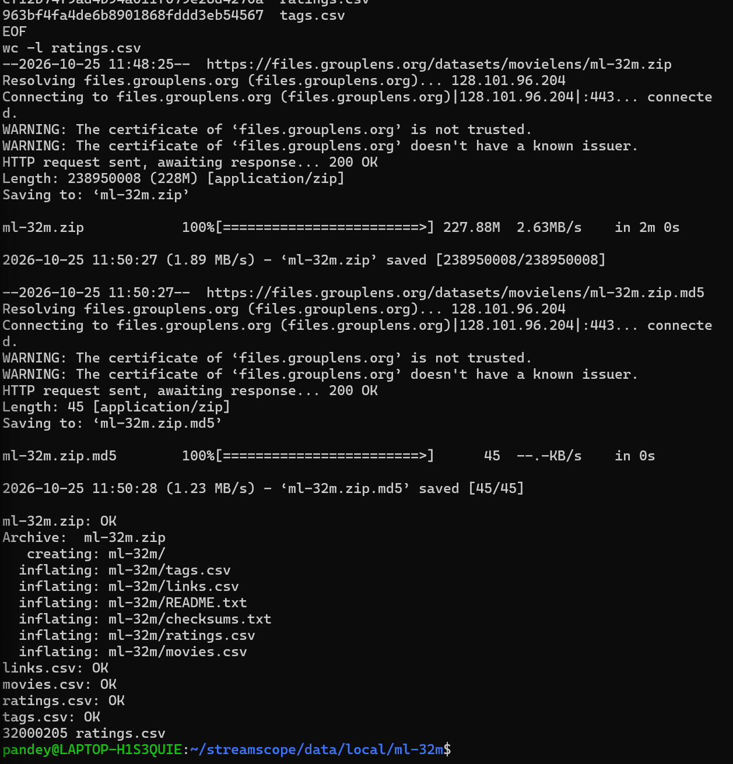
Figure 5. Checksums OK for the zip and the four CSV files, and wc -l of ratings.csv.
Figure 5 is the integrity check before the upload. The zip checksum and the checksums of links.csv, movies.csv, ratings.csv, and tags.csv all printed OK. wc -l printed 32,000,205. One of those lines is the header, so the number of ratings is 32,000,204. The certificate warning from the GroupLens host is recorded, and the md5 result is what is trusted.
3.3 Procedure and Parameters
There is no training split and no test accuracy, because the computation is an aggregation, not a fitted model. The checks that take the place of a train-test report are a matching count, a healthy file-system check, and the genre metrics defined below.
The NameNode was formatted once and was not formatted again. start-dfs.sh was run after SSH was up. ratings.csv, movies.csv, and links.csv were copied with hdfs dfs -put. fsck was run on the ratings path. The Spark count job read the same HDFS path. The genre job joined ratings to movies on movieId, split genres on the vertical bar, dropped empty labels and the label (no genres listed), and computed four aggregates: the number of ratings, the number of distinct users, the number of distinct movies, and the average rating rounded to four decimals. A separate job wrote the top 2,000 linked titles to /streamscope/curated/catalog_universe. hdfs dfs -getmerge copied the genre directory to one local CSV. The dashboard container reads that CSV at start and replaces the MongoDB collection genre_interest.
Parameters that change the result, and the values used: replication 1; block size 128 MiB; Spark master local[*]; driver memory limited on the dashboard host; TMDB region IN; provider type flatrate only; catalogue limit 2,000 titles; a genre allow-list of the 19 real MovieLens genres. One broken row caused by a doubled quote in movies.csv is dropped by that allow-list. It is visible in Figure 12 and is not treated as a genre.
The MongoDB aggregation used for ratings per movie is a divide of rating_count by movie_count, sorted descending. Gap, when provider documents exist, is 1 minus the share of stored titles whose payload.results.IN.flatrate list is non-empty. The API key is read from TMDB_API_KEY and is not stored in the image or in this report.

CHAPTER 4 RESULTS AND DISCUSSION
The first result is that the file on HDFS is the same file that was counted on disk, and that its blocks are healthy. Figure 6 shows fsck ending in HEALTHY, with total size 877,076,222 bytes, 7 validated blocks, replication 1, and no missing or corrupt blocks. Six blocks are 134,217,728 bytes and the last is 71,769,854 bytes. Those seven lengths add up to the fsck total, so the put did not drop the tail of the file. movies.csv and links.csv each occupy one block because each is smaller than 128 MiB. The cluster therefore holds 9 blocks.
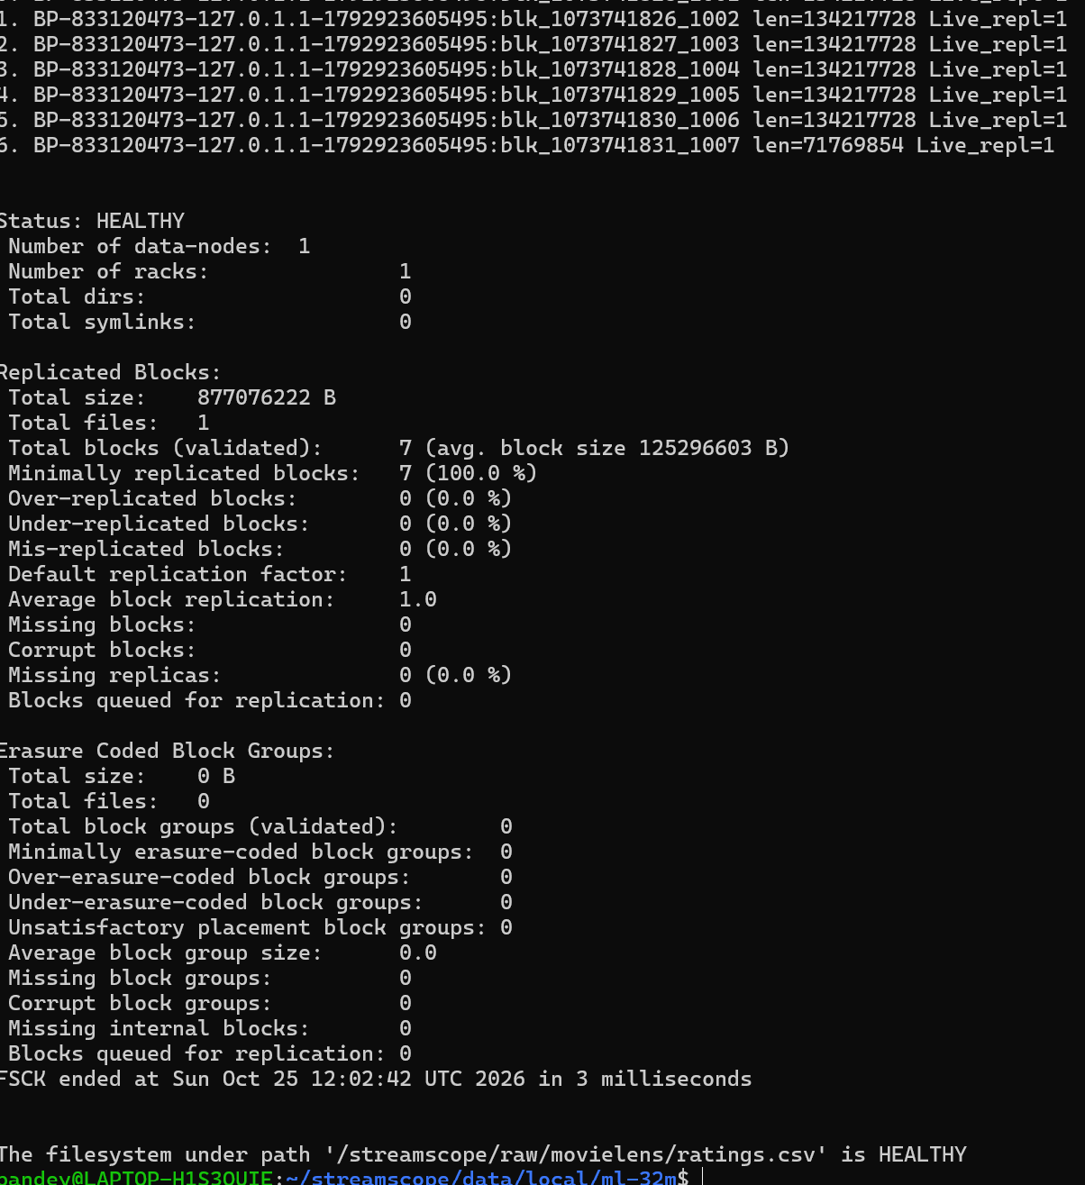
Figure 6. fsck of ratings.csv: HEALTHY, 7 blocks, 877,076,222 bytes, replication 1.
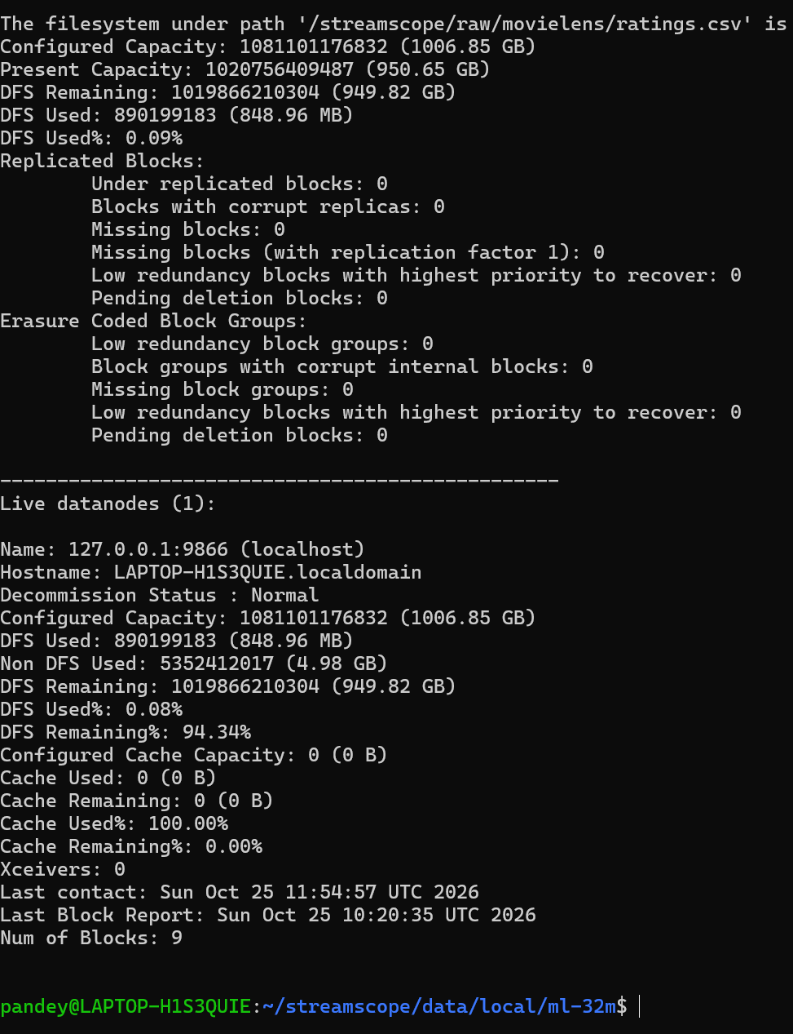
Figure 7. dfsadmin report: one live DataNode at 127.0.0.1:9866 and 9 blocks.
Figure 7 names the DataNode and shows the disk. Capacity is 1006.85 GB, DFS used is 848.96 MB, and about 949.82 GB remains. The cache line at 100 percent is not a full cache. The configured cache capacity is 0. Figure 8 is the same fact in the NameNode web interface: security off, safe mode off, 1 live node, 0 dead nodes, 0 under-replicated blocks. Figure 9 shows the directory from Figure 2 actually in service as the NameNode image.
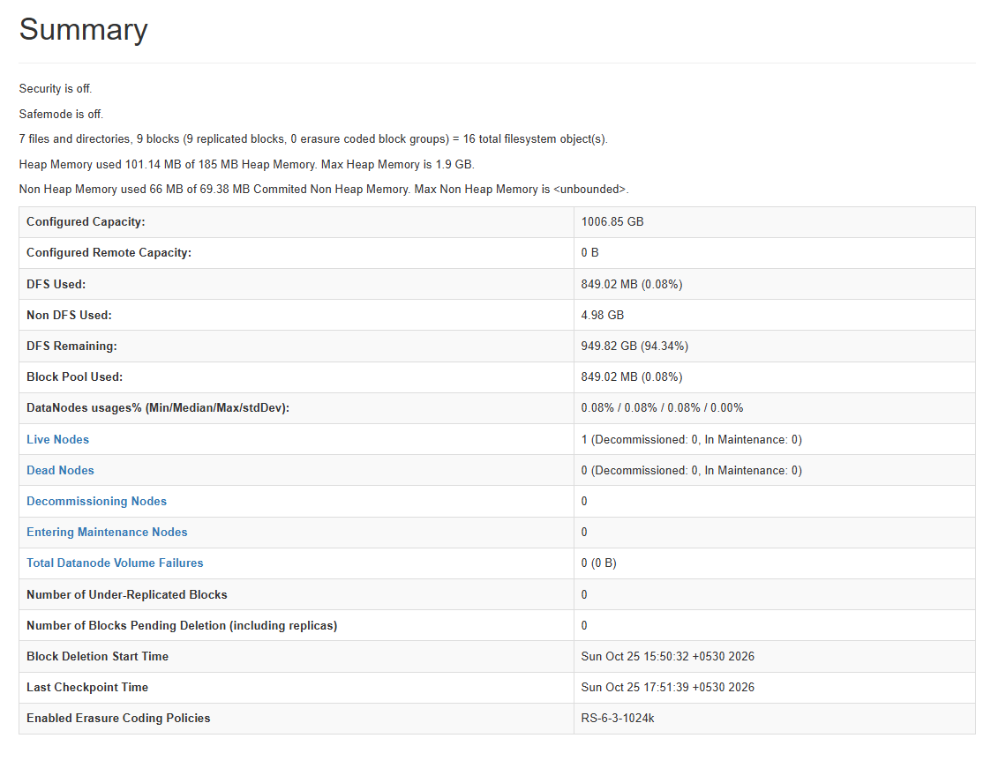
Figure 8. NameNode UI. Safe mode is off and one node is live.
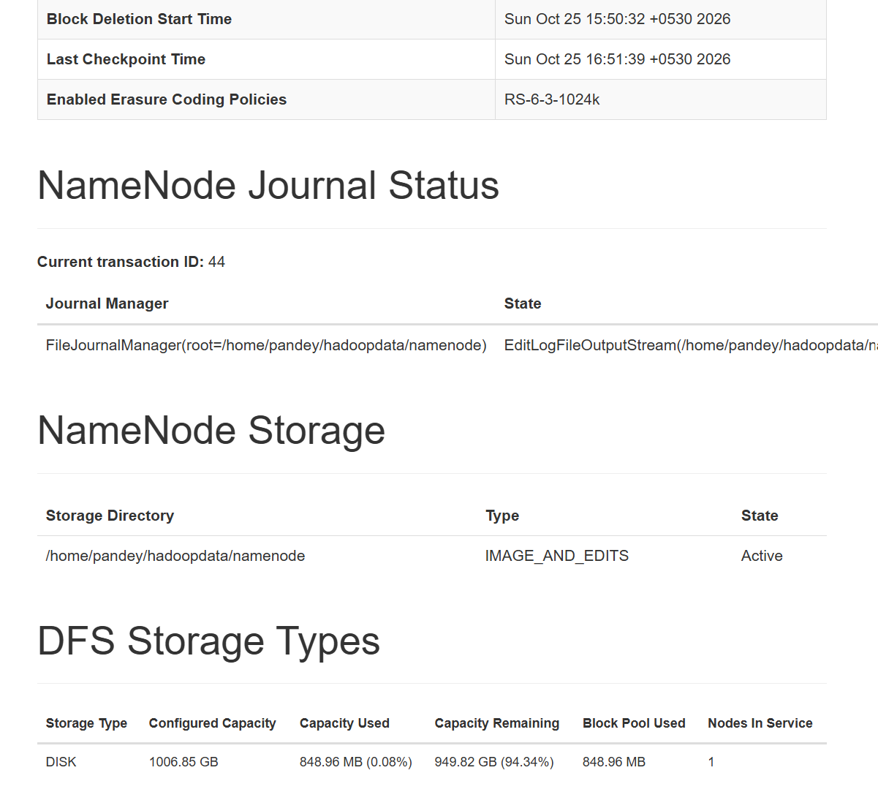
Figure 9. NameNode storage at /home/pandey/hadoopdata/namenode is Active.
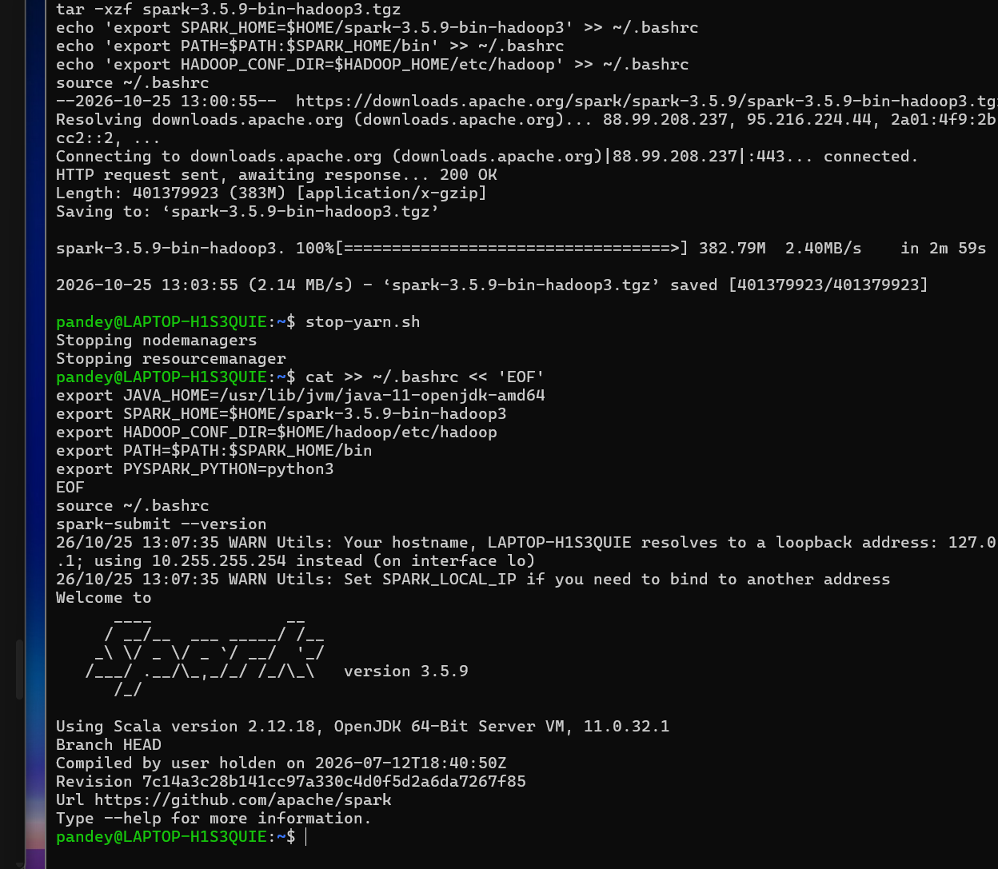
Figure 10. spark-submit --version: Spark 3.5.9, Scala 2.12.18, Java 11.
Figure 10 fixes the Spark build. It is the Hadoop 3 build on Java 11, which can read the configuration from Figure 3. The hostname warning only says that the WSL name resolves to a loopback address. The job still runs. Figure 11 is the processing check. PySpark printed RATINGS_ON_HDFS 32000204 and exited 0. That is the line count from Figure 5 without the header, read through hdfs://localhost:9000 rather than from the local disk.
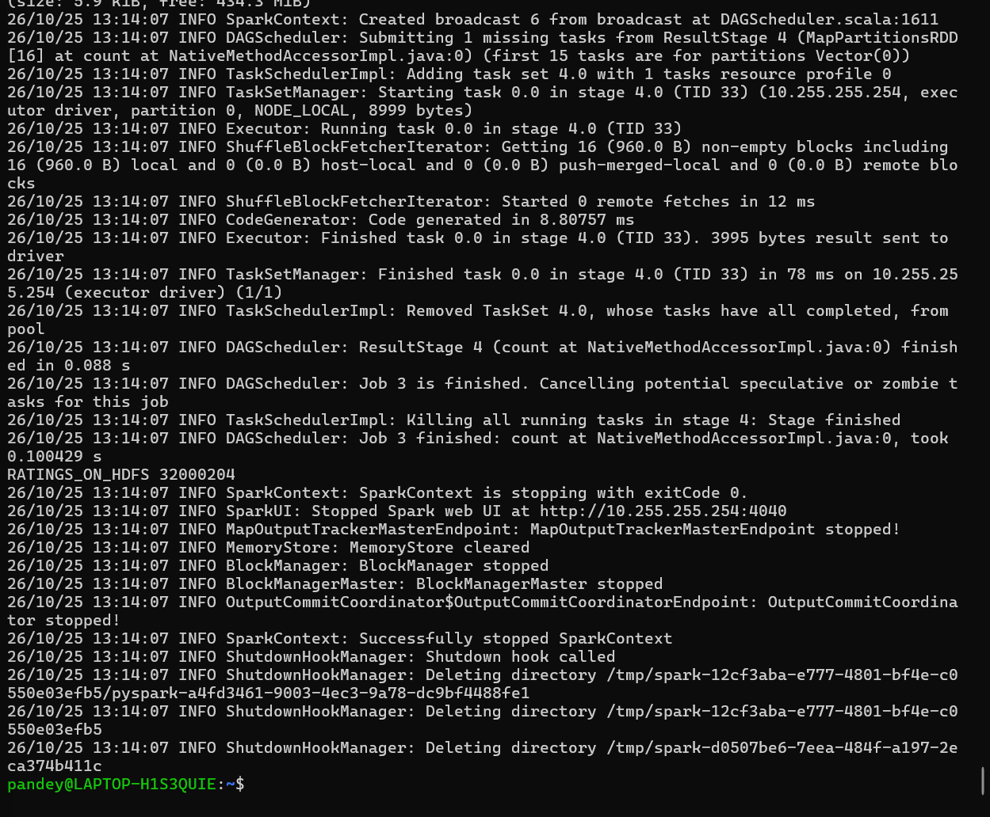
Figure 11. Spark count of the HDFS ratings file: 32,000,204, exit code 0.
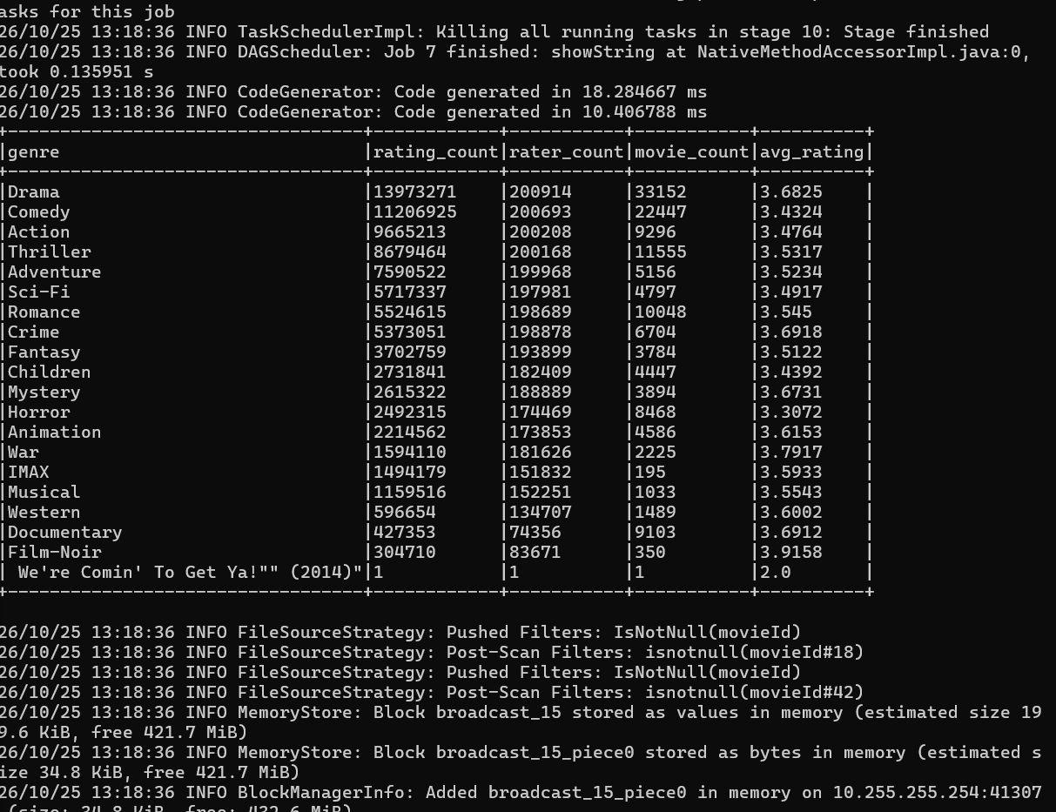
Figure 12. PySpark genre table. The last row is a broken title, not a genre.
Figure 12 is the analytical result. Drama has 13,973,271 ratings, 200,914 distinct raters, 33,152 movies, and average 3.6825. The last printed row is the quote-broken title and has a single rating. It is excluded from Table 3. Because a film with two genres is counted twice, the nineteen rating counts sum to 87,063,719, which is 55,063,515 above the raw rating count. That difference is the overlap, not new data.
Table 3. Genre aggregate after dropping the broken row. Share is the share of the 87,063,719 genre-row ratings.
Genre | Ratings | Movies | Average | Ratings per movie | Share %
Drama | 13,973,271 | 33,152 | 3.6825 | 421.5 | 16.05
Comedy | 11,206,925 | 22,447 | 3.4324 | 499.3 | 12.87
Action | 9,665,213 | 9,296 | 3.4764 | 1,039.7 | 11.10
Thriller | 8,679,464 | 11,555 | 3.5317 | 751.1 | 9.97
Adventure | 7,590,522 | 5,156 | 3.5234 | 1,472.2 | 8.72
Sci-Fi | 5,717,337 | 4,797 | 3.4917 | 1,191.9 | 6.57
Romance | 5,524,615 | 10,048 | 3.5450 | 549.8 | 6.35
Crime | 5,373,051 | 6,704 | 3.6918 | 801.5 | 6.17
Fantasy | 3,702,759 | 3,784 | 3.5122 | 978.5 | 4.25
Children | 2,731,841 | 4,447 | 3.4392 | 614.3 | 3.14
Mystery | 2,615,322 | 3,894 | 3.6731 | 671.6 | 3.00
Horror | 2,492,315 | 8,468 | 3.3072 | 294.3 | 2.86
Animation | 2,214,562 | 4,586 | 3.6153 | 482.9 | 2.54
War | 1,594,110 | 2,225 | 3.7917 | 716.5 | 1.83
IMAX | 1,494,179 | 195 | 3.5933 | 7,662.5 | 1.72
Musical | 1,159,516 | 1,033 | 3.5543 | 1,122.5 | 1.33
Western | 596,654 | 1,489 | 3.6002 | 400.7 | 0.69
Documentary | 427,353 | 9,103 | 3.6912 | 46.9 | 0.49
Film-Noir | 304,710 | 350 | 3.9158 | 870.6 | 0.35

Three comparisons come out of Table 3, and they are not the same ranking. Drama leads raw activity and catalogue size. Film-Noir leads the average, 3.9158, on 350 movies. IMAX leads ratings per movie, about 7,663, because 195 titles carry 1,494,179 ratings. Documentary is the opposite, about 47 ratings per movie across 9,103 titles. Horror has a large catalogue, 8,468 movies, and the lowest average, 3.3072. Ratings per movie is the content-gap signal that can be stated before any provider document is stored: interest is concentrated, or it is spread thin.
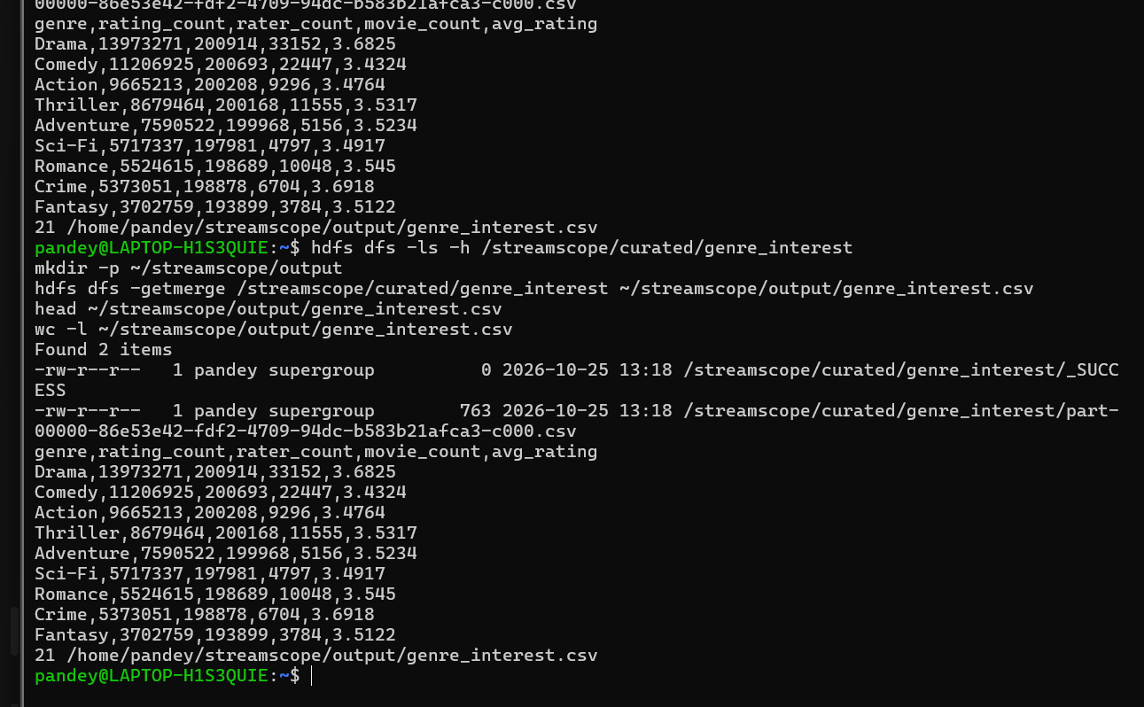
Figure 13. Spark output directory and the merged genre_interest.csv, 21 lines.
Figure 13 connects Spark to Docker. The HDFS directory contains _SUCCESS and one part file, so the job finished and wrote a single CSV part. getmerge produced the local file, and wc -l printed 21: the header, 19 genres, and the broken row. The container uploads the 19 allow-listed rows.
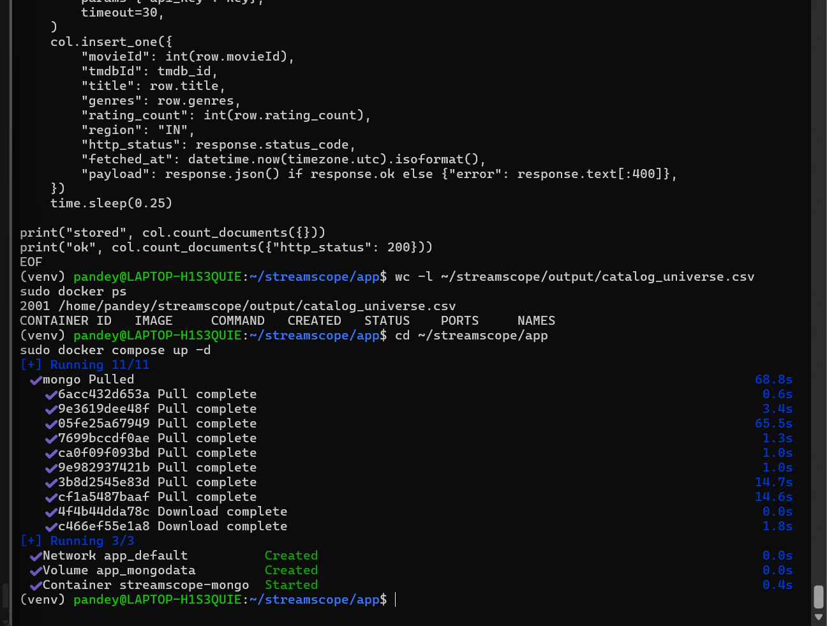
Figure 14. catalogue_universe.csv has 2,001 lines, and streamscope-mongo is running.
Figure 14 is the Docker result available in the captured screens. The catalogue file has 2,001 lines, which is the header plus 2,000 titles. Compose created the volume app_mongodata and started streamscope-mongo from mongo:7. That database is on the laptop. It is not MongoDB Atlas. Table 4 is what the dashboard queries.
Table 4. MongoDB collections in database streamscope
Collection | Contents | Query
genre_interest | One document per genre | find sorted by rating_count; aggregate ratings divided by movies
tmdb_providers | TMDB JSON for region IN | find where http_status is 200, then read flatrate providers

The Streamlit page then draws the activity bar and pie, the average-rating comparison, the ratings-per-movie comparison, and a rank table from genre_interest. The coverage tab runs the provider query. A finished stored-count near 2,000 was not in the captured output, so no coverage percentage is reported. A later screenshot of http://localhost:8502 and of one tmdb_providers document should be pasted into this chapter when that count exists.

CHAPTER 5 CONCLUSION
The ratings file is on HDFS, the block check is healthy, and PySpark both counted 32,000,204 ratings from that HDFS path and produced the genre table. Docker runs MongoDB, and the dashboard uploads and queries the 19-genre result. The useful finding is that the rankings disagree. Drama is the largest activity. Film-Noir is the highest average. IMAX is the most concentrated demand per title, and Documentary is the most diffuse. Those four statements are the content-gap reading of MovieLens on this single node.
The work does not show multi-node scaling, and it does not show OTT views. Genre totals double-count multi-genre titles. The provider collection must be described as incomplete until the fetch reports a full stored count. Within those limits, the pipeline order required by the project is in place: HDFS, then Spark, then the MongoDB query, then the dashboard in Docker.

REFERENCES
[1] F. M. Harper and J. A. Konstan, “The MovieLens datasets: History and context,” ACM Transactions on Interactive Intelligent Systems, vol. 5, no. 4, article 19, Dec. 2015.
[2] J. Dean and S. Ghemawat, “MapReduce: Simplified data processing on large clusters,” in Proc. 6th USENIX Symp. Operating Systems Design and Implementation (OSDI), 2004, pp. 137–150.
[3] K. Shvachko, H. Kuang, S. Radia, and R. Chansler, “The Hadoop Distributed File System,” in Proc. IEEE 26th Symp. Mass Storage Systems and Technologies (MSST), 2010, pp. 1–10.
[4] M. Zaharia et al., “Resilient distributed datasets: A fault-tolerant abstraction for in-memory cluster computing,” in Proc. 9th USENIX Symp. Networked Systems Design and Implementation (NSDI), 2012, pp. 15–28.
[5] GroupLens, “MovieLens 32M dataset,” https://grouplens.org/datasets/movielens/.
[6] The Movie Database, “Movie watch providers,” API reference, https://developer.themoviedb.org/reference/movie-watch-providers.

APPENDIX COMMANDS AND QUERIES
Hadoop check, from the WSL terminal, without formatting the NameNode again:
jps
hdfs dfsadmin -safemode get
hdfs dfs -ls /streamscope/raw/movielens
hdfs fsck /streamscope/raw/movielens/ratings.csv
Dashboard, after the genre file has been merged out of HDFS:
hdfs dfs -getmerge /streamscope/curated/genre_interest ~/streamscope/output/genre_interest.csv
cd ~/streamscope/app
sudo docker compose up -d --build
The two queries the page runs against streamscope are:
db.genre_interest.find({}, {_id: 0}).sort({rating_count: -1})
db.genre_interest.aggregate([ { $match: { movie_count: { $gt: 0 } } }, { $project: { genre: 1, ratings_per_movie: { $divide: ["$rating_count", "$movie_count"] } } }, { $sort: { ratings_per_movie: -1 } } ])

