Defect Tracking System

1. Defect 1 - Crash

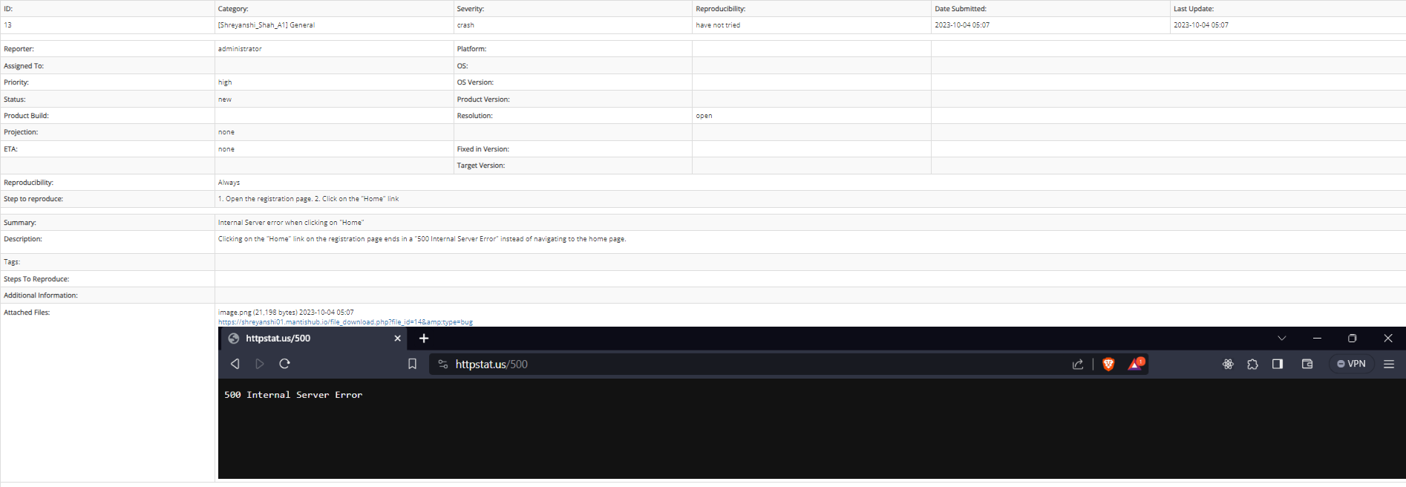

1. Defect 2 – Major

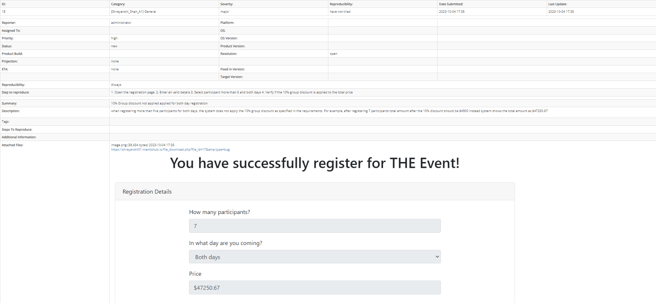

1. Defect 3 – Major

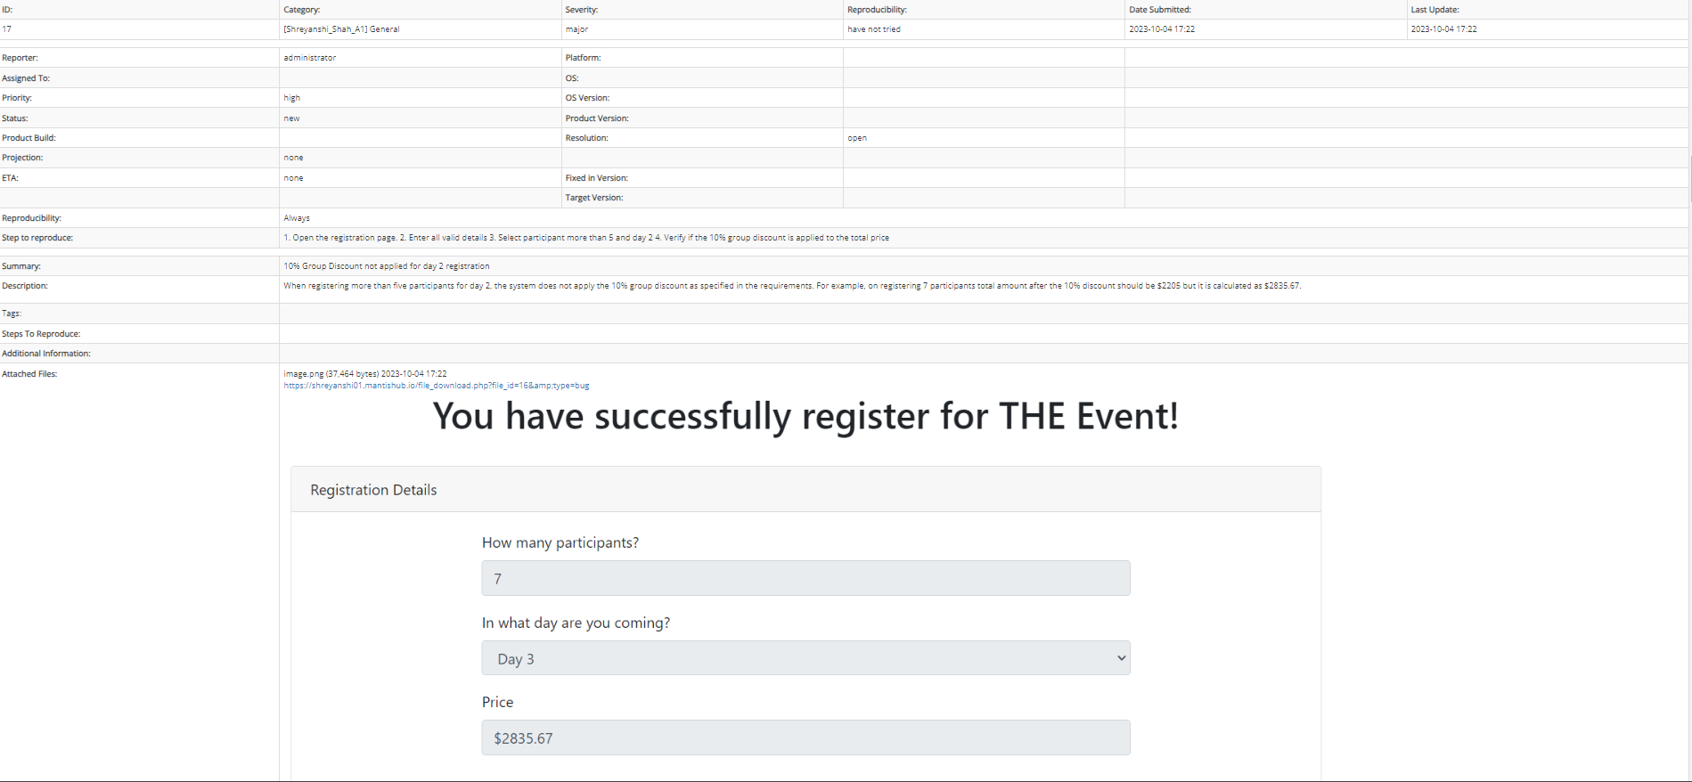

1. Defect 4 – Major

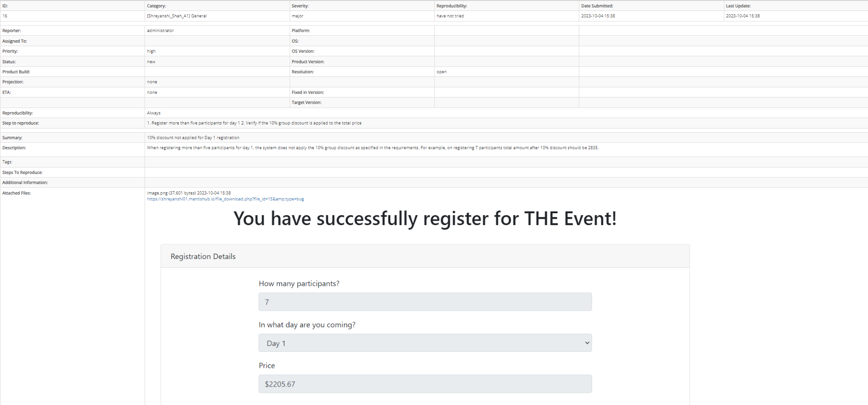

1. Defect 5 – Major

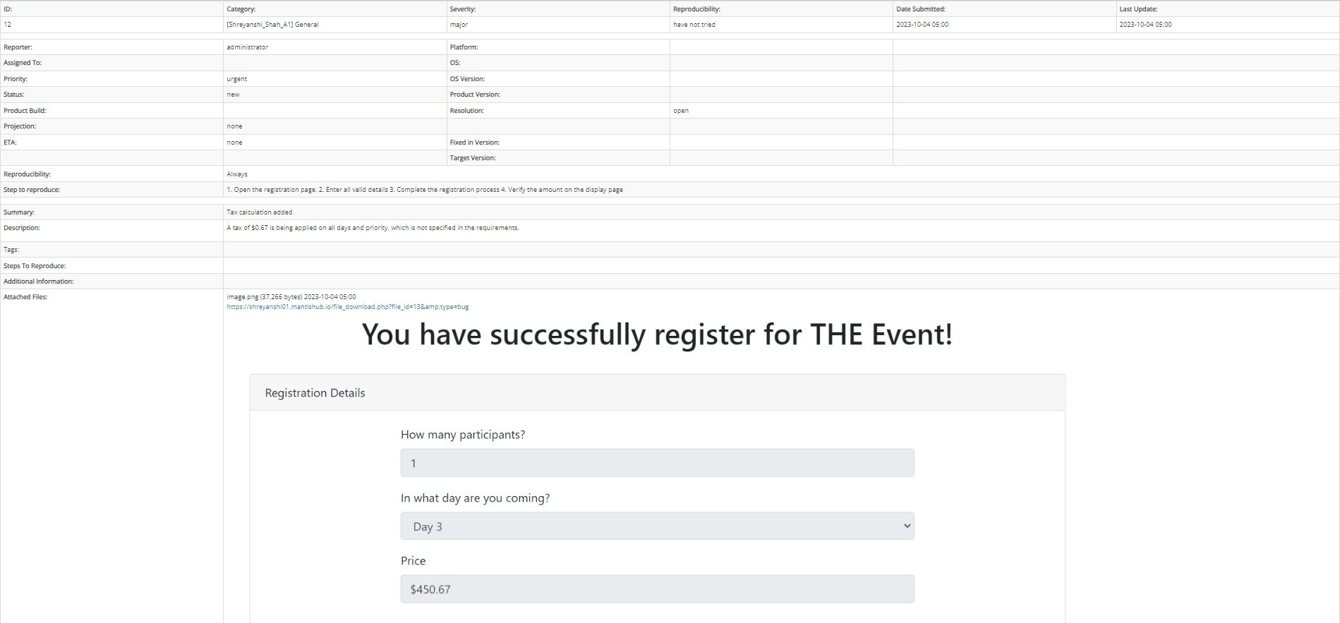

1. Defect 6 - Major

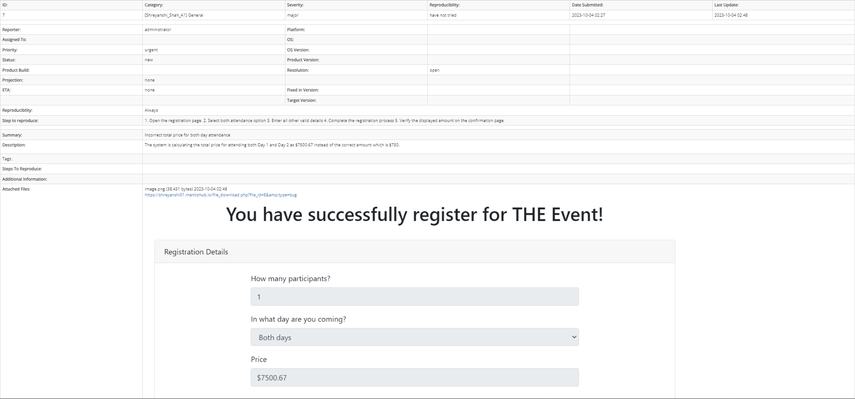

1. Defect 7 - Major

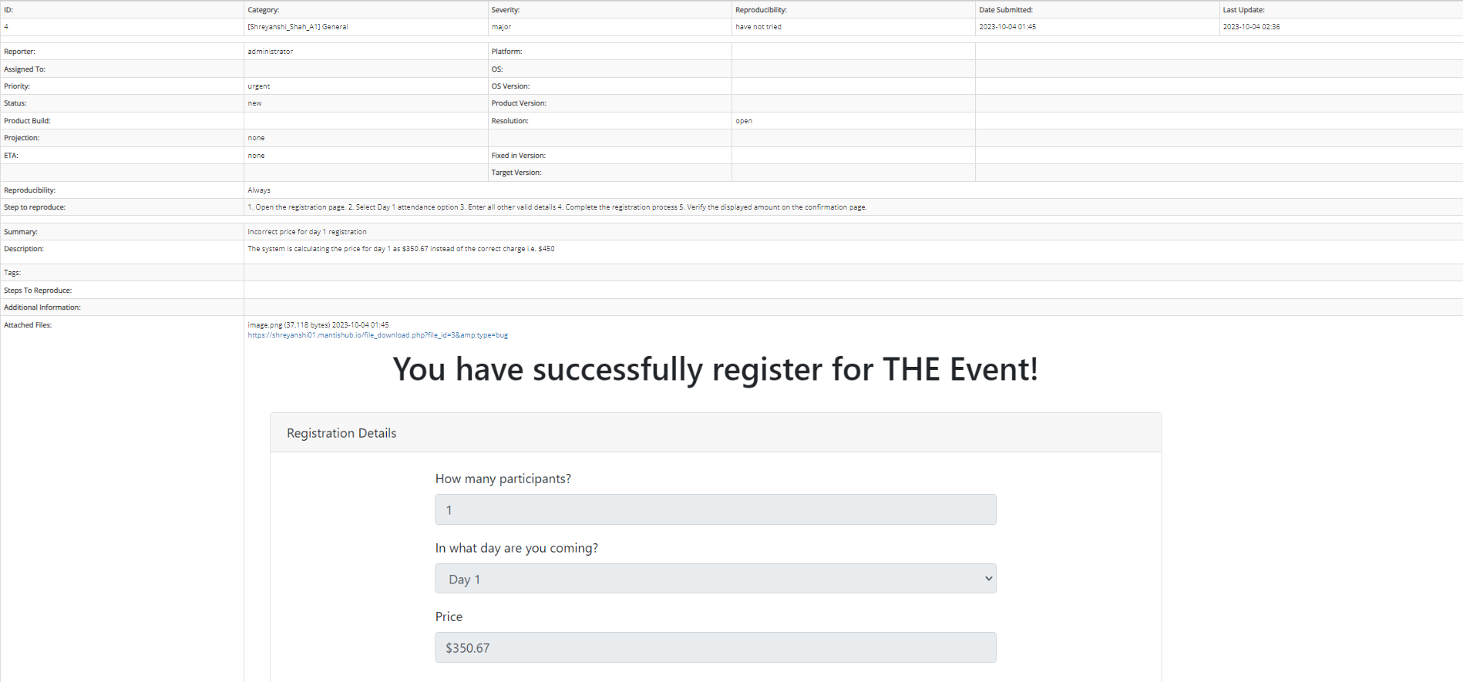

1. Defect 8 - Major

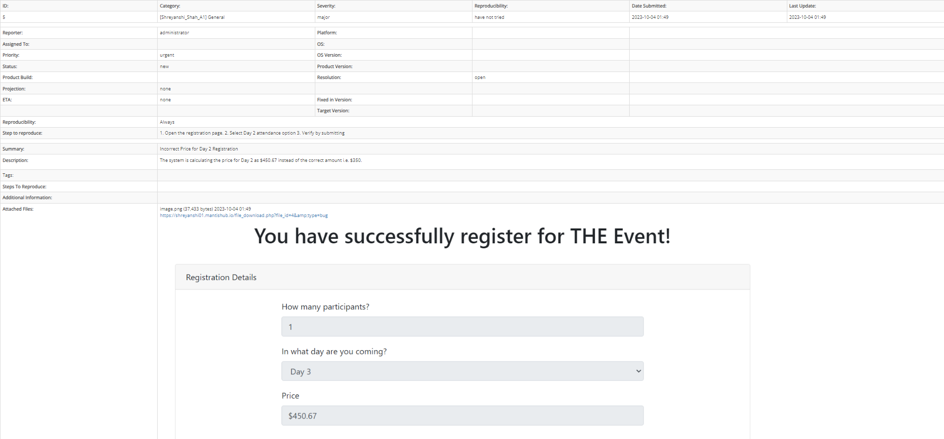

1. Defect 9 - Minor

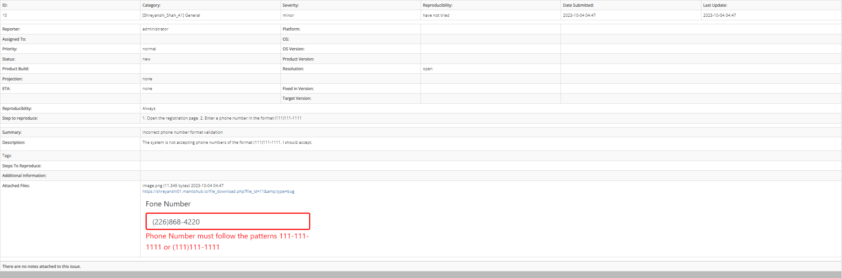

1. Defect 10 - Minor

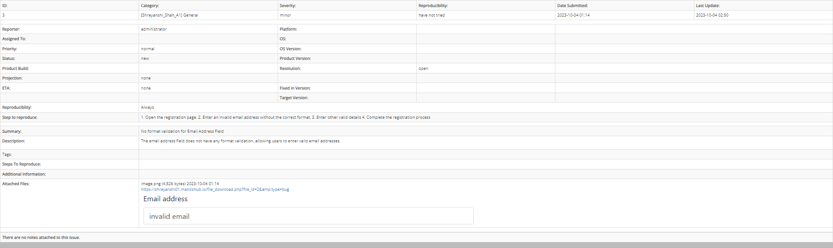

1. Defect 11 – Minor

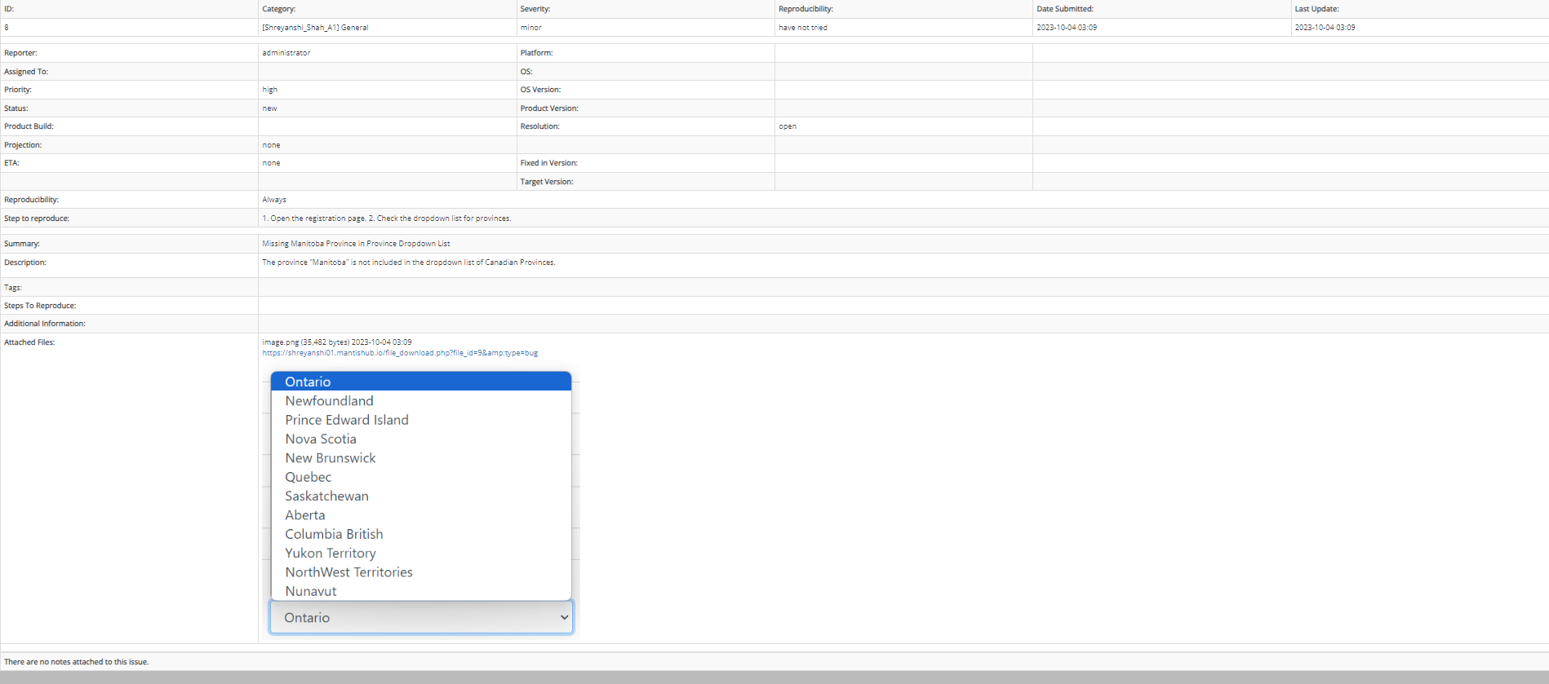

1. Defect 12 – Text

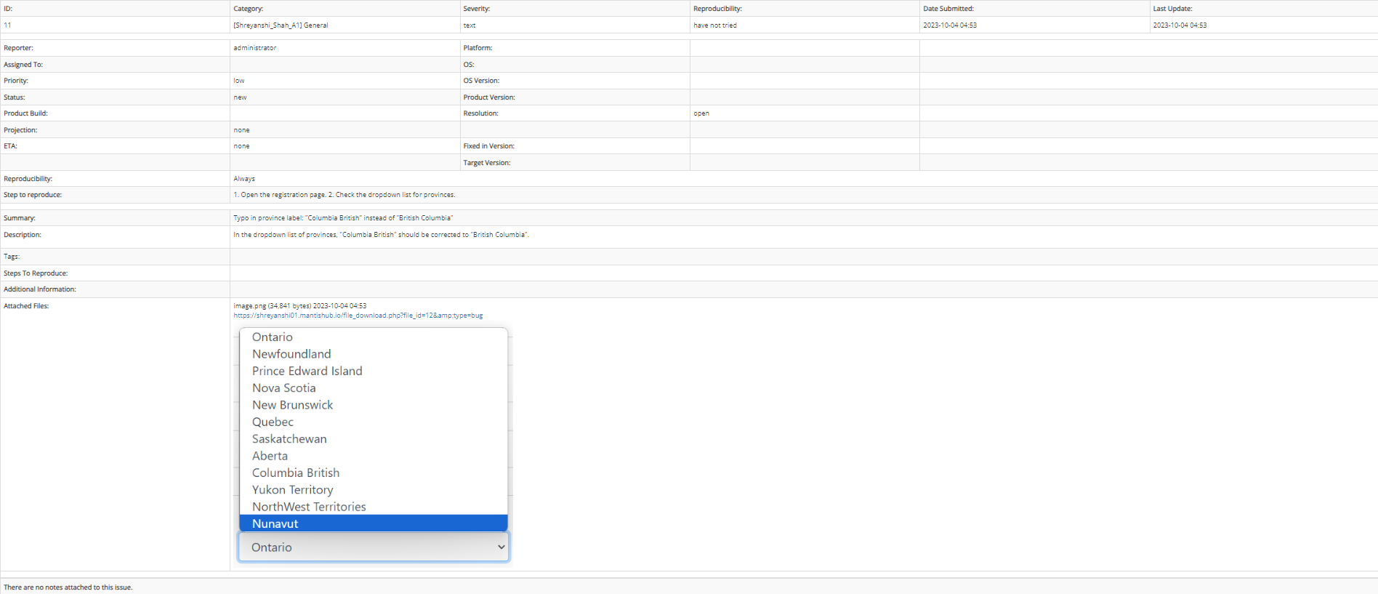

1. Defect 13 – Text

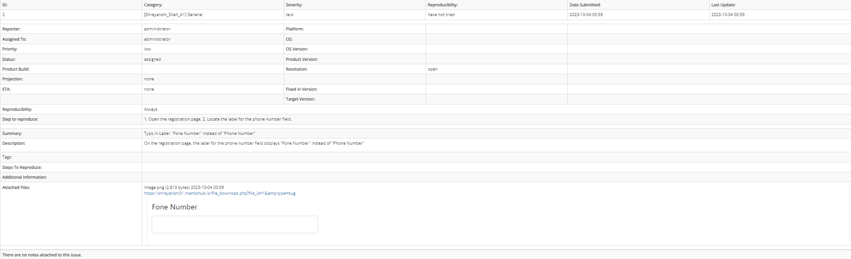

1. Defect 14 – Text

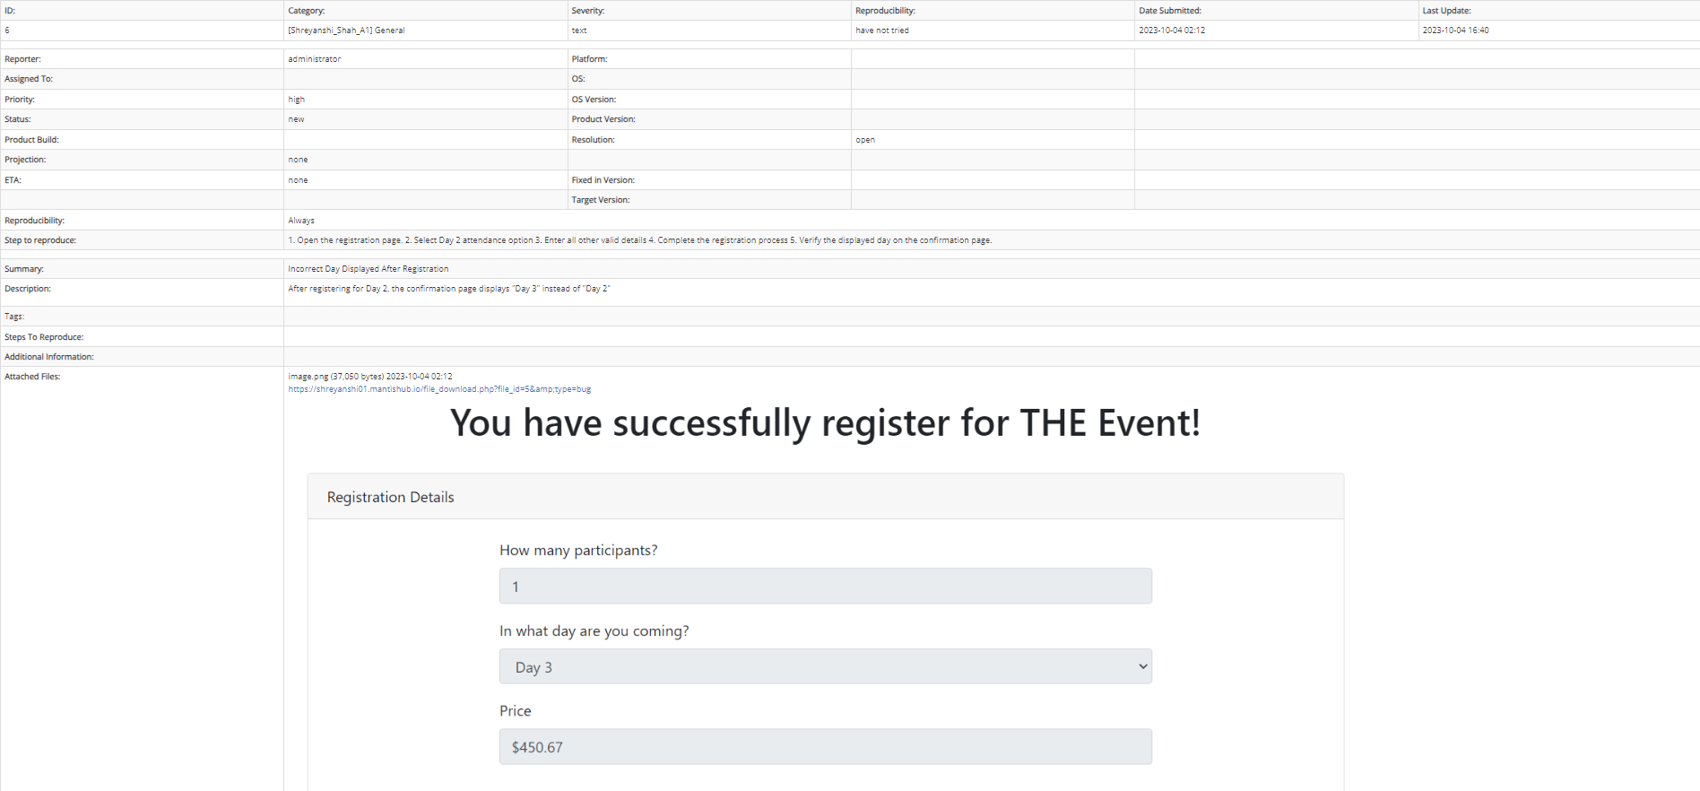

1. Defect 15 – Trival

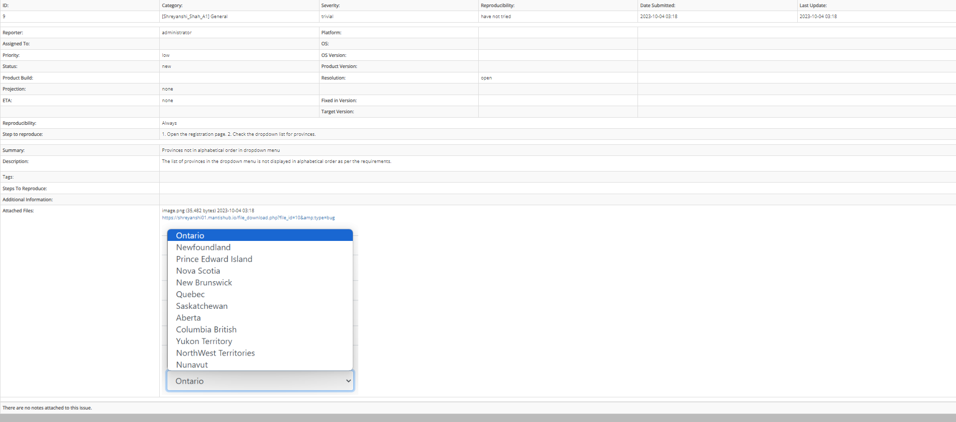

1. Feature 1

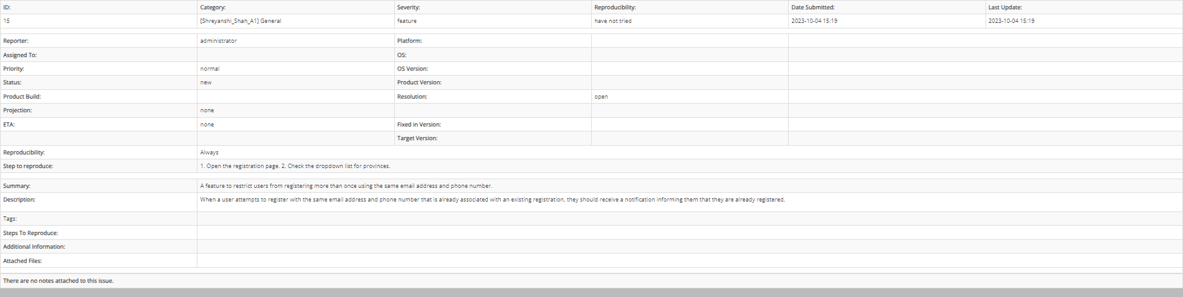

1. Feature 2

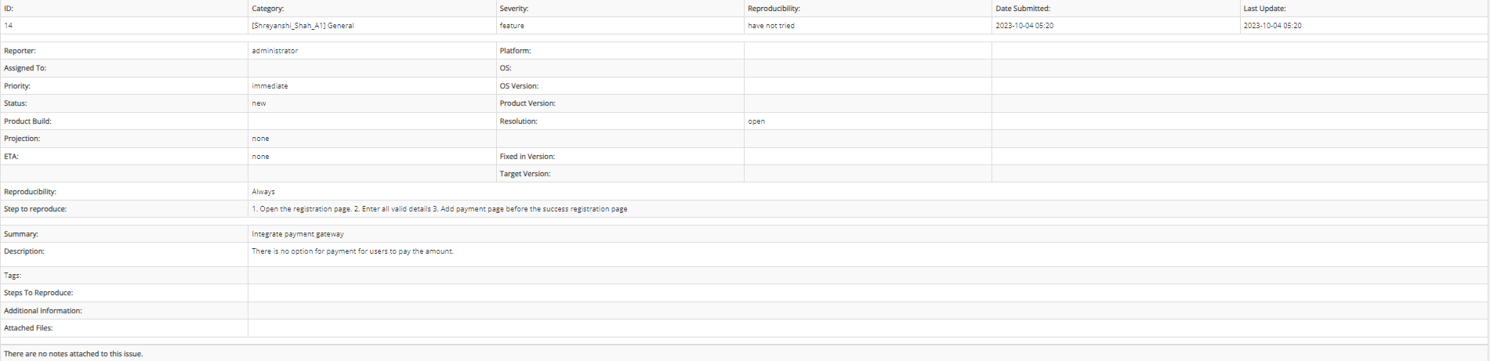

Summary Report – Synthesis

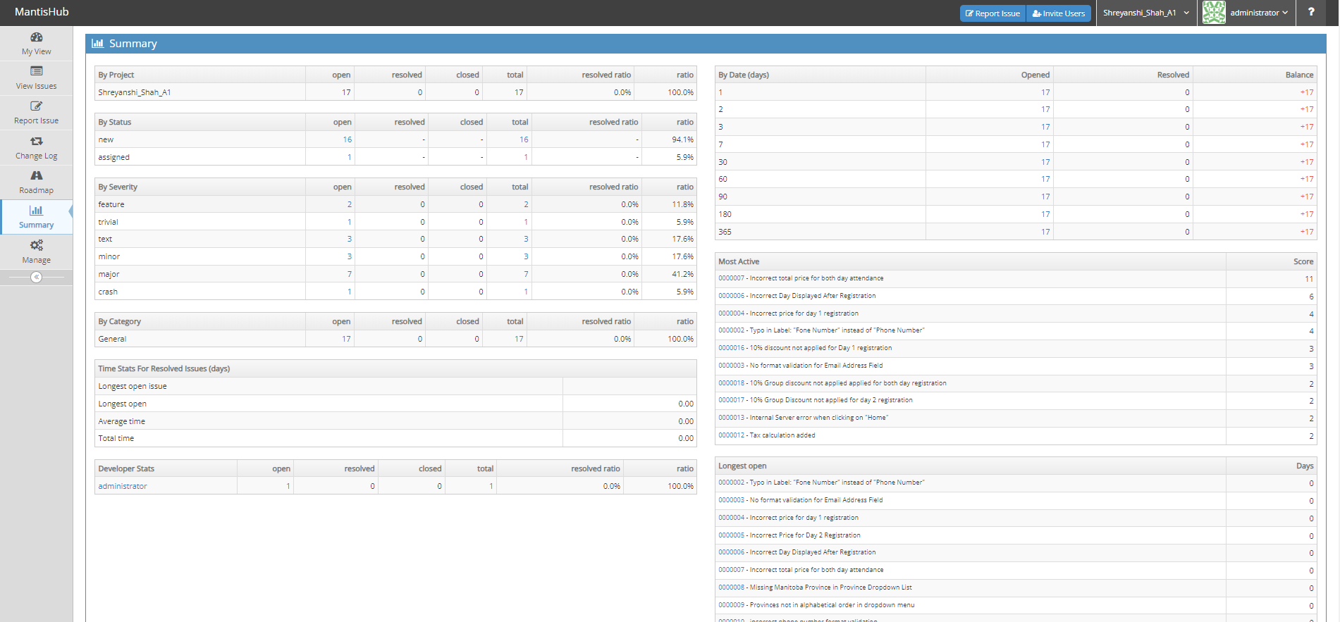

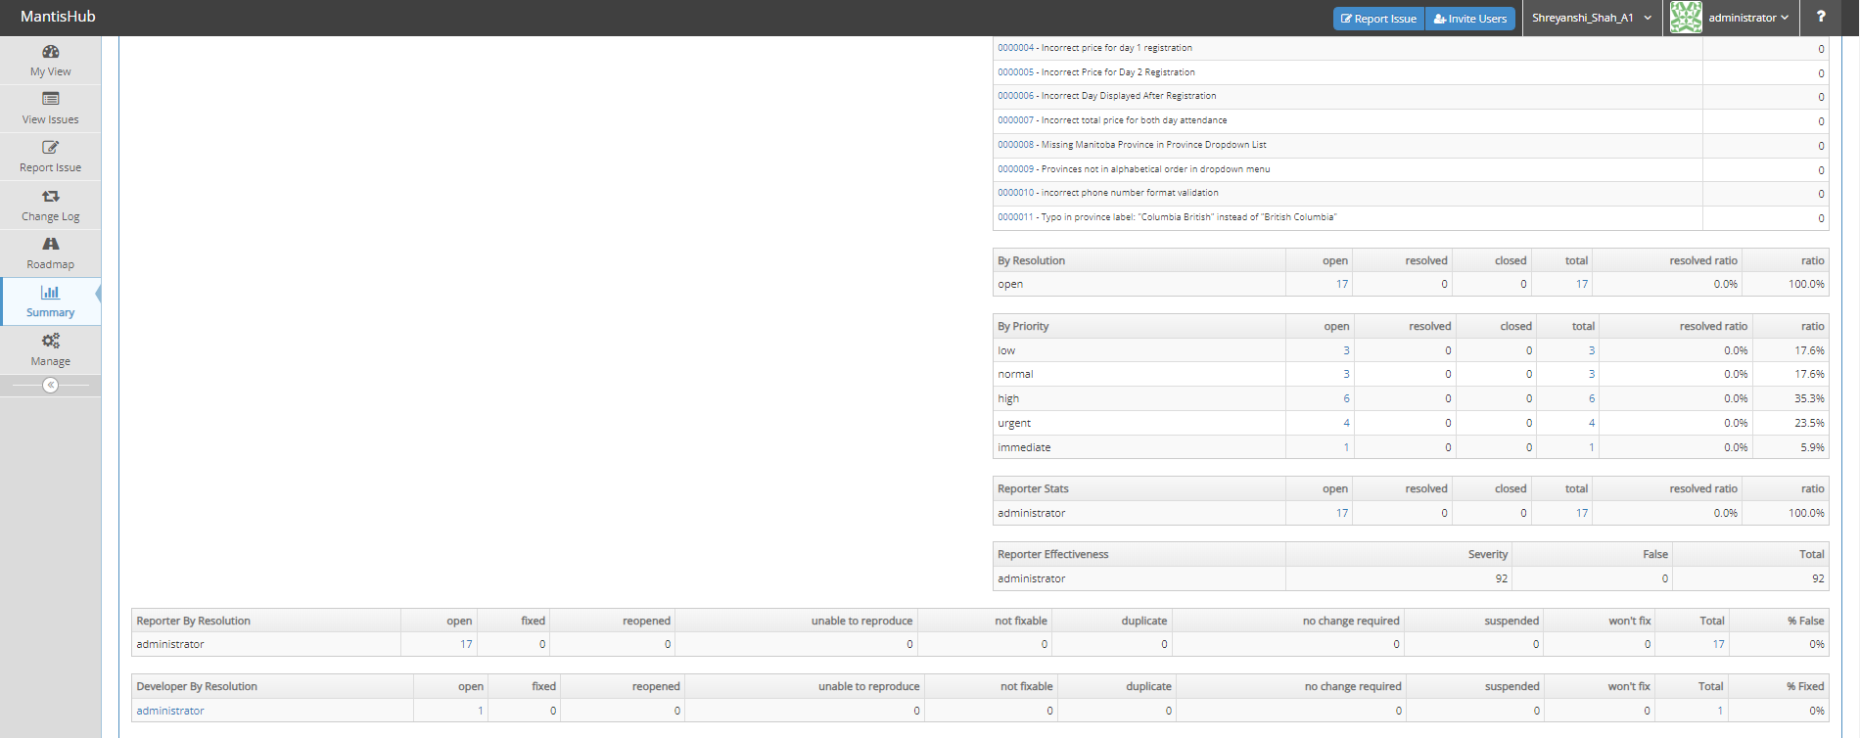

Summary Report – by severity

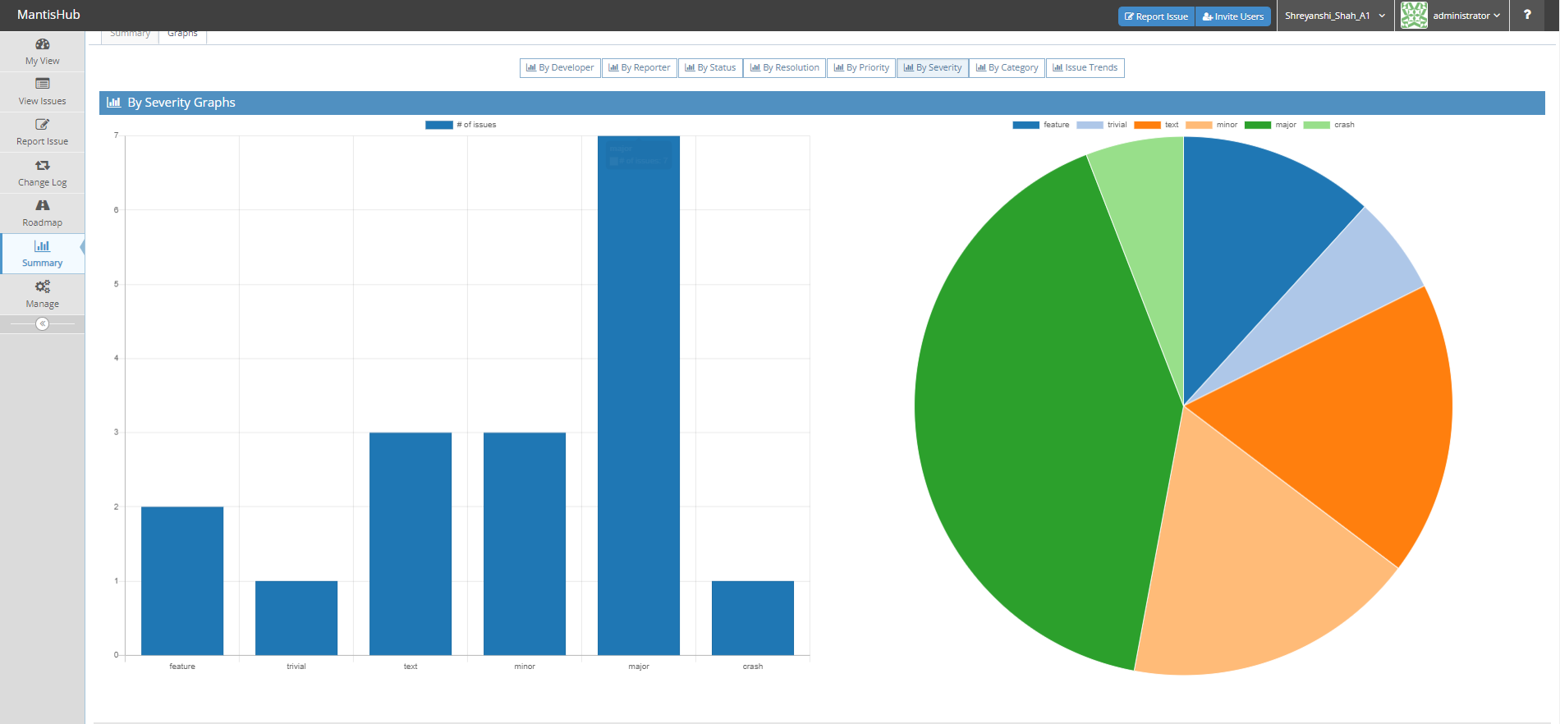

Analysis of the defect logged:

After carefully analysing the reports, it is quite clear that the application is not suitable for the deployment to end users. There are lot of defects of critical and high-severity levels, such as incorrect pricing calculation, breaking down on clicking home link, not applying 10% group discount to users, poses major risks to both functionality and customer satisfaction. For Instance, incorrect calculation of prices causes inconvenience to users and shows the potential underlying problems within the application’s logic and overall structure.

It is important to address these crucial issues before deploying the application. Once these issues are solved, a regression testing should be carried to ensure no new bugs are there. After solving all the defect and passing the test application will be ready to launch to end users. Emphasizing better user interface as well as good performance and functionality will give a satisfactory experience to user.