SOLUTION

1. How are inline and block elements different from each other?

A block level element always starts on a new line and also takes up the full width available. example are : <p> <div>

A inline level element is not start with new line its only take as much as we provide width size. Example are: <span>

1. Explain the difference between visibility:hidden and display:none

display : none means that content is not appear also the space is not allocated for that content.

Visibility : hidden means content is not appear but in that case the space is allocated for the content as much size that required.

1. Explain the clear and float properties.

We generally use float : left and float : right for positioning and formatting content

Like we need image and text in same frame so use right for image and left for text.

Clear : left

Clear : right

Clear : both

We use it to remove the float affect in web page.

1. explain difference between absolute, relative,fixed and static.

A) Static: All the elements are positioned static by default. They do not have any special positioning and are aligned as per the flow of content.

B) Relative: The element will be positioned relative to its normal position. The top, right, left and bottom will be used to position it relative to its normal position. The other elements will not be adjusted to create space for the element.

C) Fixed: The element will position fixed are aligned with respect to its view port. It means that they stay at a constant position even when the page is scrolled.

D) Absolute: It is almost the same as the fixed but the only difference is that it is positioned to its nearest viewport and not to other viewport like fixed.

1. Write the HTML code to create a table in which there are 4 columns( ID , Employee Name, Designation, Department) and at least 6 rows. Also do some styling to it.

Html file is attach in git branch -> (table.html).

1. Why do we use meta tags?

Meta tag is provided metadata which is helps to improve the search engine optimization by using certain keywords. And also metadata is not display in page but will be machine parsable.

Example:

<meta name=”keywords” content=”TOTHENEW, product eng, digital, ios developer”>

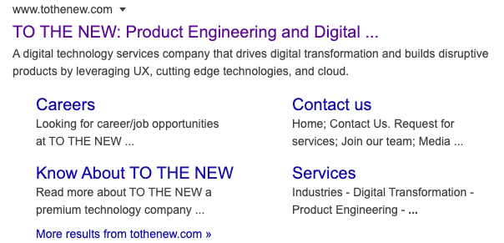

1. Explain box model.

box model is essentially a box that wraps around every HTML element.It consists of:

margins, borders, padding, and the actual content.

Div{

Padding : 30px;

Margin : 40px;

Border : 10px;

}

1. What are the different types of CSS Selectors?

CSS id selector: The id that is assigned shall be unique and is denoted by hash(#) symbol. When we have to give some different styling to a particular HTML tag, this can be used.

CSS class selector: The class selectors need not to be unique. It is denoted by dot(.) symbol. When some group of HTML tags needs to by styled, this can be used.

1. Define Doctype

Doctype is not an HTML tag. it is an instruction to the web browser which tell us about the version of html is use in that file.

Example: <!doctype html>

1. Explain 5 HTML5 semantic tags.

Semantic tags basically explain their meaning to the browser as well as to the developer just by their name.

The 5 HTML5 semantic tags :-

a.<table>

b.<header>

c.<footer>

d.<nav>

e.<time>

1. Create HTML for web-page.jpg (check resources, highest weightage for answers)

Html file is attach in git branch -> (que1.html, que1.css).

1. Create HTML for form.png (check resources, highest weightage for answers)

Html file is attach in git branch -> (que2.html, que2.css).