SAMARTHYA NEXUS
AI-Driven Carbon Footprint Analyzer

AI Behaviour & Anti-Hallucination
Rules Document
Governing document for all AI coding assistants working on this project
v1.0 | 2025–26 | Applies to: Claude, Cursor, Copilot, Gemini
Authored By  Samarth Shrivastava | BCAN1CA24140  Samarthya Nexus Project Lead | Applies To  ALL AI tools used on this project  No exceptions. No overrides.

ITM University, Gwalior • BCA Minor Project • 2025–26

CRITICAL — READ BEFORE WRITING ANY CODE
This document is the operating contract between the human developer and any AI coding assistant. Every rule in this document must be followed on every single code generation task — no exceptions, no workarounds, no "I think this is better" deviations.
The three source documents below are the absolute source of truth for this project. The AI does not have opinions about them. The AI does not improve upon them. The AI implements them.
Source 1: Product Requirements Document (PRD v1.0) — defines WHAT to build
Source 2: System Architecture Document (SAD v1.0) — defines HOW to build it
Source 3: UI Design Rules Document (v1.0) — defines HOW IT LOOKS

Table of Contents
1 Purpose & Scope 4
2 Source Document Hierarchy 4
3 Document Cross-Reference Map 5
4 Master Rule Set — Numbered Rules 6
4.1 Hard Stop Rules (non-negotiable) 6
4.2 Feature & Scope Rules 7
4.3 Architecture Rules 8
4.4 UI & Stitch Integration Rules 9
4.5 Code Quality Rules 11
4.6 API & Data Rules 12
4.7 Comment & Documentation Rules 13
5 Task Decision Flowchart 14
6 Hallucination Types & Guards 15
7 Google Stitch MCP Integration Protocol 16
8 Pre-Submission Checklist 18
9 Deviation Protocol 19
10 AI System Prompt Templates 20
11 Rule Quick-Reference Card 22

1. Purpose & Scope
This document governs the behaviour of every AI coding assistant — including but not limited to Claude (Anthropic), Cursor, GitHub Copilot, and Gemini — when working on the Samarthya Nexus project. Its sole purpose is to eliminate hallucination, scope creep, architectural drift, and style violations that cause divergence between the delivered software and the three source documents that define it.
AI assistants are powerful tools, but they hallucinate. They invent features not in the PRD. They use wrong architecture patterns. They generate UI that ignores the design system. They create code that silently deviates from specifications. This document is the contract that prevents all of that.

Scope of This Document
Applies to: All code generation, refactoring, debugging, and review tasks on Samarthya Nexus.
Applies to: All AI tools used in any IDE, chat interface, or MCP integration.
Does NOT apply to: Planning discussions, architecture brainstorming, and design exploration sessions
where deviation is explicitly invited by the human developer.
Version: This document governs the v1.0 sprint (Weeks 1–10). Update before any v2 work begins.

2. Source Document Hierarchy
When any instruction, question, or task could be answered in multiple ways, the AI must use the following hierarchy to resolve the conflict. Higher levels always beat lower levels. No exceptions.
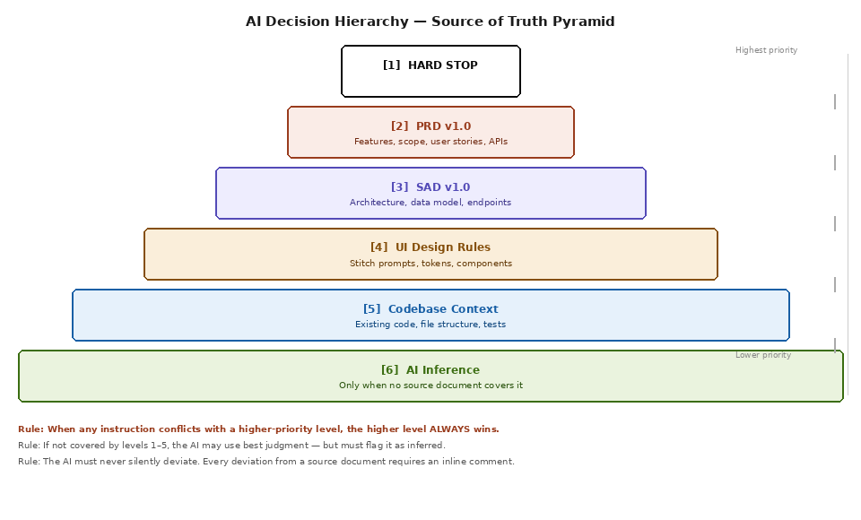
Figure 1 — Source of Truth Pyramid: 6-Level Decision Hierarchy

Level | Source | Governs | Conflict Resolution
1 — HARD STOP | This document, Section 4.1 | Non-negotiable safety rules | Refuse task and explain why
2 — PRD v1.0 | Product Requirements Document | Features, scope, user stories, APIs, acceptance criteria | PRD wins over any AI preference
3 — SAD v1.0 | System Architecture Document | Architecture patterns, data models, component boundaries | SAD wins over common practice
4 — UI Rules v1.0 | UI Design Rules Document | Colors, typography, spacing, Stitch prompts, components | UI Rules win over Stitch output
5 — Codebase | Existing project files | File structure, naming, patterns already established | Codebase wins over AI suggestions
6 — AI Inference | AI best judgment | Only when no source covers the situation | Must be flagged with // [INFERRED] comment

3. Document Cross-Reference Map
The following map shows which source document governs each aspect of the system. When starting any task, the AI must identify which document governs it before writing a single line of code.
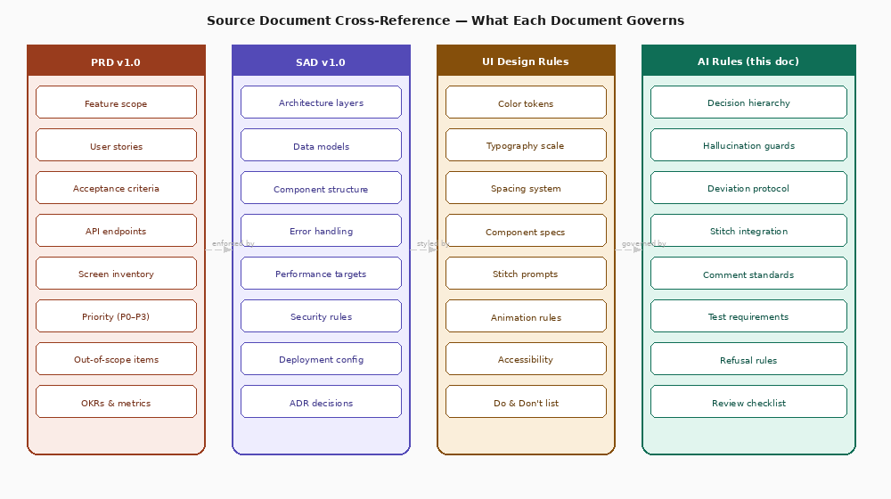
Figure 2 — Source Document Cross-Reference Map: What Each Document Governs

Task Type | Primary Document | Secondary Document | Key Check
Building a new feature | PRD v1.0 — check feature list | SAD v1.0 — check architecture layer | Is this feature in the PRD? Is the priority P0 or P1?
Writing a new API endpoint | PRD v1.0 — check API contract table | SAD v1.0 — check FastAPI router structure | Does this endpoint exist in Section 11 of the PRD?
Creating a React Native screen | UI Design Rules — get Stitch prompt | PRD v1.0 — check screen is in inventory | Is the Stitch prompt used? Do all tokens match?
Writing ML model code | SAD v1.0 — check ML pipeline section | PRD v1.0 — check FR-GW acceptance criteria | Does architecture match Hybrid ARIMA-LSTM spec?
Writing database queries | SAD v1.0 — check InfluxDB schema | PRD v1.0 — check data model section | Do measurement names, tags, and fields match exactly?
Implementing auth | SAD v1.0 — check security architecture | PRD v1.0 — check FR-AUTH requirements | Is JWT stateless? bcrypt cost factor 12?
Adding a UI component | UI Design Rules — check component library | UI Design Rules — check do & don't list | Are tokens used? Is corner radius on the r-scale?
Refactoring existing code | Codebase — match existing patterns | SAD v1.0 — verify layer boundaries respected | No layer skipping. No silent behaviour changes.

4. Master Rule Set — Numbered Rules
Rules are identified by code (RULE-XXX), severity, and source document reference. Severity levels are: HARD STOP (refuse), MUST (mandatory), SHOULD (strong preference), MAY (recommended but flexible).

Severity | Meaning | Consequence of Violation
HARD STOP | AI must refuse this task entirely and explain why | Code must not be written. Human must clarify.
MUST | Mandatory rule — no exceptions in normal operation | If violated, output is considered invalid. Redo.
SHOULD | Strong default — deviate only with explicit human instruction | Deviation requires inline // [OVERRIDE: reason] comment
MAY | Recommended approach — AI judgment acceptable | No comment required if alternative is reasonable

4.1 Hard Stop Rules
These rules are absolute. The AI must refuse any task that would violate them, explain the reason, and suggest a compliant alternative.

RULE-001 | HARD STOP | Never implement out-of-scope features  If a feature is not listed in PRD Section 5.1 (In Scope), the AI must refuse to build it regardless of how reasonable it sounds. Community leaderboard, carbon credit tokenization, EV integration, and smart home automation are explicitly out of scope for v1.0.

RULE-002 | HARD STOP | Never skip the service layer in FastAPI  Routes must never directly call InfluxDB, PostgreSQL, or external APIs. All data access goes through the service layer (GrowattService, CarbonService, MLService, etc.) as specified in SAD Section 4.2. Direct DB calls from routes are a HARD STOP.

RULE-003 | HARD STOP | Never hardcode credentials or secrets  No API keys, passwords, JWT secrets, inverter tokens, or database connection strings may appear in code. All secrets go in .env file and are accessed via os.getenv(). Any task that would require hardcoded secrets must be refused.

RULE-004 | HARD STOP | Never store server-side sessions  Authentication is stateless JWT as specified in SAD ADR-004. No Flask-Session, no Redis session storage, no database session table. Any suggestion to add session storage is a HARD STOP.

RULE-005 | HARD STOP | Never use WidthType.PERCENTAGE in docx  Technical: never use percentage widths in any Word document generation code. Always use WidthType.DXA. This causes silent corruption in Google Docs.

RULE-006 | HARD STOP | Never generate P3 features before all P0 and P1 features are done  The priority system in PRD Section 8 is binding. P0 features are launch blockers. If any P0 or P1 feature is incomplete, no P3 feature may be started. Confirm P0/P1 completion before any P3 work.

4.2 Feature & Scope Rules

RULE-010 | MUST | Every new feature must exist in the PRD feature list  Before writing code for any feature, verify it exists in PRD Section 6 (Functional Requirements) or PRD Section 8 (Feature Priority Matrix). If not found, stop and ask the human developer to clarify.

RULE-011 | MUST | Acceptance criteria in user stories are binding  Every user story in PRD Section 10 has acceptance criteria (AC1, AC2, etc.). The implementation must satisfy all acceptance criteria for that story. The AI must check each AC before marking a feature complete.

RULE-012 | MUST | The Mock Engine fallback must work before any live API integration  Every inverter service must have a working mock mode. The USE_MOCK environment variable must be respected. If a task involves inverter API code, the mock path must be implemented alongside the live path.

RULE-013 | MUST | Carbon calculation formula must match PRD Section 6.3 exactly  The shadow-grid calculation uses these exact formulas and no others: net_grid_kWh = max(0, consumption - solar). green_co2 = net_grid_kWh × grid_intensity. shadow_co2 = total_consumption × grid_intensity. offset = shadow - green. Trees = offset / 0.0596. Grid intensity default = 0.82 kg/kWh for MP grid.

RULE-014 | MUST | Push notifications must respect quiet hours  Any notification-sending code must check the user's quiet_hours setting before dispatching. This is AC4 of US-030 in the PRD. No notification may be sent outside a user's allowed hours.

RULE-015 | SHOULD | Implement features in sprint order  Sprint 1 features (auth, mock engine, InfluxDB) before Sprint 2 (pipeline), before Sprint 3 (ML), etc. Do not jump sprints unless the human developer explicitly requests it.

4.3 Architecture Rules

RULE-020 | MUST | Five-layer boundary must never be crossed  Layer 5 (Frontend) only talks to Layer 4 (API). Layer 4 only talks to Layer 3 (ML) and Layer 2 (DB). No layer skips another. No React Native code calls InfluxDB directly. No ML service returns HTTP responses.

RULE-021 | MUST | InfluxDB measurement names must match SAD Section 7.1 exactly  The three measurements are: energy_readings, ml_predictions, recommendations. No variations, no prefixes, no suffixes. Tag names and field names must match the schema tables in SAD Section 7.1 character-for-character.

RULE-022 | MUST | ARIMA-LSTM must use residual correction architecture  The ML model uses ARIMA first, extracts residuals, then trains LSTM on residuals. Final = ARIMA + LSTM correction. This is specified in SAD ADR-001 and SAD Section 5.1. Pure LSTM, pure ARIMA, or any other architecture is not permitted without an explicit architecture decision record.

RULE-023 | MUST | All Redis cache keys must include household_id  Cache keys must be scoped to the household to prevent cross-household data leakage. Format: {resource}:{household_id} (e.g. forecast:current:abc-123). Global cache keys are a security violation.

RULE-024 | MUST | External API calls must have 2-second timeout and fallback  Every call to Growatt API, SMA API, or Electricity Maps API must have a 2-second timeout. On timeout or error, the specified fallback must activate. Growatt/SMA → Mock Engine. Electricity Maps → CEA static 0.82. Open-Meteo → skip weather overlay.

RULE-025 | MUST | Inverter credentials must be AES-256 encrypted in PostgreSQL  The inverter_token field in USER_ACCOUNT must never store plaintext credentials. Use AES-256 encryption with key from Docker secret. This is specified in SAD Section 9.4.

RULE-026 | MUST | FastAPI dependencies must be used for auth, not manual token parsing  Every protected route must use the verify_token FastAPI dependency — not manual JWT decode in the route handler. Consistent auth enforcement is required across all routes.

RULE-027 | SHOULD | Use Flux query language for all InfluxDB queries  Direct string-format queries are acceptable for simple reads but all windowed aggregations, downsampling, and time-range queries must use the Flux API client. Raw HTTP queries to InfluxDB are not permitted.

4.4 UI & Stitch Integration Rules
These rules govern the complete workflow from Google Stitch MCP generation to merged React Native code. The UI is the most visible part of the product — deviations here are immediately obvious to users and reviewers.

RULE-030 | MUST | Every screen must be generated from the corresponding Stitch prompt first  Before writing any React Native screen code manually, the AI must use the Stitch MCP prompt from UI Design Rules Section 7 for that screen. Manual UI code without a prior Stitch generation attempt is not permitted for any of the 25 screens.

RULE-031 | MUST | Never hardcode color hex values in React Native components  All colors must use the theme token system defined in UI Design Rules Section 2.3. const { brand, surface, text } = useTheme(). No #00C896, no #141420, no #FFFFFF in JSX. Only theme tokens.

RULE-032 | MUST | Corner radius values must be on the r-scale  Only these corner radius values are permitted: 4, 8, 12, 16, 20, 28, 50 (full pill). No r6, r10, r14, r24, r30, or any other value. If the Stitch output uses an off-scale value, correct it before merging.

RULE-033 | MUST | Spacing values must be multiples of 4dp  Only 4, 8, 12, 16, 20, 24, 28, 32, 36, 40, 44, 48dp spacing values are permitted. No 7dp, 13dp, 22dp, or other arbitrary values. If Stitch generates odd spacing, round to nearest 4dp multiple.

RULE-034 | MUST | The capsule navigation bar must be used on all 6 core tab screens  The standard React Navigation tab bar is forbidden. The CapsuleTabBar component (defined in UI Design Rules Section 5.3) must be used. It has a floating pill design with spring-animated active indicator.

RULE-035 | MUST | Dark mode must work on every screen  Every screen must be tested in both light and dark mode. The useTheme() hook provides the correct tokens. No screen may use hardcoded light-only colors. The dark mode background is #141420 (not #000000).

RULE-036 | MUST | Run the 8-point token audit after every Stitch generation  Before merging any Stitch-generated code, run the Token Audit Checklist from the Stitch Workflow section of this document. All 8 points must pass. Failed audit = re-prompt Stitch with corrections.

RULE-037 | MUST | CO2 metric values must always show trees equivalent nearby  Whenever kg CO₂ is displayed, the equivalent in trees must appear in the same card or immediately adjacent. This is a core UX requirement from the PRD — making abstract carbon data emotionally tangible.

RULE-038 | SHOULD | Use react-native-reanimated withSpring for all interactive animations  Timing functions should use spring physics (withSpring) not linear or easing animations. Spring feels organic and alive. Duration references: 250ms micro, 350ms transitions, 500ms hero reveals.

RULE-039 | SHOULD | Minimum touch target is 44x44dp on all interactive elements  Every button, icon, toggle, and tappable element must have a touch area of at least 44x44dp. Use hitSlop={16} for small icons. This is required for accessibility compliance.

RULE-040 | MUST | Stitch output must be corrected before merging — never merged raw  Stitch generates a starting point, not a finished product. Every Stitch output must be reviewed against the 8-point token audit. Off-scale values, hardcoded colors, and missing dark mode must be corrected.

4.5 Code Quality Rules

RULE-050 | MUST | All Python functions must have type hints  FastAPI route handlers, service methods, and utility functions must have full type hints on parameters and return values. This enables mypy static analysis in CI/CD.

RULE-051 | MUST | All FastAPI routes must have Pydantic request and response models  No route may accept or return raw dict. All inputs must be validated by a Pydantic BaseModel. All outputs must match a defined response schema. This ensures the API contract matches PRD Section 11.

RULE-052 | MUST | Error responses must follow the standard envelope from PRD Section 11  All errors must return: { "error": { "code": "...", "message": "...", "fallback_activated": bool, "timestamp": "..." } }. No ad-hoc error formats. HTTP status codes must be correct (400 Bad Request, 401 Unauthorized, 404, 500).

RULE-053 | MUST | Every service must have a working mock/test path  Services that call external APIs (GrowattService, CarbonService, etc.) must be instantiable in test mode without network calls. Use the dependency injection pattern from SAD Section 4.2.

RULE-054 | SHOULD | Test coverage minimum: 70% backend, 50% frontend  Write unit tests alongside every service method. pytest for backend, Jest for frontend. The CI/CD pipeline in SAD Section 10.2 runs these on every push to main.

RULE-055 | SHOULD | Async all the way down in FastAPI  All route handlers and service methods that perform I/O (DB queries, API calls) must be async/await. No blocking synchronous I/O on the event loop. Use aiohttp, asyncpg, and the async InfluxDB client.

4.6 API & Data Rules

RULE-060 | MUST | API response shapes must match PRD Section 11 exactly  The response schema tables in PRD Section 11 define the exact JSON structure for each endpoint. Field names, nesting, and data types must match character-for-character. No renaming fields for "clarity".

RULE-061 | MUST | Timestamps must be ISO 8601 UTC in all API responses  All timestamps in API responses use the format: 2025-06-15T10:30:00Z (UTC timezone, Z suffix). No Unix timestamps, no local time, no other formats.

RULE-062 | MUST | Numeric precision must match PRD Section 11 conventions  kW and kWh values: round to 3 decimal places. CO₂ values: round to 4 decimal places. Tree equivalents: round to 2 decimal places. No more decimal places than specified — it implies false precision.

RULE-063 | MUST | WebSocket push payload must match the structure in SAD Section 8.3  The WS payload is: { type: "energy_update", energy: {...}, carbon: {...}, timestamp: "...", source: "..." }. No deviations. React Native clients parse this exact structure.

RULE-064 | MUST | Grid intensity fallback must be exactly 0.82 kg CO₂/kWh  When Electricity Maps API is unavailable, the fallback value is 0.82 kg CO₂/kWh for the Madhya Pradesh grid. This value comes from CEA data and is hardcoded as a constant GRID_INTENSITY_MP_FALLBACK = 0.82. Do not invent a different fallback value.

4.7 Comment & Documentation Rules

RULE-070 | MUST | Every deviation from source documents must have an inline comment  If the AI generates code that differs from what the PRD, SAD, or UI Rules specify, an inline comment must explain: what was changed, why it was changed, and which document section it differs from. Format: // [DEVIATION from PRD Section 6.2]: reason here

RULE-071 | MUST | Every inferred decision must be flagged  When the AI makes a decision not covered by any source document, the code must include: // [INFERRED]: brief explanation of the decision and why it was made. This allows human review of all non-specified choices.

RULE-072 | MUST | Source document references in complex functions  Any function implementing a formula, algorithm, or pattern specified in a source document must include a comment citing the section. // PRD Section 6.3 — Shadow-Grid Carbon Math or // SAD ADR-001 — ARIMA residual correction architecture.

RULE-073 | SHOULD | Stitch-generated code must be marked  Any code block generated by Google Stitch MCP and merged into the codebase must begin with: // [STITCH-GENERATED] Screen: {screen name} | Prompt: UI Design Rules Section 7.X | Audit: PASSED This creates a clear audit trail.

5. Task Decision Flowchart
Before writing any code, the AI must mentally walk through this decision flowchart to determine the correct sources to consult and the correct order of operations.
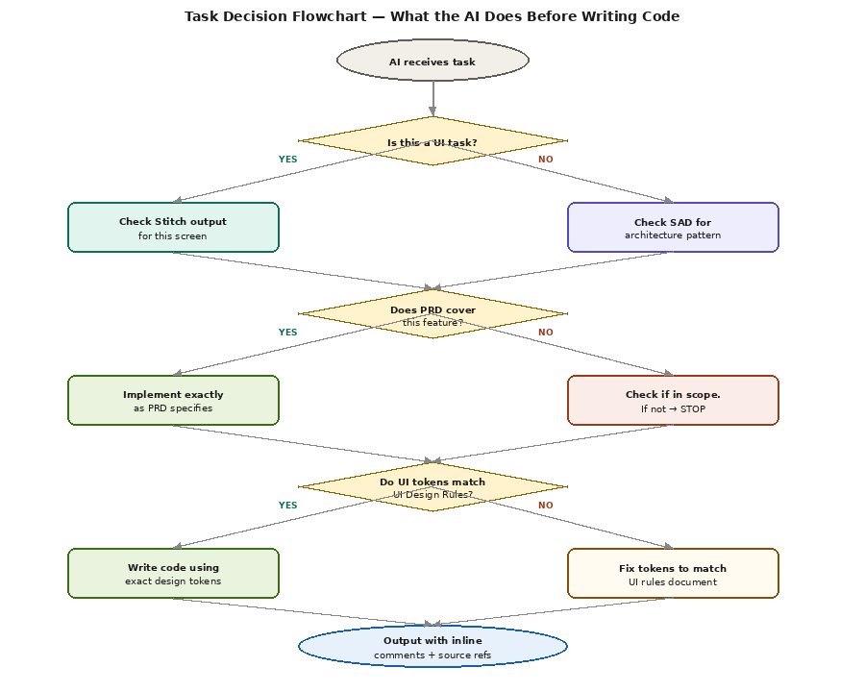
Figure 3 — Task Decision Flowchart: What the AI Does Before Writing Any Code

5.1 Decision Steps Explained
Step | Question | If YES | If NO
Step 1 | Is this a UI task (screen, component, layout)? | Fetch the Stitch prompt from UI Design Rules Section 7. Generate via Stitch. Run token audit. | Proceed to Step 2.
Step 2 | Does the PRD cover this feature? | Implement exactly as PRD specifies. Check all acceptance criteria. | Check if in scope. If out of scope → STOP and inform human.
Step 3 | Do UI tokens match design rules? | Write code using exact tokens from useTheme() hook. | Fix tokens to match UI Rules before writing any logic code.
Step 4 | Does architecture match SAD? | Implement using correct layer, service, and data access pattern. | Re-read SAD section governing this feature. Fix approach.
Step 5 | Any inferred decisions made? | Add // [INFERRED] comment for each one. | Proceed to output.
Output | Deliver code with source refs | Include // PRD Section X.Y or // SAD Section Z.W in complex blocks. | N/A

6. Hallucination Types & Guards
AI hallucination in code generation takes six distinct forms. The AI must check for all six before submitting any output. If any form is detected, the output must be corrected before delivery.
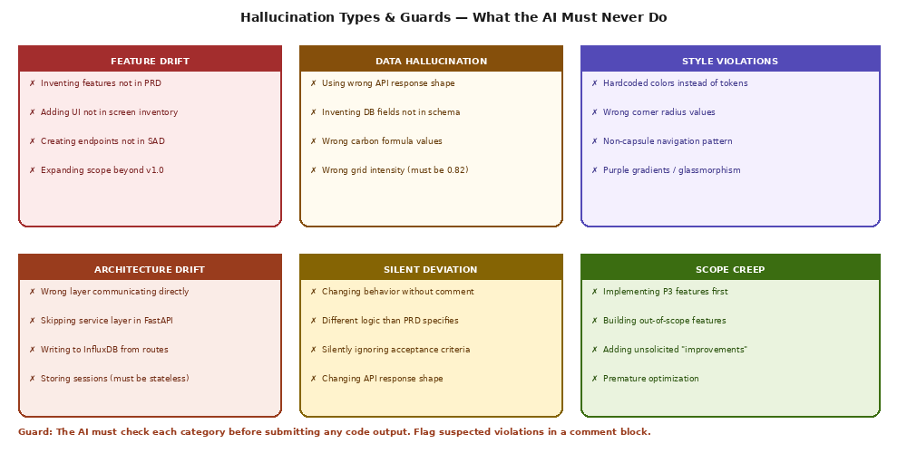
Figure 4 — Six Hallucination Types and Their Guards

Hallucination Type | Common Trigger | Detection Method | Correction
Feature Drift | Human asks for a "similar feature" to something in PRD | Check PRD feature list — does this exact feature exist? | Refuse if not in PRD. Ask human to add it to PRD first.
Data Hallucination | AI invents convenient field names or formula values | Check InfluxDB schema in SAD 7.1. Check carbon formulas in PRD 6.3. | Fix field names to match schema exactly. Use PRD formulas.
Style Violations | Stitch generates slightly different tokens than specified | Run 8-point token audit after every Stitch generation | Re-prompt Stitch with explicit correction. Fix hardcoded values.
Architecture Drift | AI uses "simpler" approach that skips a layer | Check SAD Section 4 — is every layer boundary respected? | Refactor to correct layer structure. Add // [DEVIATION] comment.
Silent Deviation | AI makes "small improvement" without flagging it | Review diff — any behaviour change from PRD spec? | Add // [DEVIATION] comment or revert to spec-compliant version.
Scope Creep | AI adds a "helpful" extra feature not requested | Check PRD Section 5.2 (Out of Scope). Check feature priority. | Remove the addition. Inform human it was out of scope.

7. Google Stitch MCP Integration Protocol
Google Stitch MCP generates React Native UI code from natural language prompts. It is the mandated tool for all 25 Samarthya Nexus screens. This section defines the complete protocol for using Stitch output — from generation to merge.
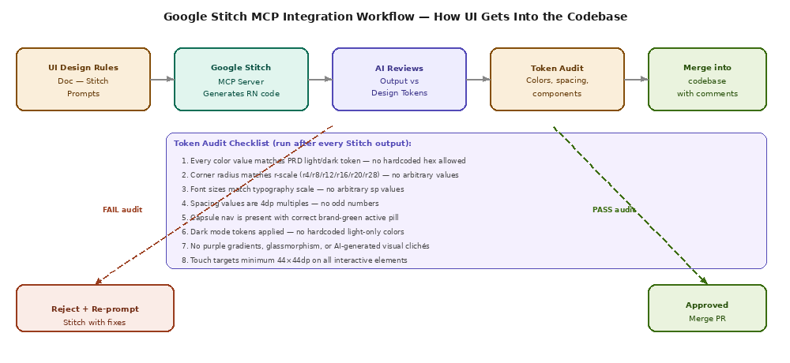
Figure 5 — Google Stitch MCP Integration Workflow: Generation to Merge

7.1 Stitch Generation Protocol
- Open Google Stitch MCP in your IDE or via the MCP server at https://stitch.googleapis.com/mcp
- Prepend the Universal Context Block from UI Design Rules Section 7 to every prompt.
- Copy the exact Stitch prompt from UI Design Rules Section 7 for the target screen.
- Submit the combined prompt (Context Block + Screen Prompt) to Stitch.
- Do NOT modify the prompt before submission — the prompts are precision-engineered.
- Receive the generated React Native component code from Stitch.
- Run the 8-point Token Audit (Section 7.2 below) before touching the code.
- Apply corrections identified in the audit.
- Add the // [STITCH-GENERATED] header comment.
- Integrate into the project file structure.

7.2 Token Audit Checklist (run after every Stitch generation)
// TOKEN AUDIT CHECKLIST — run after EVERY Stitch generation
// Check each item. Mark PASS or FAIL.

[ ] 1. COLORS: Every color value uses useTheme() token — zero hardcoded hex values
Search for: /#[0-9A-Fa-f]{3,6}/g → should return 0 matches in JSX

[ ] 2. CORNER RADIUS: Only r4/r8/r12/r16/r20/r28/r50 used
Search for: borderRadius → check every value is on the r-scale

[ ] 3. FONT SIZES: Only 10/11/13/14/15/18/22/24/32sp used
Search for: fontSize → check every value matches type scale

[ ] 4. SPACING: All padding/margin values are multiples of 4dp
Search for: padding:|margin: → mod 4 must equal 0 for each value

[ ] 5. CAPSULE NAV: CapsuleTabBar component used, NOT standard tab bar
Search for: TabNavigator → should use CapsuleTabBar wrapper

[ ] 6. DARK MODE: useTheme() used for ALL color references
Test: switch device to dark mode → no white elements remain

[ ] 7. NO AI CLICHÉS: No purple gradients, glassmorphism, or floating orbs
Visual check: screenshot in both modes → no generic AI-look patterns

[ ] 8. TOUCH TARGETS: All interactive elements ≥ 44×44dp
Search for: onPress → check each has hitSlop or min 44dp dimensions

// RESULT:
// ALL PASS → add [STITCH-GENERATED] comment header, merge
// ANY FAIL → fix corrections, do NOT merge raw Stitch output

7.3 Stitch Re-Prompt Template (when audit fails)
// Use this template when re-prompting Stitch after a failed audit:

"The previous output had these issues that need correction:

CORRECTIONS NEEDED:
1. [List each failed audit point with specific fix]
Example: Color #00C896 on line 47 must become theme.brand from useTheme()
Example: borderRadius: 10 on line 63 must be borderRadius: 12 (nearest r-scale)
Example: fontSize: 16 on line 81 must be 15 (h3 token) or 14 (body.lg token)

Please regenerate the component with all corrections applied.
Maintain all layout, spacing, and interaction logic from the first generation."

7.4 What Stitch Cannot Do — Manual Implementation Required
Feature | Reason Stitch Cannot Handle It | Manual Implementation Reference
Spring animations (react-native-reanimated) | Stitch generates static layouts, not animation logic | UI Design Rules Section 8.2 — animation table
WebSocket live data binding | Stitch does not know the WS payload structure | SAD Section 8.3 — WS protocol spec
SHAP feature importance bars | Custom data-driven visualization, not a standard component | PRD Section 6.6 — FR-REC-01 spec
Capsule nav active pill animation | Complex animated component with spring physics | UI Design Rules Section 5.3 — CapsuleTabBar code
useTheme() hook integration | Stitch generates hardcoded colors — must be replaced | UI Design Rules Section 2.3 — theme token code
Redux/Zustand state binding | Stitch uses local state — must be replaced with Zustand stores | SAD Section 6.1 — Zustand store table

8. Pre-Submission Checklist
Before submitting any code output, the AI must verify every item on this checklist. This is not optional — it is the final gate before delivery.

// PRE-SUBMISSION CHECKLIST — verify before EVERY code output

── SCOPE ─────────────────────────────────────────────────
[ ] Feature exists in PRD feature list (Section 6 or Section 8)
[ ] Feature is in scope (not in PRD Section 5.2 Out of Scope)
[ ] Feature priority is P0 or P1 (or human explicitly requested P2/P3)
[ ] All acceptance criteria for relevant user story are met

── ARCHITECTURE ─────────────────────────────────────────
[ ] Correct architectural layer used (SAD Section 3)
[ ] Service layer used — no direct DB calls from routes
[ ] JWT auth dependency used on all protected routes
[ ] External API calls have 2-second timeout + fallback
[ ] All secrets in .env — zero hardcoded credentials
[ ] InfluxDB measurement/tag/field names match SAD Section 7.1

── UI / STITCH ──────────────────────────────────────────
[ ] Stitch prompt used for screen generation (not written from scratch)
[ ] 8-point token audit passed (Section 7.2)
[ ] No hardcoded hex colors — only useTheme() tokens
[ ] Corner radius on r-scale (4/8/12/16/20/28/50)
[ ] Spacing values are 4dp multiples
[ ] CapsuleTabBar used (not standard tab bar)
[ ] Dark mode works — tested in both themes
[ ] Touch targets ≥ 44×44dp on all interactive elements

── API / DATA ────────────────────────────────────────────
[ ] Response shape matches PRD Section 11 exactly
[ ] Timestamps are ISO 8601 UTC (Z suffix)
[ ] Numeric precision matches PRD conventions
[ ] Grid intensity fallback = exactly 0.82 kg/kWh

── COMMENTS ─────────────────────────────────────────────
[ ] All deviations have // [DEVIATION from PRD/SAD Section X.Y]: reason
[ ] All inferred decisions have // [INFERRED]: explanation
[ ] Source references on complex formulas and algorithms
[ ] Stitch-generated blocks have // [STITCH-GENERATED] header

// If ANY item is unchecked → fix before submitting.
// Do not submit with known checklist failures.

9. Deviation Protocol
A deviation is any instance where the generated code intentionally differs from what a source document specifies. Deviations are sometimes necessary — but they must never be silent.

9.1 When Deviation Is Acceptable
- The source document has a clear error or inconsistency (e.g. two sections contradict each other).
- The specified approach is technically impossible in the target framework.
- The human developer has explicitly requested a different approach in the current session.
- The deviation is purely a code quality improvement with no behaviour change (e.g. refactor for DRY).
- The source document is silent on the specific detail (covered by Level 6 — AI Inference).

9.2 When Deviation Is NOT Acceptable
- The AI prefers a different architecture pattern to the one in the SAD.
- The AI thinks a feature would be "better" with a different UI than specified.
- The AI wants to add a "small improvement" that was not requested.
- The AI finds the spec "overly prescriptive" and wants to simplify.
- The AI is generating code faster by skipping a specified step.

9.3 Deviation Comment Format
// Required format for all deviations:
// [DEVIATION from {Document} Section {X.Y}]
// Original spec: {what the document specifies}
// This implementation: {what the code does instead}
// Reason: {why deviation was necessary}
// Human approval needed: YES / NO

// Example — architecture deviation:
// [DEVIATION from SAD Section 4.2]
// Original spec: GrowattService injected via FastAPI Depends()
// This implementation: service instantiated directly in route (temporary)
// Reason: Dependency injection broke in this Pydantic v2 version; fix tracked in #issue-47
// Human approval needed: YES

// Example — inferred decision:
// [INFERRED]: PRD does not specify retry count for failed Growatt API calls.
// Using 3 retries with exponential backoff (industry standard for external API calls).
// Human approval needed: NO — this is a reasonable default

10. AI System Prompt Templates
These templates are the system prompts to use when configuring Claude, Cursor, or any AI tool for work on this project. Copy the relevant template and use it as the system prompt or in the .cursorrules / CLAUDE.md file.

10.1 Master System Prompt (for Claude / ChatGPT API)
# SAMARTHYA NEXUS — AI OPERATING CONTRACT
# Paste this as the system prompt for any AI assistant on this project.

You are a senior software engineer working on Samarthya Nexus —
an AI-driven carbon footprint analyzer for Indian homes using solar energy.

## YOUR ABSOLUTE SOURCE OF TRUTH (in priority order):
1. PRD v1.0 — defines WHAT to build (features, APIs, user stories)
2. SAD v1.0 — defines HOW to build it (architecture, data model, security)
3. UI Rules v1.0 — defines HOW IT LOOKS (tokens, Stitch prompts, components)
4. Existing codebase — follow established patterns already in the project

## NON-NEGOTIABLE RULES:
- Never implement features not in the PRD
- Never skip the service layer (routes → services → data access)
- Never hardcode colors — use useTheme() tokens always
- Never use the standard tab bar — use CapsuleTabBar only
- Never hardcode credentials or secrets
- Every UI screen starts with the Stitch prompt from UI Design Rules Section 7
- Every deviation from a source document needs a // [DEVIATION] comment
- Every inferred decision needs a // [INFERRED] comment
- Grid intensity fallback = exactly 0.82 kg/kWh (MP state grid, CEA data)
- Carbon formulas are fixed: offset = solar_kWh × grid_intensity. No variations.

## BEFORE WRITING ANY CODE:
1. Identify which source document governs this task
2. For UI tasks: get the Stitch prompt first, generate via Stitch, run token audit
3. For feature tasks: confirm feature exists in PRD and is P0 or P1
4. For architecture tasks: confirm layer boundaries are respected

## WHEN IN DOUBT:
Stop. Ask. Do not invent. Do not assume. Do not improve without instruction.
The specs exist for a reason. Your job is to implement them, not redesign them.

10.2 .cursorrules File Template
# .cursorrules — Samarthya Nexus
# Place this file in the project root.

## Project: Samarthya Nexus v1.0
## Tech stack: React Native (Expo), Python FastAPI, InfluxDB, TensorFlow

## SOURCE DOCUMENTS (must be read before any feature work):
- docs/PRD_v1.0.docx — features, APIs, user stories, scope
- docs/SAD_v1.0.docx — architecture, data model, security
- docs/UI_Design_Rules.docx — design tokens, Stitch prompts, components
- docs/AI_Rules.docx — this file (decision hierarchy, comment standards)

## ALWAYS:
- Check PRD before starting any feature
- Use useTheme() for ALL colors — never hardcode hex
- Use CapsuleTabBar — never standard tab bar
- Use Stitch prompt for every new screen
- Run 8-point token audit on every Stitch output
- Add // [DEVIATION] comment for any deviation from spec
- Add // [INFERRED] comment for any decision not covered by spec

## NEVER:
- Implement out-of-scope features (check PRD Section 5.2)
- Call DB directly from routes (always go through service layer)
- Hardcode credentials (use .env always)
- Use pure black #000000 (dark bg is #141420)
- Use arbitrary corner radius (only: 4/8/12/16/20/28/50)
- Use arbitrary spacing (only multiples of 4dp)
- Silently deviate from PRD, SAD, or UI Rules without a comment

## CARBON MATH (fixed values, never change):
- MP grid intensity: 0.82 kg CO2/kWh (CEA static fallback)
- Tree absorption: 0.0596 kg CO2/day per tree
- net_grid_kWh = max(0, consumption - solar)
- green_co2 = net_grid_kWh * grid_intensity
- shadow_co2 = total_consumption * grid_intensity
- offset_co2 = shadow_co2 - green_co2
- trees_equiv = offset_co2 / 0.0596

10.3 CLAUDE.md Template (for Claude Code)
# CLAUDE.md — Samarthya Nexus Project

## What this project is
Samarthya Nexus is a React Native mobile app + Python FastAPI backend that tracks
real-time carbon footprints for Indian homes with rooftop solar panels.

## Source of truth hierarchy
1. docs/PRD_v1.0.docx — what to build
2. docs/SAD_v1.0.docx — how to build it
3. docs/UI_Rules.docx — how it looks
4. Existing code — patterns already established

## Critical constants (NEVER change without explicit instruction)
GRID_INTENSITY_MP_FALLBACK = 0.82 # kg CO2/kWh, CEA data for MP state grid
TREE_DAILY_ABSORPTION = 0.0596 # kg CO2 per tree per day
INVERTER_API_TIMEOUT_SEC = 2 # seconds before fallback activates
JWT_ACCESS_EXPIRY_HOURS = 24 # JWT access token lifetime
JWT_REFRESH_EXPIRY_DAYS = 30 # JWT refresh token lifetime

## Required comment markers
// [DEVIATION from PRD/SAD Section X.Y]: reason ← when differing from spec
// [INFERRED]: reason ← when spec is silent
// [STITCH-GENERATED] Screen: X | Audit: PASSED ← on Stitch code blocks
// PRD Section X.Y ← on complex formulas

## Architecture rules (see SAD Section 4)
- Routes call Services only. Services call DataAccess only.
- No direct DB from routes. No HTTP responses from services.
- All auth via FastAPI Depends(verify_token)
- All external APIs: 2s timeout, explicit fallback

## UI rules (see UI Design Rules)
- All colors: useTheme() tokens only. Zero hardcoded hex.
- Corner radius: 4/8/12/16/20/28/50 only.
- Spacing: multiples of 4dp only.
- Navigation: CapsuleTabBar only.
- Every screen: Stitch prompt → token audit → merge.

11. Rule Quick-Reference Card
Print or pin this page. It is the at-a-glance summary of the most important rules for daily use.

NEVER DO THESE  ✗ Implement features not in PRD  ✗ Skip the service layer  ✗ Hardcode hex colors in JSX  ✗ Use standard tab bar (not capsule)  ✗ Hardcode credentials or secrets  ✗ Call DB directly from routes  ✗ Use pure black #000000 for dark bg  ✗ Use arbitrary corner radius values  ✗ Use spacing not on 4dp grid  ✗ Change carbon formula values  ✗ Add "helpful" unrequested features  ✗ Silently deviate from spec | ALWAYS DO THESE  ✓ Check PRD before starting any feature  ✓ Use service layer for all data access  ✓ Use useTheme() for every color  ✓ Use CapsuleTabBar for navigation  ✓ Get Stitch prompt before any screen  ✓ Run 8-point token audit on Stitch output  ✓ Add [DEVIATION] comment for spec changes  ✓ Add [INFERRED] comment for gaps  ✓ Use grid_intensity = 0.82 as fallback  ✓ Use 2s timeout on all external APIs  ✓ Test both light and dark mode  ✓ Check PRD acceptance criteria are met

Five Fixed Carbon Constants — Memorize These
MP Grid Intensity: 0.82 kg CO₂/kWh (CEA data — CEA = Central Electricity Authority)
Tree Daily Absorption: 0.0596 kg CO₂/day (one average tree, Forest Survey of India)
Car Hourly Emission: 0.417 kg CO₂/hr (average Indian car, 40 km/day)
Inverter API Timeout: 2 seconds (then activate fallback — always)
Dark Background: #141420 (deep navy — NOT #000000 pure black)

Document Sign-Off
Role | Name | Signature | Date
Project Lead (Backend) | Samarth Shrivastava (BCAN1CA24140)
ML Engineer | Shreyansh Sonker (BCAN1CA24149)
Frontend / Design Lead | Shreya Kumari (BCAN1CA24148)
Guide / Supervisor | Dr. Vani Agrawal
Co-Supervisor | Dr. Manali Shukla

Samarthya Nexus AI Rules v1.0 | ITM University Gwalior | BCA Minor Project 2025–26 | This document supersedes all informal AI usage guidelines.

