SAMARTHYA NEXUS
AI-Driven Carbon Footprint Analyzer for Homes Using Renewable Energy

System Architecture Document
SAD | Version 1.0 | 2025–26
Product Team  Samarth Shrivastava | BCAN1CA24140  Shreyansh Sonker | BCAN1CA24149  Shreya Kumari | BCAN1CA24148 | Faculty Supervisors  Dr. Vani Agrawal  Dr. Manali Shukla  Dept. of CSA, SOET | ITM University Gwalior

ITM University, Gwalior • School of Engineering & Technology • BCA Minor Project • 2025–26

Document Control
Version | Date | Author | Summary of Changes
1.0 | March 2026 | Samarth Shrivastava | Initial SAD — full architecture documented
1.1 | (Planned) | Full Team | Post-implementation review and corrections
2.0 | (Planned) | Full Team | v2 feature additions and scale-up architecture

Document Purpose & Audience
This System Architecture Document (SAD) describes the complete technical architecture of Samarthya Nexus —
an AI-driven carbon footprint analyzer for Indian homes using renewable energy.

Intended audience: Development team, faculty supervisors, academic reviewers, future maintainers.
This document is the authoritative reference for all architectural decisions made in the system.

Table of Contents
1 Architectural Overview 4
2 Design Principles & Constraints 5
3 Full System Architecture — Five Layers 6
4 Backend Internal Architecture 8
5 ML Pipeline Architecture 10
6 Frontend Architecture (React Native) 12
7 Database Architecture 13
8 API Architecture 15
9 Security Architecture 17
10 Deployment Architecture 19
11 Sequence Diagram — Live Data Flow 21
12 Component Communication Patterns 22
13 Error Handling Strategy 23
14 Performance & Scalability Strategy 24
15 Technology Decision Log 25
16 Architecture Decision Records (ADRs) 26
17 Glossary 28

1. Architectural Overview
Samarthya Nexus is built on a five-layer, event-driven architecture that separates data ingestion, processing, intelligence, serving, and presentation into independently deployable layers. The system follows a microservices-inspired modular design within a monorepo structure, allowing each functional module (inverter integration, ML pipeline, carbon engine, API server, mobile client) to be developed, tested, and iterated independently.
The architectural style is a hybrid of: a layered architecture for the backend processing stack, an event-driven architecture for real-time data flow via WebSockets and MQTT, and a client-server architecture for the mobile-to-backend communication channel.

Architectural Style Summary
Primary pattern: Layered Architecture (5 distinct tiers)
Real-time pattern: Event-Driven (WebSocket push, MQTT pub/sub)
Client pattern: Mobile Client-Server (REST + WebSocket)
ML pattern: Pipeline Architecture (sequential training + inference stages)
Data pattern: CQRS-lite (InfluxDB for reads/writes, separate ML write path)
Security pattern: Defense in Depth (5 security layers)

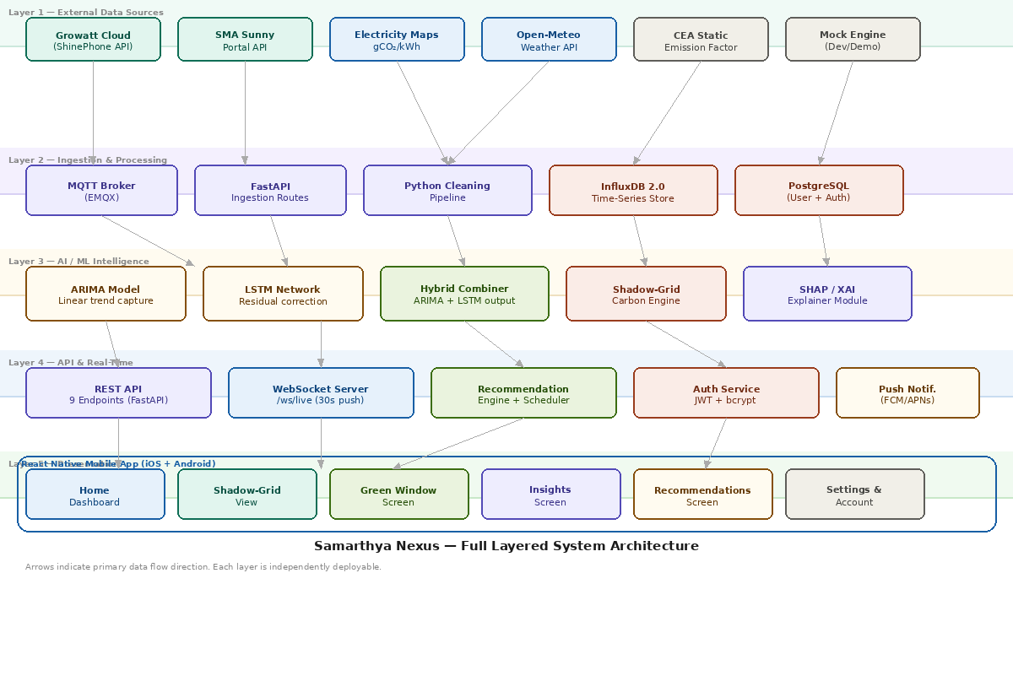
Figure 1 — Samarthya Nexus: Full Five-Layer System Architecture

2. Design Principles & Architectural Constraints

2.1 Core Design Principles
Principle | Description | Where Applied
Graceful Degradation | The system must always show something meaningful to the user, even when external APIs fail. Never a blank screen. | Mock Engine fallback, CEA static grid factor fallback, cached ML predictions
Separation of Concerns | Each module has a single responsibility. Data ingestion does not perform carbon calculations. ML service does not serve API responses. | Services layer: GrowattService, CarbonService, MLService, AuthService — all independent
Real-Time First | The core user experience depends on live data. Architecture prioritizes low-latency data paths over batch processing. | WebSocket push primary, HTTP polling fallback. InfluxDB WAL for zero data loss.
Explainability by Design | AI recommendations must be understandable to a non-technical homeowner. SHAP is not an afterthought — it is a first-class architectural component. | XAI module integrated at inference time, not post-hoc. SHAP values stored alongside predictions.
Localization Over Generics | The system uses Gwalior-specific grid intensity data rather than national averages. Architecture must support per-location configuration. | HOUSEHOLD entity stores grid_zone. Carbon calculations parameterized by household.
Privacy by Default | User data is personal environmental data. Architecture enforces minimal data exposure at every layer. | Route-level JWT guards, AES-256 encrypted inverter tokens, GDPR-ready delete API
Testability | Every module must be independently testable without requiring live hardware or external APIs. | Mock Engine, dependency injection in FastAPI services, factory pattern for DB clients

2.2 Architectural Constraints
- Hardware: No physical inverter available during development — all hardware interaction must have a mock fallback path.
- Budget: BCA academic project — zero cloud cost architecture required. All components must run locally on a MacBook or free-tier VPS.
- Team size: 3 developers — architecture must support parallel development without frequent merge conflicts. Module boundaries must be strict.
- Timeline: 10-week build — no time for microservices with separate deployments. Monorepo with modular internal boundaries.
- Data locality: Gwalior-specific grid data. No public Gwalior API exists — architecture must handle the fallback to state-level (MP) data gracefully.
- Academic requirement: Document every decision. Architecture Decision Records (ADRs) must accompany each significant choice.

3. Full System Architecture — Five Layers
The five layers of Samarthya Nexus are designed so that each layer only communicates with its immediately adjacent layers. Data flows downward (from external sources toward the database) and upward (from database through ML and API to the mobile client). No layer skips another.

3.1 Layer 1 — External Data Sources
This layer contains all data producers that exist outside the Samarthya Nexus system boundary. The system consumes data from this layer but never stores code or business logic here. All external API calls are wrapped in service classes with timeout handling and fallback strategies.
Component | Protocol | Data Provided | Fallback Strategy
Growatt ShinePhone Cloud | HTTPS REST (unofficial) | solar_kw, eToday_kWh, device_status | Mock Engine activates after 2s timeout
SMA Sunny Portal | HTTPS REST (official OAuth2) | currentPower_W, energyToday_Wh | Mock Engine activates after 2s timeout
Electricity Maps API | HTTPS REST (free tier) | carbonIntensity gCO₂/kWh (MP state grid) | CEA static factor 0.82 kg/kWh
Open-Meteo Weather API | HTTPS REST (free, no key) | solarIrradiance W/m², cloudCover %, temp °C | LSTM uses historical irradiance pattern
CEA Static Factor | Config file (hardcoded) | MP grid: 0.82 kg CO₂/kWh (annual average) | Always available — last resort fallback
Mock Engine | Internal (in-process) | Synthetic bell-curve solar + behavioral consumption | Always available — primary dev tool

3.2 Layer 2 — Ingestion & Processing
This layer receives raw data from Layer 1, cleans and normalizes it, and writes it to persistent storage. It is the only layer that writes to InfluxDB. The MQTT broker handles real-time IoT-style data streams. The FastAPI ingestion routes handle REST-based inverter API polling.
- MQTT Broker (EMQX): receives MQTT messages from IoT energy monitors if connected physically. Topic structure: samarthya/{household_id}/energy
- FastAPI Ingestion Routes: scheduled polling of Growatt/SMA APIs every 5 minutes using APScheduler. Writes raw readings to InfluxDB.
- Python Cleaning Pipeline: converts Wh to kWh, handles null values with forward-fill interpolation, flags outliers (3σ from rolling mean), synchronizes timestamps to IST.
- InfluxDB 2.0: primary time-series store. All energy readings, carbon records, ML predictions, and recommendations stored here with nanosecond precision timestamps.
- PostgreSQL: relational store for user accounts, household configurations, and authentication tokens. Accessed via SQLAlchemy ORM.

3.3 Layer 3 — AI / ML Intelligence
This layer contains all machine learning and computational intelligence components. It reads from InfluxDB (Layer 2) and writes predictions back to InfluxDB. It is scheduled to run every 4 hours. The Shadow-Grid Engine runs synchronously on every incoming energy reading.
- ARIMA Model: statsmodels ARIMA(2,1,2) fitted on solar_kw time series. Captures linear trends and weekly seasonality. Re-fitted every 4 hours.
- LSTM Network: TensorFlow/Keras 2-layer LSTM (64 units each) trained on ARIMA residuals. Sequence length 96 (24 hours), output 16 (4 hours forecast).
- Hybrid Combiner: final_forecast = ARIMA_prediction + LSTM_residual_correction. Values clipped to ≥ 0.
- Shadow-Grid Engine: computes green_co2, shadow_co2, and offset_co2 at every 15-minute interval using the carbon intensity from Layer 1.
- SHAP/XAI Module: SHAP DeepExplainer applied to LSTM model at inference time. Top 3 feature importances stored with each ml_prediction record.

3.4 Layer 4 — API & Real-Time
This layer exposes all system capabilities to the outside world through a clean REST API and a WebSocket connection. It also contains the Recommendation Engine and the Push Notification Service.
- REST API (FastAPI): 9 endpoints plus auth routes, documented via auto-generated Swagger UI at /docs.
- WebSocket Server: /ws/live endpoint pushes the full carbon/live payload to all connected mobile clients every 30 seconds.
- Recommendation Engine: reads the latest ML predictions and carbon history, applies rule-based and ML-assisted scoring to generate ranked action recommendations.
- Auth Service: python-jose JWT token management + passlib bcrypt hashing. Stateless authentication — no server-side session storage.
- Push Notification Service: Firebase Cloud Messaging (FCM) for Android, APNs for iOS. Green Window alerts sent 30 minutes before detected peak window.

3.5 Layer 5 — Presentation
The React Native mobile application is the sole consumer of Layer 4. It communicates via HTTPS REST and WebSocket. It renders 25 screens organized into 5 navigation flows. The app is stateless on the client side — all persistent data lives in the backend.

4. Backend Internal Architecture
The FastAPI backend follows a three-sublayer internal structure: Routes → Services → Data Access. Routes handle HTTP concerns (validation, auth, serialization). Services contain all business logic. Data access clients handle all database and external API communication. No route directly touches a database. No service directly constructs HTTP responses.
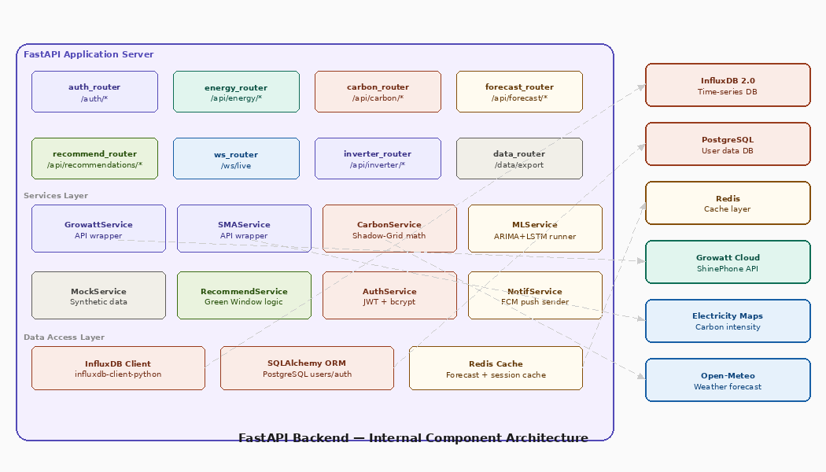
Figure 2 — FastAPI Backend: Internal Component Architecture

4.1 Router Layer
Eight router modules map URL patterns to handler functions. Each router is mounted on the FastAPI app with a prefix. All routes (except /auth/register and /auth/login) require a valid JWT Bearer token enforced via a FastAPI dependency.
Router | Prefix | Responsibility
auth_router | /auth | Registration, login, token refresh, profile, password reset
energy_router | /api/energy | Live readings, historical queries, inverter polling trigger
carbon_router | /api/carbon | Shadow-Grid calculations, daily/weekly summaries
forecast_router | /api/forecast | ARIMA-LSTM solar forecast, Green Window detection
recommend_router | /api/recommendations | Daily recommendation list, mark-as-followed endpoint
ws_router | /ws | WebSocket connection management, live push loop
inverter_router | /api/inverter | Credential management, connection test, sync trigger
data_router | /data | CSV export, data deletion, privacy controls

4.2 Service Layer
All business logic lives in service classes injected into route handlers as FastAPI dependencies. Services are instantiated with the Mock/Live mode flag set at startup via environment variable, enabling full development without hardware.
# Dependency injection pattern used throughout
def get_inverter_service() -> BaseInverterService:
if settings.USE_MOCK:
return MockService() # synthetic bell-curve solar data
elif settings.INVERTER_BRAND == 'growatt':
return GrowattService() # ShinePhone API wrapper
elif settings.INVERTER_BRAND == 'sma':
return SMAService() # Sunny Portal API wrapper

# Route handler receives service via dependency
@router.get('/current')
async def get_current(svc: BaseInverterService = Depends(get_inverter_service)):
return await svc.get_current_reading()

4.3 Data Access Layer
Three data access clients handle all persistence. They are instantiated as singletons at application startup and closed cleanly on shutdown via FastAPI lifespan events.
Client | Library | Connected To | Key Operations
InfluxDBClient | influxdb-client-python | InfluxDB 2.0 (port 8086) | write_point(), query_range(), query_aggregate()
AsyncSession | SQLAlchemy + asyncpg | PostgreSQL (port 5432) | create_user(), get_household(), update_inverter_token()
Redis | aioredis | Redis (port 6379) | cache_forecast(), get_cached_forecast(), invalidate()

5. ML Pipeline Architecture
The ML pipeline operates in two distinct modes: a training pipeline that runs on a schedule (every 4 hours) and an inference pipeline that serves real-time requests. These are architecturally separated — the training pipeline writes to InfluxDB and the model registry, while the inference pipeline reads from both and caches results in Redis.
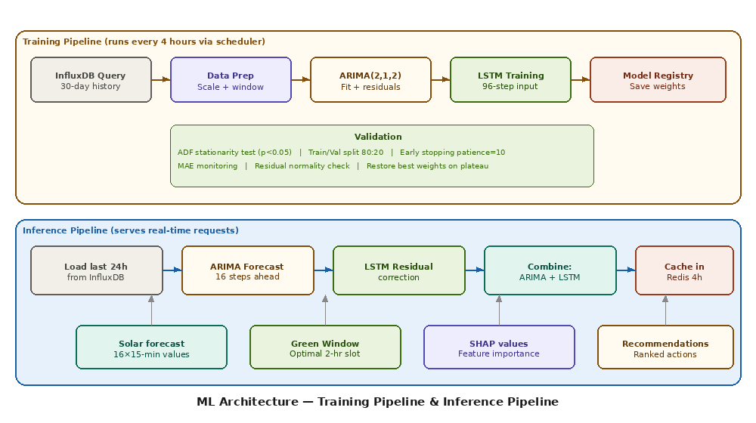
Figure 3 — ML Architecture: Training Pipeline and Inference Pipeline

5.1 Training Pipeline
The training pipeline is triggered by APScheduler every 4 hours. It loads the most recent 30 days of energy_readings from InfluxDB, validates data quality, trains the ARIMA model, extracts residuals, trains the LSTM network on those residuals, validates performance, and saves model weights to the model registry directory.

Step 1 — Data Preparation
- Query InfluxDB: SELECT solar_kw FROM energy_readings WHERE time > now()-30d
- Forward-fill missing intervals (InfluxDB returns sparse data for night hours)
- Apply ADF stationarity test — if p-value > 0.05, apply d=1 differencing
- MinMaxScaler normalization of residual series to [0,1] range for LSTM stability

Step 2 — ARIMA Training
- Model: statsmodels ARIMA(order=(2,1,2))
- Fit on full 30-day solar_kw series
- Extract fittedvalues — compute residuals = actual - fittedvalues
- Log MAE of ARIMA alone to InfluxDB for model monitoring

Step 3 — LSTM Training on Residuals
- Architecture: LSTM(64) → Dropout(0.2) → LSTM(32) → Dropout(0.2) → Dense(16)
- Input shape: (batch, 96, 1) — 24 hours of 15-min residuals
- Output shape: (batch, 16) — 4 hours of residual corrections
- Loss function: Huber loss (robust to cloud-induced outliers in solar data)
- Optimizer: Adam, lr=0.001
- Early stopping: patience=10, monitor=val_loss, restore_best_weights=True
- Train/val split: 80/20 on sliding window sequences

Step 4 — Validation & Model Registry
- Compute MAE on validation set — if MAE > 0.6 kW, log warning but still save
- Save LSTM weights to /models/lstm_{timestamp}.h5
- Save ARIMA fitted model to /models/arima_{timestamp}.pkl
- Write training_run record to InfluxDB: { mae, val_loss, timestamp, data_points }
- Update 'current_model' symlink to point to new weights

5.2 Inference Pipeline
The inference pipeline is triggered by API requests to /api/forecast/solar and /api/forecast/green-window. It first checks the Redis cache — if a valid forecast exists (< 4 hours old), it is served immediately. Otherwise the full inference runs in < 3 seconds.
# Inference flow pseudocode
async def get_solar_forecast():
cached = await redis.get('forecast:current')
if cached and age(cached) < 4h:
return cached # serve from cache <10ms

recent_24h = await influxdb.query_last_24h() # ~200ms
arima_forecast = arima_model.forecast(steps=16) # ~50ms
residuals_scaled = scaler.transform(recent_residuals)
lstm_correction = lstm_model.predict(residuals_scaled) # ~800ms
final = clip(arima_forecast + inverse_scale(lstm_correction), min=0)

await redis.set('forecast:current', final, ttl=4h) # cache result
return final # total: ~1.1 seconds

5.3 SHAP Explainability Integration
SHAP (SHapley Additive exPlanations) is applied at inference time using the DeepExplainer for the LSTM model. The top 3 feature importances are computed for each forecast step and stored alongside the prediction in InfluxDB. Human-readable feature names are mapped before storage.
Raw Feature Name | Human-Readable Label | Typical Importance
solar_kw_t-1 | Solar generation 15 min ago | High (0.45-0.65)
solar_kw_t-4 | Solar generation 1 hour ago | Medium (0.20-0.35)
cloud_cover_pct | Cloud cover forecast | Medium (0.15-0.30)
consumption_kw_t-1 | Home consumption 15 min ago | Low (0.05-0.15)
hour_of_day | Current hour (0-23) | Low (0.05-0.10)
day_of_week | Day of week (0-6) | Very Low (0.01-0.05)

6. Frontend Architecture (React Native)
The React Native frontend is a stateless mobile client. All persistent data lives on the backend. The client holds transient UI state in Zustand stores and receives real-time updates via WebSocket. The navigation structure uses React Navigation with a bottom tab bar for the 5 core screens and a stack navigator for detail and settings screens.

6.1 State Management Architecture
Zustand Store | State Held | Updated By
useEnergyStore | solar_kw, consumption_kw, net_grid_kw, source, timestamp | WebSocket push every 30s
useCarbonStore | green_co2, shadow_co2, offset, trees, daily summary | /api/carbon/* REST calls
useForecastStore | forecast array, green_window start/end, confidence | /api/forecast/* REST calls
useRecommendStore | recommendations list, followed status, streak count | /api/recommendations/* calls
useAuthStore | access_token, user_id, household_id, inverter_connected | Auth flow + token refresh
useSettingsStore | quiet_hours, alert_threshold, inverter_mode, notifications | Settings screen actions

6.2 Navigation Structure
App.tsx
└── AuthStack (if not logged in)
├── SplashScreen
├── LoginScreen
├── RegisterScreen
└── OnboardingStack
├── InverterSetupScreen
├── LocationSetupScreen
├── SystemCapacityScreen
└── FeatureTourScreen
└── MainTabs (if logged in)
├── HomeTab → HomeDashboard → LiveReadingDetail
├── ShadowTab → ShadowGridView → DayDetail
├── GreenTab → GreenWindowScreen → ForecastDetail
├── InsightsTab → InsightsScreen
└── RecommendTab → RecommendationsScreen → RecommendDetail
└── SettingsStack (modal from profile icon)
├── ProfileScreen
├── InverterSettingsScreen
├── NotificationPrefsScreen
├── DataPrivacyScreen
└── AboutScreen

6.3 WebSocket Client Architecture
// WebSocket lifecycle managed in App.tsx
const ws = new WebSocket(`wss://api.samarthya.app/ws/live?token=${token}`);

ws.onmessage = (event) => {
const payload = JSON.parse(event.data);
useEnergyStore.getState().update(payload.energy);
useCarbonStore.getState().updateLive(payload.carbon);
};

ws.onerror = () => {
// Fallback: HTTP polling every 60 seconds
startPollingFallback();
};

7. Database Architecture

7.1 InfluxDB — Time-Series Storage
InfluxDB 2.0 is the primary data store for all time-series energy, carbon, and ML prediction data. It is chosen over PostgreSQL for this data because of its native support for high-frequency writes, automatic downsampling via Tasks, and the Flux query language which is optimized for time-windowed aggregations.
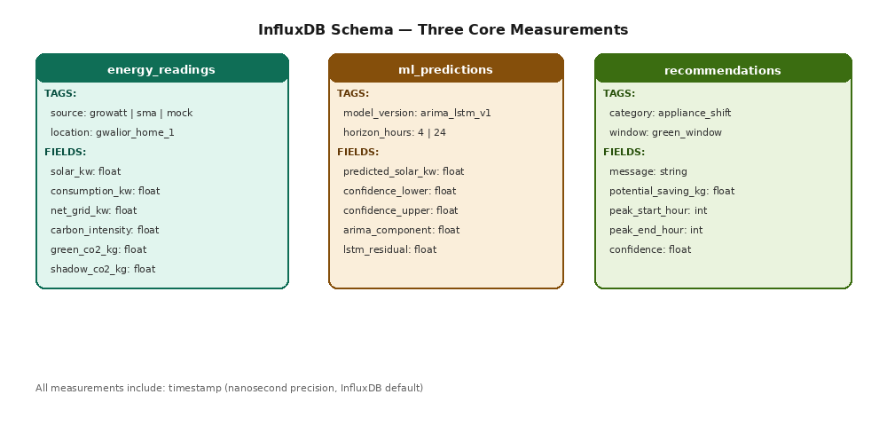
Figure 4 — InfluxDB Schema: Three Measurements with Tags, Fields, and Retention Policies

Measurement: energy_readings
// Write example — Python influxdb-client
point = Point("energy_readings") \
.tag("source", "growatt") \
.tag("location", "gwalior_home_1") \
.tag("inverter_id", household.inverter_id) \
.field("solar_kw", reading.solar_kw) \
.field("consumption_kw", reading.consumption_kw) \
.field("net_grid_kw", reading.net_grid_kw) \
.field("carbon_intensity", reading.carbon_intensity) \
.field("green_co2_kg", carbon.green_co2_kg) \
.field("shadow_co2_kg", carbon.shadow_co2_kg) \
.field("offset_co2_kg", carbon.offset_co2_kg) \
.time(datetime.utcnow(), WritePrecision.NANOSECONDS)

Retention & Downsampling Strategy
Data Resolution | Storage Duration | Downsampling Method | Query Use Case
15-minute raw | 90 days | None — kept as-is | Live dashboard, day detail screen
1-hour average | 2 years | InfluxDB Task: mean() window(1h) | 7-day insights charts, weekly summary
1-day aggregate | Forever | InfluxDB Task: sum() window(1d) | Monthly trend, annual certificate

7.2 PostgreSQL — Relational Data
PostgreSQL stores user accounts, household configurations, authentication tokens, and any data that requires ACID transactions or complex relational queries. It is accessed exclusively through SQLAlchemy async ORM to prevent SQL injection.
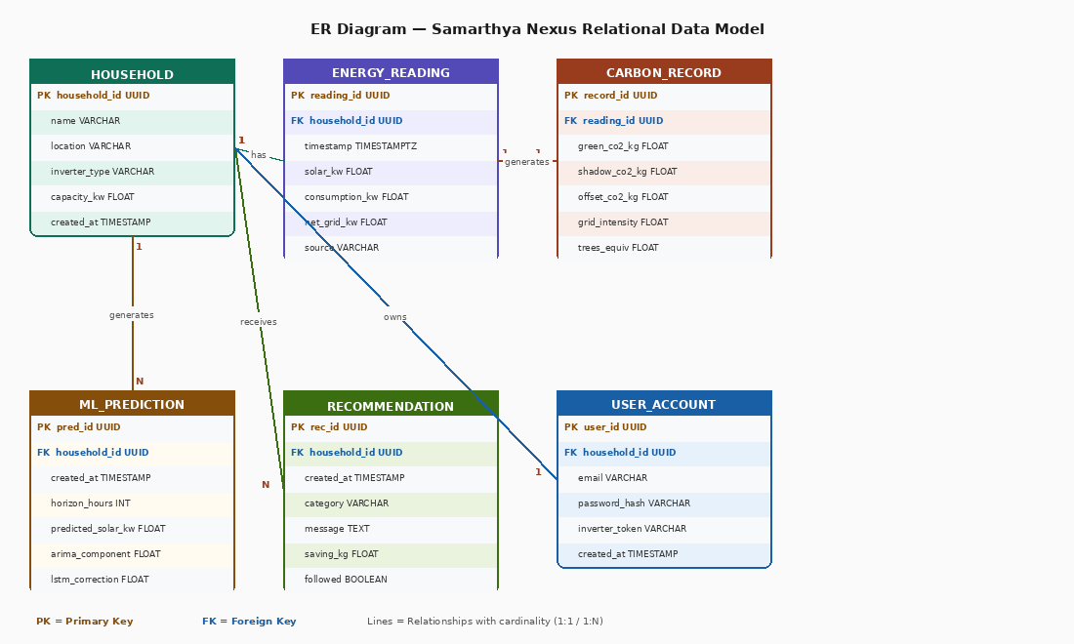
Figure 5 — Entity-Relationship Diagram: PostgreSQL Relational Model

7.3 Redis — Caching Layer
Cache Key | Value | TTL | Purpose
forecast:current:{household_id} | Full 16-step ARIMA+LSTM forecast JSON | 4 hours | Avoid re-running ML inference on every API call
green_window:{household_id} | Green Window start/end/saving JSON | 4 hours | Consistent Green Window across concurrent requests
carbon_summary:daily:{household_id}:{date} | Daily carbon summary aggregation | 24 hours | Avoid expensive InfluxDB aggregate query per request
session:{user_id} | JWT refresh token metadata | 30 days | Fast token validation without PostgreSQL hit

8. API Architecture
The FastAPI backend exposes a versioned REST API and a WebSocket endpoint. All API responses follow a consistent envelope format. Error responses include machine-readable error codes for client-side handling.
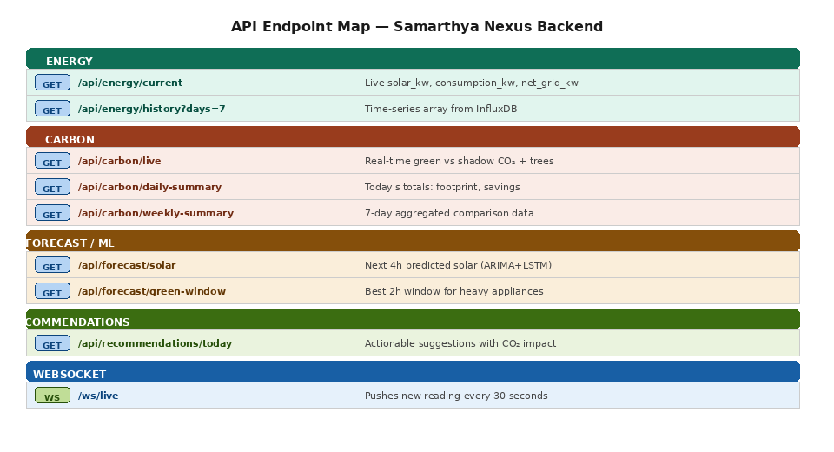
Figure 6 — API Endpoint Map: All Routes with Methods and Auth Requirements

8.1 API Design Conventions
- Base URL: https://api.samarthya.app/v1 (production) or http://localhost:8000 (development)
- Authentication: Bearer token in Authorization header on all routes except /auth/register and /auth/login
- Content-Type: application/json for all requests and responses
- Timestamps: ISO 8601 format with UTC timezone (e.g. 2025-06-15T10:30:00Z)
- Numeric values: kW and kWh rounded to 3 decimal places. CO₂ values rounded to 4 decimal places.
- Pagination: not required in v1.0 (household-scoped data is bounded). Will be added for /history in v2.

8.2 Response Envelope
// Success response
{
"data": { /* actual payload */ },
"meta": { "timestamp": "2025-06-15T10:30:00Z", "source": "growatt_live" }
}

// Error response
{
"error": {
"code": "INVERTER_TIMEOUT",
"message": "Growatt API did not respond within 2 seconds.",
"fallback_activated": true,
"fallback_source": "mock_engine",
"timestamp": "2025-06-15T10:30:01Z"
}
}

8.3 WebSocket Protocol
// Client connects with JWT token as query parameter
ws = new WebSocket('wss://api.samarthya.app/ws/live?token=eyJ...')

// Server pushes this payload every 30 seconds
{
"type": "energy_update",
"energy": { "solar_kw": 2.84, "consumption_kw": 1.20, "net_grid_kw": 0.0 },
"carbon": { "green_kg": 0.0, "shadow_kg": 0.347, "saved_kg": 0.347,
"trees": 5.82, "cars_minutes": 49.9 },
"timestamp": "2025-06-15T10:30:15Z",
"source": "growatt_live"
}

// Client sends heartbeat every 25 seconds to keep connection alive
{ "type": "ping" }
// Server responds: { "type": "pong" }

9. Security Architecture
Samarthya Nexus implements a defense-in-depth security model with five distinct security layers. Each layer catches threats that slip through the layers above it. No single point of failure can compromise user data.
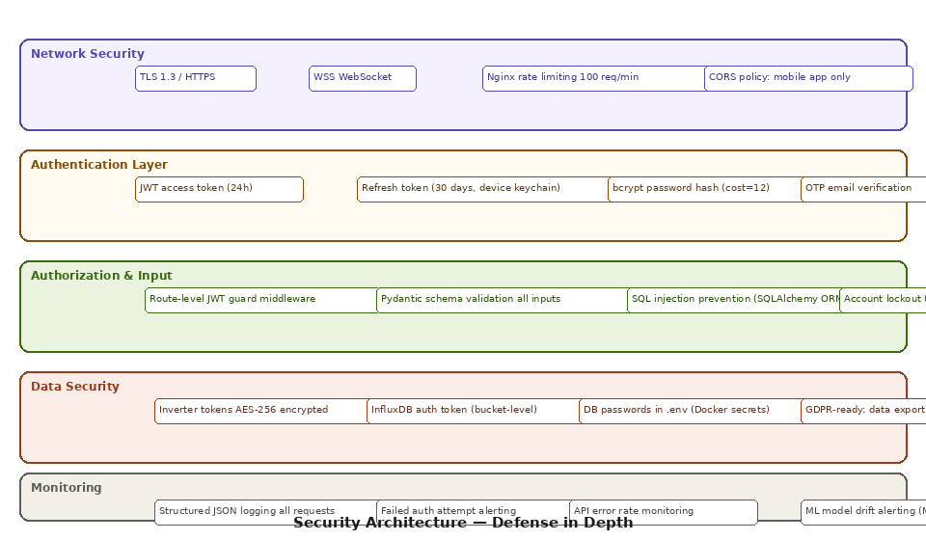
Figure 7 — Security Architecture: Five Layers of Defense in Depth

9.1 Network Security
- All communication encrypted with TLS 1.3. HTTP requests redirected to HTTPS by Nginx.
- WebSocket connections use WSS (WebSocket Secure) over TLS 1.3.
- Nginx rate limiting: 100 requests/minute per IP address. WebSocket connections: max 5 per user.
- CORS policy: only the Samarthya Nexus mobile app bundle ID is whitelisted. No browser CORS allowed.

9.2 Authentication Layer
- Passwords hashed with bcrypt, cost factor 12 (approx. 300ms per hash — slow enough to resist brute force).
- JWT access tokens (24-hour expiry) signed with HS256. Refresh tokens (30-day expiry) stored in device keychain.
- OTP email verification required on registration. OTP valid 10 minutes, 6 digits, rate-limited to 3 sends per hour.
- Account lockout: 5 consecutive failed logins triggers 15-minute lockout. Logged to security audit table.

9.3 Authorization
- Every protected route uses a FastAPI dependency: verify_token() — decodes JWT and attaches user_id to request state.
- All database queries are scoped to the authenticated user's household_id. No cross-household data leakage possible.
- Pydantic models validate all incoming request bodies. Type coercion and length limits enforced at serialization time.

9.4 Data Security
- Inverter API credentials (ShinePhone/Sunny Portal passwords) stored AES-256 encrypted in PostgreSQL. Encryption key stored in Docker secret, never in code.
- InfluxDB access uses fine-grained bucket-level tokens. The application token has write-only access to energy_readings and read access to its own bucket.
- All environment variables (DB passwords, API keys, JWT secret) stored in .env file excluded from Git. Docker Compose secrets for production.
- GDPR-ready: /data/export returns all user data as CSV. /data/delete permanently removes all readings within 30 days.

10. Deployment Architecture
Samarthya Nexus uses a containerized deployment strategy with Docker Compose managing all backend services. The development environment mirrors production exactly, eliminating 'works on my machine' problems.
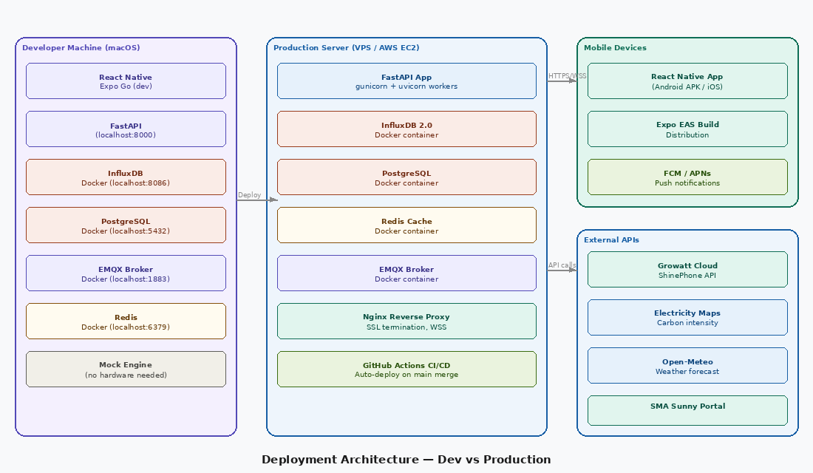
Figure 8 — Deployment Architecture: Development Machine vs Production Server vs Mobile

10.1 Docker Compose Services
# docker-compose.yml service structure
services:
fastapi: image: samarthya/backend:latest
ports: [8000:8000]
depends_on: [influxdb, postgres, redis, emqx]
influxdb: image: influxdb:2.7
ports: [8086:8086]
volumes: [influx_data:/var/lib/influxdb2]
postgres: image: postgres:15-alpine
ports: [5432:5432]
volumes: [pg_data:/var/lib/postgresql/data]
redis: image: redis:7-alpine
ports: [6379:6379]
emqx: image: emqx:5.6
ports: [1883:1883, 8083:8083] # MQTT + WebSocket
nginx: image: nginx:alpine
ports: [80:80, 443:443] # HTTPS + WSS
depends_on: [fastapi]

10.2 CI/CD Pipeline (GitHub Actions)
Stage | Trigger | Actions | Duration
Lint & Test | Push to any branch | ruff linter, pytest unit tests, mypy type checks | ~90 seconds
Build | Push to main | docker build backend image, push to GitHub Container Registry | ~3 minutes
Deploy | Push to main (passing tests) | SSH to VPS, docker-compose pull, docker-compose up -d | ~60 seconds
Smoke Test | Post-deploy | Curl /health endpoint, verify /api/carbon/live returns 200 | ~15 seconds

10.3 Production Infrastructure Requirements
Component | Minimum Spec | Rationale
VPS / EC2 | 2 vCPU, 4 GB RAM, 40 GB SSD | InfluxDB + LSTM inference needs ~1.5 GB RAM minimum
Operating System | Ubuntu 22.04 LTS | Long-term support, Docker native, GitHub Actions runners
Domain & SSL | Any domain + Let's Encrypt (free) | TLS 1.3 certificate auto-renewal via Certbot + Nginx
Backup | Daily InfluxDB + PostgreSQL snapshot to S3 or local | Data is irreplaceable — 30-day backup retention
Monitoring | UptimeRobot (free tier) + InfluxDB metrics | Alert on downtime and ML model drift

11. Sequence Diagram — Live Energy Reading Request Flow
The following sequence diagram shows the complete interaction between all system components for a single live energy reading request cycle — from the mobile app requesting current data through to the final rendered dashboard update.
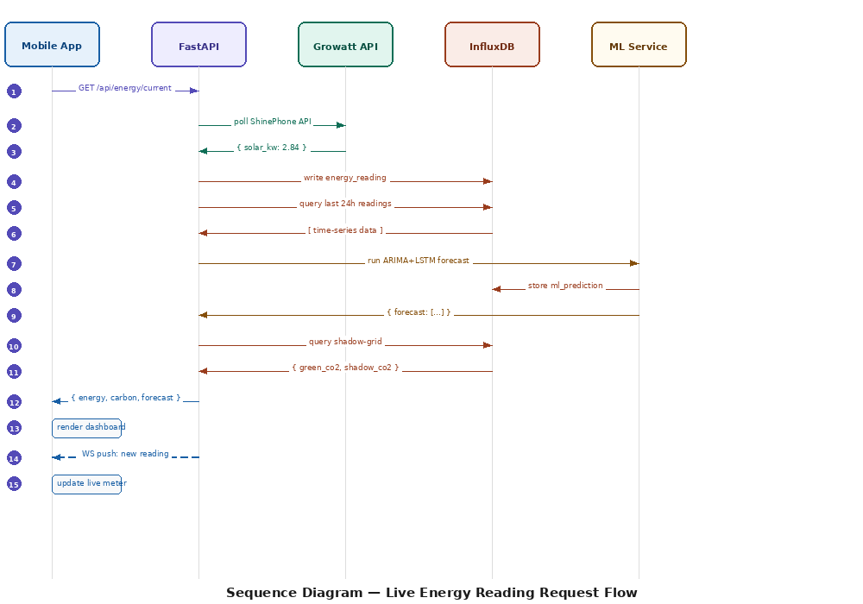
Figure 9 — Sequence Diagram: 15-Step Live Energy Reading Request Flow

Step | From | To | Message | Notes
1 | Mobile App | FastAPI | GET /api/energy/current | JWT Bearer token in header
2 | FastAPI | Growatt Cloud | HTTP GET /plant/device/list | Timeout: 2 seconds
3 | Growatt Cloud | FastAPI | { solar_kw: 2.84, eToday: 12.3 } | Or timeout → Mock Engine
4 | FastAPI | InfluxDB | write energy_reading point | Tags: source, location, inverter_id
5 | FastAPI | InfluxDB | query last 24h readings | For ML input preparation
6 | InfluxDB | FastAPI | [ 96 × 15-min data points ] | ~200ms query time
7 | FastAPI | ML Service | run ARIMA+LSTM forecast | Async — non-blocking
8 | ML Service | InfluxDB | store ml_prediction record | ARIMA + LSTM components saved
9 | ML Service | FastAPI | { forecast: 16 steps, green_window } | Cached in Redis for 4h
10 | FastAPI | InfluxDB | query shadow-grid for today | Aggregate query
11 | InfluxDB | FastAPI | { green_co2: 0.49, shadow_co2: 1.97 } | Daily totals
12 | FastAPI | Mobile App | { energy, carbon, forecast, green_window } | Full response JSON
13 | Mobile App | Mobile App | render Home Dashboard | Zustand state updated
14 | FastAPI | Mobile App | WS push: new reading (30s later) | WebSocket push to all connected clients
15 | Mobile App | Mobile App | update live carbon meter | Animated counter increment

12. Component Communication Patterns
Pattern | Components | Protocol | Frequency | Data Volume
Request-Response | Mobile App → FastAPI | HTTPS REST | On user interaction + 60s polling fallback | < 5 KB per response
Server Push | FastAPI → Mobile App | WebSocket (WSS) | Every 30 seconds | ~1 KB per push
Pub/Sub (IoT) | Energy Monitor → EMQX → FastAPI | MQTT over TCP | Every 15 minutes (IoT sensor) | < 200 bytes per message
Async Task | APScheduler → ML Service | In-process | Every 4 hours (training) | Reads 2,880 data points
Cache Read-Through | FastAPI → Redis → InfluxDB | TCP (Redis), HTTP (InfluxDB) | Every API call for forecast | < 2 KB cached payload
Event-Driven Alert | Recommendation Engine → FCM | HTTPS (FCM API) | Per Green Window detection (~1/day) | < 500 bytes per notification

13. Error Handling Strategy

13.1 External API Failure Hierarchy
Failed Component | Detection | Immediate Response | User Experience
Growatt API | HTTP timeout > 2s or 4xx/5xx | Activate Mock Engine | Badge shows 'MOCK'. Data still flows.
SMA API | HTTP timeout > 2s or 4xx/5xx | Activate Mock Engine | Badge shows 'MOCK'. Data still flows.
Electricity Maps API | HTTP timeout > 2s | Use CEA static 0.82 kg/kWh | Carbon calculations continue. Note shown in detail screen.
Open-Meteo API | HTTP timeout > 2s | Skip weather overlay in forecast | Forecast runs without weather. Cloud cover chart hidden.
InfluxDB | Connection refused or write error | Log error, queue retry (max 3) | Dashboard shows 'Last updated X min ago'. No data loss — WAL.
Redis | Connection refused | Bypass cache — compute fresh | Slightly slower response. No user-facing impact.
ML Service | Training failure | Serve last cached forecast | Green Window uses stale forecast. Warning logged.
WebSocket | Connection dropped | Start HTTP polling (60s interval) | Brief delay in live updates. User notified via status badge.

14. Performance & Scalability Strategy

14.1 Performance Targets
Endpoint / Operation | p50 Target | p95 Target | p99 Target
GET /api/carbon/live (cached) | < 40ms | < 100ms | < 200ms
GET /api/forecast/solar (cached) | < 50ms | < 120ms | < 250ms
GET /api/forecast/solar (cold) | < 1.5s | < 2.5s | < 3.5s
WebSocket push latency | < 200ms | < 500ms | < 800ms
App cold start to dashboard | < 1.5s | < 2.5s | < 4s
ARIMA+LSTM training run | < 45s | < 90s | < 180s
InfluxDB 24h query (96 points) | < 100ms | < 200ms | < 400ms

14.2 Scalability Approach for v1.0
- Household-scoped queries: all InfluxDB and PostgreSQL queries are tagged/filtered by household_id — no full-table scans.
- Redis caching: ML forecast (expensive) cached for 4 hours. Daily carbon summary cached for 24 hours. Cache invalidated on new reading write.
- Async FastAPI: all I/O operations (DB queries, external API calls) are async/await. No blocking operations on the event loop.
- InfluxDB retention policies: automatic downsampling to 1-hour and 1-day resolution via InfluxDB Tasks. Raw data auto-deleted after 90 days.
- Connection pooling: SQLAlchemy async engine with pool_size=5, max_overflow=10 for PostgreSQL. InfluxDB client reused via singleton pattern.
For v1.0, the target is 100 concurrent households. At this scale, a single 4 GB VPS handles all services comfortably. Horizontal scaling (multiple FastAPI workers behind Nginx) would be needed at 500+ households.

15. Technology Decision Log
Decision | Options Considered | Chosen | Rationale
Backend framework | Flask, Django, FastAPI | FastAPI | Async native, auto-Swagger, Pydantic validation, fastest for I/O tasks
Time-series database | PostgreSQL + TimescaleDB, InfluxDB, Prometheus | InfluxDB 2.0 | Purpose-built for sensor data. Flux language better than SQL for time windows. Free OSS.
ML framework | PyTorch, scikit-learn, TensorFlow | TensorFlow + statsmodels | statsmodels for ARIMA (mature, well-documented). Keras for LSTM (simpler API than PyTorch for this architecture).
Mobile framework | Flutter, React Native, native Android | React Native + Expo | Team has JavaScript experience. Single codebase. Expo removes build complexity for academic timeline.
Cache layer | Memcached, Redis, in-memory dict | Redis | Persistent cache survives FastAPI restart. TTL support native. Free OSS.
Message broker | RabbitMQ, Kafka, EMQX | EMQX | MQTT-native broker purpose-built for IoT. Lightweight. MQTT is the industry standard for sensor data.
Auth method | OAuth2 + social login, session-based, JWT | JWT (stateless) | Stateless — no session storage needed. Works perfectly for mobile API clients.
Carbon intensity source | POSOCO scraping, WattTime, CEA static, Electricity Maps | Electricity Maps + CEA fallback | Free tier. Regional Indian grid data. CEA static as always-available fallback.

16. Architecture Decision Records (ADRs)
Architecture Decision Records capture the context, decision, and consequences of each significant architectural choice. They provide a historical audit trail for future maintainers.

ADR-001 — Use Hybrid ARIMA-LSTM over pure LSTM
Status: Accepted | Date: January 2026 | Author: Shreyansh Sonker

Context:
Solar generation forecasting requires capturing both linear weekly seasonality (ARIMA's strength)
and non-linear weather-driven patterns (LSTM's strength). A pure LSTM would require significantly
more training data to learn the linear patterns that ARIMA captures in seconds.

Decision:
Use residual correction hybrid: ARIMA fits linear component → LSTM learns residuals.
Final = ARIMA forecast + LSTM residual correction.

Consequences (+):
Faster training (LSTM trains on residuals only, smaller signal).
Better interpretability (ARIMA + LSTM components stored separately for SHAP analysis).

Consequences (-):
Two-model system adds complexity.
Both models must be re-fitted in sequence every 4 hours.

References: Zhang G.P. (2003) Neurocomputing vol.50 pp.159-175

ADR-002 — Use InfluxDB over PostgreSQL+TimescaleDB for energy data
Status: Accepted | Date: January 2026 | Author: Samarth Shrivastava

Context:
Energy readings arrive every 15 minutes per household. Each reading is ~10 fields.
The primary query pattern is time-range aggregations (last 24h, last 7 days, last 30 days).

Decision:
Use InfluxDB 2.0 as primary time-series store.
Use PostgreSQL only for user accounts and household configuration (relational data).

Consequences (+):
Flux query language purpose-built for time windowing, downsampling, and aggregation.
Native retention policies eliminate manual data lifecycle management.
10-50x faster than PostgreSQL for time-range queries on timestamped sensor data.

Consequences (-):
Two databases to manage (InfluxDB + PostgreSQL).
Team must learn Flux query language in addition to SQL.

ADR-003 — Use Mock Engine as first-class architectural component
Status: Accepted | Date: December 2025 | Author: Full Team

Context:
The team has no physical inverter during the 10-week development sprint.
All three developers need to build and test against realistic energy data simultaneously.

Decision:
Build Mock Engine as a production-quality service that generates statistically realistic
synthetic data (bell-curve solar generation calibrated for Gwalior lat 26.2°N, behavioral
consumption with morning/evening peaks). Toggle via environment variable USE_MOCK=true.

Consequences (+):
Full parallel development with zero hardware dependency.
Demo mode available for viva presentation regardless of inverter availability.
Mock data is deterministic with fixed random seed — reproducible for testing.

Consequences (-):
Mock data may not capture all real-world edge cases (inverter errors, grid outages).

ADR-004 — Stateless JWT authentication over server-side sessions
Status: Accepted | Date: December 2025 | Author: Samarth Shrivastava

Context:
Mobile API clients require authentication that works across network interruptions,
app restarts, and device changes without losing session state.

Decision:
Stateless JWT: access token (24h) + refresh token (30 days). No server-side session store.
Tokens stored in device keychain (not AsyncStorage — keychain is encrypted by OS).

Consequences (+):
Horizontally scalable — any FastAPI worker can verify any JWT without shared session store.
No Redis dependency for auth (Redis used for forecast caching only).

Consequences (-):
Access tokens cannot be revoked before expiry (24h max exposure window for stolen token).
Mitigation: short 24h access token + refresh token rotation on each use.

17. Glossary
Term | Definition
ADR | Architecture Decision Record — a document capturing the context, decision, and consequences of a significant architectural choice
ARIMA | AutoRegressive Integrated Moving Average — statistical model for time series forecasting: (p) autoregressive order, (d) differencing, (q) moving average order
ADF Test | Augmented Dickey-Fuller test — statistical test for time series stationarity. p-value < 0.05 confirms stationarity required for ARIMA
Carbon Intensity | CO₂ emitted per unit of electricity generated (kg CO₂/kWh). Varies by grid mix. MP state grid: 0.82 kg/kWh.
CEA | Central Electricity Authority — Government of India body publishing annual grid emission factors by state
Clean Energy Offset | CO₂ prevented by solar generation = solar_kWh × grid_intensity_factor
CQRS | Command Query Responsibility Segregation — architectural pattern separating read and write operations
Defense in Depth | Security strategy using multiple independent layers so no single failure compromises the system
EMQX | Enterprise-grade open-source MQTT broker used as the IoT message broker
FCM | Firebase Cloud Messaging — Google's push notification service for Android devices
Flux | InfluxDB's native query language, optimized for time-series aggregations and downsampling
Green Window | Optimal 2-hour period when predicted solar generation exceeds consumption — best time to run heavy appliances
Growatt | China-based solar inverter manufacturer — India's leading rooftop solar inverter brand
InfluxDB | Purpose-built open-source time-series database. Version 2.0 used with Flux query language
JWT | JSON Web Token — self-contained, cryptographically signed token for stateless authentication
LSTM | Long Short-Term Memory — type of Recurrent Neural Network that learns long-range temporal dependencies in sequential data
Mock Engine | Internal synthetic data generator that produces realistic solar generation curves without physical hardware
MQTT | Message Queuing Telemetry Transport — lightweight IoT messaging protocol for sensor data streams
Residual Correction | ARIMA-LSTM hybrid method: LSTM trains on ARIMA's prediction errors (residuals) to correct non-linear patterns
SAD | System Architecture Document — this document. Authoritative reference for all architectural decisions.
Shadow Home | Hypothetical grid-only household with identical consumption but zero solar generation — used to compute clean energy offset
Shadow-Grid Engine | Backend service computing real-time CO₂ comparison between the user's actual home and the Shadow Home
SHAP | SHapley Additive exPlanations — game-theory-based method for explaining individual ML predictions by quantifying each feature's contribution
SMA | German solar inverter manufacturer (Sunny Boy series) — premium residential solar segment in India
WAL | Write-Ahead Log — InfluxDB's mechanism ensuring data durability. Writes are logged before being applied to storage.
Zustand | Lightweight React state management library used in the React Native app. No boilerplate, minimal re-renders.

Document Sign-Off
Role | Name | Signature | Date
Backend Architect | Samarth Shrivastava (BCAN1CA24140)
ML Architect | Shreyansh Sonker (BCAN1CA24149)
Frontend Architect | Shreya Kumari (BCAN1CA24148)
Guide / Supervisor | Dr. Vani Agrawal
Co-Supervisor | Dr. Manali Shukla

Samarthya Nexus SAD v1.0 | ITM University Gwalior | BCA Minor Project 2025–26 | Confidential

