SAMARTHYA NEXUS
AI-Driven Carbon Footprint Analyzer

UI Design Rules Document
with Google Stitch MCP Prompt Guide
v1.0 | 2025–26 | React Native (Expo)
Design Lead  Shreya Kumari | BCAN1CA24148  Frontend Architecture | Supervised By  Dr. Vani Agrawal  ITM University Gwalior

ITM University, Gwalior • BCA Minor Project • 2025–26

About Google Stitch & This Document
This document defines the complete UI design system for Samarthya Nexus and provides ready-to-use prompts for generating every screen using Google Stitch MCP — a model-context-protocol tool that translates natural language prompts into production-quality React Native UI code.

What is Google Stitch MCP?
Google Stitch is a generative UI tool accessible via MCP (Model Context Protocol) server integration.
It generates React Native components, screens, and navigation structures from descriptive natural language prompts.
Integration: add the Stitch MCP server to your Claude/AI tool configuration, then use the prompts
in this document to generate each screen. Each prompt is precision-engineered to produce output
that exactly matches the Samarthya Nexus design system defined in this document.

MCP server URL: https://stitch.googleapis.com/mcp (requires Google Cloud project + API key)

How to Use This Document
1. Read Sections 1–6 to understand the design system rules (colors, typography, spacing, components).
2. Use Section 7 prompts verbatim in Google Stitch MCP to generate each screen.
3. Each prompt includes: theme tokens, component specs, navigation config, and behavior rules.
4. After generation, apply any corrections using the design tokens defined in Section 2.
5. The prompts are ordered in build sequence — generate auth screens first, then core tabs.

Table of Contents
1 Design Philosophy & Anti-Patterns 4
2 Color System — Light & Dark Tokens 5
3 Typography Scale 7
4 Spacing, Corners & Elevation 8
5 Capsule Navigation Bar — Specification 9
6 Component Library Rules 11
7 Google Stitch MCP Prompts — All 25 Screens 14
7.1 Auth Flow (3 screens) 14
7.2 Onboarding Flow (4 screens) 16
7.3 Core Tab Screens (6 screens) 18
7.4 Detail & Drill-down Screens (7 screens) 23
7.5 Settings Screens (5 screens) 27
8 Animation & Interaction Rules 29
9 Accessibility Rules 30
10 Do & Don't — Design Anti-Patterns 31

1. Design Philosophy & Anti-Patterns

1.1 The Samarthya Nexus Design Ethos
The Samarthya Nexus UI must feel like it was designed by a team at a premium climate-tech startup — not generated by an AI. Every screen should feel considered, intentional, and human. The visual language draws from three references: the dashboard depth of Apple's Health app, the data clarity of Linear, and the earthy warmth of environmental apps like Olio and Too Good To Go.

Principle | What It Means | What It Looks Like
Immersive depth | Screens have foreground/midground/background layers. Nothing feels flat or sheet-like. | Hero card floats. Stats row sits mid-depth. Background has subtle texture or gradient.
Organic energy | The app is about nature and solar energy. The visual language should feel alive, not corporate. | Rounded corners everywhere. Green as the hero color. Soft, warm dark mode (deep navy, not pure black).
Data as story | Numbers are the product. They must be beautiful, prominent, and emotionally resonant. | Large display numbers. Animated counters. CO₂ in kg always shown with trees equivalent nearby.
Earned complexity | The app is technically sophisticated but must feel effortless. Complexity lives under the surface. | Simple home screen. Detailed data one tap away. Progressive disclosure everywhere.
Not AI-generated | The UI must look handcrafted. Avoid all clichés of AI-generated interfaces. | No generic card grids. No flat icon sets. No purple gradients. No generic "dashboard" layouts.

1.2 Visual Identity Keywords
When in doubt, ask: does this screen feel like these words? If not, simplify or redesign.

Alive • Precise • Earthy • Generous • Trustworthy • Tactile • Unhurried • Purposeful

2. Color System — Light & Dark Tokens
All colors are defined as design tokens. Use token names in code — never hardcode hex values. This ensures consistent theming and makes the light/dark switch a single config change.
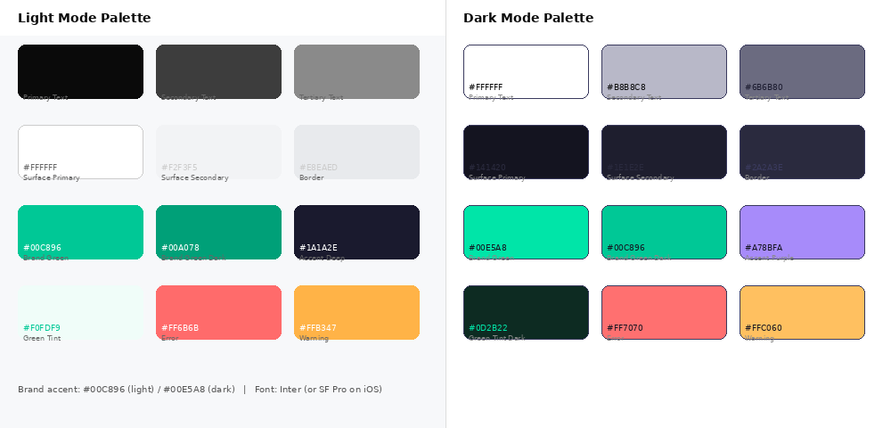
Figure 1 — Complete Color Palette: Light Mode (left) and Dark Mode (right)

2.1 Semantic Color Tokens
Light Mode  // Light mode tokens  background.primary: #F7F8FA  background.surface: #FFFFFF  background.surface2: #F2F3F5  text.primary: #0A0A0A  text.secondary: #3D3D3D  text.tertiary: #8A8A8A  border.default: #E8EAED  border.strong: #C8CBD0  brand.primary: #00C896  brand.dark: #00A078  brand.tint: #F0FDF9  brand.text: #003020  accent.deep: #1A1A2E  status.error: #FF6B6B  status.warning: #FFB347  status.success: #00C896 | Dark Mode  // Dark mode tokens  background.primary: #141420  background.surface: #1E1E2E  background.surface2: #252535  text.primary: #FFFFFF  text.secondary: #B8B8C8  text.tertiary: #6B6B80  border.default: #2A2A3E  border.strong: #3A3A5E  brand.primary: #00E5A8  brand.dark: #00C896  brand.tint: #0D2B22  brand.text: #141420  accent.deep: #A78BFA  status.error: #FF7070  status.warning: #FFC060  status.success: #00E5A8

2.2 Brand Color Usage Rules
- Brand green (#00C896 light / #00E5A8 dark) is the single hero accent color. Use it for: active states, key metrics, CTA buttons, progress fills, and the active tab pill.
- Never use brand green as a background for text-heavy areas — only for metric values, CTA buttons, icons, and progress bars.
- The dark mode surface is deep navy (#141420, #1E1E2E) — not pure black (#000000). Pure black feels cold and corporate. Deep navy feels like a night sky.
- Accent purple (#A78BFA) appears only in dark mode for secondary accents (Green Window banner, AI badges). Never used in light mode.
- Error red (#FF6B6B) is used sparingly — only for error states and the "without solar" shadow bar comparison. Never as a decorative color.

2.3 Theme Switch Implementation
// React Native — theme context setup
import { useColorScheme } from 'react-native';

const LIGHT = {
bg: '#F7F8FA', surface: '#FFFFFF', surface2: '#F2F3F5',
text: '#0A0A0A', textMuted: '#8A8A8A', border: '#E8EAED',
brand: '#00C896', brandText: '#003020', brandTint: '#F0FDF9',
accent: '#1A1A2E',
};
const DARK = {
bg: '#141420', surface: '#1E1E2E', surface2: '#252535',
text: '#FFFFFF', textMuted: '#6B6B80', border: '#2A2A3E',
brand: '#00E5A8', brandText: '#141420', brandTint: '#0D2B22',
accent: '#A78BFA',
};

export const useTheme = () => {
const scheme = useColorScheme(); // 'light' | 'dark'
return scheme === 'dark' ? DARK : LIGHT;
};

3. Typography Scale
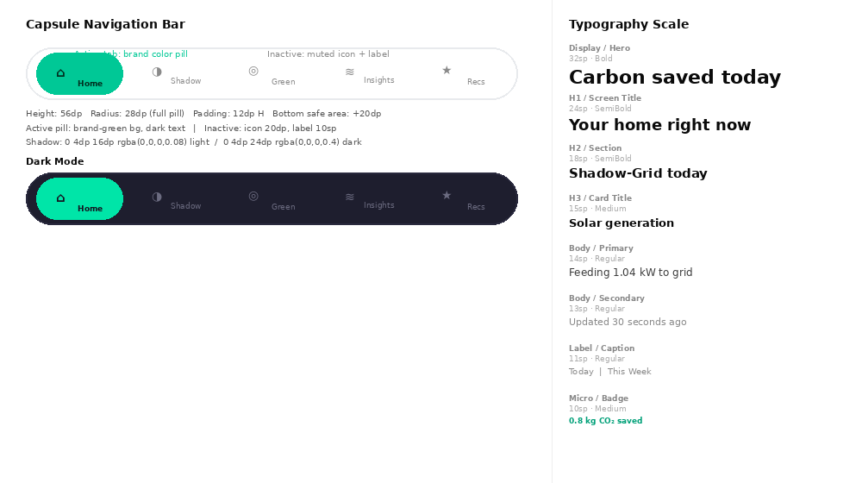
Figure 2 — Typography Scale with Size, Weight, and Usage Examples

3.1 Font Family
- Primary font: Inter (Google Fonts — free, variable weight). Install via expo-font.
- iOS fallback: SF Pro Display (system font — automatic on iOS devices).
- Android fallback: Roboto (system font — automatic on Android devices).
- Monospace (code/data): JetBrains Mono or Courier New for any numeric-heavy metric displays.

3.2 Type Scale Tokens
Token | Size | Weight | Line Height | Usage
display | 32sp | 700 Bold | 1.1 | Hero metrics: "3.24 kW", "2.34 kg CO₂"
h1 | 24sp | 600 SemiBold | 1.2 | Screen titles: "Your home right now"
h2 | 18sp | 600 SemiBold | 1.25 | Section headers: "Shadow-Grid today"
h3 | 15sp | 500 Medium | 1.3 | Card titles: "Solar generation"
body.lg | 14sp | 400 Regular | 1.6 | Primary body: "Feeding 1.04 kW to grid"
body.sm | 13sp | 400 Regular | 1.6 | Secondary body, descriptions
label | 11sp | 400 Regular | 1.4 | Captions, timestamps, axis labels
micro | 10sp | 500 Medium | 1.3 | Badges, status pills, inline units

3.3 Typography Rules
- Never use font weight below 400. Never use font weight above 700 (Bold).
- Metric numbers (kW, CO₂, trees) always use the "display" token. The number is the hero — make it large.
- Units (kW, kg, %) use "micro" token at 70% opacity placed inline after the number. Never same size as the number.
- Line length: cap body text at 72 characters per line on a 390dp screen. This means most body text needs no constraint.
- Letter spacing: -0.3px for display/h1 (slightly tighter for large text). +0.4px for label/micro (slightly wider for legibility at small sizes).

4. Spacing, Corners & Elevation
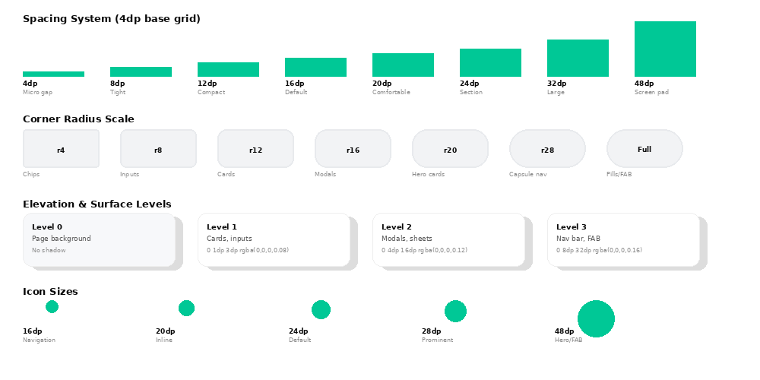
Figure 3 — Spacing System, Corner Radius Scale, Elevation Levels, and Icon Sizes

4.1 Spacing System (4dp Base Grid)
All spacing values are multiples of 4dp. Never use arbitrary spacing (e.g. 7dp, 13dp, 22dp). If you find yourself using an odd number, round to the nearest 4dp multiple.
Token | Value | Usage
space.1 | 4dp | Icon-to-label gaps, badge padding
space.2 | 8dp | Tight internal component gaps
space.3 | 12dp | Button padding vertical, chip padding
space.4 | 16dp | Default card padding, input padding
space.5 | 20dp | Card padding for hero cards
space.6 | 24dp | Section gaps, list item padding
space.8 | 32dp | Screen section spacing
space.12 | 48dp | Screen horizontal padding (left/right of content)

4.2 Corner Radius Scale
- r4 (4dp): Chips, inline badges, small tags
- r8 (8dp): Input fields, small cards, toggles
- r12 (12dp): Standard content cards, list items
- r16 (16dp): Large cards, modals, bottom sheets
- r20 (20dp): Hero cards (solar generation card, Shadow-Grid card)
- r28 (28dp / "full pill"): Capsule navigation bar, CTA buttons, FAB
- r50 (full circle): Status indicators, avatar circles, FAB with icon only

4.3 Elevation Rules
- Level 0 — Page background: no shadow. Fill with background.primary token.
- Level 1 — Cards: shadow 0 1dp 3dp rgba(0,0,0,0.08) light / 0 2dp 8dp rgba(0,0,0,0.3) dark.
- Level 2 — Modals, bottom sheets: shadow 0 4dp 16dp rgba(0,0,0,0.12) light / 0 4dp 24dp rgba(0,0,0,0.4) dark.
- Level 3 — Navigation bar, FAB: shadow 0 8dp 32dp rgba(0,0,0,0.16) light / 0 8dp 32dp rgba(0,0,0,0.5) dark.
- Dark mode shadows use slightly higher opacity — surfaces are dark so shadows must be stronger to create separation.

5. Capsule Navigation Bar — Full Specification
The capsule navigation bar is the most distinctive element of the Samarthya Nexus UI. It replaces the standard tab bar with a floating, fully-rounded pill that sits above the safe area at the bottom of every core screen. It must feel premium, tactile, and slightly elevated above the content below it.

Figure 4 — Capsule Navigation Bar: Light Mode, Dark Mode, and Anatomy

5.1 Capsule Anatomy
Property | Value (Light) | Value (Dark) | Notes
Background | #FFFFFF | #1E1E2E | Surface level 3
Border | 1dp #E8EAED | 1dp #2A2A3E | Subtle definition
Border radius | 28dp (full pill) | 28dp (full pill) | Must be exactly height/2
Height | 56dp | 56dp | Excluding safe area
Width | screen.width - 48dp | screen.width - 48dp | 24dp margin each side
Bottom offset | 16dp + safe area | 16dp + safe area | Always above home indicator
Shadow | 0 8dp 32dp rgba(0,0,0,0.16) | 0 8dp 32dp rgba(0,0,0,0.5) | Level 3 elevation
Active pill bg | #00C896 | #00E5A8 | Brand green
Active pill radius | 22dp (inner pill) | 22dp (inner pill) | 4dp inset from outer capsule
Active pill padding | 10dp H, 6dp V | 10dp H, 6dp V | Wraps icon + label
Inactive icon size | 20dp | 20dp | Centered in tab zone
Active icon size | 20dp | 20dp | Same — pill provides emphasis
Label size | 10sp, weight 500 | 10sp, weight 500 | Only shown when active
Active text color | #003020 (light) | #141420 (dark) | Dark text on brand-green pill
Inactive icon color | #8A8A8A | #6B6B80 | text.tertiary token
Tab transition | spring animation 300ms | spring animation 300ms | Active pill slides between tabs

5.2 Tab Definitions
Position | Tab Name | Icon (Phosphor) | Route | Badge
1 | Home | House | /(tabs)/home | None
2 | Shadow | ChartBar | /(tabs)/shadow | None
3 | Green Window | SunHorizon | /(tabs)/green | Countdown timer if active
4 | Insights | Waveform | /(tabs)/insights | None
5 | Recommendations | Sparkle | /(tabs)/recs | Unread count dot (red)

5.3 React Native Implementation
// CapsuleTabBar.tsx — custom bottom tab bar
import Animated, { useSharedValue, withSpring } from 'react-native-reanimated';

export function CapsuleTabBar({ state, navigation, theme }) {
const pillX = useSharedValue(0);

return (
<View style={[styles.wrapper, { bottom: insets.bottom + 16 }]}>
<BlurView style={styles.capsule} intensity={80} tint={theme}>
{state.routes.map((route, i) => {
const active = state.index === i;
return (
<Pressable key={route.key} onPress={() => navigate(route)}
style={styles.tab}>
{active && (
<Animated.View style={[styles.activePill,
{ backgroundColor: theme.brand }]} />
)}
<Icon name={ICONS[route.name]} size={20}
color={active ? theme.brandText : theme.textMuted} />
{active && (
<Text style={[styles.label, { color: theme.brandText }]}>
{LABELS[route.name]}
</Text>
)}
</Pressable>
);
})}
</BlurView>
</View>
);
}

const styles = StyleSheet.create({
wrapper: { position: 'absolute', left: 24, right: 24, alignItems: 'center' },
capsule: { flexDirection: 'row', borderRadius: 28, height: 56,
paddingHorizontal: 8, overflow: 'hidden',
borderWidth: 1, borderColor: theme.border },
tab: { flex: 1, alignItems: 'center', justifyContent: 'center',
flexDirection: 'row', gap: 6, borderRadius: 22, padding: 8 },
activePill: { ...StyleSheet.absoluteFillObject, borderRadius: 22 },
label: { fontSize: 10, fontWeight: '500' },
});

6. Component Library Rules
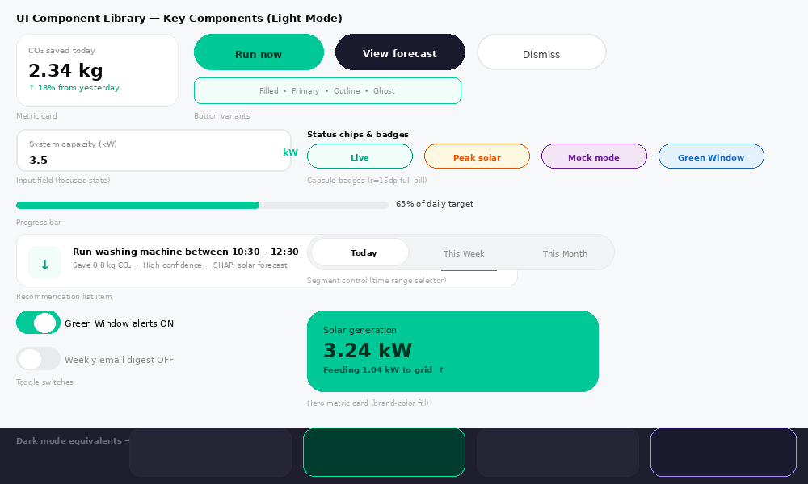
Figure 5 — UI Component Library: All Key Components in Light Mode (with dark strip)

6.1 Metric Cards
Metric cards are the most repeated component in the app. Every key number lives in a card. There are three types: Standard (white bg, subtle shadow), Hero (brand-green bg), and Stat (compact, 3-column row).
Card Type | Use Case | Background | Corner Radius | Shadow
Standard | Daily summary, weekly totals | surface token | r12 | Level 1
Hero | Primary metric (solar kW, CO₂ saved) | brand.primary | r20 | Level 2
Stat (compact) | 3-column stat row under hero | surface2 token | r14 | Level 1
Comparison | Shadow-Grid side-by-side | surface token | r16 | Level 1
Alert/Banner | Green Window, system alerts | accent.deep | r14 | Level 2

6.2 Buttons
Variant | Use Case | Background | Text Color | Border Radius
Primary | Main CTA (Do it now, Run now) | brand.primary | brand.text | 22dp (full pill)
Secondary | Supporting actions (View forecast) | accent.deep | #FFFFFF | 22dp (full pill)
Outline | Tertiary actions (Dismiss, Cancel) | transparent | text.primary | 22dp (full pill)
Ghost | In-card actions (See all →) | transparent | brand.primary | 0 (no border)
Destructive | Delete account, Clear data | #FF6B6B | #FFFFFF | 22dp (full pill)
- All buttons have a minimum touch target of 44dp x 44dp.
- Button text is always 14sp, weight 600 SemiBold.
- Loading state: replace text with a spinner (same color as text). Width does not change.
- Disabled state: 40% opacity. Never change the color to gray — it looks broken.

6.3 Input Fields
- Height: 52dp. Padding: 16dp horizontal, 14dp vertical.
- Border: 1dp border.default when inactive. 2dp brand.primary when focused.
- Label: floats above field on focus (animated, 11sp). Never placeholder-only — always a floating label.
- Error state: 2dp border #FF6B6B. Error message appears below in 11sp #FF6B6B.
- Right accessory: unit labels (kW, kg), show/hide password eye, clear button.

6.4 Cards — Do & Don't
Do | Don't
Use r20 for hero cards with brand-green background | Use sharp corners anywhere — everything is rounded
Show the metric value in display (32sp) size | Show numbers in body (14sp) size — they are the product
Use trees equivalent whenever CO₂ is shown | Show only kg — it's abstract without context
Add a subtle progress bar to show daily target | Use percentage text alone — bars are more scannable
Use level 2 shadow for hero cards | Use no shadow — cards must visually float above background

7. Google Stitch MCP Prompts — All 25 Screens
Each prompt below is optimized for Google Stitch MCP. Copy the entire prompt verbatim — the level of detail is intentional. Stitch requires precise specifications to produce non-generic output.

Universal Context Block — Include in Every Prompt
Prepend this to every Stitch prompt to establish the design system:

Design system: Samarthya Nexus. Framework: React Native with Expo SDK 51.
Theme: supports both light and dark mode. Brand color: #00C896 (light) / #00E5A8 (dark).
Background: #F7F8FA (light) / #141420 (dark). Surface: #FFFFFF (light) / #1E1E2E (dark).
Font: Inter. Corners: always rounded — r12 cards, r20 hero, r28 navigation capsule.
Navigation: floating capsule tab bar at bottom (not standard tab bar).
Style: premium, immersive, climate-tech. NOT generic dashboard. NOT AI-generated looking.

7.1 Auth Flow

Screen 1 — Login
Google Stitch Prompt — Login Screen
// SAMARTHYA NEXUS — LOGIN SCREEN
// React Native, Expo SDK 51, supports light and dark mode

Create a React Native login screen for a premium solar energy app called Samarthya Nexus.

LAYOUT (top to bottom):
1. Full-screen background: #F7F8FA (light) / #141420 (dark). No gradient.
2. Top 35% of screen: large wordmark "Samarthya Nexus" in Inter Bold 28sp, color #0A0A0A (light)
/ #FFFFFF (dark). Below it, tagline "Know your home's carbon impact" in 14sp #8A8A8A.
Small leaf icon (Phosphor Icons: Leaf, size 24) in #00C896 beside the wordmark.
3. White (#FFFFFF light / #1E1E2E dark) rounded card (r24, level 2 shadow, padding 24dp)
containing:
- Section heading "Welcome back" in Inter SemiBold 22sp
- Email input: 52dp height, r12 border, floating label "Email address", left icon Envelope
- Password input: 52dp height, r12, floating label "Password", right eye toggle icon
- "Forgot password?" link right-aligned in 13sp #00C896
- Primary CTA button: full-width, r22 pill, background #00C896, text "Sign in" Inter SemiBold
14sp #003020, height 52dp
- Divider "or" with horizontal lines
- Secondary link: "Don't have an account? Register" centered 13sp
4. Bottom safe area padding.

STATES: loading state on button (spinner replaces text, width unchanged).
Error state: red border (#FF6B6B) on failed field, error message below in 11sp.
NO generic stock photo backgrounds. NO gradient overlays. Clean, minimal, premium.

Screen 2 — Register
Google Stitch Prompt — Register Screen
// SAMARTHYA NEXUS — REGISTER SCREEN

Create a React Native registration screen for a solar carbon tracking app.

LAYOUT:
1. Background: #F7F8FA light / #141420 dark.
2. Back arrow top-left (Phosphor ArrowLeft, 24dp, tappable with 44dp touch target).
3. Screen title "Create account" Inter Bold 24sp, subtitle "Start tracking your solar impact" 14sp muted.
4. Scrollable form card (r20, surface bg, level 1 shadow, padding 20dp) with:
- Full name input (PersonSimple icon, floating label)
- Email input (Envelope icon, floating label)
- Password input (Lock icon, floating label, eye toggle, strength indicator bar below:
3 segments, fills left-to-right: red → amber → #00C896 as password strengthens)
- Confirm password input
- Checkbox row: "I agree to Terms & Privacy Policy" — checkbox r4, brand green when checked
- Primary CTA: "Create account" full-width pill button #00C896
5. Already have an account? Sign in — link at bottom.

PASSWORD STRENGTH BAR: 280dp wide, 4dp height, r2, 3 equal segments with 4dp gap.
Segment colors: #FF6B6B (weak), #FFB347 (medium), #00C896 (strong).
Animate fill progress as user types.

Screen 3 — OTP Verification
Google Stitch Prompt — OTP Verification Screen
// SAMARTHYA NEXUS — OTP VERIFICATION SCREEN

Create an OTP email verification screen.

LAYOUT:
1. Background #F7F8FA / #141420.
2. Back arrow top-left.
3. Centered icon: animated envelope (Phosphor EnvelopeSimple, 64dp, #00C896).
4. Title "Check your email" Bold 24sp, body "We sent a 6-digit code to user@email.com" 14sp muted.
5. OTP input row: 6 individual digit boxes, each 48dp x 56dp, r12, surface bg.
Active box: 2dp brand green border. Filled box: brand green border, bold digit.
Auto-advance focus on each digit entry. Paste support from clipboard.
6. "Resend code" text button — disabled and gray with countdown timer for first 60 seconds,
then becomes active in #00C896.
7. Verify button: full-width r22 pill #00C896 "Verify email".

BEHAVIOR: auto-submit when all 6 digits filled. Success state: brief green checkmark animation
before navigation. Error state: boxes shake animation + red border + "Incorrect code" below.

7.2 Onboarding Flow

Screen 4 — Inverter Setup
Google Stitch Prompt — Inverter Setup Screen
// SAMARTHYA NEXUS — INVERTER SETUP

Create a React Native inverter connection setup screen — step 1 of 4 in onboarding.

LAYOUT:
1. Background #F7F8FA / #141420.
2. Progress indicator: 4-step horizontal dots at top (step 1 active = #00C896 filled circle 10dp,
others = #E8EAED / #2A2A3E unfilled 8dp circles). Connected by thin line.
3. Step label "Step 1 of 4" in 11sp muted. Title "Connect your inverter" Bold 24sp.
4. Inverter brand selector: 3 option cards in a row:
Card 1 "Growatt" with solar panel icon
Card 2 "SMA" with inverter icon
Card 3 "Use Demo Mode" with play icon
Each card: r16, surface bg, 1dp border. Selected state: 2dp #00C896 border + light green tint bg.
5. Conditional form (shown when Growatt or SMA selected):
- "ShinePhone Email" or "Sunny Portal Email" input
- Password input with eye toggle
- "Test Connection" button: outline variant r22, #00C896 border + text
Test connection states: loading spinner → green "Connected!" checkmark → red "Failed, retry"
6. "Skip for now" ghost button at bottom. "Continue →" primary pill button.
7. Bottom note in 11sp muted: "Credentials stored AES-256 encrypted. Never shared."

Screen 5 — Location Setup
Google Stitch Prompt — Location Setup Screen
// SAMARTHYA NEXUS — LOCATION SETUP

Create a location setup screen — step 2 of 4.

1. Progress indicator (step 2 active).
2. Phosphor MapPin icon 48dp #00C896 centered.
3. Title "Set your location" Bold 22sp, subtitle "We use this to get your grid's carbon intensity" 13sp muted.
4. Two options presented as selectable cards (r16):
Option A "Detect automatically" — GPS icon, subtitle "Uses your device location"
Option B "Enter manually" — TextField icon, subtitle "Type your city or area"
5. When Option B selected: city/district text input appears (animated slide-in).
6. Grid zone confirmation card (r14, green tint bg #F0FDF9 / #0D2B22 dark):
"Your grid zone: Madhya Pradesh State Grid"
"Carbon intensity: 0.82 kg CO₂/kWh"
Small info icon (i) that opens a tooltip explaining what this means.
7. "Continue →" primary button.

Screen 6 — System Capacity
Google Stitch Prompt — System Capacity Screen
// SAMARTHYA NEXUS — SYSTEM CAPACITY

Step 3 of 4 onboarding.

1. Progress (step 3 active).
2. Title "Your solar system" Bold 22sp, subtitle "This helps us calibrate your forecasts" 13sp.
3. Three input fields with appropriate icons:
- "Installed capacity" (SunDim icon): numeric input, right unit label "kW" in #00C896
- "Installation year" (Calendar icon): year picker or numeric input
- "Avg monthly consumption" (Lightning icon): numeric input, right unit "kWh/month"
4. Below inputs: live preview card (r16, surface bg) that shows:
"Based on your inputs:" header
"Estimated daily solar: ~14.2 kWh" in display size
"Estimated daily CO₂ offset: ~11.6 kg" in brand green
This updates in real-time as user types.
5. "Continue →" primary button. "Skip" ghost.

Screen 7 — Feature Tour
Google Stitch Prompt — Feature Tour Screen
// SAMARTHYA NEXUS — FEATURE TOUR

Step 4 of 4 — swipeable 4-slide introduction.

OVERALL STRUCTURE:
Full-screen swipeable slides. Page dots at bottom (4 dots, active = #00C896 filled pill 24dp wide,
others = 8dp circles muted). "Skip" text button top-right. "Next →" pill button bottom-right.

SLIDE 1 — Live Carbon Meter:
Large animated circular gauge (SVG) showing solar generation. Text: "See your impact live"
Subtext: "Real-time CO₂ savings updated every 30 seconds."

SLIDE 2 — Shadow-Grid:
Two house icons side by side — one green (solar), one gray (grid). Animated numbers count up.
Text: "Compare with your shadow home" Subtext: "See exactly how much CO₂ your panels prevented."

SLIDE 3 — Green Window:
Sun arc timeline graphic with highlighted peak window in #00C896.
Text: "Run appliances during peak solar" Subtext: "AI forecasts your best 2-hour window each day."

SLIDE 4 — Ready:
Samarthya Nexus wordmark + leaf icon. Text: "You're all set, Samarth!"
Big primary button: "Go to my dashboard →" full width r22 pill #00C896.

All slide illustrations: flat, simple SVG shapes. No photos. No generic stock art.

7.3 Core Tab Screens

Screen 8 — Home Dashboard
Google Stitch Prompt — Home Dashboard Screen
// SAMARTHYA NEXUS — HOME DASHBOARD (most important screen)
// This is the first screen users see every day. It must feel alive.

Create the main home dashboard screen for a solar carbon tracking app.

SCREEN LAYOUT (top to bottom, scroll view with sticky status bar):

STATUS BAR: System status bar, styled for current theme.

HEADER (not scrollable, sticks at top):
- Left: greeting "Good morning, Samarth" 13sp muted, "Your home right now" Bold 20sp below
- Right: notification bell icon (Phosphor Bell, 24dp) + profile avatar circle (32dp, initials "SS")
- No border below header — content flows from header directly

SCROLL CONTENT:
1. HERO CARD (r20, background #00C896 light / #003D2E dark, padding 20dp, level 2 shadow):
Top row: "Solar generation" label 12sp white/dark-green
Large number: "3.24 kW" Inter Bold 36sp white/dark-green
Status row: "Feeding 1.04 kW to grid ↑" 13sp Bold, lighter green tint
Right side: animated arc gauge (SVG, 90dp diameter) showing current vs capacity
The arc is white/light-green, fills clockwise proportionally

2. STATS ROW (3 equal cards side by side, gap 10dp, each r14 surface bg):
Card 1: down-arrow icon #00C896, "2.34 kg" Bold 18sp, "CO₂ saved" 10sp muted
Card 2: house icon #1A1A2E / #A78BFA, "1.80 kW" Bold 18sp, "Home use" 10sp muted
Card 3: "~" icon muted, "0.00 kW" Bold 18sp, "Grid draw" 10sp muted

3. SHADOW-GRID CARD (r16, surface bg, padding 16dp):
Header row: "Shadow-Grid today" SemiBold 15sp LEFT, "See all →" 13sp #00C896 RIGHT
Bar row 1: "Your home" label, green bar 90dp wide, "2.34 kg" right
Bar row 2: "Without solar" label, red (#FF6B6B) bar 340dp wide, "8.70 kg" right
Both bars: height 8dp, r4, animated width on load
Bottom: "You saved 6.4 kg CO₂ = 107 trees today ✓" Bold 13sp #00C896

4. GREEN WINDOW BANNER (r14, #1A1A2E / #0D2B22 dark, if active — else hidden):
Left icon: SunHorizon 24dp #00E5A8
Title: "Green Window" Bold 14sp white
Body: "Peak solar in 32 min — run your washing machine" 12sp #AAAADD
Right: "0.8 kg CO₂" Bold 12sp #00C896

5. LIFETIME IMPACT CARD (r14, surface2 bg):
"847 kg CO₂ offset = 38 trees planted" with tree icons (small, 16dp)

BOTTOM: Capsule navigation bar floating above safe area.
24dp bottom content padding before nav bar starts.

ANIMATIONS: arc gauge animates on load (spring 600ms). CO₂ counter counts up from 0.
Cards fade-in stagger (100ms delay between each card).

Screen 9 — Shadow-Grid View
Google Stitch Prompt — Shadow-Grid Screen
// SAMARTHYA NEXUS — SHADOW-GRID COMPARISON SCREEN

Create the Shadow-Grid screen showing green home vs hypothetical grid-only home comparison.

HEADER: "Shadow-Grid" Bold 22sp. Subtitle "Your real environmental impact" 13sp muted.

TIME RANGE SELECTOR: Segmented control (r22 pill container, 3 options: Today / This Week / This Month).
Active segment: white pill (r18) with shadow. Inactive: transparent, muted text.

HERO COMPARISON (r20, surface, padding 20dp, level 2 shadow):
Two column layout:
LEFT column header: house icon #00C896 + "Your home" Bold 14sp
Large number: "2.34 kg" display Bold 32sp #0A0A0A / #FFFFFF
Label: "CO₂ emitted" 12sp muted
Bottom: "With 3.5kW solar" 11sp #00C896
RIGHT column header: house icon #FF6B6B + "Without solar" Bold 14sp
Large number: "8.70 kg" display Bold 32sp #FF6B6B
Label: "would have emitted" 12sp muted
Bottom: "Grid-only scenario" 11sp muted
Center divider: vertical line 1dp border.default
Bottom of card: "You saved 6.36 kg CO₂ today" Bold 16sp #00C896 centered with leaf icon

IMPACT TRANSLATION CARDS (2-column grid, r14, surface2):
"6.4 kg CO₂" = "107 trees, 1 day"
"6.4 kg CO₂" = "25 km car-free"
"6.4 kg CO₂" = "3 min flight avoided"
"6.4 kg CO₂" = "12 LED bulbs, 1 month"
Each card: relevant icon, number Bold, context muted.

SHARE BUTTON: centered, outline variant, ShareNetwork icon + "Share my impact card"

Capsule nav bar.

Screen 10 — Green Window
Google Stitch Prompt — Green Window Screen
// SAMARTHYA NEXUS — GREEN WINDOW FORECAST SCREEN

Create the Green Window screen showing ML solar forecast and optimal appliance window.

HEADER: "Green Window" Bold 22sp. Subtitle "Today's optimal solar hours" 13sp muted.

NEXT WINDOW CARD (r20, #003020 bg light / #0D2B22 dark, padding 20dp):
Top: "Next peak window" 12sp white/light-green
Time: "10:30 AM — 12:30 PM" Bold 28sp white
Subtitle: "Run your washing machine now to save 0.8 kg CO₂" 13sp light-green
Countdown: "Starts in 1h 24m" Bold 15sp white, monospace countdown timer
CTA button: "Set reminder" outline (white border, white text) r22 pill

FORECAST CHART (r16, surface, padding 16dp):
Title: "Solar forecast — next 4 hours" SemiBold 15sp
Line chart: smooth bezier curve, #00C896 line 2dp, brand tint (#F0FDF9 / #0D2B22) area fill
X-axis: time labels every 30 min, 11sp muted
Y-axis: kW labels 0–4, 11sp muted
Highlighted region: green tint overlay on Green Window time range
Confidence band: very subtle ±1σ shaded area (10% opacity brand color)
Open-Meteo cloud cover: secondary gray dashed line overlay
Chart height: 180dp

APPLIANCE SUGGESTIONS (r14, surface, list):
Each row: appliance icon (Phosphor), name SemiBold 14sp, power + CO₂ saving, chevron right
Row 1: washing machine — "Washing Machine 2.1 kW → save 0.9 kg"
Row 2: dishwasher — "Dishwasher 1.4 kW → save 0.6 kg"
Row 3: EV charger — "EV Charging 7.4 kW → save 3.2 kg"

Capsule nav bar.

Screen 11 — Insights
Google Stitch Prompt — Insights Screen
// SAMARTHYA NEXUS — INSIGHTS ANALYTICS SCREEN

Create the Insights screen with 7-day analytics and charts.

HEADER: "Insights" Bold 22sp. Time range segmented control: 7 days / 30 days / 3 months.

DAILY FOOTPRINT CHART (r16, surface, padding 16dp):
Bar chart, 7 bars, each bar: 28dp wide, r6 top corners, gap 12dp
Bar color: below average = #00C896, above average = #FFB347
Today's bar: slightly more saturated, labeled "Today" below in #00C896 bold
Above chart: "Daily CO₂ footprint" SemiBold 14sp + average line dashed
Average line label: "Avg 3.2 kg" in 11sp at the line position
Chart height: 160dp

GENERATION VS CONSUMPTION (r16, surface, padding 16dp):
Overlapping area chart. Solar generation: #00C896 fill. Consumption: #6B6B80 line only.
Title: "Solar vs Consumption" SemiBold 14sp
Legend: two dots with labels "Solar" and "Home use"
Chart height: 130dp

HOURLY HEATMAP (r16, surface, padding 16dp):
7 rows (days) × 24 columns (hours). Each cell 10dp × 20dp, r2.
Color scale: dark (#141420) = low/night, #00C896 = high solar hours.
Y-axis: day labels Mon-Sun. X-axis: 0h, 6h, 12h, 18h, 24h.
Title: "Green hours heatmap" — when is your solar strongest?

BENCHMARK CARD (r14, surface2):
"Your home vs average Indian household" SemiBold 14sp
Two horizontal bars side by side. Your: 2.34 kg #00C896. Average: 6.5 kg #FFB347.
"You emit 64% less than average" Bold 14sp #00C896

Capsule nav bar.

Screen 12 — Recommendations
Google Stitch Prompt — Recommendations Screen
// SAMARTHYA NEXUS — AI RECOMMENDATIONS SCREEN

Create the daily recommendations screen with SHAP explanations.

HEADER: "For you today" Bold 22sp. Subtitle: "5 actions to reduce your footprint" 13sp muted.
Streak badge top-right: pill "#00C896 bg" — "7 day streak 🌿" Bold 12sp #003020.

RECOMMENDATION CARDS (r16, surface, padding 16dp, level 1 shadow, gap 12dp):
Each card contains:
TOP ROW: category icon (24dp) in branded tint circle (40dp, r12) — LEFT
CO₂ saving badge — "Save 0.8 kg" pill (#F0FDF9 bg, #00A078 text, r14) — RIGHT
TITLE: action name SemiBold 15sp, 1-2 lines max
BODY: 13sp muted, concise reason (1 line)
SHAP ROW: "Why?" label 11sp muted, then 3 feature pills side by side
Each pill: feature name 10sp, fill width proportional to importance, #00C896 left bar
e.g.: [Solar forecast ████] [Weather ██] [Hour █]
ACTION ROW: "Do it now →" primary ghost button LEFT, "Remind later" ghost RIGHT

CARD 1: Washing machine shift (appliance_shift category)
CARD 2: Postpone dishwasher (appliance_shift)
CARD 3: Charge phone now (behavioral)
CARD 4: Open roof vent before 3pm (behavioral)
CARD 5: EV charge window (green_window)

All cards: swipe-left to dismiss (with red trash icon reveal).

Capsule nav bar.

Screen 13 — Score & Badges
Google Stitch Prompt — Score and Badges Screen
// SAMARTHYA NEXUS — DAILY SCORE & BADGES SCREEN

Create the gamification screen showing daily sustainability score and achievement badges.

HEADER: "Your impact" Bold 22sp.

SCORE HERO CARD (r20, surface, padding 24dp, level 2 shadow):
Centered large circular progress ring (160dp diameter, 12dp stroke):
Background ring: border.default color
Filled ring: #00C896, animates on load from 0 to score
Center: score "74" in Inter Bold 52sp, "/100" in 18sp muted below
Below ring: "Today's sustainability score" 14sp muted
Badge row: star icon + "7-day streak" Bold 14sp #00C896

SCORE BREAKDOWN (r14, surface2, padding 16dp):
3 rows, each with: label LEFT, mini progress bar CENTER, points RIGHT
Row 1: "Carbon offset (40pts)" — bar shows 28/40, "28 pts" #00C896
Row 2: "Recommendations followed (40pts)" — bar 36/40, "36 pts" #00C896
Row 3: "Daily engagement (20pts)" — bar 10/20, "10 pts" #FFB347

ACHIEVEMENT BADGES (2-column grid, each badge r16, surface, padding 12dp):
Earned badges: full color icon + name Bold + unlock date
Locked badges: 40% opacity + "Locked" label
Badge examples: "First Watt" (sun icon), "Carbon Crusader" (leaf), "Forest Builder" (tree),
"Green Streak" (flame), "Solar Champion" (trophy), "100 Trees" (forest)

SHARE BUTTON: "Share my score" centered outline pill.

Capsule nav bar.

7.4 Detail & Drill-Down Screens

Screen 14 — Day Detail
Google Stitch Prompt — Day Detail Screen
// SAMARTHYA NEXUS — DAY DETAIL SCREEN

Create a drill-down screen showing 15-minute interval data for a selected past day.

NAVIGATION: back arrow + date title (e.g. "Tuesday, 10 June") + left/right day navigation arrows.

DAY SUMMARY ROW (4 stat pills side by side, r12, surface2, gap 8dp):
"18.6 kWh" generated | "12.4 kWh" consumed | "6.3 kg" saved | "24 trees" equivalent
Each pill: value Bold 15sp, label 10sp muted

15-MINUTE CHART (r16, surface, padding 16dp, height 200dp):
Dual area chart: solar generation (#00C896 fill) and consumption (#6B6B80 line + subtle fill)
X-axis: hour labels 6am to 8pm, 11sp
Tap-to-scrub: vertical crosshair line + floating tooltip showing values at that time
Tooltip: r8, surface, shadow, "11:15 AM | Solar: 3.2 kW | Home: 1.1 kW"

SHADOW-GRID MINI COMPARISON (r14, surface2, horizontal layout):
Green house icon + "2.34 kg actual" vs gray house + "8.70 kg without solar"

HOURLY BREAKDOWN LIST (r12, surface, padding 12dp each row):
Time slot | solar kW | consumption kW | CO₂ offset (all in a clean 3-column row)
Every hour from 6am to 8pm. Alternating row bg for readability.

Screen 15 — Forecast Detail
Google Stitch Prompt — Forecast Detail Screen
// SAMARTHYA NEXUS — FORECAST DETAIL SCREEN

Create a detailed ML forecast breakdown screen.

HEADER: "Forecast breakdown" Bold 22sp. Subtitle: "Next 24 hours · ARIMA + LSTM model" 13sp muted.

MODEL ACCURACY CARD (r14, surface2, horizontal layout):
Left: "Model accuracy" label, "MAE 0.31 kW" Bold #00C896
Right: "Last trained" label, "2 hours ago" 13sp
Bar: thin accuracy bar from 0–1, filled to 0.85 in #00C896

24-HOUR FORECAST CHART (r16, surface, height 220dp):
X-axis: every 2 hours. Y-axis: 0–4 kW.
Main line: #00C896 2dp smooth bezier
Confidence band: ±1σ shaded #00C896 at 15% opacity
Dotted vertical line at "now"
Weather line: cloud cover %, gray dashed, secondary Y-axis right side

COMPONENT BREAKDOWN (r14, surface, padding 16dp):
Title: "Model components" SemiBold 14sp
Two stacked bars for current forecast step:
"ARIMA (linear)" — amber bar — "2.1 kW linear trend"
"LSTM correction" — purple bar — "+0.8 kW weather correction"
= "Total: 2.9 kW" Bold

TOP SHAP FEATURES (r14, surface2, list):
"Why this forecast?" SemiBold 14sp
3 rows: feature name + horizontal importance bar + percentage
Solar gen 15min ago: ████████ 64%
Cloud cover: █████ 22%
Hour of day: ██ 14%

Screen 16 — Recommendation Detail
Google Stitch Prompt — Recommendation Detail Screen
// SAMARTHYA NEXUS — RECOMMENDATION DETAIL SCREEN

Create a full detail screen for a single AI recommendation.

NAVIGATION: back arrow + title "Recommendation" + dismiss (X) top-right.

ACTION HERO CARD (r20, #003020 / #0D2B22 dark, padding 20dp):
Icon: WashingMachine 48dp white
Title: "Run your washing machine now" Bold 22sp white
Saving: "Save 0.8 kg CO₂ · 13 trees equivalent" 14sp light-green
Time: "Best time: 10:30 – 12:30 PM" 13sp muted

WHY SECTION (r16, surface, padding 16dp):
Title: "Why this recommendation?" SemiBold 15sp
Body text: 2-3 sentence explanation in 14sp body
SHAP chart: horizontal bar chart of feature importances
Each feature: colored left bar (width = importance), feature name, percentage
Bar colors: #00C896 for solar features, #A78BFA for time features, #FFB347 for weather

HOW IT HELPS (r14, surface2, padding 14dp):
"If you do this:" then 3 bullet points with green checkmarks:
"0.8 kg CO₂ prevented · saving 13 trees per year · uses solar instead of grid"

HISTORY (r14, surface, list):
Title: "This recommendation's history" SemiBold 14sp
Last 7 times shown, with: date + followed (green check) / missed (gray x)

2 CTA BUTTONS BOTTOM: "Do it now →" primary full-width. "Remind me at 10am" outline below.

Screen 17 — Carbon Certificate
Google Stitch Prompt — Carbon Certificate Screen
// SAMARTHYA NEXUS — CARBON CERTIFICATE SCREEN

Create a shareable annual carbon savings certificate screen.

HEADER: back arrow + "Carbon Certificate" Bold 22sp.

CERTIFICATE CARD (r20, surface, 2dp #00C896 border, padding 24dp, looks like a real certificate):
TOP: small leaf logo + "Samarthya Nexus" wordmark + "Certificate of Impact" italic 13sp muted
DIVIDER: thin 1dp border.default
ISSUED TO: "Samarth Shrivastava" Bold 20sp, "Gwalior, Madhya Pradesh" 13sp
DATE RANGE: "January 1 – December 31, 2025" 13sp muted
MAIN NUMBER: "847 kg" display Bold 44sp #00C896, "CO₂ prevented" below 14sp
GRID: 2×2 equivalency grid (r12 tint cards):
38 trees | 3,380 km car-free
8 flights (1hr) | 4,200 LED bulb-months
DIVIDER
SYSTEM: "3.5 kW Growatt System · Installed 2023" 12sp muted
FOOTER: "Verified by Samarthya Nexus AI · ITM University Gwalior" 11sp muted

SEAL: circular emblem top-right corner of certificate: tree icon + "VERIFIED 2025"

ACTION BUTTONS (below certificate):
"Share certificate" primary pill #00C896 full-width
"Download PDF" outline pill below

Screen 18 — Inverter Status
Google Stitch Prompt — Inverter Status Screen
// SAMARTHYA NEXUS — INVERTER STATUS SCREEN

Create a hardware health/status screen for the connected solar inverter.

HEADER: back arrow + "Inverter status" Bold 22sp.

STATUS HERO (r16, surface, padding 16dp):
Left: Growatt logo placeholder (rounded rect 48dp #E1F5EE with "G" letter)
Right:
"Growatt MIN 3000TL-X" Bold 15sp
Status pill: "Connected ●" with green dot, #F0FDF9 bg #00A078 text
"Last sync: 2 minutes ago" 12sp muted

LIVE METRICS ROW (3 stat cards, r12, surface2):
Power: "3.24 kW" | Temperature: "42°C" | Today: "18.6 kWh"

7-DAY UPTIME CHART (r14, surface, 120dp height):
Bar chart: 7 bars, each showing uptime %. Above 95% = #00C896. Below = #FFB347.
Title: "7-day uptime: 98.6%" SemiBold 14sp

ERROR LOG (r14, surface, list):
"No recent errors" shown in center with CheckCircle icon #00C896 if clean
Otherwise: list of errors with timestamp, error code, severity badge

BUTTONS: "Sync now" primary outline. "Update credentials" ghost.

7.5 Settings Screens

Screens 21–25 — Settings Flow
Google Stitch Prompt — Profile & Settings Screens
// SAMARTHYA NEXUS — SETTINGS STACK (5 screens)
// Generate all 5 settings screens as a stack navigator

== SCREEN 21: PROFILE & ACCOUNT ==
HEADER: "Profile" Bold 22sp.
PROFILE CARD (r16, surface, padding 20dp):
Avatar circle 72dp, initials "SS", brand green bg #00C896
"Samarth Shrivastava" Bold 18sp
"samarth@email.com" 14sp muted
"Edit profile" ghost button right

SETTINGS LIST (grouped, r14 cards per group, each row 52dp height):
Group 1 — Account: Change email | Change password | Linked inverter
Group 2 — Danger zone (red tint card): Export my data | Delete account
All rows: icon left, label, chevron right. Destructive rows: red label.

== SCREEN 22: INVERTER SETTINGS ==
HEADER: "Inverter" Bold 22sp.
Connected inverter card (r16, surface). Brand selector. Credential fields. Toggle: Live / Demo mode.
Sync button: "Sync now" primary outline.

== SCREEN 23: NOTIFICATIONS ==
HEADER: "Notifications" Bold 22sp.
Grouped toggle list:
"Green Window alerts" toggle (ON default)
"Weekly summary" toggle
Quiet hours row → opens time picker sheet: "10:30 PM – 7:00 AM"
Minimum saving threshold → stepper: "> 0.3 kg CO₂"

== SCREEN 24: DATA & PRIVACY ==
HEADER: "Data & Privacy" Bold 22sp.
Card with data retention info (prose). Export CSV button. Delete all readings button (destructive).
Anonymous benchmarking toggle.

== SCREEN 25: ABOUT & HELP ==
HEADER: "About" Bold 22sp.
App version card: "Samarthya Nexus v1.0" + logo.
FAQ accordion list: 5 items, tap to expand with spring animation.
Feedback button. Open source licenses link. Team credits.

8. Animation & Interaction Rules

8.1 Motion Principles
- Use spring animations for all interactive elements (react-native-reanimated withSpring). Spring feels organic and alive — not mechanical.
- Duration reference: 250ms for micro-interactions (button presses, toggles), 350ms for transitions (screen slides), 500ms for hero reveals (arc gauge, score ring).
- Stagger card reveals: when a screen loads, fade-in cards with 80ms stagger between each. The home screen feels like it "wakes up" when you open it.
- CO₂ counter animation: on dashboard load, count from 0 to the current value over 800ms using an easing curve. This makes the number feel earned.
- Capsule nav active pill: use withSpring to slide the active pill from one tab to another. Never use opacity alone — the pill physically moves.

8.2 Specific Animations
Element | Animation | Duration | Easing
Solar arc gauge | Stroke draws clockwise from 0 | 600ms | easeOutCubic
Score ring | Stroke fills from 0 to score | 800ms | spring(mass:1, damping:15)
CO₂ counter | Number counts up from 0 | 800ms | easeOutQuart
Card fade-in | Opacity 0→1 + translateY 12→0 | 350ms | spring(damping:20)
Shadow bars | Width animates from 0 | 400ms | spring(stiffness:200)
Active nav pill | translateX slides between tabs | 300ms | spring(damping:20)
Recommendation swipe | Translate + opacity on dismiss | 250ms | easeInCubic
Green Window banner | Slide in from top | 350ms | spring(damping:18)
Toggle switch | Thumb slides L→R or R→L | 200ms | spring(damping:25)

8.3 Haptic Feedback Rules
- Light haptic: toggle switches, checkbox taps, tab bar switches.
- Medium haptic: primary CTA button press, recommendation "Do it now" confirmation.
- Heavy haptic: achievement badge unlocked, annual certificate generated.
- Error haptic: failed connection, wrong OTP code (vibration pattern).
- Use expo-haptics for all haptic triggers. Always wrap in try-catch — some devices do not support haptics.

9. Accessibility Rules
Rule | Requirement | Implementation
Color contrast | All text must meet WCAG AA (4.5:1 minimum ratio) | Brand green on white: 3.2:1 — compensate with Bold weight. Brand green on #003020: 7.8:1 — compliant.
Touch targets | Minimum 44×44dp for all interactive elements | Add hitSlop={16} to small icons. Ensure capsule nav tabs are touch-expanded.
Screen readers | All interactive elements have accessibilityLabel | Every icon button: accessibilityLabel="Notifications". Cards: accessibilityRole="button".
Dynamic type | Text scales with system font size setting | Use sp units (not dp) for all font sizes. Test at 1.5× system scale.
Reduced motion | Animations respect system preference | Check AccessibilityInfo.isReduceMotionEnabled(). Skip counter animations if true.
Color-blind safe | Never use red/green alone to convey meaning | Shadow bars: red + dashed pattern. Metric cards: icon + label alongside color.

10. Do & Don't — Design Anti-Patterns
Category | DO | DON'T
Numbers | Show CO₂ in kg with trees equivalent always alongside | Show only raw kWh or kg without context — users cannot feel abstract units
Colors | Use brand green sparingly — hero metrics, CTAs, active states | Use green on every element — it loses meaning and looks like a generic eco-app
Dark mode | Use deep navy (#141420) for background — feels warm and night-sky | Use pure black (#000000) — feels cold, dated, and OLED-only optimized
Cards | Use r20 corner radius for hero cards, floating with shadow | Use flat cards with sharp corners — nothing in nature has sharp corners
Typography | Make metric numbers huge (32–44sp) — they are the product | Show all text in the same size — destroys the information hierarchy
Navigation | Use the capsule nav with spring-animated active pill | Use standard React Navigation tab bar — it looks unfinished
Whitespace | Leave generous breathing room (16–24dp) around all content | Pack content edge-to-edge — it feels anxious and hard to read
AI clichés | Design with intention — every element earns its place | Use: purple gradients, generic glassmorphism, floating orbs, gradient text, neon glow effects
Empty states | Show a helpful, on-brand empty state with an action | Show a blank white screen or generic "No data" text
Loading states | Use skeleton screens that match the layout shape | Use a centered spinner — it makes users feel like nothing is happening

Document Sign-Off
Role | Name | Signature | Date
Frontend & Design Lead | Shreya Kumari (BCAN1CA24148)
Backend Lead | Samarth Shrivastava (BCAN1CA24140)
ML Engineer | Shreyansh Sonker (BCAN1CA24149)
Guide | Dr. Vani Agrawal

Samarthya Nexus UI Design Rules v1.0 | ITM University Gwalior | BCA Minor Project 2025–26 | Confidential

