**Assignment1:** Create a basket app.

We can make this basket app by :

* making a product API in that we will create an array of object containing product name, product id, category.
* Create a hook to define the state of the compnent and pass this Product object as an argument .
* Create a map method on the hook item and using object destructuring we can access the properties of the product object and display all the list of product in the main page.
* Will create a different tabs for different catagories using buttons and call the onClick event on the button passing a argument in a filterItem() function.
* Using filter method on the product object access all the categories in an array.
* Create a hook to set the categories .
* Create a filterItem() with on conditional statement if the category is equal to all ,then set the hook item as the whole Product list .using filter method compare the category of the current element is equal to the category passed to the function if true set the category to that perticular category .
* When you will click on one category tab you will be able to see those category items only.
* To add that list while clicking on + sign . create a hook of an array.and onclick of that plus button add that item into that array.
* On clicking on the delete button empty that array.and show message zero items.

Improvement :

* We have created categories to better visualisation of products.
* When we are deleting perticular item it should delete one by one .

**Assignment2:**Search for the latest trending Gifs in your favorite categories from Giphy or Reddit!

To make this app :

* We can make this app in one page by giving two links Giphy and Reddit on the top.
* If user will select Giphy he can find all the Giphy GIF as per their search. And while clicking on Reddit find the result of Reddit GIF .
* We can make a common search box with the condithinal statement.
* If prefix of Reddit url is present find the reddit result from reddit API.
* If prefix of Giphy url is present find the reddit result from Giphy API.
* By using the value property of input element and updating the state in onChange method, So we can easily test this regex in onChange and update the state only when the input will be valid
* In order to make th search work, we need to add a filter function with the map function which filters data based on the requirement but before that, we need to set up the state which would change as the content in search box changes.

1. **Assignment3:** Write a wizard in react 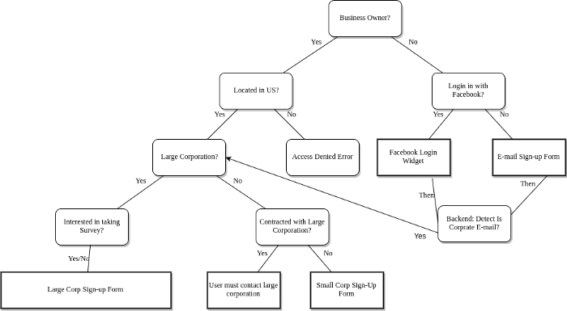

* We will create a formStep hook to maintain the state of the form values.
* Then wrapping each input element inside a conditional statement if formStep == 0 like that for all different state value.
* Intially the state value will be 0. So we will able to see only one input element on the page
* Create a next and previous button .
* While clicking on next button on formNext function will call inside that function we will set the hook state property each time increase by one .
* In that way we will move to the next input element by clicking on next.
* Same with previous button we will decrement the value of state by one. To move back to the previous element.

**Assignment4:** How do you make sure that user remains authenticated on page refresh while using Context API State Management?

* By using useEffect we can store the user to remain authenticate while page refresh.
* By using JSON.stringify () inside window.localStorage.setItem .
* wrap the AuthState in index.js so that App.js can access the auth context.

**Assignment5:** Given the code defined above, can you identify two problems?

* super(props) is missing in the code inside constructor() method.
* Ref is not created in the code given we have to create a ref using createRef() inside constructor().
* <h2>My Component ({this.state.clicks} clicks})</h2> Extra curly bracket is available in the above line after clicks.