DBMS CASE STUDY
OM SALES DISTRIBUTORS
Beauty Products Distribution Management System
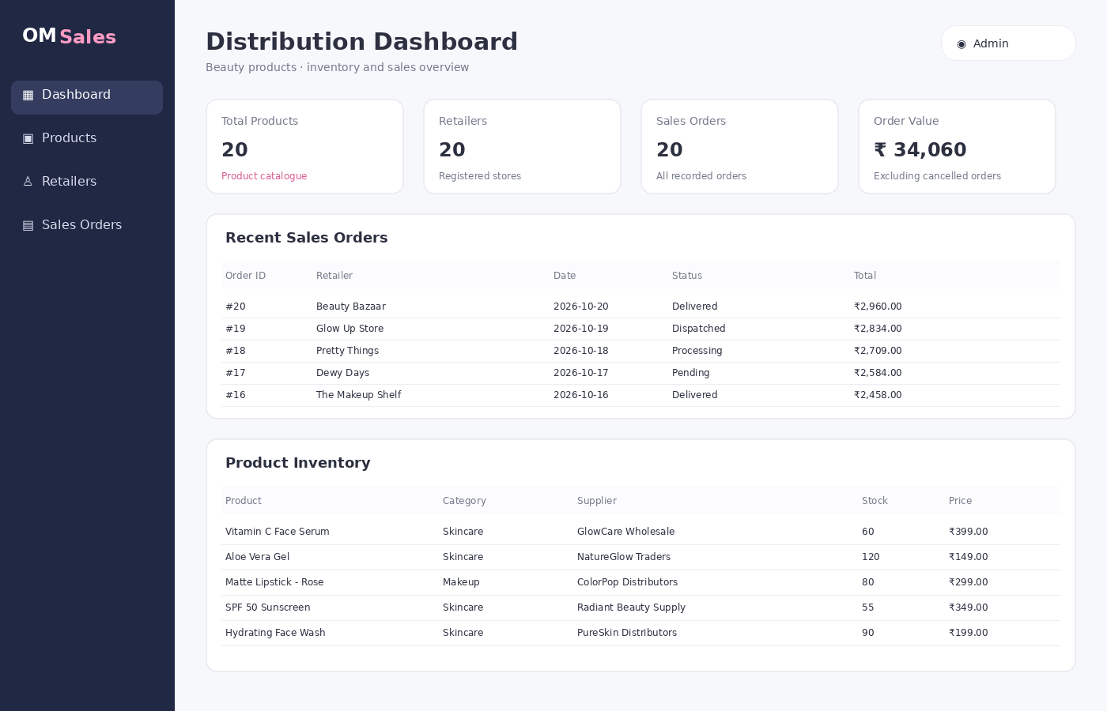
Submitted by: Shreya Pise
Subject: Database Management Systems (DBMS)
Database: PostgreSQL

1. Introduction
OM Sales Distributors is a proposed distribution business that purchases beauty and personal-care products from suppliers and distributes them to retail shops. Its catalogue includes skincare, makeup, haircare and bodycare products. The business needs a reliable system to manage suppliers, product stock, retailer details, sales orders, order line items and purchase records.
This case study designs a relational database using PostgreSQL and connects it to a simple web application developed with Python Flask, HTML and CSS. The design uses primary keys, foreign keys, data types, validation constraints, joins and aggregate queries to demonstrate core DBMS concepts.

2. Description of the Problem
If distribution activities are maintained in notebooks or separate spreadsheets, the business may face duplicate records, incorrect stock counts, difficulty tracking orders, inconsistent supplier information and slow sales reporting. A retailer's order may contain several products, and each product may be supplied by a particular supplier. These connections should be stored consistently.
- Maintain one reliable record for each supplier, product and retailer.
- Link sales orders to the retailer who placed them and link each order to its product line items.
- Track stock quantity, product price, supplier purchases and purchase status.
- Reduce duplication by separating entities into related tables.
- Generate reports using filtering, sorting, joins, grouping and aggregate SQL functions.
- Provide a simple frontend to view products, retailers and sales orders and to add products.

3. Objectives and Scope
- Create a PostgreSQL database named shreya_pise_om_sales.
- Implement six related tables with constraints and keys.
- Insert at least 20 records into every table.
- Demonstrate SELECT, WHERE, ORDER BY, GROUP BY, aggregate functions, joins, subqueries, INSERT, UPDATE and DELETE.
- Connect the database to a Flask web application and display database records in the frontend.

4. Table Description
Table name | Purpose and reason for inclusion
suppliers | Stores supplier identity and contact details. Each supplier can supply multiple products and can be linked to purchase records.
products | Stores the beauty product catalogue, category, selling price, available stock and the supplier responsible for the product.
retailers | Stores shops that purchase products from OM Sales. One retailer can place many sales orders.
sales_orders | Stores order-level information such as retailer, date, status and total amount. It avoids repeating retailer details for every order.
order_items | Stores the individual products and quantities included in each order. It connects sales_orders and products and supports multi-product orders.
purchases | Records products ordered from suppliers, purchase quantities, unit cost, purchase date and delivery status.

5. Relational Database Schema
Database name: shreya_pise_om_sales. Create the database first, then connect to it and run schema.sql followed by seed.sql. The following commands are for PostgreSQL.
CREATE DATABASE shreya_pise_om_sales;
-- In psql, connect using:
\c shreya_pise_om_sales
-- Then run schema.sql and seed.sql from the project folder.

5.1 Table attributes, data types and constraints
Table | Attributes and constraints
suppliers | supplier_id INT PK; supplier_name VARCHAR(100) NOT NULL UNIQUE; contact_person VARCHAR(80) NOT NULL; phone VARCHAR(15) NOT NULL UNIQUE; email VARCHAR(120) UNIQUE; city VARCHAR(60) NOT NULL.
products | product_id INT PK; product_name VARCHAR(120) NOT NULL; category VARCHAR(50) CHECK; selling_price NUMERIC(10,2) CHECK >= 0; stock_quantity INT DEFAULT 0 CHECK >= 0; supplier_id INT FK → suppliers.supplier_id.
retailers | retailer_id INT PK; retailer_name VARCHAR(100) NOT NULL; contact_person VARCHAR(80) NOT NULL; phone VARCHAR(15) NOT NULL UNIQUE; email VARCHAR(120) UNIQUE; city VARCHAR(60) NOT NULL.
sales_orders | order_id INT PK; retailer_id INT FK → retailers.retailer_id; order_date DATE NOT NULL; order_status VARCHAR(20) CHECK; total_amount NUMERIC(12,2) CHECK >= 0.
order_items | order_item_id INT PK; order_id INT FK → sales_orders.order_id; product_id INT FK → products.product_id; quantity INT CHECK > 0; unit_price NUMERIC(10,2) CHECK >= 0; line_total generated as quantity × unit_price.
purchases | purchase_id INT PK; supplier_id INT FK → suppliers.supplier_id; product_id INT FK → products.product_id; purchase_date DATE NOT NULL; quantity INT CHECK > 0; unit_cost NUMERIC(10,2) CHECK >= 0; purchase_status VARCHAR(20) CHECK.

Key and constraint notes:
- Primary key (PK): uniquely identifies each row. Identity columns generate IDs automatically for new records.
- Foreign key (FK): ensures referenced supplier, retailer, product or order exists.
- NOT NULL: required values cannot be omitted.
- UNIQUE: prevents duplicate supplier names and selected contact fields.
- CHECK: limits categories, statuses, prices, stock and quantities to valid values.
- ON DELETE CASCADE is used for order_items when an order is deleted; supplier/product/retailer references are restricted where deletion could leave business records orphaned.

5.2 SQL table creation
-- OM Sales Distributors: PostgreSQL schema
-- Database: shreya_pise_om_sales
-- Create database separately in psql/pgAdmin, then connect to it before running this file.
CREATE TABLE suppliers (
supplier_id INT GENERATED BY DEFAULT AS IDENTITY PRIMARY KEY,
supplier_name VARCHAR(100) NOT NULL UNIQUE,
contact_person VARCHAR(80) NOT NULL,
phone VARCHAR(15) NOT NULL UNIQUE,
email VARCHAR(120) UNIQUE,
city VARCHAR(60) NOT NULL
);
CREATE TABLE products (
product_id INT GENERATED BY DEFAULT AS IDENTITY PRIMARY KEY,
product_name VARCHAR(120) NOT NULL,
category VARCHAR(50) NOT NULL CHECK (category IN ('Skincare','Makeup','Haircare','Bodycare')),
selling_price NUMERIC(10,2) NOT NULL CHECK (selling_price >= 0),
stock_quantity INT NOT NULL DEFAULT 0 CHECK (stock_quantity >= 0),
supplier_id INT NOT NULL REFERENCES suppliers(supplier_id) ON UPDATE CASCADE ON DELETE RESTRICT
);
CREATE TABLE retailers (
retailer_id INT GENERATED BY DEFAULT AS IDENTITY PRIMARY KEY,
retailer_name VARCHAR(100) NOT NULL,
contact_person VARCHAR(80) NOT NULL,
phone VARCHAR(15) NOT NULL UNIQUE,
email VARCHAR(120) UNIQUE,
city VARCHAR(60) NOT NULL
);
CREATE TABLE sales_orders (
order_id INT GENERATED BY DEFAULT AS IDENTITY PRIMARY KEY,
retailer_id INT NOT NULL REFERENCES retailers(retailer_id) ON UPDATE CASCADE ON DELETE RESTRICT,
order_date DATE NOT NULL DEFAULT CURRENT_DATE,
order_status VARCHAR(20) NOT NULL CHECK (order_status IN ('Pending','Processing','Dispatched','Delivered','Cancelled')),
total_amount NUMERIC(12,2) NOT NULL CHECK (total_amount >= 0)
);
CREATE TABLE order_items (
order_item_id INT GENERATED BY DEFAULT AS IDENTITY PRIMARY KEY,
order_id INT NOT NULL REFERENCES sales_orders(order_id) ON UPDATE CASCADE ON DELETE CASCADE,
product_id INT NOT NULL REFERENCES products(product_id) ON UPDATE CASCADE ON DELETE RESTRICT,
quantity INT NOT NULL CHECK (quantity > 0),
unit_price NUMERIC(10,2) NOT NULL CHECK (unit_price >= 0),
line_total NUMERIC(12,2) GENERATED ALWAYS AS (quantity * unit_price) STORED
);
CREATE TABLE purchases (
purchase_id INT GENERATED BY DEFAULT AS IDENTITY PRIMARY KEY,
supplier_id INT NOT NULL REFERENCES suppliers(supplier_id) ON UPDATE CASCADE ON DELETE RESTRICT,
product_id INT NOT NULL REFERENCES products(product_id) ON UPDATE CASCADE ON DELETE RESTRICT,
purchase_date DATE NOT NULL,
quantity INT NOT NULL CHECK (quantity > 0),
unit_cost NUMERIC(10,2) NOT NULL CHECK (unit_cost >= 0),
purchase_status VARCHAR(20) NOT NULL CHECK (purchase_status IN ('Pending','In Transit','Received','Cancelled'))
);
CREATE INDEX idx_products_supplier ON products(supplier_id);
CREATE INDEX idx_orders_retailer ON sales_orders(retailer_id);
CREATE INDEX idx_order_items_order ON order_items(order_id);
CREATE INDEX idx_purchases_supplier ON purchases(supplier_id);

6. E-R Diagram
The diagram shows the entities, primary keys, foreign keys and one-to-many relationships used by the schema.
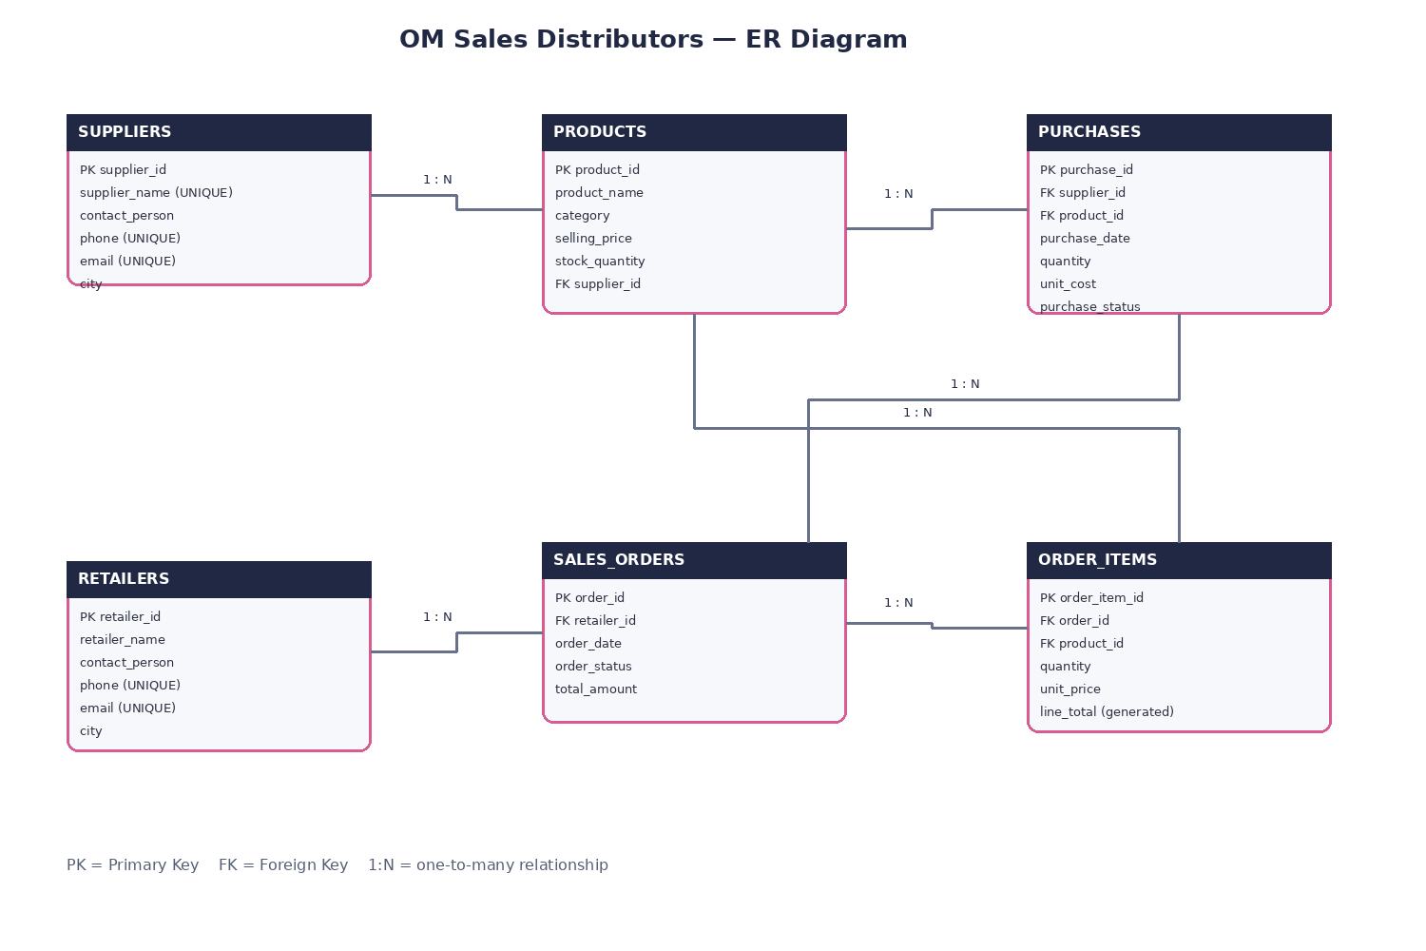
Relationships: suppliers 1:N products; suppliers 1:N purchases; products 1:N purchases; retailers 1:N sales_orders; sales_orders 1:N order_items; products 1:N order_items. The order_items table resolves the many-to-many relationship between sales_orders and products.

7. Insert Values — 20 Records per Table
The accompanying seed.sql file contains 20 sample records for each of the six tables (120 rows total). Execute it after schema.sql. The data is illustrative and is intended for academic demonstration.
-- Seed data: 20 records in each of the six tables
INSERT INTO suppliers (supplier_id,supplier_name,contact_person,phone,email,city) VALUES
(1, 'GlowCare Wholesale', 'Riya Sharma', '9876501001', 'glowcare@example.com', 'Nagpur'),
(2, 'Radiant Beauty Supply', 'Amit Verma', '9876501002', 'radiant@example.com', 'Pune'),
(3, 'NatureGlow Traders', 'Neha Patil', '9876501003', 'natureglow@example.com', 'Mumbai'),
(4, 'Elite Cosmetics Hub', 'Karan Shah', '9876501004', 'elite@example.com', 'Nashik'),
(5, 'PureSkin Distributors', 'Pooja Mehta', '9876501005', 'pureskin@example.com', 'Indore'),
(6, 'Blush & Bloom Supply', 'Rohan Joshi', '9876501006', 'blush@example.com', 'Aurangabad'),
(7, 'DermaFirst Wholesale', 'Sneha Kulkarni', '9876501007', 'dermafirst@example.com', 'Hyderabad'),
(8, 'LuxeLook Traders', 'Arjun Rao', '9876501008', 'luxelook@example.com', 'Bengaluru'),
(9, 'HerbalAura Supply', 'Kavya Nair', '9876501009', 'herbalaura@example.com', 'Thane'),
(10, 'ColorPop Distributors', 'Dev Malhotra', '9876501010', 'colorpop@example.com', 'Delhi'),
(11, 'SoftTouch Wholesale', 'Isha Deshmukh', '9876501011', 'softtouch@example.com', 'Nagpur'),
(12, 'SkinNest Traders', 'Manav Gupta', '9876501012', 'skinnest@example.com', 'Pune'),
(13, 'VelvetRose Supply', 'Ananya Rao', '9876501013', 'velvetrose@example.com', 'Mumbai'),
(14, 'FreshFace Distributors', 'Rahul Jain', '9876501014', 'freshface@example.com', 'Nashik'),
(15, 'Aura Essentials', 'Meera Soni', '9876501015', 'aura@example.com', 'Bhopal'),
(16, 'BeautyBasket Wholesale', 'Nikhil Pawar', '9876501016', 'beautybasket@example.com', 'Nagpur'),
(17, 'DewDrop Cosmetics', 'Tara Singh', '9876501017', 'dewdrop@example.com', 'Jaipur'),
(18, 'EverGlow Traders', 'Sahil Khan', '9876501018', 'everglow@example.com', 'Surat'),
(19, 'PetalPink Supply', 'Maya Iyer', '9876501019', 'petalpink@example.com', 'Chennai'),
(20, 'PrimeCare Beauty', 'Vikram Das', '9876501020', 'primecare@example.com', 'Kolkata');
INSERT INTO products (product_id,product_name,category,selling_price,stock_quantity,supplier_id) VALUES
(1, 'Vitamin C Face Serum', 'Skincare', 399.0, 60, 1),
(2, 'Aloe Vera Gel', 'Skincare', 149.0, 120, 3),
(3, 'Matte Lipstick - Rose', 'Makeup', 299.0, 80, 10),
(4, 'SPF 50 Sunscreen', 'Skincare', 349.0, 55, 2),
(5, 'Hydrating Face Wash', 'Skincare', 199.0, 90, 5),
(6, 'Compact Powder', 'Makeup', 249.0, 70, 4),
(7, 'Kajal Pencil', 'Makeup', 99.0, 150, 10),
(8, 'Argan Hair Oil', 'Haircare', 275.0, 45, 8),
(9, 'Nourishing Shampoo', 'Haircare', 229.0, 65, 6),
(10, 'Body Lotion', 'Bodycare', 189.0, 100, 9),
(11, 'Rose Water Toner', 'Skincare', 129.0, 110, 3),
(12, 'Night Repair Cream', 'Skincare', 499.0, 35, 7),
(13, 'Makeup Remover', 'Makeup', 219.0, 50, 11),
(14, 'Sheet Mask Pack', 'Skincare', 179.0, 95, 12),
(15, 'Nail Paint - Coral', 'Makeup', 89.0, 140, 13),
(16, 'Anti-Dandruff Shampoo', 'Haircare', 249.0, 60, 14),
(17, 'Hand Cream', 'Bodycare', 119.0, 85, 15),
(18, 'BB Cream', 'Makeup', 329.0, 48, 16),
(19, 'Lip Balm', 'Bodycare', 79.0, 160, 17),
(20, 'Clay Face Mask', 'Skincare', 259.0, 42, 18);
INSERT INTO retailers (retailer_id,retailer_name,contact_person,phone,email,city) VALUES
(1, 'Aarohi Cosmetics', 'Sonal Kale', '9876512001', 'aarohi@example.com', 'Nagpur'),
(2, 'Beauty Point', 'Ramesh Thakur', '9876512002', 'beautypoint@example.com', 'Pune'),
(3, 'The Skin Store', 'Priya Nair', '9876512003', 'skinstore@example.com', 'Mumbai'),
(4, 'Pink Petals Beauty', 'Ankit Shah', '9876512004', 'pinkpetals@example.com', 'Nashik'),
(5, 'Care & Glow Shop', 'Mitali Jain', '9876512005', 'careglow@example.com', 'Indore'),
(6, 'Urban Beauty Mart', 'Kunal Patil', '9876512006', 'urbanmart@example.com', 'Aurangabad'),
(7, 'Blush Boutique', 'Rutuja More', '9876512007', 'blushboutique@example.com', 'Hyderabad'),
(8, 'Glamour Gallery', 'Ayesha Khan', '9876512008', 'glamour@example.com', 'Bengaluru'),
(9, 'Natural Beauty Corner', 'Pallavi Rao', '9876512009', 'naturalcorner@example.com', 'Thane'),
(10, 'Color House', 'Omkar Joshi', '9876512010', 'colorhouse@example.com', 'Delhi'),
(11, 'Fresh Face Store', 'Nikita Pawar', '9876512011', 'freshface@example.com', 'Nagpur'),
(12, 'Skin & Shine', 'Harsh Mehta', '9876512012', 'skinshine@example.com', 'Pune'),
(13, 'Beauty Lane', 'Aditi Soni', '9876512013', 'beautylane@example.com', 'Mumbai'),
(14, 'Cosmetic Corner', 'Vivek Das', '9876512014', 'coscorner@example.com', 'Nashik'),
(15, 'The Makeup Shelf', 'Ira Kulkarni', '9876512015', 'makeupshelf@example.com', 'Bhopal'),
(16, 'Everyday Essentials', 'Siddharth Rao', '9876512016', 'everyday@example.com', 'Nagpur'),
(17, 'Glow Up Store', 'Kriti Verma', '9876512017', 'glowup@example.com', 'Jaipur'),
(18, 'Dewy Days', 'Farhan Ali', '9876512018', 'dewydays@example.com', 'Surat'),
(19, 'Pretty Things', 'Tanvi Iyer', '9876512019', 'prettythings@example.com', 'Chennai'),
(20, 'Beauty Bazaar', 'Aman Gupta', '9876512020', 'beautybazaar@example.com', 'Kolkata');
INSERT INTO sales_orders (order_id,retailer_id,order_date,order_status,total_amount) VALUES
(1, 1, '2026-10-01', 'Pending', 575.5),
(2, 2, '2026-10-02', 'Processing', 701.0),
(3, 3, '2026-10-03', 'Dispatched', 826.5),
(4, 4, '2026-10-04', 'Delivered', 952.0),
(5, 5, '2026-10-05', 'Pending', 1077.5),
(6, 6, '2026-10-06', 'Processing', 1203.0),
(7, 7, '2026-10-07', 'Dispatched', 1328.5),
(8, 8, '2026-10-08', 'Delivered', 1454.0),
(9, 9, '2026-10-09', 'Pending', 1579.5),
(10, 10, '2026-10-10', 'Processing', 1705.0),
(11, 11, '2026-10-11', 'Dispatched', 1830.5),
(12, 12, '2026-10-12', 'Delivered', 1956.0),
(13, 13, '2026-10-13', 'Pending', 2081.5),
(14, 14, '2026-10-14', 'Processing', 2207.0),
(15, 15, '2026-10-15', 'Dispatched', 2332.5),
(16, 16, '2026-10-16', 'Delivered', 2458.0),
(17, 17, '2026-10-17', 'Pending', 2583.5),
(18, 18, '2026-10-18', 'Processing', 2709.0),
(19, 19, '2026-10-19', 'Dispatched', 2834.5),
(20, 20, '2026-10-20', 'Delivered', 2960.0);
INSERT INTO order_items (order_item_id,order_id,product_id,quantity,unit_price) VALUES
(1, 1, 1, 2, 399.0, 798.0),
(2, 2, 2, 3, 149.0, 447.0),
(3, 3, 3, 4, 299.0, 1196.0),
(4, 4, 4, 1, 349.0, 349.0),
(5, 5, 5, 2, 199.0, 398.0),
(6, 6, 6, 3, 249.0, 747.0),
(7, 7, 7, 4, 99.0, 396.0),
(8, 8, 8, 1, 275.0, 275.0),
(9, 9, 9, 2, 229.0, 458.0),
(10, 10, 10, 3, 189.0, 567.0),
(11, 11, 11, 4, 129.0, 516.0),
(12, 12, 12, 1, 499.0, 499.0),
(13, 13, 13, 2, 219.0, 438.0),
(14, 14, 14, 3, 179.0, 537.0),
(15, 15, 15, 4, 89.0, 356.0),
(16, 16, 16, 1, 249.0, 249.0),
(17, 17, 17, 2, 119.0, 238.0),
(18, 18, 18, 3, 329.0, 987.0),
(19, 19, 19, 4, 79.0, 316.0),
(20, 20, 20, 1, 259.0, 259.0);
INSERT INTO purchases (purchase_id,supplier_id,product_id,purchase_date,quantity,unit_cost,purchase_status) VALUES
(1, 1, 5, '2026-09-01', 6, 287.28, 'Received'),
(2, 2, 6, '2026-09-02', 7, 107.28, 'In Transit'),
(3, 3, 7, '2026-09-03', 8, 215.28, 'Pending'),
(4, 4, 8, '2026-09-04', 9, 251.28, 'Received'),
(5, 5, 9, '2026-09-05', 5, 143.28, 'Received'),
(6, 6, 10, '2026-09-06', 6, 179.28, 'In Transit'),
(7, 7, 11, '2026-09-07', 7, 71.28, 'Pending'),
(8, 8, 12, '2026-09-08', 8, 198.0, 'Received'),
(9, 9, 13, '2026-09-09', 9, 164.88, 'Received'),
(10, 10, 14, '2026-09-10', 5, 136.08, 'In Transit'),
(11, 11, 15, '2026-09-11', 6, 92.88, 'Pending'),
(12, 12, 16, '2026-09-12', 7, 359.28, 'Received'),
(13, 13, 17, '2026-09-13', 8, 157.68, 'Received'),
(14, 14, 18, '2026-09-14', 9, 128.88, 'In Transit'),
(15, 15, 19, '2026-09-15', 5, 64.08, 'Pending'),
(16, 16, 20, '2026-09-16', 6, 179.28, 'Received'),
(17, 17, 1, '2026-09-17', 7, 85.68, 'Received'),
(18, 18, 2, '2026-09-18', 8, 236.88, 'In Transit'),
(19, 19, 3, '2026-09-19', 9, 56.88, 'Pending'),
(20, 20, 4, '2026-09-20', 5, 186.48, 'Received');

8. SQL Operations and Sample Outputs
Run the statements in queries.sql after inserting the sample data. Representative outputs are shown below; values are based on the included sample records.

8.1 View product catalogue
SELECT product_id, product_name, category, selling_price, stock_quantity FROM products ORDER BY product_id;
product_id | product_name | category | selling_price | stock_quantity
1 | Vitamin C Face Serum | Skincare | 399.00 | 60
2 | Aloe Vera Gel | Skincare | 149.00 | 120
3 | Matte Lipstick - Rose | Makeup | 299.00 | 80
4 | SPF 50 Sunscreen | Skincare | 349.00 | 55
5 | Hydrating Face Wash | Skincare | 199.00 | 90
6 | Compact Powder | Makeup | 249.00 | 70
7 | Kajal Pencil | Makeup | 99.00 | 150
8 | Argan Hair Oil | Haircare | 275.00 | 45

8.2 Filter products priced above ₹250
SELECT product_name, selling_price FROM products WHERE selling_price > 250 ORDER BY selling_price DESC;
product_name | selling_price
Night Repair Cream | 499.00
Vitamin C Face Serum | 399.00
SPF 50 Sunscreen | 349.00
BB Cream | 329.00
Matte Lipstick - Rose | 299.00
Argan Hair Oil | 275.00
Clay Face Mask | 259.00

8.3 GROUP BY category
SELECT category, COUNT(*) AS product_count FROM products GROUP BY category ORDER BY category;
category | product_count
Bodycare | 3
Haircare | 3
Makeup | 6
Skincare | 8

8.4 Join sales orders with retailer details
SELECT so.order_id, r.retailer_name, so.order_date, so.order_status, so.total_amount
FROM sales_orders so JOIN retailers r ON so.retailer_id = r.retailer_id
ORDER BY so.order_id;
order_id | retailer_name | order_date | order_status | total_amount
1 | Aarohi Cosmetics | 2026-10-01 | Pending | 575.50
2 | Beauty Point | 2026-10-02 | Processing | 701.00
3 | The Skin Store | 2026-10-03 | Dispatched | 826.50
4 | Pink Petals Beauty | 2026-10-04 | Delivered | 952.00
5 | Care & Glow Shop | 2026-10-05 | Pending | 1077.50
6 | Urban Beauty Mart | 2026-10-06 | Processing | 1203.00
7 | Blush Boutique | 2026-10-07 | Dispatched | 1328.50
8 | Glamour Gallery | 2026-10-08 | Delivered | 1454.00

8.5 Find products with low stock
SELECT product_name, stock_quantity FROM products WHERE stock_quantity < 50 ORDER BY stock_quantity;
product_name | stock_quantity
Night Repair Cream | 35
Clay Face Mask | 42
Argan Hair Oil | 45
BB Cream | 48

8.6 Aggregate sales value
SELECT SUM(total_amount) AS total_sales FROM sales_orders WHERE order_status <> 'Cancelled';
total_sales
35355.00

8.7 UPDATE, DELETE and INSERT demonstrations
The queries.sql file includes an UPDATE, DELETE and INSERT demonstration inside BEGIN/ROLLBACK transactions. This demonstrates data manipulation while restoring the sample database afterwards. Review the selected row before running any modification in a real database.
BEGIN;
UPDATE products SET stock_quantity = stock_quantity + 10 WHERE product_id = 1;
SELECT product_id, product_name, stock_quantity FROM products WHERE product_id = 1;
ROLLBACK;
BEGIN;
DELETE FROM purchases WHERE purchase_id = 20;
SELECT COUNT(*) FROM purchases;
ROLLBACK;
BEGIN;
INSERT INTO suppliers(supplier_name,contact_person,phone,email,city)
VALUES ('Demo Supplier','Demo Contact','9000000000','demo.supplier@example.com','Nagpur');
SELECT * FROM suppliers WHERE supplier_name='Demo Supplier';
ROLLBACK;
Other operations included in queries.sql: ORDER BY, category filtering, average price by category, product-supplier join, order status counts and a subquery for products priced above the overall average.

9. Frontend and Database Connectivity
The frontend is a responsive web interface made using HTML and CSS. Python Flask handles HTTP routes and PostgreSQL connectivity through psycopg2. Database credentials are read from a local .env file rather than hard-coded in the source.

9.1 Frontend screenshot preview
The following image is a design preview of the dashboard. After running the Flask application with PostgreSQL configured, open http://127.0.0.1:5000 to capture the actual running application for final submission.

9.2 Pages and features
Page | Function
Dashboard (/) | Displays product, retailer and order counts, total order value, recent orders and inventory.
Products (/products) | Displays products with supplier names and provides a form to add a product.
Retailers (/retailers) | Lists registered retailer contact details.
Sales Orders (/orders) | Shows order date, retailer, status and total amount.

9.3 Installation and execution
# 1. Create and connect to the database in PostgreSQL
CREATE DATABASE shreya_pise_om_sales;
# 2. In psql, connect to the database
\c shreya_pise_om_sales
# 3. Run schema.sql, then seed.sql (from psql, use full paths)
\i 'C:/path/to/OM_Sales_Distributors_Case_Study/schema.sql'
\i 'C:/path/to/OM_Sales_Distributors_Case_Study/seed.sql'
# 4. Open terminal in the project folder and install dependencies
python -m venv .venv
# Windows PowerShell:
.\.venv\Scripts\python.exe -m pip install -r requirements.txt
# 5. Copy .env.example to .env and enter your local PostgreSQL password
# 6. Start the application
.\.venv\Scripts\python.exe app.py
# 7. Open in browser
http://127.0.0.1:5000
If PowerShell blocks virtual-environment activation, run the environment's python.exe directly as shown above; activation is optional. Never share the real .env file or database password in screenshots or submissions.

10. Testing and Validation
Test | Expected result
Insert product with valid supplier_id | Product is saved and appears in inventory.
Insert product with negative price | Rejected by CHECK constraint.
Insert product with a nonexistent supplier_id | Rejected by foreign-key constraint.
Create order item with quantity 0 | Rejected by CHECK constraint.
Open dashboard | Counts and recent orders are retrieved from PostgreSQL.
Open products page and submit form | Flask inserts the new product using parameterized SQL.

11. Conclusion
The OM Sales Distributors case study demonstrates how a relational database can organize beauty-product distribution data. The six-table design separates supplier, product, retailer, order, order-item and purchase information while connecting them through foreign keys. Constraints improve data integrity, and SQL queries provide useful stock, pricing and sales reports. The Flask frontend provides a practical interface to view and add records backed by PostgreSQL.

12. References
- PostgreSQL Documentation — https://www.postgresql.org/docs/
- Flask Documentation — https://flask.palletsprojects.com/
- Psycopg Documentation — https://www.psycopg.org/docs/

